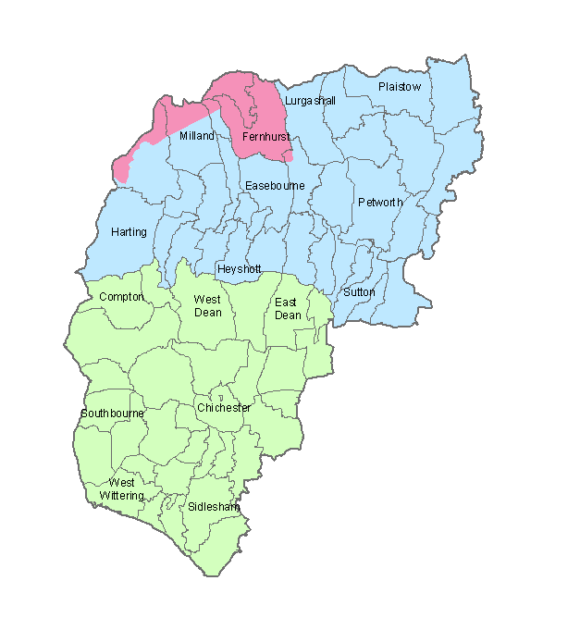
South East Water PLC
Southern Water
Portsmouth Water Ltd

Mains Water Supply Companies in Chichester District

