

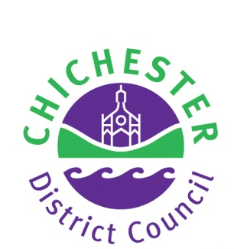

BOSHAM PARISH

NEIGHBOURHOOD PLANNING

REFERENDUM

INFORMATION FOR VOTERS

About this booklet
On 16 November 2016, there will be a referendum on a neighbourhood development plan for your area. This booklet explains more about the referendum that is going to take place and how you can take part in it. In this booklet you can find out about:
• The referendum and how you can take part
• The neighbourhood area
• The neighbourhood plan
• The development plan [of which neighbourhood plans are part]

Referendum on the Neighbourhood Plan
A referendum asks you to vote ‘yes’ or ‘no’ to a question. For this referendum you will receive a ballot paper with this question:

Do you want Chichester District Council to use the neighbourhood plan for Bosham Parish to help it decide planning applications in the neighbourhood area?

How do I vote in the referendum?
You vote by putting a cross (X) in the ‘Yes’ or ‘No’ box on your ballot paper. Put a cross in only one box or your vote will not be counted.

If more people vote ‘yes’ than ‘no’ in this referendum, then Chichester District Council will use the Neighbourhood Development Plan to help it decide planning applications in Bosham.

The Neighbourhood Development Plan once adopted will then become part of the Development Plan. In the Chichester District Council Local Planning Authority area the development plan currently consists of the adopted Chichester Local Plan: Key Policies 2014-2029, the adopted West Sussex Minerals Local Plan, July 2003 (saved policies edition); and the West Sussex Waste Local Plan (April 2014).

If more people vote ‘no’ than ‘yes’, then planning applications will be decided without using the Neighbourhood Development Plan as part of the Development Plan for the local area.

What is Neighbourhood Planning?
Neighbourhood planning aims to help local communities play a direct role in planning the areas in which they live and work.

A community can prepare a neighbourhood plan. This plan can show how the community wants land to be used and developed in its area.

What is a neighbourhood area?
A neighbourhood area can cover single streets or large urban or rural areas. The boundaries of a neighbourhood area are put forward by:

- Parish councils
- A neighbourhood forum (a group of at least 21 people in areas without parish councils)

In Bosham, the boundary of the neighbourhood area was determined by Chichester District Council and is identical to the parish area of Bosham.

Who can prepare a Neighbourhood Plan?
Neighbourhood plans are prepared by town or parish councils, or neighbourhood forums. In this case, the Bosham Parish Neighbourhood Development Plan was prepared by Bosham Parish Council.

What is a Development Plan?
In England, planning applications are determined by local planning authorities in accordance with the Development Plan. A Development Plan is a set of documents that set out the policies for the development and use of land across the entire local authority area. Within the area of Chichester District outside the South Downs National Park, the local planning authority is Chichester District Council.

Neighbourhood Planning in Bosham
The Referendum area is identified on the map overleaf as the parish area of Bosham Parish Council and is identical to the area which has been designated as the Bosham Parish Neighbourhood Development Plan area.

Who is the Planning Authority?
The planning authority for Bosham Parish is Chichester District Council. Chichester District Council is the lead authority for Neighbourhood Planning matters in the parish, including Neighbourhood Planning Referendums.

MAP OF BOSHAM PARISH

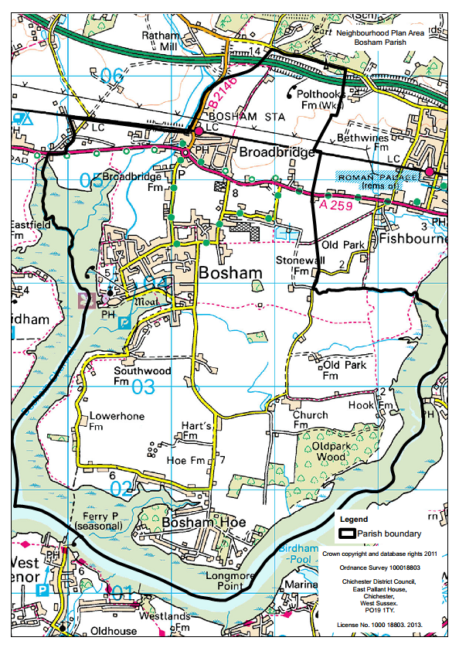

Referendum expenses
Expenses can be incurred by an individual or body during the period of the Referendum for referendum purposes.

The Referendum expenses limit that will apply in relation to this Referendum is £2510.62. The number of persons entitled to vote in the Referendum by reference to which the limit has been calculated is 2519.

Specified documents
A copy of the specified documents, that is the documents listed, may be inspected at:

Chichester District Council Offices, East Pallant House, 1 East Pallant, Chichester, West Sussex PO19 1TY Tel No 01243 785166
Opening Hours: Monday - Thursday: 08:45 - 17:10, Friday: 08:45 - 17:00
The White Swan, Station Rd Bosham, Chichester PO18 8NG Tel No: 01243 696465 Opening Hours: 11.30am to 11pm Monday to Saturday, 12pm to 10pm Sundays

The Berkeley Arms, Delling Lane, Old Bosham, Chichester PO18 8HG Tel No: 01243 573167 Opening Hours: 11.30am to 11pm Monday to Saturday, 12pm to 10pm Sundays

Bosham Village Hall, Walton Lane, Bosham, Chichester PO18 8QF Opening Hours: Most daylight hours.

St Nicholas Church Hall, Brook Lane, Bosham, West Sussex, PO18 8JZ Opening Hours: Most daylight hours.

The Bosham Centre, Recreation Ground Walton Lane Bosham PO18 8QF Tel No: 01243 576464 Opening Hours: Tuesday & Thursday 10am to 2pm or by appointment at time of your convenience

The specified documents are the:

• Post Examination version of Bosham Parish Neighbourhood Plan
• Report of the independent Examiner
• Summary of the representations submitted to the independent Examiner
• Statement by the local planning authority that the draft plan meets the basic conditions and the requirements of sections 38A & B of the Planning and Compulsory Purchase Act 2004 (Decision Statement 6 September 2016)

All the above documents can be viewed on Chichester District Council’s website at
www.chichester.gov.uk/neighbourhoodplan

• Statement that sets out general information as to town and country planning including neighbourhood planning and the referendum (this is included in this Information Statement)

Can I vote?
You can vote in the referendum if you live in the Bosham Parish area and:

• you are registered to vote in local council elections; and
• you are 18 years of age or over on 16 November 2016.

The referendum will be conducted based on procedures which are similar to those used at local government elections.

Ways of voting
There are three ways of voting:

In person on 16 November 2016:
• At your local polling station. It is easy and a member of staff will always help
if you are not sure what to do
• You will receive a poll card confirming your polling station for this referendum
• Polling stations are open from 7am to 10pm

By post:
• If you have a postal vote already, you will receive a poll card confirming this
• If you want to vote by post, you will need to complete an application form and send it to the Electoral Registration Officer to arrive by 5pm 1 November at this address:

Chichester District Council
East Pallant House
Chichester
PO19 1TY

• Postal votes can be sent overseas but you need to think about whether you will have time to receive and return your completed postal vote 16 November 2016
• You should receive your postal vote about a week before polling day. If it doesn’t arrive in time, you can ask for a replacement up to 5pm on 16 November 2016 by contacting our Helpline on 01243 521010.

By proxy:
• If you have a proxy vote already, you will receive a poll card confirming this
• If you can’t get to the polling station and don’t wish to vote by post, you may be able to vote by proxy. This means allowing somebody that you trust to vote on your behalf
• If you want to vote by proxy, you will need to complete an application form and send it to the Electoral Registration Officer to arrive by 5pm on 8 November at this address:

Chichester District Council
East Pallant House
Chichester
PO19 1TY

• When you apply for a proxy vote, you must say why you cannot vote in person
• Anyone can be your proxy as long as they are eligible to vote and are willing to vote on your behalf. You will have to tell them how you want to vote.

Postal and proxy vote application forms are available from our Helpline on 01243 521010 or by emailing elections@chichester.gov.uk.

Am I registered to vote?
If you’re not registered, you won’t be able to vote. You can check if you are registered by calling our Helpline on 01243 521010.

If you are not registered to vote, you can go online to www.gov.uk/register-to-vote with your national insurance number by Midnight 31 October 2016. If you do not have access to the internet please call our helpline on 01243 521010.

How to find out more:
• Further general information on neighbourhood planning is available at: www.chichester.gov.uk
• For queries about planning issues and neighbourhood planning in general, please contact the Chichester Planning Policy Team on 01243 534594

• For more information about voting and the arrangements for this referendum, please contact our Helpline on 01243 521010 or email: elections@chichester.gov.uk

