

Pre-Submission Chichester Site Allocation Development Plan Document
Schedule of Minor Modifications

January 2018

Schedule of Minor Modifications to Site Allocation Development Plan Document

Modification  Number | SD01Page No. | Para/  Policy | Modified text (deleted text shown as struck through and additional text shown in bold) | Reasons for modification | Source of modification (inc rep number as appropriate)
General
MIN1 | All | All | Amend text to reflect any updates/changes required as a consequence of progress of the DPD or changes elsewhere in the DPD. | Clarification and certainty | Examination Hearings
Chapter 1: Introduction
MIN2 | 2-12 | All | Site Allocation: Proposed Submission Development Plan Document  1 Introduction  Introduction  1.1 This is The Site Allocation Development Plan Document (DPD) represents the second part and ‘daughter’ document to the adopted Chichester Local Plan: Key Policies 2014-2029. which the Council intends to formally submit to the Secretary of State for independent examination. Its publication represents a further step in the process which enables anyone who may have an interest in the allocation of housing and employment sites to comment. The DPD does not include relate to that part of the District within the South Downs National Park.  1.2 The DPD has evolved through extensive consultation and research to determine help in determining the best the approaches to the allocation of housing and employment sites. Consultation on the draft DPD took place between 7 January and 18 February 2016, following which a further consultation took place between 28 July and 22 September 2016. Comments and information received during these consultations have helped develop the DPD.  1.3 Consultation has been guided by the adopted Statement of Community Involvement (SCI) and a summary of the steps undertaken is set out in the Statement of Consultation which is published alongside the Plan.  1.4 The purpose of the consultation is to obtain views on the “soundness” of the DPD before it is submitted to the Secretary of State for independent examination. It is not intended to be a consultation stage that results in the Council producing another amended version of the DPD. Instead the purpose of this stage is to enable people to make comments which they want to have taken into account by an Inspector, who conducts an independent examination, based upon issues of soundness. This is whether the DPD:  - has been prepared in accordance with the Duty to Cooperate, legal and procedural requirements, and  - is "sound".  1.5 Soundness means:  - Positively prepared – the plan should be prepared based on a strategy which seeks to meet objectively assessed need and infrastructure requirements, including unmet requirements from neighbouring authorities where it is reasonable to do so and consistent with achieving sustainable development;  - Justified – the plan should allocate the most appropriate sites, when considered against the reasonable alternatives, based on proportionate evidence;  - Effective – the plan should be deliverable over its period and based on effective joint working on cross-boundary strategic priorities; and  - Consistent with national policy – the plan should enable the delivery of sustainable development in accordance with the policies in the National Planning Policy Framework (NPPF).  What is the Site Allocation Development Plan Document?  1.6 The DPD flows from the adopted Chichester Local Plan: Key Policies 2014-2029 (Chichester Local Plan). The Chichester Local Plan sets out the housing numbers and the amount of employment land required to be delivered over the Plan period.  1.7 The primary purpose of the DPD is to deliver non- strategic residential and employment sites as set out in the Chichester Local Plan (Policy 2 - Development Strategy and Settlement Hierarchy; Policy 3 - The Economy and Employment Provision and Policy 5 - Parish Housing Sites 2012-2029), and to set out guidance for the development of these sites.  1.8 On adoption The DPD should be read in conjunction with other parts of the development plan which comprises:  - Chichester Local Plan: Key Policies 2014-2029 (July 2015)  - West Sussex Waste Local Plan (April 2014)  - West Sussex Minerals Local Plan (2003 – currently under review)  - Made Neighbourhood Plans  1.9 The sites identified in the DPD comprise will deliver the following:  Residential Sites  1.10 Sites identified have only been considered where they in the DPD are above 0.25 hectares in size or capable of accommodating at least 5 dwellings. Parishes that have undertaken the Pre-submission consultation of their neighbourhood plan or have a plan in a more advanced stage have not been included in the DPD.  1.11 Strategic Development Locations are identified in the Chichester Local Plan and this DPD addresses:  - Chichester city and sites surrounding the Chichester city Settlement Boundary in neighbouring parishes (including sites separated from the Settlement Boundary by the A27) (in line with the Chichester Local Plan Policy 5 - Parish Housing Sites 2012-2029). Where a site has been identified, if there has been a recent planning application granted, the site has been retained in the DPD, in order to give certainty, until the site is developed;  - The parishes of Bosham; Boxgrove; Hunston; Lynchmere; and Plaistow and Ifold (in line with Chichester Local Plan policies 2 – Development Strategy and Settlement Hierarchy, 5 - Parish Housing Sites 2012-2029 and 7 - Neighbourhood Development Plans.  Employment Sites  1.12 The need to allocate sites within or close to Chichester city is as identified at paragraph 6.7 and Policy 11of the Chichester Local Plan Policy 3 The Economy and Employment Provision. Where a site has been identified, if there has been a recent planning application granted, the site has been retained in the DPD, in order to give certainty, until the site is developed.  Relationship to the adopted Chichester Local Plan  1.17 When adopted, The DPD will form part of the development plan for the Chichester Local Plan Area. It will sit alongside the adopted Chichester Local Plan: Key Policies 2014-2029 and those neighbourhood plans which have been ‘made’.  1.18 The DPD must reflects the development strategy set out in the Chichester Local Plan; it is not an opportunity to re-open debate on the level or general location of development as set out in the Chichester Local Plan.  Background Information  1.19 The DPD is supported by a number of background documents and reports, which are not fully summarised here. Key documents are specifically referred to within the text.  1.20 The DPD has been subject to a Sustainability Appraisal and Habitats Regulations Assessment which considered the anticipated effects of the proposals on the area’s environmental, economic and social conditions. The results have informed decisions made in the document.  1.21 The background information on the Sustainability Appraisal and Habitats Regulations Assessment are available to download from the Council's website.  How to comment  1.22 We would like your comments on the soundness of the Site Allocation Proposed Submission Development Plan Document. If you wish to make a representation seeking a change to the DPD you should make clear in what way it is not sound having regard to the four tests, as set out in paragraph 1.4. You should try to support your representation with evidence showing why the DPD should be changed. It will be helpful if you also say precisely how you think it should be changed. When making comments, please make clear reference to the policy or paragraph number and, where appropriate, page number you are commenting on.  1.23 Due to the holiday period, the DPD (Regulation 19 Proposed Submission) has been published for an eight week consultation period between 1 December 2016 to 26 January 2017. All comments must be received no later than 17:00 on Thursday 26 January 2017. The Council will be unable to accept any comments that are received after this time.  1.24 Where possible we prefer that comments are made electronically, as this is the quickest and easiest way of responding.  1.25 Alternatively, there is a comment form for you to send back which is available from the council’s offices or by visiting our website www.chichester.gov.uk.  1.26 You can email forms to us at planningpolicy@chichester.gov.uk. When commenting please use a separate sheet for each comment, marking each sheet with the paragraph or policy number to which you are referring.  1.27 Please be aware that your comments (or a summary) will be publicly available for people to read on the website. The Council acknowledges that this document is lengthy, as the Council has to justify the policy approach it is taking and has to meet various 'tests of soundness' as laid down by the Government.  Next Steps  1.28 Once the eight week Proposed Submission consultation period is completed, the comments will be summarised as part of the submission arrangements. If any fundamental issue of soundness is identified, then further consideration to the progress of the DPD will be given with the advice of the Planning Inspectorate (PINS). Providing no fundamental soundness concerns are raised then the DPD will be formally submitted to the Government in the spring 2017.  1.29 Following formal submission, an independent examination into the soundness of the DPD will take place. It is expected that the examination will take place in spring 2017. Subject to the Inspector finding the DPD sound, it is programmed to be adopted in autumn 2017.  Any further queries  1.30 If you have any further queries regarding any of the issues raised in this document, please contact the Planning Policy Team on 01243 785166 or email planningpolicy@chichester.gov.uk.  Data Protection  All documents will be held at Chichester District Council, and representations will be published online. They will be handled in accordance with the Data Protection Act 1998 and kept for three years following adoption of the Site Allocation DPD. Personal contact details will be removed from copies of representations published electronically.  Please be aware that representations made about this document (including your name and address) cannot be treated as confidential.  ….  Local Context  Chichester Local Plan ….  ….1.35 This DPD identifies sites suitable for development in order to meet the Chichester Local Plan requirements for residential and employment and in so doing make a contribution contributes to delivering the objectives in the Chichester Local Plan. The DPD covers the same plan period as the Chichester Local Plan.  1.36 The DPD sets out what type and level of development will be identified within the Local Plan area and provides . The DPD will provide certainty for local communities, landowners, developers and infrastructure providers about the future pattern location of development.  Methodology for site assessment  1.39 The sections on residential and employment outline the amount of development required through the Chichester Local Plan. The methodology used in assessing the sites is included in the Site Allocation DPD Methodology and Assessment Document.  1.40 In general sites have been identified in one of two ways:  - Promoted by landowners or their agent either through consultation on the adopted Chichester Local Plan or a call for sites as part of the DPD; or  - Identified through the Strategic Housing Land Availability Assessment (SHLAA).  1.41 A full list of all the sites considered for residential can be seen at Appendix 1, sites for employment/mixed use are at Appendix 2 of this DPD. Each site is assessed using a three-stage approach; the number of sites are reduced at each stage as sites failing to meet the specified criteria are rejected.  1.42 The sites and reasons for their inclusion in the assessment are set out in the residential and employment sections below. The Site Allocation DPD Methodology and Assessment Document contains a list of all sites considered. This approach has allowed a transparent assessment, reflecting the independent site assessments carried out through the Sustainability Assessment process. This in turn enables robust and informed decisions to be made within the DPD.  1.43 The role of the assessment is to consider the relative merits of the site and to focus on the locational traits, rather than attempting to provide a detailed assessment of the schemes put forward by landowners and their agents.  Proposed Allocations  1.48 The following sections set out for each of the parishes the DPD is planning for, site specific proposals to the meet the requirements of the Chichester Local Plan. For each site allocation there is a policy setting out the criteria that subsequent planning applications will need to address. The boundaries of allocated sites, which all greenfield sites beyond existing Settlement Boundaries, will be integrated into a revised Settlement Boundary when the DPD is adopted and shown on the Policies Map.  1.49 This DPD has been prepared against a background of increasing pressure to provide sufficient housing to meet increasing needs. This has led to a number of planning applications across the Local Plan area. Some of these applications have been permitted where they have been regarded as being sustainable development that complies with the NPPF and development plan. In some settlements therefore a part of the parish housing requirement has already been met. It should therefore be noted that as a consequence some site allocations have already been granted planning permission. Such sites, being an important part of the housing and employment land supply, remain in the DPD as an allocation to ensure the site can come forward in the future if the current planning permission is not implemented. | Improve clarity | Examination Hearings
Chapter 3: Bosham Parish
MIN3 | 15 | Map for BO1 – | Add title to read: Inset Map 1  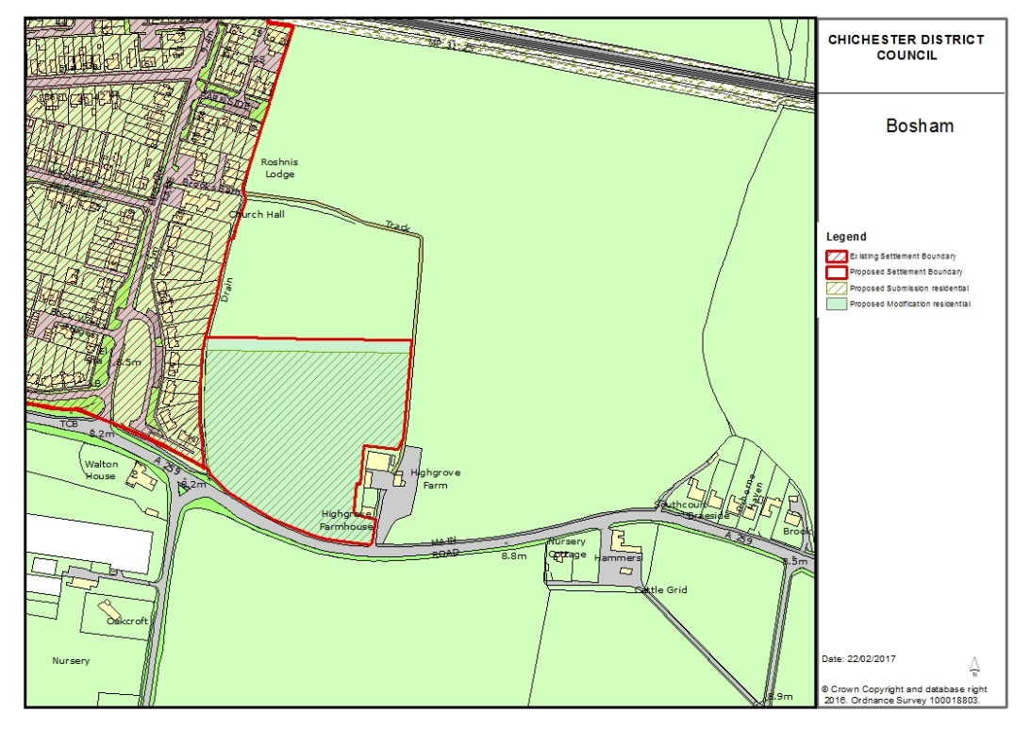 | Amend northern boundary north by 10m. In order to facilitate a meaningful layout and design approach. | Officer and following Examination
Chapter 4: Boxgrove Parish
MIN4 | 17 | Map for BX1 – Rename Map 2 | Add title to read: Inset Map 2  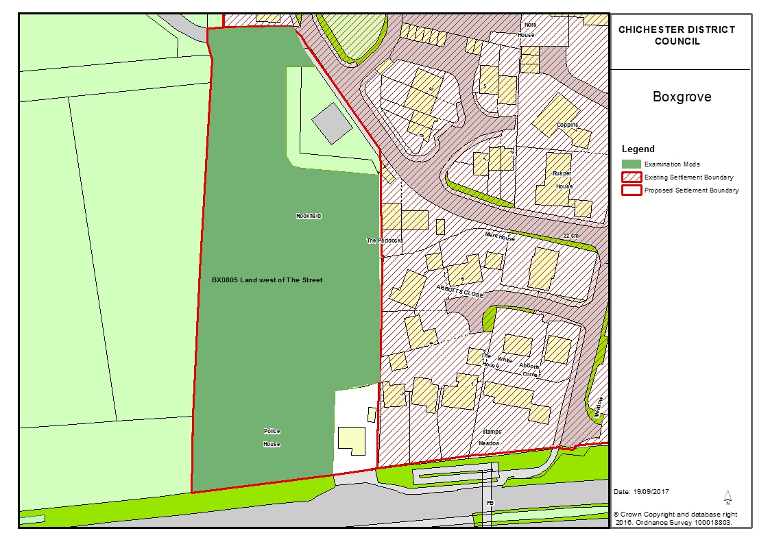 | Map amended to reflect the boundary  (BX/14/03827) | Examination
Chapter 5: Chichester City
MIN5 | 22 | Map | Add title to read: Inset Map 3 | Clarification | Following Examination
MIN6 | 24 | Map | Add title to read: Inset Map 4 | Clarification | Following Examination
MIN7 | 26 | Map | Add title to read: Inset Map 5 | Clarification | Following Examination
MIN8 | 28 | Map | Add title to read: Inset Map 6 | Clarification | Following Examination
MIN9 | 30 | Map | Add title to read: Inset Map 7 | Clarification | Following Examination
MIN10 | 32 | Map | Add title to read: Inset Map 8 | Clarification | Following Examination
MIN11 | 34 | Map | Add title to read: Inset Map 9 | Clarification | Following Examination
MIN12 | 36 | Map | Amend map to reflect the amended size area.  Add title to read: Inset Map 10  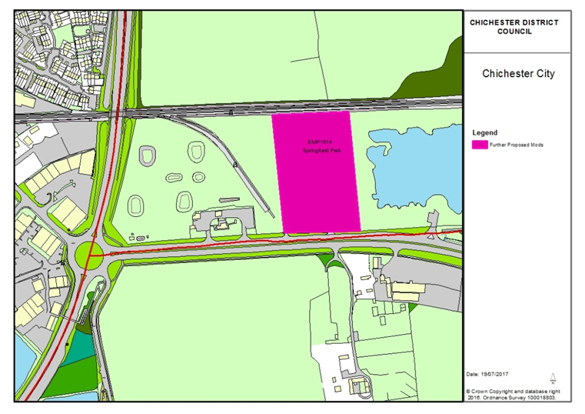 | Clarification | Following Examination
Chapter 6: East Wittering and Bracklesham Parish
MIN13 |  | Map | Add title to read: Inset Map 11 | Clarification | Following Examination
Chapter 7: Hunston Parish
MIN14 |  | Map | Add title to read: Inset Map 12 | Clarification | Following Examination
Chapter 8: Lynchmere Parish
MIN15 | 41 / 42 | Map | Amend Map to show the proposed Settlement Boundary amendment in line with Chichester District Boundary and the South Downs National Park boundary  Add title to read: Inset Map 13  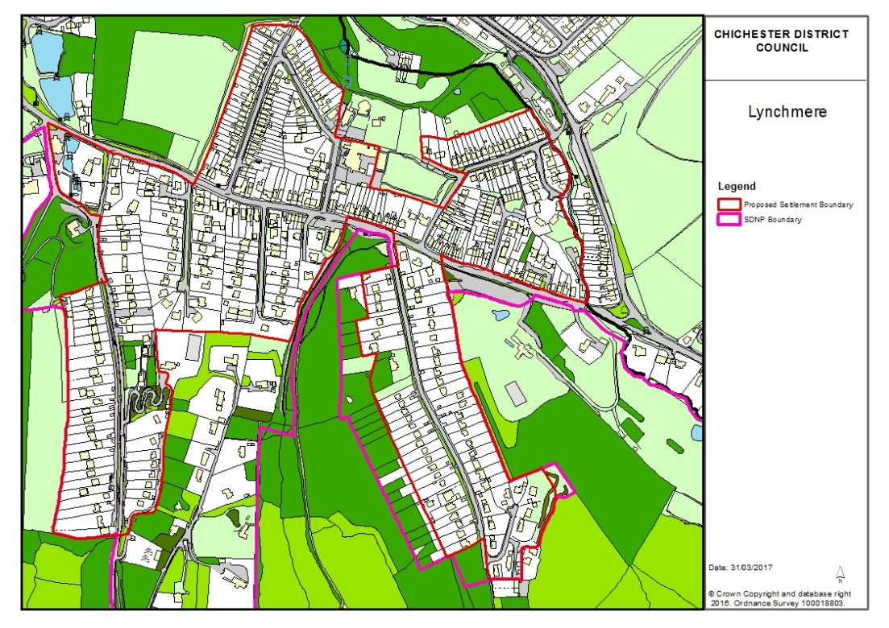 | Clarification | Following Examination
Chapter 9: North Mundham Parish
MIN16 | 43 | Map | Add title to read: Map 14 | Clarification | Officer
Chapter 9: North Mundham Parish
MIN17 | 45 | Map | Add title to read: Map 15 | Clarification | Officer
Chapter 11: West Wittering
MIN18 | 46 | Map | Add title to read: Map 16 | Clarification | Officer

