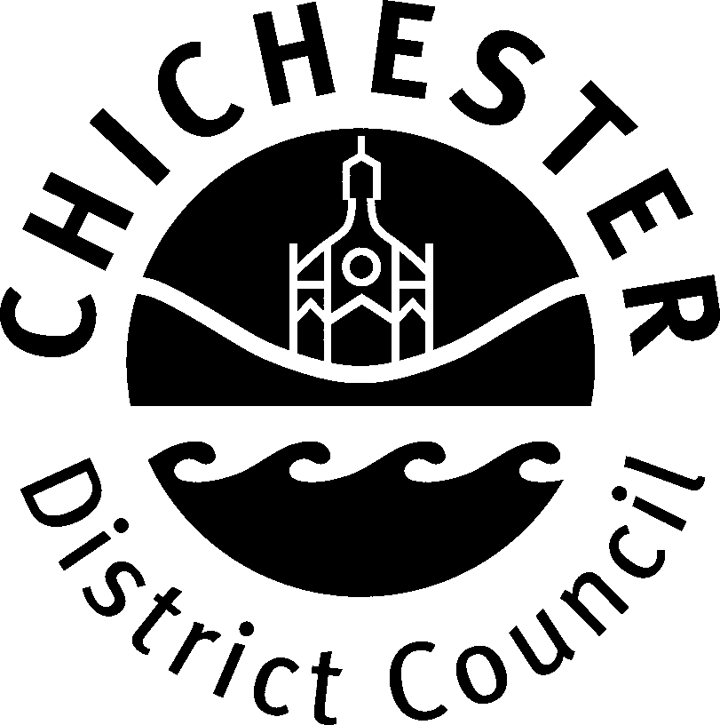 | Licensing Unit, Chichester District Council,  East Pallant House, East Pallant, Chichester,  West Sussex, PO19 1TY | FORM: H6  (Office use only)

Form of Account of collection of property (other than money) given away,
used or collected for giving away
House to House Collections Act 1939

This statement must be submitted no later than one month after the day on which the collection (or last collection) took place. It must be signed by the person responsible for promoting the collection.

Name of person to whom the Licence was granted
Address of person to whom the Licence was granted

Contact Number
Purpose of collection
Area to which account relates
Period to which account relates
Permit issue number …………………………………………………………………………………………………

To assist us with processing the above information please complete the table below by listing the name and address of each person that has been issued with a prescribed certificate of authority, prescribed badge, collecting box and/or receipt book. (Please use a separate sheet of paper if required).

Name | Signature | Contact Number | Address

Certificate of Chief Promoter

I certify to the best of my knowledge and belief all property collected in the collection of which particulars are given above (unless found useless and destroyed or otherwise disposed of as rubbish) has been given away or used for charitable purposes as follows (Please provide details of how the property collected has been disposed of i.e. the details of the charity to which articles/clothing etc has been donated):-

I further certify that the above certificate has been signed by every person responsible for the disposal of the property collected.

Signed: Dated:

Print Name:

Chichester District Council office use only
Return form checked and found to be satisfactory / unsatisfactory.

Signed: Print Name:

Capacity: Date:

Uni-form updated: Y / N

