JOB PROFILE

# Job profile summary

Job Title Building Control Manager

Reports to: Divisional Manager, Environmental Protection

Date: May 2018

Organisational Chart 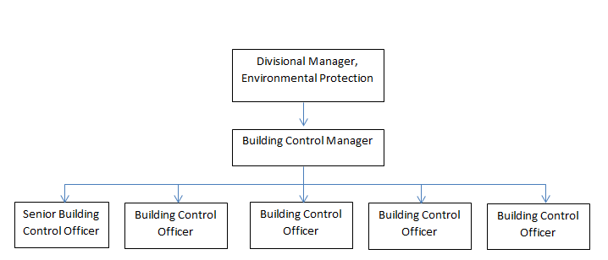

# Main Purpose of JOB

## Why the job exists

This post is to lead the Building Control team, managing the delivery and development of the Building Control Service to ensure and secure compliance with Building Control Regulations and associated legislation, in accordance with the corporate standards of the Council and its policy on Building Control, thereby ensuring good building standards and public safety.

This post is the lead officer for the Council for Building Control, giving professional expert advice, guidance, opinion and support across the Council, including to elected members.

## What it has to achieve

To ensure the achievement of the Council’s relevant strategic objectives and through day to day management, ensure the efficient and effective operation of individual services.

To ensure those services deliver their functions to the standards set by legislation, policy or by management to provide an effective and high quality of service to customers.

Ensure good building standards are achieved and that potentially dangerous buildings are made secure for public safety.

To manage the political environment within which the service operates.

Actively contribute to corporate initiatives or projects.

# Key Duties/Accountabilities

1. Be the Council’s lead officer for Building Control, with overall responsibility for continued service development, giving professional expert advice, guidance, opinion and support on an area of specialism across the Council, including to elected members.
2. To lead and manage the service, monitoring objectives to ensure the provision of effective, efficient and modern services with high standards of staff achievement and customer satisfaction.
3. To develop, implement and review policies and procedures in relation to the efficient delivery of the Building Control service.
4. Manage the service accounts/budget, review fee charges, monitor and control income and expenditure and ensure financial outcomes are in line with the approved service business plan.
5. To monitor new legislation, statutory instruments, government circulars and other guidance on good professional practice and to provide advice and support to the Divisional Manager, staff and Members.
6. Interpretation and application of the Building Control legislation and approved documents to make significant autonomous decisions on a daily basis, especially when undertaking site inspections that can be a matter of urgency including monetary and life safety issues.
7. To ensure the Service complies with the Constitution and adheres to the Council corporate policies and procedures.
8. Prepare the team’s contribution to the annual Service Plan, manage and monitor performance targets as the team manager and as the lead officer for an area of specialism to ensure delivery and implementation of projects within it.
9. To report to the Divisional Manager and be accountable for progress in relevant areas and to lead and develop the teams, oversee and co-ordinate as necessary progress on strategies, projects and work areas to ensure the provision of an efficient and effective service and achievement of work plans, including providing support and guidance for team members.

# ADDITIONAL DUTIES AND ACCOUNTABILITIES

1. To foster the well-being of staff by giving and sharing experience, by keeping up to date with changes in legislation and policy and by involving staff in more complex matters at appropriate opportunities.
2. To ensure that subordinate managers and staff are trained and fully equipped to discharge fully their given areas of responsibility and to oversee the preparation and implementation of the service training plan.
3. To ensure that the team works closely and effectively with other teams within the Directorate and across the organisation.
4. As a member of the Environmental Protection Management Team to attend and contribute fully to the development and achievement of determined priorities.
5. To provide advice, leadership and support to members and to attend meetings of Cabinet, Council and any other member meetings, Task and Finish Groups and meetings of Parish Council’s and other interest groups as appropriate.
6. To promote, communicate and help deliver corporate objectives where appropriate by active participation in cross service topic groups.
7. To be responsible for the consideration of service complaints and support the response to Ombudsman investigations.
8. To represent the Service on external, internal and other groups as required.

# KNOWLEDGE, SKILLS & EXPERIENCE

## Business knowledge

1. Highly developed technical and enforcment skills across the breadth of Building Control legislation and achievement in management at a senior officer level within a local authority setting.
2. A comprehensive understanding of the functions, roles and key accountabilities for the service for which the role is responsible in order to support the Building Control Officers and to effectively interpret this knowledge to a wider audience.
3. Understand business sectors that the team regulate, with the ability to communicate accurately and demonstrate the ability to discuss and communicate matters which are sometimes both contentious and complex with need for tact and persuasion to pursue a particular course of action.
4. Sound understanding of regulatory and governance framework to ensure all work is undertaken in accordance with the Constitution and with awareness of the corporate risk to the organisation.
5. Extensive knowledge of the current national and local government agenda for building control, in particular the wider public health implications.
6. Demonstrate political awareness and experience of effective engagement with Elected Members

## Essential Functional / Technical Skills

1. Strong leadership qualities that genuinely motivate and instil commitment in others.
2. Evidence of developing a strong service performance culture, to continually improve standards and outcomes.
3. Ability to think and plan operationally, set realistic objectives and prioritise resources.
4. Experience of undertaking plan checking on non standard or complex applications to verify compliance with the building regulations and associated legislation.
5. Experience of calculating bespoke fees for larger or unusual applications that don’t fall into the standard fee categories.
6. Demonstrate practical application of the enforcement procedure from the Building Act 1984.
7. Understand and have an awareness of the private sector and the effect it has on LA Building Control.
8. Political judgement and a high degree of political sensitivity
9. Demonstrate knowledge of the current national and local government agenda for Building Control matters.
10. Full Driving licence.

## Qualifications

* Chartered Member of RICS
* Chartered Member of CABE

## Personal Attributes / Competencies

1. Leadership skills, ability to make decisions without need for direction.
2. Demonstrates high standards of professional practice / development and appropriate behaviour that upholds the reputation of the profession.
3. Decisive and self-motivated with a can do approach.
4. Ability to use initiative, progress work in a timely manner to deadlines and work with predominately without supervision.
5. Ability to manage performance, plan work and install a clear sense of direction, priority and pace.
6. Resilient, flexible and reliable.
7. Self-sufficiency
8. To work collaboratively as part of the team ensuring effective information sharing, support for colleagues and a desire to make a difference and overall improve wellbeing.
9. Diplomatic and confident manner when dealing with the public, colleagues and members.
10. Demonstrate sound risk management skills
11. Physically able to site inspections and working outside in all weathers, including crossing rough ground and working at height.

This Job Profile is a description of the job as it is currently comprised.  The Council reserves the right to review and amend this Job Profile from time to time, if required to enable it to effectively carry out its functions.  Any changes that are made would be done so in consultation with the post holder and would be commensurate with the grade or salary of the post.