JOB PROFILE

# Recruitment Information:

**Post title** **:**Business Support Divisonal Manager

**Service: Business Support**  Based at East pallant House , Chichester, West Sussex.PO19 1TY

**Directorate:** Corporate Services

-----------------------------------------------------------------------------------------------------------------------

# JOB Profile SUMMARY

Job Title Business Support Divisional Manager

Reports to Service Director – Corporate Services

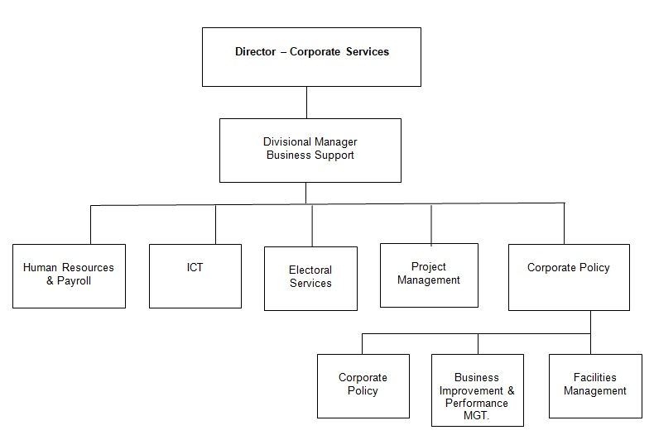

# 1.0 Main Purpose of JOB

1.1 To manage the, delivery and development of all functions within the Business Support division.

1.2 To ensure the achievement of the Council’s relevant strategic objectives and the efficient and effective operation of individual services. To ensure those services deliver their functions to the standards set by legislation, policy or management to provide a high quality of service to customers.

1.3 To ensure resources are provided and managed appropriately.

1.4 To manage the political environment within which the service operates.

1.5 Actively contribute to corporate initiatives or projects.

# 2. Key Duties/Accountabilities:

2.1 Leadership of the service including overall responsibility for continued service development to ensure the provision of effective, efficient and modern services, meeting the standards and performance expected by the council.

* 1. Management of the service to ensure the delivery of high quality value for money services meeting high levels of customer satisfaction, service performance standards including staff performance and personal development.
  2. Preparation of the service budget, monitoring and control of income and expenditure and to ensure financial outcomes are in line with the approved service business plan.
  3. The effective and efficient use of resources to deliver service functions.
  4. To ensure Health & safety legislation, policy and procedures are adhered to in all relevant service functions
  5. To ensure the Service complies with the relevant legislation, council policies and the Constitution.
  6. To drive constant improvement and ensuring that the Council’s services and its workforce are efficient and effective.
  7. To advise the Director of Corporate Services on ICT developments and strategies, and in conjunction with the ICT manager, prepare the ICT strategy and policy documents.

# 3. Additional Duties & Accountabilities

* 1. To provide advice on strategic policy, corporate planning and performance management to the Chief Executive and Directors.
  2. Regular attendance at Senior Management Team, and strategy planning days with officers and members.
  3. To ensure local and national policy developments are proactively researched and keep the management team, Leader of the Council, and the Cabinet advised of the implications for the Council.
  4. To provide support to Directors and Divisional Managers to lead service reviews in the pursuit of modern, efficient and effective service delivery. Including providing a corporate challenge or “critical friend” role and project management of major reviews.
  5. To ensure performance management techniques are developed and maintained in support of the management team and Programme Boards. Ensuring projects, strategic and service objectives are performance managed.

3.2 To support Cabinet in the on-going review of medium term priorities, and the prioritisation of resources, to ensure tangible benefits for the community.

3.3 To ensure strategic documents (such as the Council’s Corporate Plan, Annual Report, and Workforce Development Plan) are prepared.

3.4 To work with Directors and Divisional managers to encourage continuous improvement in services both in the short term, and over the medium term, to help shape future service delivery and the achievement of council priorities.

* 1. To provide an efficient and effective Human Resources and Payroll service to the Council. Ensuring the provision of strong HR leadership and advice to Directors and managers.
  2. To ensure HR strategies and policies are developed to ensure compliance with regulations, and best practice.
  3. To develop and deliver a workforce development plan that will assist the council to meet its strategic objectives through a well skilled and motivated work force.
  4. To liaise with the unions and staff representatives to maintain good relations.
  5. Oversee the Electoral Services Section which maintains the register and conducts local parish, district, Police, county, European and parliamentary elections and referenda.
  6. To conduct elections acting as the Deputy Returning Officer as required by the Chief Executive or Director of Corporate Services as necessary.
  7. To develop, implement and maintain the Council’s ICT strategy and policies in consultation with senior managers, members and business users, ensuring they drive service improvement and provide good value for money.
  8. Oversee and give strategic direction to the development of, and delivery of, the ICT service plan projects and targets with the ICT manager. Ensuring that these are achieved, either through direct delivery of the service team or where appropriate through partnership working.
  9. Ensure via the ICT manager the delivery of ICT projects, ensuring that all expenditure is compliant with the Council’s Constitution.
  10. To deliver innovations and solutions that drive agile/flexible working.
  11. To ensure that ICT Business Continuity plans and systems are aligned to the Council’s Business Continuity Management Strategy and are regularly tested and maintained for those areas of responsibility held.
  12. To oversee the work of the Facilities team, including caretaking, security and postal services for all council occupied buildings. Ensuring all relevant legislation is complied with.
  13. To ensure the Facilities Manager conducts the Legionella Inspection and reporting regime for CDC occupied operational properties.
  14. To work in collaboration with the Health and Safety Manager to ensure office safety procedures are effective and complied with at Council offices including evacuation procedures.

# 4.0 KNOWLEDGE, SKILLS & EXPERIENCE

## Business Knowledge

* 1. Demonstrable achievement in providing strong, decisive leadership for multi-disciplined teams/individuals.
  2. Successful track record of establishing a strong service performance culture to continually improve standards, value for money and outcomes.
  3. Experience of managing change.
  4. Experience of applying employment related procedures, policies and legislation where appropriate.
  5. Ability to deliver/undertake difficult messages and conversations.
  6. Ability to fully understand the functions, roles and key accountabilities for those services for which the role is responsible for in order to support the service managers/staff and to effectively interpret this knowledge to a wider audience.
  7. Experience of managing complex, large scale service reviews, and a sound understanding of project management techniques.
  8. An ability to negotiate and resolve conflicts.
  9. A sound understanding of the Council’s ambitions and priorities at member level, and the ability to translate those into targets and objectives for officer implementation.
  10. Sound performance management skills. And being able to challenge and negotiate with other senior officers including members of the senior management team.
  11. The ability to build positive and effective relationships with staff representatives.
  12. The ability to deal with, and resolve, conflict.

## 5.0 Essential Functional / Technical Skills

5.1 Ability to demonstrate leadership qualities that genuinely motivate and instil commitment in others.

5.2 Ability to think and plan operationally, set realistic objectives, lead and inspire people and prioritise resources.

* 1. Political Judgement and a high degree of political sensitivity.
  2. Experience of leading & implementing major change with the resources available.
  3. Highly developed analytical, networking, advocacy, oral, written and presentational skills.

5.6 Ability to work under pressure and to tight timescales to deliver projects and performance targets.

* 1. Contribute to partnerships and stakeholder groups to deliver wider community projectsand/or Council initiatives in your role as a representative of CDC.
  2. Ability to work in a matrix management system to deliver priority projects and service reviews across the Council.

6.0 Qualifications

6.1 Relevant degree or equivalent level qualification is desirable plus management qualification.

* 1. Relevant experience in managing large complex projects.
  2. Relevant HR, and Project Management qualifications are desirable.

## 7.0 Personal Attributes / Competencies

* 1. Reliable and resilient individual.
  2. Project management.
  3. Commercial acumen.
  4. Managing performance.
  5. Self-sufficiency.

7.6 Risk management.

This Job Profile is a description of the job as it is currently comprised.  The Council reserves the right to review and amend this Job Profile from time to time, if required to enable it to effectively carry out its functions.  Any changes that are made would be done so in consultation with the post holder and would be commensurate with the grade or salary of the post.