JOB PROFILE

# JOB Profile SUMMARY

Job Title: Service Manager – Chichester Contract Services

Reports to: Service Director

Date: February 2018 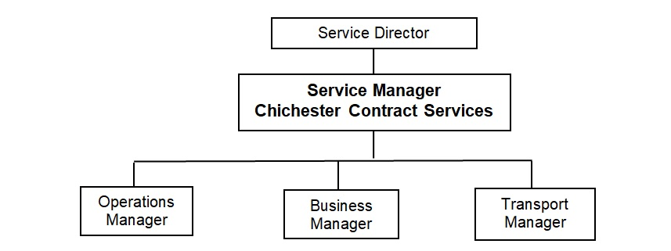

# Main Purpose of JOB

To be responsible for the management, delivery and development of all functions within the remit of Chichester Contract Services, including domestic and commercial waste management and recycling, street cleaning and grounds maintenance, ensuring the achievement of the Council’s strategic objectives and the efficient and effective operation of individual functions.

## Key Accountabilities

To be accountable for:

1. Leadership of the service including overall responsibility for continued service development to ensure the provision of effective, efficient and modern services, meeting the standards and performance expected by the council.
2. Management of the service to ensure the delivery of high quality value for money services meeting high levels of customer satisfaction, service performance standards including staff performance and personal development.
3. Preparation of the service budget, monitoring and control of income and expenditure and to ensure financial outcomes are in line with the approved service business plan.
4. The effective and efficient use of resources that are made available to deliver various service functions to ensure service standards are achieved, including staff, vehicles, equipment and materials.
5. Health and Safety matters relating to all relevant service functions.
6. Service compliance with relevant legislation and council policy including contracts and procurement.

# KNOWLEDGE, SKILLS & EXPERIENCE

This position requires an exceptional manager, experienced in running a large service that includes both policy development and significant routine daily activities. The following knowledge, skills and experience will be expected.

## Business Knowledge

1. Demonstrable achievement in providing strong, decisive leadership and management with a large, complex organisation delivering front line services.
2. Successful track record of establishing a strong service performance culture to continually improve standards, value for money and outcomes.
3. High level of financial, risk management and commercial skills with ability to negotiate complex arrangements.
4. A high degree of political sensitivity.
5. Experience of working in a highly unionised environment.
6. Experience of negotiating large contracts.
7. Proven suitable knowledge and experience of domestic and commercial waste management and street cleaning services. Minimum of 5 years’ experience managing a waste collection and recycling operation.
8. Suitable knowledge and awareness of commercial vehicle maintenance and fleet management issues, including HGVs, is desirable.
9. Suitable knowledge and awareness of grounds maintenance and green spaces management issues is desirable.

## Essential Functional / Technical Skills

1. Ability to demonstrate leadership qualities that genuinely motivate and instil commitment into others
2. Ability to think and plan operationally, set realistic objectives, lead and inspire people and prioritise resources
3. Ability to provide leadership to ensure the council’s deficit reduction plan and other improvement plans are achieved
4. Evidence of effective multi-agency and partnership working to improve outcomes for the community
5. Experience of leading, implementing and evaluating major change with limited resources.
6. Highly developed analytical, networking, advocacy, oral, written and presentational skills
7. Ability to work under pressure and to tight timetables
8. A strong commitment to customer services, the role of the communities and supporting Members
9. Outcome focussed leader
10. Degree or equivalent level qualification is desirable plus management qualification.
11. Member of the Chartered Institute of Wastes Management.

## Personal Attributes / Competencies

1. An inspirational and motivated individual with political sensitivity, honesty, loyalty, integrity and probity
2. Exceptional inter-personal and communication skills that inspire confidence, trust and respect at all levels, influence and enable successful negotiations.
3. Decisive and determined to achieve results.

This Job Profile is a description of the job as it is currently comprised.  The Council reserves the right to review and amend this Job Profile from time to time, if required to enable it to effectively carry out its functions.  Any changes that are made would be done so in consultation with the post holder and would be commensurate with the grade or salary of the post.