JOB PROFILE

# Recruitment Information:

**Post title** **:** Divisonal Manager – Communication, Licensing and Events

**Service: Place**  Based at East pallant House , Chichester, West Sussex.PO19 1TY

**Directorate:** Growth and Place

-----------------------------------------------------------------------------------------------------------------------

# JOB Profile SUMMARY

Job Title Divisional Manager – Communication, Licensing and Events

Reports to Service Director – Growth and Place

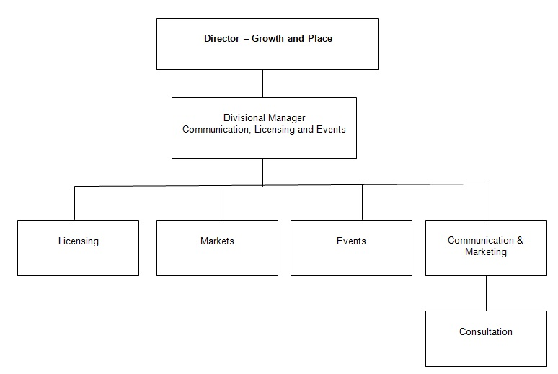

# 1.0 Main Purpose of JOB

1.1 To manage the, delivery and development of all functions within the Communication, licensing and Events service.

1.2 To ensure the achievement of the Council’s relevant strategic objectives and the efficient and effective operation of individual services. To ensure those services deliver their functions to the standards set by legislation, policy or management to provide a high quality of service to customers. To ensure resources are provided and managed appropriately. To manage the political environment within which the service operates.

1.3 Actively contribute to corporate initiatives or projects.

# 2.0 Key Duties/Accountabilities:

2.1 Leadership of the service including overall responsibility for continued service development to ensure the provision of effective, efficient and modern services, meeting the standards and performance expected by the council.

* 1. Management of the service to ensure the delivery of high quality value for money services meeting high levels of customer satisfaction, service performance standards including staff performance and personal development.

2.3 Preparation of the service budget, monitoring and control of income and expenditure and to ensure financial outcomes are in line with the approved service business plan.

* 1. The effective and efficient use of resources to deliver service functions.
  2. To ensure Health & safety legislation, policy and procedures are adhered to in all relevant service functions
  3. To ensure the Service complies with the relevant legislation, council policies and the Constitution.

# 3.0 ADDITIONAL DUTIES & ACCOUNTABILITIES

* 1. To be responsible for the effective and efficient delivery of the licensing function.
  2. To participate in the duty EHO scheme if required to do so by the Director.
  3. To performance manage the City Centre market to ensure the quality of the service is maintained in accordance with the contract.
  4. To manage the farmers market and to review the operational management of the service.
  5. To develop, implement and evaluate the Councils corporate and internal communications strategies to inform and assist residents, businesses, staff, visitors and stakeholders.

3.6 To ensure delivery of all services supporting the corporate communications strategies and internal communication strategies

3.7 To work with existing major event providers in the District and to develop an event programme for the Council.

3.8 To develop a marketing strategy for Council services and to assist service areas in implementing marketing plans to ensure that services are ready to promote and sell where appropriate

3.8 To manage the consultation programme for the Council to effectively inform key decisions and to ensure that this process is following best practise with regard to inclusion.

# 4.0 KNOWLEDGE, SKILLS & EXPERIENCE

## Business Knowledge

* 1. Demonstrable achievement in providing strong, decisive leadership for multi-disciplined teams/individuals.
  2. Successful track record of establishing a strong service performance culture to continually improve standards, value for money and outcomes.
  3. Experience of managing change.
  4. Experience of applying employment related procedures, policies and legislation where appropriate.
  5. Ability to deliver/undertake difficult messages and conversations.
  6. Ability to fully understand the functions, roles and key accountabilities for those services for which the role is responsible for in order to support the service managers/staff and to effectively interpret this knowledge to a wider audience.
  7. Ability to develop positive and effective relationships with contractors and partners
  8. Ability to prepare, procure and performance monitor contracts.

## 5.0 Essential Functional / Technical Skills

5.1 Ability to demonstrate leadership qualities that genuinely motivate and instil commitment in others.

5.2 Ability to think and plan operationally, set realistic objectives, lead and inspire people and prioritise resources.

* 1. Political Judgement and a high degree of political sensitivity.
  2. Experience of leading & implementing major change with the resources available.
  3. Highly developed analytical, networking, advocacy, oral, written and presentational skills.

5.6 Ability to work under pressure and to tight timescales to deliver projects and performance targets.

* 1. Contribute to partnerships and stakeholder groups to deliver wider community projectsand/or Council initiatives in your role as a representative of CDC.
  2. Ability to work in a matrix management system to deliver priority projects for the council.
  3. Ability to provide strategic advice on planning applications

## 6.0 Qualifications

6.1 Relevant degree or equivalent level qualification is desirable plus management qualification.

* 1. Relevant experience. At least five years managerial experience.

## 7.0 Personal Attributes / Competencies

* 1. Reliable and resilient individual.
  2. Project management.
  3. Commercial acumen.
  4. Managing performance.
  5. Self-sufficiency.

7.6 Risk management.

This Job Profile is a description of the job as it is currently comprised.  The Council reserves the right to review and amend this Job Profile from time to time, if required to enable it to effectively carry out its functions.  Any changes that are made would be done so in consultation with the post holder and would be commensurate with the grade or salary of the post.