JOB PROFILE

# Recruitment Information:

**Post title** **:** Communities & Wellbeing Divisonal Manager

**Service: Communities Services** Based at East pallant House , Chichester, West Sussex.PO19 1TY

**Directorate:** Housing and Community Services

-----------------------------------------------------------------------------------------------------------------------

# JOB Profile SUMMARY

Job Title Divisional Manager – Communities & Wellbeing

Reports to Service Director – Housing and Communities

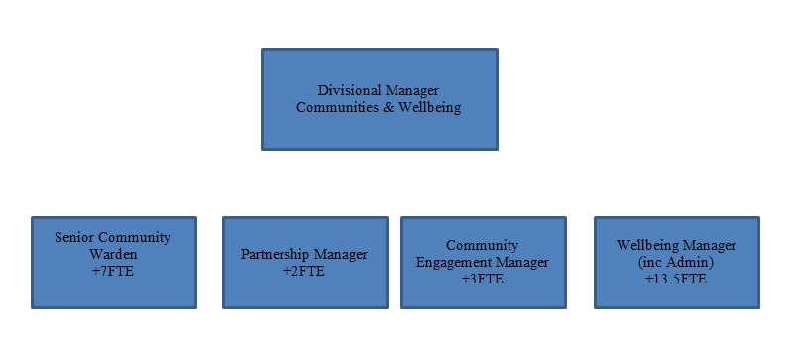

# 1.0 Main Purpose of JOB

* 1. To lead and manage the, delivery and development of all functions within the Communities & Wellbeing service, including: Youth Engagement, Community Facilities Audit, Grants including New Home Bonus, Assets of Community Value, Community engagement and development, Community Safety, CCTV, Choose Work, Community Wardens, Gypsies & Travellers, Chichester Wellbeing programme, Healthier Chichester Partnership (CiP), Social Prescribing & the Housing & Communities Admin team.
  2. Oversee delivery of CDC’s statutory responsibilities to tackle crime, disorder and Anti-Social Behaviour through the multi-agency Community Safety Partnership (CSP).
  3. Oversee the Healthier Chichester Partnership (Chichester in Partnership) and CDC involvement in the Health & Wellbeing board and deliver health promotion projects as agreed.
  4. Be the key contact for members and senior staff for Public Health, particularly to improve the health of CDC staff, and the delivery of the CDC action plan through the cross directorate Public Health Working Group.
  5. To be responsible for the development of any health and wellbeing related strategies and plans.
  6. To be the key contact for members and senior staff for Safeguarding issues.
  7. To be the lead officer, working closely with the Chair, for Overview and Scrutiny Panel. Agreeing workplans and briefing the Chair on forthcoming reports.
  8. To be responsible for the development of any community related strategies and plans, and to oversee effective Partnerships including Chichester in Partnership and Chichester Safety Partnership. Working with the Voluntary Sector to deliver community development projects whether by commissioning or other means.

1.5 To ensure the achievement of the Council’s relevant strategic objectives and the efficient and effective operation of individual services. To ensure those services deliver their functions to the standards set by legislation, policy or management to provide a high quality of service to customers. To ensure resources are provided and managed appropriately. To manage the political environment within which the service operates.

1.6 Actively contribute to corporate initiatives or projects.

# 2.0 Key Duties/Accountabilities:

2.1 Leadership of the service including overall responsibility for continued service development to ensure the provision of effective, efficient and modern services, meeting the standards and performance expected by the council.

* 1. Management of the service to ensure the delivery of high quality value for money services meeting high levels of customer satisfaction, service performance standards including staff performance and personal development.
  2. Represent the service to SMT and members, ensuring that appropriate advice, training and assistance is provided to SMT, members of the council and the relevant portfolio holder to ensure they are sufficiently informed to make key decisions.
  3. Preparation of the service budget, monitoring and control of income and expenditure and the services capital budget and to ensure financial outcomes are in line with the approved service business plan and project plans.
  4. To develop close links with other service teams on joint projects and matters of common interest and to work collaboratively to improve service delivery through a cross-cutting approach.
  5. To maintain close working relationships with other local authorities, central government, the voluntary sector and other partner organisations and ensure that the Council is represented at appropriate multi-agency meetings relevant to its statutory function and any other meetings appropriate to the delivery of its service.
  6. The effective and efficient use of resources to deliver service functions.
  7. To ensure Health & safety legislation, policy and procedures are adhered to in all relevant service functions
  8. To ensure the Service complies with the relevant legislation, council policies and the Constitution.

# 3.0 Additional Duties & AccountabilitieS

* 1. Lead officer for the provision and management of Rest Centres and any other related emergency planning duties such as Survivor Reception Centres etc.

# 4.0 KNOWLEDGE, SKILLS & EXPERIENCE

## Business Knowledge

* 1. Demonstrable achievement in providing strong, decisive leadership for multi-disciplined teams/individuals.
  2. Successful track record of establishing a strong service performance culture to continually improve standards, value for money and outcomes.
  3. Experience of managing change.
  4. Experience of applying employment related procedures, policies and legislation where appropriate.
  5. Ability to deliver/undertake difficult messages and conversations.
  6. Ability to fully understand the functions, roles and key accountabilities for those services for which the role is responsible for in order to support the service managers/staff and to effectively interpret this knowledge to a wider audience.
  7. A comprehensive understanding of existing legislation and policies relating to Community development and Community Safety and the ability to interpret complex government legislation and understand the implications in terms of meeting the needs of the district and the delivery of services by both CDC and our stakeholder partners.

## 5.0 Essential Functional / Technical Skills

5.1 Ability to demonstrate leadership qualities that genuinely motivate and instil commitment in others.

5.2 Ability to think and plan operationally, set realistic objectives, lead and inspire people and prioritise resources.

* 1. Political Judgement and a high degree of political sensitivity with experience of working with members and the voluntary sector.
  2. Experience of leading & implementing major change with the resources available.
  3. Highly developed analytical, networking, advocacy, oral, written and presentational skills with the ability to present complex information to SMT, members and the public.

5.6 Ability to work under pressure and to tight timescales to deliver projects and performance targets.

* 1. Contribute to partnerships and stakeholder groups to deliver wider community projectsand/or Council initiatives in your role as a representative of CDC.
  2. Ability to influence and negotiate with external partners, particularly the voluntary sector, to achieve desired outcomes.

## Qualifications

6.1 Relevant degree or equivalent level qualification is desirable plus management qualification.

* 1. Experience in a range of relevant community related services at management level.

## 7.0 Personal Attributes / Competencies

* 1. Reliable, self-sufficient and resilient individual.
  2. The ability to influence, persuade and to inspire confidence, trust and respect at all levels,
  3. The ability to project manage a series of complex projects alongside the day to day role.
  4. Financial and commercial awareness demonstrating effective strategic planning and the management of risk.
  5. Experienced in managing and monitoring performance across a service to drive continuous improvement.
  6. Innovative and adaptive thinker
  7. A “can do” approach demonstrating strong analytical skills and a creative approach to problem solving.
  8. An understanding of and commitment to local democracy and delivery of efficient and cost effective public services.
  9. The ability to formulate and articulate corporate strategies in a Local Government setting.
  10. The ability to analyse, interpret and act upon the implications of National and Local Government directives.
  11. Demonstrable ability to manage changing priorities and deadlines with a need for prioritisation of conflicting demands within the services managed.
  12. Team Player and ability to network