JOB PROFILE

# Recruitment Information:

**Post title** **:** Legal &Democratic Services Divisonal Manager

**Service: Business Support**  Based at East pallant House , Chichester, West Sussex.PO19 1TY

**Directorate:** Corporate Services

-----------------------------------------------------------------------------------------------------------------------

# JOB Profile SUMMARY

Job Title Democratic Services Divisional Manager

Reports to Service Director – Corporate Services

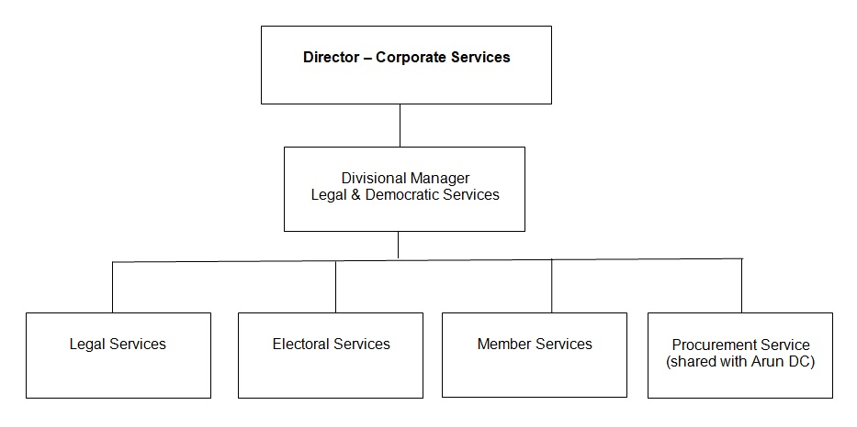

# 1.0 Main Purpose of JOB

1.1 To manage the, delivery and development of all functions within the Democratic Services division.

1.2 To ensure the achievement of the Council’s relevant strategic objectives and the efficient and effective operation of individual services. To ensure those services deliver their functions to the standards set by legislation, policy or management to provide a high quality of service to customers.

1.3 To ensure resources are provided and managed appropriately.

1.4 To manage the political environment within which the service operates.

1.5 Actively contribute to corporate initiatives or projects.

# 2 Key Duties/Accountabilities:

2.1 Leadership of the service including overall responsibility for continued service development to ensure the provision of effective, efficient and modern services, meeting the standards and performance expected by the council.

* 1. Management of the service to ensure the delivery of high quality value for money services meeting high levels of customer satisfaction, service performance standards including staff performance and personal development.

2.3 Preparation of the service budget, monitoring and control of income and expenditure and to ensure financial outcomes are in line with the approved service business plan.

* 1. The effective and efficient use of resources to deliver service functions.
  2. To ensure Health & safety legislation, policy and procedures are adhered to in all relevant service functions
  3. To ensure the Service complies with the relevant legislation, council policies and the Constitution.
  4. To act as the Council’s statutory Monitoring Officer, personally discharging the statutory functions and duties of that office to secure compliance with the law with high standards of ethics and probity.

# 3 Additional Duties & Accountabilities

* 1. Provide correct and timely legal advice and support to senior officers and members. Helping to ensure that the Council, its members and officers act lawfully.
  2. Provide legal and procedural advice to Council, Cabinet and other such committees and panels. Working with the Council’s Section 151 officer to ensure that executive decisions are within the budget and policy framework.
  3. Manage the Legal Services Section which undertakes legal advice, contracts, commercial conveyancing and litigation, and maintain performance under the local performance indicator framework.
  4. Assist others services to operate within all statutory frameworks and comply with relevant legislation.
  5. Maintain and keep up to date the Council’s Constitution ensuring it is effective and fit for purpose and assist officers and members to operate within it.
  6. Conduct investigations into matters required by the Standards Committee or referred by ethical standards officers and make reports and recommendations in respect of them to Standards Committee
  7. Provide expert support and advice to the Council’s Standard Committee, working with the independent chairman and other committee members to ensure the effective operation of the Committee and manage issues relating to Members Code of Conduct.
  8. Manage the Independent Remuneration Panel and other similar panels.
  9. Bringing and defending proceedings on behalf of the Council to protect its interests.
  10. Oversee the Electoral Services Section which maintains the register and conducts local parish, district, Police, county, European and parliamentary elections and referenda.
  11. To oversee the work of the Member Services Team, ensuring the smooth operation of the committee administration function. Contributing to the development of services provided to both Councillors and members of the public, and overseeing the induction programme for new members.
  12. To oversee the work of the Procurement team, and manage the shared service arrangement with Arun District Council. Ensuring a proactive approach to procurement and contract management.
  13. To act as the Council’s Data Protection officer, overseeing the handling of Data Protection, Freedom of Information (FOI) and Environmental Impact Regulations (EIR) enquiries.
  14. To conduct elections acting as the Deputy Returning Officer as required by the Chief Executive or Director of Corporate Services as necessary.

# 4.0 KNOWLEDGE, SKILLS & EXPERIENCE

## Business Knowledge

* 1. Demonstrable achievement in providing strong, decisive leadership for multi-disciplined teams/individuals.
  2. Successful track record of establishing a strong service performance culture to continually improve standards, value for money and outcomes.
  3. Experience of managing change.
  4. Experience of applying employment related procedures, policies and legislation where appropriate.
  5. Ability to deliver/undertake difficult messages and conversations.
  6. Ability to fully understand the functions, roles and key accountabilities for those services for which the role is responsible for in order to support the service managers/staff and to effectively interpret this knowledge to a wider audience.
  7. Experience of managing a Legal Service providing a range of legal support and advice to all client departments in a large complex organisation.
  8. An ability to negotiate and resolve conflicts.
  9. A sound understanding of the Council’s ambitions and priorities at member level, and the ability to translate those into targets and objectives for officer implementation.
  10. Sound performance management skills. And being able to challenge and negotiate with other senior officers including members of the senior management team.
  11. The ability to build positive and effective relationships with client departments.
  12. The ability to deal with, and resolve, conflict including dealing with code of conduct complaints against members.
  13. Experience as Monitoring Officer, and possessing the ability to act independently and impartially, giving management and members sound legal advice.

## 5.0 Essential Functional / Technical Skills

5.1 Ability to demonstrate leadership qualities that genuinely motivate and instil commitment in others.

5.2 Ability to think and plan operationally, set realistic objectives, lead and inspire people and prioritise resources.

* 1. Political Judgement and a high degree of political sensitivity.
  2. Experience of leading & implementing major change with the resources available.
  3. Highly developed analytical, networking, advocacy, oral, written and presentational skills.

5.6 Ability to work under pressure and to tight timescales to deliver projects and performance targets.

* 1. Contribute to partnerships and stakeholder groups to deliver wider community projectsand/or Council initiatives in your role as a representative of CDC.
  2. Ability to work in a matrix management system to deliver priority projects outcomes across the Council.
  3. Ability to provide strategic advice on legislation and interpret the potential impacts on the Council.
  4. Ability to tackle difficult situations and manage conflict effectively.

## 6.0 Qualifications

6.1 Relevant degree or equivalent level qualification is desirable plus management qualification.

* 1. Professionally qualified solicitor
  2. Relevant experience as Monitoring Officer.
  3. Relevant Procurement, Data Protection and Project Management qualifications are desirable.

## 7.0 Personal Attributes / Competencies

* 1. Reliable and resilient individual.
  2. Project management.
  3. Commercial acumen.
  4. Managing performance.
  5. Self-sufficiency.

7.6 Risk management.

This Job Profile is a description of the job as it is currently comprised.  The Council reserves the right to review and amend this Job Profile from time to time, if required to enable it to effectively carry out its functions.  Any changes that are made would be done so in consultation with the post holder and would be commensurate with the grade or salary of the post.