JOB PROFILE

# Recruitment Information:

**Post title** **:** Financial Services Divisonal Manager

**Service: Business Support**  Based at East pallant House , Chichester, West Sussex.PO19 1TY

**Directorate:** Corporate Services

-----------------------------------------------------------------------------------------------------------------------

# JOB Profile SUMMARY

Job Title Financial Services Divisional Manager

Reports to Service Director – Corporate Services

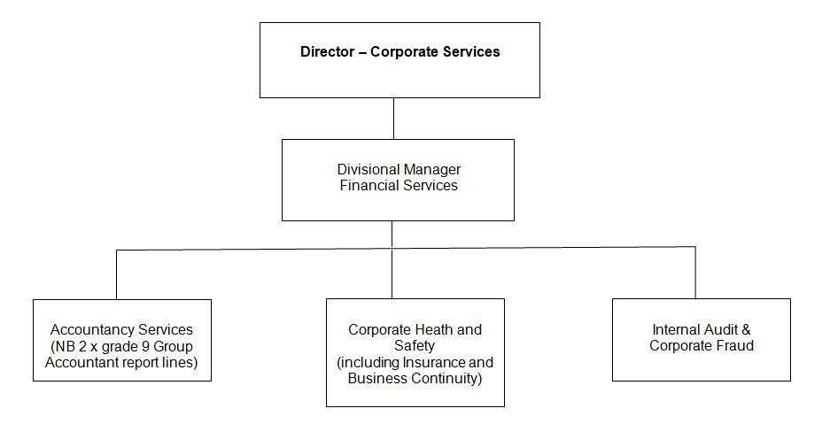

# 1.0 Main Purpose of JOB

1.1 To manage the delivery and development of all functions within the Financial Services division.

1.2 To ensure the achievement of the Council’s relevant strategic objectives and the efficient and effective operation of individual services. To ensure those services deliver their functions to the standards set by legislation, policy or management to provide a high quality of service to customers.

1.3 To ensure resources are provided and managed appropriately.

1.4 To manage the political environment within which the service operates.

1.5 Actively contribute to corporate initiatives or projects.

# 2 Key Duties/Accountabilities:

2.1 Leadership of the service including overall responsibility for continued service development to ensure the provision of effective, efficient and modern services, meeting the standards and performance expected by the council.

* 1. Management of the service to ensure the delivery of high quality value for money services meeting high levels of customer satisfaction, service performance standards including staff performance and personal development.
  2. Preparation of the service budget, monitoring and control of income and expenditure and to ensure financial outcomes are in line with the approved service business plan
  3. . To lead the annual budget process for the Council, ensuring corporate objectives can be funded, and in accordance with the Council’s adopted financial strategy.
  4. To advise the Director of Corporate Services on Treasury Management developments and strategies, and draft the annual Treasury Management strategy and policy documents for members.
  5. To manage the Council’s treasury investments in accordance with the approved Treasury Management Policy. Minimising risk whilst maintaining liquidity and investment returns consistent with those risks.
  6. The effective and efficient use of resources to deliver service functions.
  7. To ensure Health & safety legislation, policy and procedures are adhered to in all relevant service functions. And to promote the corporate profile of Health and safety across the Council, working with SMT, senior manager and members.
  8. To be the lead officer for the Corporate Risk Management officer / member panel.
  9. To ensure the Service complies with the relevant legislation, council policies and the Constitution.
  10. To act as the Council’s Deputy S151 officer (Deputy Chief Financial Officer) and to act for the S151 officer in his absence in relation to that statutory function. Acting with high standards of ethics and probity.

# 3 Additional Duties & Accountabilities

* 1. To provide support to the Director of Corporate Services in providing strategic financial advice, support and leadership to SMT, members and other senior officers so that the Council’s values, vision and corporate priorities can be delivered.
  2. To deputise for the Director of Corporate services and carry out the S151 responsibilities in his absence.
  3. Provide effective leadership, management and development of The Finance Division, and improve financial performance and service delivery through innovation.
  4. To ensure that the Council’s accounts are accurate and comply with all relevant professional codes of practice and statutes.
  5. To maintain a robust Medium Term Financial Strategy and Financial Plan which will deliver cost effective services and enhance the Council’s performance whilst maintaining a balanced and affordable budget.
  6. To work collaboratively with colleagues and Members to achieve corporate goals and targets and develop the provision of financial support, Internal Audit and Risk Management services to the Council.
  7. Assist others services to operate within all statutory frameworks and comply with relevant legislation.
  8. To oversee the work of Internal Audit and the Corporate Fraud Officer, ensuring all significant control risks are periodically audited, and maintain the extent to which External Audit can rely on the work of the section.
  9. To be the lead officer for Corporate Governance and Audit Committee, and attend other committees, cabinet and Council as required.

# 4.0 KNOWLEDGE, SKILLS & EXPERIENCE

## Business Knowledge

* 1. Demonstrable achievement in providing strong, decisive leadership for multi-disciplined teams/individuals.
  2. Successful track record of establishing a strong service performance culture to continually improve standards, value for money and outcomes.
  3. Experience of managing change.
  4. Experience of applying employment related procedures, policies and legislation where appropriate.
  5. Ability to deliver/undertake difficult messages and conversations.
  6. Ability to fully understand the functions, roles and key accountabilities for those services for which the role is responsible for in order to support the service managers/staff and to effectively interpret this knowledge to a wider audience.
  7. Experience of managing a Finance Service providing a range of support and advice to all client departments in a large complex organisation.
  8. An ability to negotiate and resolve conflicts.
  9. A sound understanding of the Council’s ambitions and priorities at member level, and the ability to translate those into targets and objectives for officer implementation.
  10. Sound performance management skills. And being able to challenge and negotiate with other senior officers including members of the senior management team.
  11. The ability to build positive and effective relationships with client departments.
  12. A sound understanding of the role of Internal Audit, and the ability to manage the team and the resources to best effect whilst maintaining and respecting the independence of the auditors’ findings.

## 5.0 Essential Functional / Technical Skills

5.1 Ability to demonstrate leadership qualities that genuinely motivate and instil commitment in others.

5.2 Ability to think and plan operationally, set realistic objectives, lead and inspire people and prioritise resources.

* 1. Political Judgement and a high degree of political sensitivity.
  2. Experience of leading & implementing major change with the resources available.
  3. Highly developed analytical, networking, advocacy, oral, written and presentational skills.

5.6 Ability to work under pressure and to tight timescales to deliver projects and performance targets.

* 1. Contribute to partnerships and stakeholder groups to deliver wider community projectsand/or Council initiatives in your role as a representative of CDC.
  2. Ability to work in a matrix management system to deliver priority projects outcomes across the Council.
  3. Ability to provide strategic advice on financial matters and the potential impacts on the Council.
  4. Ability to tackle difficult situations and manage conflict effectively.

## 6.0 Qualifications

6.1 Relevant degree or equivalent level qualification is desirable plus management qualification.

* 1. Professionally qualified Accountant.
  2. Relevant experience as senior Finance manager.
  3. Relevant experience in managing large investment portfolios.
  4. Relevant Procurement, Data Protection and Project Management qualifications are desirable.

## 7.0 Personal Attributes / Competencies

* 1. Reliable and resilient individual.
  2. Project management.
  3. Commercial acumen.
  4. Managing performance.
  5. Self-sufficiency.

7.6 Risk management.

This Job Profile is a description of the job as it is currently comprised.  The Council reserves the right to review and amend this Job Profile from time to time, if required to enable it to effectively carry out its functions.  Any changes that are made would be done so in consultation with the post holder and would be commensurate with the grade or salary of the post.