JOB PROFILE

# Recruitment Information:

**Post title** **:** ICT Manager

**Service: Business Support**  Based at East Pallant House , Chichester, West Sussex.PO19 1TY

**Directorate:** Corporate Services

-----------------------------------------------------------------------------------------------------------------------

# JOB Profile SUMMARY

Job Title ICT Divisional Manager

Reports to Service Director – Corporate Services

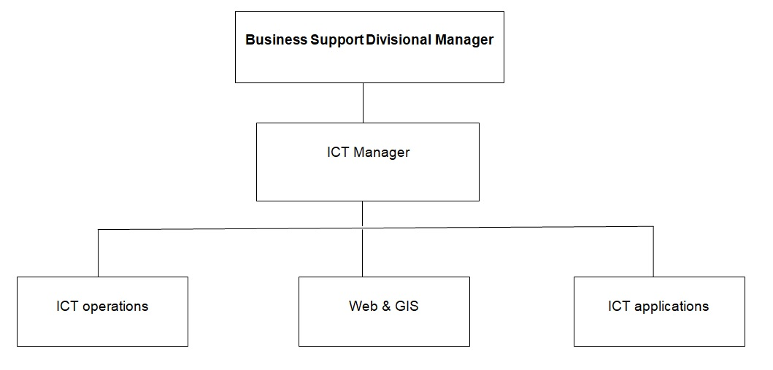

# 1.0 Main Purpose of JOB

* 1. To manage the delivery and development of all functions within ICT.
  2. To ensure the achievement of the Council’s relevant strategic objectives through the efficient and effective operation of the ICT service.
  3. To ensure resources are provided and managed appropriately to ensure a high quality ICT service to enable the effective delivery of the wider council’s services..
  4. To be the lead in ensuring the satisfactory resolution of ICT issues raised by staff, members and external sources.
  5. Actively contribute to corporate initiatives or projects.

# 2.0 Key Duties/Accountabilities:

* 1. Leadership and management of the ICT service including overall responsibility for continued service development to ensure the provision of an effective, efficient and modern ICT service.
  2. Responsible for the development and delivery of ICT projects, working alongside a broad range of services (both internal and external) to innovate and deliver creative solutions to help deliver corporate priorities, ensuring that all expenditure is compliant with the Council’s constitution
  3. Preparation of the service budget, monitoring and control of income and expenditure and to ensure financial outcomes are in line with the approved service business plan and the financial objectives of the council.
  4. To advise the Business Support Divisional Manager, management team, and elected members on ICT developments and strategies and their implications for the council.
  5. The effective and efficient use of resources to deliver service functions including the liaison and negotiation with services to ensure that a balance of technological service improvements with limited resources is achieved.
  6. To develop, write and implement the ICT strategy ensuring that it enables services to be delivered in an efficient and effective way that benefits both the public and internal service customers.
  7. To ensure that ICT Business Continuity plans and systems are aligned to the Council’s Business Continuity Management Strategy and are regularly tested and maintained for those areas of responsibility held
  8. To ensure the Council’s ICT systems and environment are compliant with accredited security standards at all times.
  9. To ensure the Council’s ICT systems and practices are compliant with current Data Protection legislation.

# 3 Additional Duties & Accountabilities

* 1. To develop the service and associated service plans, ensuring that these are consistent with the Corporate Plan, meet statutory requirements and customer needs.
  2. To compile reports and business cases, attend and present to Committees, Panels, Forums and meetings as required.
  3. To proactively contribute to the council’s modernisation and channel shift agenda.
  4. To ensure Health & safety legislation, policy and procedures are adhered to in all of the service functions.
  5. To respond to requests for or access to information.
  6. To ensure the Service complies with the relevant legislation, council policies and the Constitution.

# 4.0 KNOWLEDGE, SKILLS & EXPERIENCE

## Business Knowledge

* 1. Demonstrable achievement in providing strong, decisive leadership for multi-disciplined teams/individuals.
  2. Successful track record of establishing a strong service performance culture to continually improve standards, value for money and outcomes.
  3. Experience of applying employment related procedures, policies and legislation where appropriate.
  4. Ability to deliver/undertake difficult messages and conversations.
  5. Ability to fully understand the functions, roles and key accountabilities for the service and to effectively interpret this knowledge to a wider audience.
  6. Experience of managing an ICT service providing a range of support and advice to all client departments in a large complex organisation.
  7. An ability to negotiate and resolve conflicts.
  8. A sound understanding of the Council’s ambitions and priorities at member level, and the ability to translate those into targets and objectives for officer implementation.
  9. Sound performance management skills.
  10. And being able to challenge and negotiate with other senior officers including members of the senior management team.
  11. The ability to build positive and effective relationships with client departments.
  12. The ability to build positive relationships with contractors and suppliers and performance manage contracts.

## 5.0 Essential Functional / Technical Skills

5.1 Ability to think and plan operationally, set realistic objectives, lead and inspire people and prioritise resources.

* 1. Political Judgement and a high degree of political sensitivity.
  2. Experience of leading & implementing major change with the resources available.
  3. Highly developed analytical, networking, advocacy, oral, written and presentational skills.

5.6 Ability to work under pressure and to tight timescales to deliver projects and performance targets.

* 1. Contribute to partnerships and stakeholder groups to deliver wider community projectsand/or Council initiatives in your role as a representative of CDC.
  2. Ability to work in a matrix management system to deliver priority projects outcomes across the Council.
  3. Ability to provide strategic advice on the Council’s ICT strategy to ensure efficient and effective ICT solutions that support the Council’s objectives.
  4. Experience managing a strong ICT security framework as well as a good working knowledge of Data Protection legislation and its implications for running a compliant ICT service.
  5. Ability to tackle difficult situations and manage conflict effectively.

## 6.0 Qualifications

6.1 Relevant degree or equivalent level qualification is desirable plus management qualification.

* 1. Relevant experience managing an ICT service or team in a large complex organisation.
  2. Relevant experience in managing projects.
  3. Relevant Procurement, Data Protection and Project Management qualifications are desirable.

## 7. 0 Personal Attributes / Competencies

* 1. Reliable and resilient individual.
  2. Project management.
  3. Commercial acumen.
  4. Managing performance.
  5. Self-sufficiency.

7.6 Risk management.

This Job Profile is a description of the job as it is currently comprised.  The Council reserves the right to review and amend this Job Profile from time to time, if required to enable it to effectively carry out its functions.  Any changes that are made would be done so in consultation with the post holder and would be commensurate with the grade or salary of the post.