JOB PROFILE

# JOB Profile SUMMARY

Job Title Principal Solicitor

Reports to Legal & Democratic Services Manager / Legal & Democratic Services

Date 14th December 2017

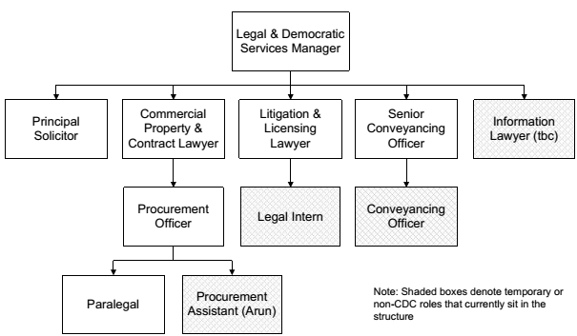

# Main Purpose of JOB

***WHY*** *the job exists?*

* To work under the direction of the Legal and Democratic Services Manager in respect of all complex planning matters as outlined below which will involve the preparation of legal documentation and giving advice to the Planning Section and other departments.
* To provide legal advice, research and drafting for complex planning matters required by that department.
* To provide cover in the absence of the Legal and Democratic Services Manager including in his capacity as Monitoring Officer to the Council.

***WHAT*** *it has to achieve?*

* Create robust legal documents in place to support all activity of the Council with planning applicants and partner agencies.
* Give detailed advice on compliance to planning and public law requirements to ensure client departments understand their duties and risks of future courses of action in that area.
* To support the development of planning policies by the Council.

# Key Duties/Accountabilities:

1. To act as the primary lawyer providing advice on planning matters for the Council planning department.
2. To advise upon and draft such notices, orders, contracts, agreements or other deeds and documents relating to the Planning function of the District Council.
3. In conjunction with the Litigation Solicitor to provide legal advice to the relevant council officers on Planning Law enforcement.
4. To affix the Council seal and approve statutory notices to be served by the Council in the absence of the Legal and Democratic Services Manager.
5. As required to advise officers of all departments on public law and governance issues.
6. To prepare instructions and work with barristers on complex matters in particular judicial reviews of planning matters.
7. To attend and advise the Planning Committees including DPIP.

# Additional Duties & Accountabilities

1. Attendance at and contribution to working parties/topic groups as required
2. Supervising the junior lawyers work as required in particular when they are acting in respect of planning matters.
3. To undertake the duties of a Deputy Monitoring Officer as required by the Legal & Democratic Services Manager including advice to Members and reporting to, attending and advising the Sub-Committees of the Standards Committee.

# KNOWLEDGE, SKILLS & EXPERIENCE

## Business Knowledge

1. Significant Local government experience dealing with Planning legislation, Public Law and governance and a wide range of other legal topics to support ad hoc enquiries from client departments.
2. Some supervisory skills.
3. Significant legal professional expertise in planning law as lead professional in this area

## Essential Functional / Technical Skills

1. Planning Law including drafting of complex planning documents and the giving of advice on the planning legal framework and related areas of law including information law, public law and Tort.
2. Governance and public law understanding and application in the context of acting as deputy monitoring officer in a complex political environment.
3. Highest level of understanding of principles of planning documents in particular complex site s.106 Planning Agreements and supplementary agreements.
4. Excellent analytical skills.
5. Able to organise differing priorities against needs of the Council.

## Qualifications

1. Solicitor, Licensed Conveyancer, FILEX or similar higher legal qualification
2. Ongoing CPD and professional training in areas of expertise
3. Specialist post-solicitor training in planning law.

## Personal Attributes / Competencies

1. Good written, numeracy and verbal skills.
2. Good inter-personal skills in particular planning agreement negotiating skills.
3. Ability to work with internal and external customers.
4. Use of own initiative, reliable and resilient, adaptable to change.
5. A confident personality able to give advice and challenge senior figures.

This Job Profile is a description of the job as it is currently comprised. The Council reserves the right to review and amend this Job Profile from time to time, if required to enable it to effectively carry out its functions. Any changes that are made would be done so in consultation with the post holder and would be commensurate with the grade or salary of the post.