JOB PROFILE

# Recruitment Information:

**Post title** **:** Divisonal Manager – Property and Growth

**Service: Place**  Based at East pallant House , Chichester, West Sussex.PO19 1TY

**Directorate:** Growth and Place

-----------------------------------------------------------------------------------------------------------------------

# JOB Profile SUMMARY

Job Title Divisional Manager – Property and Growth

Reports to Service Director – Growth and Place

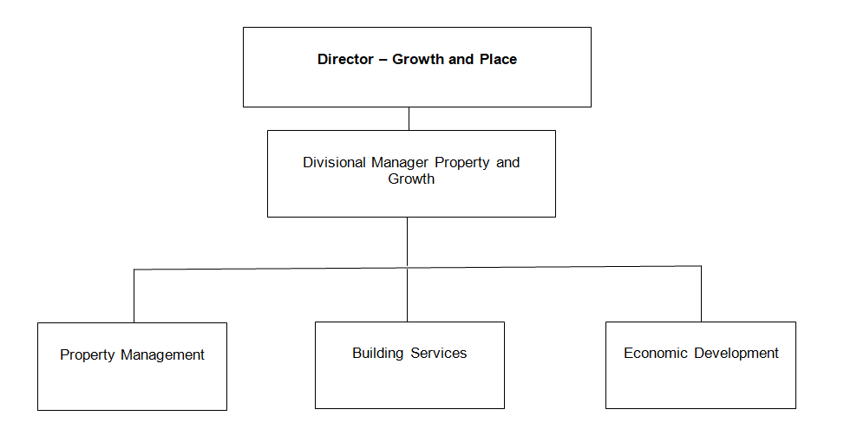

# 1.0 Main Purpose of JOB

* 1. To manage the, delivery and development of all functions within the Property and Growth service

1.2 To ensure the achievement of the Council’s relevant strategic objectives and the efficient and effective operation of individual services. To ensure those services deliver their functions to the standards set by legislation, policy or management to provide a high quality of service to customers. To ensure resources are provided and managed appropriately. To manage the political environment within which the service operates

1.3 Actively contribute to corporate initiatives or projects

# 2.0 Key Duties/Accountabilities:

2.1 Leadership of the service including overall responsibility for continued service development to ensure the provision of effective, efficient and modern services, meeting the standards and performance expected by the council

* 1. Management of the service to ensure the delivery of high quality value for money services meeting high levels of customer satisfaction, service performance standards including staff performance and personal development.

2.3 Preparation of the service budget, monitoring and control of income and expenditure and to ensure financial outcomes are in line with the approved service business plan

* 1. The effective and efficient use of resources to deliver service functions
  2. To ensure Health & safety legislation, policy and procedures are adhered to in all relevant service functions
  3. To ensure the Service complies with the relevant legislation, council policies and the Constitution

# 3.0 Additional Duties & Accountabilities

3.1 Responsible for the management and effective operation of the Councils Economic Development, Estate and Building Services

3.2 Manage the undertaking of the annual and end of year asset valuations in accordance with IFRS and RICS requirements

3.3 To oversee the development and maintenance of an accurate property record system including any condition surveys

3.4 To maintain the capital asset replacement programme and the repairs and maintenance programme and to oversee any capital replacement works or new builds

3.5 To ensure the optimisation of the council’s portfolio, maximise income and develop opportunities to realise additional revenue and capital from property assets

3.6 To ensure plans are in place to promote the district to existing and new businesses to drive growth and maintain a healthy economy

3.7 To contribute to the development and implementation of sub regional economic development strategies, local economic development strategies, City Vision, Rural town Visions and the Local Plan

# 4.0 KNOWLEDGE, SKILLS & EXPERIENCE

## Business Knowledge

* 1. Demonstrable achievement in providing strong, decisive leadership for multi-disciplined teams/individuals
  2. Successful track record of establishing a strong service performance culture to continually improve standards, value for money and outcomes
  3. Experience of managing change
  4. Experience of applying employment related procedures, policies and legislation where appropriate
  5. Ability to deliver/undertake difficult messages and conversations
  6. Ability to fully understand the functions, roles and key accountabilities for those services for which the role is responsible for in order to support the service managers/staff and to effectively interpret this knowledge to a wider audience
  7. Experience of managing complex large scale capital projects and the ability to negotiate and resolve contractual issues
  8. Ability to prepare specifications and contracts for the new builds and maintenance requirements
  9. The ability to develop positive relationships with contractors and partners

## 5.0 Essential Functional / Technical Skills

5.1 Ability to demonstrate leadership qualities that genuinely motivate and instil commitment in others

5.2 Ability to think and plan operationally, set realistic objectives, lead and inspire people and prioritise resources

* 1. Political Judgement and a high degree of political sensitivity
  2. Experience of leading & implementing major change with the resources available
  3. Highly developed analytical, networking, advocacy, oral, written and presentational skills

5.6 Ability to work under pressure and to tight timescales to deliver projects and performance targets

* 1. Contribute to partnerships and stakeholder groups to deliver wider community projectsand/or Council initiatives in your role as a representative of CDC
  2. Ability to work in a matrix management system to deliver priority projects for the Council
  3. Ability to provide strategic advice relating to planning applications and planning policy

## 6.0 Qualifications

6.1 Relevant degree or equivalent level qualification is desirable plus management qualification

* 1. Relevant experience

## 7.0 Personal Attributes / Competencies

* 1. Reliable and resilient individual
  2. Project management
  3. Commercial acumen
  4. Managing performance
  5. Self-sufficiency

7.6 Risk management

This Job Profile is a description of the job as it is currently comprised.  The Council reserves the right to review and amend this Job Profile from time to time, if required to enable it to effectively carry out its functions.  Any changes that are made would be done so in consultation with the post holder and would be commensurate with the grade or salary of the post.