JOB PROFILE

# JOB Profile SUMMARY

Job Title Revenues and Benefits Divisional Manager

Reports to Director of Residents’ Services / Residents’ Services

Date 31st August 2017

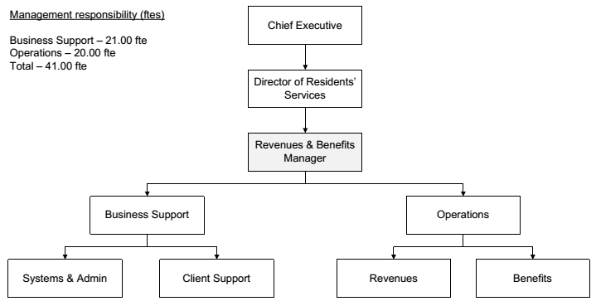

# Main Purpose of JOB

***WHY*** *the job exists?*

- To lead, manage and develop the Revenues and Benefits Service to deliver high quality, resident-focused, efficient services that meet the Service’s objectives and secure continuous and sustained improvements in service delivery.

***WHAT*** *it has to achieve?*

* To ensure the service meets all statutory requirements and that any new legislation is implemented effectively and incorporated into working processes and procedures.
* To ensure the service delivers its functions in a non-discriminatory manner to provide a high quality service to customers and the community.
* To lead and manage the Revenues and Benefits service, ensuring delivery of the relevant strategic and service objectives.
* To ensure resources are effectively managed across the service.
* To ensure that effective arrangements are in place for management of the council tax base so that accurate estimates can be used in the Council’s budget processes.
* To ensure that the Council’s share of rate retention is maximised through effective working, communication and accurate estimation of potential losses due to bad debts and appeals.
* To ensure that Housing Benefit and Council Tax Reductions are managed in strict accordance with legislation and Council policy.
* To ensure data protection, security and confidentiality of customer information is effectively managed at all times.
* To promote and safeguard the welfare of vulnerable people, ensuring the principle, culture and practice is embedded throughout the service, in compliance with national and local procedures and protocols.

- To manage the political environment within which the service operates.

- Actively contribute to corporate initiatives or projects.

**Main Duties and Responsibities**

# Key Duties/Accountabilities:

1. Sound and robust leadership of the Service, including overall responsibility for continued service development to ensure the provision of effective, efficient and modern services, meeting the standards and performance expected by the Council.
2. Management of the Service to ensure the delivery of high quality value for money services meeting high levels of customer satisfaction and service performance standards, including staff performance and personal development.
3. In conjunction with the relevant Director determine strategy planning and service delivery for the Revenues and Benefits service.
4. Preparation of the service budget, monitoring and control of income and expenditure and to ensure financial outcomes are in line with the approved service business plan.
5. The effective and efficient use of resources to deliver service functions.
6. Completion of management information, statistics, claims and Government returns as necessary.
7. Anticipate, analyse, manage trends and changes in the operating environment and plan to meet those changes in order to provide best value for service users.
8. To ensure Health & Safety legislation, policy and procedures are adhered to in all relevant service functions.
9. To ensure the Service complies with the relevant legislation, Council policies and the Constitution.

# Additional Duties & Accountabilities

1. Maintain effective financial controls for billing, collection and recovery of Council Tax, Business Rates, BID levy and corporate debt, including monitoring of old debt etc.
2. Maintain effective financial controls for housing benefit and council tax reduction expenditure, including monitoring overpayment recovery, DHPs etc.
3. In conjunction with managers monitor performance, collating system data and statistics to review working methods and procedures, introducing change where necessary.
4. Analyse, report and advise upon new legislation, practice and procedures to a range of internal and external stakeholders.
5. Risk assessments and business continuity planning.
6. Build and lead strong teams, communicating service objectives to ensure effective delivery to the agreed standards and targets.
7. Efficient and effective contract procurement and management across the division, ensuring compliance with legislation and the Constitution.
8. Any other duties commensurate with the grade in order to help service delivery.

# KNOWLEDGE, SKILLS & EXPERIENCE

## Business Knowledge

1. At least 5 years experience in a management role in a Revenues and Benefits environment.
2. Extensive knowledge of the roles of Revenues and Benefits within a local authority.
3. Detailed knowledge of corporate debt recovery.
4. Experience of team management across multiple operational areas.
5. Ability to manage resources to achieve plans, objectives and priorities by demonstrating financial awareness,utilising and leading available resources and driving projects to achieve results.
6. Awareness of the impact that Revenues and Benefits has upon the overall local authority budget process.
7. Understanding the local and national political environment and the potential for change.
8. Extensive knowledge, experience and understanding of the major issues facing the service specifically in a Revenues and/or Benefits area.
9. Experience of applying employment related procedures, policies and legislation where appropriate.
10. Ability to deliver/undertake difficult messages and conversations.
11. Ability to fully understand the functions, roles and key accountabilities for those services for which the role is responsible for in order to support the service managers/staff and to effectively interpret this knowledge to a wider audience.

## Essential Functional / Technical Skills

1. Ability to demonstrate strong leadership qualities that genuinely motivate and instill commitment in others.
2. Ability to think and plan operationally, set realistic objectives, lead and inspire people and prioritise resources.
3. Successful track record of establishing a strong service performance culture to  
   continually improve standards, value for money and outcomes.
4. Innovative and challenging to bring about organisational improvement, developing and implementing plans to improve effectiveness / efficiency.
5. Political judgement and a high degree of political sensitivity.
6. Experience of leading and implementing major change with the resources available.
7. Ability to use, analyse and interpret data and information to guide and influence decision making.
8. Highly developed analytical, networking, advocacy, oral, written and presentational skills.
9. Ability to prioritise and manage a complex workload across different functional areas

to deliver projects and performance targets.

1. Contribute to partnerships and stakeholder groups to deliver wider community projects and/or Council initiatives in your role as a representative of CDC.

## Qualifications

1. Degree or equivalent level qualification is desirable plus management qualification.
2. IRRV Professional Diploma (a commitment to work towards these qualifications will also be considered).
3. DBS Check.
4. Full driving licence and access to a car.

## Personal Attributes / Competencies

1. Ability to apply creative and innovative thinking to complex service challenges.
2. A champion of high performance culture.
3. Reliable and resilient with a capacity to perform a demanding job under pressure.
4. Project management experience with a high level of commercial acumen.
5. Excellent customer care focus.
6. Successful track record in managing performance.
7. Leadership, motivation, mentoring and empowerment skills.
8. Highly adaptable and motivated to implement change.
9. Ability to build positive working relationships.
10. Self-motivated, delivering expected outcomes within a defined timeframe with minimal supervision.
11. Risk management.

This Job Profile is a description of the job as it is currently comprised.  The Council reserves the right to review and amend this Job Profile from time to time, if required to enable it to effectively carry out its functions.  Any changes that are made would be done so in consultation with the post holder and would be commensurate with the grade or salary of the post.