**Development Management**

**Public Access Guide**

**Contents**

Contents

Searching 4

Simple Search 4

Advanced Search 5

Map Search 6

Map measurement 22

Search Results 25

Saving a Search 26

Record Details 26

Details 32

Comments 33

Constraints 35

Documents 35

Related cases 36

Map 38

Tracking Applications 39

# Searching

Your primary activity when you are logged in to the Public Access site will be to search for

planning records according to a variety of criteria. There are a variety of search methods to

allow you to find the information you are looking for:

* **Simple** - search quickly for applications or enforcements according to
* some entered text
* **Advanced** - search according to a wide combination of relevant factors
* **Weekly/monthly list** - search for applications whose status is validated or decided
* Within a particular time period
* **Property** - search for a particular property to which applications may apply
* **Map** - search using an interactive map tool

## Simple Search

A simple search allows you to search quickly for an application or enforcement by entering some text that will help identify it.

Image of Simple Search Box


1. Enter some text in the **Search** box that will correspond to one of:
   * reference number (for example, "21/00001/DOM")
   * post code (for example, "PO19 1TY")
   * part of an address (for example, "East Pallant", "South Street").
2. Click on the **Search** button to display the results of your search (see “Search Results” on page 30).

## Advanced Search

An advanced search allows you to build a complex combination of specific criteria on which to search for information.

1. From the Search drop down list choose the Planning module, then select **Advanced Search**.

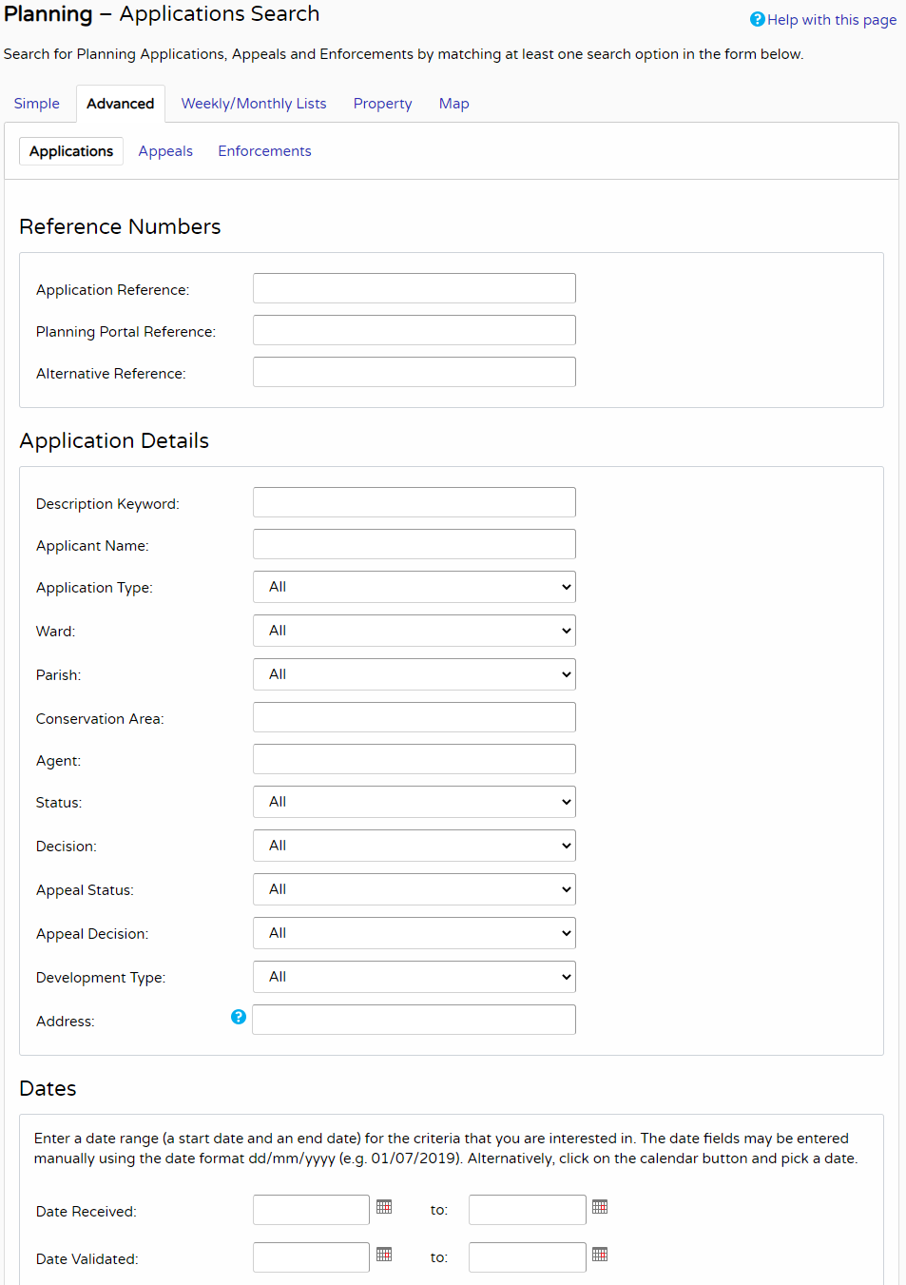

1. In the Planning module you can search for:
   * Planning Applications
   * Enforcements.

Click to select the type of record that you want to locate.

1. A variety of reference numbers are associated with planning records. Enter one or more to help identify a specific record.
2. The details you can fill in depend on the record type selected.

|  |  |
| --- | --- |
| **Record Type** | **Details Required** |
| Application details | Allows you to specify application type, application/ appeal status or decision, and development type as well as location details, including ward, parish and address information. |
| Enforcement details | Allows you to specify breach type and enforcement status as well as location details, including ward, par- ish and address information. |

Enter the details you want to search on.

1. Every planning case has a number of important dates associated with it (for example, the date the application was validated or the date that a court decision was issued). Use the date pickers to define an appropriate period to search within for any dates of interest.
2. Click on the Search button to display the results of your search (see “Search Results” on page 30).

## Map Search

Map search allows you to identify properties that are the subjects of applications or enforcements using an interactive map. The map allows you to zoom in and examine each property to locate the records of interest to you. You can filter the display by adding or remov- ing record types and by changing the time period.

**Notes**

* This mapping functionality is not available for Acolaid, however, an external web link may be enabled.
* The mapping functionality may not be available on mobile devices.
* The instructions in this section are based on the most up-to-date version of the map. However, some authorities are still using an older version of the map, so its appearance will be different, although much of the same functionality is available.

Alternatively, if you are interested in applications relevant to a specific geographical area, such as close to your home, you can search for records limited either to the currently displayed

map extent or to a specified radius from the map’s centre. These searches can be saved to your Saved Searches.

**Note** Idox Public Access does not support watermarking on maps and continues to be compli- ant with Ordinance Survey standards.

1. From the Search menu, choose the Planning module, then select **Map Search**.

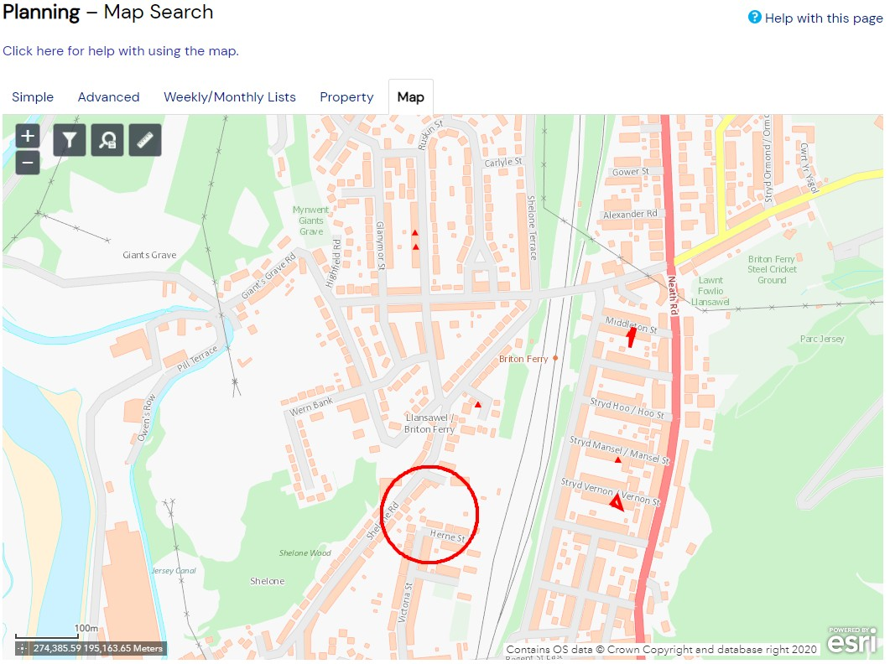

1. To zoom in on a specific location, drag the map to centre on the location and click on the

+ button. To zoom out, click on the - button.

Alternatively, you can zoom in and out by scrolling the mouse wheel.

**Note** The scale at the bottom left of the map changes as you zoom.

1. To pan the image around, click on the map and, keeping the mouse button depressed, drag in the direction you want to pan.
2. To refine the display, click on the **Layer List Filter**.

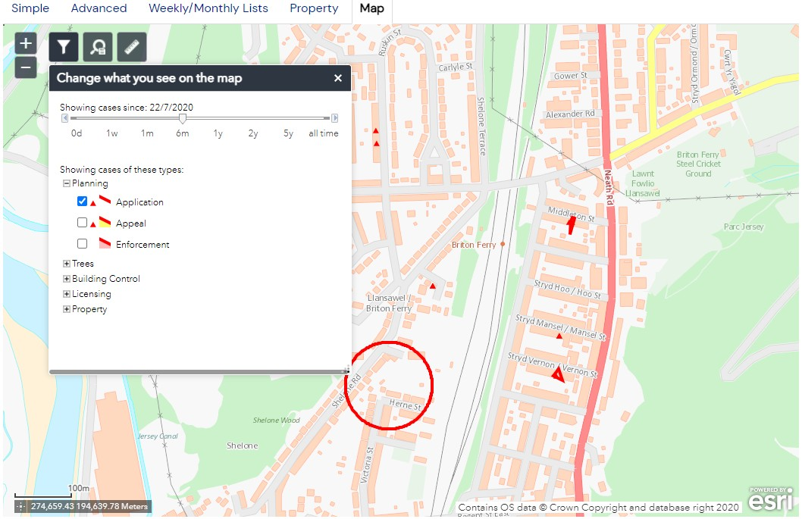

1. To change the time period drag the slider to the desired time frame.

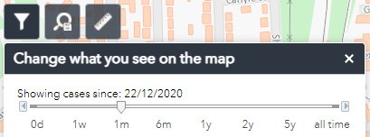

1. To display more record types on the map, check the relevant boxes in the **Legend and Filter** list. To remove record types from the map, uncheck them.

Most records can be displayed in two ways:

* + Records which only affect the property which is the subject of the application are shown as triangular points.
  + Records which affect others (for example, neighbours or the public) are displayed as a polygon which illustrates the boundary of the property affected by the application.

1. Once you have identified a record of interest, click on the triangle point or polygon to dis- play a summary of the information about the record.

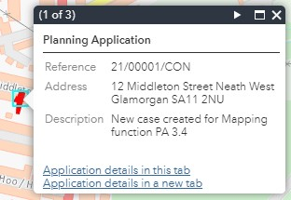

If there is more than one record associated with the property, you can click on the navi- gation arrows to page through the record summaries.

1. When the black Properties markers are displayed, you can click on any of these to view the property summary.

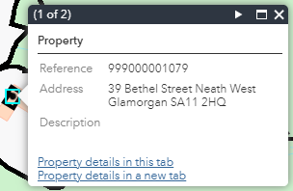

1. To view full details of a property or record of interest, with the summary information dis- played, click one of the links at the bottom of the summary window to either view the details in the current tab or a new tab in the browser.

### Map measurement

You can take rough measurements of distances and areas on the map as well as mark down the latitude and longitude of a point on the map.

**Note** The measurement tool is for indicative purposes only. It is to be used only to give an idea to users of the distance between objects or area of an object. It does not define legal boundaries nor can it be used for dispute purposes.

1. Zoom and pan the map to display the geographical area of interest.
2. Click on the Measurement icon. Image of the ruler
3. To measure an area, click on the Area icon.

Image showing the area icon

1. Select your units from the drop down menu.
2. Click on the map where you wish to start your measurement.
3. Continue to click on each corner of the area of measurement.
4. Double click on a point to complete the area.

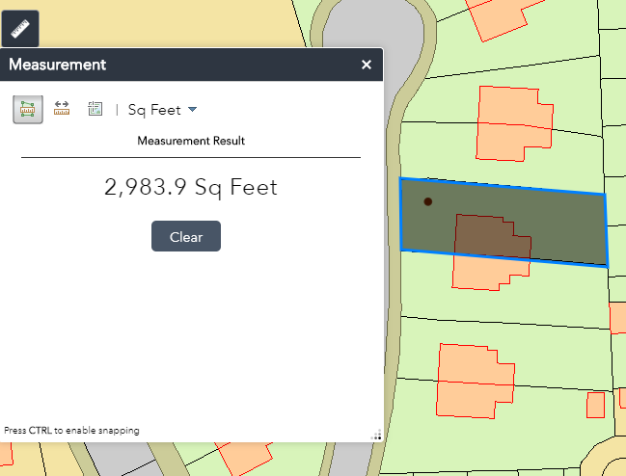

1. You can refresh this measurement by pressing Clear, to start a new measurement.
2. To measure a distance on the map, click the Distance icon.

distance icon

1. Select the unit of measurement from the drop down menu.
2. Click on the map where you wish to start your measurement.
3. Continue to click on each corner of the distance of measurement.

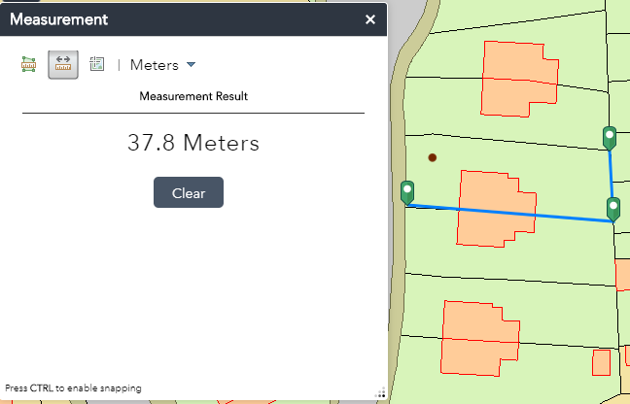

1. Double click to complete the measurement.
2. To see the position of a point on the map in latitude and longitude, click on the Location icon.
3. Select the coordinate unit from the drop down menu.

**Note** DMS stands for Degrees Minutes Seconds.

1. Click on a point on the map to find its location.

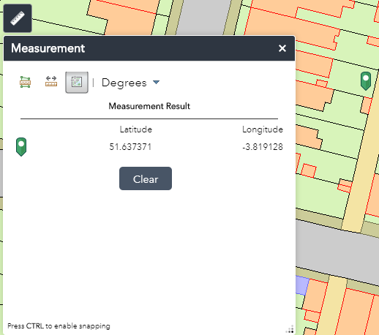

# Search Results

Once you have run a search, a list of records matching the search criteria is displayed.

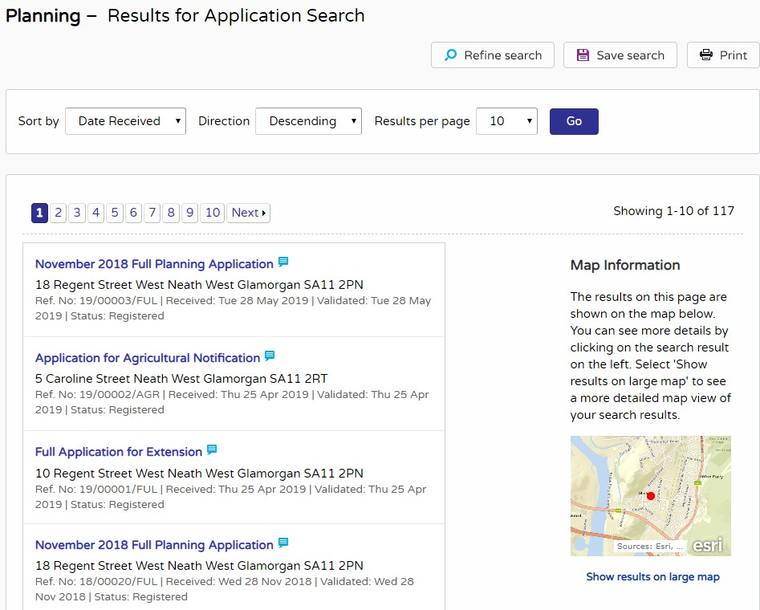

**Note** A speech bubble icon attached to a record indicates that comments may be made about that record at this time

1. You can manipulate how the search results are displayed to help you find applications of particular interest:
   * **Sort By** - re-order the results according to a selected criterion
   * **Direction** - choose whether the results are displayed in ascending or descending order
   * **Results per page** - choose how many results should be displayed on the page at once.

When you have made your display selections, click on the Go button.

1. The number of results displayed (out of the total number of results) is shown. If there are more results than fit on to one page you can navigate between the results pages either by clicking on Next to view the next page or Previous to view the previous one, or by clicking directly on the page number
2. If configured, a map of the relevant area is displayed. Click on **Show results on Large map** to see the locations of the search results in greater detail (see “Map Search” on page 18).
3. If there are too many results, or if the results do not contain the applications you are looking for, you can go back and amend your search criteria. Press the **Refine Search** button.
4. To display the current page of search results in a printable format, click on the **Print** but- ton.

Click on Print again in the new window to send the page to your local printer. Press Close when you are finished with this window.

1. To view an individual record in detail, click on its title.

## Saving a Search

You may find that you use a particular search regularly. For example, a simple search based on your post code or an advanced search charting the progress of a specific planning applica- tion. As a registered user, you can save these searches to be run again from your Saved Searches page (see “Saved searches” on page 9). Additionally, when new records correspond- ing to a saved search arrive, news of these will automatically appear on your Notified Applica- tions page (see “Notified applications” on page 11).

1. To save a search, click on the **Save Search** button.

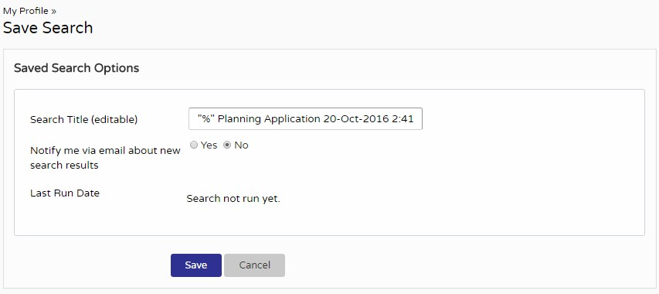

1. Change the default search title if you wish.
2. If you want to be notified by email of any new records matching your search criteria, select **Yes**.
3. Click on **Save** to save the search.

## Record Details

When you select to view a record, the application details are displayed at the top of the page, with further tabs below containing all of the relevant information about the application. Plan- ning records contain the following tabs:

* **Details** - displays the key information about the record
* **Comments** - displays any existing comments made about the case and allows users to contribute their own
* **Constraints** - lists any constraints placed on the case
* **Documents** - displays a list of documents relevant to the case
* **Related Cases** - displays a list of items which are related to the current record
* **Map** - displays the case property using the map view.

### Details

The Details tab displays key information about the record.

1. Click on the **Details** tab.

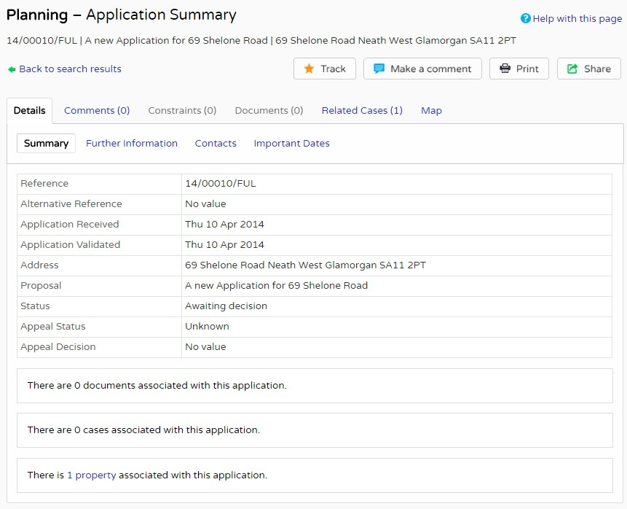

1. The record details are split up into four tabbed sections. Click on the appropriate tab to display those details.
   * **Summary** - displays the basic information pertaining to the record. The summary also identifies the number of the documents, cases and properties that have been added to this record. Click on one of these to view them.
   * **Further Information** - displays additional information about the application that was not included in the summary.
   * **Contacts** - displays a list of contacts relevant to this case. The number of contacts is displayed on the tab.
   * **Important Dates** - displays the dates on which important events in the life span of the case occur from initial submission through to the decision. If the case is still in pro- gress some of these may be blank.

### Comments

The Comments tab displays any comments that have been made about this case by members of the public or members or official consultee groups. The number of comments is displayed on the tab.

On the Comments tab, you can:

* View comments made by members of the public and/or consultees.
* Report a public comment which you feel is inappropriate, if this functionality has been enabled for the case.
* If the case is currently open for comments, add your own comment.

**Note** Depending on how the system has been set up, you may need to be logged in as a registered user to add a comment.

#### Adding a comment

**Note** Depending on how the system has been set up, you may need to be logged in as a reg- istered user to add a comment. To add your own comment:

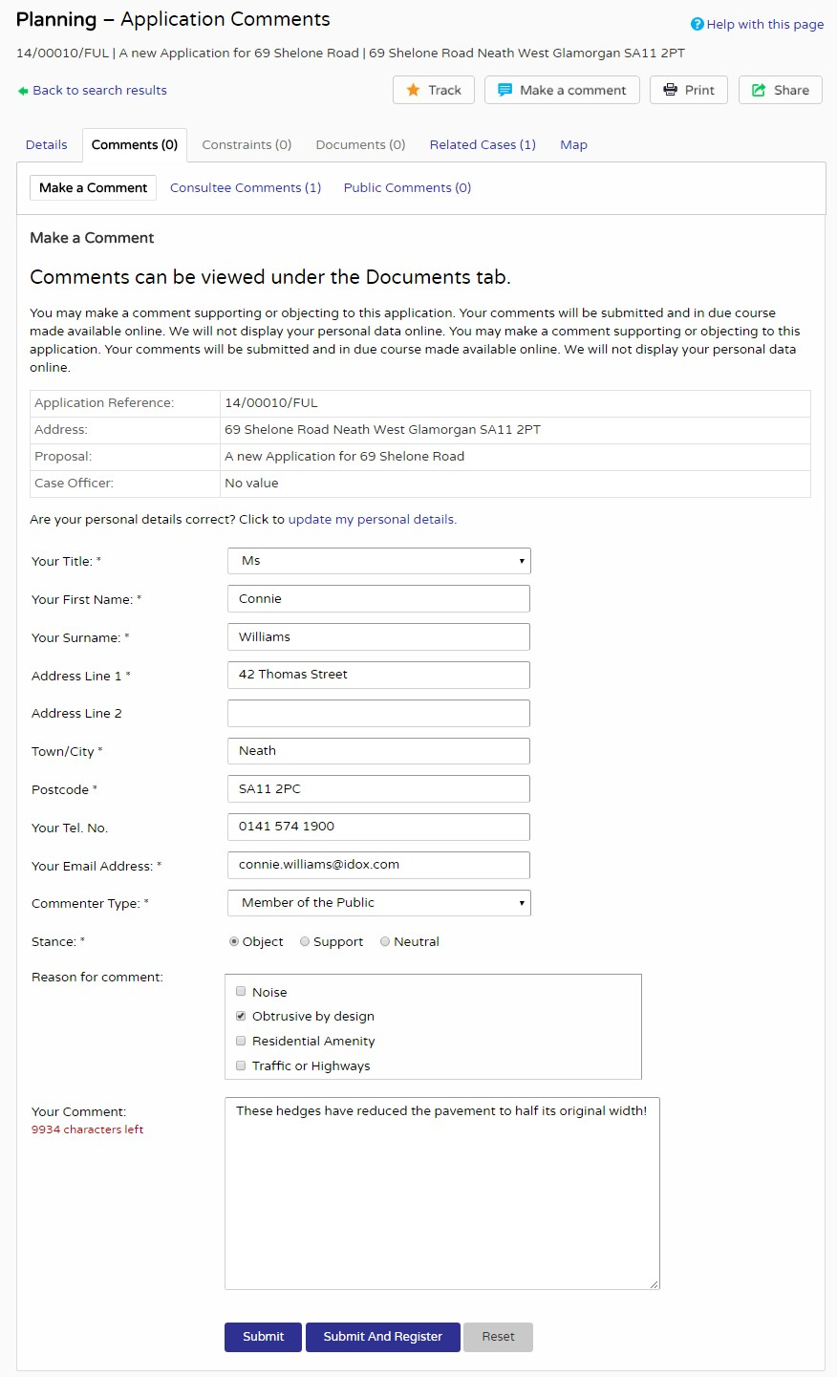

Click on **Make a Comment**.

1. If you’re logged in, your name and address are added automatically to the form.
   * If you’re logged in and the details are incorrect, click on **update my personal details** and make the appropriate changes. Then add your remaining contact details in the appropriate boxes.
   * If you’re not logged in, insert your personal details in the fields as appropriate. Manda- tory fields are highlighted with an asterisk.
2. The **Commenter Type** drop down list describes the type of people who may need to make a comment about a case. These include councillors, neighbours to the application address and members of the public. Select the one that applies to you.
3. Under **Stance** select whether you object to or support the application, or if you want to remain neutral.
4. In the **Reason for comment** box select one or more of the offered reasons for making your comment.
5. Enter the details of your comment in the **Your Comment** box.

**Note** For registered users, draft comments are retained up to two days after being logged out due to a time-out. You must log in using the same browser and PC as the comment was started on. Successfully Submitted comments are not retained.

1. Spell check your comment before submitting, by correcting errors or by right clicking on red underlined words and selecting the appropriate correction.
2. When you have completed all the details, click on the **Submit** button. Your comment will appear in the Public Comments page for this case.

Alternatively, if the authority allows comments from unregistered users, you can register at the same time as submitting your comment, by clicking the **Submit and Register** button.

**Note** For certain sensitive applications, your comment may be automatically sent for review on submission, and so will not be displayed until it has been reviewed.

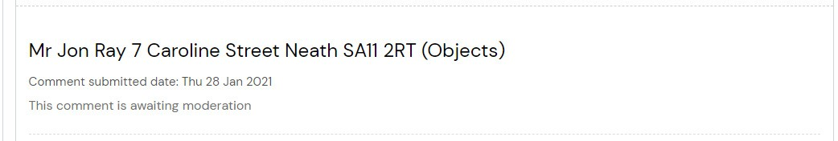

### Constraints

1. Click on the **Constraints** tab to display any constraints that have been placed on this application. The number of constraints are displayed on the tab.

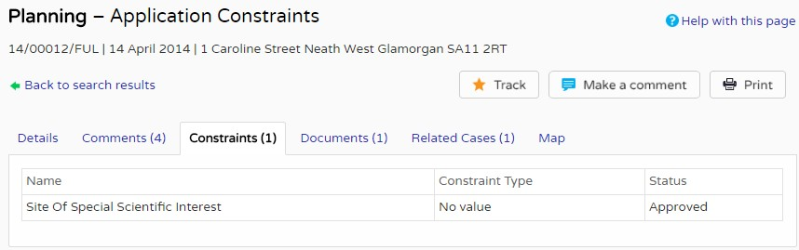

### Documents

1. Click on the **Documents** tab to display any documents that have been added to this application.

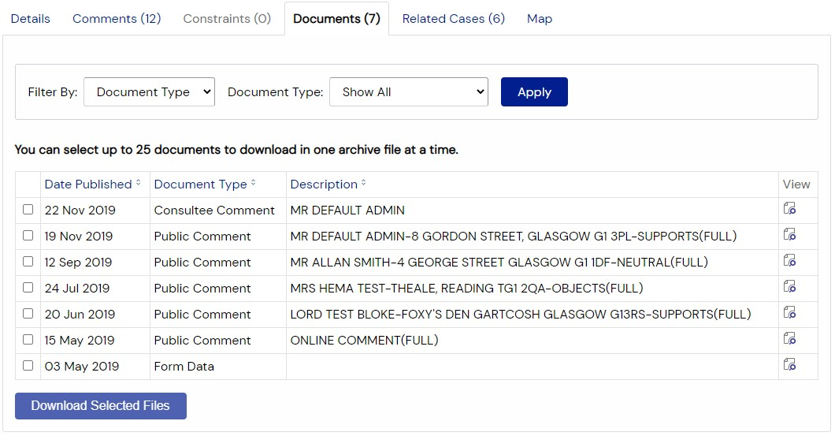

1. If there are a lot of documents you can filter the list. Select one of the following from the

**Filter By** list:

* + **Document Type**, and then select the type from the Document Type list.
  + **Description**, and then enter some text that may appear in a document’s description. Press **Apply**.

1. You can re-order the list according to:
   * Date Published
   * Document Type
   * Drawing Number
   * Description.

Click on the appropriate heading to re-order the list.

1. To view any of the documents in a separate window, click on **View**.
2. To download up to 25 documents at a time (depending on your configuration) to view at a later date, check the appropriate check boxes next to the desired documents, and click **Download Selected Files**.

**Note** This may not be available to all users. Contact your administrator for any queries.

### Related cases

The Related Cases tab displays the other cases that have a relation to the current one. These may be other Applications or Enforcements in the Planning module or cases in other Idox Public Access modules, if they are available.

Affected properties are also listed in the Related Cases tab. The total number of items are displayed on the tab.

1. Click on **Related Cases** to view a summary of additional information related to the appli- cation.

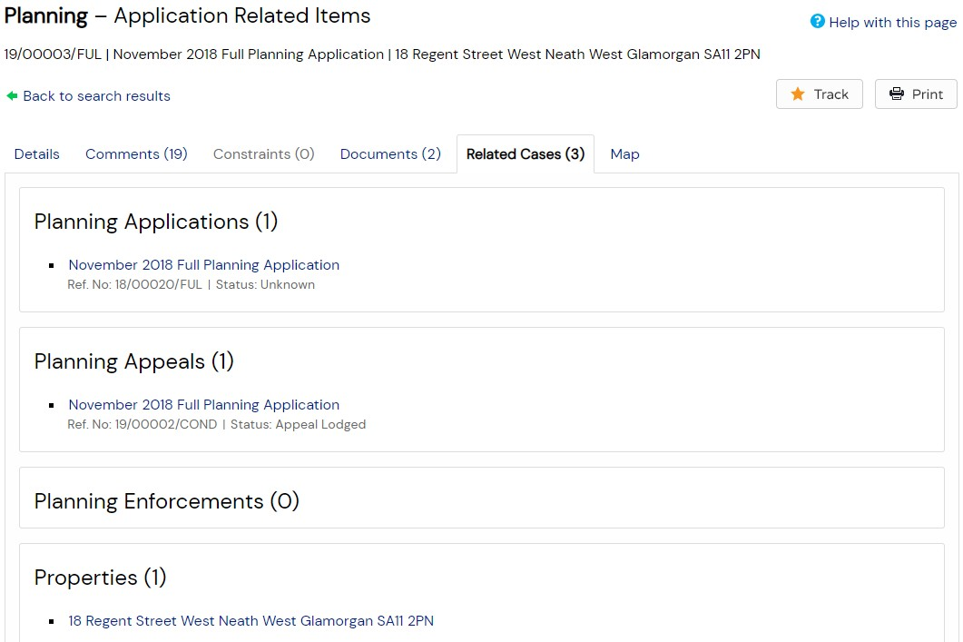

1. To view any of the listed items, click on its title.

If you click on the link for a property, its details are displayed in a Property Address page.

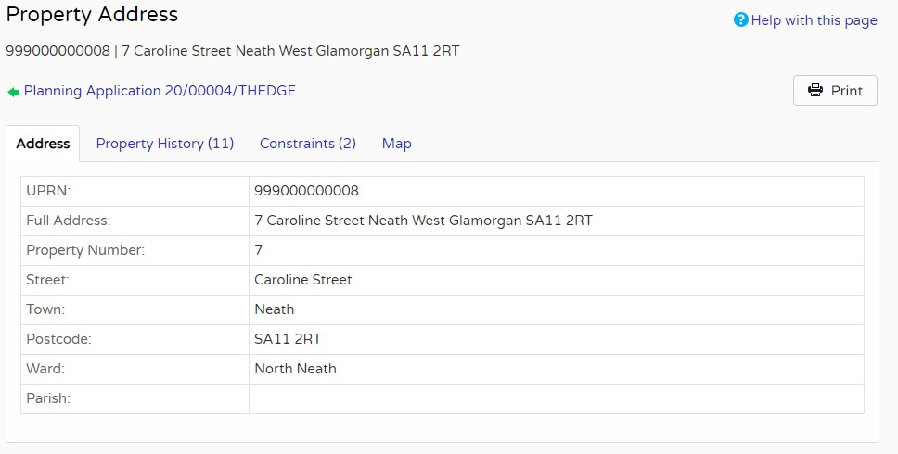

Similar to the application summary pages, this contains Constraints and Map tabs. It also contains a Property History tab, listing the cases in all modules which relate to the address. Clicking one of these opens the application summary page.

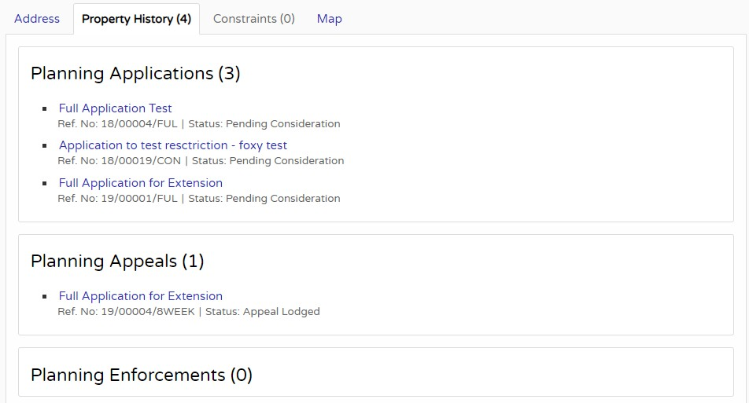

### Map

**Note** The map functionality may not be available on mobile devices.

The Map tab displays the location of the case property on the interactive map.

1. Click on the **Map** tab.

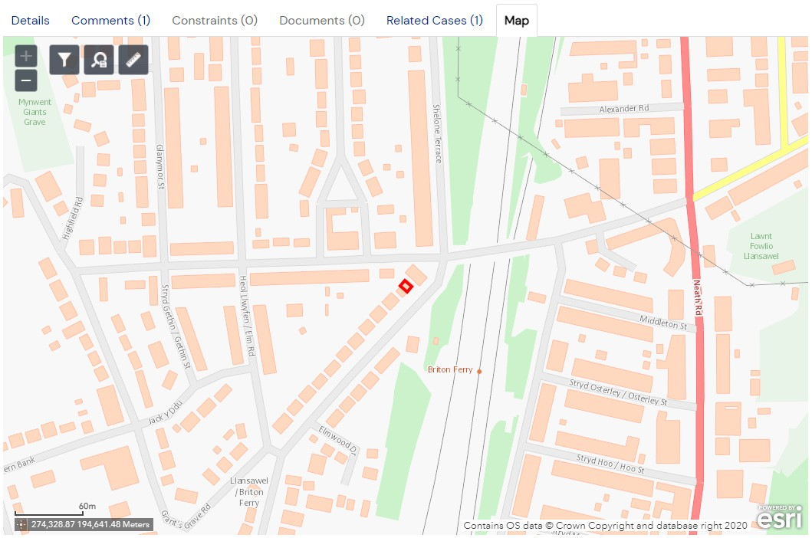

1. The interactive map contains a number of tools to help you view the application area (see “Map Search” on page 18 for details).

#### External mapping

If your administrator has enabled remote maps, the Map tab will display a View Map button which will open the location of the case property on an external map.

1. Click on the **Map** tab.

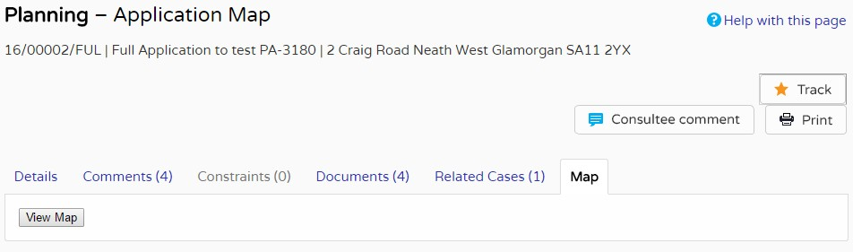

1. Press the **View Map** button.
2. The external map contains a number of tools to help you view the application area.

## Tracking Applications

Any application can be tracked so that you can keep up to date with its progress without hav- ing to search for it again. These cases are listed in your **Tracked Applications** page (see “Tracked applications” on page 10).

1. If you want to add a case to your Tracked Applications page click on the **Track** button.

Track symbol

1. To find this case again, select Tracked Applications under My Profile.

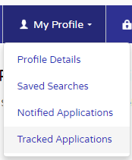

1. To stop tracking an application, return to the application details and click the **Stop Tracking** button at the top of the page. Alternatively, click the Stop Tracking button next to the application in the Tracked Applications page.

