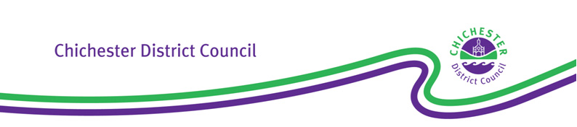

|  |  |  |  |
| --- | --- | --- | --- |
|  | If calling please ask for: | Customer Services  Tel: 01243 534601  E-mail  taxilicensing@chichester.  gov.uk | |
| Our ref: | TX4(v12) |
| Your ref: |  | |
|  |  | |

Dear Sir/ Madam

**Town Police Clauses Act 1847/ Local Government (Miscellaneous Provisions) Act 1976**

**Renewal reminder - Hackney Carriage/ Private Hire Driver’s Licence**

If you want to renew a current licence, a complete application must be received at this office **at least 5 working days before the date of expiry**. If you fail to allow this time, the existing licence may expire before the renewal application is determined and granted. In that situation, you will be unlicensed and immediately must cease driving licensed vehicles until such time as the renewal is granted.

**If a complete renewal application is not received by 7th September 2025, the current licence will lapse,** **you will be unlicensed, and immediately must cease driving licensed vehicles until such time as a completely new application is made, and a new licence granted.** If you do not wish to renew, or fail to apply in time, within 7 days of the date of expiry, legally you must return any expired paper Licence, Driver’s Badge, and Internal ID to this Licensing Authority.

Regularly, certain checks are undertaken of all holders of a licence, including the DBS criminal conviction check, D4 medical examination, and DVLA Driving Licence check. The relevant due dates in respect of your licence are:

|  |  |
| --- | --- |
| DBS Criminal conviction check *(see No. 4 overleaf)* |  |
| D4 Medical examination & T14 Declaration by Medical Practitioner *(if required, see No. 5 overleaf)* |  |
| DAVIS Mandate *(if required, see No. 6 overleaf)* |  |

*../continued*

East Pallant House, 1 East Pallant, Chichester, West Sussex PO19 1TY

Telephone: (01243) 785166   Fax: (01243) 776766   [www.chichester.gov.uk](http://www.chichester.gov.uk)  DX30340 Chichester

For current opening hours of East Pallant House: <https://www.chichester.gov.uk/contactus>

Below lists the actions you must take and/ or documents you may need to provide in order to submit an application to renew the licence. Forms and information regarding the renewal of licences are on our website <https://www.chichester.gov.uk/taxilicence>. Applications may be emailed or posted.

Yours faithfully,

Chichester District Council Licensing Team

**1.** **Renewal Application Form** - Form T4 (check and finalise the partially completed form attached)

**2.** **Fees** - Current Renewal Application fee is £337.50 and an additional £10.50 must be paid in order that we can continue to check your DVLA Driving Licence record

**3. Photo** - Recent, colour, Passport-type photograph of you.

1. **DBS Enhanced Criminal Conviction Check - You must state on the application form that you are undertaking one of the following**:

**Option A** - Confirming the Certificate Number of a previously-provided DBS Enhanced Certificate for Hackney Carriage/ Private Hire work which remains subscribed to the DBS Update Service.

**Option B** - Providing at our offices at East Pallant House your most recent DBS Enhanced Certificate for Hackney Carriage/ Private Hire work which is subscribed to the DBS Update Service.

**Option C** - Submitting via First Advantage an online application for a DBS Enhanced Certificate for Hackney Carriage/ Private Hire work - see <https://www.chichester.gov.uk/taxidbs#DBS-Online>: Upon receipt of the Certificate, immediately you must provide the original at our offices at East Pallant House.

**Note that subscription to the DBS Update Service is a requirement of this Licensing Authority in respect of its Driver’s Licences** so, within 30 days of the Certificate issue date, you need to subscribe and then maintain that subscription with the DBS Update Service: This means that for as long as your Criminal Conviction status remains unchanged, you will not need to pay for a new Certificate every 6 months.

1. **D4 Medical Examination & T14 Declaration by Medical Practitioner** - Both documents must be completed by a Doctor from the surgery at which you are registered and who has full access to your medical records. It is recommended that you contact your surgery as early as possible to arrange an appointment: Only the latest versions of Forms will be accepted.

* D4 form for Group 2 Medical Standard - see <https://www.gov.uk/government/publications/d4-medical-examiner-report-for-a-lorry-or-bus-driving-licence>
* T14 Declaration form - see - <https://www.chichester.gov.uk/privatehiredriverslicence>

1. **DAVIS mandate (DVLA Driving Licence check)** - You need to action the email/ SMS Text Message you will receive from DAVIS on behalf of Chichester District Council.