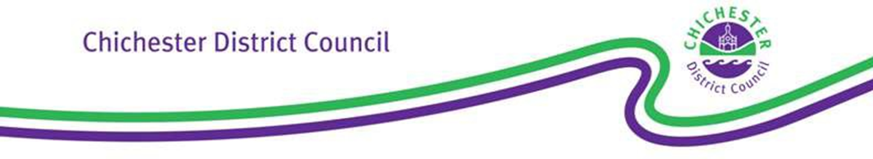

If calling please ask for: Customer Services

Tel: 01243 534601

E-mail

contact@chichester.gov.uk

Our ref: TX4(v5)

Your ref:

Dear Sir/Madam,

**Town Police Clauses Act 1847/Local Government (Miscellaneous Provisions) Act 1976 Renewal reminder - Hackney Carriage/Private Hire Drivers’ Licence**

The above Hackney Carriage and/or Private Hire Drivers’ Licence (the ‘licence’) will lapse at the end of the *****. Should you wish to renew the licence, please ensure that a complete and correct renewal application is submitted by this time. If you do not wish to renew, you must return your current badge(s) to this Licensing Authority within 7 days of the date of expiry.

If an application for renewal is not submitted by *****, your licence(s) will lapse and you would immediately have to cease driving any licensed vehicle until such time that a new application has been made and a licence granted.

Once a complete and correct application is submitted, it may take up to 5 working days for it to be processed, the renewed licence prepared, checked and signed. Therefore if a renewal application is submitted with less than 5 working days notice, then the renewed licence may not be ready prior to the existing licence expiring. **It is therefore strongly recommended that a renewal application is submitted at the earliest opportunity.**

Items which must be provided as part of an application are shown overleaf at Annex 1. Please note that all documents must be submitted at the same time, either via post or to a member of the Customer Services Team. Upon receipt, the documentation will be considered so as to ensure that a valid application has been submitted. If any issues or discrepancies are found with the application, then it will be invalidated and you will be contacted to advise.

If you require any further advice or wish to make an appointment in order to submit the application, please contact a member of the Customer Services Team.

Yours faithfully,

Licensing Team

**Growth & Place**

**ANNEX 1**

1. Application Form (Form T4).
2. Driving and Vehicle Licensing Agency (the ‘DVLA’) Driving Licence - We require you to provide this authority with your DVLA photo card driving licence. This will be processed using our approved DAVIS software which enables us to access the DVLA database to verify your driving licence record and status. Should you still have a paper licence, please bring this instead.
3. Fees:
4. Application Fee - £113.00 for a one year licence or £285.00 for a three year licence.
5. DAVIS Driving Licence check - £3 for a one year licence and £9 for a three year licence.
6. If a new Enhanced Criminal Record Check is due (this is required every three years) and you submit a paper application the cost is £40.00. If you currently subscribe to the Disclosure & Barring Service update service and a check is due, you must provide a copy of the most recently issued criminal record certificate.

Our preferred method of payment is by debit or credit card. If submitting the application by post, the necessary payments can be made by telephoning Customer Services on 01243 534740. Please give careful consideration to whether you wish to apply for a one or three year licence as no refunds are available.

Should you have received a copy of any of the following forms, then it is necessary for these to be completed and returned in accordance with the specified requirements:

1. Disclosure & Barring Service (DBS) Application Form (criminal records check). For details on how to obtain a DBS enhance disclosure form please refer to our Criminal Records Check Fact Sheet which is available from [www.chichester.gov.uk/DBS-enhanced- disclosure-criminal-records-check](http://www.chichester.gov.uk/article/25497/DBS-enhanced-%20disclosure-criminal-records-check)

Please do not submit the form direct to the DBS, but instead return it to us as we will check and countersign it and then send it to the DBS. Please note that it can take up to 6 weeks for the DBS to provide the criminal record certificate. To support the DBS Application, the following original documents need to be seen and copied by a member of the Customer Services or Licensing Team:

* Passport or Birth Certificate or UK Driving Licence.
* 2 recent utility bills or bank statements showing your address.
* Recent passport sized colour photograph.

The criminal records certificate will only be returned to the applicant by the DBS and a duplicate will not be provided to us. Therefore, please contact the office within 7 days of receiving the certificate, in order to arrange a convenient time to provide it for inspection.

1. Driving & Vehicle Licensing Agency (DVLA) Medical Examination Report (Form D4) and Declaration by Medical Practitioner to support application for a Hackney Carriage/ Private Hire Drivers Licence (Form T14). Both documents must be completed by your own Doctor or a Doctor from the same medical practice who has access to your medical history notes. It is recommended that you make contact with your medical practice as soon as possible to arrange an appointment