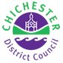

**NAVIGATION GUIDE FOR**

**CHICHESTER DISTRICT COUNCIL**

**DEVELOPER CONTRIBUTIONS**

**PUBLIC FACING MODULE**

# Introduction

This guide has been produced to assist users in navigating around the Developer Contributions Public Facing Module (PFM).

The PFM has been introduced to provide transparency and accountability for contributions received as a result of development within the Chichester District (excluding the South Downs National Park area) towards the provision of infrastructure.

Since the adoption of the Community Infrastructure Levy (CIL) in 2016 the majority of these contributions are from this source. However, the Council still has some funds due and collected under S106 legal agreements signed prior to the introduction of CIL. In addition, monies for Affordable Housing and Recreation Disturbance continue to be secured by S106.

On larger sites there may be specific items of infrastructure required in addition to any CIL payment. Again, these continue to be secured by S106 legal agreement and will be detailed within the S106 Non-Financial tab within this module.

**Important**

The View Deed button functionality referred to in the S106 navigation notes will not be available on launch and will follow in a future upgrade.

In the meantime individual agreements can be viewed on the Council’s public planning application portal which can be accessed [here](https://www.chichester.gov.uk/viewplanningapplications)

# CIL Section

This site holds data on the CIL due, received, allocated and spent since the implementation of CIL on the 1 February 2016. It does not hold data for the parts of the district which fall within the South Downs National Park area as the National Park collects and spends its own CIL.

## Navigation

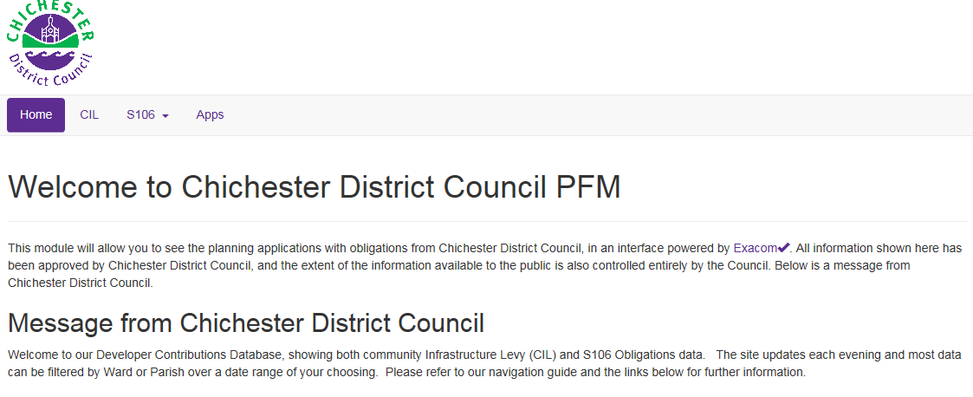

1. From the Home page click on the CIL Tab and this will open up the CIL dashboard.

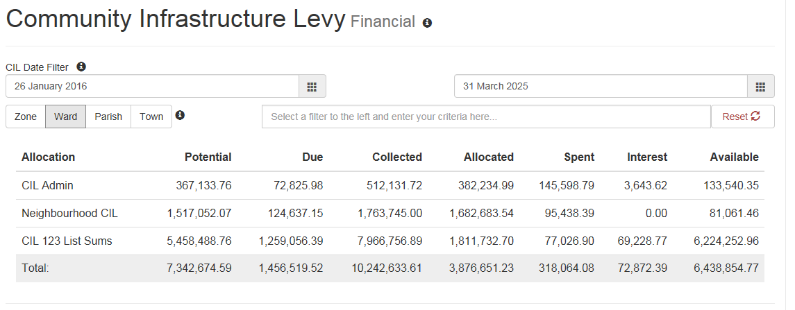

1. By default it will cover the data from the implementation of CIL to date. Users can search on a specific period by clicking on the date boxes and amending the pop-up calendar as appropriate.
2. Hovering over any of the column headings will bring up a pop-up box that provides a definition for the heading.
3. The data can be filtered by Ward or Parish. Click on the criteria you wish to use and then select from the drop down list in the box alongside. (We do not recommend filtering by Zone or Town as CDC does not fully use this functionality).
4. You can combine search criteria if you wish. For example, for the data relating to Chichester North & Chichester South Wards then; Click Ward and select Chichester North from the drop down list, then select Chichester South. A green filtering legend will appear above the table to show the criteria selected. To remove the filters click the Reset buttonbutton
5. Clicking on most of the figures within the table will bring up a list, displayed below the table, showing the planning applications that make up the total. An example showing an extract of the CIL 123 Sums due is shown below.

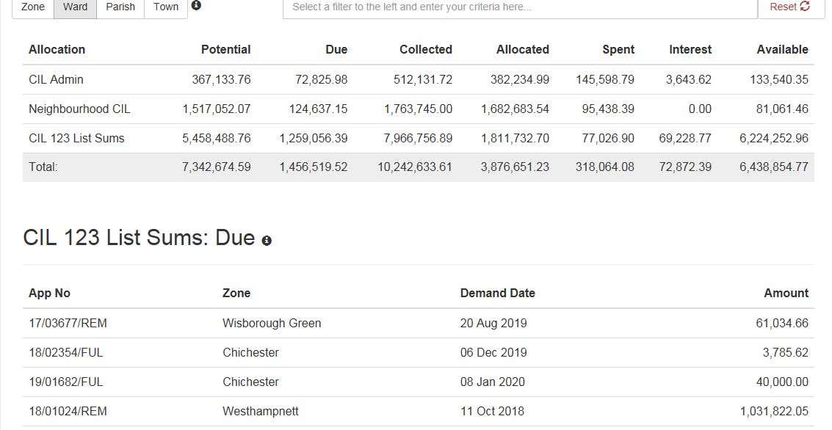

1. Clicking on the App No and scrolling to the bottom of the list will provide the site address and a brief description of the development.
2. In the case of the Allocated and Spent Columns then clicking on these numbers will bring up a list of projects that the funds are allocated to, or have been spent on. Please see an example extract below, in this case it is the CIL 123 List Sums Allocated

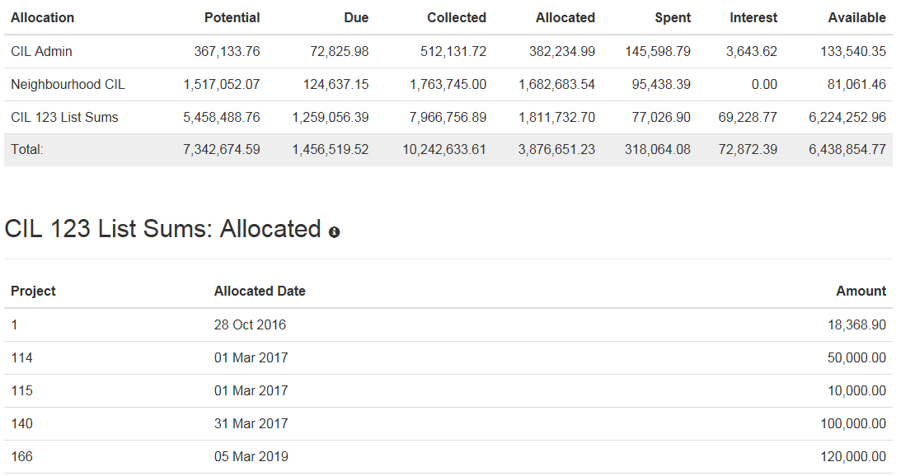

1. Clicking on a project number and scrolling to the bottom of this list will bring up the project name and IBP reference number. Further details of the project are available in the Infrastructure Business Plans published on the CDC website and there is a link to the relevant page on the PFM home page.

## Important Information

1. A Liability for CIL arises when a chargeable development is granted planning permission. At this stage a Liability Notice is issued and the amount due will appear in the **Potential** column. Some caution needs to be exercised when interpreting the figures in this column as not all permissions will be built out and therefore not all of these monies will be paid.
2. CIL is payable upon commencement of a development in accordance with the Council’s instalment policy. Upon notice of commencement, a Demand Notice is issued and the amount due moves from the potential Column to the **Due** column. When the monies are paid it moves to the **Collected** column.
3. The CIL regulations allow for up to 5% of the liability to be used to cover the CIL administration costs with any surplus being spent on infrastructure projects. This is shown on the **CIL Admin** row.
4. The CIL regulations require some monies to be handed over to Local Councils (Parish, Town or City as appropriate). This is 25% for those Councils that have a Neighbourhood Plan or 15% for those that do not. (This 15% is capped on an annual basis dependant on the Council Tax properties within the locality.) The amounts due to Local Councils are shown on the **Neighbourhood** **CIL** row.
5. In the case of **Neighbourhood CIL,** the amount **Allocated** has been passed to the relevant Local Council by CDC for them to spend. These monies are handed over in April and October. The amount **Spent** by the Local Council is updated annually. On this site, CDC only publishes the amount spent and not details of any individual projects. This information can be found with the Annual Monitoring Report that is produced annually by each Local Council that has received CIL. This information is published on their website and a copy is also available on the CDC website. A link to the website AMR page is on the PFM home page.

# S106 section

The site holds data on S106 Financial Obligations, Non-Financial Obligations and Affordable Housing secured by S106 agreements. It covers all deeds signed since 1 April 2017, together with earlier deeds where, as at that date either;

1. Triggers had not fallen due or been met, or
2. Chichester District Council held unspent funds

## Important Notes

1. Chichester District Council does not monitor obligations to West Sussex County Council in these deeds and you will need to make enquires directly to WSCC for information.
2. This database does not contain any information for deeds signed after 1 April 2011 for areas of the district within the South Downs National Park. You will need to enquire directly to the South Downs National Park Authority for information.

## Navigation

1. From the home page click on the S106 tab which will open up the S106 sub menu as shown below
2. Click on S106 Financial or S106 Non-Financial or S106 Affordable Housing as required

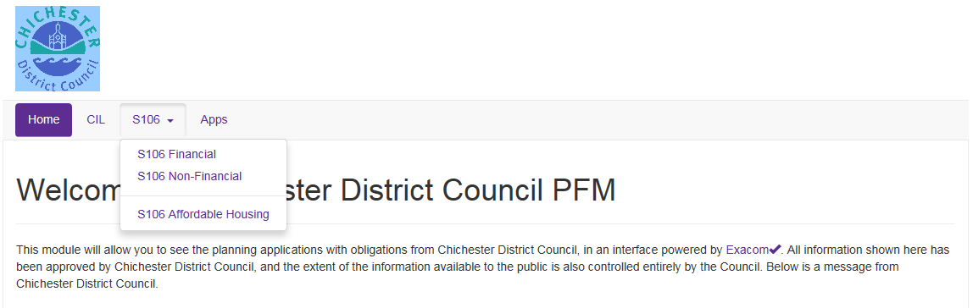

# S106 Financial

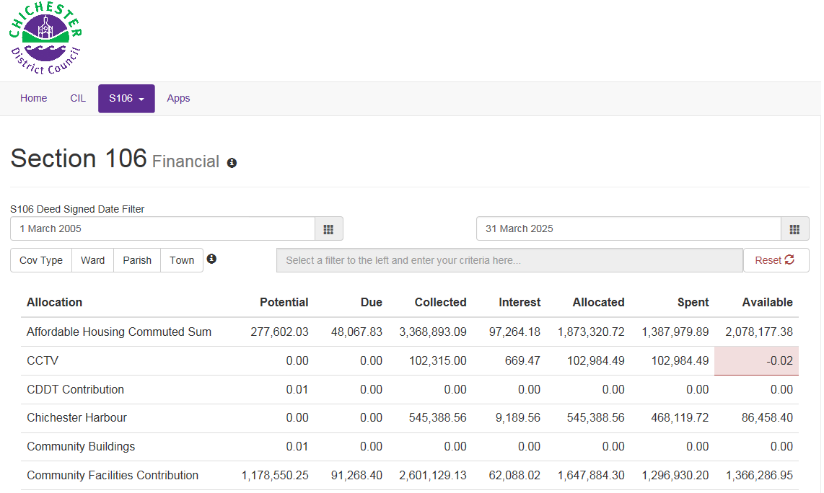

1. The S106 Financial page is a dashboard summarising the S106 funds for all records on the database as shown in the extract above.
2. The default date range covers all deeds on the database. Users can amend to search on deeds signed during a specific period by clicking on the date boxes and amending the pop-up calendar as appropriate.
3. Hovering over any of the column headings will bring up a pop-up box that provides a definition for the heading.
4. The table can be filtered by Covenant Type, Ward, Parish or Town. Click on the criteria that you wish to filter by and then select from the drop down list in the box alongside.
5. You can combine search criteria if you wish. For example, for the data relating to Chichester North & Chichester South Wards then; Click Ward and select Chichester North from the drop down list, then select Chichester South. A green filtering legend will appear above the table to show the criteria selected. To remove the filters click the Reset buttonbutton
6. Clicking on any of the figures within the table will generate a list beneath the table of the S106 agreements that make up the total. Please see the example extract below. In this case it is an extract of the Sports & Leisure spent figure.

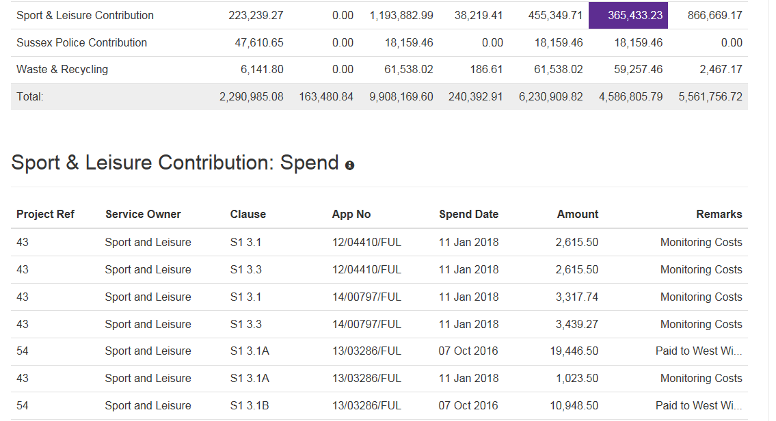

1. Clicking on the project reference number and scrolling to the bottom of the list will reveal the project title, together with the Ward, Parish and Town to which it relates (where appropriate).
2. Hovering over the remarks in the last column of the main table (as above) will produce a ‘pop-up’ which gives brief details of the allocation or spend (if appropriate).
3. Clicking on the application number and scrolling to the bottom of the list will reveal details of the site and the development.
4. Clicking on the clause reference and scrolling to the bottom of the list will reveal further details of the obligation and deed. Clicking on the View deed button icon will open a pdf version of the relevant agreement in a new window. See screen print below.

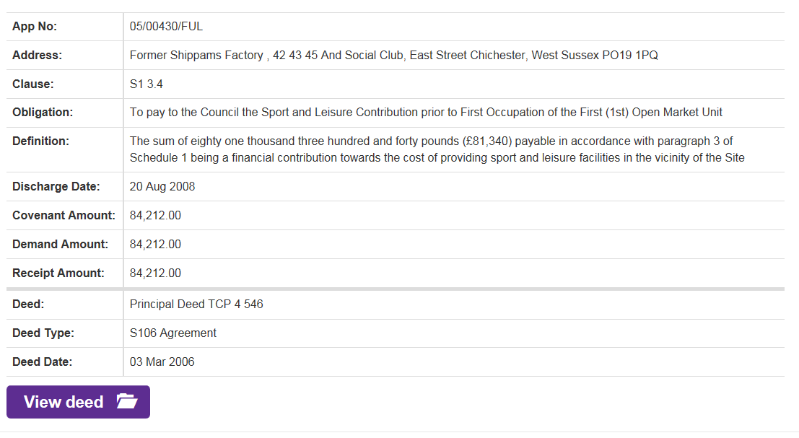

## Important Notes to the S106 Financial Module

1. For historic deeds that have been back loaded into this database the Covenant Amount may differ to the amount shown in the deed. This is because it includes indexation.
2. Negative funds may appear in the **‘Available’** column when filtering by Ward and Parish. To mitigate the impact of inflation on the value of the monies whilst held by the Council, it calculates ’interest’ based on the average rate of return earned on its cash reserves for the period it has held the funds. Whilst this can be allocated to each service it cannot be allocated at Ward and Parish level. Therefore when filtering by these parameters it may appear that the amount allocated and spent exceeds the sum received.

# S106 Non-Financial



From the homepage, click on S106 and then S106 Non-Financial from the sub menu as shown above. This will open a search page as shown below.

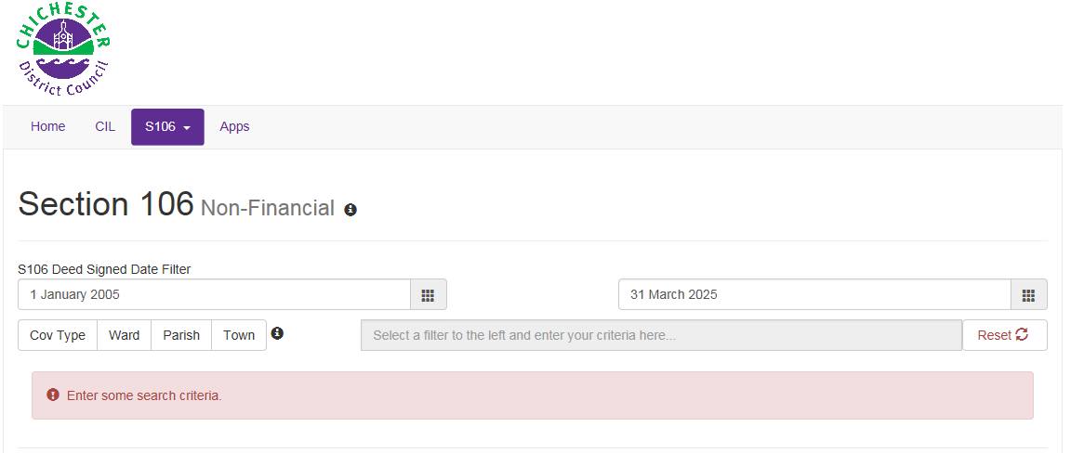

1. The default date range covers all deeds on the database. Users can amend the date range by clicking on the date box and selecting an appropriate range from the pop-up calendar.
2. You can search the deeds on the database by Covenant Type, Ward, Parish or Town.
3. Click on the relevant criteria you wish to search by and then select from the appropriate list in the drop down box alongside. To clear filtering click the Reset buttonbutton
4. A list will appear of covenants meeting your search criteria. A date in the final column indicates the obligation has been discharged.
5. Search criteria can be combined so for example the screen print extract below shows a search for Covenant Type ‘Open Space Land’ in the Parish of ‘Southbourne’

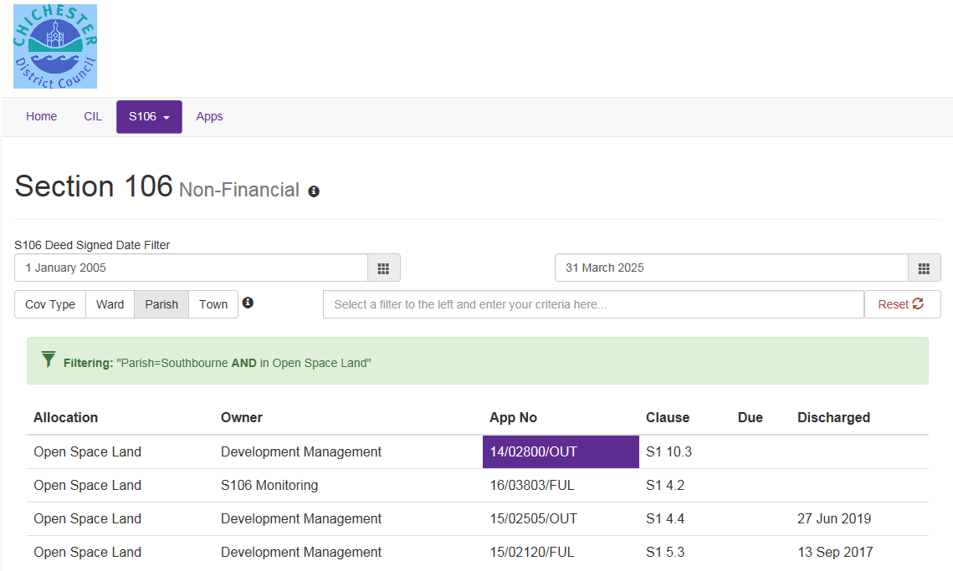

1. Clicking on the Application No and scrolling down will reveal details of the site and development
2. Clicking on the clause number and scrolling down will reveal details of the obligation
3. A pdf version of the deed can be accessed by clicking on the View deed button Icon as shown below and this will open in a new window.

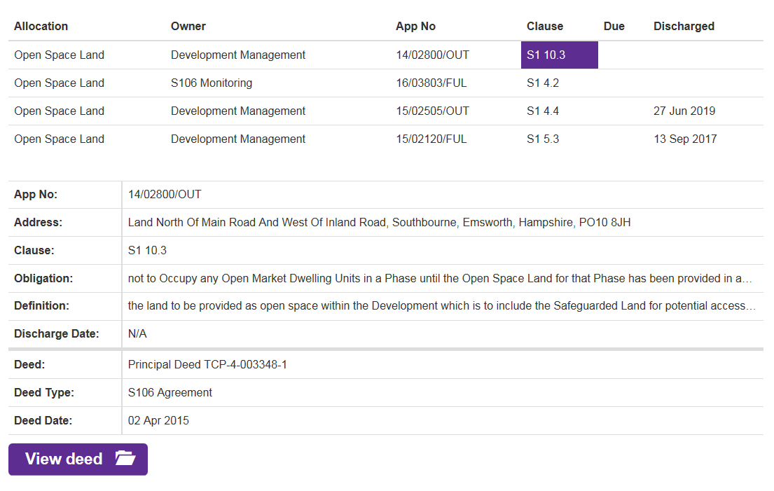

# S106 Affordable Housing



From the homepage, click on S106 and then S106 Affordable Housing from the sub menu as shown above. This will open a search page as shown below.

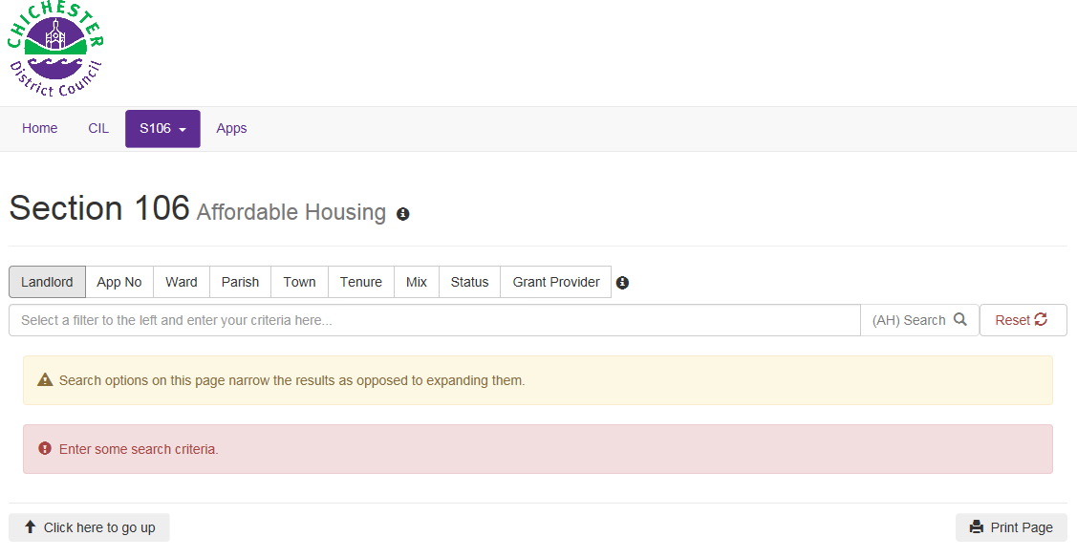

1. Click on a search criteria and select from the options in the drop down box.
2. A list of results will be produced
3. Clicking on an application number and scrolling to the bottom of this list will reveal the site details and the numbers and percentage of Affordable Housing secured

## Important Notes

1. Chichester District Council does not monitor details of any grants that providers may or may not have received in relation to Affordable Housing provision. Clicking on ‘Grant Provider’ (in the search criteria at the top of the page) and then selecting ‘Not Known’ in the drop down box below, will produce a full list of Affordable Housing secured by S106 agreements recorded on this database since 1 April 2017
2. When a S106 is signed, the Registered Provider is usually not known and so these are recorded as ‘TBA’ (To Be Advised). Details will be updated when known.
3. For outline applications the housing type and mix are often not known and so are recorded under the generic title ‘Affordable Housing’. Once reserved matters are permitted and the housing mix becomes known the data will be updated.

# Applications

This section contains all the CIL & S106 records that are within this database and these can be accessed by clicking on Apps from the Home page. It will bring up a search menu as shown below

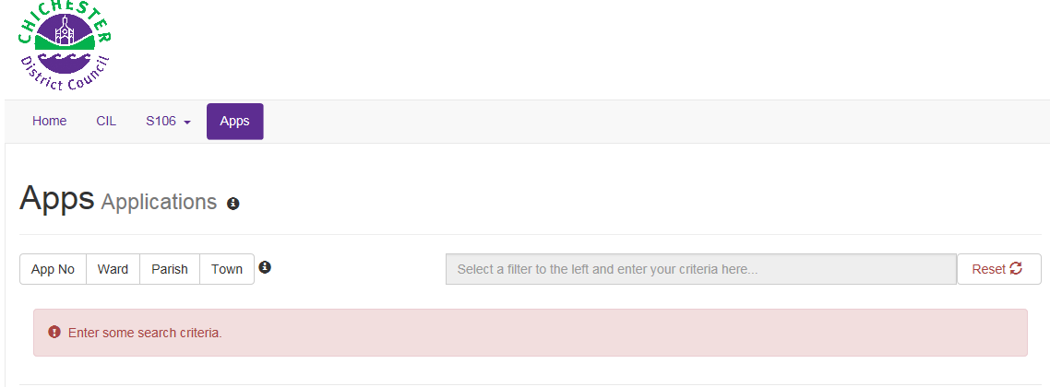

1. You can search by Application Number, Ward, Parish and Town by clicking on the appropriate button and selecting from the drop down menu. For example searching on Chidham & Hambrook

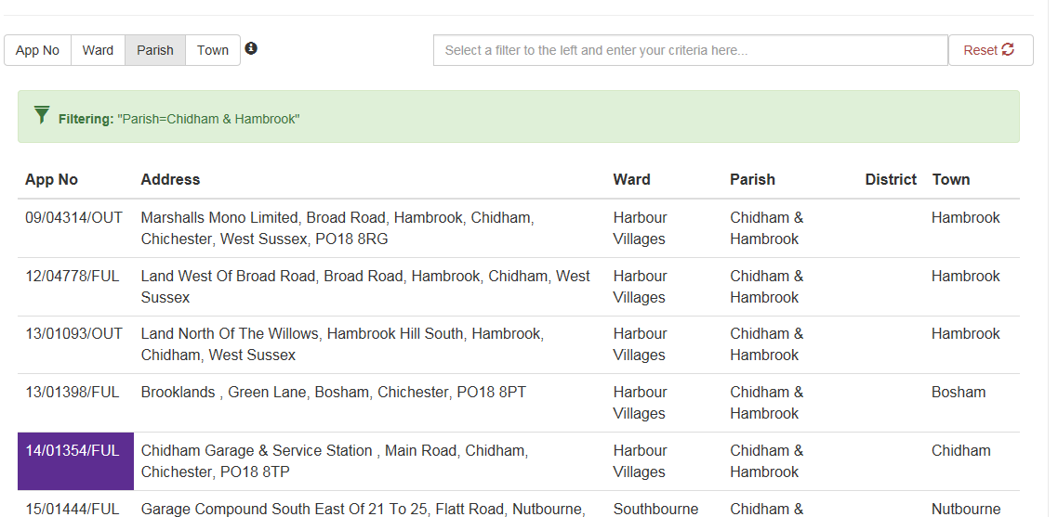

1. Clicking on an application number and scrolling down will bring up details of the development and if subject to a S106 agreement a list of monitored covenants together with their discharge date (if appropriate).

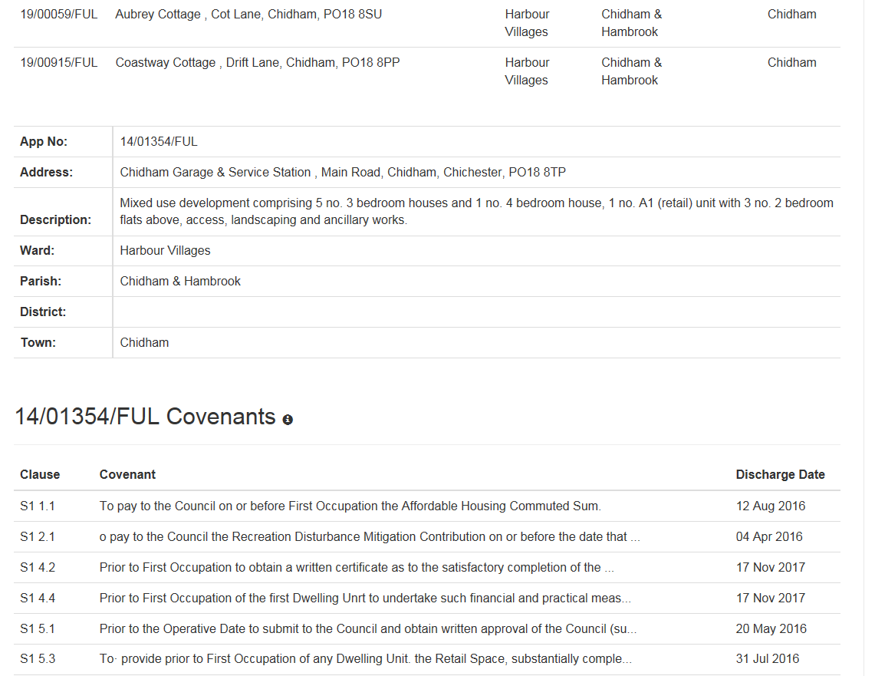

1. You can click on the covenant number or description, scroll down, and access further information including a link to the full deed via the View deed button icon which will open a pdf version in a new window.