# CDCwaveSc_tagC_LHead_pcLicensing Authority, Chichester District Council, East Pallant House, East Pallant, Chichester, West Sussex, PO19 1TY

## Guidelines for Application of Vinyl Adhesive Door Signs

Recommended materials required: Clean soft cloth/ duster.

1. Choose the correct area on the **rear passenger doors** of the vehicle by offering the door sign up to the designated central position. Now thoroughly clean the surface where the sign is to be applied with a clean, dry cloth or duster.
2. Peel off a small segment of the backing paper from one end of the door sign, and fold over to expose a portion of adhesive on the rear of the printed door sign.
3. Apply the exposed portion of the adhesive area on the rear of the sign directly to the door, making sure that the sign is horizontal and straight. Now slowly from the peeled area which is now attached to the vehicle, pull off the remainder of the backing paper and smooth down firmly and evenly with a soft cloth or duster.
4. Finally, smooth over the sign with a soft cloth or duster applying pressure.
5. Both of the **rear passenger doors** to the vehicle must have the door signs attached as per the image below.

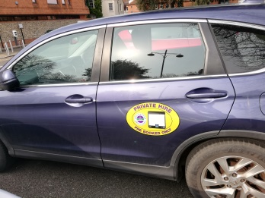

**Care and Maintenance of Door Signs**

Normal car washing with non-aggressive detergents will keep door signs in prime condition. Wax based products such as ‘Turtle Wax’ may also be used. **DO NOT USE** aggressive or solvent based products such as T-CUT or AutoGlym paint restorers as these products are designed to remove the top layer of paint.

**Removal of Door Signs**

Ensuring that the sign remains in one piece, gently peel from the outside edge and keeping the door sign taut, pull away from the vehicle. Following removal of the sign, clean off any adhesive residue on the vehicle with soapy water. Finally, wipe down the surface again with a clean, soft cloth leaving paintwork clean and dry. Applying gentle heat with a hairdryer may be helpful if required.