|  |
| --- |
|  |
|  |

|  |
| --- |
| Mott MacDonald  35 Newhall Street  Birmingham B3 3PU  United Kingdom  T +44 (0)121 234 1500  mottmac.com |
| Chichester District Council  East Pallant House  1 East Pallant  Chichester  PO19 |
| Mott MacDonald Limited. Registered in England and Wales no. 1243967. Registered office: Mott MacDonald House, 8-10 Sydenham Road, Croydon CR0 2EE, United Kingdom |

|  |
| --- |
| Tangmere Strategic Development Location Compulsory Purchase Order |
| Equality Impact Assessment |
| 7 February 2020 |

Issue and Revision Record

|  |  |  |  |  |  |
| --- | --- | --- | --- | --- | --- |
| Revision | Date | Originator | Checker | Approver | Description |
| A | 24 Jan 2020 | Cristina Cojocaru  Osman Kocini | Hannah Grounds | James Beard | Draft EqIA update |
| B | 5 Feb 2020 | Osman Kocini | Hannah Grounds | James Beard | EqIA update following client comments |
| C | 7 Feb 2020 | Hannah Grounds | Hannah Grounds | James Beard | Final EqIA update following client comments |
|  |  |  |  |  |  |
|  |  |  |  |  |  |
|  |  |  |  |  |  |
|  |  |  |  |  |  |
|  |  |  |  |  |  |
|  |  |  |  |  |  |

| Document reference: | 416155 | A | 1 |
| --- | --- |

|  |  |
| --- | --- |
| Information class: | Standard |

|  |
| --- |
| This document is issued for the party which commissioned it and for specific purposes connected with the above-captioned project only. It should not be relied upon by any other party or used for any other purpose.  We accept no responsibility for the consequences of this document being relied upon by any other party, or being used for any other purpose, or containing any error or omission which is due to an error or omission in data supplied to us by other parties.  This document contains confidential information and proprietary intellectual property. It should not be shown to other parties without consent from us and from the party which commissioned it. |
|  |

Contents

1 Introduction 1

2 Tangmere Strategic Development Location: redevelopment context 5

3 Area profile 13

4 Impact assessment 19

5 Conclusions and action plan 27

Appendices 31

A. Bibliography 32

B. Demographic mapping 34

Tables

Table 3.1: Population by age group 13

Table 3.2: Population by disability 14

Table 3.3: Population by birth and fertility rates 14

Table 3.4: Population by race and ethnicity 15

Table 3.5: Population by religion and belief 16

Table 3.6: Population by sex 16

Table 3.7: Employment rate of population 17

Table 3.8: Summary of demographic groups 17

Table 4.1: Impact assessment 19

Table 5.1: Summary of potential impacts, mitigations and recommendations 27

Table 5.2: Action Plan 29

Figures

Figure 1.1: Article 149 of the Equality Act 2010: The Public Sector Equality Duty 1

Figure 2.1: Tangmere Strategic Development Location red line boundary 5

Figure 2.2: Community resources in Tangmere 6

Figure 5.1: Proportion of total population aged 0-15 34

Figure 5.2: Proportion of total population aged 16-24 35

Figure 5.3: Proportion of total population aged 65 and over 36

Figure 5.4: Proportion of total residents with a long-term health problem or disability 37

Figure 5.5: Proportion of total residents who are from a Black, Asian or minority ethnic (BAME) background 38

# Introduction

## Overview

This report presents the findings of the Equality Impact Assessment (EqIA) for the making of the Chichester District Council (Tangmere) Compulsory Purchase Order 2020. The Compulsory Purchase Order (CPO) is a key tool in the delivery of housing and other development upon land at Tangmere, referred to within the Chichester District Council’s (‘the Council’) Local Plan as the Tangmere Strategic Development Location (TSDL).

The report sets out a summary of the background of the TSDL, the requirements of the Equality Act 2010 (‘Equality Act’), and the potential impacts of the TSDL on people with characteristics protected under the Equality Act.

The EqIA presents a comprehensive view of potential effects of the CPO for the TSDL and explores strategies which may help to mitigate any adverse effects of development, using suitable literature. It is intended to analyse the effects of the development to a level proportionate to the associated activities.

The assessment is focussed on the actual and potential impacts (both positive and negative) arising from the development, likely to be experienced by people in light of their protected characteristics. The report sets out the measures put in place by the Council and provides recommendations on how any remaining impacts can be managed or mitigated.

## The Equality Impact Assessment

The EqIA has been undertaken in support of the Council’s obligations under UK equality legislation, and in particular the Equality Act. The Act sets out a Public Sector Equality Duty (PSED), at section 149, and is set out in the Figure below.

Figure 1.1: Article 149 of the Equality Act 2010: The Public Sector Equality Duty

**(1) A public authority must, in the exercise of its functions, have due regard to the need to**

**(a) eliminate discrimination, harassment, victimisation and any other conduct that is prohibited by or under this Act;**

**(b) advance equality of opportunity between persons who share a relevant protected characteristics and persons who do not share it.**

**(2) A person who is not a public authority but who exercises public functions must, in the exercise of those functions, have due regard to the matters mentioned in subsection (1).**

**(3) Having due regard to the need to advance equality of opportunity between persons who share a relevant protected characteristic and persons who do not share it involves having due regard, in particular, to the need to –**

**(a) remove or minimise disadvantages suffered by persons who share a relevant protected characteristic that are connected to that characteristic;**

**(b) take steps to meet the needs of persons who share a relevant protected characteristic that are different form the needs of persons who do not share it;**

**(c) encourage persons who share a relevant protected characteristic to participate in public life or in any other activity in which participation by such persons is disproportionately low.**

Source: Equality Act, 2010

The PSED is intended to support good decision-making – it encourages public bodies such as the Council to understand how different people will be affected by their activities. This helps to ensure policies and services are appropriate and accessible to all and meet different people’s needs. The Council must have due regard to the aims of the PSED throughout the decision-making process for the redevelopment of the site. The process used to do this must take account of the protected characteristics which are identified below in the section 1.2.2.

### Assessing equality effects

While the PSED does not specify a particular process for considering the likely effects of policies, programmes and projects on different sections of society for public authorities to follow, this process is usually undertaken through some form of equality analysis. This can include EqIA.

By understanding the effect of their activities on different people, and how inclusive delivery can support and open up opportunities, public bodies can be more efficient and effective.

### Protected characteristics

This document provides an analysis of the likely or actual effects of policies or proposals on social groups with the following protected characteristics (as defined by the Equality Act):

|  |  |
| --- | --- |
| Protected characteristic | Equality and Human Rights Commission (EHRC) definition |
| Age | A person belonging to a particular age (for example 32-year olds) or range of ages (for example 18 to 30-year olds). |
| Disability | A person has a disability if they have a physical or mental impairment which has a substantial and long-term adverse effect on that person's ability to carry out normal day-to-day activities. |
| Gender reassignment | The process of transitioning from one gender to another. |
| Marriage and civil partnership | Marriage is a union between a man and a woman or between a same-sex couple.  Couples can also have their relationships legally recognised as 'civil partnerships'. Civil partners must not be treated less favourably than married couples (except where permitted by the Equality Act). |
| Pregnancy and maternity | Pregnancy is the condition of being pregnant or expecting a baby. Maternity refers to the period after the birth and is linked to maternity leave in the employment context. In the non-work context, protection against maternity discrimination is for 26 weeks after giving birth, and this includes treating a woman unfavourably because she is breastfeeding. |
| Race | Refers to the protected characteristic of race. It refers to a group of people defined by their race, colour, and nationality (including citizenship) ethnic or national origins. |
| Religion and belief | Religion has the meaning usually given to it, but belief includes religious and philosophical beliefs including lack of belief (such as Atheism). Generally, a belief should affect someone’s life choices or the way they live for it to be included in the definition. |
| Sex | A man, woman or non-binary person. |
| Sexual orientation | Whether a person's sexual attraction is towards their own sex, the opposite sex or to both sexes. |

The analysis determines the likely or actual effects of policies or proposals on social groups by:

* Assessing whether one or more of these groups could experience disproportionate effects (over and above the effects likely to be experienced by the rest of the population) as a result of the proposal development.
* Identifying opportunities to promote equality more effectively.
* Developing ways in which any disproportionate negative impacts could be removed or mitigated to prevent any unlawful discrimination and minimise inequality of outcomes.

## Approach

### Overall approach to the EqIA

The approach to this EqIA employs parts of the bespoke Mott MacDonald INCLUDE toolkit, which sets out the following steps:

4

**Action planning.**

Drawing conclusions and identifying opportunities and further actions to manage and mitigate and impacts.

3

**Impact assessment.** Understanding the extent and scale of any impacts arising, taking mitigation measures into account.

2

**Evidence, distribution and proportionality.**

Review of available demographic data and other published evidence to establish the likely scope and nature of equality impacts.

1

**Understanding the project**

Analysis of the proposals for the TSDL, the plans for CPO and any activity intended to manage impacts by the Council.

### Tasks undertaken

Within the steps above, the following tasks were undertaken to deliver the assessment:

#### Understanding the project

Review of redevelopment proposals: A review of the documents associated with the development of Tangmere CPO including Chichester Local Plan 2014-2029, the Masterplan and planning background to the scheme, previous phases of Equalities Assessments undertaken by the Council in 2013 and 2018.

In terms of consultation, evidence reviewed includes the local Consultation Action Plan, the Council’s pre-submission Neighbourhood Plan letter, consultation responses in the Tangmere Neighbourhood Plan, stakeholder feedback on the ‘Local Plan Review: Preferred Approach’, community feedback from masterplan drop-in sessions and community feedback from public consultation events.

The website of the Council’s development partner, Countryside Properties (UK) Ltd (‘Countryside’), has also been reviewed to crosscheck the scheme descriptions and the timeline of contractual developments.

#### Evidence, distribution and proportionality

Desk-based evidence and literature review: In order to better understand the potential impacts arising from the TSDL and CPO, and to help to identify possible mitigations and opportunities associated with the project, relevant published literature from governmental, academic and third sector sources were reviewed. This allowed for the characterisation of potential risks and impacts typically associated with housing developments, to understand whether they apply in this instance.

Demographic analysis of the site and surrounding area: A social and demographic profile of the local area around the TSDL site was collated and compared with wider social and demographic data to understand the context of the area.

#### Impact assessment

Assessment of potential effects: Potential impacts were identified and assessed using the research undertaken in the stages above. Assessment of impacts was undertaken in the light of sensitivity of the affected parties to the TSDL and CPO. Both adverse and beneficial impacts were identified in the context of any mitigation measures implemented or proposed by the Council.

#### Action planning

Making recommendations: Based on the impacts identified, a series of conclusions and further recommendations were developed, to help manage CPO process, the TSDL and the impacts identified in the local area.

## Approach to identifying impacts

### Differential impacts

Differential impacts occur where people with protected characteristics are likely to be affected in a different way to other members of the general population. This may be because groups have specific needs or are more susceptible to the impact due to their protected characteristics. These impacts are not dependent on the number of people affected.

The desk-based research stages of the analysis are used to explore the potential impact of the CPO and TSDL. The output of this work identifies those protected characteristic groups that are likely to experience impacts arising from the CPO and TSDL and explains why.

### Disproportionate impacts

Disproportionate impacts occur where there is likely to be a comparatively greater effect on people from a particular protected characteristic group than on other members of the general population. Disproportionate effects may occur if the affected community comprises of a higher than average proportion of people with a particular protected characteristic, or because people from a particular protected characteristic group are the primary users of an affected resource.

Identifying disproportionate impacts involves determining the demographic composition of the area where impacts are expected to arise; this work identifies the numbers and proportions of people from protected characteristic groups around Tangmere, Chichester and the South East region.

# Tangmere Strategic Development Location: redevelopment context

## Overview

The 76.3ha TSDL is located to the immediate west of the village of Tangmere. The site is greenfield in nature, separated into fields and currently used for agricultural purposes (primarily the growing of crops). There is no physical infrastructure present on the TSDL. The extent of the site is defined by the red line boundary (RLB) as shown in Figure 2.1 below.

Tangmere is a village located to the east of Chichester, within Chichester District Council’s administrative boundary, in the South East of England. Several community resources are located in Tangmere, to the east of the TSDL site, including a children’s nursery, church, dentist, health centre, primary school and a public hall. The location of these resources is shown in Figure 2.2.

Figure 2.1: Tangmere Strategic Development Location red line boundary

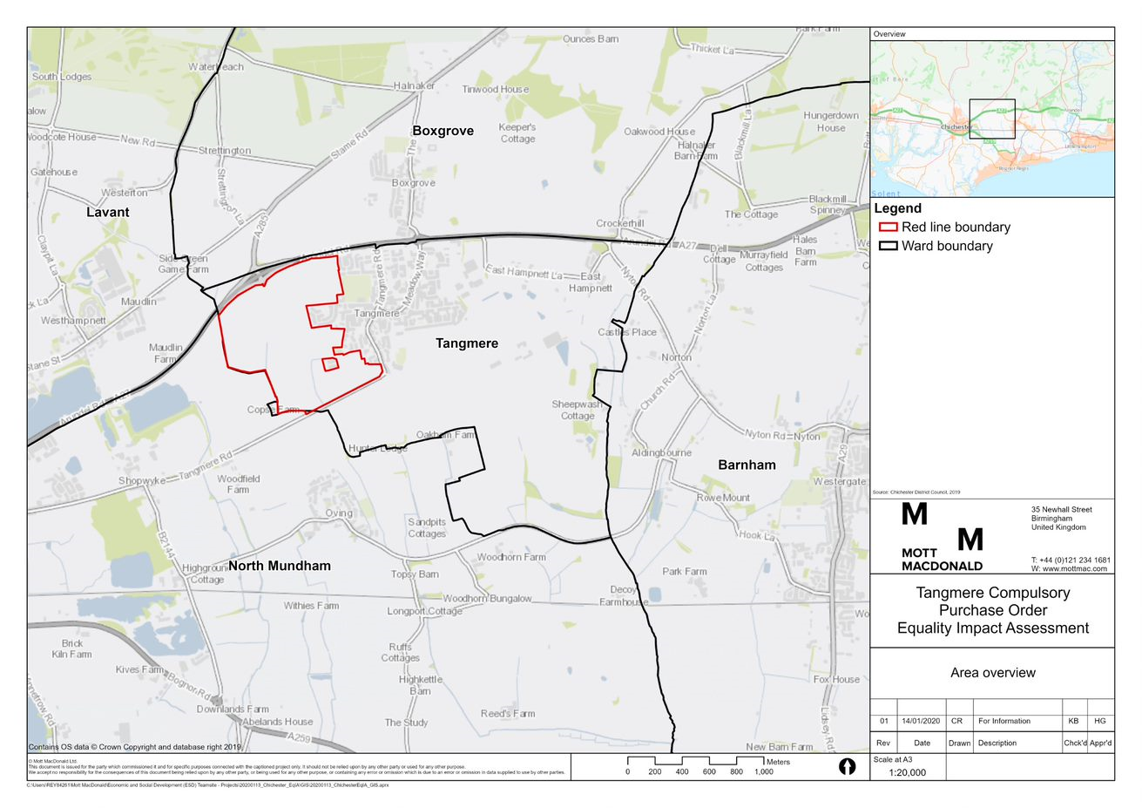

Source: Mott MacDonald, 2020

Figure 2.2: Community resources in Tangmere

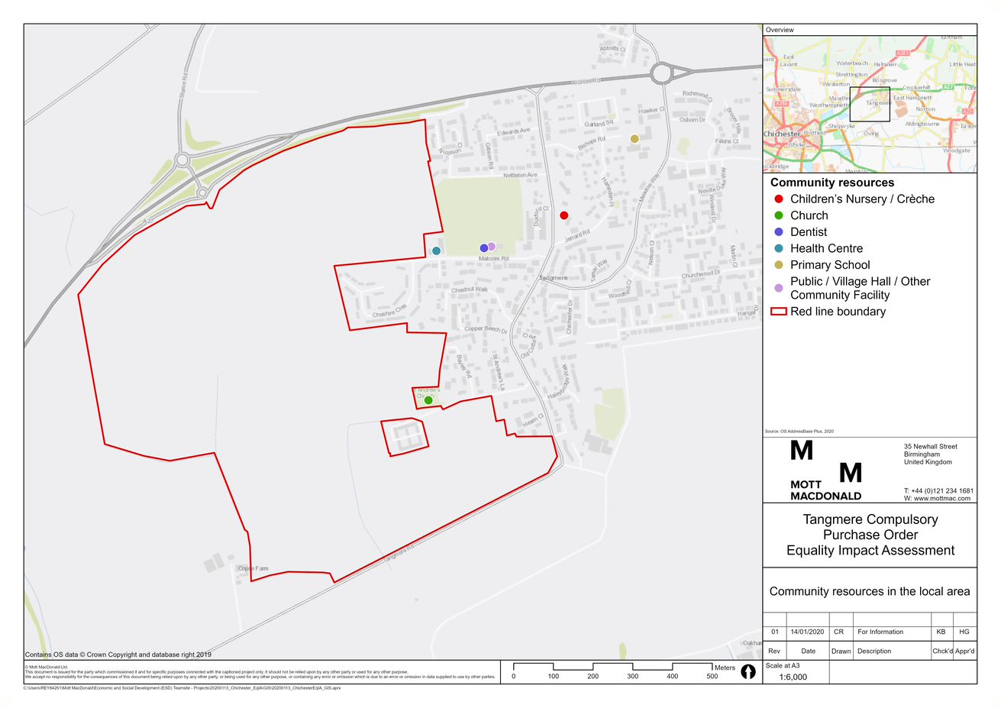

Source: Mott MacDonald, 2020

The Chichester Local Plan[1], adopted in 2015, sets out the key policies for the enhancement of the local community through the development of new homes, workspaces and improved transport connection. The key policies that relate to Tangmere are set out below.

* ***Policy 2 (Development Strategy and Settlement Hierarchy)*** of the Local Plan identifies Tangmere as being capable of accommodating further sustainable growth to enhance and develop its role as a settlement hub.
* ***Policy 4 (Housing Provision)*** states that strategic development locations are allocated in the Local Plan to accommodate 3,250 homes over the local plan period.
* The TSDL is identified within ***Local Plan Policy 18*** for the delivery of 1,000 homes and associated infrastructure including a school, open space and community facilities.
* ***Policy 7 (‘Masterplanning Strategic Development’)*** confirms that development of strategic locations identified in the Local Plan (including the TSDL) will be planned through a comprehensive masterplanning process, which will involve the active participation and input of the relevant stakeholders.

The Local Plan identifies Tangmere as a ‘settlement hub’ – a local centre that will provide a reasonable range of employment, retail, social and community facilities that serve the community and local catchment areas. The Tangmere Neighbourhood Plan[2], which was made in 2016, also sets out a future vision for the village and the necessary policies to achieve this. Delivery of the TSDL forms one of the key objectives of both the Chichester Local Plan and Tangmere Neighbourhood Plan, and demonstrates Tangmere’s role in improving housing provision and the community enhancement. The Council’s emerging Local Plan proposes to increase the number of dwellings on the TSDL from 1,000 to 1,300. In order to facilitate delivery on the site, the Council has decided to bring forward the comprehensive development of the TSDL. Through a competitive tender process, in February 2019 Countryside was appointed as the Council’s development partner to help facilitate the residential-led development of the TSDL.

Delivery of the TSDL supports the aspiration of Tangmere Neighbourhood Plan for a ‘One Village’ concept, using the following components to achieve this:

* A mixed-use ‘Village Main Street’ (approx. 0.5ha) will comprise up to 1,000 sqm of units suited to retail and business use.
* Up to 1,300 dwellings, 30% (390 dwellings) of which will be affordable[3].
* A two-form entry primary school including early years provision. The school site will also include additional land to be safeguarded for the potential future expansion to three forms of entry.
* Multi-modal access from Tangmere Road at the south of the TSDL and the A27 grade-separated junction at the north of the TSDL.
* Multi-functional public open space and green infrastructure: including approximately 26.5 hectares of public open space (including amenity and open space), 1.9ha of formal sports provision, 2.1ha of allotments and 0.8ha of community orchard.
* A network of pedestrian and cycle links, including off-site cycleway improvements.
* Community centre improvements: two options exist at this stage - to deliver an expansion of the existing community centre in Tangmere, or provide a new centre elsewhere (to be determined through planning application process). Facilities in the centre may include community rooms, café, indoor sports facilities and library provision.

## Background to the CPO

Section 226(1)(a) of the Town and Country Planning Act 1990 authorises a local authority to exercise its compulsory purchase powers if it considers that acquiring the land in question will facilitate the carrying out of development, redevelopment, or improvement on, or in relation to, the land being acquired, and it is not certain that they will be able to acquire it by agreement.[4]

Additionally, a local authority must not exercise the power under section 226(1)(a) of the 1990 Act unless they think that the development, re-development or improvement is likely to contribute to the achievement of any one or more of the following objectives:

* the promotion or improvement of the economic well-being of their area;
* the promotion or improvement of the social well-being of their area;
* the promotion or improvement of the environmental well-being of their area. [5]

The Chichester Local Plan makes provision for the Council to deliver a total of 7,388 homes between 2012 and 2029, with 3,250 dwellings are to be provided at Strategic Development Locations (SDLs). Reflecting on the larger housing development in the Local Plan, delivery of the TSDL is essential in ensuring that there is no shortfall in meeting the regional and wider housing target set out in the Local Plan. The TSDL is the second largest allocation in the Local Plan, accounting for approximately 14% of the housing need for the Local Plan area. The Council believes that the TSDL development will benefit the administrative area in terms of local and regional socio-economic development, and will therefore exercise its CPO right if this is necessary.[6] As a result, those that currently own the greenfield land that comprises the TSDL site may be subject to the Council’s CPO powers.

## The Council and its development partner’s commitments

Countryside have maintained regular contact with the landowners and their respective representatives, seeking to negotiate private treaties in order to acquire interests, or to reach an agreement which establishes the basis on which a future transaction will be undertaken to avoid the need for the CPO. Currently, no agreement has been made with landowners regarding the voluntary acquisition of their land interests.

Alongside these private treaty negotiations, the contact and communication made by Countryside with landowners and their representatives includes the following:

* Countryside has kept all of the landowners and their representatives fully updated throughout the planning process to date. It has regularly met with the landowners and their representatives as part of the ongoing negotiations in relation to land assembly. Meetings have been used to inform landowners of any updates to the CPO or wider development plans, and to respond to any queries that may arise.
* The landowners have been specifically invited to each of the public consultation events held, with representatives of all principal landowners attending the public exhibition in September 2019.
* Where specific comments have been received from landowners on the TSDL, Countryside have sought to address these wherever possible in the same way as all other stakeholders, taking account of the detailed technical assessments and overarching need for comprehensive redevelopment of the TSDL site.

## Stakeholder Engagement

To date, stakeholder engagement has been undertaken for both the preparation of the Chichester Local Plan and Tangmere Neighbourhood Plan, and more recently, the TSDL, specifically in relation to the preparation of the Masterplan for the site. Engagement for the Local Plan was conducted between 2010 and 2015, whilst the TSDL engagement took place throughout 2019. A summary of both sets of engagement is provided below.

### Previous wider Local Plan engagement

Stakeholder engagement took place in line with the planning regulations throughout the preparation of the wider Chichester Local Plan, and the Tangmere Neighbourhood Plan.

The process of allocating the TSDL within the adopted Chichester Local Plan required engagement throughout various stages including consultation on the Preferred Approach plan, Pre-submission consultation, and at Submission stage. During these consultation stages, the Council invited residents, businesses and organisations, including statutory consultees, to make representations on the draft proposed policies, sent out press releases, statutory public notices in newspapers and placed notices in parish magazines. All consultees were notified on their consultation database via email or printed letter, where relevant. Drop-in sessions were also held at locations across Chichester.

Stakeholders from Tangmere were also previously engaged using e-mails as part of the wider consultation process on the Publication version of the Tangmere Neighbourhood Plan between 30 April 2015 and 11 June 2015. Land ownership, communications and the timely inclusion of stakeholder views in the Tangmere Neighbourhood Plan came across as the main issues. Several businesses also highlighted that the masterplan would need to consider a range of opportunities and constraints to the laying out of the infrastructure, services, facilities and housing. An issue was also raised that given that the Neighbourhood Plan for Tangmere included the proposed allocation of small-scale housing and commercial development, it should have noted in advance that this would be subject to the resolution of highway safety and accessibility issues at the planning stage, or as part of the consultation on Community Right to Build Order.

### TSDL 2019 engagement

Key events that took place as part of the 2019 TSDL engagement are as follows:

* **October 2018** - First introductory meeting with ward member, chair of parish council and chair of parish council environment committee
* **April 2019** - Meeting with ward member and chair of parish council regarding engagement strategy and programme
* **April 2019** – Engagement website launched providing details on Countryside’s proposed programme of local engagement ([www.countryside-tangmere.co.uk](http://www.countryside-tangmere.co.uk)). The website includes a ‘Latest News’ page where regular updates are posted, as well as advertising upcoming engagement events.
* **April 2019** – Introductory article published in the bi-monthly village newsletter ‘Tangmere News’.
* **May 2019** – The first of a series of three masterplanning workshops was held with representatives of Tangmere Parish Council. The workshop focussed on site opportunities and constraints, and Tangmere’s morphology and character, particularly any positive and negative aspects that should be considered as part of the village’s future growth.
* **June 2019** – The second masterplanning workshop was held with representatives of Tangmere Parish Council. The workshop began by considering what makes a ‘good place’ and the implications of the ‘One Village’ vision within the Neighbourhood Plan. The workshop also looked at village-wide design objectives and principles that should inform the new development and how these would relate to the overarching vision for Tangmere
* **June 2019** – Community drop-in events were held over the course of two days in Tangmere Village Centre where members of the project team discussed the evolution of the TSDL Masterplan with the community. There were total of 66 attendees at the three community drop-in sessions. Landowners were informed of the drop-in events in advance via email, with the event advertised in the village via leaflet drop and consultation website.
* **June 2019** – The third masterplanning workshop was held with representatives of Tangmere Parish Council. The structuring principles of the neighbourhood were considered, mapping the movement network, green infrastructure, drainage, key community facilities and centres, and residential neighbourhoods.
* **August 2019** – Update article published in Tangmere News.
* **August 2019** – Countryside wrote to residents of Saxon Meadow to provide an update on the latest masterplanning proposals
* **September 2019** – Countryside hosted a stand at Tangmere Village Fair where Countryside Ltd and the project team spoke to members of the public about the emerging proposals, in advance of the public consultation the week.
* **September 2019** – A public consultation was held between 12 noon and 8pm in ‘the Hub’ at the Village Centre in Tangmere. The landowners were informed of the consultation in advance via email, and the event was advertised in the village via direct mail to householders, the consultation website and in the August 2019 edition of the Tangmere News.
* **October 2019** – article published in Tangmere News
* **December 2019** – Article published in Tangmere News. A public Parish Council meeting was held at Tangmere Village Centre where the submitted version of the masterplan was presented to the parish council and local residents, and questions were answered from those present.
* **January 2020** – Article published in Tangmere News.

As part of the 2019 TSDL engagement process summarised above, both landowners and local residents have had opportunities to engage as part of the consultation process – with further engagement with Parish Council and Chichester Cycle Forum, as well as various other statutory consultees.

#### Key themes emerging during the 2019 engagement process

The residents of Tangmere and the TSDL landowners are largely in favour of the TSDL Masterplan. However, the landowners expressed the desire to be more involved in the decision-making processes around the design and development of the site. Landowners highlighted that it is vital that the Masterplan is market-tested to give confidence in terms of deliverability. Consequently, further engagement and consultation around the design of TSDL would be welcomed by landowners.

There is a high level of support for the new development and optimism that the TSDL will provide an opportunity to create a mixed, balanced village where young people would like to live and contribute to the community. The new development should provide homes of an appropriate type, size and tenures to address the identified needs, as well as the market demand. Conversely, some stakeholders expressed concerns that the percentage of affordable houses is too high at 30%, but there was no opposition to providing specialised (e.g. accessible or adaptable) housing where it is deemed to be appropriate. Landowners have also suggested that the development should strive to facilitate the delivery of 1,500 dwellings, as opposed to 1,300 currently planned.

A petition opposing new homes behind existing housing on Cheshire Crescent was signed by 50 residents concerned that this could encourage Traveller access and lead to further development on the proposed open space. Stakeholders also raised the concern that construction of new homes in this location could impact on the outlook of the church and amenity of residents in Cheshire Crescent.

Members of the public were supportive of the TSDL creating flexible open spaces that are inclusive for both new and existing residents, including play facilities that are suitable for children of all ages. There was a high level of support for the allotments, particularly in the proposed location, and it was suggested that the schools should have access to a garden area in order to promote outdoor learning. It was requested that consideration be given to providing open space and parks that are suitable for the older population in terms of design. There was also support amongst stakeholders for new gym facilities, as well as a new swimming pool.

Stakeholders suggested that the new school should be delivered as soon as possible to minimise the pressure on the existing school, along with better parking provisions, to prevent the impact on the wider village at drop off and pick up times.

There is also public support for the creation of small workshop spaces alongside retail units, in order to provide a variety of employment opportunities for new and existing residents.

Regarding existing services in Tangmere, such as the GP surgery and pumping station, stakeholders raised concerns that these would not have adequate capacity to cope with additional residents.

Residents supported the creation of new pedestrian and cycle ways, with respondents requesting improved sustainable links into and from the TSDL, along with improved access to surrounding villages and towns. The need for more affordable public transport to and from Tangmere was emphasised.

There is support to keep traffic movements along Malcolm Road to a minimum, in order to maintain the character of the new local centre and ensure the safety of children at the new primary school. Local residents felt that a no-through road would avoid congestion along Malcolm Road and improve road safety for families and children. Concerns around the potential increase in traffic levels and speeds (specifically coming from the A27) and its effect on pedestrian safety, were also raised. Emphasis was placed on children frequently crossing Meadow Way to get to the primary school. As such, it was requested that a new speed limit of 20mph be introduced both in the TSDL and in the existing village.

Concerns for the air quality and noise increase impacts in Tangmere, resultant from the proximity to the A27, and whether this would become worse with more development and vehicles were identified.

## Previous Equalities work

Prior to this EqIA, the Council carried out other forms of equalities analysis. In 2013, the ‘Chichester Local Plan EqIA Phase 1’, ‘Chichester Local Plan EqIA Phase 1 Addendum’ and ‘Chichester Local Plan EqIA Phase 2’ were produced with a focus on the potential equalities impacts of the wider Chichester Local Plan. In addition to the 2013 iterations, the Local Plan Review Preferred Approach EqIA was undertaken in 2018. An overview of these documents is provided below.

### Local Plan Phase 1 EqIA (2013)

Phase 1 of the Local Plan EqIA was produced alongside the Local Plan as a tool to assess the implications of planning policies upon the whole community. The first submission of the Phase 1 EqIA was in January 2013, while the second submission was an Addendum in July 2013. The update to the January 2013 EqIA was necessary because the consultation on the Local Plan Preferred Approach from March to May 2013 resulted in some major amendments to the Local Plan policies. The reports informed public consultation and assessed a list of policies within the Local Plan to prevent discrimination against protected characteristic groups. Both EqIAs concluded that there were no negative impacts of the Local Plan policies on protected characteristic groups. The Local Plan was therefore considered to be inclusive to all people and groups and as such no mitigation measures were necessary.

### Local Plan Phase 2 EqIA (2013)

The Phase 2 assessment was submitted alongside the Local Plan. The changes from the Local Plan were not significant in terms of the Protected Characteristics, as the aims of the policies were similar to those in the Preferred Approach. The Phase 2 EqIA also identified that no negative impacts on protected characteristic groups would arise as a result of any of the Local Plan policies. The Local Plan was again considered to be inclusive to all people and groups and therefore no additional mitigation measures were necessary.

### Local Plan Review Preferred Approach EqIA (2018)

The Council adopted the Chichester Local Plan: Key Policies (2014-2029)[7] in July 2015. However, the Local Plan examination concluded that the Plan did not meet the full housing needs for the area. The Council were therefore required to undertake a Local Plan Review within five years to ensure that the plan area’s housing needs were fully met. The Preferred Approach version of the Local Plan set out to achieve this by as identifying strategic locations suitable for development and proposed policies to meet the development needs of the Plan area.

The EqIA published in December 2018 considered the impact of the vision, objectives and policies contained in the Local Plan Preferred Approach. The EqIA indicated that there were no negative impacts on protected characteristic groups as a result of the Preferred Approach. The Local Plan was again considered to be inclusive to all people and protected characteristic groups, with no additional mitigation measures necessary.

# Area profile

## Overview

## The demographic profile of the area in which the scheme is located is outlined below. This shows the proportion of people with different protected characteristics living in Tangmere (where this data is available) and provides Chichester district, the South East region and England as comparators. Maps of the site based on nationally available data are included in Appendix B.

## Overview

### Age

The table below shows the population by age group including children, young people, the working age population and older people. Please note the groups below are not mutually exclusive and the columns are not intended to sum to 100%.

Table 3.1: Population by age group

|  |  |  |  |  |
| --- | --- | --- | --- | --- |
| **Age** | **Tangmere** | **Chichester** | **South East** | **England** |
| **Children (aged 0-15)** | 23% | 16% | 19% | 19% |
| **Young people (aged 16-24)** | 9% | 9% | 10% | 11% |
| **Working age population (aged 16-64)** | 63% | 57% | 61% | 63% |
| **Older people (aged 65 and over)** | 14% | 27% | 19% | 18% |

Source: Office for National Statistics (2018) Mid-Year Population Estimates

The table above shows:

* Tangmere has a significantly higher proportion of children aged 0-15 than Chichester (23% compared to 16%), and a slightly proportion than both the South East and England (23% compared to 19%).
* The proportion of young people in Tangmere (aged 16-24) is the same as Chichester (9%), and largely in line with both the South East (10%) and England (11%) averages.
* The working age population (aged 16-64) in Tangmere (63%) is in line with the South East (61%) and England (63%) averages, but is considerably higher than Chichester (57%).
* Older people make up 14% of the Tangmere population. This is lower than both the South East and England averages (19% and 18%, respectively) and significantly lower than Chichester average (27%).

### Disability

The table below shows the proportion of the population with a disability that limits their day-to-day activities.

Table 3.2: Population by disability

|  |  |  |  |  |
| --- | --- | --- | --- | --- |
| **Disability** | **Tangmere** | **Chichester** | **South East** | **England** |
| **Day-to-Day Activities Limited (either a little or a lot)** | 14% | 17% | 16% | 18% |

Source: Census (2011)

The table above shows that the proportion of the Tangmere population whose day-to-day activities are limited either a little or a lot (14%) is slightly lower than the Chichester (17%), South East (16%) and England (18%) averages.

### Gender reassignment

There is no robust data for gender variant people in the study area or the UK more widely. The Government Equalities Office, though, has estimated that the size of the Trans community in the UK could range 200,000 to 500,000.[8]

### Marriage and civil partnership

No relevant impacts are anticipated with regard to marriage and civil partnership, therefore, demographic data for this groups have not been included in the area profile.

### Pregnancy and maternity

The table below shows the number of live births and the Total Fertility Rate (TFR) for Chichester, South East and England. No data is available for Tangmere.

Table 3.3: Population by birth and fertility rates

|  |  |  |  |
| --- | --- | --- | --- |
| **Births and fertility rate** | **Chichester** | **South East** | **England** |
| **Live births** | 991 | 96,748 | 625,651 |
| **TFR** | 1.71 | 1.74 | 1.7 |

Source: Office for National Statistics (2018) Live births in England and Wales (data not available at ward level).

The table above shows that the live births and TFR in Chichester are in line with both the South East and England.

### Race and ethnicity

The below table provides a breakdown of the population of Tangmere, Chichester, South East and England by ethnicity.

Table 3.4: Population by race and ethnicity

|  |  |  |  |  |  |
| --- | --- | --- | --- | --- | --- |
| **Race and ethnicity** | | **Tangmere** | **Chichester** | **South East** | **England** |
| **White** | **White British** | 91.9% | 93% | 85.2% | 79.8% |
| **White Irish** | 0.8% | 0.7% | 0.9% | 1% |
| **White Gypsy or Irish Traveller** | 1% | 0.2% | 0.2% | 0.1% |
| **Other White** | 3.4% | 3.1% | 4.4% | 4.6% |
| **Mixed/multiple ethnic groups** | **White and Black Caribbean** | 0.2% | 0.2% | 0.5% | 0.8% |
| **White and Black African** | 0.3% | 0.1% | 0.3% | 0.3% |
| **White and Asian** | 0.2% | 0.3% | 0.7% | 0.6% |
| **Other Mixed** | 0.2% | 0.3% | 0.5% | 0.5% |
| **Asian/Asian British** | **Indian** | 0.3% | 0.4% | 1.8% | 2.6% |
| **Pakistani** | 0% | 0% | 1.1% | 2.1% |
| **Bangladeshi** | 0% | 0.1% | 0.3% | 0.8% |
| **Chinese** | 0.6% | 0.3% | 0.6% | 0.7% |
| **Other Asian** | 0.5% | 0.6% | 1.4% | 1.5% |
| **Black/African/**  **Caribbean/Black British** | **Black African** | 0.4% | 0.3% | 1% | 1.8% |
| **Black Caribbean** | 0% | 0.1% | 0.4% | 1.1% |
| **Other Black** | 0% | 0.1% | 0.2% | 0.5% |
| **Other ethnic group** | **Arab** | 0% | 0.1% | 0.2% | 0.4% |
| **Any other ethnic group** | 0.1% | 0.1% | 0.4% | 0.6% |

Source: Census (2011)

The above table shows:

* The ethnic composition of Tangmere is largely in line with the Chichester, South East and England averages.
* The White British population in Tangmere (91.9%) is in line with Chichester (93%), but higher than both the South East (85.2%) and England (79.8%) averages.
* White Gypsy or Irish Traveller proportion of the population in Tangmere (1%) is considerably higher than the Chichester (0.2%), South East (0.2%) and England (0.1%) averages.
* The proportion of Asian/Asian British and Black African, Black Caribbean and Black British population is in line with the Chichester average, but noticeably lower than South East and England averages: Indian (0.3% compared to 1.8% and 2.6%, respectively), Pakistani (0% compared to 1.1% and 2.1%, respectively), Other Asian (0.5% compared to 1.4% and 1.5%, respectively), Black African (0.4% compared to 1%, and 1.8%, respectively), Black Caribbean (0% compared to 0.4% and 1.1%, respectively).

### Religion and belief

The table below provides a religious profile of Tangmere, compared with Chichester, South East and England.

Table 3.5: Population by religion and belief

|  |  |  |  |  |
| --- | --- | --- | --- | --- |
| **Disability** | **Tangmere** | **Chichester** | **South East** | **England** |
| **Christian** | 66% | 66.1% | 59.8% | 59.4% |
| **Buddhist** | 0.4% | 0.4% | 0.5% | 0.5% |
| **Hindu** | 0.3% | 0.2% | 1.1% | 1.5% |
| **Jewish** | 0% | 0.1% | 0.2% | 0.5% |
| **Muslim** | 0% | 0.4% | 2.3% | 5% |
| **Sikh** | 0% | 0% | 0.6% | 0.8% |
| **Other Religion** | 0.7% | 0.5% | 0.5% | 0.4% |
| **No Religion** | 32.6% | 24.6% | 27.7% | 24.7% |
| **Religion Not Stated** | 5.9% | 7.6% | 7.4% | 7.2% |

Source: Census (2011)

The table above shows:

* The religious makeup of Tangmere population is largely in line with the Chichester average.
* However, the Christian population in Tangmere (66%) is higher than both the South East (59.8%%) and England (59.4%) averages.
* The Hindu population living in Tangmere is a fifth of the size of the England average (0.3% compared to 1.5%).
* There is no Muslim population living in Tangmere.
* The proportion of the population in Tangmere that has no religion is considerably higher than the Chichester, South East and England averages (32.6% compared to 24.6%, 27.7% and 24.7%, respectively).

### Sex

The table below shows the proportion of the population who are male and female in Tangmere compared to Chichester, South East and England.

Table 3.6: Population by sex

|  |  |  |  |  |
| --- | --- | --- | --- | --- |
| **Births and fertility rate** | **Tangmere** | **Chichester** | **South East** | **England** |
| **Male** | 48% | 48% | 49% | 49% |
| **Female** | 52% | 52% | 51% | 51% |

Source: Office for National Statistics (2018) Mid-Year population estimates

The proportion of men and women in Tangmere is in line with Chichester, South East and national averages.

### Sexual orientation

There is no data available on this protected characteristic for the study area. However, emerging experimental statistics relating to sexual identity are available nationally and at a regional level.

In 2016, estimates from the Annual Population Survey (APS)[9] showed that 93% of the UK population identified as heterosexual or straight and 2% of the population identified themselves as lesbian, gay or bisexual (LGB). This comprised of:

* 1.2% identifying as gay or lesbian
* 0.8% identifying as bisexual
* A further 0.5% of the population identified themselves as “Other”, which means that they did not consider themselves to fit into the heterosexual or straight, bisexual, gay or lesbian categories.
* A further 4.1% refused or did not know how to identify themselves.

### Socio-economic data

Table 3.7: Employment rate of population

The table below shows the proportion of the populations of Chichester, the South East and England who are employed and unemployed.

|  |  |  |  |
| --- | --- | --- | --- |
| **Employment status** | **Chichester** | **South East** | **England** |
| % Employment rate (% 16-64 year olds) | 82.1% | 78% | 75.4% |
| % Unemployment rate (% 16-64 year olds) | 3.8% | 3.5% | 4.2% |

Source: Office for National Statistics (2018) Annual Population Survey

The table above shows that the employment rate in Chichester (82.1%) is slightly higher than both the South East (78%) and England (75.4%) averages. The unemployment rate in Chichester is in line with both the region and national averages.

## Summary

Table 3.8 below demonstrates where demographic groups in Tangmere are under or over-represented when compared to the regional and national averages, where this data is available.

Table 3.8: Summary of demographic groups

|  |  |  |  |
| --- | --- | --- | --- |
| **Protected characteristic group** | | **Regional average** | **National average** |
| **Age** | **Children** | **Above average** | **Above average** |
| **Younger people** | **In line** | **In line** |
| **Working age** | **In line** | **In line** |
| **Older people** | **Below average** | **Below average** |
| **Disability** | **Day-to-Day Activities Limited (either a little or a lot)** | **Below average** | **Below average** |
| **Gender reassignment** | | **No data available** | **No data available** |
| **Marriage and civil partnership** | | **n/a** | **n/a** |
| **Pregnancy and maternity** | **Live births** | **No data available** | **No data available** |
| **TFR** | **No data available** | **No data available** |
| **Race and ethnicity** | **White** | **Above average** | **Above average** |
| **White Gypsy or Irish Traveller** | **Above average** | **Above average** |
| **Mixed/multiple ethnic groups** | **Below average** | **Below average** |
| **Asian/Asian British** | **Below average** | **Below average** |
| **Black/African/Caribbean/Black British** | **Below average** | **Below average** |
| **Other ethnic group** | **Below average** | **Below average** |
| **Religion and belief** | **Christian** | **Above average** | **Above average** |
| **Minority religions** | **Below average** | **Below average** |
| **No religion/not stated** | **Above average** | **Above average** |
| **Sex** | **Female** | **In line** | **In line** |
|  | **Male** | **In line** | **In line** |
| **Sexual orientation** | | **No data available** | **No data available** |

Source: Mott MacDonald, 2020

# Impact assessment

## Overview

This section of the report presents the impacts that have been identified in relation to protected characteristic groups. Wherever possible, findings from the wider literature have been included to provide supporting evidence. Impacts that have been identified for the TSDL include those in relation to the construction phase, new housing development, the creation of new community facilities, an improved public realm and loss of income.

Where impacts have not been stated, this is because it is felt that no impact would disproportionately or differentially impact the protected characteristic group.

Table 4.1: Impact assessment

|  |  |  |
| --- | --- | --- |
| **Impacts arising due to CPO** | | |
| **Impact** | **Protected characteristic groups affected** | **Supporting evidence** |
| Potential loss of income due to loss of land used for agricultural purposes, including the growing of crops. | * Older people | **Older people** tend to have less financial flexibility than the general population and may be disproportionately affected by the financial implications of the CPO due to loss of agricultural land. Research suggests that those who are older when they are made redundant experience additional barriers in returning to employment and achieving financial stability again.[10]  As the proposed scheme will lead to a loss of agricultural land, adverse impacts on financial security of older people might arise should they be landowners. |
| Impact of redundancy on health and wellbeing due to loss of agricultural land potentially used for business purposes. | * Older people | Evidence suggests that the health and wellbeing of **older people** are particularly vulnerable to impacts associated with involuntary unemployment. This group can be disproportionately negatively impacted by a lower likelihood or re-employment, loss of income and social severance of work-based interactions.[11]  Should the redevelopment result in loss of employment currently provided on agricultural land, this may negatively impact older people. |
| Impact of increased noise exposure associated with the construction phase of the development. | * Children * Older people * Disabled people * Religious groups | Increased noise exposure has been linked to several negative health outcomes for **children, older people** and **disabled people** as they are more vulnerable to the negative healthcare outcomes which occur as a result.  Noise levels due to increased construction traffic in proximity to schools, or community facilities frequently used by **children** can negatively impact their concentration and long-term cognitive development.[12] A children’s nursery and a primary school are in proximity of TSDL and are likely to be impacted by increased noise exposure, and a new school could be created at the early stages of the development.  Health impacts of increased noise exposure on **older people** include cardiovascular disease, sleep deprivation, stress and anxiety.[13]  Changes to noise levels can impact **those with learning disabilities** by creating challenging behaviours. Also, noise can discourage **disabled people** from participating in activities outside the home, leading to social isolation.[14]  There is a church located next to the boundary of the TSDL site. An increase in noise throughout construction has the potential to impact religious ceremonies, should these take place when constructions works are taking place. **Religious groups** may therefore be impacted from an increased exposure to construction noise.  Should construction of the TSDL lead to a significant increase in noise levels, these groups may be differentially impacted. |
| Impact of reduced air quality associated with the construction phase of the development. | * Children * Older people * Pregnant women * Disabled people | **Children** can be negatively affected by reduced air quality, as they have faster breathing rates, their lungs are still developing (and thus are more susceptible to changes in air quality) and they are more likely to spend time outdoors[15], where changes in air quality tend to be greatest.  **Older people** are more likely to have respiratory or cardiovascular illness when compared to most other age groups, making them more susceptible to the effects of reduced air quality. Those with COPD (Chronic Obstructive Pulmonary Disorder) are particularly at risk.[16] COPD occurs most often in older adults and can also affect people in their middle ages.[17]  **Pregnant women** living in areas with poor air quality are at risk of giving birth to a baby with a low birthweight, which can lead to an increased risk of the child developing a chronic disease in later life. Research conducted by the Royal College of Physicians indicates that air pollution may negatively impact upon the growth, intelligence and weight of babies in the womb.[18]  **Disabled people** with heart or lung conditions are particularly vulnerable to serious negative health outcomes linked to reduced air quality.[19]  Should construction of the TSDL lead to a significant increase in air pollution in the local area, these groups may be differentially impacted. |
| Potential increase in traffic flow during the construction phase and barriers to accessing the community resources. | * Children * Older people * Disabled people | Construction of the proposed scheme is likely to increase vehicle movements and congestion around Tangmere and the surrounding area. There is a potential negative impact of increased traffic on **children**, **older people** and **disabled people**. These protected characteristic groups are likely to be regular users of at least one of the community facilities identified to be of close proximity to the TSDL site (please see figure 2.2).  Increased traffic in proximity to schools, or community facilities that are frequently used by **children** can also negatively impact their concentration and long term cognitive development.[20] Stakeholders also expressed their concerns over traffic speeds and the severance impacts affecting the pedestrian safety of children crossing the Meadow Way to get to the primary school.  Research evidence also shows that the presence of vehicular traffic can present a barrier to ability of **disabled** people[21] and **older** **people**[22] in accessing community resources. |
| Access to employment opportunities | * Younger people * BAME groups | Research shows that youth unemployment has consistently been an issue in the UK for around a decade. The unemployment rate for **young people** aged 16-24 is proportionally higher when compared to other age groups.[23]  Research has found that **BAME** (Black, Asian and Minority Ethnic) groups are at a disadvantage compared to the White British population, with such inequalities persisting over time. Unemployment rates are particularly high among the African, White Gypsy/Irish Traveller, Pakistani and Bangladeshi ethnic groups.[24]  Temporary employment generated through the need to provide construction and non-construction support throughout the construction period would benefit young people and BAME groups. |
| **Impacts arising due to development of the Tangmere Strategic Development Location** | | |
| **Impact** | **Protected characteristic groups affected** | **Supporting evidence** |
| Delivery of 1,300 homes, 30% of which will be affordable | * Young people * BAME groups | A study published by Joseph Rowntree Foundation states that in 2020 competition for the limited supply of social housing will increase. It is predicted that more young people will stay at home for longer, while others will be forced to live in lower-end accommodation as a result of low incomes. Therefore, low-income and vulnerable **young people** should have improved access to social rented housing.[25]  **BAME** households may also be impacted by the availability of affordable housing. In 2017, it was reported that rents were less affordable for most BAME groups when compared to White British households. Two-fifths of people from a BAME background lived in low-income households, and 52% of Black African, Black Caribbean, and Black British households lived in Council accommodation compared to 24 per cent of White British.[26]  The above groups are therefore likely to benefit from new, affordable housing as a result of the TSDL. However, in the stakeholder engagement process, there were concerns around the proportion affordable housing proposed (30%) being too high. |
| Delivery of 1,300 homes which will utilise sustainable design and construction techniques and be more energy efficient. | * Children * Older people * BAME groups * Disabled people | Research shows that well insulated homes are important to **children** as cold housing can be detrimental to their physical and mental health.[27]  **Older people** are particularly vulnerable to the effects of cold housing as they spend 80% of their time in their home,[28] considerably more when compared to the general population. Conditions such as arthritis and rheumatism disproportionately effect older people and are also exacerbated by cold living conditions.[29] Research shows that damp, cold and unfit housing can lead to a range of health problems for older people including respiratory conditions, arthritis, heart disease and stroke. Poor housing can also lead to mental health problems caused by stress and anxiety, often exacerbated by worries about high energy bills and fuel poverty.[30]  In 2016, 17% of **BAME** households in England were living in fuel poverty compared to 10% of White households (including White ethnic minorities).[31]  Research has highlighted that over a third of **disabled people** think that their impairment or condition has an impact on the amount of energy that they consume and pay for. For example, those with reduced mobility may be required to use the heating more to stay warm.[32] Therefore, a more energy efficient house may help to ensure that disabled people have less expensive energy bills. The above groups are therefore likely to benefit from new homes built with sustainable construction techniques and enhanced energy efficiency. |
| Delivery of 1,300 mixed tenure homes of varied size and type. | * Children * BAME groups | A 2016 report highlighted that 3.6 million **children** in England are thought to be affected by poor housing, and a higher proportion of children live in overcrowded conditions than any other age group. Overall, overcrowded conditions present a potential source of stress and can negatively impact a child's emotional and physical health in the long term.[33]  Research by the Runnymede Trust highlighted that people from all **BAME** groups are more likely to live in overcrowded housing when compared to the White British population. Around 40% of Black African and 36% of Bangladeshi people in the UK live in overcrowded housing.[34]  The above groups may therefore benefit should the TSDL ensure houses of varied size are built and appropriately allocated upon completion. |
| Delivery of a two-form entry primary school including early years provision. | * Children | Education is fundamental to improving health and plays a vital role in social, human and economic development. Education is seen as critical for breaking the poverty cycle, with schools acting as the central focus of many communities.[35] The delivery of a two-form entry primary school will therefore benefit **children (aged 5-11 years).**  **Children (aged 3-5 years),** particularly those from disadvantaged backgrounds, will also benefit from high quality early years provision at the school. It is the social skills and improved motivation that are gained in this setting that can lead to lower levels of special education and school failure and higher educational achievement in the future.[36]  Children, particularly those from disadvantaged backgrounds, are therefore likely to benefit from the new two-form entry primary school, which includes early years provision. |
| Delivery of public open space including 2.1ha of allotments and 0.8ha for a community orchard. | * Disabled people * Pregnant women * Older people | Research into the health benefits of green space has found that it can positively impact both physical and mental health, highlighting the potential impact of increased green space for those who are **disabled**. Access to safe green and open space can benefit people with mental health illnesses as evidence suggests that this can significantly improve people’s mental health and wellbeing. Spending time in green and open space can reduce stress, restore thoughts and attention, initiate reflection, reduce mental fatigue and improve cognition.[37]  Evidence suggests that **pregnant women**'s exposure to green space can improve children's development in the womb.[38] Access to safe green and open space can also benefit pregnant women by reducing blood pressure and depression.[39]  Research shows that gardening can have a positive impact on **older people**, suggesting that an allotment would be beneficial to this group. According to research, gardening can be beneficial to an older person’s mental health, sense of responsibility, connection to others and continuation of learning. Gardening, especially in a community environment, can also alleviate feelings of loneliness in this group.[40] Stakeholders have identified the need for accessible open spaces and parks designed for older people.  The above groups are therefore likely to benefit from the public open space, including the 2.1ha allotments and 0.8ha of community orchard. |
| Delivery of 1.9ha formal sports provision (sport pitches, sports pavilion, children’s play area) | * Children * Younger people * Older people * BAME groups * Disabled people | **Children** are particularly likely to benefit from increased formal sports provision, including a designated children’s play area. Research suggests that, in early childhood, children gain vital social, conceptual and creative skills through outdoor free play.[41]  Increased recreational space, including access to formal sport provisions, can provide numerous health benefits for **younger people**. Such benefits include reduced body fat and the promotion of healthy weight, enhanced bone and cardio-metabolic health and enhanced psychological wellbeing.[42] The need for new gym facilities was also emphasised throughout the engagement process, where stakeholders additionally requested a swimming pool to be included as part of the planning proposals in Tangmere.  With regards to an active environment, physical activity is proven to be beneficial to the health of **older people**. People over the age of 65 who spend an average of 10 hours or more a day sedentary have higher rates of falls, obesity, heart disease and premature death compared to the general population.[43] Similarly, older people who are physically active have lower rates of all-cause mortality, type 2 diabetes, high blood pressure and stroke.[44] Evidence also suggests that the health of older people increases where there is more space for walking close to home, such as green spaces.[45]  Evidence shows that individuals from **BAME** backgrounds are twice as likely as White British people to use parks and green spaces to meet and socialise with friends and participate in sporting activity.[46]  Research by Public Health England suggests that **disabled** **people** are half as likely as non-disabled people to be physically active. For example, only one in four people with learning difficulties take part in physical activity each month compared to over half of those without a disability.[47]  The above groups are therefore likely to benefit from the 1.9ha of formal sports provision (sport pitches, sports pavilion, children’s play area). |
| Creation of a network of pedestrian and cycle links | * Children * Younger people * Working age people * Disabled people * BAME groups | **Children** who cannot move about safely and independently on foot and bicycle often become more dependent on their parents for mobility needs, and less physically active themselves. This, in turn, reduces opportunities for children to develop certain cognitive, motor and physical skills – as well as contributing towards childhood obesity risks.[48]  Currently, 41% trips made to school by children between the ages of five and ten are made by car. If walking, cycling and scooting to school was promoted, this would have an impact on air pollution, especially around school gates when currently parents are dropping off / picking up children.[49]  Promotion of active travel over private car use would have a large impact on **younger people** and **working age people** due to the likelihood of the modal switch, especially on a commute to work. A study examining individual, employment and psychosocial factors influencing walking to work found walkers were younger (and generally under 30), did not have a car or free car parking at work, were more confident about including walking in their commute, and had support from colleagues.[50] Also, adults who commute to work by active and public modes of transport have been shown to have significantly lower body mass index (BMI) and percentage body fat than their counterparts using private cars.[51]  Cycling infrastructure often does not cater for the needs of **disabled people.** This is largely due to cycling infrastructure not being inclusive or adopted to specific needs. It is therefore important that the needs of disabled cyclists are considered in infrastructure design.[52] Regular physical activity can also improve mental health amongst those with serious mental illness.[53]  According to a 2011 research report published by TfL, **BAME** groups are currently under-represented in cycling.[54] It is therefore important that this group are considered in the promotion of active travel.  The above groups are therefore likely to benefit from a network of pedestrian and cycle links. |
| Delivery of a ‘Village Main Street’ with units for retail and business use | * Young people * BAME groups | Research shows that youth unemployment has consistently been an issue in the UK for around a decade. The unemployment rate for **young people** aged 16-24 is proportionally higher when compared to other age groups.[55]  Research has found that **BAME** groups are at a disadvantage compared to the White British population, with such inequalities persisting over time. Unemployment rates are particularly high among the African, White Gypsy/Irish Traveller, Pakistani and Bangladeshi ethnic groups.[56]  An increase in employment opportunities as a result of new business and retail units located on the TSDL is therefore likely to positively impact younger people and BAME groups. |
| Delivery of a new community centre | * Older people * Disabled people | A community centre provides a public location in which members of a specific community can come together as a group to enjoy group activities, social support and public information that can change in response to local community needs.[57] Community centres are likely to benefit groups that are more likely to experience loneliness, by providing a means for social interaction and engagement.  According to Age UK, there are currently 1.4m lonely **older people** living in England. Loneliness occurs when people’s ability to have meaningful conversations and interactions is inhibited. Community participation and involvement is one way of supporting those experiencing loneliness.[58]  A 2017 survey conducted by disability charity Scope found that 67% of **disabled people** felt lonely in the past year, and on a typical day one in eight disabled people had less than half an hour’s interaction with someone else.[59] Further research shows that those with physical and mental health conditions can be more likely to be isolated because of their condition, which can ultimately increase feelings of loneliness amongst this group.[60]  The importance of community activities was also identified as part of the stakeholder engagement process, where stakeholders put an emphasis on increased retail activity, facilities and new village centre.  The creation of a new community centre may therefore benefit the above groups by providing a local space for social interaction and engagement. |

# Conclusions and action plan

## Conclusion

The EqIA has identified a number of risks, opportunities and potential impacts that could arise for those with protected characteristics, as a result of the CPO and the TSDL. The table below summarises the potential impacts on the different groups of the residents and the proposed mitigation and enhancement measures. Further recommendations have also been provided where appropriate.

Table 5.1: Summary of potential impacts, mitigations and recommendations

|  |  |  |  |
| --- | --- | --- | --- |
| **Potential impact** | **Protected characteristic groups affected** | **Mitigation / enhancement measures in place** | **Recommendations** |
| Loss of agricultural land currently used for business purposes | * Older people | Financial compensation for landowners via private treaty negotiations  Ongoing engagement and meetings with landowners throughout the development and planning process | Produce a user-friendly guide to compensation for landowners that states their rights, how much compensation they are entitled to and steps that they have to take throughout the CPO process.  Have regular conversations with the landowners in order to share timescales and details of the redevelopment, considering their feedback and concerns they may have around loss of income or employment opportunities. |
| Impact of increased noise exposure and reduced air quality | * Children * Older people * Pregnant women * Disabled people | Considerate design of the site layout with sufficient landscape buffers in order to reduce exposure of future occupants and users of the site to poor air quality and noise.[61] | Effective management of noise impacts can be achieved through a range of measures including restrictions on appropriate working hours.  Reduced noise pollution can also be achieved through careful handling of materials; utilisation of low impact technologies; and effective use of sound shields.  During the construction period, measures should be implemented to limit the negative impacts of reduced air quality. This could include the development and adoption of a Construction Environmental Management Plan (CEMP), incorporating provisions to screen sites to stop dust spreading and limiting the number of vehicles needed on site at any one time. |
| Improved housing provision | * Children * Older people * Disabled people * People from BAME backgrounds | The TSDL will provide 1,300 new homes, 30% of which are to be affordable housing.  Sustainable design and construction techniques will be used to ensure homes are energy efficient. | Ensure the provision of appropriate proportion of accessible homes to benefit those with a mobility impairment or who use a wheelchair. Consider implementing a target of 10% accessible homes[62] as part of the TSDL.  Ensure the provision of an appropriate mix of housing (property size, number of bedrooms, housing tenure) that addresses the range of local housing needs.  Keep local residents informed of new housing provision, should they wish to relocate once the TSDL is complete. |
| Employment opportunities | * Young people * People from BAME backgrounds | As a direct and indirect result of the development, new jobs will be created for those living in Tangmere and neighbourhood areas. | Develop a range of suitable proposals that maximise the employment, apprenticeship and training opportunities created by the development, for local residents, both at the construction stage and after the development is finished.  Add contract clauses that specify a certain proportion of the construction workforce is drawn from the local area and offer opportunities for work-based training, such as apprenticeships.  Consider adding small workshop spaces alongside retail units, in order to provide a variety of employment opportunities for new and existing residents. |
| Access to open public space and green space | * Older people * Disabled people | An increase in the quantity of green space including 2.1ha allotments, 0.8ha for a community orchard and formal sports provision. | Ensure that improvements to public space and green space appropriately consider best practice in accessible design, that would benefit older and disabled people, including those with mobility and sensory impairments.  Consider involving local schools in the running of allotments to encourage outdoor learning. |
| Access to a better active travel network | * Children * Younger people * Working age people * Disabled people * People who are deprived * BAME groups | A network of pedestrian and cycle links, including off-site cycleway improvements, will be developed as part of the TSDL. | Ensure that improvements to active travel infrastructure appropriately consider best practice in accessible design, that would benefit disabled people, including those with mobility and sensory impairments.  Traffic-free and segregated cycle paths and footpaths would make journeys much safer for those on foot or bike by separating them from traffic entirely.  Where cyclists and pedestrians have to share the road with traffic, it is essential that traffic is slowed down.  Make cycling more economically accessible through initiatives such as recycled/pool bikes, empowering members of the local community to help plan and deliver such initiatives.  Consider including plans for TSDL to be better integrated with the local public transport network, encouraging sustainable transport use.  Consider introducing a new 20mph speed limit both in the existing village and the new TSDL. |
| Access to social infrastructure and community resources | * Older people * Disabled people | The TSDL will provide a new community centre. | Ensure that the community centre provides adequate space for community-based activities, with consideration given to provision of events for older and disabled people. |

Source: Mott MacDonald, 2020

## Action Plan

The following action plan seeks to establish activities and responsibilities to continue to identify and address equality issues where they arise.

Table 5.2: Action Plan

| **Action** | **Responsibility** | **Implementation and timing** |
| --- | --- | --- |
| Ensure continued engagement with landowners and all those who have a land interest in the TSDL about the CPO Process and planning permission, including;   * A review and update of information available on the dedicated website * Additional development update and engagement meetings.   Consideration should be given to ensuring all information is provided in appropriate formats and languages to suit different needs where required. | Chichester District Council Countryside Properties | Information sessions and meetings to be continued to be scheduled with landowners and/or their appointed representatives.  All information should be shared in a transparent manner.  Any new equality issues that arise as a result of the engagement that are not identified in this document should be flagged.  Each task should be assigned to a responsible party. |
| Ensure continued engagement with the local community and residents including;   * Additional development update and engagement meetings * Development update and consultation events * Information sessions on specific topics affecting local community stakeholders   Consideration should be given to ensuring all information is provided in appropriate formats and languages to suit different needs. | Countryside Properties to coordinate in consultation with Chichester District Council | Programme of future engagement events to be kept under review by Countryside in consultation with Chichester District Council, and the consultation website to be kept updated accordingly as the CPO, planning and development process progresses.  All information should be shared in a transparent manner.  Any new equality issues that arise as a result of the engagement that are not identified in this document are flagged.  . |
| Create a strategy that highlights the responsible parties’ commitment to supporting employment in the local area as a result of the redevelopment. | Countryside Properties  Chichester District Council | Following the submission of the planning application for the TSDL, the responsible parties should develop a range of suitable proposals that maximise the employment, apprenticeship and training opportunities created by the development, for local residents and from neighbourhood area. |
| Create a strategy to manage effectively the noise and air pollution impacts during the construction works. | Countryside Properties  Chichester District Council | Before and during the construction period, measures should be implemented to limit the negative impacts of noise and reduced air quality.  This could include the development and adoption of a CEMP, which should be made publicly available and accessible to all.  A responsible party is to be assigned. |
| Engage with local residents and keep them informed of new housing provision, should they wish to relocate once the TSDL is complete. | Countryside Properties  Chichester District Council | Regular sessions of engagement with local residents should take place at different stages of the development.  A responsible party should be assigned. |
| Produce a strategy to make active travel a priority and promote it as a positive option, creating a safe and accessible to all network. | Chichester District Council | The Local Planning authority should devise and implement such policies that maximise the potential of active and sustainable travel, with consideration given to public transport incorporated in the scheme.  A responsible party should be assigned. |
| Ensure that the community centre provides adequate space for community-based activities, with consideration given to provision of events for older and disabled people. | Countryside Properties  Chichester District Council | The responsible parties should decide as soon as possible the provision of a new or an enhanced community centre, its design and the timescale of its delivery, in consultation with Tangmere Parish Council. |

Appendices

|  |
| --- |
| A. Bibliography 35  B. Demographic mapping 37 |

1. Bibliography
2. Age UK (2018): ‘All the Lonely People’
3. Asthma UK (2019) Pollution
4. British Heart Foundation (no date): ‘Air pollution and cardiovascular disease’
5. Chichester District Council (2015) ‘Chichester Local Plan: Key Policies 2014-2029’
6. Chichester District Council (2015) ‘Chichester Local Plan: Key Policies 2014-2029 (page 40, 49, 60 and 114 for each policy)
7. Chichester District Concil (2019): ‘Tangmere Strategic Development Location Draft EqIA’
8. Countryside (2019) ‘Tangmere Strategic Development Location – Masterplan Document’
9. Dadvand, P. Wright, J. Martinez, D. Basagana, X. McEachan, R.R.C. Cirach, M. Gidlow, C.J. De Hoogh, K. Grazuleviciene, R. and Nieuwenhuijsen, M.J. (2014) Inequality, green spaces, and pregnant women: roles of ethnicity and individual and neighbourhood socioeconomic status.
10. Department for Business, Energy and Industrial Strategy (2018): ‘Fuel Poverty’*.*
11. Department for Environmental Food and Rural Affairs (2013): ‘Guide to UK Air Pollution Information Resources’.
12. Edward C. Melhuish, Institute for the Study of Children, Families & Social Issues, Birkbeck, University of London, ‘A literature review of the impact of early years provision on young children, with emphasis given to children from disadvantaged backgrounds’
13. EY Foundation (2016): ‘The employment landscape for young people in the UK’.
14. Fields in Trust. (2018); Revaluing Parks and Green Spaces: ‘Measuring their economic and wellbeing value to individuals’
15. Flint E, Cummins S, Sacker A. ‘Associations between active commuting, body fat, and body mass index: population based, cross sectional study in the United Kingdom.’
16. Gallo, W. T., Bradley, E. H., Falba, T. A., Dubin, J. A., Cramer, L. D., Bogardus Jr, S. T., & Kasl, S. V. (2004).’ Involuntary job loss as a risk factor for subsequent myocardial infarction and stroke: findings from the Health and Retirement Survey’. American journal of industrial medicine, 45(5), 408-416
17. Global Partnership for Education (no date): ‘Benefits of Education’.
18. Government Equalities Office (2018): ‘Trans People in the UK’.
19. Graham, H et al (2018): ‘The experiences of everyday travel for older people in rural areas: A systematic review of UK qualitative studies’.
20. McEachan, R.R. Prady, S.L. Smith, G. Fairley, L. Cabieses, B. Gidlow, C. Wright, J Dadvand, P. Van Gent, D and Nieuwenhuijsen, M.J. (2016) The association between green space and depressive symptoms in pregnant women: moderating roles of socioeconomic status and physical activity.
21. Hartig, T. Mang, M. Evans, G.W (1991) ‘Restorative effects of natural environment experiences’
22. House of Commons Women and Equalities Committee (2017): ‘Building for Equality: Disability and the Built Environment’. Available at: https://publications.parliament.uk/pa/cm201617/cmselect/cmwomeq/631/631.pdf
23. Joseph Rowntree Foundation (2015): ‘Ethnic Minority Disadvantage in The Labour Market’.
24. Joseph Rowntree Foundation, ‘Housing options and solutions for young people in 2020” (2012)
25. Leeds University Business School (2004): ‘The Economic and Social Impact of Redundancies from Corus and Allied Steel and Wire in Wales’
26. Legislation UK (1990) Town and Country Planning Act 1990

Marmot Review Team (2011) 'The Health Impacts of Cold Homes and Fuel Poverty'. London: Department of Epidemiology and Public Health, University College London.

Matt Barnes, Carl Cullinane, Sara Scott and Hannah Silvester, People living in bad housing – numbers and health impacts (2013)

Merton Council (2018): ‘The Merton Story – health and wellbeing in Merton in 2018’.

Ministry of Housing, Communities & Local Government (2019) Guidance on Compulsory purchase process and The Crichel Down Rules

My Community (2017): ‘Community hubs for local services’.

Nation Children’s Bureau (2007): ‘Free Play in Early Childhood’

National Children's Bureau (2016): 'Housing and the health of young children: Policy and evidence briefing for the VCSE sector'.

Public Health England (2016) Health matters: getting every adult active every day.

Richardson, C., Faulkner, G., McDevitt, J., Skrinar, G., Hutchinson, D., Piette, J. (2005) Integrating physical activity into mental health services for persons with serious mental illness.

Royal College of Physicans (2016): ‘Every breath we take: the lifelong impact of air pollution’

Runnymede Trust (2016) 'Ethnic Inequalities in London: Capital For All'.

Scope (2017): ‘Nearly half of disabled people chronically lonely’.

Scope (2018): ‘Out in the cold’.

Scope (undated) ‘Challenging behaviour’

Source: Office for National Statistics (2017)

Tangmere Parish Council (2016) ‘Tangmere Neighbourhood Plan 2014-2029’.

The Housing and Ageing Alliance. (2013). ‘Policy Paper: Health, Housing and Ageing’

The Poverty Site (2017).

Transport for London (2011): 'What are the barriers to cycling amongst ethnic minority groups and people from deprived backgrounds?'.

Verplanken B, Walker I, Davis A, Jurasek M. (2008) ‘Context change and travel mode choice: combining the habit discontinuity and self-activation hypotheses.’

We are Cycling UK (2017): ‘What is inclusive cycling?’

WHO (2017) Health co-benefits of climate change mitigation -Transport sector

World Health Organisation (2011): ‘Burden of disease from environmental noise Quantification of healthy life years lost in Europe’.

1. Demographic mapping
   1. Tangmere Strategic Development Location demographic mapping

The maps below provide a wider, contextual demographic profile of the Site and its surrounding area.

* 1. Age
     1. Children aged 0-15

Figure 5.1: Proportion of total population aged 0-15

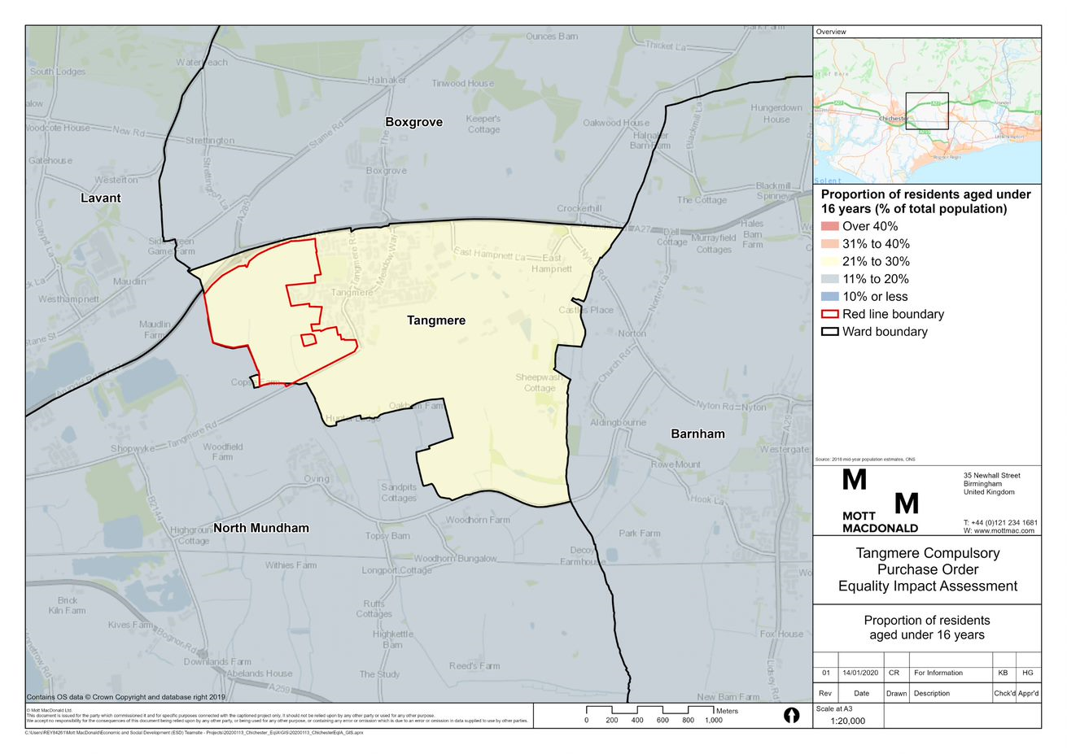

Source: Mott MacDonald, 2020

Figure 5.1 shows that the proportion of children aged under 16 within the RLB is the same as Tangmere at 21% to 30% of the total population. Tangmere has a higher proportion of this age group when compared to the surrounding area.

* + 1. Young people aged 16-24

Figure 5.2: Proportion of total population aged 16-24

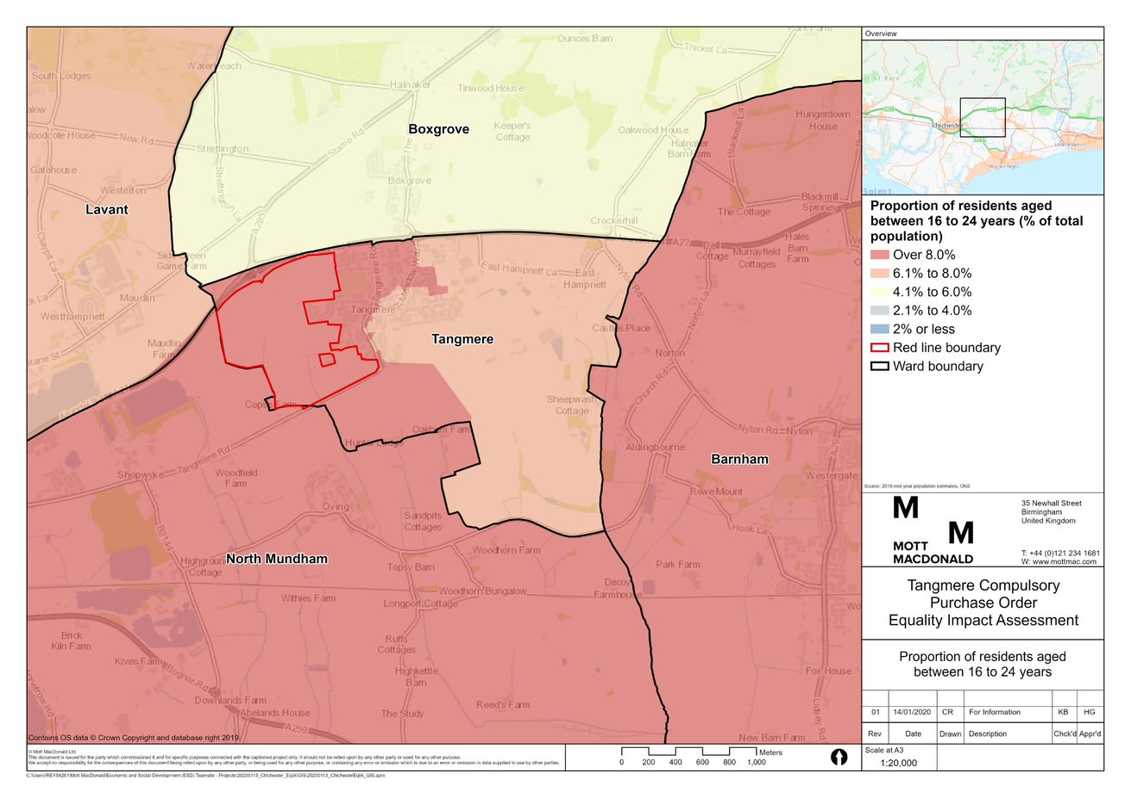

Source: Mott MacDonald, 2020

Figure 5.2 shows that the proportion of young people aged 16 to 24 within the RLB is over 8% of the total population. This is in line with the rest of west Tangmere, North Mundham and Barnham, but higher than east Tangmere, Boxgrove and Lavant.

* + 1. Older people aged 65 and over

Figure 5.3: Proportion of total population aged 65 and over

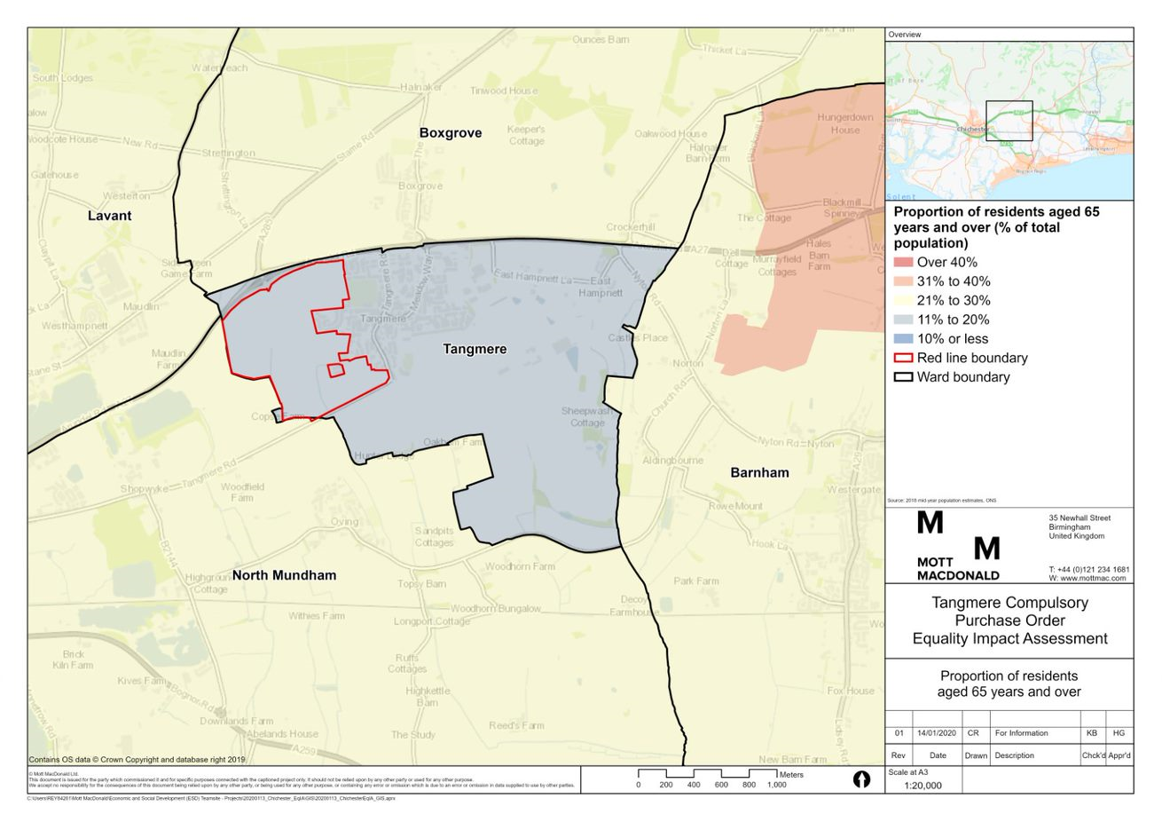

Source: Mott MacDonald, 2020

Figure 5.3 shows that the proportion of older people aged 65 and over within the RLB is between 11% and 20% of the total population. This is in line with Tangmere, but lower than Lavant, North Mundham, Barham and Boxgrove.

* 1. Disability

Figure 5.4: Proportion of total residents with a long-term health problem or disability

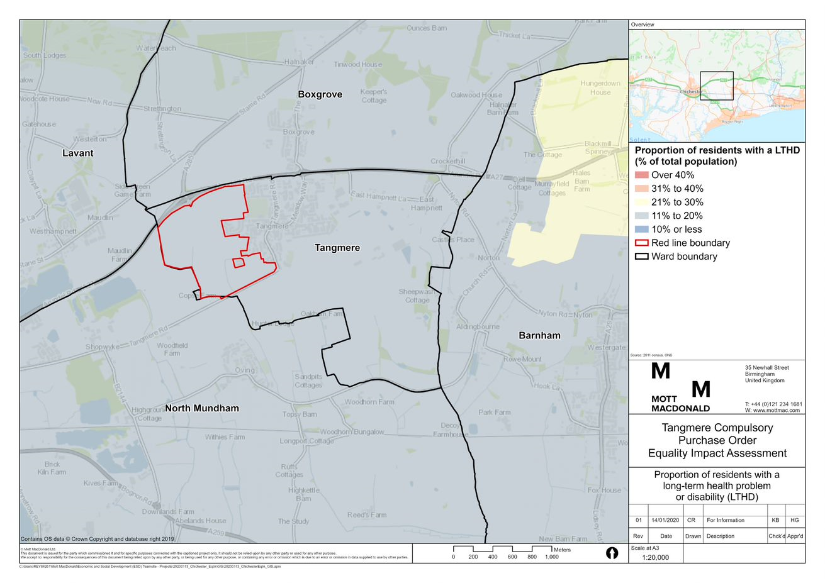

Source: Mott MacDonald, 2020

Figure 5.4 shows that the proportion of residents with a long-term health problem or disability is between 11% and 20% of the total population. This is in line with Tangmere and the wider surrounding area.

* 1. Race and ethnicity

Figure 5.5: Proportion of total residents who are from a Black, Asian or minority ethnic (BAME) background

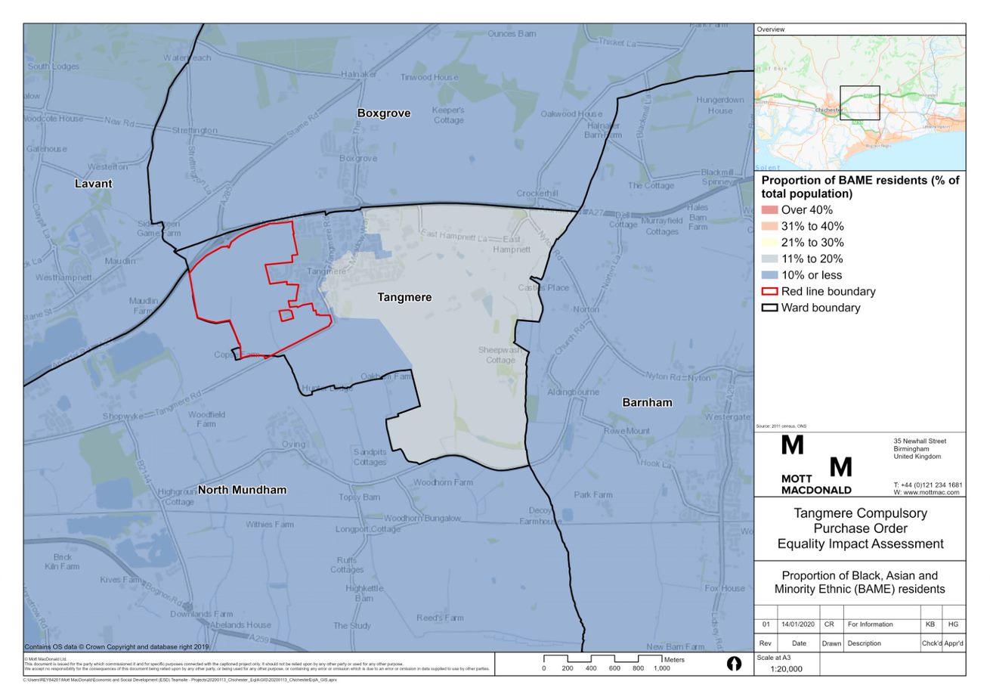

Source: Mott MacDonald, 2020

Figure 5.5 shows that the proportion of residents who are from a BAME background is 10% or less of the total population in the west of Tangmere. This is in line with surrounding areas.

|  |
| --- |
|  |

|  |
| --- |
|  |
| mottmac.com |

1. Chichester District Council (2015) ‘Chichester Local Plan: Key Policies 2014-2029’. Available at: <https://www.chichester.gov.uk/CHttpHandler.ashx?id=24759&p=0>
2. Tangmere Parish Council (2016) ‘Tangmere Neighbourhood Plan 2014-2029’. Available at: www.chichester.gov.uk/CHttpHandler.ashx?id=26728&p=0
3. 30% affordable housing make up is split 60:40 between affordable rent and intermediate (in line with the Tangmere Neighbourhood Plan) equating to 234 affordable rent homes and 156 intermediate homes. Affordable housing mix will be fixed as part of outline planning application.
4. Ministry of Housing, Communities & Local Government (2019) Guidance on Compulsory purchase process and The Crichel Down Rules
5. Legislation UK (1990) Town and Country Planning Act 1990
6. Chichester District Council (2015) ‘Chichester Local Plan: Key Policies 2014-2029’. Available at: <https://www.chichester.gov.uk/CHttpHandler.ashx?id=24759&p=0>
7. Chichester District Council (2015) ‘Chichester Local Plan: Key Policies 2014-2029’
8. Government Equalities Office (2018): ‘Trans People in the UK’. Available at: <https://assets.publishing.service.gov.uk/government/uploads/system/uploads/attachment_data/file/721642/GEO-LGBT-factsheet.pdf>
9. Source: Office for National Statistics (2017): Available at: <https://www.ons.gov.uk/peoplepopulationandcommunity/culturalidentity/sexuality/bulletins/sexualidentityuk/2016>
10. Leeds University Business School (2004): ‘The Economic and Social Impact of Redundancies from Corus and Allied Steel and Wire in Wales’
11. Gallo, W. T., Bradley, E. H., Falba, T. A., Dubin, J. A., Cramer, L. D., Bogardus Jr, S. T., & Kasl, S. V. (2004).’ Involuntary job loss as a risk factor for subsequent myocardial infarction and stroke: findings from the Health and Retirement Survey’. American journal of industrial medicine, 45(5), 408-416
12. World Health Organisation (2011): ‘Burden of disease from environmental noise Quantification of healthy life years lost in Europe’. Available at http://www.euro.who.int/__data/assets/pdf_file/0008/136466/e94888.pdf
13. World Health Organisation (2011): ‘Burden of disease from environmental noise Quantification of healthy life years lost in Europe’.
14. Scope (undated) ‘Challenging behaviour’, Available at <https://www.scope.org.uk/support/parents/challenging-behaviour/reasons>
15. Asthma UK, Pollution, available at: <https://www.asthma.org.uk/advice/triggers/pollution/>
16. British Heart Foundation (no date): ‘Air pollution and cardiovascular disease’. Available at: <https://www.bhf.org.uk/about-us/our-policies/preventing-heart-disease/air-pollution>
17. https://www.healthline.com/health/copd/age-of-onset
18. Royal College of Physicans (2016): ‘Every breath we take: the lifelong impact of air pollution’, available at: <https://www.rcplondon.ac.uk/projects/outputs/every-breath-we-take-lifelong-impact-air-pollution>
19. Department for Environmental Food and Rural Affairs (2013): ‘Guide to UK Air Pollution Information Resources’.
20. World Health Organisation (2011): ‘Burden of disease from environmental noise Quantification of healthy life years lost in Europe’. Available at <http://www.euro.who.int/__data/assets/pdf_file/0008/136466/e94888.pdf>
21. House of Commons Women and Equalities Committee (2017): ‘Building for Equality: Disability and the Built Environment’. Available at: https://publications.parliament.uk/pa/cm201617/cmselect/cmwomeq/631/631.pdf
22. Graham, H et al (2018): ‘The experiences of everyday travel for older people in rural areas: A systematic review of UK qualitative studies’. Available at: <https://www.sciencedirect.com/science/article/pii/S2214140518303827>
23. EY Foundation (2016): ‘The employment landscape for young people in the UK’. Available at: <https://www.ey.com/Publication/vwLUAssets/Employment_landscape_for_young_people_in_the_UK/$FILE/Employment%20landscape%20for%20young%20people%20in%20the%20UK%20-%20final%20report.pdf>
24. Joseph Rowntree Foundation (2015): ‘Ethnic Minority Disadvantage in The Labour Market’.
25. Joseph Rowntree Foundation, ‘Housing options and solutions for young people in 2020” (2012) Available at: <https://www.jrf.org.uk/report/housing-options-and-solutions-young-people-2020>
26. The Poverty Site (2017). See: http://www.poverty.org.uk/06/index.html
27. Marmot Review Team (2011) 'The Health Impacts of Cold Homes and Fuel Poverty'. London: Department of Epidemiology and Public Health, University College London.
28. The Housing and Ageing Alliance. (2013). ‘Policy Paper: Health, Housing and Ageing’
29. The Housing and Ageing Alliance. (2013). ‘Policy Paper: Health, Housing and Ageing’
30. Matt Barnes, Carl Cullinane, Sara Scott and Hannah Silvester, People living in bad housing – numbers and health impacts (2013) <https://england.shelter.org.uk/__data/assets/pdf_file/0010/726166/People_living_in_bad_housing.pdf>
31. Department for Business, Energy and Industrial Strategy (2018): ‘Fuel Poverty’*.* 
32. Scope (2018): ‘Out in the cold’. Available at: <https://www.barrowcadbury.org.uk/wp-content/uploads/2018/03/Out-in-the-cold-Scope-report.pdf>
33. National Children's Bureau (2016): 'Housing and the health of young children: Policy and evidence briefing for the VCSE sector'. Available at: https://www.ncb.org.uk/sites/default/files/field/attachment/Housing%20and%20the%20Health%20of%20Young%20Children.pdf
34. Runnymede Trust (2016) 'Ethnic Inequalities in London: Capital For All'. Available at: https://www.runnymedetrust.org/uploads/images/London%20Inequality%20report%20v3.pdf
35. Global Partnership for Education (no date): ‘Benefits of Education’. Available at: <https://www.globalpartnership.org/benefits-of-education>
36. Edward C. Melhuish, Institute for the Study of Children, Families & Social Issues, Birkbeck, University of London, ‘A literature review of the impact of early years provision on young children, with emphasis given to children from disadvantaged backgrounds’
37. Hartig, T. Mang, M. Evans, G.W (1991) Restorative effects of natural environment experiences; Hartig, T. Mitchell, R. DE VRIES, S. and Frumkin, H. (2014) Nature and health; Herzog, T. Black, A.M. Fountaine, K.A. Knotts, D.J (1997) Reflective and attentional recovery as distinctive benefits of restorative environments; Kaplan, R and Kaplan, S (1989) The experience of nature: A psychological perspective; Ulrich, R.S, Simmons R.F, Losito B.D, Fiority, E, Miles, M.A and Zeison, M. (1991) Stress recovery during exposure to natural and urban environments.
38. Dadvand, P. Wright, J. Martinez, D. Basagana, X. McEachan, R.R.C. Cirach, M. Gidlow, C.J. De Hoogh, K. Grazuleviciene, R. and Nieuwenhuijsen, M.J. (2014) Inequality, green spaces, and pregnant women: roles of ethnicity and individual and neighbourhood socioeconomic status.
39. Grazuleviciene, R. Dedele, A. Danileviciute, A. Venclovine, J. Grazulevicius, T. Andrusaityte, S. Uzdanaviticute, I and Nieuwenhuijsen, M.J. (2014) The Influence of Proximity to City Parks on Blood Pressure in Early Pregnancy; McEachan, R.R. Prady, S.L. Smith, G. Fairley, L. Cabieses, B. Gidlow, C. Wright, J Dadvand, P. Van Gent, D and Nieuwenhuijsen, M.J. (2016) The association between green space and depressive symptoms in pregnant women: moderating roles of socioeconomic status and physical activity.
40. The King’s Fund (2016): ‘Gardens and health: Implications for policy and practice’. Available at: <https://www.kingsfund.org.uk/sites/default/files/field/field_publication_file/Gardens_and_health.pdf>
41. Nation Children’s Bureau (2007): ‘Free Play in Early Childhood’
42. Nina Morris, ‘OPENspace: the research centre for inclusive access to outdoor environments’, 2003 Available at: <http://www.openspace.eca.ed.ac.uk/wp-content/uploads/2015/10/Health-Well-being-and-Open-Space-literature-review.pdf> and ‘Access to green and open spaces and the role of leisure services’ <https://www.kingsfund.org.uk/projects/improving-publics-health/access-green-and-open-spaces-and-role-leisure-services>
43. NHS (2018): ‘Exercise as you get older’. Available at: <https://www.nhs.uk/live-well/exercise/exercise-as-you-get-older/>
44. World Health Organization (no date): ‘Physical activity in older adults’. Available at: <http://www.who.int/dietphysicalactivity/factsheet_olderadults/en/> <http://www.who.int/dietphysicalactivity/factsheet_olderadults/en/>
45. Public Health England (2014): ‘Everybody active, every day’. Available at: <https://assets.publishing.service.gov.uk/government/uploads/system/uploads/attachment_data/file/374914/Framework_13.pdf>
46. Fields in Trust. (2018); Revaluing Parks and Green Spaces: ‘Measuring their economic and wellbeing value to individuals’
47. Public Health England (2016) Health matters: getting every adult active every day.
48. WHO, Health co-benefits of climate change mitigation -Transport sector, 2011
49. Health matters : air pollution <https://www.gov.uk/government/publications/health-matters-air-pollution/health-matters-air-pollution>
50. Verplanken B, Walker I, Davis A, Jurasek M. ‘Context change and travel mode choice: combining the habit discontinuity and self-activation hypotheses.’ (2008)
51. Flint E, Cummins S, Sacker A. ‘Associations between active commuting, body fat, and body mass index: population based, cross sectional study in the United Kingdom.’ Available at: <https://www.bmj.com/content/349/bmj.g4887>
52. We are Cycling UK (2017): ‘What is inclusive cycling?’. Available at: https://www.cyclinguk.org/blog/what-inclusive-cycling
53. Richardson, C., Faulkner, G., McDevitt, J., Skrinar, G., Hutchinson, D., Piette, J. (2005) Integrating physical activity into mental health services for persons with serious mental illness.
54. Transport for London (2011): 'What are the barriers to cycling amongst ethnic minority groups and people from deprived backgrounds?'. Available at: <http://content.tfl.gov.uk/barriers-to-cycling-for-ethnic-minorities-and-deprived-groups-summary.pdf>
55. EY Foundation (2016): ‘The employment landscape for young people in the UK’. Available at: <https://www.ey.com/Publication/vwLUAssets/Employment_landscape_for_young_people_in_the_UK/$FILE/Employment%20landscape%20for%20young%20people%20in%20the%20UK%20-%20final%20report.pdf>
56. Joseph Rowntree Foundation (2015): ‘Ethnic Minority Disadvantage in The Labour Market’.
57. My Community (2017): ‘Community hubs for local services’. Available at: <https://mycommunity.org.uk/help-centre/resources/local-services/community-hubs/>
58. Age UK (2018): ‘All the Lonely People’. Available at: <https://www.ageuk.org.uk/globalassets/age-uk/documents/reports-and-publications/reports-and-briefings/loneliness/loneliness-report_final_2409.pdf>
59. Scope (2017): ‘Nearly half of disabled people chronically lonely’. Available at: <https://www.scope.org.uk/press-releases/nearly-half-of-disabled-people-chronically-lonely>
60. Merton Council (2018): ‘The Merton Story – health and wellbeing in Merton in 2018’. Available at: <https://www2.merton.gov.uk/Merton%20Story%20FINAL_June_2018.pdf>
61. Countryside, ‘Tangmere Strategic Development Location – Masterplan Document’ (2019). Available at: <https://www.countryside-tangmere.co.uk/downloads/masterplan-document.pdf>
62. Accessible homes would be required to meet Building Regulation requirement M4 (3) ‘wheelchair user dwellings’, i.e. a home is designed to be wheelchair accessible, or easily adaptable for residents who are wheelchair users.