

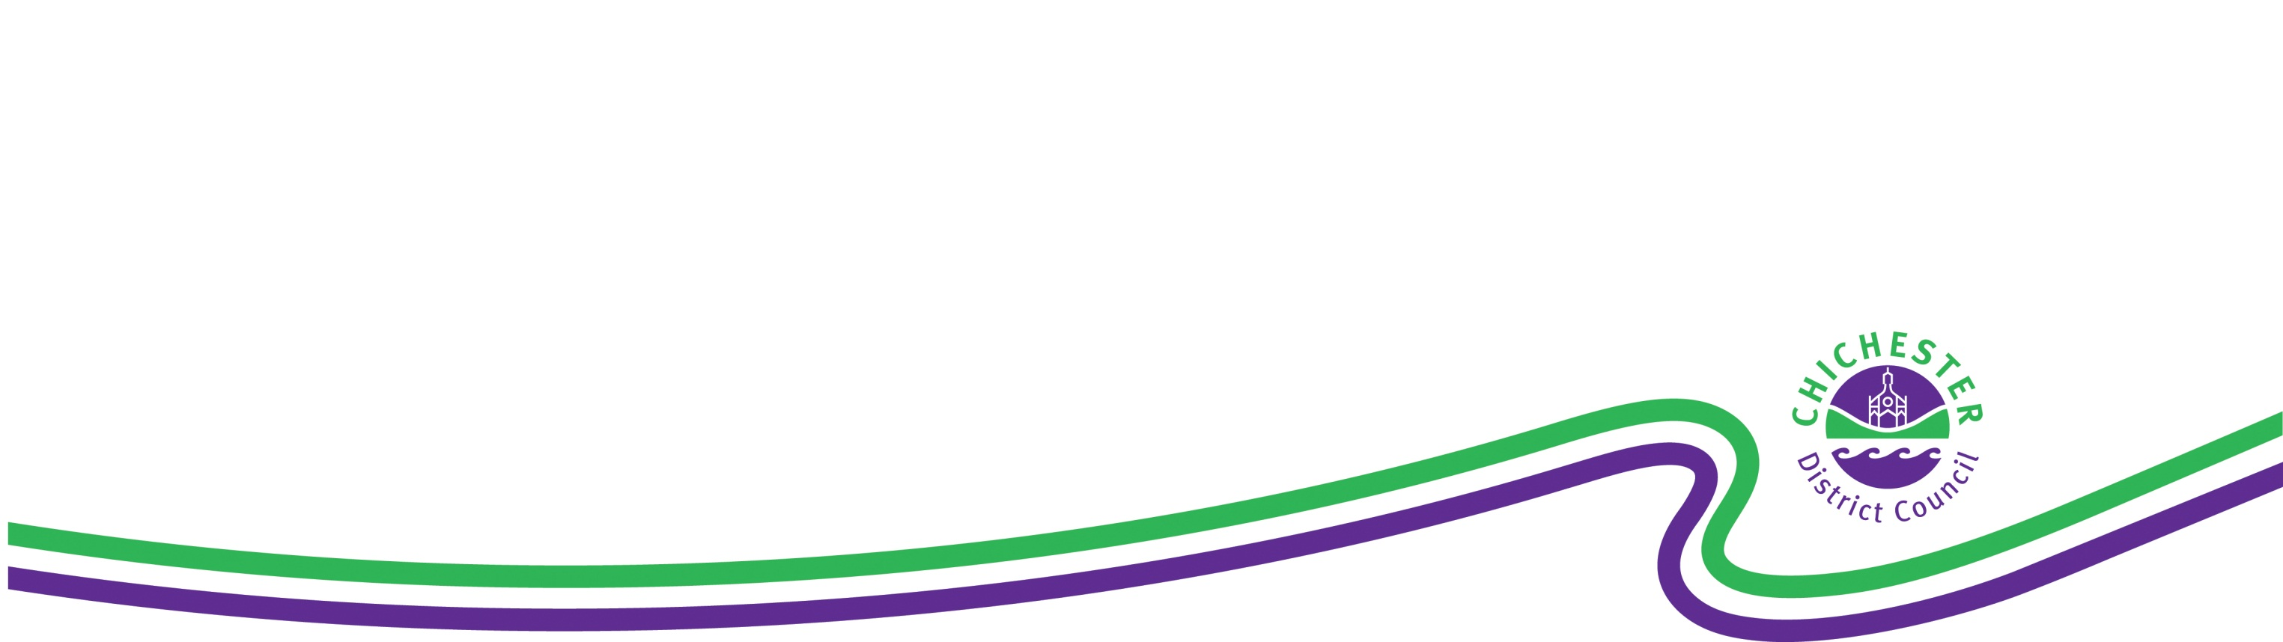

**SELSEY PARISH**

**NEIGHBOURHOOD PLANNING**

**REFERENDUM**

**INFORMATION FOR VOTERS**

**About this booklet**

On 6 May 2021, there will be a referendum on a neighbourhood development plan for your area. This booklet explains more about the referendum that is going to take place and how you can take part in it. In this booklet you can find out about:

• The referendum and how you can take part

• The neighbourhood area

• The neighbourhood plan

• The development plan [of which neighbourhood plans are part]

**Referendum on the Neighbourhood Plan**

A referendum asks you to vote ‘yes’ or ‘no’ to a question. For this referendum you will receive a ballot paper with this question:

*Do you want Chichester District Council to use the neighbourhood development plan for Selsey Parish to help it decide planning applications in the neighbourhood area?*

**How do I vote in the referendum?**

You vote by putting a cross (X) in the ‘Yes’ or ‘No’ box on your ballot paper. Put a cross in only **one** box or your vote will not be counted.

If more people vote ‘yes’ than ‘no’ in this referendum, then Chichester District Council will use the Neighbourhood Development Plan to help it decide planning applications in Selsey.

The Neighbourhood Development Plan once adopted will then become part of the Development Plan. In the Chichester District Council Local Planning Authority area the development plan currently consists of the adopted Chichester Local Plan: Key Principles 2014-2029 adopted July 2015, the adopted Site Allocation Development Plan Document 2014-2029, the Joint West Sussex Minerals Local Plan adopted July 2018; and the West Sussex Waste Local Plan (April 2014).

If more people vote ‘no’ than ‘yes’, then planning applications will be decided without using the Neighbourhood Development Plan as part of the Development Plan for the local area.

**What is Neighbourhood Planning?**

Neighbourhood planning aims to help local communities play a direct role in planning the areas in which they live and work.

A community can prepare a neighbourhood plan. This plan can show how the community wants land to be used and developed in its area.

**What is a neighbourhood area?**

A neighbourhood area can cover single streets or large urban or rural areas. The boundaries of a neighbourhood area are put forward by:

* Parish councils
* A neighbourhood forum (a group of at least 21 people in areas without parish councils)

In Selsey, the boundary of the neighbourhood area was determined by Chichester District Council and is identical to the parish area of Selsey.

**Who can prepare a Neighbourhood Plan?**

Neighbourhood plans are prepared by town or parish councils, or neighbourhood forums. In this case, the Selsey Neighbourhood Development Plan was prepared by Selsey Town Council.

**What is a Development Plan?**

In England, planning applications are determined by local planning authorities in accordance with the Development Plan. A Development Plan is a set of documents that set out the policies for the development and use of land across the entire local authority area. Within the area of Chichester District outside the South Downs National Park, the local planning authority is Chichester District Council.

**Neighbourhood Planning in Selsey**

The Referendum area is identified on the map overleaf as the parish area of Selsey Parish Council and is identical to the area which has been designated as the Selsey Neighbourhood Development Plan area.

**Who is the Planning Authority?**

The planning authority for Selsey Parish is Chichester District Council. Chichester District Council is the lead authority for Neighbourhood Planning matters in the parish, including Neighbourhood Planning Referendums.

**MAP OF SELSEY PARISH**

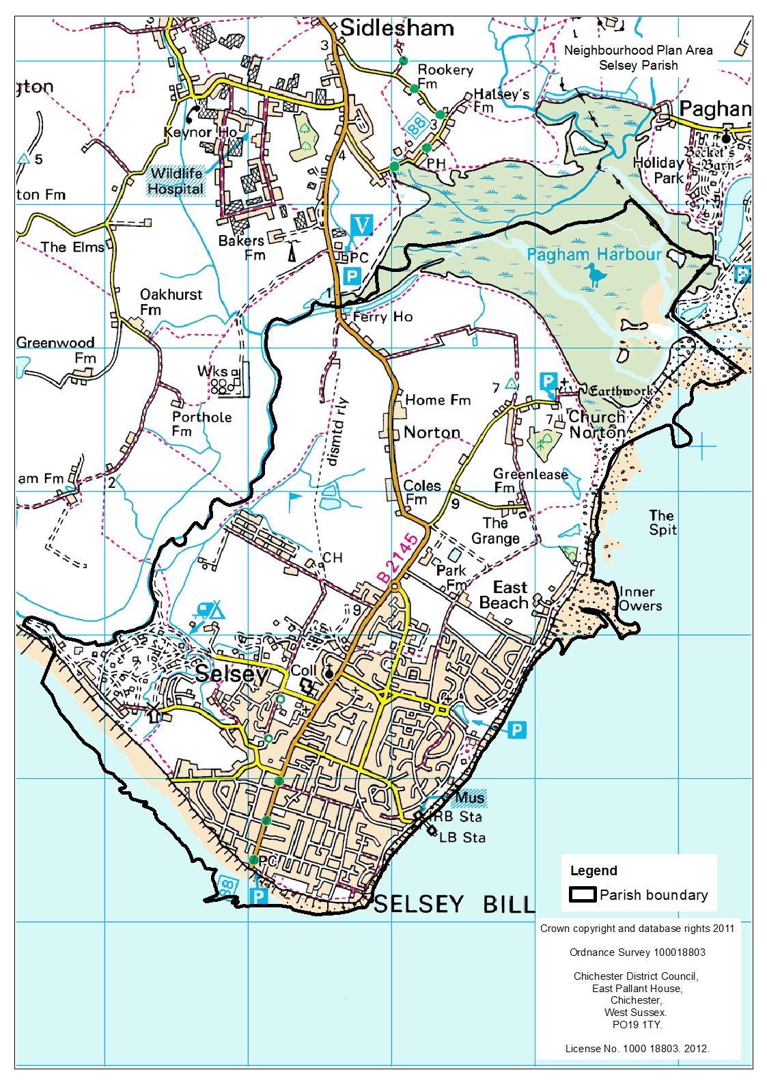

**Referendum expenses**

Expenses can be incurred by an individual or body during the period of the Referendum for referendum purposes.

The Referendum expenses limit that will apply in relation to this Referendum is £2875.71. The number of persons entitled to vote in the Referendum by reference to which the limit has been calculated is 8707.

**Specified documents**

A copy of the specified documents, that is the documents listed, may be inspected at:

In relation to the on-going circumstances of Covid 19 the following arrangements have been made for access to the specified documents, taking account of the need to minimise individuals’ interaction and to avoid encouraging any more interaction than required.

A tiered approach is set out as indicated below:

1. All documents are available on the CDC website and, in the first instance, people are encouraged to access the documents online

[www.chichester.gov.uk/neighbourhoodplan](http://www.chichester.gov.uk/neighbourhoodplan) under the entry for Selsey.

1. Second, a copy of the documents can be sent or made available to view by contacting Selsey Town Council on 01243 605803 or by email [enquiries@selseytowncouncil.gov.uk](mailto:enquiries@selseytowncouncil.gov.uk)
2. A copy of the various documents can be sent by contacting the CDC customer service team by phone on 01243 785166 or by email [contact@chichester.gov.uk](mailto:contact@chichester.gov.uk)
3. A copy of all the documents will be made available at the CDC offices at East Pallant House and will be available to view on request through making an appointment by contacting the customer service team 01243 785166 or by email [contact@chichester.gov.uk](mailto:contact@chichester.gov.uk)

The specified documents are the:

• Post Examination version of Selsey Neighbourhood Plan

• Report of the independent Examiner

• Summary of the representations submitted to the independent Examiner

• Statement by the local planning authority that the draft plan meets the basic conditions and the requirements of sections 38A & B of the Planning and Compulsory Purchase Act 2004 (*Decision Statement 7 July 2020*)

• Habitats Regulations Assessment (HRA) Screening Matrix and Appropriate Assessment Statement for Selsey Neighbourhood Plan

• Environmental Report for Strategic Environmental Assessment (SEA) of Selsey Neighbourhood Plan (October 2019)

All the above documents can be viewed on Chichester District Council’s website at

[www.chichester.gov.uk/neighbourhoodplan](http://www.chichester.gov.uk/neighbourhoodplan) under the entry for Selsey.

• Statement that sets out general information as to town and country planning including neighbourhood planning and the referendum *(this is included in this Information Statement)*

**Can I vote?**

You can vote in the referendum if you live in the Selsey Parish area and:

• you are registered to vote in local council elections; and

• you are 18 years of age or over on 6 May 2021

The referendum will be conducted based on procedures which are similar to those used at local government elections.

**Ways of voting**

There are three ways of voting:

**In person on 6 May 2021:**

• At your local polling station. It is easy and a member of staff will always help

if you are not sure what to do

• You will receive a poll card confirming your polling station for this referendum

• Polling stations are open from 7am to 10pm

**By post:**

• If you have a postal vote already, you will receive a poll card confirming this

• If you want to vote by post, you will need to complete an application form and send it to the Electoral Registration Officer to arrive by 5pm on 20 April 2021 at this address:

Chichester District Council

East Pallant House

Chichester

PO19 1TY

• Postal votes can be sent overseas but you need to think about whether you

will have time to receive and return your completed postal vote by 6 May.

• You should receive your postal vote about a week before polling day. If it

doesn’t arrive in time, you can ask for a replacement up to 5pm on 6 May by contacting our Helpline on 01243 521010.

**By proxy:**

• If you have a proxy vote already, you will receive a poll card confirming this

• If you can’t get to the polling station and don’t wish to vote by post, you may

be able to vote by proxy. This means allowing somebody that you trust to vote

on your behalf

• If you want to vote by proxy, you will need to complete an application form and send it to the Electoral Registration Officer to arrive by 5pm on 27 April 2021 at this address:

Chichester District Council

East Pallant House

Chichester

PO19 1TY

• When you apply for a proxy vote, you must say why you cannot vote in person

• Anyone can be your proxy as long as they are eligible to vote and are willing

to vote on your behalf. You will have to tell them how you want to vote.

Postal and proxy vote application forms are available from our Helpline on 01243 521010 or by emailing elections@chichester.gov.uk.

**Am I registered to vote?**

If you’re not registered, you won’t be able to vote. You can check if you are registered by calling our Helpline on 01243 521010.

If you are not registered to vote, you can go online to [www.gov.uk/register-to-vote](http://www.gov.uk/register-to-vote) with your national insurance number by Midnight 19 April. If you do not have access to the internet please call our helpline on 01243 521010.

**How to find out more:**

• Further general information on neighbourhood planning is available at: www.chichester.gov.uk

• For queries about planning issues and neighbourhood planning in general,

please contact the Chichester Planning Policy Team on 01243 534594

• For more information about voting and the arrangements for this referendum,

please contact our Helpline on 01243 521010 or email: elections@chichester.gov.uk