A27 Stockbridge Roundabout and Link Road

Stage 1 Junction Assessment

Document Control Sheet

Project Name: A27 Stockbridge Roundabout and Link Road

Project Ref: 49550

Report Title: Stage 1 Junction Assessment

Doc Ref: 001

Date: November 2020

|  |  |  |  |  |
| --- | --- | --- | --- | --- |
|  | Name | Position | Signature | Date |
| Prepared by: | Joe House | Principal Engineer |  | Nov 2020 |
| Reviewed by: | Dave Cope | Principal Transport Planner |  | Nov 2020 |
| Approved by: | Phil Brady | Director |  | Nov 2020 |
| For and on behalf of Stantec UK Limited | | | | |

|  |  |  |  |  |  |
| --- | --- | --- | --- | --- | --- |
| Revision | Date | Description | Prepared | Reviewed | Approved |
| A | 20/11/2020 | Update of text from CDC’s comments | JH | DC | PB |
| B | 04/02/2021 | Amended within WSCC comments | JH | DC | PB |
| C | 25/03/2021 | Final Issue for CDC | JH | DC | PB |

This report has been prepared by Stantec UK Limited (‘Stantec’) on behalf of its client to whom this report is addressed (‘Client’) in connection with the project described in this report and takes into account the Client's particular instructions and requirements. This report was prepared in accordance with the professional services appointment under which Stantec was appointed by its Client. This report is not intended for and should not be relied on by any third party (i.e. parties other than the Client). Stantec accepts no duty or responsibility (including in negligence) to any party other than the Client and disclaims all liability of any nature whatsoever to any such party in respect of this report.

Contents

Executive Summary 2

1 Introduction 4

1.1 Overview 4

1.2 Stage 1 Junction Assessment 4

1.3 Background 4

2 Stage 1 – Part A: Junction Overview 9

2.1 Existing Conditions 9

2.2 Local Plan Proposal Mitigation 10

2.3 Alternative Mitigation 10

3 Stage 1 – Part B: Scenario Testing 12

3.1 Assessment Scenario 12

3.2 Modal Shift 12

4 Stage 1 – Part C: Modelling Outcomes 14

4.1 Overview 14

4.2 Junction Assessment Results 14

5 Stage 1 – Part D: Modelling Summary and Conclusion 16

5.1 Summary 16

5.2 Additional Assessments Prior to Stage 2 17

5.3 Conclusion 17

Figures

Figure 1.1: HE Optimum Scheme 5

Figure 1.2: HE Alternate Scheme 5

Figure 1.3: West / South Connection (Without SLR) 7

Figure 1.4: West / South Connection (With SLR) 7

Figure 1.5: Proposed Stockbridge Link Road Design 8

Figure 2.1: Existing A27 Stockbridge Roundabout 9

Figure 2.2: Proposed A27/Stockbridge Road Signalised Crossroads 10

Figure 2.3: Proposed A27/Stockbridge Road Signalised Roundabout 11

Figure A.1: 2014 and 2035 Traffic Flows (existing roundabout) 19

Figure A.2: 2035 LP Mitigation (Signalised Crossroads with banned right turns from A27) 19

Figure A.3: 2035 LP Mitigation (Signalised Roundabout) 19

Figure B.1: AM Queue and Delay Results 22

Figure B.2: PM Queue and Delay Results 23

Tables

Table B.1: AM Peak Period Assessment Results 21

Table B.2: PM Peak Period Assessment Results 21

Appendices

Appendix A Traffic Flow Output

Appendix B Junction Assessment Results

Appendix C Existing Junction Assessment Outputs

Appendix D Proposed Signalised Crossroad Junction Assessment Outputs

Appendix E Proposed Signalised Roundabout Junction Assessment Outputs

This page is intentionally blank

# Executive Summary

This report was commissioned by Chichester District Council to inform the emerging Local Plan.  In the absence of a national scheme to deal with the known issues on the A27 at Chichester, the Local Plan must demonstrate that in the meantime, development proposed in the Plan will not have unacceptable transport impacts.

The Preferred Approach Plan, published in December 2018, was accompanied by the document *Transport Study of Strategic Development Options and Sustainable Transport Measures* prepared by PBA (now Stantec). That document set out a package of measures to deal with the transport impacts of the level of growth envisaged in the Preferred Approach Plan, including a Stockbridge Link Road.

Concerns over the environmental and financial cost of the package, and the Stockbridge Link Road in particular, led to the commissioning of Stantec to undertake work to consider an alternative approach to the link road.  The brief asked for work to “*identify feasible and deliverable mitigation measures to address the potential capacity and safety impacts on the highway. This should take into account existing plans and proposals, established or emerging, and the potential for managing traffic demand including proactive promotion (physical and behavioural) of modal shift to non-car based travel in appropriate areas”.*  This study sets out the findings of that work.

The alternative approach outlined in this document was identified with reference to a number of factors, including the constraints at each A27 junction, the need to facilitate access to and from the Manhood Peninsula, and the need for a scheme which could feasibly be funded and delivered. Other potential measures, such as grade separation or an alternative approach at Whyke Roundabout were not taken forward given likely issues with deliverability and efficacy.

The measure promoted at the junction in the Local Plan Review sought to reduce the level of queuing and delay on the A27 approach to the Stockbridge Road Roundabout. In the Local Plan the proposals were for the conversion of the junction into a signalised crossroads with banned right turn movements from the A27. The alternative mitigation option at the junction is for a signalised ‘hamburger’ roundabout configuration permitting right turning movements and thus could be delivered in isolation from the Stockbridge Link Road (SLR).

The modelling presented in this report utilises the 2035 Reference Case developed during the previous Local Plan which will be reviewed before the Plan is finalised but at present is the most recent set of modelling outputs available and it is considered this is a reasonable basis for carrying out this assessment.

The main objective of the junction model review was to understand the impacts of removing the SLR from the Local Plan scenario and whether the alternative signalised roundabout design can still mitigate the Local Plan impacts.

The assessment has shown that the identified alternative improvements at the Stockbridge Road Roundabout (comprising a signalised roundabout) on its own is not sufficient to mitigate the effects of proposed Local Plan development. Although a new signalised roundabout is an improvement on the current roundabout junction, without the SLR the signalised roundabout cannot accommodate the level of reassignment onto the A27.

It should be noted that this report represented the outcomes of a technical piece of work undertaken by Stantec Consultants on behalf of Chichester District Council to inform the production of the emerging Chichester Local Plan.  The report was subject to technical comment from both Highways England and West Sussex County Council.  Whilst Chichester District Council and the Highway Authorities are content with the technical findings of this report, this document does not set out the Council’s (or Highway Authorities) policy on this matter, which will be determined through the Chichester Local Plan and other documents.

This report was commissioned in 2019 and work was undertaken as follows:

* Commission and investigation of traffic impacts without Stockbridge Link Road – October to December 2019
* Identification of alternative, and initial discussion of junction design with highway authorities December 2019 to February 2020
* Agreeing further work, refined design and modelling February 2020 to September 2020
* Initial briefing for Chichester District Council – September 2020
* Production of this technical report, sharing with highway authorities for technical comment – September 2020 – March 2021
* Presentation of report to Chichester District Council - March 2021

# Introduction

## Overview

* + 1. This report has been prepared by Stantec on behalf of Chichester District Council to provide a review of the operational performance of the A27 Stockbridge Roundabout and its inter-dependencies with the proposed Stockbridge Link Road (SLR).
    2. A transport study was undertaken to inform the Chichester Local Plan Review (LPR) 2016-2035/36. This study identified a series of suitable mitigation measures deemed necessary to mitigate the effects of development proposed in the Local Plan.
    3. One of the key junctions that mitigation was proposed at was the A27 Stockbridge Roundabout. This junction currently operates as a large roundabout. However the Local Plan measures at the junction were for the conversion of the existing roundabout into traffic signals crossroad with dual carriageway for the A27 and banned right turns from the A27 onto Stockbridge Road.
    4. The transport study also identified the need for a new link road, referred to as the Stockbridge Link Road (SLR), which connected the A27 at the Fishbourne roundabout to the A286 Birdham Road.
    5. The full assessment of the A27 Stockbridge Roundabout and Link Road is to be carried out across four stages of work, as per the following;
* **Stage 1: Localised Junction assessments**
* Stage 2: VISSIM microsimulation
* Stage 3: AQ Impact
* Stage 4: Costings
  + 1. This report presents the assessment and findings from Stage 1 only. Following the completion of Stage 1, Stages 2-4 outlined above were not proceeded with for the reasons set out in Section 5 of this report.

## Stage 1 Junction Assessment

* + 1. The purpose of this assessment is to understand the implications on the road network’s operational performance at the A27 Stockbridge Roundabout should the SLR not be brought forward as a mitigation measure.
    2. To carry out this assessment localised junction assessment models have been prepared for the proposed Local Plan mitigation junction layout and an alternative signalised roundabout arrangement. Both junction forms have been assessed against various modelling scenarios with and without the SLR so as to identify the impact of the different junction types and impact of the SLR.

## Background

Highways England Options Consultation

* + 1. In December 2014, the government published its first Roads Investment Strategy which included a commitment to improving the A27 Chichester Bypass. During 2016/17, Highways England (HE) undertook a consultation on a number of options for improvement schemes to the A27 Chichester Bypass.
    2. Five options were developed by HE of which two options (Options 2 and 3) were identified to be considered in further detail, they include:
* Option 2: HE Optimum Scheme (Grade Separation, Bridges, banned movements and new link) as illustrated in Figure 1.1.
* Option 3: HE Alternate Scheme (Hamburger junctions and banned movements) as illustrated in Figure 1.2.

Figure 1.1: HE Optimum Scheme

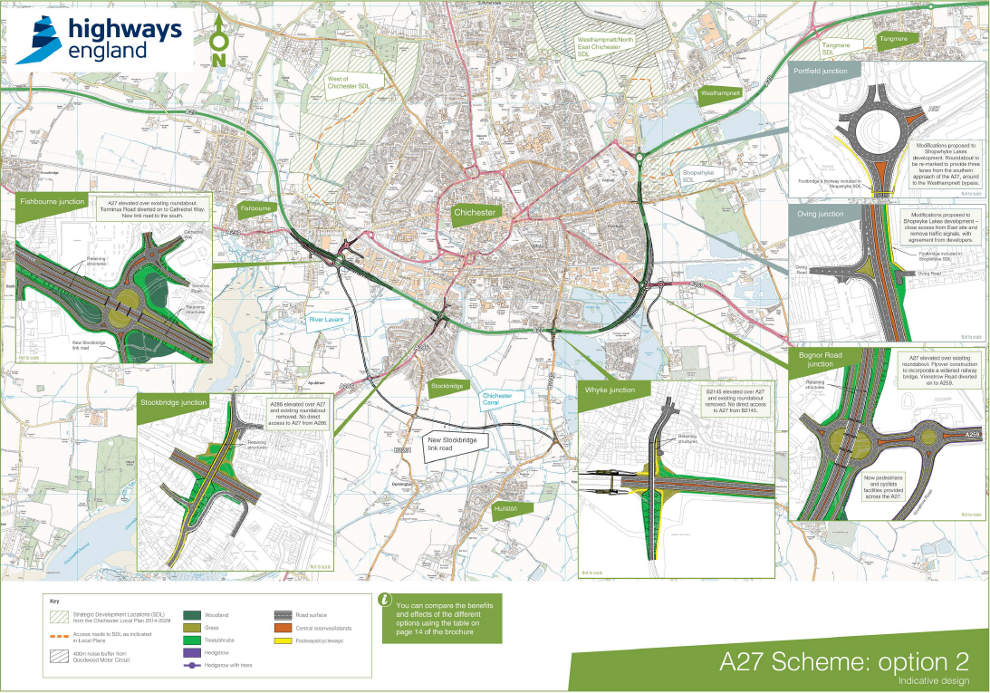

Figure 1.2: HE Alternate Scheme

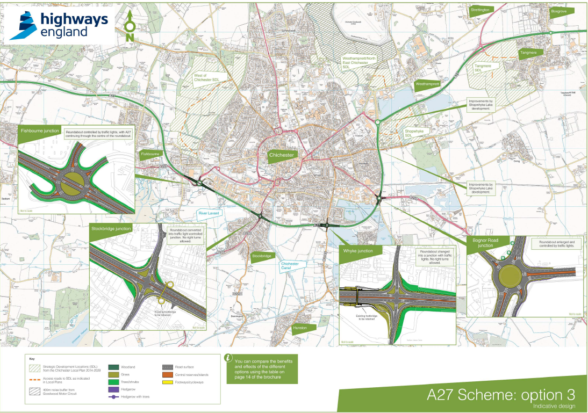

* + 1. The responses received during the consultation highlighted the lack of community support for the options as presented by Highways England. By February 2017, Highways England had been instructed by the Secretary of State to no longer progress the project. Highways England formally withdrew their funding for the online A27 improvements schemes in 2017.
    2. Alternative routes for funding where investigated; seeing whether the future A27 Chichester Bypass schemes could be requested to be included in Highways England’s second Route Investment Strategy (RIS2). This again was not forthcoming, and the 2029 Local Plan schemes were not implemented.

Chichester Local Plan

* + 1. The Chichester Local Plan: Key Policies 2014-2029 was adopted on 14th July 2015. The Plan set out an overarching framework for the future of the plan area to 2029 and comprises a long-term spatial vision, strategic objectives and spatial strategy. Although the Local Plan was adopted, the examination Inspector required the Council to undertake a review within 5 years to ensure sufficient housing would be planned to meet the longer-term needs of the area. As such, there was a requirement to review the current adopted Local Plan for the period up to 2035. Since then, the Plan period has been extended and it is currently anticipated that the new Chichester Local Plan will run to 2037. The next iteration of the Plan will be informed by a new set of transport modelling outputs, but for the purposes of this paper an end date of 2035 has been used.

Chichester Local Plan Review (LPR) 2016-2035/36

* + 1. To inform the 2035 Local Plan Review, Peter Brett Associated (now Stantec) prepared a Transport Study of Strategic Development Options and Sustainable Transport Measures. The peak hour modelling undertaken to support this review sought to develop future forecasts and undertake testing in order to understand the network impacts of the potential development scenarios considered for the Local Plan Review to 2035 with a contingency to 2036.
    2. This review identified the need for potential interventions on the highway network with the city centre to mitigate the anticipated levels of development, as well as a package of improvements to several junctions on the A27 Chichester Bypass.
    3. In addition to the 19 junctions that were identified as needing improvements, the transport study also identified the need for a new link road to be provided between the A27 Fishbourne roundabout and the Birdham Road to the southeast. The Stockbridge Link Road is a scheme that was previously considered in part by Highways England within proposals for highway improvements for the wider strategic highway network.
    4. The two primary benefits that the SLR was outlined to provide were:
* The link provides an alternate route to the south of Chichester serving the coast. This allows turning restrictions at other junctions along the A27 such as at Stockbridge and Whyke to be considered, which would minimise the turning traffic conflicting with the A27 through traffic; and
* The Local Plan Review has the potential to accommodate a significant proportion of its employment requirement in the area south of the A27 between Fishbourne and Stockbridge Roundabouts. Therefore, this link could also become the primary access for this land use to and from the A27. It should be noted that following the publication of the *Transport Study of Strategic Development Options and Sustainable Transport Measures* study in 2018, West Sussex County Council as owner of the land has stated that it does not consider this land to be deliverable for employment or housing uses in the first five years of the Plan period and therefore the District Council is considering alternative approaches to delivering land for those uses elsewhere
  + 1. Figure 1.3 and Figure 1.4 illustrate the without the SLR and with the SLR options respectively, for the west to south connection between the A27 Fishbourne Roundabout to Birdham Road. The mitigation scheme proposed for the Stockbridge Link Road is shown in Figure 1.5.

Figure 1.3: West / South Connection (Without SLR)

Figure 1.4: West / South Connection (With SLR)

Figure 1.5: Proposed Stockbridge Link Road Design

# Stage 1 – Part A: Junction Overview

## Existing Conditions

* + 1. The A27 Chichester Bypass is a section of the A27 trunk road passing to the south of Chichester. The bypass is approximately five and a half kilometres long and is part of the strategic route along the South Coast of England. This section of the A27 has five at grade roundabout junctions comprising Fishbourne, Stockbridge, Whyke, Bognor Road and Portfield, with a further signalised crossroad at Oving Road. Congestion is known to occur on a daily basis during peak periods resulting in delays to traffic as well as being a constraint on the local economy.
    2. For this study, the focus of the assessment work and impact of the SLR is on the A27 Stockbridge Roundabout.
    3. The Stockbridge Roundabout is a large at grade 4 arm junction along the strategic A27 Chichester Bypass and connects with the A286 Stockbridge Road to the north and south. Both of the A27 approaches provide 3 lanes upon entry to the junction with the Stockbridge Road arms providing single lane approaches with flared two lane entries. Figure 2.1 illustrates the existing junction layout.

Figure 2.1: Existing A27 Stockbridge Roundabout

* + 1. The junction is located on the city’s southern boundary. Stockbridge Road to the north gives access to the city centre city, railway station, Chichester Gate Leisure Park and The Terminus Road industrial park. Stockbridge Road to the south of the roundabout provides the localised access to the Stockbridge area and also one of the main routes to the coastal regions of West and East Wittering, Bracklesham Bay and Selsey.

## Local Plan Proposal Mitigation

* + 1. There are several constraints at the location of the junction which influenced the development of the mitigation put forward, including landownerships, statutory utilities apparatus and tree/hedgerows. The proposed junction changes that formed part of the Chichester Local Plan Review was for the conversion of the existing roundabout into a traffic signals crossroad with dual carriageway for the A27 and banned right turns from the A27 onto Stockbridge Road, both to the north and south.
    2. The proposed signal junction also included new left turn slip lanes on the A27 approaches and exits. Figure 2.2 illustrated the junction proposals that were considered within the Chichester Local Plan Review.

Figure 2.2: Proposed A27/Stockbridge Road Signalised Crossroads

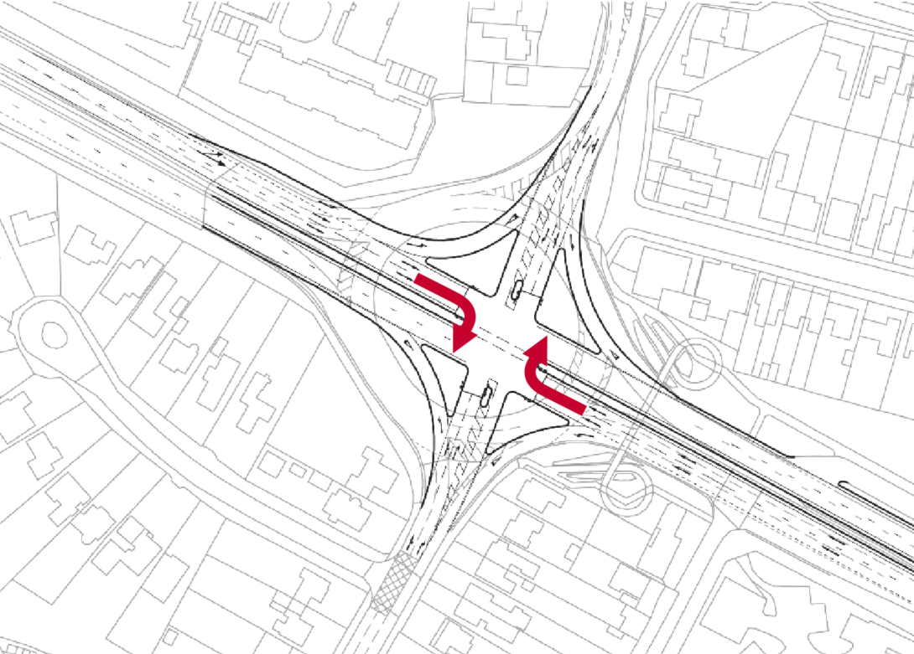

* + 1. The banned right turn movement from the A27 (illustrated by the red arrows) were introduced to reduce the delay to the through traffic on the A27 Chichester Bypass. These design principles of banning the right turns from the A27 were also on the mitigation measures proposed at the A27 Whyke junction to the east along the bypass. Running these banned movements in the traffic modelling effectively diverted trips on the A27 seeking to travel south to use alternative routes, which the inclusion of the SLR proposals looked to support.
    2. In removing the right turn movements from the A27 at these junctions, the proposed SLR plays a key role in accommodating the diverted trips travelling south towards the coast.

## Alternative Mitigation

* + 1. In the scenario whereby the SLR isn’t brought forward, the A27 Stockbridge junction would need to be altered to permit right turning movement to maintain access from the A27 (west) to the south.
    2. To achieve this there is an alternative mitigation option which comprises of a signalised ‘hamburger’ roundabout configuration. This arrangement would offer the ability to still allow a right turn movement from the A27 west (green arrow) and but still ban the right turn from the A27 east (red arrow) towards Stockbridge Road (north).

Figure 2.3: Proposed A27/Stockbridge Road Signalised Roundabout

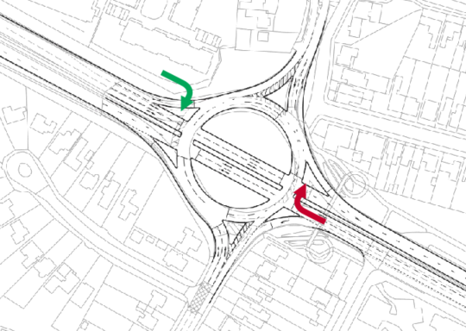

* + 1. This principles of the scheme have been provisionally reviewed by Highways England and West Sussex County Council with provisional agreement to progress with the design and junction assessment review.
    2. The measure promoted as part of the junction arrangement in the Local Plan Review sought to reduce the level of queuing and delay on the A27 approach. As such this is one of the primary assessment factors to understand the impact at the junction if the SLR is removed.

# Stage 1 – Part B: Scenario Testing

## Assessment Scenario

* + 1. To understand the impact that removing the SLR has at the Stockbridge Roundabout a total of 6 scenarios have been modelled.

|  |  |  |  |
| --- | --- | --- | --- |
| Scenario No. | Scenario Name | Junction Layout | SLR |
| *-* | *2014 Base Year* | *Existing* | *No* |
| 1 | Scenario 1: 2035 Reference Case  (excluding LP mitigation) | Existing | No |
| 2 | Scenario 2: 2035 LP Mitigation (Signalised crossroads) Without SLR | Signalised Crossroads | No |
| 3 | Scenario 3: 2035 LP Mitigation (Signalised crossroads) With SLR | Signalised Crossroads | Yes |
| 4 | Scenario 4: 2035 Signalised Stockbridge Roundabout - Without SLR | Signalised Roundabout | No |
| 5 | Scenario 5: 2035 Signalised Stockbridge Roundabout - With SLR | Signalised Roundabout | Yes |

* + 1. The available Saturn model has a base year of 2014 which essentially provides an indication of the current operation at the Stockbridge roundabout. Using this base model, the 5 forecast assessment scenarios have been generated and run for a 2035 future year to align with the Local Plan period.
    2. Modelling scenarios included a ‘2035 Reference Case’ that was developed during the previous Local Plan update but will be reviewed as part of the latest round of Local Plan review modelling, although is unlikely to result in a significant impact on the results. This scenario presents conditions without the Local Plan development and Local Plan Scenarios which include Local Plan development traffic.
    3. Based on the different junction configurations and SLR inclusion or not, turning movements have been extracted for the roundabout for the AM and PM peak hours which are provided at Appendix A.

## Modal Shift

* + 1. The current methodology uses a predict and provide forecast, which looks to provide additional or new infrastructure to accommodate the future demands of any local plan process. This is based on industry guidelines, which inevitably therefore focuses on car based schemes.
    2. With the climate emergency, air quality and noise issues there is a movement to predict and ‘manage’, thus looking to manage the current infrastructure and promote modal shift to non-car based trips. This is an emerging alternative approach, but it has to be linked to practical and viable sustainable transport improvements which will not only generate the modal switch but maintain the switch into the future.
    3. A key point with respect to non-car based trips is that often many of them are linked to walking, cycling and even public transport and are localised journeys, which remove trips from within urban areas. Therefore, they do not promote regional or longer distance journeys, which in the case of Chichester’s Local Plan is a material consideration given the nature of the A27.
    4. Highways England have to be satisfied that the local plan methodology and proposed mitigation, whether physical infrastructure or new/enhanced non-car based schemes, will accommodate the level of growth forecast.
    5. Options such as park and rides, increased train services, new bus services etc would all support a higher shift of regional trips to non-car based modes, but the quantum of modal shift needs to be credible and therefore unlikely to have a material impact on the level of through traffic.
    6. The current COVID-19 situation has raised an alternative consideration, in that rather than switching modes to make the journey, the actual journey is removed with the increase of work from home. The quantum of travel has significantly reduced especially in the peak hours, which has had a similar impact to when the schools are on holidays and the local and regional networks operate more efficiently and delay and journey times are often reduced.
    7. There is likely to be a long term impact on travel as a result of COVID-19, but at this time there is no certainty on what that would be in terms of car or non-car based trips. It is recognised that employers are now considering more flexible working practices, reducing office space and promoting home working, but at the same time, the employees may still seek to attend work, for a variable number of days a week, increase in early start/finish and consolidation of hours. This uncertainty means they there is no way to consider this in the current local plan modelling process.

# Stage 1 – Part C: Modelling Outcomes

## Overview

* + 1. To understand the Stockbridge Roundabout performance under the different scenarios and allow for a comparison between the with and without SLR proposals, localised junction assessments have been undertaken. Delay, queues and capacities of the proposed design option has been prepared across two different modelling softwares. To assess the existing Stockbridge Roundabout the model has been created within the industry standard software JUNCTIONS (Ver. 9). This software can only model priority junctions and priority roundabout junctions and does not allow for the assessment of signalised junctions. The proposed signalised roundabout and signalised crossroads have been modelled using LinSig (Ver. 3).
    2. The primary objectives of the localised junction modelling are to understand the impacts of removing the SLR from the 2035 LP mitigation scenario and whether the alternative signalised roundabout design mitigates the LP impacts.
    3. The mitigation options proposed for Stockbridge Roundabout seek to only address the impacts of the Local Plan up to 2035. As such the proposals do not have to solve current capacity issues at the junction. This means they may well still be identified as being over capacity in the future but deemed to have mitigated the Local Plan if the results illustrate the conditions are no worse compared to the 2035 Reference Case scenario.

## Junction Assessment Results

Morning Peak Results

* + 1. The results from the AM peak hour junction assessment modelling shows the following:
* With the SLR included, the signalised roundabout would result in similar delay and queues compared to the Local Plan crossroad scheme on both the A27 arms and Stockbridge Road (north).
* In both the with and without SLR assessments, the signalised roundabout scheme provides significant queue and delay reductions to the southern Stockbridge Road arm of the junction compared to the LP crossroad scheme.
* If the SLR is removed the signalised roundabout scheme has increased congestion, queues and delays on the major A27 arms compared to the Local Plan crossroad scheme.
* Under the scenario where the SLR is removed, there is major traffic re-assignment to the Stockbridge Signalised roundabout in the AM peak hour:
  + Increase of approximately 340 trips turning left onto A27 from Stockbridge Road (south) which in turns conflicts with the A27 westbound movements.
  + Increase of 100 trips on the A27 westbound approach arm and as a result will be approaching its theoretical capacity.
    1. Contained within Appendix B of this report, Table B.1 provides a summary of the Queue and Delay results for the 5 assessment scenarios for the AM peak period. The level of ‘Queue’ reported below is recorded as the mean maximum queue (MMQ) and ‘Delay’ is recorded as average delay per passenger car unit (PCU). The results have been graphically represented on Figure B.1 to illustrate the extent of queues on each arm across the 5 assessment scenarios.

Evening Peak Results

* + 1. The results from the PM peak hour junction assessment modelling shows the following:
* Under a signalised roundabout scheme, the results suggest that there would be increased congestion, queues and delay to both A27 approaches compared to the respective Local Plan crossroad schemes.
* The change from a cross road to signalised roundabout most notably impacts on the A27 eastern arm. The ability to turn right from the west towards Stockbridge Road (south) under the roundabout scenario introduces additional conflict with westbound traffic on the A27.
* Removing the SLR from the signalised roundabout scheme results in a negative impact on all arms compared to the Local Plan signalised crossroads. The introduction of the additional traffic on the A27 eastbound approach delays Stockbridge Road significantly compared to the Local Plan scenario.
* Under the scenario where the SLR is removed, there is major traffic re-assignment to the Stockbridge Signalised roundabout in the PM peak hour:
  + Increase of approximately 600 vehicle trips on the A27 eastbound approach. Most of this increase is associated with those wanting to turn right towards Stockbridge Road (south) which in turns conflicts with the other A27 westbound and Stockbridge Road movements.
    1. Contained within Appendix B of this report, Table B.2 provides a summary of the Queue and Delay results for the 5 assessment scenarios for the PM peak period. The level of ‘Queue’ reported below is recorded as the mean maximum queue (MMQ) and ‘Delay’ is recorded as average delay per passenger car unit (PCU). The results have been graphically represented on Figure B.2 to illustrate the extent of queues on each arm across the 5 assessment scenarios.

The full model outputs for both peak hour assessments are contained within Appendix C to Appendix E.

# Stage 1 – Part D: Modelling Summary and Conclusion

## Summary

* + 1. Based on the junction modelling outputs and results provided in the previous table we have summarised the key results and outcomes below.
* The new signalised roundabout has increased congestion, queue and delays compared to the Local Plan Signalised Crossroad Scheme with and without the SLR.
* If the SLR is removed there is a major reassignment of traffic onto the A27 in the am and pm peaks which in turn create further conflicts with westbound A27 traffic and Stockbridge Road (north).
* A proposed signalised roundabout in this location cannot accommodate the level of reassignment if the SLR is removed without witnessing additional queues and delay especially in the PM Peak.

*AM Peak Hour Reassignment PM Peak Hour Reassignment*

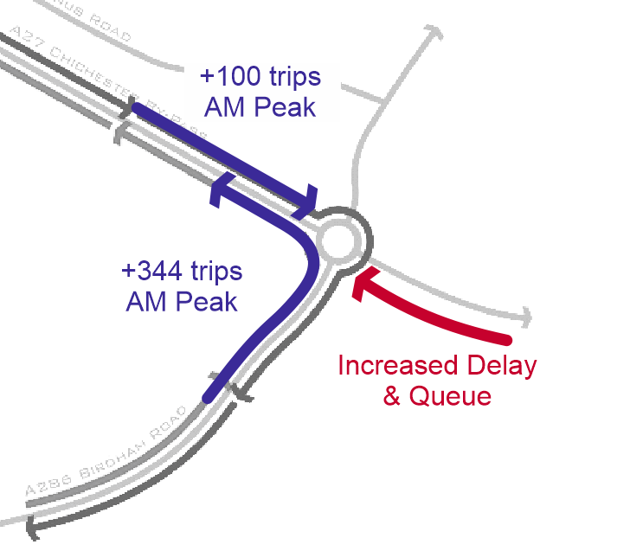 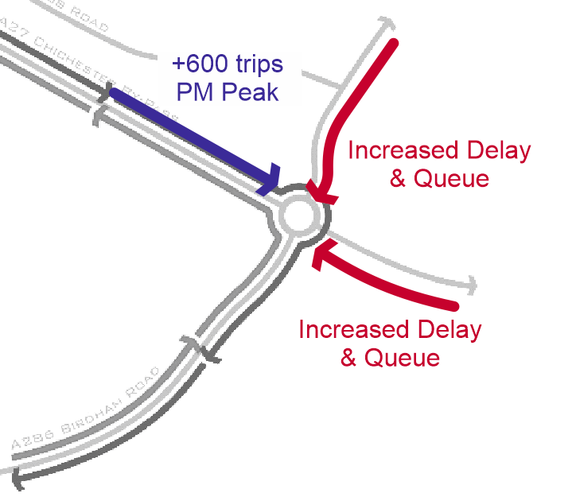

* The new signalised roundabout is an improvement on the current roundabout junction, although the level of queuing and subsequent delay on A27 westbound approach is an issue.
* The proposed signalised roundabout may be able to support some level of Local Plan Growth without the SLR as an interim solution, but NOT the full forecast for 2035.
* Likely to be concerns from WSCC and Highways England if the Stockbridge signalised roundabout scheme is considered as permanent, however they may be willing to consider the scheme as an interim arrangement with associated conditions.

## Additional Assessments Prior to Stage 2

* + 1. Due to the physical constraints at the junction there is limited scope to modify the junction sufficiently to mitigate the impact of the SLR traffic re-assignment to an acceptable level.
    2. There is the possible option for the signalised roundabout to be considered as an interim solution until the SLR is forthcoming, although there are still concerns over the impacts to the A27 westbound approach. This would require further assessment work to understand the nature of this interim position.
    3. As the proposed signalised roundabout permitted a right turn movement from the west which in turn increases delay to the northern and eastern arm, there is the option to consider banning movements similar to that of the LP scheme, but the roundabout offers more flexibility. The banned movements could be introduced once the SLR is on line.
    4. Its recommended that the signalised roundabout option is retained for the next Local Plan iteration but only as an interim option. The roundabout scheme can then be considered further as the permanent option but with banned movements and with the Stockbridge Link Road.

## Conclusion

* From the assessment work presented we recommend that CDC do not progress with the Stage 2 proposals for VISSIM microsimulation, as modelling to date has shown that junction improvements (comprising a signalised roundabout) on their own are not sufficient to mitigate the effects of proposed Local Plan development. The signalised roundabout arrangement could only be retained for consideration as part of the next Local Plan iteration in Oct/Nov 2020 as an interim option.

1. Traffic Flow Output

Figure A.1: 2014 and 2035 Traffic Flows (existing roundabout)

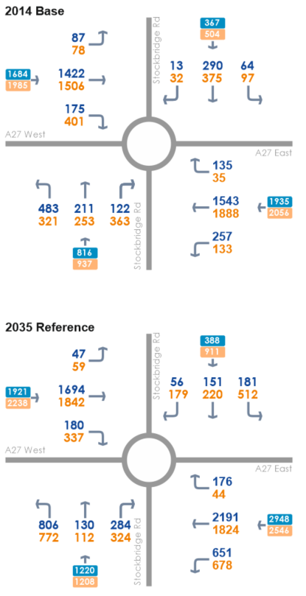 

Figure A.2: 2035 LP Mitigation (Signalised Crossroads with banned right turns from A27)

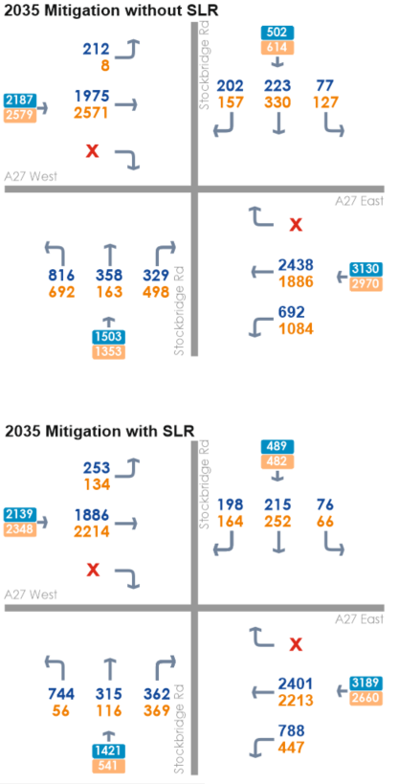 

Figure A.3: 2035 LP Mitigation (Signalised Roundabout)

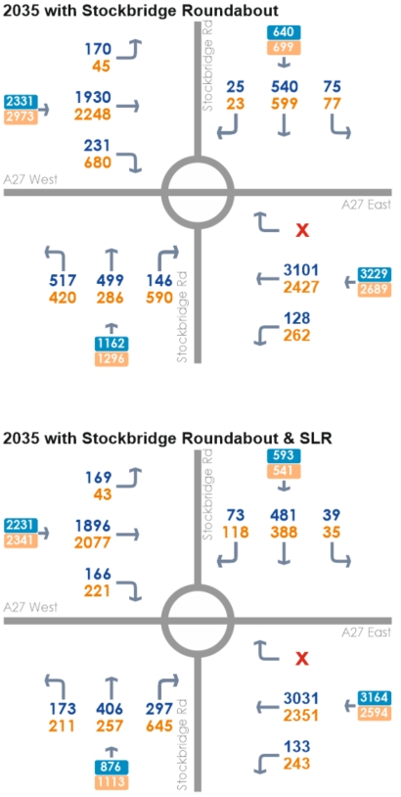 

1. Junction Assessment Results

Table B.1: AM Peak Period Assessment Results

|  |  |  |  |  |  |
| --- | --- | --- | --- | --- | --- |
| Arm | Without SLR | |  | With SLR | |
| Queue (PCU) | Delay (s) |  | Queue (PCU) | Delay (s) |
| ***2035 Reference Case*** | ***Scenario 1*** | |  | *-* | |
| Arm A: A27 (west) | 84 | 315.2 |  |  |  |
| Arm B: Stockbridge Road (north) | 2 | 14.3 |  |  |  |
| Arm C: A27 (east) | 210 | 560.4 |  |  |  |
| Arm D: Stockbridge Road (south) | 638 | 1932.4 |  |  |  |
| ***2035 LP Signalised Crossroads*** | ***Scenario 2*** | |  | ***Scenario 3*** | |
| Arm A: A27 (west) | 68 | 163.7 |  | 23 | 42.6 |
| Arm B: Stockbridge Road (north) | 8 | 70.0 |  | 7 | 64.7 |
| Arm C: A27 (east) | 347 | 688.2 |  | 323 | 612.5 |
| Arm D: Stockbridge Road (south) | 255 | 670.7 |  | 220 | 636.8 |
| ***2035 LP Signalised Roundabout*** | ***Scenario 4*** | |  | ***Scenario 5*** | |
| Arm A: A27 (west) | 135 | 328.5 |  | 27 | 32.5 |
| Arm B: Stockbridge Road (north) | 11 | 17.4 |  | 16 | 44.7 |
| Arm C: A27 (east) | 427 | 897.5 |  | 311 | 643.5 |
| Arm D: Stockbridge Road (south) | 24 | 23.1 |  | 12 | 19.5 |

Table B.2: PM Peak Period Assessment Results

|  |  |  |  |  |  |
| --- | --- | --- | --- | --- | --- |
| Arm | Without SLR | |  | With SLR | |
| Queue (PCU) | Delay (s) |  | Queue (PCU) | Delay (s) |
| ***2035 Reference Case*** | ***Scenario 1*** | |  | ***-*** | |
| Arm A: A27 (west) | 206 | 754.0 |  |  |  |
| Arm B: Stockbridge Road (north) | 170 | 777.4 |  |  |  |
| Arm C: A27 (east) | 48 | 104.8 |  |  |  |
| Arm D: Stockbridge Road (south) | 494 | 1631.2 |  |  |  |
| ***2035 LP Signalised Crossroads*** | ***Scenario 2*** | |  | ***Scenario 3*** | |
| Arm A: A27 (west) | 228 | 558.1 |  | 195 | 405.6 |
| Arm B: Stockbridge Road (north) | 60 | 440.2 |  | 10 | 92.3 |
| Arm C: A27 (east) | 289 | 472.4 |  | 148 | 307.5 |
| Arm D: Stockbridge Road (south) | 145 | 411.1 |  | 10 | 97.9 |
| ***2035 LP Signalised Roundabout*** | ***Scenario 4*** | |  | ***Scenario 5*** | |
| Arm A: A27 (west) | 307 | 602.4 |  | 185 | 489.6 |
| Arm B: Stockbridge Road (north) | 250 | 1251 |  | 11 | 27.8 |
| Arm C: A27 (east) | 286 | 725.0 |  | 284 | 747.5 |
| Arm D: Stockbridge Road (south) | 15 | 19.0 |  | 12 | 16.7 |

Figure B.1: AM Queue and Delay Results

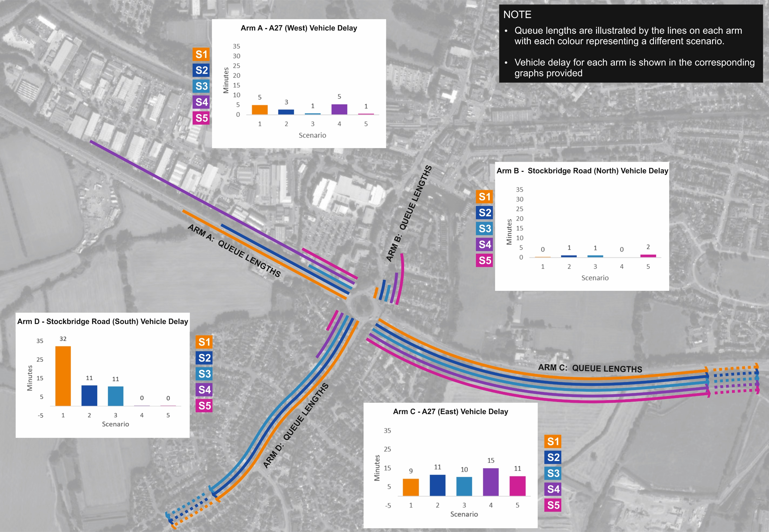

Figure B.2: PM Queue and Delay Results

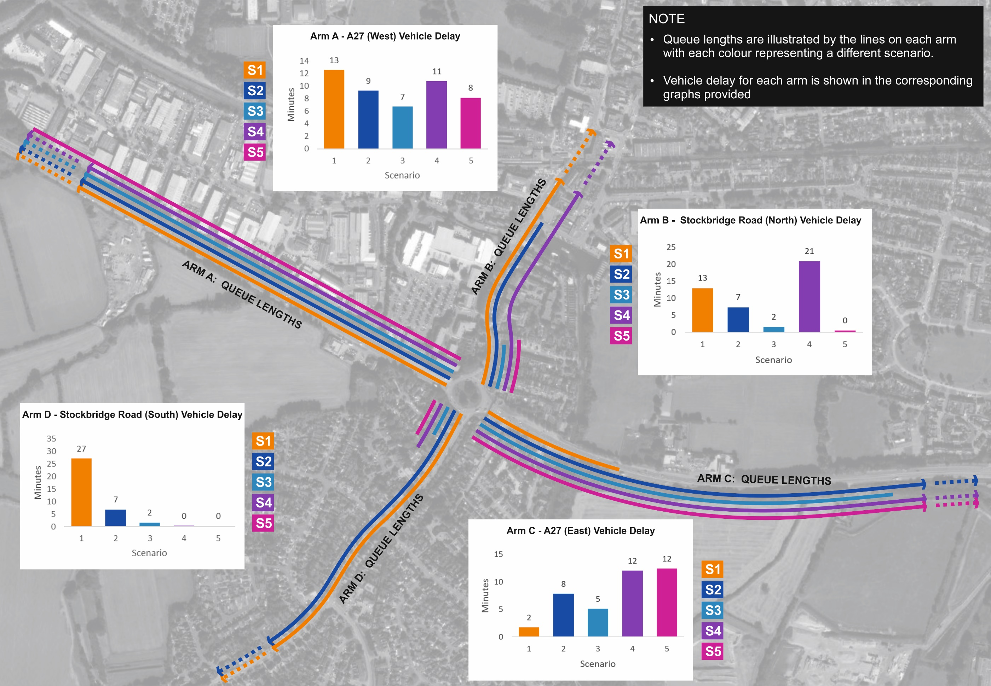

1. Existing Junction Assessment Outputs

See separate document.

1. Proposed Signalised Crossroad Junction Assessment Outputs

See separate document.

1. Proposed Signalised Roundabout Junction Assessment Outputs

See separate document.