# ARTICLE 4 DIRECTIONS

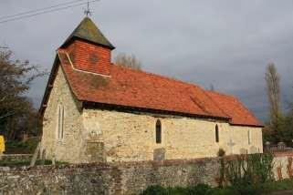

# EARNLEY

**CONSERVATION AREA**

**This leaflet explains the implication of the Article 4 Directions that have been implemented to protect the character of the Earnley Conservation Area**



Even in conservation areas certain kinds of development and alterations do not require planning permission. These works are often referred to as

**‘permitted development’** and the rights relating to them are defined in the Town and Country Planning (General Permitted Development) Order 1995, as amended.

Consequently many small-scale alterations such as replacement of windows and doors, changes to roof coverings, removal of boundary walls, addition of satellite dishes and loss of architectural features do not require permission.

Individually many of these changes may appear fairly minor but added together they can begin to have a significant effect on the character and appearance of conservation areas.

However under Article 4 of the Order, a Council may make directions to remove such rights if it feels that the development permitted would be harmful to the character of a conservation area.

## What is an Article 4 Direction?

An Article 4 Direction is a special planning regulation adopted by a Local Planning Authority to provide additional powers of planning control in a particular location. There are 2 types of Article 4 directions:

1. Specific to conservation areas that withdraw certain permitted development rights in respect of dwelling houses for specified classes of minor alterations and extensions, such as porches, replacement of windows and doors and painting of the exterior of a building, which are set out in the Direction. These have immediate effect from the date the Direction is made
2. General Article 4 Directions which in the case of Earnley relates to the installation of solar panels on the front roof pitches which only come into effect once the Direction is confirmed, which must be within 6 months of the date it is made.

They cannot be applied retrospectively to development, which has already been carried out prior to the making of the direction.

They generally only apply to the main elevations of a property facing a highway, footpath, waterway or public space. They only apply to houses and not to flats (which do not benefit from the same permitted development rights as houses), or other commercial properties.

## What properties are covered by the Article 4 Direction?

The Direction includes all dwelling houses within the Earnley Conservation Area (see map on the reverse), but only to those elevations which front onto a public area (including side elevations of corner properties). Rear and side elevations where they do not face a public footpath or public space or waterway are not included.

Any new extensions or building work at the rear are likely to require planning permission under existing legislation. Commercial properties and flats already have similar stricter controls over what requires planning permission it is always advisable to contact the planning department before undertaking works.

## What work is covered by the Direction?

All alterations (and demolition) within the following classes of permitted development affecting **a front or public elevation** will in future require planning permission:

1. the enlargement, improvement or other alteration of a dwelling-house – ie changes to windows, doors, door surrounds
2. changes to roof coverings and demolition of or alterations to chimneys
3. the addition or alteration of a porch on the front elevation
4. construction of a building or enclosure within the front garden (or side boundary facing onto a road)
5. provision of a hard standing
6. Installation, alteration or replacement of a chimney, flue or soil and vent pipe
7. installation, alteration or replacement of a satellite antenna
8. erection or demolition of a gate, fence, wall or other means of enclosure
9. the painting of previously unpainted stone or brickwork of a dwelling house (the addition of render or stone cladding is already controlled under conservation area legislation)
10. the installation, alteration or replacement of solar photovoltaic (PV) or solar thermal equipment on a roof slope fronting onto a public highway, public space or waterway on:

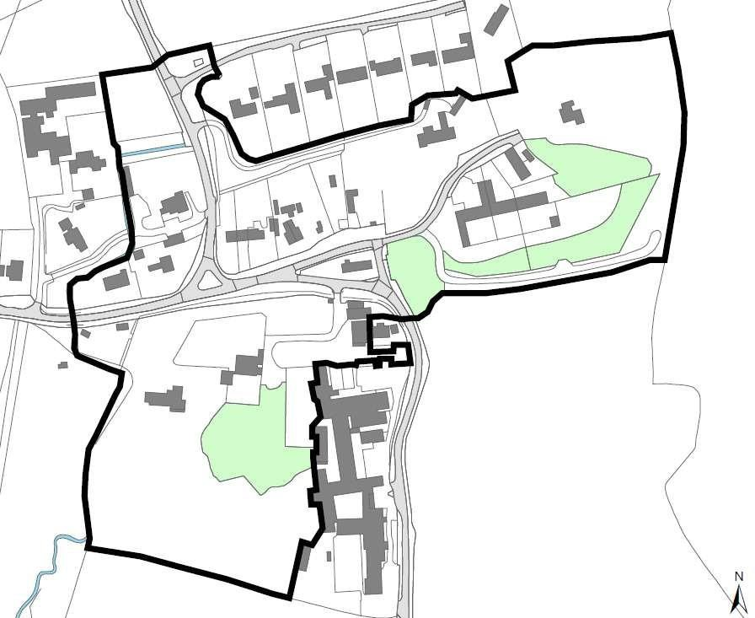

1. a dwelling house or block of flats or
2. a building situated within the curtilage of a dwelling house

## The effects of the Article 4 Direction.

You now need planning permission for the works described above. Consent will not normally be given to replace traditional features with modern ones, or to use substitute materials such as aluminium or plastic. Where modern materials have replaced traditional ones in the past, it is expected that the correct original materials and details will be restored when circumstances allow or when further replacement is needed. Planning applications for alterations that would not preserve or enhance the character or appearance of the conservation area will normally be recommended for refusal.

## Planning Fees.

Please refer to the current Fee Schedule on [Chichester District Council’s website](https://www.chichester.gov.uk/planningpermission).

## Repairs.

You do not need planning permission for repairs, provided these are carried out in a traditional manner repeating the details of the original elements involved and using the same materials.

You can also replace worn out minor elements without permission provided these replacements are replicas.

## Further Advice.

This leaflet is a general guide only. We recommend that you check with Chichester District Council's Planning Service who will advise you on whether planning permission is needed for alterations or other works.

The Design and Implementation Team can advise you on how to repair listed and unlisted traditional buildings in order to protect the original features and character of the building.

**For further information please contact:** Design and Implementation Team

Chichester District Council

East Pallant House1East Pallant Chichester, PO19 1TY

T: 01243 785166

E: [designandimplementation@chichester.gov.uk](mailto:designandimplementation@chichester.gov.uk) [www.chichester.gov.uk](http://www.chichester.gov.uk/)

**Please retain this leaflet for future reference.**