
Chichester Local Cycling & Walking Infrastructure Plan (LCWIP)
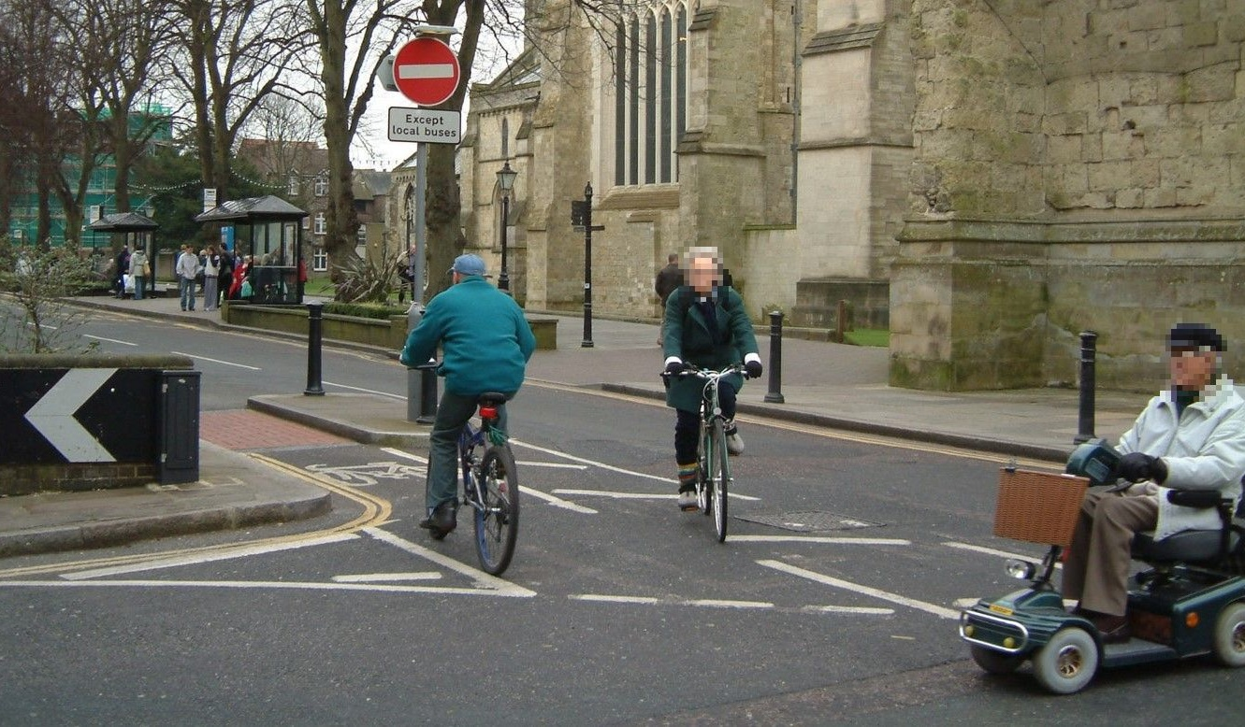
January 2021 (revised following consultation)
Produced by Transport Initiatives | supported by

Chichester City Local Cycling & Walking Infrastructure Plan (LCWIP)
Contents

Executive Summary 2
- Introduction and background 5
- Cycling & walking in Chichester 10
- Potential for cycling & walking 26
- Cycling assessment & proposals 34
- Walking assessment & proposals 41
- Detailed proposals & costs 47
- Conclusions 61

Appendices

A. Glossary (acronyms & technical terms) (separate document)

B. Cycling audit & RST assessments (separate document)

C. Walking audit (separate document)

D. LCWIP public consultation analysis report, Oct 2020 (separate document)
Checking / sign off
Job: Chichester Local Cycling & Walking Infrastructure Plan |  | Client: Chichester District Council
Job number: CSSE29 |  | Version number: 5.2
Issued by: Mark Strong | Checked by: Ken Spence
Date: 31/1/21 (initial version 30/6/20) | Date: 31/1/21

© Chichester District Council / Transport Initiatives LLP 2021
All photos © Transport Initiatives except where stated
All OS mapping © Crown copyright and database rights 2021 Ordnance Survey 100018803
Transport Initiatives LLP  www.transport-initiatives.com info@transport-initiatives.com 0845 345 7623  Registered Office: Office 4, 145 Islingword Road, Brighton BN2 9SH  Registered in England & Wales Partnership number OC310831 VAT registration no. 855 4208 21 | 
Executive Summary
Aim and brief
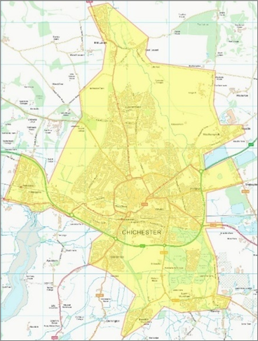 | In 2019 Chichester District Council (CDC) commissioned Transport Initiatives, supported by PJA, to develop a Local Cycling and Walking Infrastructure Plan (LCWIP) for the City of Chichester and the immediately surrounding area (see plan to the right).  A range of tasks were carried out to produce the Plan, which was developed in parallel with the county-wide LCWIP produced by West Sussex County Council (WSCC).  Provision for cycling was assessed using tools produced by the Department for Transport (DfT). Detailed options for safe, convenient and attractive cycle routes were developed, based on site visits plus advice from councillors, officers and stakeholders. The assessment of walking was also carried out using DfT tools. This was focused on the city centre Core Walking Zone (CWZ), plus two main routes between the CWZ and outlying areas.
In the initial part of the study, two workshops were held with key stakeholders including councillors and officers from both CDC and WSCC, other statutory bodies, local businesses and voluntary and community groups. A public consultation was then carried out from September to October 2020 for which 240 responses were received.
Development of the LCWIP took into account other transport schemes being promoted by WSCC as well as proposed developments in the LCWIP area. Meetings with officers of both WSCC and CDC were held to ensure that projects being led by developers as part of the planning process were also covered in the study. WSCC established a working group for all West Sussex authorities as well as the South Downs National Park Authority (SDNPA) to attend for knowledge sharing and to ensure consistency of approach across the county. The working group will continue into the future as LCWIPs are adopted and officers seek to implement LCWIP schemes.
Government Policy
In early 2020, during the final stages of the LCWIP process, the world was hit by the COVID-19 pandemic, with an unprecedented effect on the lives of everyone in the UK. The impact on transport led to a large increase in cycling. Although the level of cycling has subsequently fallen, it remains higher than before the pandemic.
At the same time, there have been significant advances in Government policy for walking and cycling, with the publication of its new strategy “Gear Change” and cycling design guidance LTN1/20, both in July 2020. These were accompanied by significantly increased levels of funding for local authority walking and cycling schemes, via the Emergency Active Travel Fund in May 2020 and subsequently the Active Travel Fund in November 2020.

Research
A detailed analysis of the Chichester LCWIP area was carried out using the DfT’s Propensity to Cycle Tool (PCT) which is based on data from the 2011 census. This revealed that the LCWIP area has the highest level of cycling in West Sussex, with good potential for increase. A desk-based audit of existing provision for cycling in and around Chichester was carried out (based on the Bikeability training levels needed to cycle safely) which showed that there was inconsistent provision for safe and convenient cycling. While there is no equivalent for the PCT for walking, the 2011 census data showed that the LCWIP area also had the highest level of walking in the county.
Analysis
Based on the PCT, the Bikeability assessment and site visits, a number of potential cycle routes were proposed and refined following an iterative process. A cycle network was identified, comprising main routes and local spurs and links, with a total length of 58km. The routes were analysed using the DfT’s Route Selection Tool (RST) which assesses five key criteria (Connectivity, Safety, Directness, Gradient and Comfort) as well as the number of Critical Junctions.
An assessment of walking in the CWZ was carried out, using the DfT’s Walking Route Assessment Tool (WRAT) which shows where provision for walking is good or poor. The two highest priority routes between the CWZ and outer areas (to the north and west) were also assessed using the WRAT. The process could be repeated for other routes in the future.
Final version of proposed cycle network
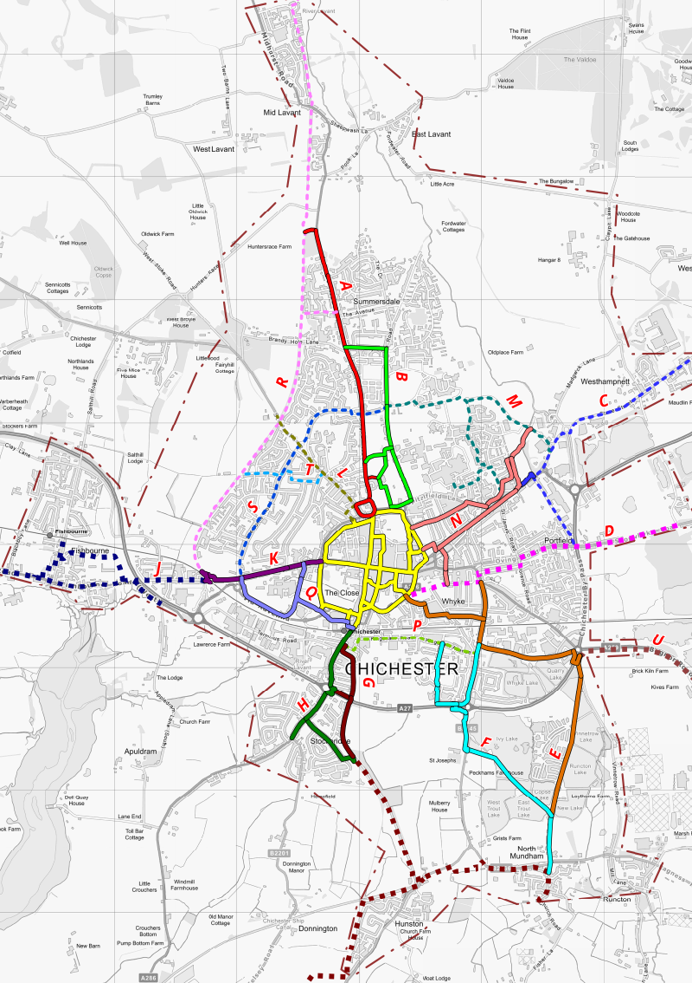 | 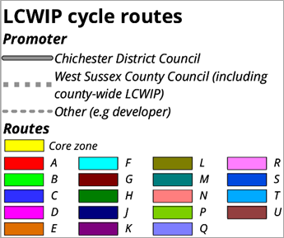
Proposals
The routes were divided into three groups, based on which body is expected to be responsible for their development (CDC, WSCC or another promoter, such as a developer or Highways England). Detailed proposals were developed to improve the cycle routes to be promoted by CDC, based initially on the RST assessments. These were further refined following feedback from the public consultation process in autumn 2020.
A set of “Do Minimum” measures were produced showing the minimum requirements to make routes fit for purpose (based on LTN1/20) plus “Do More” measures that would upgrade them to a higher quality or extend provision to a wider area (e.g. Low Traffic Neighbourhoods).
Proposals were also drawn up to improve walking in the CWZ and on the two identified routes.
Costs and Funding
The outline cost for the revised LCWIP over a 10 year period is estimated at around £9.8 million for the Do Minimum scenario. A total of £14.3 million would be needed to achieve the Do More outcomes. These figures both include a 10% uplift for contingency/optimism bias.
As in most area wide projects, a variety of funding sources will be needed to supplement CDC and WSCC funds, including central government (especially future phases of the Active Travel Fund), external grants and contributions from developers and other third parties.
It is important to note that the LCWIP is intended as a 10 year programme for the delivery of infrastructure. The average cost of around £1m/year if all the Do Minimum measures were implemented would be equal to around £25/year for each person in the LCWIP area. While this is a significant increase on current levels of expenditure, it matches the level regarded as being necessary to have a significant impact on cycling levels, including by the All Party Parliamentary Cycling Group report “Get Britain Cycling” in 2013.
The annual expenditure to deliver Do More measures would be £1.4m (around £35/year per person). This would lead to a higher level of mode shift to cycling, as well as benefitting walking through measures such as Low Traffic Neighbourhoods. There would be a significant positive impact on local communities as well as the city’s overall environment and economy.
Next steps
The next stage of the LCWIP is to prioritise the proposed interventions. This will be carried out by WSCC in conjunction with the county-wide, SDNPA and other area LCWIPs. It will include a Multi-Criteria Assessment Framework to allow proposals in different areas and LCWIPs to be assessed on the same basis.
CDC is seeking to integrate the Chichester LCWIP and WSCC’s county-wide LCWIP, Local Transport Investment Programme and Sustainable Transport Package schemes with policy in the emerging Revised Local Plan. This will provide the most fertile opportunities for scheme development in association with land-use planning over the Plan period which runs to 2035. CDC will also include the LCWIP schemes in its Infrastructure Business Plan, which prioritises the infrastructure needed to support growth via a five year rolling programme for delivery.
It is intended that the LCWIP will be reviewed in response to new funding and delivery opportunities and/or in five years’ time, in order to ensure that delivery of active travel infrastructure is sustained.
1. Introduction and background
1.1 Aim of study
This Local Cycling and Walking Infrastructure (LCWIP) study was commissioned by Chichester District Council (CDC) in 2019.
The overall aim of the study was to deliver:
- A network plan for walking and cycling within Chichester City, identifying preferred routes and core zones for further improvement
- A programme of infrastructure improvements for future investment
- A report setting out the underlying analysis, with a narrative supporting the identified improvements and network
- Assistance with public engagement
1.2 Background to LCWIP
In 2017 the Government published its first Cycling and Walking Investment Strategy (CWIS). This was a requirement of the Infrastructure Act 2015 which placed a duty on the Secretary of State for Transport to develop “Cycling & Walking Investment Strategies” with objectives & financial resources.
The 2017 CWIS set out why cycling and walking are considered important by the government. It states that the aim is “to make cycling and walking the natural choices for shorter journeys, or as part of a longer journey”. In February 2020 the first report to parliament was made on progress in delivering the CWIS.
CWIS Figure 1: Opportunities from cycling and walking
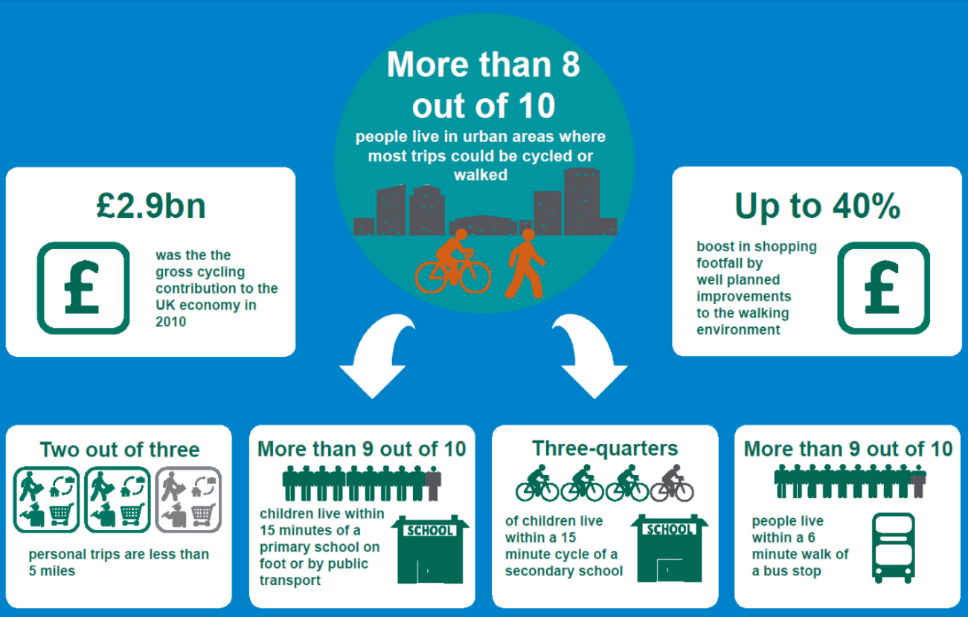
As part of the CWIS, the DfT set out an expectation that local authorities would develop a LCWIP for their area. This is intended to deliver a strategic approach to identifying cycling and walking improvements required at the local level. LCWIPs enable a long-term approach, ideally over a 10 year period, and form a vital part of the Government’s objectives to increase the number of trips made on foot or by cycle.
Detailed technical guidance on developing an LCWIP was issued in April 2017. This states that the LCWIP’s key aims should be:  - To develop a planned cycle network connecting key origins and destinations  - To provide high quality walking environments  The LCWIP should include the following outputs:  - A network plan for cycling and walking which identifies preferred routes and core zones for further developments  - A prioritised programme of infrastructure improvements for future investment  - A report setting out the underlying analysis with a clear explanation to support the network and improvements | 
The guidance sets out six stages for the LCWIP process, shown in Table 1 below. This LCWIP report covers Stages 2 to 4. It was initially intended to also include Stage 5. However, this will now be delivered by WSCC in conjunction with the county-wide and South Downs National Park Authority (SDNPA) LCWIPs (see Sections 1.3 and 7.3). This will allow proposals in different areas and LCWIPs to be assessed on the same basis.
Table 1: LCWIP stages and names
Stage | Name | Tasks
1 | Determining scope | Establish geographic extent and governance
2 | Gathering information | Review policies, collate information on existing network and trips, identity main destinations
3 | Network planning for cycling | Identify potential trips and develop routes
4 | Network planning for walking | Identify potential trips and develop area proposals
5 | Prioritising improvements | Appraisal and prioritisation of proposals
6 | Integration and application | Incorporate into local plans and strategies

1.3 LCWIPs in West Sussex & Chichester
In 2018, the DfT launched a bid process to offer LCWIP support to a limited number of local authorities. A partnership of West Sussex local authorities, led by West Sussex County Council (WSCC), successfully bid for this support to help develop LCWIPs in the county. WSCC’s support has been divided in three ways:
- County-wide LCWIP, looking at strategic routes
- Four locality based LCWIPs (Adur & Worthing, Chichester, Crawley and Horsham)
- South Downs National Park Authority (SDNPA) LCWIP
Stage 1 of the LCWIP process (scoping) was carried out by WSCC and CDC. As part of this stage it was agreed that the Chichester LCWIP should cover the main urban area of Chichester City and adjacent smaller settlements. The LCWIP area is shown in Plan 1 below.
Plan 1: Chichester LCWIP area
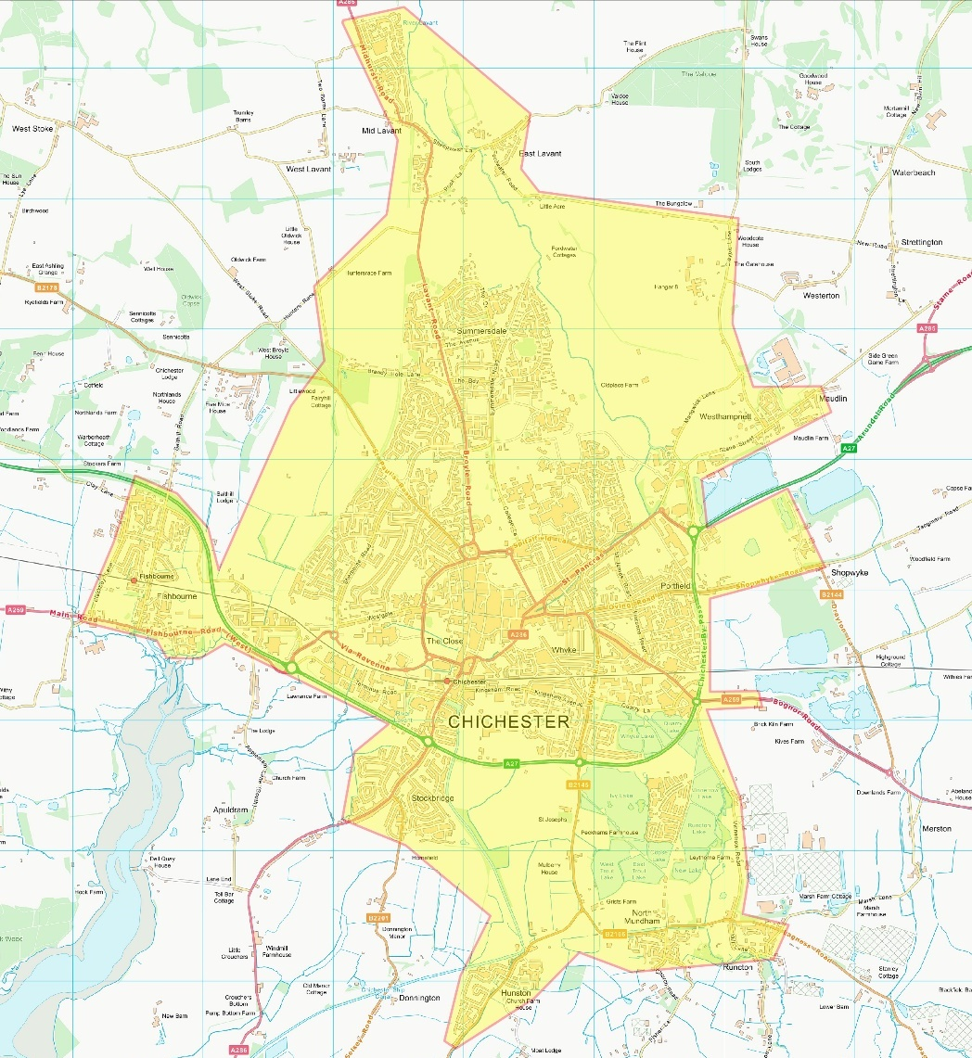
1.4 Chichester City area
Chichester District Council (CDC) covers a mostly rural area of over 300 square miles in the west of West Sussex. It has an overall population of around 129,000 (2018 estimates).
As a second tier authority it has a range of responsibilities and powers, including planning and parks. However, most issues affecting transport, including walking and cycling, are the responsibility of West Sussex County Council (WSCC) which is the Highway Authority. This includes public Rights of Way.
Much of the district falls within the South Downs National Park, administered by SDNPA. It also includes the Chichester Harbour Area of Outstanding Natural Beauty as well as two National Nature Reserves and many smaller green spaces.
Chichester itself is a cathedral city and the county town of West Sussex (with a City Council operating as the third tier of local government). It lies just north of the coast with the South Downs immediately to the north. Chichester has a long history as a settlement from Roman times and was important in Anglo-Saxon times. It is the seat of the Church of England Diocese of Chichester, and Chichester Cathedral itself dates back to the 12th century.
Chichester is served by the West Coastway rail line between Brighton and Portsmouth/ Southampton, with Chichester and Fishbourne stations in the LCWIP area. There are regular mainline services to and from London as well as to Worthing and Brighton in the east and Havant, Portsmouth and Southampton to the west.
The city is also the hub of several main road routes. While the A27 south coast trunk road bypasses the city to the south, other main roads such as the A259, A285 and A286 run through the built-up area of the city.
The city has a wide range of businesses, including Rolls Royce Motor Cars, Mercer and the UK headquarters of John Wiley publishers. However, the largest employers are in the public sector: St Richard’s Hospital is the largest with over 4,000 staff, with West Sussex County Council and Chichester District Council combined employing over 3,000 staff. Education is also an important focus, with many schools in the LCWIP area. Chichester College is the largest Further Education establishment on the South Coast, with over 20,000 full- and part-time students. The University of Chichester has over 5,000 students at its campus just north of the city centre.
There is also a strong tourism and leisure focus. There are many visitor attractions, including the cathedral, Chichester Festival Theatre, a number of museums (including Pallant Gallery and Fishbourne Roman Palace, just west of the city) and Goodwood Racecourse (just outside the LCWIP area to the north east). The surrounding coast and countryside are also a significant attraction for many visitors. A number of attractive traffic-free routes offer cycling and walking allow access to these from Chichester, including Centurion Way, Salterns Way and the Chichester Canal towpath (leading to the Selsey Greenway).
The LCWIP area comprises the city plus adjacent settlements, including Fishbourne, Lavant, Westhampnett, North Mundham, Hunston and Stockbridge. It has a population of around 38,000 of which around 32,000 are in Chichester City itself (2018 estimates).
Plan 2 below shows the location of key facilities in and around the LCWIP area.

Plan 2: Main facilities in and around the LCWIP area
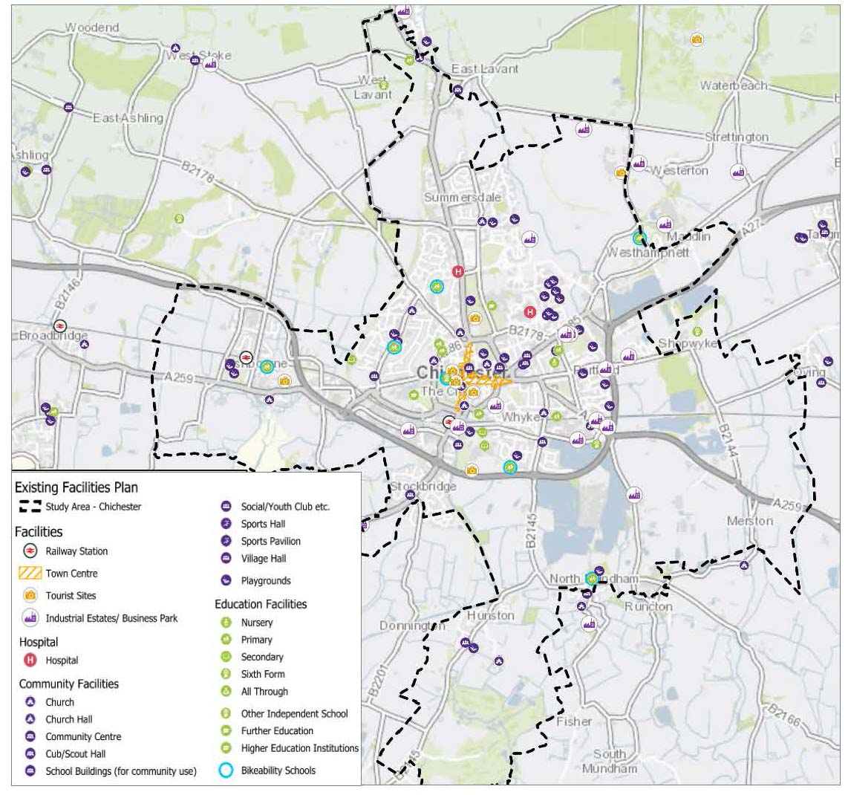
Access to Chichester Festival Theatre from Northgate car park
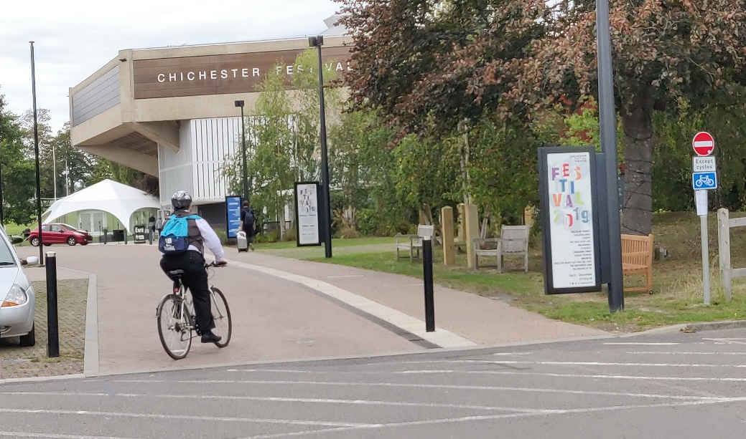

2. Cycling & walking in Chichester
2.1 Summary
Establishing the demand for cycling and walking is a key part of the LCWIP. The following tasks were carried out to deliver this:
- Research into general travel flows in West Sussex and Chichester (based on WSCC data)
- Analysis of cycling and walking data in the LCWIP area
- Audit of cycling and walking provision in the LCWIP area
- Workshop with stakeholders to gather views on key issues and locations
2.2 Travel to work in West Sussex
In 2013 WSCC produced a Census Bulletin with transport data from the 2011 census. This provides a wide range of information about travel patterns across the county.
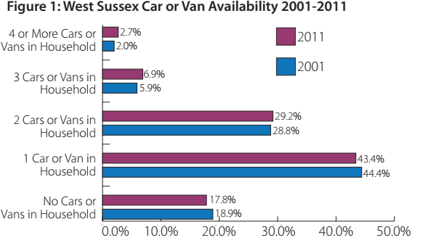
Figure 1 from the Census Bulletin shows that the majority (61%) of households in West Sussex have access to no more than one car or van. Assuming an average of two people per household this means that around 40% of residents do not have access to a private motor vehicle. Many of these will be people who are unable to drive, especially children.

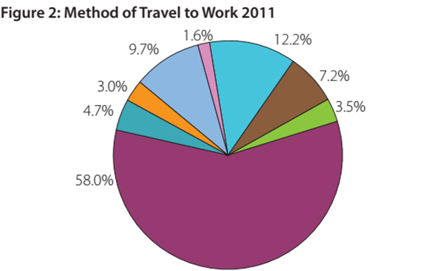 | 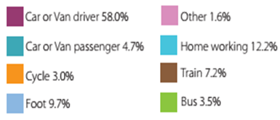

Figure 2 shows the overall split across West Sussex between different modes (including working from home). The dominant mode is car or van, with walking being just under 10%. At 3%, cycling is higher than the national average and on a par with bus use.
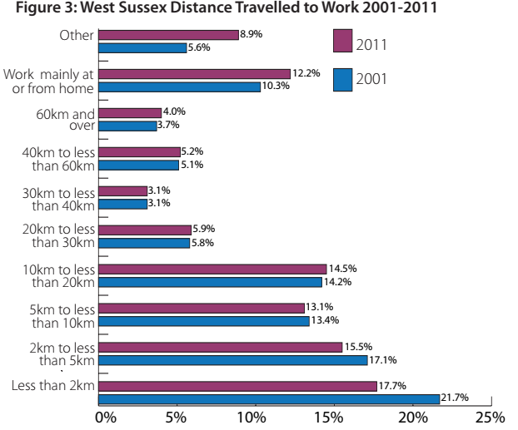
Figure 3 of the Census Bulletin showed the proportion of trips of different lengths. Around 40% of all trips to work are under 5km (3 miles) in length. Despite this, most trips in the county are made by car or van. The high level of short trips demonstrates the potential for increased travel by walking and especially cycling.
The Census Bulletin also includes an appendix with detailed data on trips in local areas of West Sussex. The selections relevant to the Chichester LCWIP are shown below. Note that the column refers to Chichester City only – this does not include the outlying settlements in the LCWIP area. However, these only make up a small proportion of the overall population.

Appendix B.1 Car and van availability (2011)
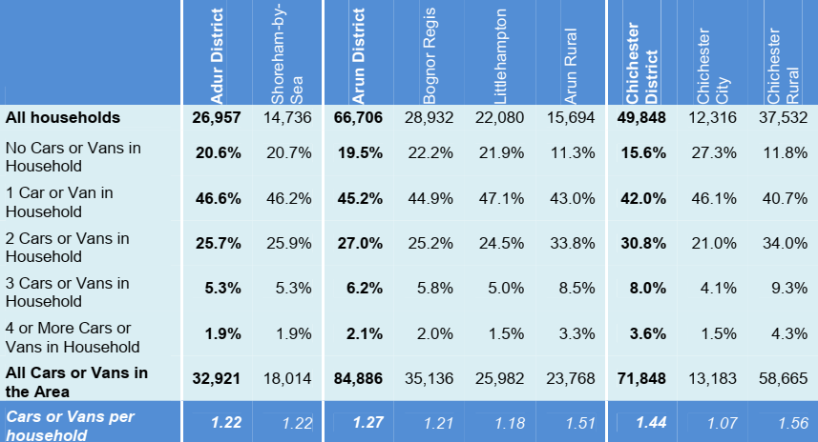
Car and van ownership is lower in Chichester City than anywhere else in West Sussex. Around 27% of households do not have a car or van and nearly half (46%) have only one. The average of 1.07 car or van per household is also the lowest in the county and only increased slightly between 2001 and 2011.
Plan 3 shows the distribution of car ownership in the LCWIP area, showing the concentration of low car ownership in the centre of the city.
Plan 3: Car ownership in and around the LCWIP area
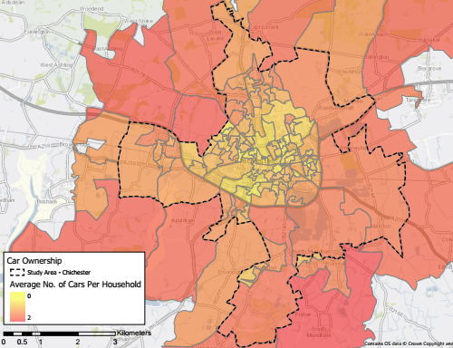
Reflecting the lower level of car ownership in the LCWIP area, the proportion of residents travelling to work by car is around 50%, around 10% lower than the county average. Notably, the overall level of walking (24%) and cycling (8%) are much higher than the county averages (10% / 3% respectively) and are in fact the highest levels in West Sussex.
It is also notable that 10% of residents in employment work from home. However, this is half the rate in the rural areas of CDC, which has the highest level in the county.
Appendix C.1 Method of Travel to Work (2011)
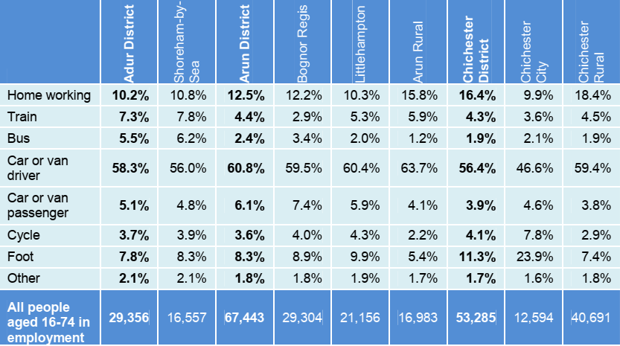
The length of trips gives some indication of why this might be the case. Over half of work trips made by residents of the Chichester City area are under 5km (3 miles), with a high level of 40% of trips under 2km (NB this excludes people working from home). This is the highest level in the county, although at 48% Worthing is a close second.
There is a clear contrast with the travel patterns of the workforce in Chichester City (not shown) where around 30% have a trip to work of 5km or less.
Appendix D.1 - Distance Travelled to Work (2011)
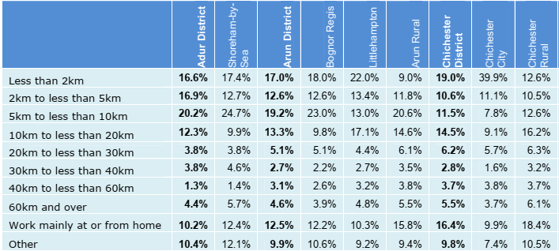
2.3 Data on cycling & walking in Chichester
National Travel Survey (2017-18)
DfT figures from 2017-18 showed that 18.1% of adults in Chichester District (as a whole) cycled at least weekly, either for travel or leisure (the highest levels in West Sussex), with 4.6% cycling five times a week. The figures for cycling for travel only were 8.4% and 2.4% respectively.
The equivalent figures for walking show that 75.6% of adults in Chichester walked at least weekly, either for travel or leisure, with 41.2 doing so five times a week. The figures for walking for travel only were 41.6% and 18.6% respectively.
Census data (2011)
The 2011 census revealed a high level of cycling, with 4.9% of trips to work by cycle in Chichester District (as a whole). Many of these were within the LCWIP area.
Table 2 below shows the level of cycling to work in wards either partly or fully in the LCWIP area. The four wards in the city had levels of cycling to work ranging from 7% to 11%. Wards immediately outside the city itself also had higher than average levels of cycling, with both Donnington and Fishbourne exceeding 8% despite the severance created by the A27.
Only 13.5% of trips to work in the CDC area were on foot, though in Chichester City the levels were much higher, ranging from 22.7% to 29.4%. Apart from Donnington, walking levels in neighbouring areas were much lower than for the four city wards, with distance presumably having a greater effect than for cycling.
Table 2: Cycling & walking levels, 2011 census
(NB ward boundaries at the time of the 2011 census)
Ward | Cycling | Walking
Chichester East | 8.64% | 28.72%
Chichester North | 6.94% | 22.64%
Chichester South | 8.59% | 29.41%
Chichester West | 11.07% | 22.70%
Donnington | 8.59% | 12.32%
Fishbourne | 8.13% | 6.48%
Lavant | 3.59% | 6.09%
North Mundham | 4.74% | 6.76%
The Department for Transport developed the Propensity to Cycle Tool (PCT) as part of its Local Cycling & Walking Infrastructure Plan (LCWIP) guidance. While it is designed to show how cycling might increase under different scenarios (this will be used later in the LCWIP), it can also be used to show data from the census
Plan 4 below shows 2011 census cycling to work levels in Lower Super Output Areas (LSOA) in the LCWIP area. LSOAs are used by government to represent geographic areas with equal population levels, giving a clearer understanding than wards. The higher cycling levels in Chichester City can be seen in more detail when plotted as LSOAs.

Plan 4: Cycling to work in and around the LCWIP area
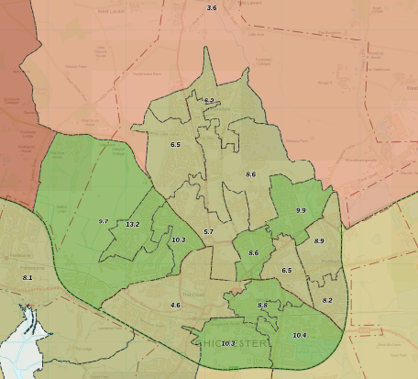
Collision data
Figures for collisions and casualties give an indication of the level of risk to people cycling and walking in the LCWIP area. However, it is important to note that the most severe injuries (commonly described as Killed or Seriously Injured – KSI) are thankfully rare, and are usually not a statistically significant way to show which locations are the most hazardous. While slight injuries are more common, a large proportion of these are often not notified to police.
Plan 5 below shows the distribution of collisions of varying severity across the LCWIP area. It can clearly be seen that in the main most injuries were incurred at main roads in the area. There were notable clusters around the Chichester ring road at the Northgate, Hornet and Southgate gyratory systems.
Plan 5: Cycling and walking collisions in the LCWIP area, 2016-2019
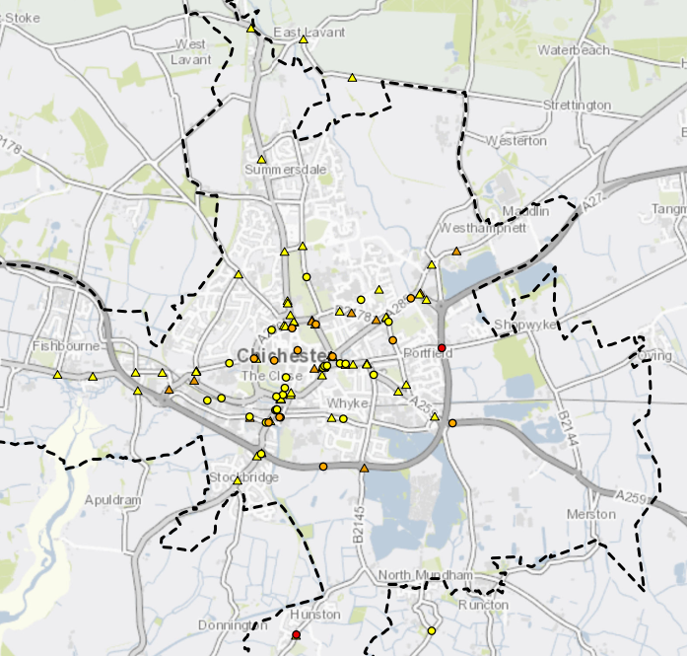
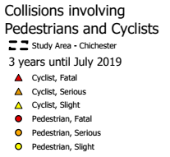
2.4 Provision for cycling & walking in Chichester
To assess how safe and convenient it is to cycle around Chichester, a desk-based study was carried out to assess the level of cycling skills needed to use the highway network. This was followed up by site visits to investigate crossing points on the network.
The process was based on Transport Initiatives’ Cycle Skills Network Audit, scaled back for speed and cost-effectiveness (omitting an area-wide assessment of paths and cycle tracks).
Plan 6 below shows the whole LCWIP area, while Plan 7 shows the central area.
Plan 6: Bikeability assessment of roads and crossings in the LCWIP area
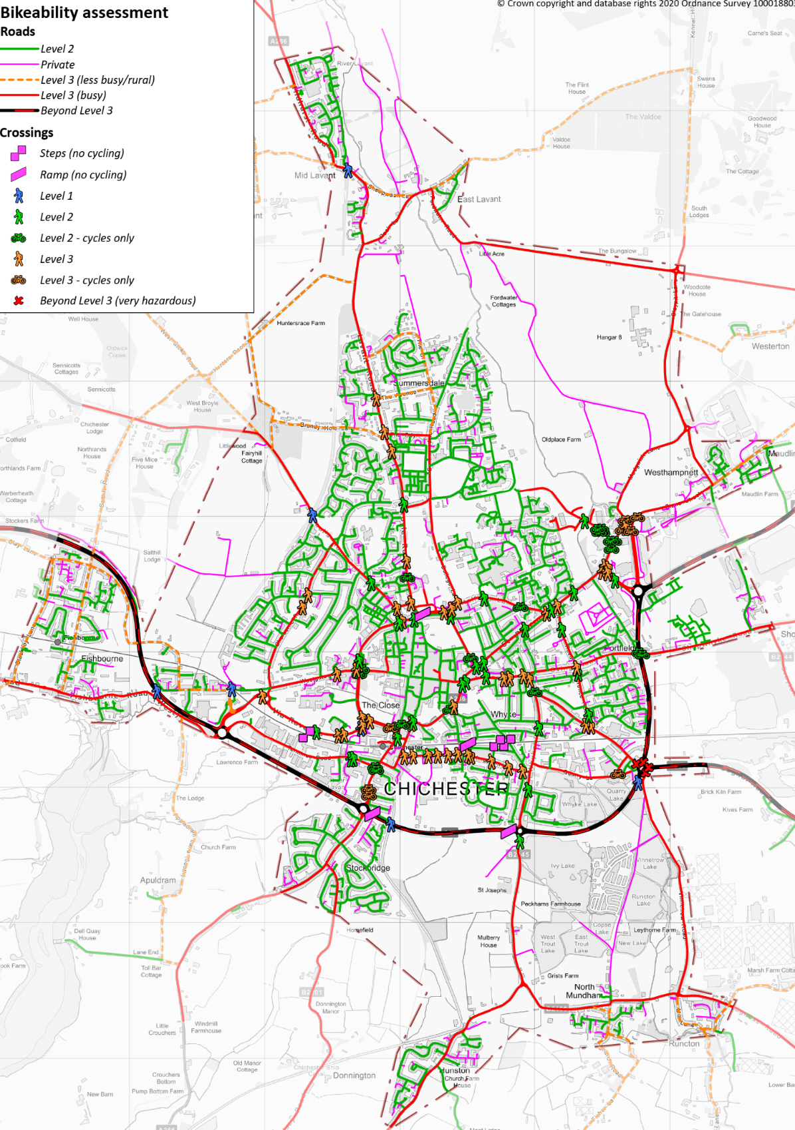
Plan 7: Bikeability assessment of roads and crossings in the central LCWIP area
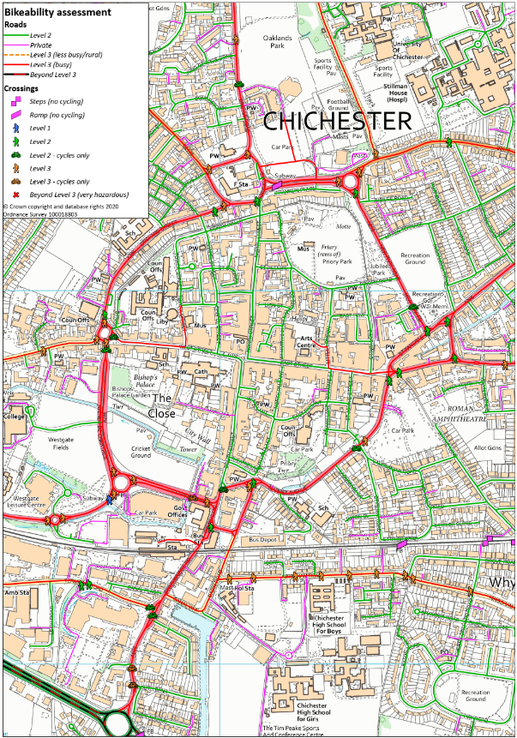

Table 3 below explains the levels used in these plans.
Table 3: Bikeability assessment audit levels
Level | Type | Description
Level 2 | Road | Residential or other quiet street, suitable for most people cycling including older children (i.e. with skills equivalent to Level 2 Bikeability)
Private | Road | Private street – access may be allowed at some times (generally similar to Level 2)
Level 3 (less busy/ rural) | Road | Busier road in urban areas (e.g. rat run) or minor road in rural areas with lower traffic but high speeds, generally only suitable for less risk averse cyclists
Level 3 (busy) | Road | Busy road only suitable for less risk averse cyclists (i.e. with skills equivalent to Level 3 Bikeability)
Beyond Level 3 | Road | Very busy road with fast moving traffic, unsuitable even for experienced cyclists (e.g. A27)
Steps | Crossing | Grade-separated crossing (bridge or subway) with steps
Ramp | Crossing | Grade-separated crossing with ramp but cycling prohibited
Level 1 | Crossing | Grade-separated crossing with ramp with cycling allowed
Level 2 | Crossing | Higher quality/protected crossing – walking only
Level 2 – cycles | Crossing | Higher quality/protected crossing – walking & cycling (or cycling-only)
Level 2 | Crossing | Lower quality/unprotected crossing – walking only
Level 2 – cycles | Crossing | Lower quality/unprotected crossing – walking & cycling (or cycling-only)
Beyond Level 3 | Crossing | Hazardous crossing for any user
The Bikeability audit shows that while there are areas where cycling is relatively safe and convenient, these are generally surrounded by roads that only people who feel confident cycling will be prepared to use. This especially applies to the A286 inner ring-road which restricts cycling (and indeed walking) access between central Chichester and the rest of the city. Road barriers are compounded by other physical features such as the railway line.
In the outlying part of the city, and especially the more rural areas, there are little or no alternatives to using unsuitable roads classified as Level 3 or beyond.
Level 3 road (A286 Avenue de Chartres) with sub-standard width cycle track & footway
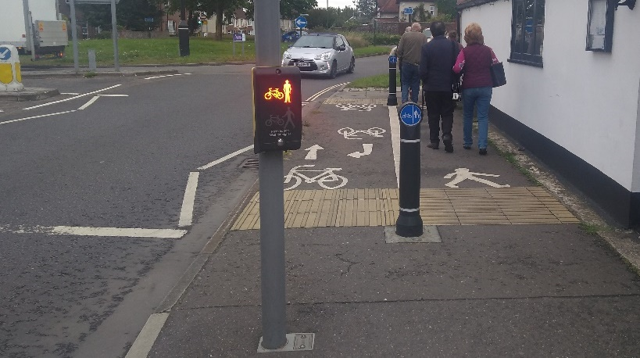
Crossing provision is also very poor. There are a large number of Level 3 crossings, including every crossing on Kingsham Road/Avenue. Apart from the Barnfield Drive/ Westhampnett Road roundabout, there are very few Level 2 crossings which permit cycling.
Crossings of the railway are particularly poor, with only one grade-separated non-road crossing, plus one ramped bridge where cycling is prohibited and three stepped foot-bridges. Apart from roads, there are two bridges and one subway across the A27 where cycling is allowed, with one ramped bridge (at Stockbridge) where cycling is prohibited.
Plan 8 below shows Rights of Way and cycle routes. These were not audited in detail at this stage as this was done as part of the future route development process. The cycle routes include both National Cycle Network (red) and other routes (blue). These are made up of motor traffic-free paths, on-road cycle infrastructure and routes that are signed only.
While there are several useful and good quality traffic-free routes for walking and cycling (notably Centurion Way and the Chichester Canal towpath), connectivity to these is poor. There are also considerable areas of the city with low standard provision and others with little or no provision, especially in the north of the LCWIP area.
Level 3 crossing of A286 Avenue de Chartres, north of Chichester station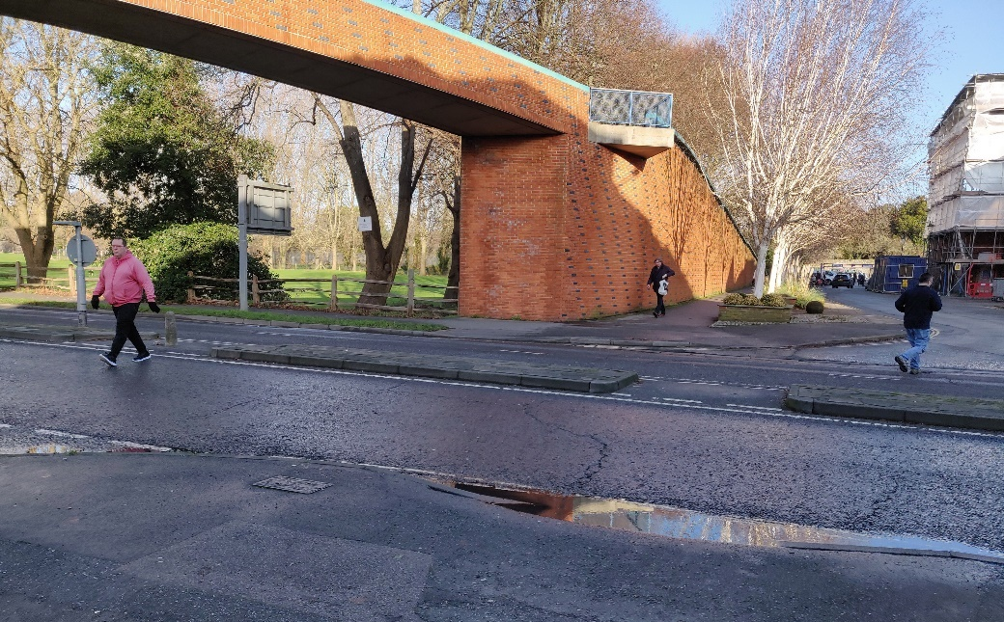
Level 3 crossing of B2145 Langness Road at Foxbridge Drive, Hunston (NCN route)
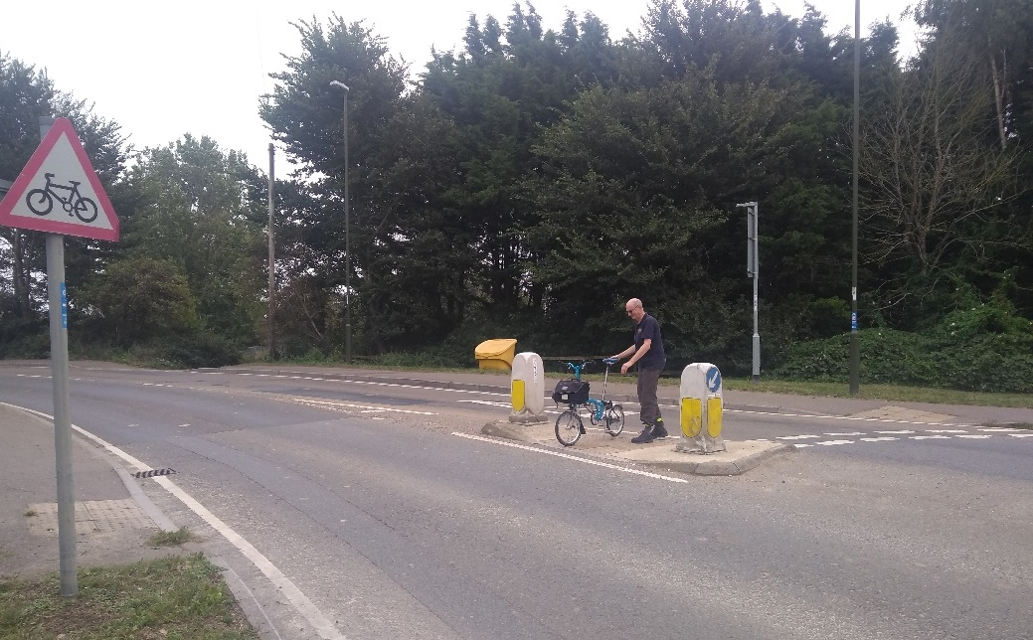
Plan 8: Rights of Way and cycle routes in LCWIP area
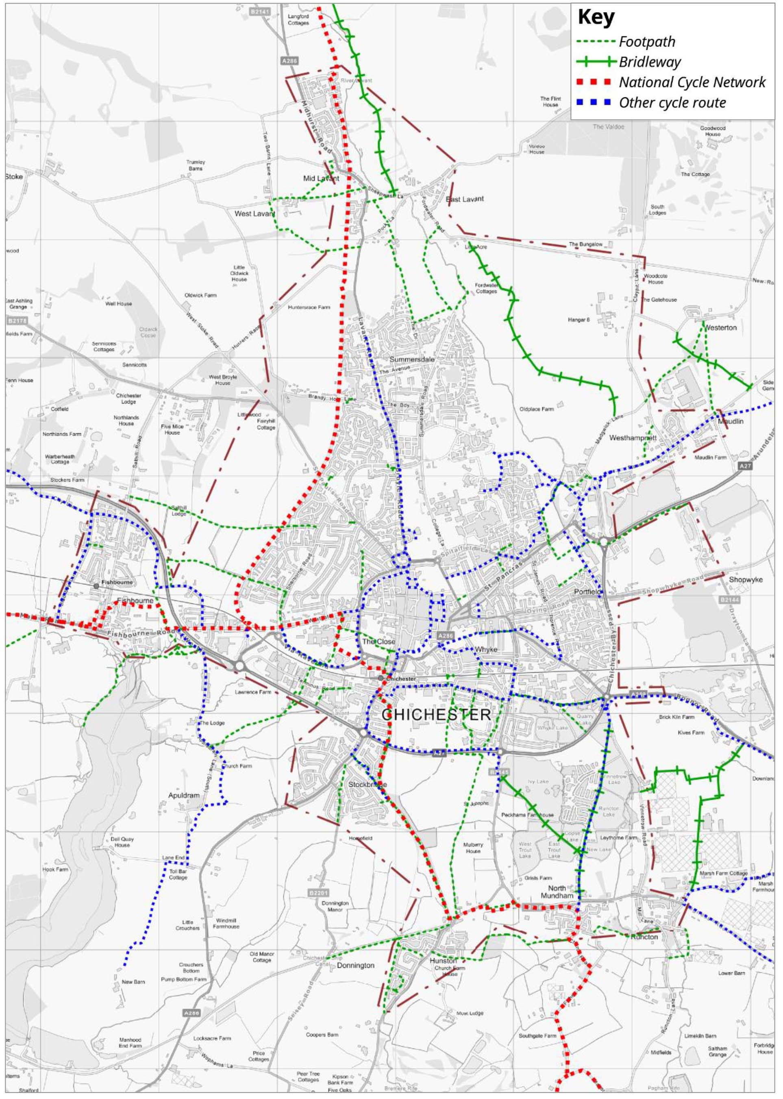

2.5 Stakeholder input
As well as data based on existing travel patterns and the road and path network, the views of key stakeholders are important. These can help to reveal areas where there are concerns or where improvements might be most beneficial.
A stakeholder workshop was held in July 2019 to gather information on the key issues. Plan 9 shows the outputs from the workshop. Detailed comments (provided separately) were gathered from participants and used later in the LCWIP process to help refine walking and cycling proposals.
Plan 9: Stakeholder comments
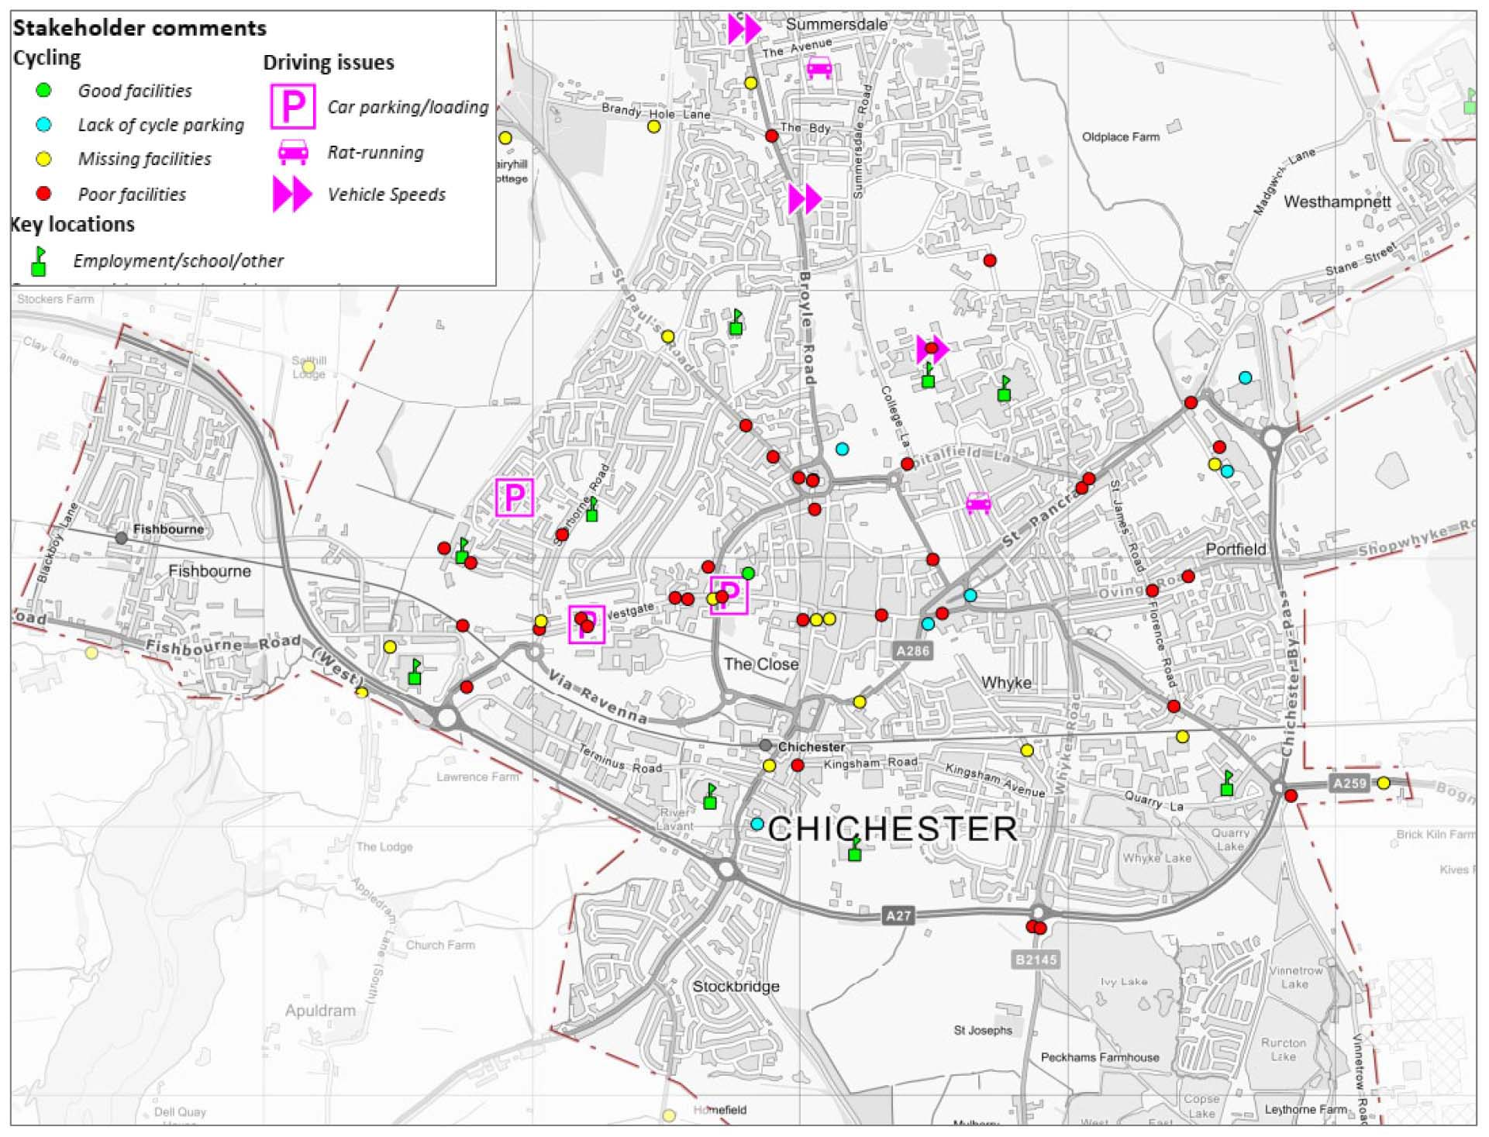
Stakeholder workshop
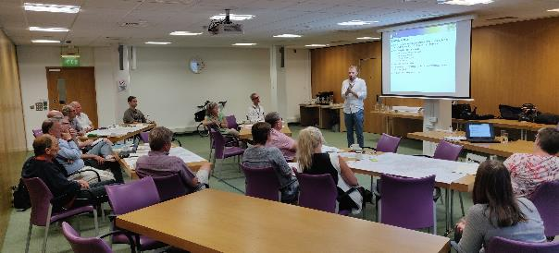
2.6 Public consultation
A draft version of the LCWIP was approved by CDC for consultation in June 2020 and a full public consultation process was carried out from 18 September to 19 October 2020. The main findings from the public consultation are set out below. A full analysis report from the consultation is available (Appendix D).
General
- There were 240 responses from the public consultation, with 11 responses stating that they represented more than one person (including four from Parish Councils). Taking these into account, the views of 3,112 individuals were recorded.
- Responses were also submitted by WSCC, SDNPA, Highways England, Chichester City Council and Chichester District Cycle Forum.
- Individual responses were fairly evenly split between male (47.5%) and female (45.4%). The majority of respondents (219) were residents of CDC, with half of these (110) living in Chichester City itself.
- The largest age group represented was aged 65 years and over (30.9%), with the next largest group being 55-64 (28.4%). 12.7% of respondents said that they have a long-term illness, health problem or disability.
- The most common way of travelling into Chichester City centre was by car or van (on their own or shared with others) with 204 responses. 148 said that they walk and 108 said that they cycle. The main purposes for travel were shopping (223), leisure (180) and work (76). Note that people could choose multiple options for these questions.
- More than half of respondents (125) felt that the money currently spent on walking and cycling infrastructure in the area was too little.
- Well over half of respondents strongly agreed with the envisaged benefits of increased cycling and walking in the area, especially improved health (see below).
Support for benefits of improved cycling and walking
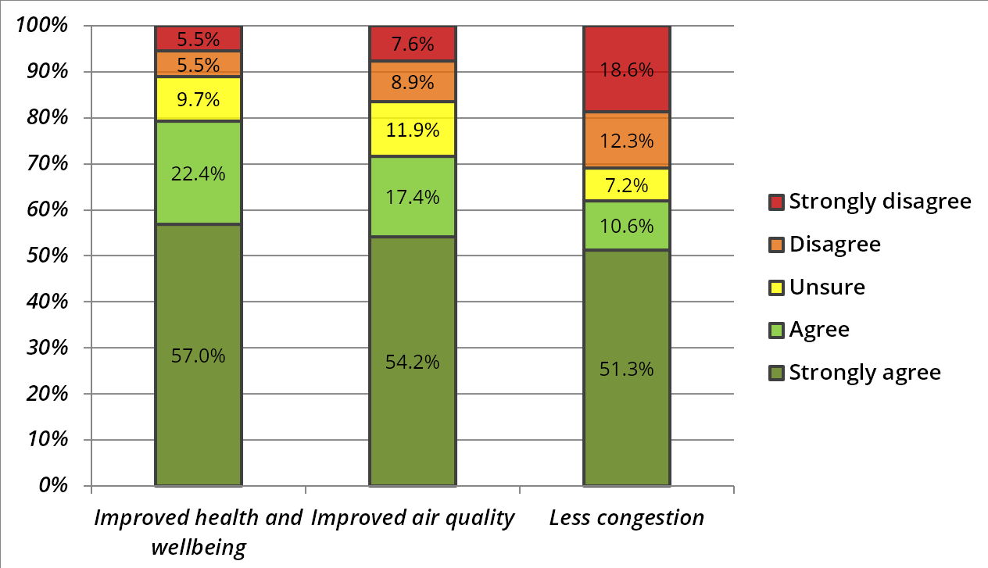
Walking
- When asked how often they currently walk into and around Chichester City, the most popular responses were ‘most days’ (25.1%) and ‘once or twice a month’ (25.1%).
- 147 respondents (61.8%) commented on the walking improvements in the draft LCWIP. Of these, 42% were dissatisfied or very dissatisfied with the current walking network.
Satisfaction with current walking network
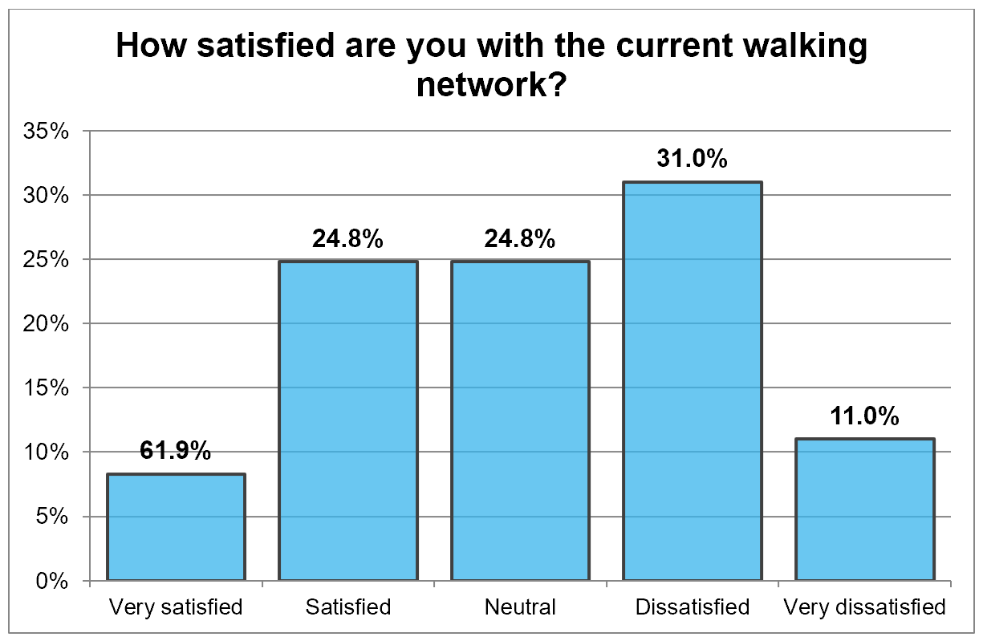
- ‘Busy roads’ was given as the main issue that prevented respondents from walking or walking more frequently in the area (77). Other top responses included ‘quality of physical environment’ (62), ‘difficult junctions’ (60) and ‘personal safety’ (55)
- Respondents were asked to what extent they thought a variety of improvements would encourage them to walk more often in the area. The majority of these respondents either agreed or strongly agreed with most of the improvements.
- 60 respondents provided comments about the walking audits carried out and they suggested walking improvements in the plan.
Cycling
- The most common response when asked how often people cycle was ‘never’ with 42.2% and then ‘once or twice a week’ (18.1%) and most days (12.7%).
- 172 respondents (72.9%) commented on the cycling improvements in the draft LCWIP. Of these, nearly three quarters (74.1%) were dissatisfied or very dissatisfied with the current cycling network.
Satisfaction with current cycling network
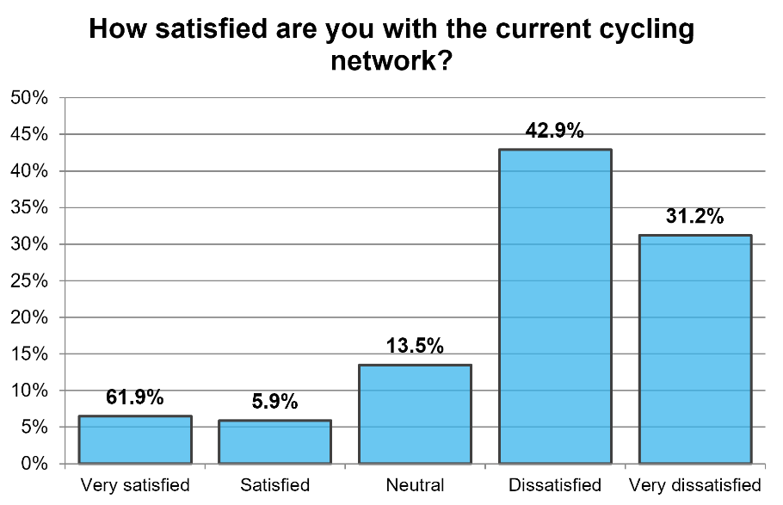
- ‘Busy roads’ (95) and ‘difficult junctions’ (95) were given as the main issues that prevented respondents from cycling or cycling more frequently in the area. Other top responses included ‘lack of segregated cycle routes’ (86) and ‘quality of physical environment’ (70).
- Respondents were asked to what extent they thought a variety of improvements would encourage them to cycle more often in the area. The majority of these respondents either agreed or strongly agreed with most of the improvements. Even where many respondents were unsure (notably School Streets), there was a higher level of agreement than disagreement (see Table 5 below, with measures underlined and in red showing majority support).
Table 5: Agreement with suggested cycling improvements (bold denotes most popular choice)
 | Strongly agree | Agree | TOTAL AGREE | Unsure | Disagree | Strongly disagree | TOTAL DISAGREE
Protected cycle track | 51.5% | 16.4% | 67.9% | 8.5% | 7.9% | 15.8% | 23.7%
Continuous cycleways | 43.6% | 17.2% | 60.8% | 7.4% | 11.7% | 20.2% | 31.9%
Additional cycle parking facilities | 37.6% | 32.7% | 70.3% | 15.4% | 7.4% | 9.9% | 17.3%
Low Traffic Neighbourhoods | 30.4% | 27.3% | 57.7% | 13.7% | 13.7% | 14.9% | 28.6%
Floating bus stop / bus stop bypass | 28.8% | 21.9% | 50.7% | 24.4% | 11.9% | 13.1% | 25.0%
Bus gates | 28.5% | 23.4% | 51.9% | 17.1% | 13.3% | 17.7% | 31.0%
Road closures/modal filter | 26.8% | 19.1% | 45.9% | 18.5% | 15.9% | 19.7% | 35.6%
Shared use path | 24.7% | 26.5% | 51.2% | 13% | 16.7% | 19.1% | 35.8%
Contraflow cycling | 24.8% | 20.5% | 45.3% | 19.3% | 9.3% | 26.1% | 35.4%
School Street | 23.4% | 22.2% | 45.6% | 29.1% | 13.9% | 11.4% | 25.3%
Toucan crossing | 18.9% | 36.5% | 55.4% | 24.5% | 8.2% | 11.9% | 20.1%
Cycle lane (with no physical separation) | 18.5% | 35.8% | 54.3% | 14.8% | 13% | 17.9% | 30.9%
- 55 general comments were received about cycling improvements, with a further 294 comments on the proposed cycling measures in the core area or on any of the nine individual cycle routes (respondents were able to comment on multiple routes).
- The number of comments received for each route are shown in Table 5 (see Section 6 for details of the routes). Unsurprisingly the largest number of comments were received on the core area. The individual routes with the largest number of comments were routes A and K, followed by G and H (combined) and N.
Table 5: Level of comments on cycle routes
Route | Number of comments | Rank
Core area | 55 | 1
Route A | 43 | 2
Route B | 31 | 6
Route E | 23 | 7
Route F | 21 | 8
Routes G & H | 32 | 4=
Route K | 38 | 3
Route N | 32 | 4=
Route Q | 19 | 9
3. Potential for cycling & walking
3.1 Introduction
Developing and planning a potential cycle network can be a complex process, but essentially relies on building up options that deliver supressed demand while being realistic and deliverable. The stages to be followed are:
- Analysing existing and potential trips, based on demand
- Identifying corridors to deliver the demand-led trips
- Prioritising corridors for further assessment
- Developing priority routes in more detail and identifying improvements
Planning strategic improvements for walking is somewhat different, since in most cases the core infrastructure (footways) is already present. Furthermore, walking is generally more evenly distributed than cycling. Hence, the stages to be followed are:
- Defining Core Walking Zone(s) and key walking routes
- Auditing Core Walking Zone(s) and key walking routes
- Identifying improvements
3.2 Potential for cycling
By understanding and analysing data on actual cycle trips, the future network can be planned to serve the highest number of trips. The DfT’s Propensity to Cycle Tool (PCT) shows the increase in cycling, based on a range of scenarios. The PCT extrapolates from current cycling patterns based on cycle trip distances and hilliness. This can then be used to show where people might cycle if it was safe and convenient.
For the Chichester LCWIP, the “Government Target – near market” scenario was used. This shows the increase based on an overall national doubling of cycling, concentrated where the types of trips and socio-demographic profile both support cycling. While cycling levels would increase across the LCWIP area, the largest increases are in the west and south.
Plan 10: PCT analysis using Government Target – near market scenario
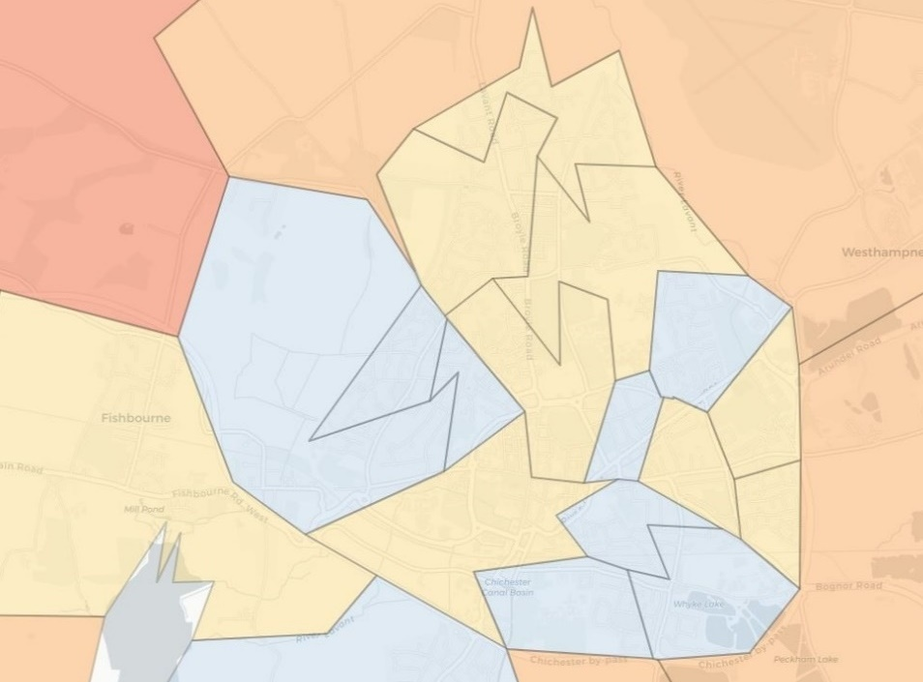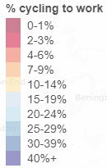
These increases can be examined in more detail to show where trips start and finish. Plan 10 shows the overall level in each LSOA, with idealised straight-line trips between all LSOA pairs in Plan 11. Highlighting the most significant trips shows that the routes with the highest potential are mostly radial (into/out of the centre of Chichester – see Plan 12).
Plan 11: PCT analysis of origin-destination trips under Government Target – near market scenario
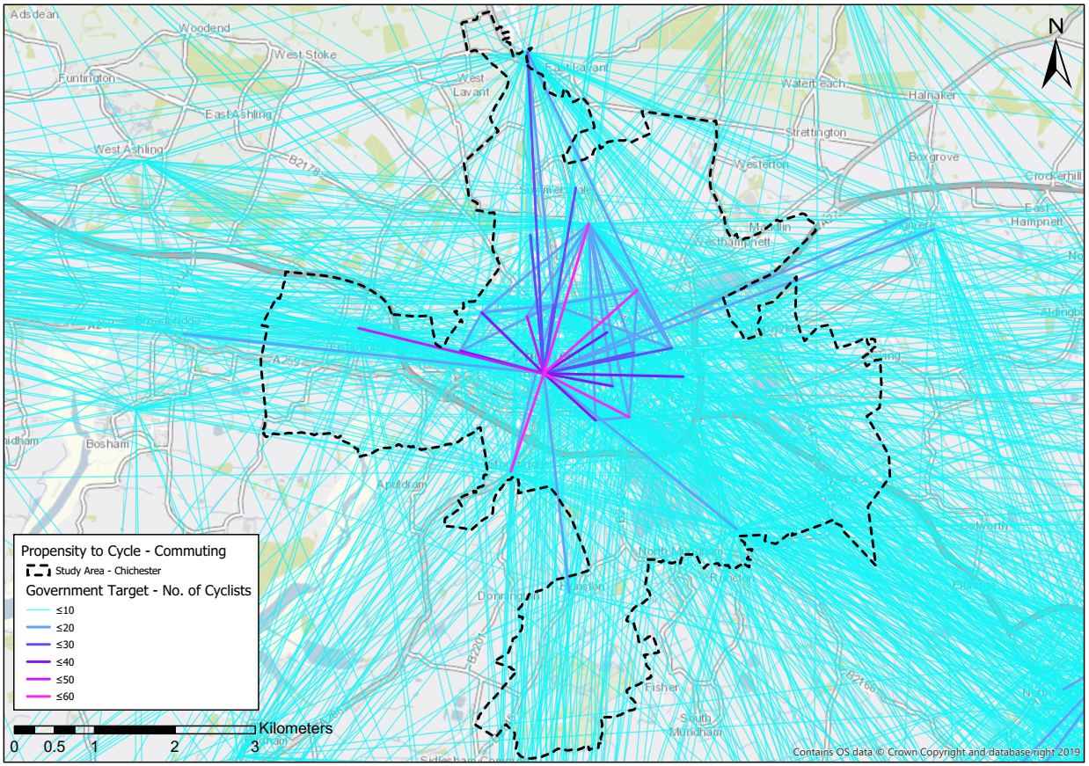
Plan 12: PCT analysis of top 30 origin-destination trips under Government Target – near market scenario
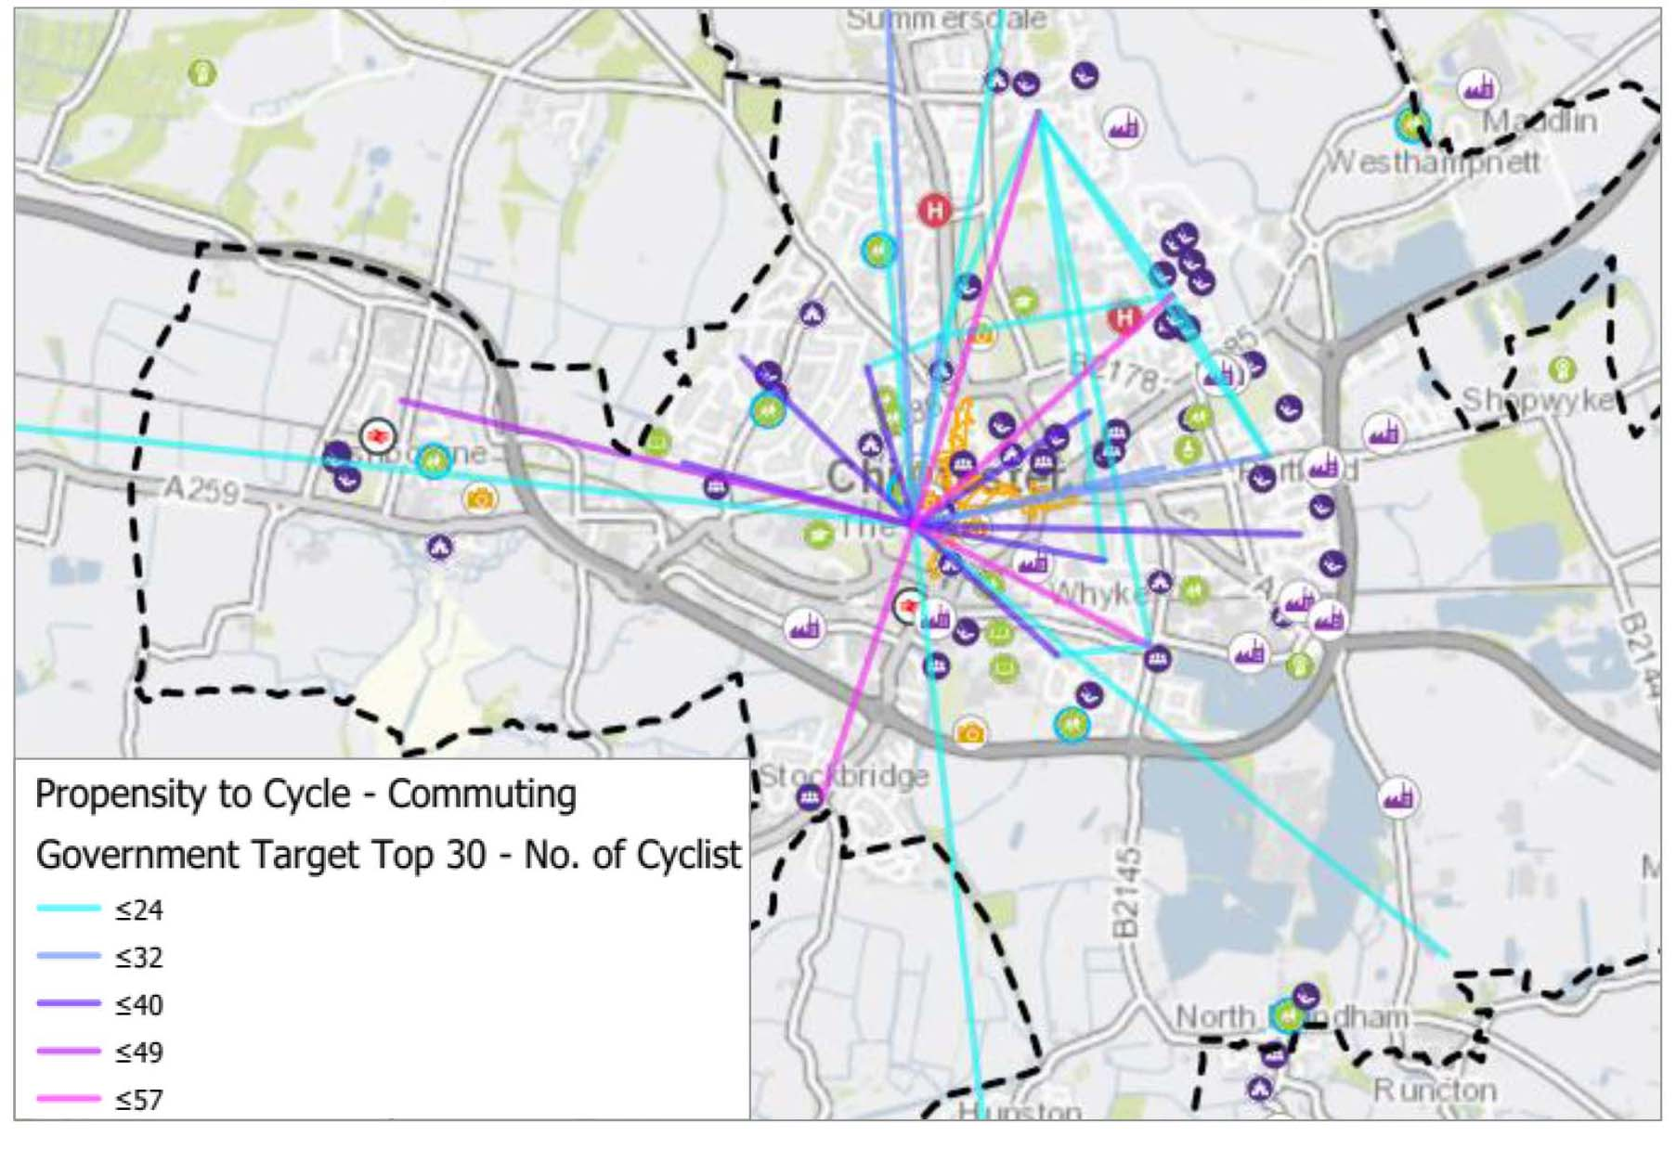

The PCT allows these trip corridors to be plotted against the actual route network, rather than idealised straight lines. Plan 13 shows the same top 30 potential trip alignments, using the road and path layout in the LCWIP area. Note that green lines show quiet (generally off-road) trips while purple lines reflect more direct trips along the road network. The thickness of the line shows the level of potential trips.
It is important to appreciate that these are potential trips assuming improvements for cycling. Hence some trips are shown along roads which most people would consider to be currently unsuitable for cycling.
Plan 13: PCT analysis of top 30 potential trip alignments under Government Target – near market scenario
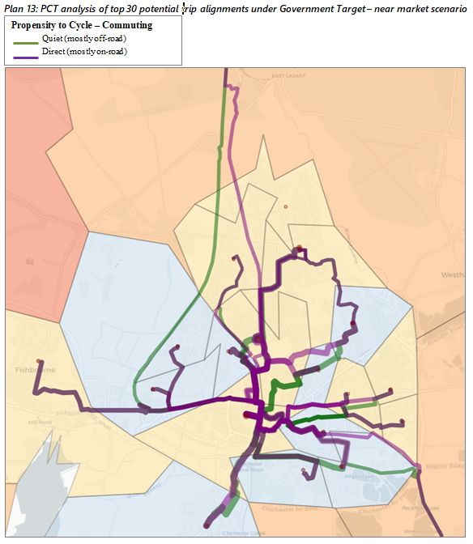

While the PCT was initially designed only to assess data on cycling to work, it has recently been revised to include cycling to school, with different scenarios. Plan 14 shows potential cycle journeys under the “Go Cambridge” scenario, in which the pattern of pupils travelling to school would be similar to that in Cambridge.
Plan 14: PCT analysis of potential cycle to school trip under “Go Cambridge” scenario
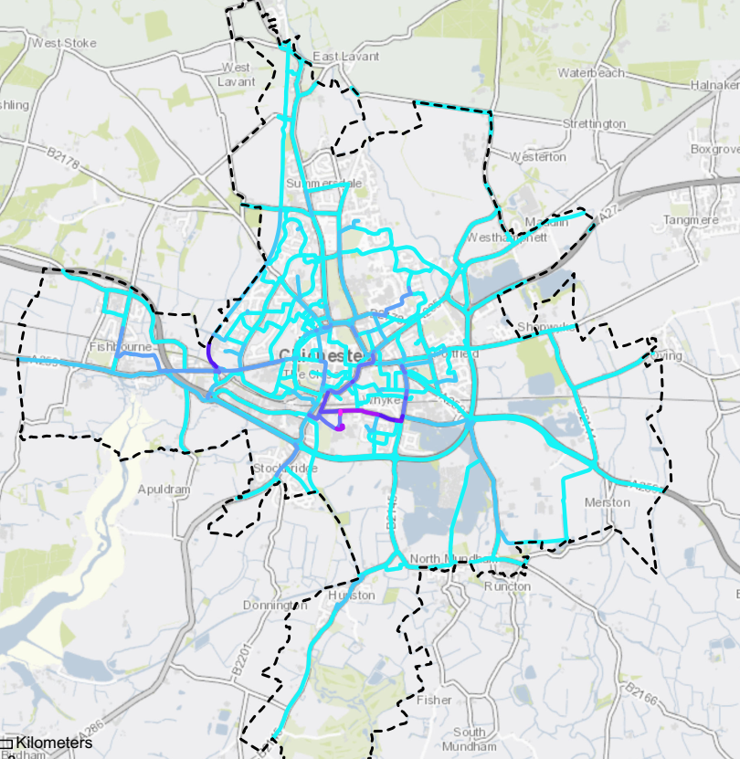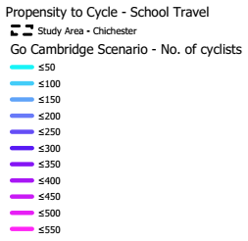
Issues with cycle demand analysis
It is important to note that the PCT is based on the 2011 census and hence does not take into account any changes in either residential or workforce population since that date. It also only uses travel to work or school data.
Furthermore, the modelling does not allow for future developments, such as those planned at White House Farm and Tangmere. As these are highly significant in the study area, these need to be addressed in terms of the potential for cycling based on the level of population increase. A realistic target would be for 15% of trips to be made by cycle, matching the highest level in the Government Target scenario shown above.
Where there is no evidence of demand, the development of routes along other desire lines identified in policies and plans may still be justified in terms of leisure and recreation. Using this as the basis for a route will lead to a different approach to alignments and type of infrastructure.
Initial suggestions for route corridors
Based on the analysis of the road and path network, a set of possible corridors was developed for further assessment. These were assessed in detail and presented at a second workshop for stakeholders in November 2019. Many detailed comments were received which were used to help refine the proposed routes. Plan 15 below shows the routes, split into four quadrants to reflect the format used at the workshop.
Plan 15: Potential route options (quadrants as used at Stakeholder meeting)
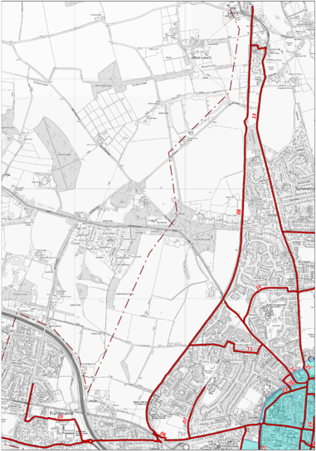 | 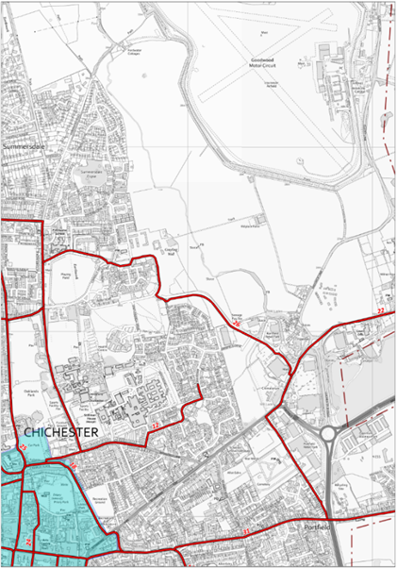
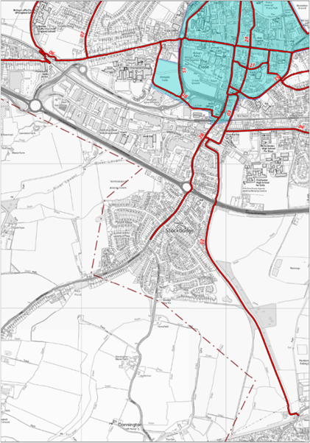 | 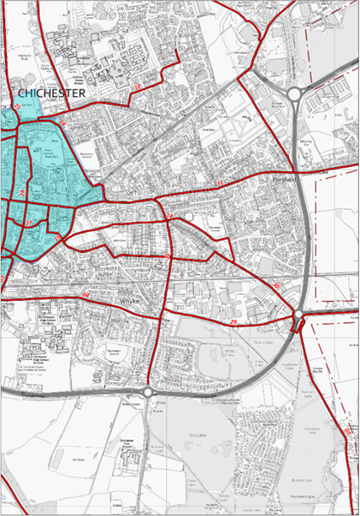

Route network
An initial version of the proposed network was developed taking into account all the factors discussed above. The network was subsequently refined following discussions between the consultants, CDC and WSCC. Routes were split into those where the lead responsibility for promoting the route would be taken by CDC, WSCC or another party (including developers). It was not considered necessary for routes to be prioritised further at this stage.
The initial version of the proposed network is shown in Plan 16, with the final version shown in Plan 19 below. All the proposed routes lie outside the core area and terminate at the A286 ring road. Improvements within the core area were not allocated to individual routes as it would be difficult to define specific alignments and most trips will use a number of links.
Plan 16: Initial version of proposed network
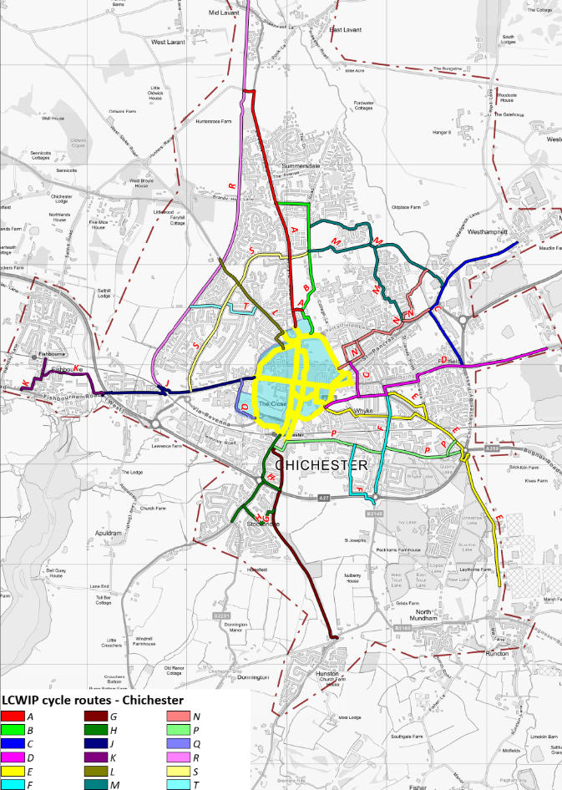
3.2 Potential for walking
There is no version of the PCT which can be used for walking. However, the Core Walking Zone (CWZ) was defined based on the cluster of key destinations in the city centre. The ring road forms a distinct boundary, matching for the most part the historic city walls. Hence this area was defined as the CWZ. This definition was mostly supported by the stakeholder workshop, which recommended extending the CWZ to incorporate three key destinations:
- Chichester station
- Chichester College
- Chichester Festival Theatre
Defining key walking routes is less straightforward and requires detailed analysis of raw census data. A tool which allows this to be done without excessive work is the Datashine portal which provides analysis of data from the 2011 census. Plan 17 shows walking trips between areas of Chichester which establishes shows that the main flows are to the north, south-east and west of the city centre.
Plan 17: Main existing walking flows to/from city centre (using Datashine portal)
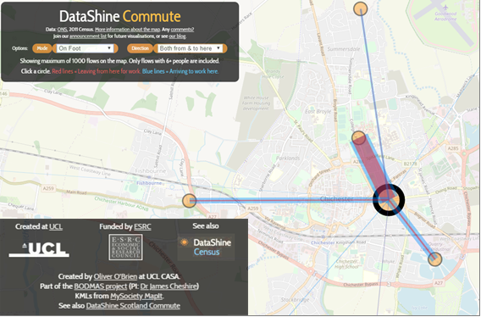
Following discussions with officers, it was agreed that two routes should be assessed in detail:
- North of CWZ – key destinations include Chichester University and St. Richard’s Hospital, extended to Summersdale
- West of CWZ – key destinations include Bishop Luffa school, White House Farm development, Centurion Way and links to Fishbourne
Plan 18 shows the Core Walking Zone with the two key walking route corridors.
Plan 18: Core Walking Zone (blue) and key walking route corridors (purple)
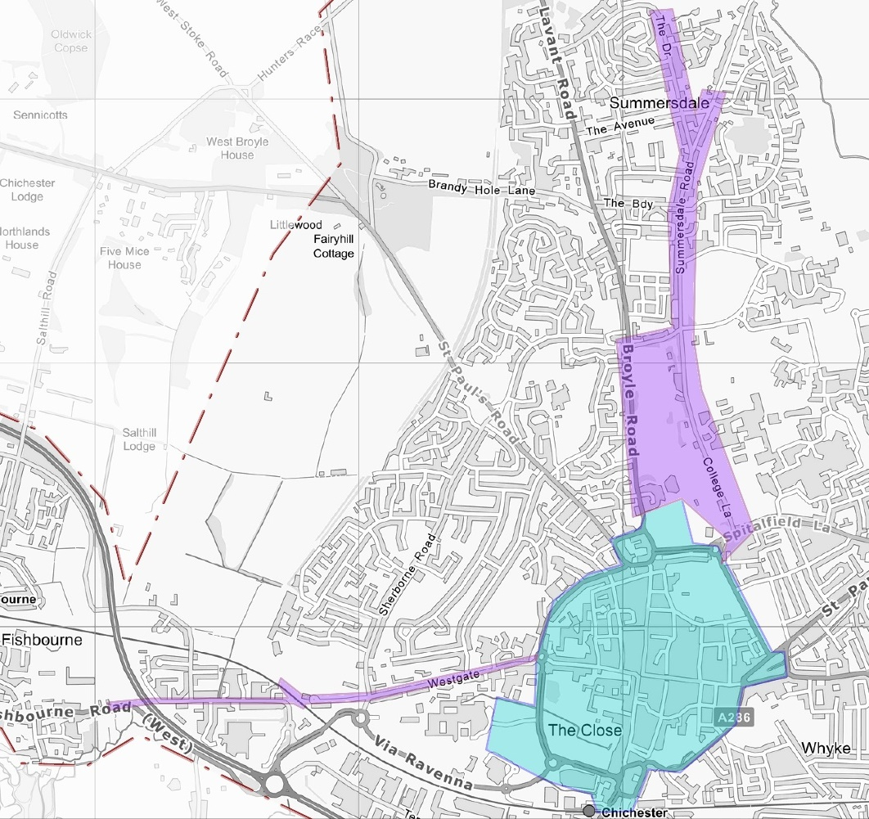
Signed walking route to town centre through Northgate car park
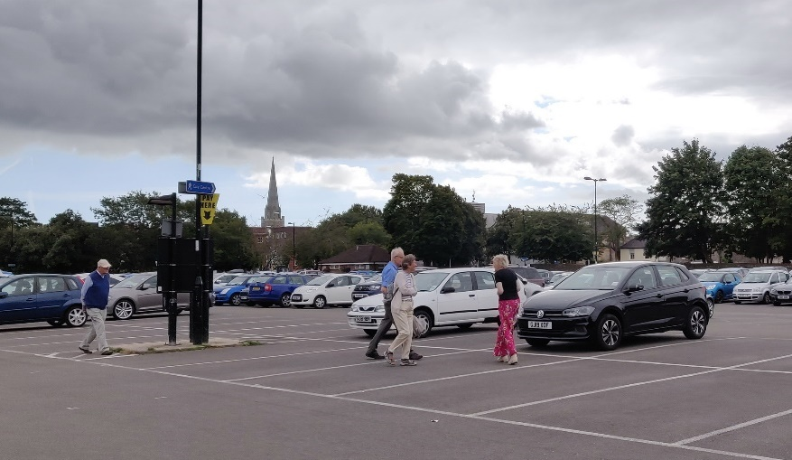
4. Cycling assessment & proposals
4.1 Summary
Desk research and site visits were carried out to investigate and assess the existing and potential alignments for the possible route options (both on- and off-road). Plan 19 shows the final version of the network, taking into account changes in Government guidance in July 2020 (notably LTN1/20) and responses to the public consultation in autumn 2020.
The review process included the following stages:
- Assessment of existing routes (both roads and paths) to determine if they are fit for purpose, based on the DfT Route Selection Tool (RST)
- Identification of links to fill gaps in the network or replace sub-standard sections
- Identification of routes and route sections to match the alignments revealed by the demand assessment and/or satisfy desire lines identified by stakeholders.
Note that routes where the “route promoter” is WSCC or developers were not assessed in detail for feasibility or cost. This includes routes forming part of the draft county LCWIP.
4.2 Issues
Table 6 shows comments on issues for cycling along routes outside the core area.
Table 6: Locations of issues on proposed routes (see Plan 19)
Route | Section | Ref | Existing cycling provision
A | Lavant Rd (Hunters Race - Hunters Way) | 1 | Recently constructed link between Centurion Way and Lavant Rd, but no cycling provision on road itself
 | Lavant Rd / Broyle Rd (Hunters Way – Churchside | 2 | Advisory cycle lanes throughout, but with gaps in provision and narrow sections of <1.2m. Space used extensively for wide central hatching & waiting areas for vehicles turning right.
B | Broadway | 3 | No cycling facilities (also no footway on southern side) – residential street serving as main access to Summersdale area
 | College Lane | 4 | No cycling facilities (similar feel to country lane despite being at edge of city centre), but main access to Chichester University for motor vehicles
E | Vinnetrow Rd | 5 | Narrow shared use path connecting with public footpath
 | A27 bridge | 6 | Shared use footbridge
 | Quarry Lane | 7 | Limited facilities (short narrow cycle link to bridge)
 | Whyke Rd (Quarry Lane - Cleveland Rd) | 8 | Signed cycle route with no facilities
 | Cleveland Rd - Lyndhurst Rd | 9 | Signed cycle route with no facilities but along quiet residential streets
 | Caledonian Rd | 10 | Signed cycle route with no facilities but along quiet residential street
 | Whyke Rd (railway to Bognor Rd) | 11 | Busy main road, no cycling facilities
F | Whyke Rd (A27 to railway) | 12 | Busy main road, cycling no facilities
 | B2145 to North Mundham | 13 | Existing shared use path as far as Free School, track south-east to North Mundham
 | Sheffield Park Rd/ Hay Rd to Kingsham Rd | 14 | White line separated cycle/footpath across park, with poorly detailed crossing by primary school
G | Chichester Canal (north) | 15 | Shared use towpath with steep link to path along A27, obstructed by barriers
H | Grosvenor Rd | 16 | No cycle facilities, but quiet residential street
 | Stockbridge Rd (Grosvenor Rd – A27) | 17 | Busy main road, with section of shared footway on western side by shops, plus Toucan crossing linking to shared path running east
 | A27 Bridge / King’s Ave | 18 | Ramped bridge across A27 with cycling not permitted, with short shared-use path to King’s Ave
 | Stockbridge Rd (King’s Ave – railway) | 19 | Narrow shared use path on western footway
K | Westgate | 20 | Signed route (NCN 2) along residential street (with rat-running traffic) with no cycle facilities apart from very narrow gaps at road narrowings
N | River Lavant open space | 21 | White line separated cycle/footpath through open space
 | Swanfield Drive East | 22 | New shared path provided as part of Lidl development
 | St. Pancras Rd / Westhampnett Rd | 23 | Busy road with no cycle provision
 | Cutten Way | 24 | No facilities but quiet residential cul-de-sac leading to footbridge across River Lavant
Q | Chichester College Park | 25 | White line separated cycle/footpath between Chichester and Mount Lane, through College Fields, with no provision at crossing of college access road (Swieqi Rd)
Issue 2: Lavant Road – existing narrow advisory cycle lanes
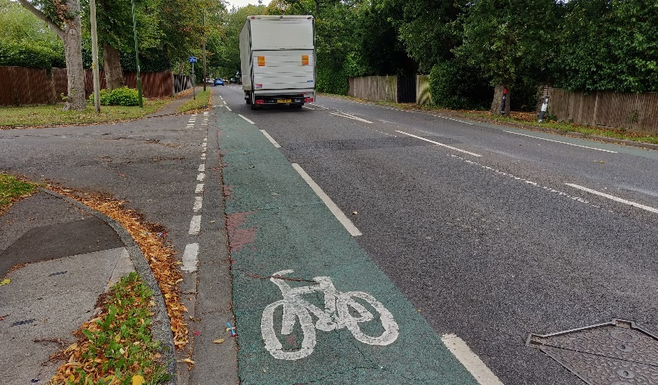

Plan 19: Main issues on proposed network (note routes are those in draft LCWIP)
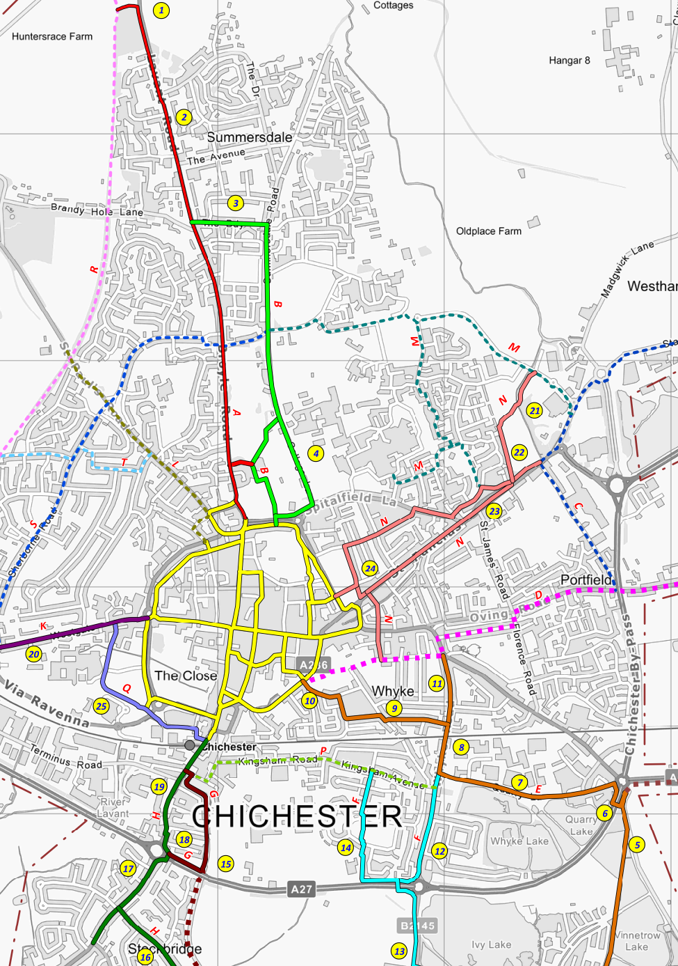

4.3 Routes
The proposed network comprises 19 individual routes totalling 51.5 km (see Table 7 and Plan 20), with 44.7 km along the main route alignments and a further 6.8 km of links and spurs.
The network in the core area comprises 6.5 km in total (not split into main/spurs).
Table 7: Proposed cycle routes
Route | Name | Promoter | Length (km)
 |  |  | Main | Spur(s)
A | Lavant | CDC | 2.7 | 0.2
B | University | CDC | 1.8 | 0.8
C | Westhampnett | Other | 2.3 | 0.2
D | Shopwyke | WSCC | 2.5
E | Vinnetrow | CDC | 3.1
F | North Mundham | CDC | 2.7 | 0.6
G (north) | Chichester Canal | CDC | 1.0 | 0.2
G (south) | Selsey Greenway | WSCC | 5.3
H | Stockbridge | CDC | 1.6 | 0.2
J | ChEmroute | WSCC/Highways England | 2.3 | 1.5
K | Westgate | Other | 1.2
L | St Paul's | Other | 1.2
M | Graylingwell | Other | 1.6 | 1.3
N | St Pancras | CDC | 1.9 | 1.2
P | Kingsham | Other | 1.2
Q | College | CDC | 0.8 | 0.7
R | Centurion Way | Other | 6.7
S | Sherborne | Other | 2.1
T | Parklands | Other | 0.8
U | Bognor-Chichester | WSCC | 2.0
Plan 20: Proposed network (final version)
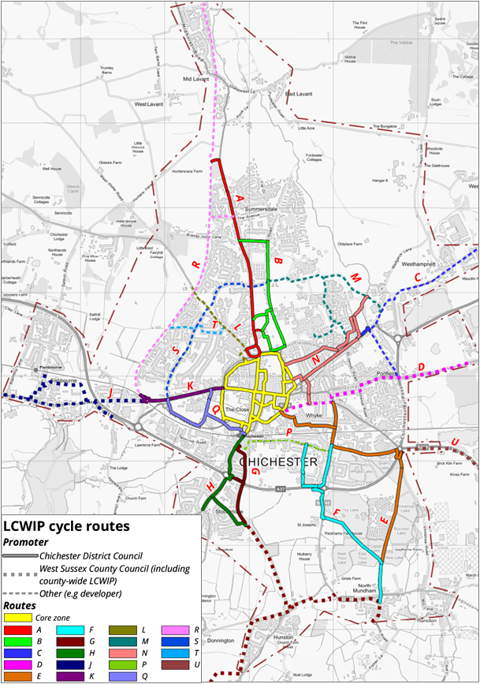
4.4 Route assessment
As noted above, detailed assessment of the routes focused on those expected to be developed and promoted by CDC: A, B, E, F, G north, H, K, N and Q. While the other routes are also important, these will be promoted and developed by either WSCC or a third party (including developers), or form part of wider plans. Three routes are included in the draft county LCWIP: G south (Selsey Greenway), J (ChEm-route, being developed by Highways England in partnership with WSCC) and U (Bognor – Chichester).
The assessment involved the application of the DfT’s RST to the existing route alignment and then to the route following the proposed interventions. This shows the level of improvement that can be achieved.
The RST measures quality of a route using five key criteria: Connectivity, Safety, Directness (deviation from straight line distance), Gradient and Comfort. Routes were divided into sections with similar characteristics and scored against these five criteria, from 0 (poor) to 5 (excellent). Junctions considered to be hazardous to cycling were also identified and recorded (described as ‘critical junctions’).
The LCWIP technical guidance outlines that the aim is to identify cycle routes which score 3 or above against each of the criteria (or could be improved to score 3 or above), ideally with no critical junctions. Improvements were therefore identified for poor scoring sections. In some cases, alternative routes were required to achieve higher quality.
The intention of the improvements is to meet the key design outcomes which are described in the LCWIP guidance. These include conforming to LTN1/20.
Key design outcomes, DfT LCWIP guidance
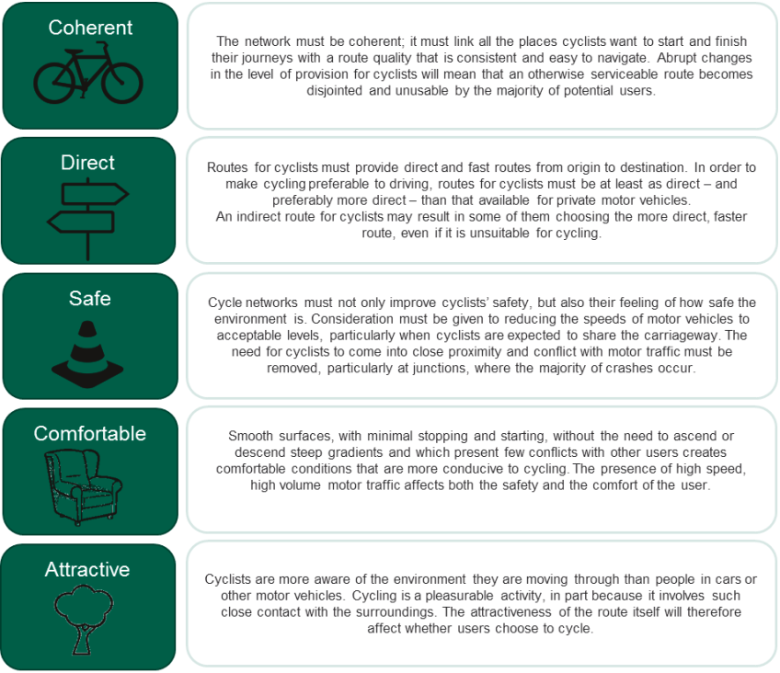
An example of the RST output, for Route A, is given below (Appendix B has RSTs for all routes). The key route proposals are summarised in Table 8, with more detail in Section 6.

Example RST assessment for proposed Route A
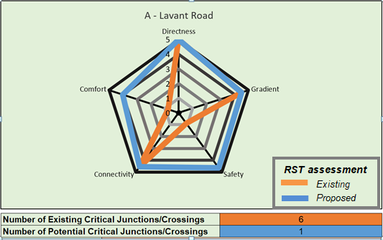

Table 8: Summary of key measures on routes promoted by CDC
Route | Name | Summary of key proposed measures
A | Lavant | New section of shared use path at northern end to connect with improved surface on recently constructed link to Centurion Way  Protected cycle lanes along Lavant Road & Broyle Road (using space redistributed from unused central hatching)
B | University | Cycle street proposals on College Lane with improved links at Oaklands Park connecting to Chichester University, possible Low Traffic Neighbourhood (LTN) in Summersdale
E | Vinnetrow | New protected facilities for cycling and upgrades to existing facilities where necessary, with two-way track on Quarry Lane
F | North Mundham | Improvements by Chichester Free School and in Whyke (possible LTN), including School Street at Kingsham Primary School  Improved surface on path to North Mundham
G (north) | Chichester Canal | Improved surfacing on canal towpath and better access to shared path along A27
H | Stockbridge | Protected cycle lanes (replacing existing shared use path) with continuous footways at side roads (using space redistributed from unused central hatching)  Upgrade of Stockbridge Road/Terminus Road junction to incorporate proposed cycle tracks/lanes with cycle priority facilities on all approaches and pedestrian crossings on all arms
K | Westgate | Major improvement at Orchard Street/Westgate junction  Cycle street, cycle lanes/tracks and/or filtered permeability between Orchard Street and Centurion Way
N | St Pancras | Protected cycle lanes on St. Pancras Road, possible LTN in Swanfield Park area
Q | College | Improvements to existing path with new crossing of Swieqi Road at Chichester College to maintain cycle and pedestrian priority  Improved links at Chichester station
5. Walking assessment & proposals
5.1 Introduction
As noted above, the DfT has set out guidance on how to assess infrastructure for walking using the ‘Walking Route Audit Tool’ (WRAT). Three areas were identified as being the priority for walking assessments:
- Core Walking Zone
- Northern walking route
- Western walking route
The highway network (including all pavements) was first divided into links and areas for more detailed auditing, using a desk-based approach. Each link or area began and ended where the characteristics of the pedestrian environment changed significantly or were interrupted by a major junction.
Site visits and detailed surveys were then carried out for all of these. The links and areas were assessed using the WRAT process (see Appendix C for the full scoring criteria from the WRAT guidance). This looks at five core categories (divided into 20 sub-categories):
- Attractiveness
- Comfort
- Directness
- Safety
- Coherence
Each of the subcategories was scored on a three point scale:
- 0 - Poor provision
- 1 - Adequate but should be improved if possible
- 2 - Good quality provision
The maximum score possible is 40. The WRAT guidance recommends that any item with a score under 70% (28 out of 40) is considered to be poor. While the guidance does not differentiate between items scoring over 70%, these have been divided into two groups for this LCWIP: Adequate (70%-85%) and Good (over 85%). This will assist development of measures to improve walking by allowing interventions to be prioritised
Example of poor provision (crossing - subcategory 12), South Street
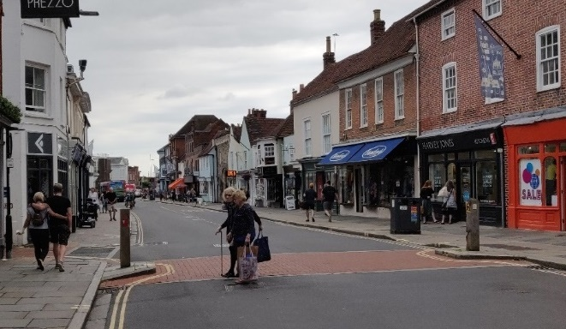
5.2 Core Walking Zone (CWZ)
The CWZ is shown in Plan 21 and covers central Chichester. As noted above, the CWZ was defined initially on the basis of local geography, with a number of changes from feedback from stakeholders as well as observations gathered during the cycling assessment.
Plan 21: Core Walking Zone
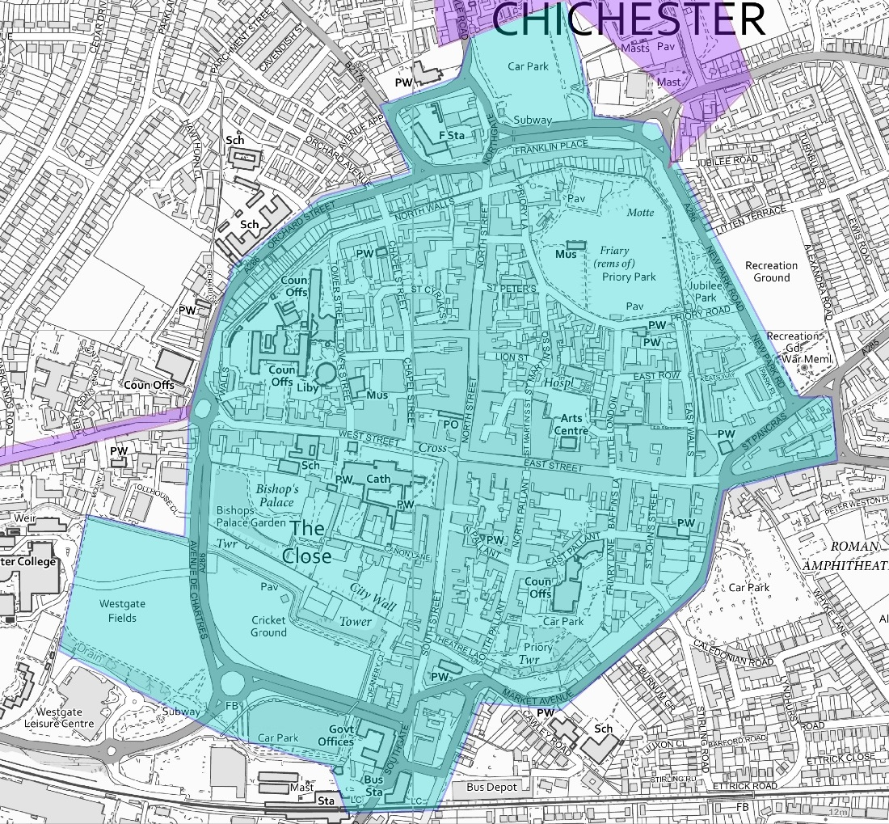
Each link was scored and assessed as shown in Plan 21 below. The results of the assessment are shown in Table 9. Appendix C contains full details of the assessment.
Table 9: Links in CWZ
Classification | No. of links/areas
Good | 54
Adequate | 31
Poor | 14
Most of the links assessed were classified as good or adequate, and hence according to the DfT criteria did not need attention.

Plan 22 shows the links, colour coded using a Red-Amber-Green scale (an alternate version suitable for people with colour-blindness is provided in Appendix C).
Plan 22: Core Walking Zone assessment
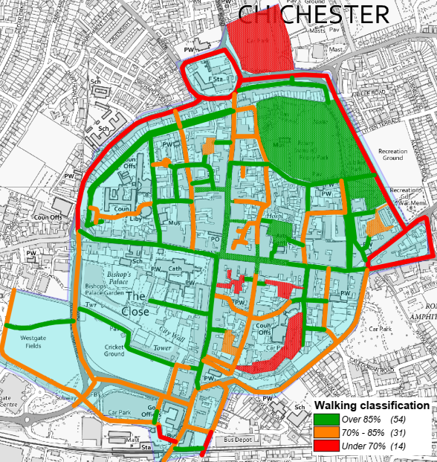
The areas with poor provision for walking fall into two main categories:
- Footways on the main roads around the centre (including the Northgate and St. Pancras/Hornet gyratory systems)
- Walking links through car parks, including at Chichester station’s northern entrance
Despite the relatively good performance, there are some significant issues to be addressed to make walking in the core area of Chichester attractive and convenient for both residents and visitors. These are set out in more detail in Appendix C.
The density of car parks in and around the city centre makes a clear statement that people arriving by car are welcome. However, once drivers have parked the consistency of their experience on foot (including that of their passengers) was assessed as being generally unsatisfactory, particularly if they are disabled or have other mobility issues. There is very little dedicated pedestrian provision within car parks and hence after leaving their cars, drivers and passengers are generally expected to share car park roadways with vehicles arriving or leaving. In particular Northgate, Baffins Lane and Cawley Priory/East Pallant car parks were all classified as Poor for people walking.
The poor performance in some areas should be considered in the light of the overall circumstances. Chichester is an historic city with historic streetscapes. Preserving these restricts some of the things which can be done to change existing infrastructure. In the historic core there are many places where narrow pavements result in a zero score, but where pavement widening is not a realistic option.
South Pallant – very narrow footway on one side only
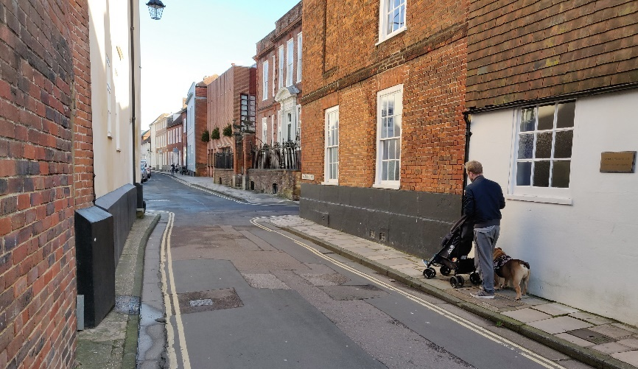
Similarly, many links scored low on fear of crime where paths are not well overlooked, such as those through most parks or along the city walls. These will be fine during daylight hours but less so in darkness (two parks, Priory Park and Bishops Palace Gardens are locked at night, but the rest are open). However, it would not be reasonable to expect that this could or should be changed significantly as this is due to the nature of those locations.
Unavoidably narrow shared path at East Walls
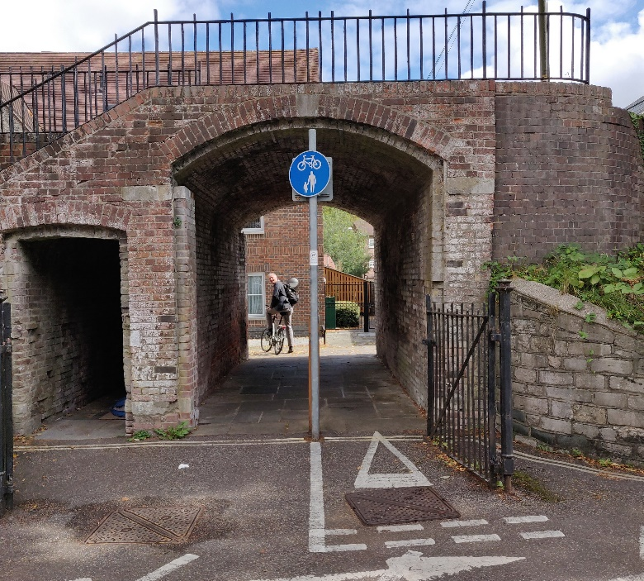
5.3 Key walking routes
Two corridor routes were assessed for walking, heading north and west from the core area:
- Northern route – about 2km long, from the north of the CWZ at Northgate car park. It includes access to the University along College Lane and then further to the north to residential areas along Summersdale Road. A linking section along Broyle Road and Wellington Road completes this corridor. The path from College Lane across Oaklands Park was also surveyed. It is roughly aligned with proposed cycle route B.
- Western route – this runs for 1.7km, from the west of the CWZ along Westgate as far as Fishbourne Road West and the link to Fishbourne Palace. It follows the same alignment as cycle routes J and K.
Northern route
The Northern route was split into 14 separate sections, shown in Plan 23 below. Every section failed on at least one of the twenty assessment criteria.
The lowest performing link was College Lane between the University of Chichester and Oaklands Way, which failed on several issues. This is a key link to the University (and also potentially St Richards Hospital) and hence should be a priority for any future intervention.
Plan 23: Northern walking route assessment
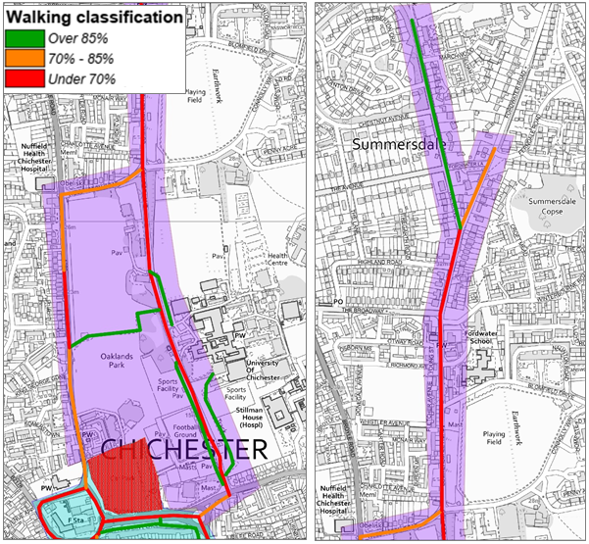
Northern walking route – link between Northgate car park & Chichester Festival Theatre
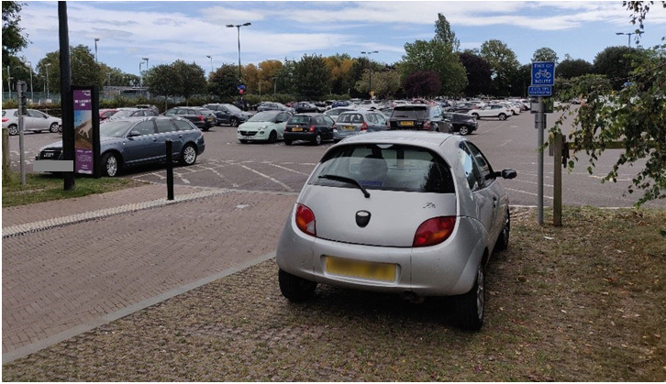
Western route
The western route was divided into eight sections, shown in Plan 24 below. Five of the sections failed on one or more criteria.
The key sections were on Westgate where there was poor crossing provision, inconsistent footway provision, and lack of consistent tactile paving.
Plan 24: Western walking route assessment
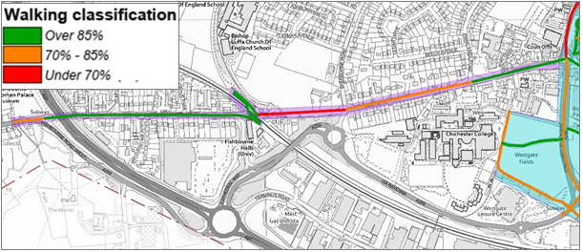
Western walking route – pinch points on footway of Westgate at Henty Gardens
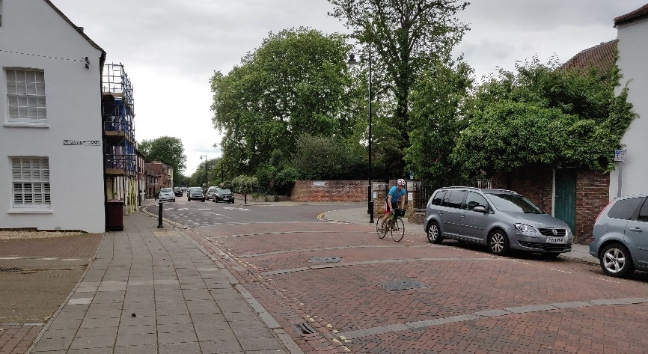
6. Detailed proposals & costs
6.1 General
A range of sources were used to develop detailed proposals for cycling and walking. As well as best practice examples from other locations in West Sussex, good practice elsewhere in the UK and indeed abroad was used. The final LCWIP has been revised to take account of LTN1/20, DfT’s guidance on design for cycling, which was published in July 2020.
6.2 Proposals for cycling – core area
A variety of inputs was used to develop detailed proposals for the core area, plus the routes outside the core area being promoted by CDC. These included feedback from stakeholders and site visits, as well as comments from the public consultation in late 2020.
Proposals have been drawn up and costed for cycle provision in the core area, shown in Plan 25. The network in the core area has been split into 19 links which are described in Table 10, with proposed ‘Do Minimum’ and ‘Do More’ measures.
Plan 25: Cycling proposals in core area
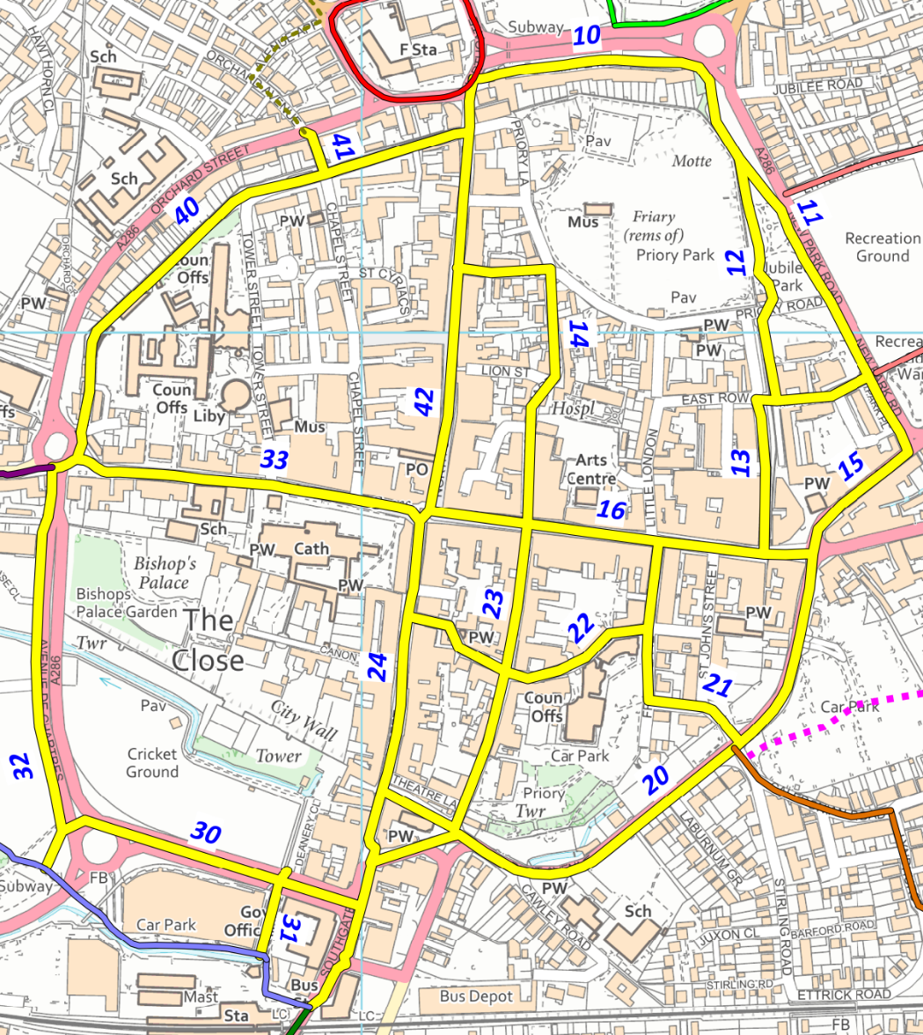
The interventions in the core area include cycle direction signing. As the core area is the main destination for increased cycle trips, there should be a significant increase in cycle parking provision to LTN1/20 standards, to offer higher security in busier areas.
The overall estimated costs for the measures in the core area (including signing and cycle parking) are £1.14m (Do Minimum) or £3.5m (Do More).
The estimated costs exclude measures that are an integral part of larger developments, particularly at the Southern Gateway. While these are at various stages, they should be examined in detail. The broader aspirations for walking and cycling access at these developments should be upgraded to match those in the Government’s ‘Gear Change’ strategy, published in July 2020. Where necessary, detailed proposals should also be updated to ensure that they fully meet the higher standards for cycling set out in LTN1/20 – for example, there should be no routes with shared use by walking and cycling.
Table 10: Main interventions – core area
Link | Quad-rant | Name | Do Minimum | Do More | Length (km)
10 | NE | Franklin Place | New parallel route on quiet side street with Toucan crossing of Oaklands Way (see B4) | See B4 | 0.211
11 | NE | New Park Road | Parallel two-way cycle track | Toucan crossing to Litten Terrace | 0.464
12 | NE | Jubilee Gardens | Widen path, introduce separation between walking & cycling sides  Parallel crossing of Priory Road | Low TrafficNeighbourhood | 0.255
13 | NE | East Walls / Keats Way | Clearer link at Keats Way with continuous footway |  | 0.275
14 | NE | St Peters / St Martin's Square / St Martin's Street | Parallel route when cycling not permitted in North St (two-way cycling in St Peters with improvements at Priory Road junction)  Allow cycles to cross East Street without dismounting with clear priority to pedestrians |  | 0.359
15 | NE | St Pancras |  | Consider removal of A259/A286 gyratory with two-way traffic on The Hornet & extension of pedestrian/cycle priority area to St Pancras west | 0.145
16 | NE | East Street | Pedestrian/cycle priority area extended eastwards to East Walls, with improved junction with St Pancras | Experimental removal of cycling restriction | 0.389
20 | SE | Market Avenue |  | Two-way cycle track | 0.643
21 | SE | St John's Street / Friary Lane | Improved links to existing Toucan crossing | Low Traffic  Neighbourhood | 0.180
22 | SE | East Pallant / West Pallant | Parallel route when cycling not permitted in East St (with two-way cycling in one-way sections)  Continuous footway / modal filter at west end of West Pallant |  | 0.368
23 | SE | North Pallant / South Pallant / Old Market Avenue | Parallel route when cycling not permitted in North St (cycle street treatment at southern end of South Pallant/Old Market Ave) |  | 0.399
24 | SE | South Street / Southgate | Cycle street with improved links at southern end | 15mph speed limit for buses  Southgate to be remodelled as part of Southern Gateway, with high quality walking and cycling provision throughout and in particular between Chichester station and South Street | 0.533
30 | SW | Avenue de Chartres (south) | New Toucan crossing at Deanery Close | Protected cycle lanes with Dutch-style redesign of Via Ravenna roundabout | 0.316
31 | SW | Deanery Close - station | Widen path, with separation between walking & cycling sides |  | 0.090
32 | SW | Avenue de Chartres (west) | Widen path, with separation between walking & cycling sides  New signalled junction at Westgate roundabout, with cycle provision on all arms | Protected cycle lanes | 0.412
33 | SW | West Street | Widen cycle gaps & redesign as cycle street | 15mph speed limit for buses | 0.383
40 | NW | North Walls | Cycle street |  | 0.570
41 | NW | Chapel Street | Modal filter at walls |  | 0.050
42 | NW | North Street / Northgate | North of Guildhall St: cycle street treatment  Guildhall St-St Peters: removal of parking on east side to create wide footway & wand protection for existing contraflow | South of St Peters: Experimental removal of cycling restriction on southern section | 0.437

6.3 Proposals for cycling – routes outside core area
Plan 26 shows the proposed route network, with routes promoted by CDC split into numbered sections. Table 11 summarises the suggested interventions on these routes. Larger scale plans of each route with additional details on proposed interventions are included in Appendix B (see Plan 27 for example of Route A).
Plan 26: Plan of proposed routes, showing individual sections 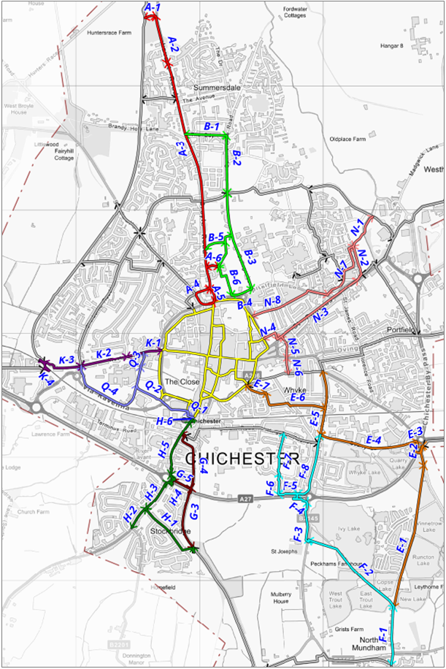

Plan 27: Example of detailed plan of proposed interventions (Route A)
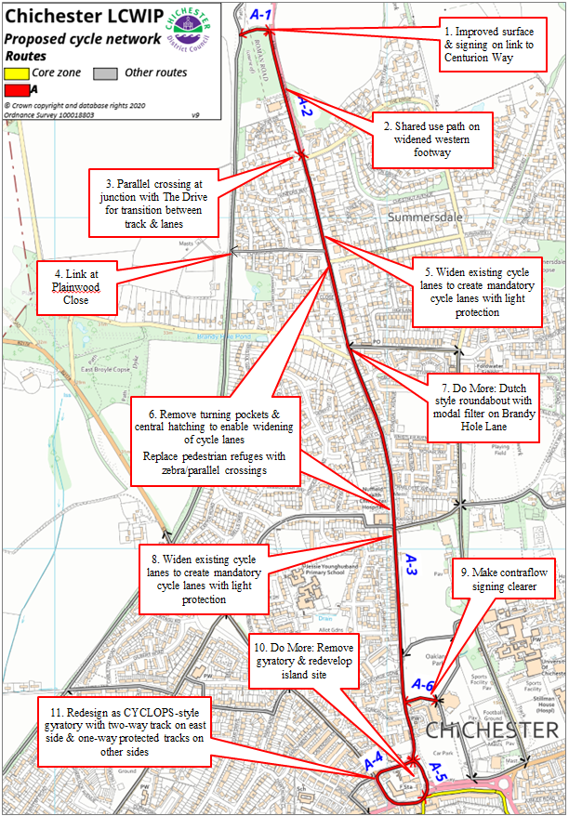

Chichester LCWIP Proposed Cycle Network Key
1. | Improved surface & signing on link to Centurion Way
2. | Shared use path on widened western footway
3. | Parallel crossing at junction with The Drive for transition between track & lanes
4. | Link at Plainwood Close
5. | Widen existing cycle lanes to create mandatory cycle lanes with light protection
6. | Remove turning pockets & central hatching to enable widening of cycle lanes  Replace pedestrian refuges with zebra/parallel crossings
7. | Do More: Dutch style roundabout with modal filter on Brandy Hole Lane
8. | Widen existing cycle lanes to create mandatory cycle lanes with light protection
9. | Make contraflow signing clearer
10. | Do More: Remove gyratory & redevelop island site
11. | Redesign as CYCLOPS-style gyratory with two-way track on east side & one-way protected tracks on other sides
Table 11: Main interventions – “Do Minimum” & “Do More” (references are to Plan 26)
Route | Section |  | Main/ spur | Existing situation | Do Minimum | Do More (extra measures)
 | Location | Ref
A | Path between Centurion Way & Lavant Rd | 1 | Main | Shared path (no cycling) | Sealed surface on path between road & Centurion Way & sign for cycling
 | A286 Lavant Rd (Hunters Race - The Drive) | 2 | Main | No provision, 60mph road (apart from short section just north of The Drive) | Widen western footway of Lavant Rd to create 3m shared use path with 0.5m buffer to road (slight reduction of carriageway width)  New parallel crossing (just north of junction with The Drive, at existing refuge) to enable transition  Provide Plainwood Close - Centurion Way link
 | A286 Lavant Rd/ Broyle Rd (The Drive - Churchside) | 3 | Main | Advisory cycle lanes, with gaps in provision & narrow sections of <1.2m  Generous provision of central hatchings & turning pockets  Shared path south of Wellington Road | Convert & widen existing cycle lanes to mandatory cycle lanes with light protection, with floating bus stops at locations of existing bus stop bays  Remove existing turning pockets & hatchings to provide space for widening, & reduce speed limit to 20mph (south of The Avenue)  Upgrade existing pedestrian refuges to zebra crossings (parallel crossing at The Broadway)  Tighter radii & continuous footways at side streets | Convert & widen existing cycle lanes to stepped cycle tracks (min 1.5m), with floating bus stops  Speed limit on Lavant Rd reduced to 20mph between The Broadway & the Avenue  Dutch-style roundabout at The Broadway with modal filter on Brandy Hole Lane
 | Northgate gyratory | 4 | Main | Busy single lane gyratory with intermittent cycle lanes (cyclists giving way at arms) | Redesign as CYCLOPS-style gyratory with two-way track on east side only | Opportunity to redevelop island site - remove gyratory, with closure of north or south side (Church-side or Northgate) except for cycling & access, two-way traffic on other 3 sides (St Paul's Rd, Broyle Rd & Northgate/Churchside) & full signalisation of 2 remaining junctions
 |  | 5 | Spur |  | Redesign as CYCLOPS-style gyratory with one-way protected tracks on south, west & north side
 | Oaklands Park / Chichester Festival Theatre access Rd | 6 | Spur | Shared path accessed from Lavant Rd  One-way access road, inconsistent contraflow cycle signing | Localised improvement to existing shared path to retain access to Oaklands Park & University, with new ramp at bus stop  Make contraflow signing clearer on theatre access road
B | The Broadway | 1 | Main | No provision – 20mph residential street but also access to residential area, including Graylingwell development | Two-way track on south side  Upgrade existing side-entry junctions to continuous footways.  Combine with parallel crossing facility of Lavant Road & proposed cycle facilities (Route A) | Low Traffic Neighbourhood in Summersdale area with modal filter on The Broadway or Wellington Rd.  NB this would also benefit Routes M & S.
 | Summers-dale Rd | 2 | Main |  | Cycle street treatment including removal of on-street parking  Upgrade existing side-entry junctions along route to continuous footways
 | College Lane/ Chichester University | 3 | Main | 20 mph road with no provision (should be quiet lane but relatively busy as only vehicular access to University campus), existing shared use path to south side of campus | Cycle street treatment north of University entrance (NB no alternative access to University)  Widen & extend existing shared path to provide separated path, with barriers & gates removed & installation of lighting  Upgrade junction at Chichester University to include continuous footway & crossing to Oaklands Park | Include in Summersdale area Low Traffic Neighbourhood  Modal filter (with bus gate) on College Lane north of University entrance, or at junction of Spitalfield Lane with new entrance to University car parks
 | Oaklands Way | 4 | Main | Dual carriageway, no cycling provision | New separated path on north side with localised widening of footway  New Toucan crossing to Franklin Place | New two-way track on north side with space from redesign as 3 lane road with 2 lanes on approach to junction
 | Oaklands Park | 5 | Spur | Narrow, unsealed paths in park | New sealed surface on existing paths | Widen existing E-W path across Oaklands Park to create separate cycle track  New shared path across park to link College Lane & theatre
 | Chichester Festival Theatre access road / Northgate car park | 6 | Spur | One-way access road with inconsistent contraflow cycle signing  Signed pedestrian route signed across car park without any provision | Dedicated & separated cycling & walking paths across Northgate car park | Full redesign of car park (rough estimate)
E | Peckhams Copse Lane | 1 | Main | Bridleway with unsealed surface | New all-weather sealed surface along path north of goods yard, with improved lighting at goods yard  Speed table & signing at crossing of campsite access road | Low level lighting along path  Parallel crossing at campsite access road
 | Vinnetrow Rd | 2 | Main | Narrow shared use footway with hatched verge markings | Extend existing shared footway to bridleway access – will probably need bollards to stop parking  Increase width of shared footway to min 3m with wand protection
 | A27 bridge | 3 | Main | Shared use footbridge with narrow cycle links at foot of ramps | Widen paths at foot of ramps including improving turns & move guardrail to 0.5m from path edge (HE) | Address in future HE A27 scheme - signalisation of roundabout and/or new flyover could include surface-level crossing
 | Quarry Lane | 4 | Main | Busy industrial estate access road with shared use footway | Replace shared footway with two-way track on south side of road (will require removal of on-street parking but there is ample capacity within business sites)  Continuous footway on north side with priority at side roads | Modal filter west of Gravel Lane (access from Bognor Road)
 | B2145 Whyke Rd (Quarry Lane - Bognor Rd) | 5 | Main &  Spur | Busy B road | Provide either mandatory cycle lanes between Quarry Lane & Cleveland Lane, with light protection/stepped cycle tracks (removal of parking on both sides) or two-way track (removal of parking on one side only)  Improve junctions of Whyke Road/Quarry Lane with parallel crossing | HE A27 scheme options include Whyke Rd bridge with no A27 access or restricting Whyke Rd to left in/out only at A27 (not costed)  Alternatively consider modal filter on Whyke Rd at railway
 | Cleveland Lane / Lyndhurst Rd | 6 | Main | No provision – quiet residential streets, 20mph zone | Modal filter at junction of Cleveland Lane/Whyke Road with parallel crossing  Speed table at Whyke Lane/Lyndhurst Rd junction with change of priority | Low Traffic Neighbourhood in Whyke area north of railway
 | Caledonian Rd / Stirling Rd | 7 | Main | No provision – quiet residential street, 20mph zone | Introduce continuous footway at junction with Market Avenue & de-clutter existing footways surrounding toucan crossing to improve the effective widths of footways.  Create two-way track between Market Rd & Stirling Rd south
F | School Lane, North Mundham | 1 | Main | Narrow lane with bridleway status | 20mph speed limit, with 'Access Only' signing & priority for pedestrians, cyclists & equestrians | Signals at junction with B2166  School street
 | School Lane - B2145 | 2 | Main | Track (bridleway) | Improve surface of southern section  New route at western end to link to crossing of B2145 | Surface western end of bridleway with new signalled crossing of B2145
 | B2145 (Free School - A27) | 3 | Main | Existing shared use path | De-clutter existing shared use path & remove excessive markings.  Introduce raised tables at school's delivery access & quarry access | Widen path to provide separate cycle track
 | A27 bridge | 4 | Main | Shared use footbridge with narrow cycle links at foot of ramps | Widen paths at foot of ramps including improving turns & move guardrail to 0.5m from path edge (HE) | Address in future HE A27 scheme - option of new Whyke Road bridge could include 3m separated cycle track, plus footway
 | A27 (Whyke Rd – path to Hay Rd) | 5 | Main | Substandard width shared path alongside 70mph dual carriageway  25m section with no crash barrier & sub-standard separation from traffic | Widen path to 3m & increase separation between cycle track & carriageway to 3m over section with no barrier (both as set out in DMRB CD195). Alternatively provide crash barrier at missing section (HE).  Install low level lighting
 | A27 - Hay Rd south | 6 | Main | Shared use path & dead-end street by school, connecting into park | Widen path between A27 & Sheffield Park Road, with removal of barriers & new surface at northern end  School Street at Kingsham Primary School (Sheffield Park Road)  Upgrade crossing of Hay Road south to parallel crossing on raised table (or priority crossing)
 | Hay Rd south - Kingsham Rd | 7 | Main | Separated cycle/pedes-trian path across park, 20mph residen-tial street | Widen cycle side of path across park  Provide new parallel crossing (or priority crossing) on raised table of Hay Road north | Modal filter on Cherry Orchard Road
 | B2145 Whyke Rd (A27 to Quarry Lane) | 8 | Spur | No provision |  | Address in future HE A27 scheme - options could include Whyke Rd bridge with no A27 access or restricting A27 access to left in/out
G | Chichester Canal (south of A27) | 3 | Main | Shared use towpath | Surface improvements to provide surface suitable for use by disabled people (sealed/flexipave)
 | Chichester Canal (north of A27) | 4 | Main | Shared use towpath | Widen path to 3m where needed | Improved links at Canal Wharf (part of Southern Gateway) (not costed)
 | A27 (Chich-ester Canal – Stockbridge Rd) | 5 | Spur | Substandard width shared path adjacent to lay-by on 70mph dual carriageway | Widen path to 3m & install bollards at lay-by to prevent encroachment by parked vehicles (HE)  Minor improvements to access ramp between A27 & towpath including replacement of staggered barrier with bollard (HE) | Redesign & extend ramp to reduce gradient (HE)
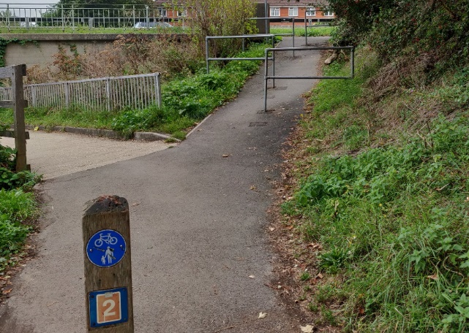 |  |  |  |  | Ramp with staggered barriers between Chichester Canal towpath & A27 cycle track
H | Grosvenor Rd | 1 | Main | No provision – quiet resid-ential street with link to towpath | 20mph speed limit with minimal traffic calming, with parallel crossing at junction with Stockbridge Road  Widen link to towpath | Stockbridge Low Traffic Neighbourhood
 | A286 Stock-bridge Rd (B2201 - Grosvenor Rd) | 2 | Spur | No provision - main road to Selsey/ Witterings | Mandatory cycle lanes with light protection, with floating bus stops at locations of existing bus stop bays  Remove existing turning pockets & hatchings to provide space for widening, with speed limit reduced to 20mph | Stepped cycle tracks, with floating bus stops
 | A286 Stock-bridge Rd (Grosvenor Rd - A27) | 3 | Main | No provision apart from short shared- use path on western footway & Toucan crossing at shops | Reduce speed limit to 20mph  South of Toucan: mandatory cycle lanes with light protection, with floating bus stops at locations of existing bus stop bays  North of Toucan: two-way track on eastern side (may need shorter stacking lane south of A27) | South of Toucan: stepped cycle tracks, with floating bus stops  Address A27 crossing in future HE A27 scheme - options could include Stock-bridge Rd bridge with no A27 access or restricting A27 access to left in/out
 | A27 footbridge / King’s Avenue | 4 | Main | Cycling not allowed on bridge | Allow cycling on bridge with improved links either side of bridge (HE) including wider access at King's Ave | Investigate widening of bridge deck (HE)
 | A286 Stockbridge Rd (King’s Avenue - railway line) | 5 | Main | Busy A road, narrow shared use path on western footway | Remove existing shared use path & replace with mandatory cycle lanes with light protection  Continuous footway provision at all side roads  Upgrade junction of Stockbridge Road/Terminus Road to incorporate proposed cycle tracks/lanes, include cycle priority facilities on all approaches | Remove existing shared use path & replace with stepped cycle tracks  Stockbridge Road to have bus gate, restricting access to cycles, buses & taxis only, as part of Southern Gateway
 | A286 Stockbridge Rd at Chichester Station | 6 | Main | Busy A road across level crossing, no cycle provision | Mandatory cycle lanes with light protection / stepped cycle tracks & advance green signals at level crossing
K | Westgate (Orchard St - Parklands Rd) | 1 | Main | Quiet road (some rat-running) with traffic calming | Cycle street with improved traffic calming  Continuous footways at Henty Gardens (with raised table) & Parklands Rd | Modal filter at Henty Gardens
 | Westgate (Parklands Rd - Sher-borne Rd) | 2 | Main | Quiet road (rat-running & school traffic), narrow gaps at traffic calming | Alternative approaches:  - Stepped one-way tracks / two way track  - Low Traffic Neighbourhood with modal filter & full cycle street treatment
 | Westgate (west of Sherborne Rd) | 3 | Main | Quiet road but with school traffic including school buses | Two way track on south side to connect to existing Centurion Way access at Bishop Luffa school  Replace existing roundabout with crossroads with E-W priority & continuous footway at Sherborne Road | Dutch style roundabout at Sherborne Rd as part of White House Farm development
 | Railway bridge | 4 | Main | Existing bridge over railway (narrow ramps & tight turns) | Investigate potential to widen bridge at tight turns (Network Rail) | Investigate potential to fully replace bridge ramps (Network Rail)
N | River Lavant open space (Kingsmead Avenue - Swanfield Dr) | 1 | Main | Separated cycle/ pedestrian path through open space | Widen cycle side of path & replace white line with sloping raised separator  Replace staggered barriers with bollards
 | Swanfield Drive East - St Pancras Rd | 2 | Main | New shared path by Lidl | Widen path to create separated cycling/walking path with raised separator  Convert existing Pelican to Toucan with wider approach path on north side (may have to be shared) | Replace existing narrow bridge over River Lavant with wider bridge on skew (permeable deck to reduce flood risk)
 | A285 West-hampnett Rd / St. Pancras | 3 | Main | A road, no cycle provision  Generous provision of central hatchings & turning pockets | Mandatory cycle lanes with light protection  Remove existing turning pockets & hatching to provide space for widening, with speed limit reduced to 20mph | Stepped cycle tracks  A285 Westhampnett Road Sustainable Transport Corridor plan to be updated to meet current cycling & walking standards, with Dutch style roundabouts at St James Rd & Spitalfields Rd junctions
 | Alexandra Rd - New Park Rd | 4 | Main | Short residential street, shared path across park | New parallel crossing of St. Pancras Road at junction with Alexandra Road | Two way track on west side of Alexandra Road  Move existing Toucan north to make crossing of New Park Rd more direct
 | Cutten Way | 5 | Main | Private residential dead-end with public cycle & walking access to footbridge | Improved signing clarifying legal access for cyclists & pedestrians
 | Velyn Avenue | 6 | Main | Shared path through development | New parallel crossing of The Hornet
 | Swanfield Drive East | 7 | Spur | Residential road, separated cycle/ pedestrian path | Widen cycle side of path where possible & replace white line with sloping raised separator  Continuous footways at junctions | Low Traffic Neighbourhood in Swanfield Park area
 | Spitalfield Rd | 8 | Spur | Local road with shared footway (hospital link) | Convert shared footway on Spitalfield Rd to separated path
Q | Chichester station car park | 1 | Main | Painted lane across car park | Improve walking & cycling route by creating protected separated path with formal crossing | Redevelopment of car park as part of Southern Gateway
 | Chichester station - Chichester College Park/ Westgate Fields | 2 | Main | Shared use separated path | Widen cycle side of track & resurface in coloured bitmac, realigned so that layout is consistent. Also replace white line with sloping raised separator.  Parallel crossing of Swieqi Road (college access road) on raised table
 | Mount Lane | 3 | Main | Quiet dead-end with cycle access | Replace "END" marking with correct signs & marking
 | A259 Via Ravenna | 4 | Spur | Shared use footway alongside road | Parallel crossing at College access roundabout | Provide separated path with sloping raised separator
Table 12 sets out overall capital costs for these routes, plus signing of part (Do Minimum) or all (Do More) of the network.
Table 12: Proposed route costs – “Do Minimum” & “Do More”
Route | Name | Do Minimum (£m) | Do More (£m)
A | Lavant | 2.23 | 1.03
B | University | 0.73 | 0.98
E | Vinnetrow | 1.62 | 0.56
F | North Mundham | 0.42 | 0.34
G (north) | Chichester Canal | 0.1 | 0.05
H | Stockbridge | 0.78 | 1.61
K | Westgate | 0.57 | 1.54
N | St Pancras | 0.5 | 2.35
Q | College | 0.25 | 0.11
Signing of whole network |  | 0.1 | 0.16
TOTAL |  | 7.29 | 8.57
Costs
Table 13 shows the overall combined cost of the proposed cycle network measures.
It is important to note that the Do More estimates include some very large-scale projects such as completely removing the Northgate gyratory. Clearly, projects such as these are not straightforward and would need to be developed over the full ten-year timescale of the LCWIP. However, the benefits they would bring to Chichester which go far beyond the impact on cycling, as they would reduce the wider effects of motor traffic on the city.
Note the costs include works associated with currently proposed developments (e.g. at White House Farm) if they are part of routes promoted by CDC.
Table 13: Estimated costs – all cycle measures
Area | Do Minimum | Do More
Cycle network outside core area | £7.29m | £8.57m
Core area | £1.14m | £3.5m
TOTAL (CYCLING) | £8.44m | £12.06m
6.4 Proposals for walking
Developing specific recommendations for the core walking zone and key walking routes is more complex than for cycling, as there are a much larger number of smaller measures. Full details are therefore provided in Appendix C rather than in the main LCWIP.
The cost estimate in Table 14 is based on the range of measures set out in the Appendix. However, the estimate in not a simple sum of each proposed measure but is instead a global estimate based on the scale of interventions. Note that the estimate includes several proposals that would be delivered in conjunction with the proposed cycling measures.
Table 14: Estimated costs – all walking measures
Area | Do Minimum | Do More
Core Zone | £0.25m | £0.45m
Key route (west) | £0.1m | £0.2m
Key route (north) | £0.15m | £0.25m
TOTAL (WALKING) | £0.5m | £0.9m
Link across Chichester station car park, with no provision for people walking (and poor for cycling)
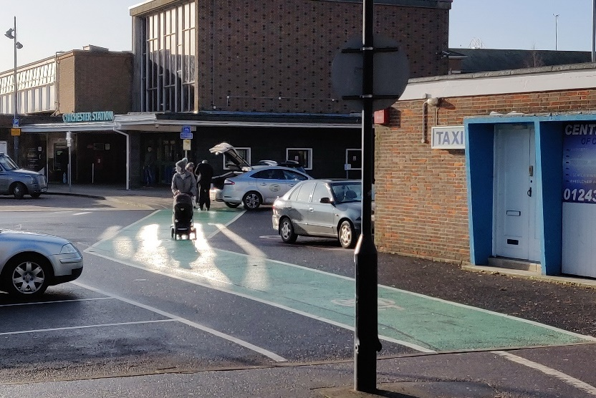
6.5 Overall estimate of costs
Table 15 shows the overall estimate, with an additional 10% for contingency/optimism bias. Note that these costs exclude project management, planning issues, detailed design or other costs (including land acquisition if required).
Based on the table of recommendations we have arrived at the outline cost of around £9.8 million (“Do Minimum”) for the LCWIP as a whole, or a total of £14.3 million for “Do More” measures.
Table 15: Estimated costs – all measures
Focus | Do Minimum | Do More
Cycling network | £9.28m | £13.27m
Walking measures | £0.55m | £0.99m
TOTAL | £9.83m | £14.26m
As noted above, some measures proposed for walking and cycling will overlap (e.g. the southern end of College Lane). Hence it is likely that the overall costs would be lower when areas are examined in detail rather than from the perspective of walking or cycling alone.
Example of potential low cost improvement – removal of unnecessary “END” marking at Mount Lane
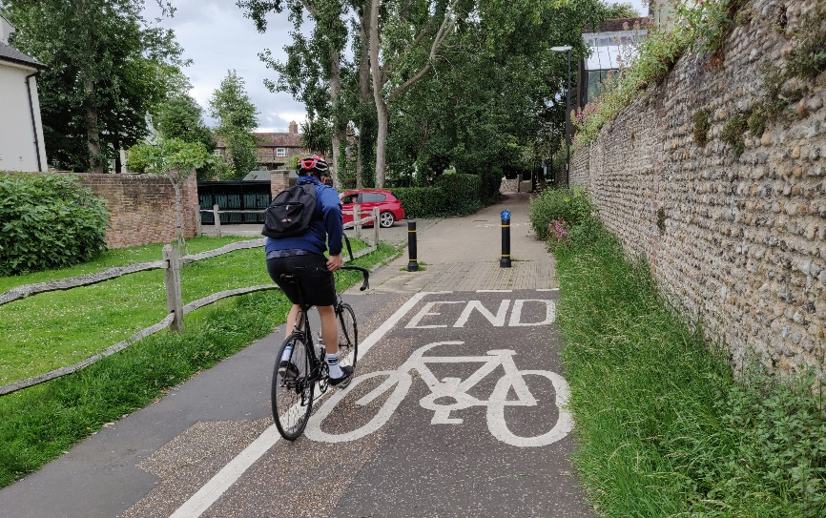
Example of potential high cost improvement – replacement of Northgate gyratory
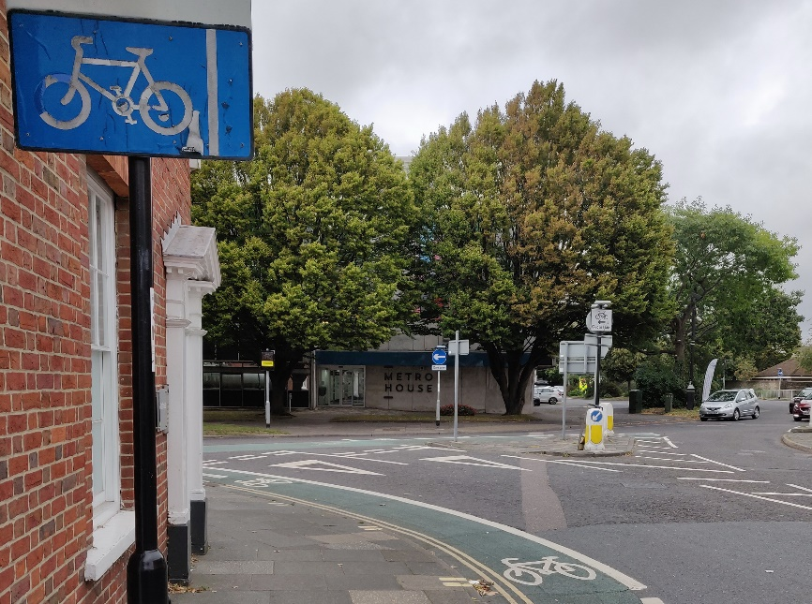
7. Conclusions
7.1 General
Assessment of the demand for both walking and cycling in Chichester shows there is clear potential to further develop the existing levels, which are already the highest in West Sussex.
However, developing proposals of sufficient quality to have an impact will require significant investment, both in terms of cost and resources. The importance of political leadership to take the proposals forward should not be underestimated.
7.2 Funding
Funding for these schemes is not expected to be provided by CDC and WSCC alone. As is generally the case with projects such as these, a variety of funding sources are likely to be needed, including external grants, other third parties and contributions from developers. This could include future phases of the Government’s Active Travel Fund (ATF), as part of the overall national funding of over £250m announced in late 2020.
The LCWIP is intended as a 10 year programme for the delivery of infrastructure. The average cost of around £1m/year if all the Do Minimum measures were implemented would be equal to around £25/year for each person in the LCWIP area. While this is a significant increase on current levels of expenditure, it matches the level regarded as being necessary to have a significant impact on cycling levels, including by the All Party Parliamentary Cycling Group report “Get Britain Cycling” in 2013.
Expenditure to deliver Do More measures would result in an annual cost of £1.4m. While this equates to over £35/year per person, this sum would deliver a much higher quality of interventions. It is predicted to lead to a higher level of shift to cycling in particular, as well as benefitting walking through measures such as Low Traffic Neighbourhoods. There would be a significant positive impact on local communities as well as the city’s overall environment and economy.

7.3 Impact of COVID-19 pandemic
The impact of the pandemic has been unprecedented. As well as the tragic loss of life and the wider effect on health, there have been major impacts on the economy and travel. One of these has been a rise in cycling and walking during the Lockdown period. This is at risk as motor traffic rises, in part due to the loss of capacity on public transport.
The Government launched the Emergency Active Travel Fund (EATF) in May 2020 to help local authorities deliver significant measures to provide infrastructure for walking and cycling, helping to address the impact of COVID-19. Guidance from the DfT stated that councils should introduce “swift and meaningful plans to reallocate roadspace to cyclists and pedestrians, including on strategic corridors.” Funding was provided in for Tranche 1 of the EATF in June 2020, with WSCC receiving £781,000 which was used to deliver 21km of new and improved cycle infrastructure across the county.
While the Tranche 1 EATF measures in Chichester led to a small increase in cycling (recorded by WSCC counters), they were not well received locally. This was partly reflected in a number of responses to the LCWIP public consultation which confused the EATF measures with longer term infrastructure changes which would require more detailed design and consultation. The schemes were removed in November 2020.
A further sum of £2.35m was provided to WSCC under Phase 2 of the Active Travel Fund (ATF2) in November 2020. In late December 2020 a Summary Consultation Plan was published by WSCC outlining how the council will consult and engage on delivery of the measures funded by the Phase 2 ATF award.
Details of ATF2 schemes will be made available on the WSCC website in due course.
7.4 Next steps
Stage 5 of the LCWIP covers prioritisation of proposed measures. Initially it was intended for this to be included as part of this LCWIP. However, this will now be delivered by WSCC in conjunction with the county-wide, South Downs National Park Authority and other District and Borough LCWIPs.
WSCC is exploring the possibility of further support to allow a consistent approach to all LCWIPS. This will include application of a Multi-Criteria Assessment Framework so that proposals in different areas (and LCWIPs) can be assessed on the same basis. This will include use of the DfT’s Active Mode Appraisal Tool (AMAT) which will further allow a degree of comparison and consistency with LCWIP projects elsewhere in England.
The final Stage 6 of the LCWIP is integration and application. This will be developed by CDC following the adoption of the current document. It will include consideration of how the LCWIP proposals will be associated with a policy in the revised Local Plan and incorporated into the council’s Infrastructure Business Plan (IBP).
The IBP prioritises the infrastructure needed to support growth identified in the CDC Local Plan via a five year rolling programme for its delivery, together with possible funding broken down by source (including the CIL Spending Plan). The latest IBP was approved in March 2020.

www.chichester.gov.uk/letstalkcyclingandwalking
www.gov.uk/government/publications/cycling-and-walking-plan-for-england
www.gov.uk/government/publications/cycle-infrastructure-design-ltn-120
https://assets.publishing.service.gov.uk/government/uploads/system/uploads/attachment_data/file/863723/cycling-and-walking-investment-strategy-report-to-parliament.pdf
https://www.gov.uk/government/publications/local-cycling-and-walking-infrastructure-plans-technical-guidance-and-tools
Travel to work and car or van ownership in West Sussex https://www.westsussex.gov.uk/media/2702/censusbulletin_traveltowork.pdf
https://datashine.org.uk/

