Chichester City LCWIP | 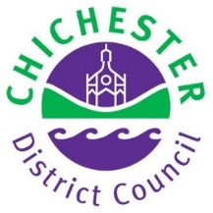
Appendix A. Glossary
1. Acronyms
AMAT | Active Mode Appraisal Tool
CDC | Chichester District Council
CIL | Community Infrastructure Levy
CWIS | Cycling & Walking Investment Strategy
CWZ | Core Walking Zone
DfT | Department for Transport
IBP | Infrastructure Business Plan
KSI | Killed or Seriously Injured
LCWIP | Local Cycling & Walking Infrastructure Plan
LSOA | Lower Super Output Area
LTIP | Local Transport Investment Programme (WSCC)
LTN | Low Traffic Neighbourhood (also Local Transport Note in LTN1/20)
LTP | Local Transport Plan
PCT | Propensity to Cycle Tool
RST | Route Selection Tool
SDNPA | South Downs National Park Authority
STP | Sustainable Transport Package (WSCC)
TI | Transport Initiatives
WRAT | Walking Route Assessment Tool
WSCC | West Sussex County Council

2. Technical terms
Measure & description | Photo ref
Bus gate  A modal filter (see below) where only buses, cycles and pedestrians (and sometimes taxis) are allowed to pass. The most effective bus gates use automated rising/falling bollards which lower to allow buses to pass (as in Graylingwell Drive) but can also be enforced by camera. Sign-only restrictions may be ignored. | 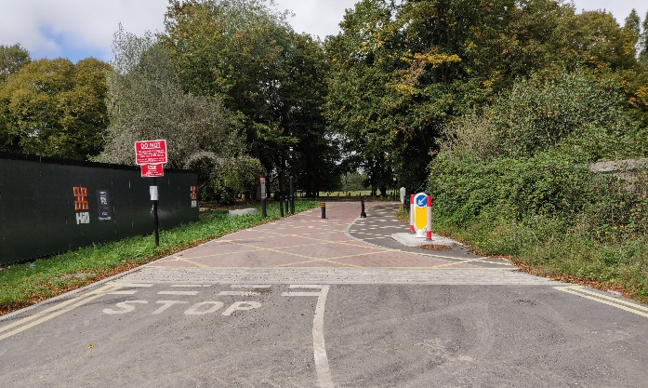
Continuous footway  A way of providing priority for pedestrians over turning vehicles at side roads by continuing the footway surface across the junction, giving strong visual priority to people walking. A ‘continuous cycleway’ can be provided in a similar way for a cycle lane or track. | 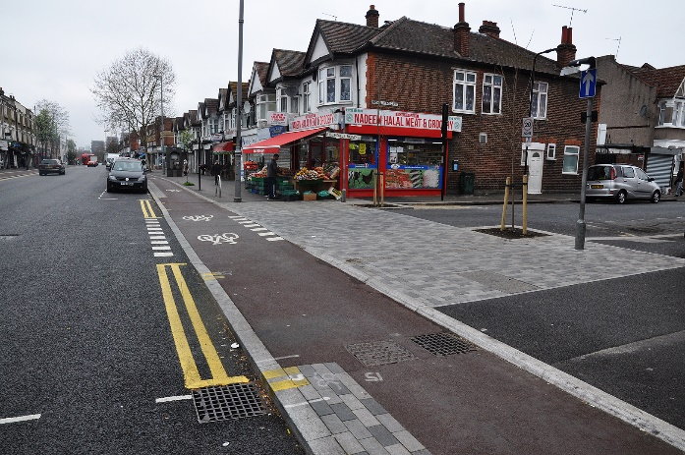
Contraflow cycling  Where cycles are allowed to travel in both directions on streets that are one-way for motor traffic. It can be implemented using lane markings and signing (with or without some form of physical protection), or by using signing only at the entrance to the contraflow section. | 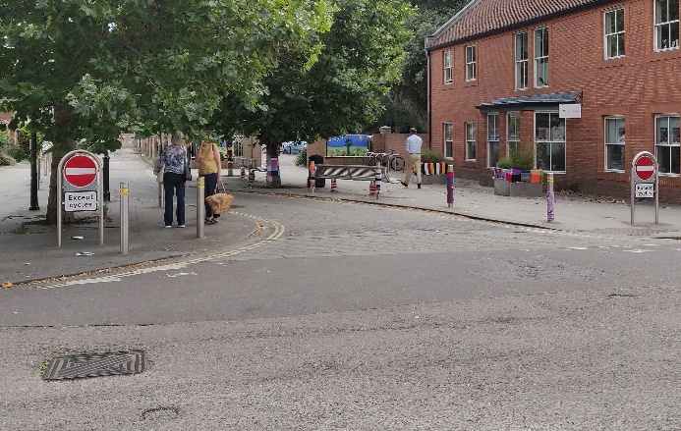
Cycle bypass  Physical separation for people cycling enabling them to avoid a restriction for other road users such as traffic signals and chicanes | 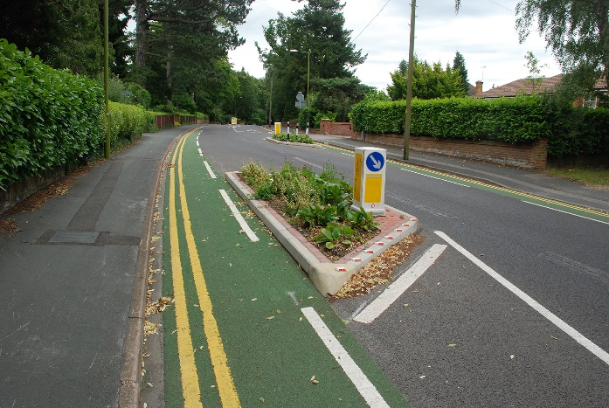
Cycle lane  Advisory – dashed white line marking out a lane intended for cycling. Motor vehicles should not enter the lane unless it is unavoidable but are not legally prohibited from doing so. Advisory lanes offer very little benefit to people cycling. | 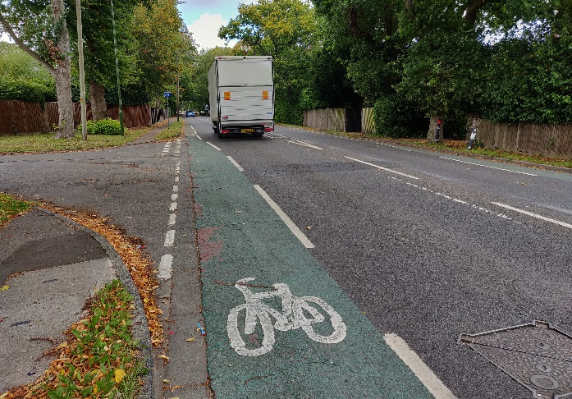
Mandatory – solid white line marking out a lane for the exclusive use of cycles. Motor vehicles are legally prohibited from driving in the lane. Mandatory lanes offer some benefit to people cycling but do not provide any protection from encroachment by motor vehicles. | 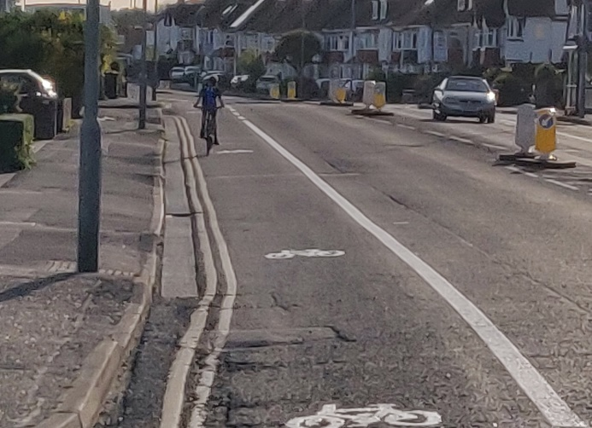
Cycle parking  Cycle parking ranges from hoops (‘Sheffield stands’) on pavements or carriageway, to secure on street parking (‘bike hangars’). It can also include lockers and free-standing compounds, as well as secure areas inside buildings. Cycle parking should be fit for purpose, secure and well located, and allow all types of cycles to be parked. | 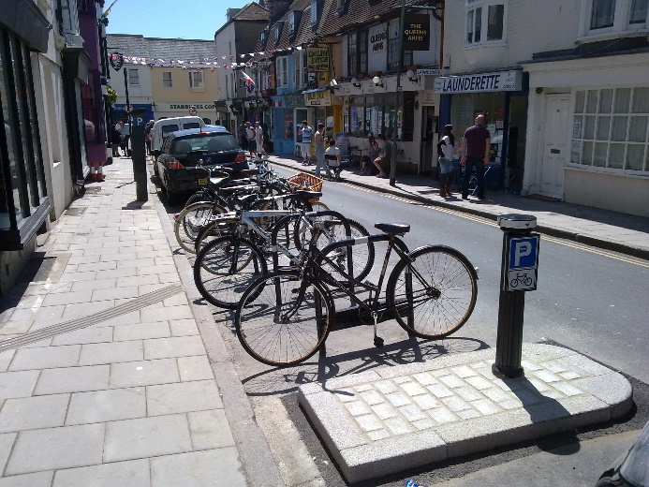  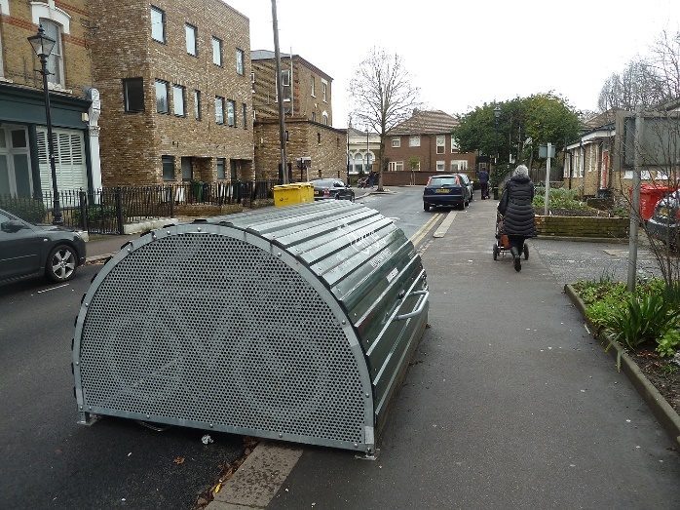
Cycle street  Low traffic street where motor vehicles are allowed but cycling has priority | 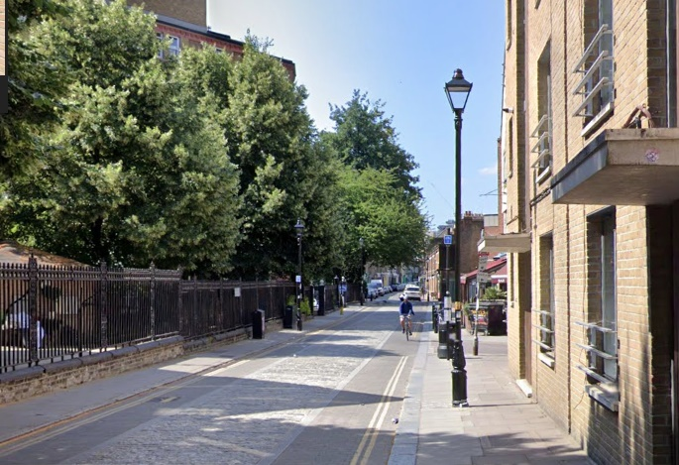
CYCLOPS  CYCLOPS (CYCle Optimised Protected Signals) junctions are a unique design, piloted in Greater Manchester, which can be used at large intersections. They fully separate people cycling from motor traffic, reducing the possibility of collisions or conflict. People walking and cycling are able to get where they want to be in fewer stages with more space to wait than in standard junction designs. | 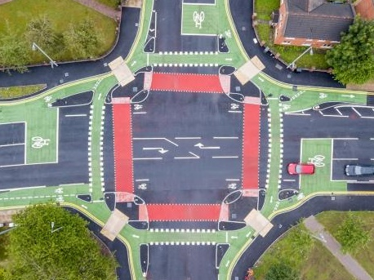
Dutch style roundabout  Roundabout based on Dutch designs, with an outer cycle track ring and parallel crossings for cycles to give them equal priority with pedestrians over oncoming vehicles.  Zebra crossings across the cycle tracks give pedestrians priority over cycles.  The roundabout is designed to encourage slower driving, with a central over-run area allowing larger vehicles to turn safely. | 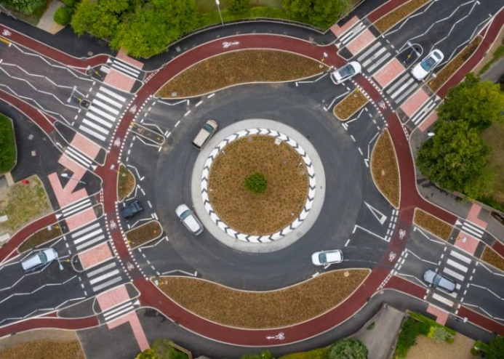
Floating bus stop / bus stop bypass
Cycle track running behind a bus stop so that people cycling do not have to interact with buses, making it safer and also reducing delay for bus passengers. May be at a lower level than the stop and footway, or at the same level. In busier areas there can be a zebra crossing for bus passengers to cross the cycle track (this can be on a raised table).
Light protected cycle lane  Intermittently placed objects (e.g. wands, bollards, posts, planters or sections of low kerb) to separate and protect people cycling from motor traffic. Usually used in conjunction with a mandatory cycle lane. Can also take the form of a stepped track, with cycling at an intermediate level between the pavement and road. | 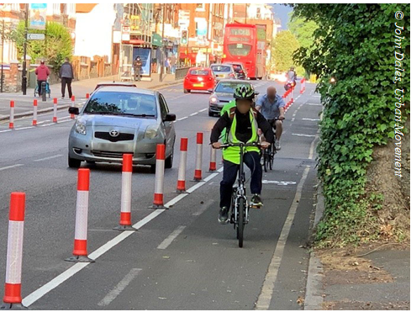  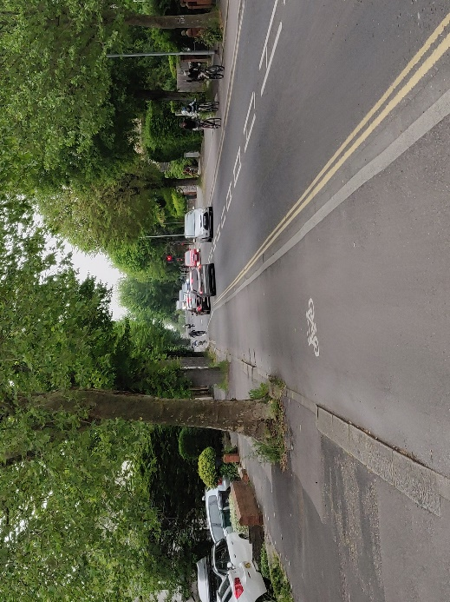
Low Traffic Neighbourhood (LTN)  An area of streets (usually mostly residential) where through motor traffic is removed or reduced and calmed. Access by motor vehicles (including buses) for residents and visitors is fully retained, though routes may be slightly longer. LTNs have been clearly demonstrated to provide better, more liveable neighbourhoods with a higher level of walking, cycling, play and community use. There is also strong evidence that they can improve air quality, health and the local economy. | 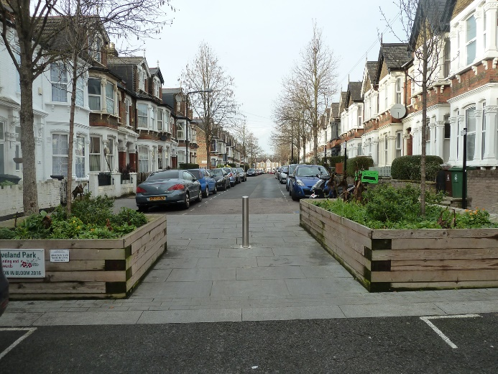
Modal filter (road closure)  A permanent or part-time road closure for motor traffic with access for pedestrians and cycles. It may be enforced by physical measures or signing. Only London councils have legal powers to use camera enforcement at all filters, though ‘Gear Change’ included a commitment to extend these powers to councils in the rest of England (currently only allowed at Bus Gates – see above) | 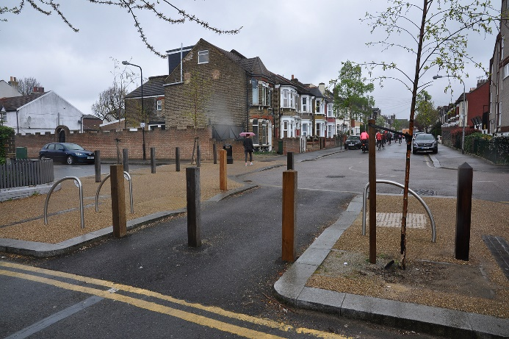
Parallel crossing  A crossing similar to a zebra crossing, which can be used by cycles as well as pedestrians with the same legal requirements on drivers and other road users to stop for those crossing whether walking or cycling. It may be on a raised table. | 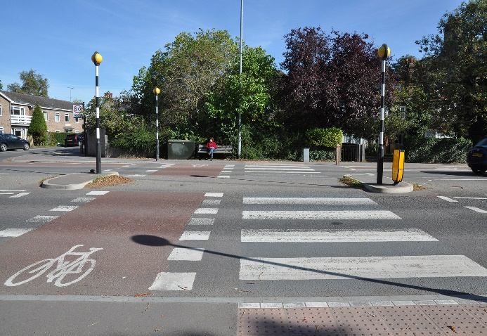
Parklet  A structure built on the carriageway in place of car parking allowing use by people sitting, with planting and cycle parking. Parklets outside cafes and restaurants can be used to allow customers space to eat and drink in the open air, especially when pavements are narrow. | 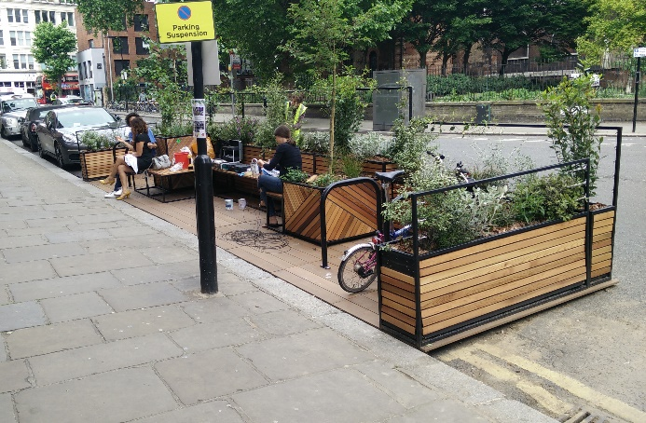
Protected cycle track  A path for cycling physically separated from areas used by motor vehicles and pedestrians. It may be next to, or completely away from the carriageway. | 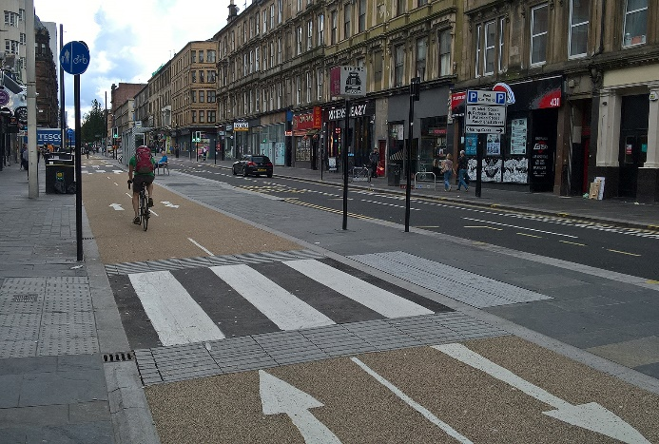
Raised table  A flat raised section of the carriageway, used to slow traffic and make it easier for pedestrians (and cycles, where appropriate) to cross | 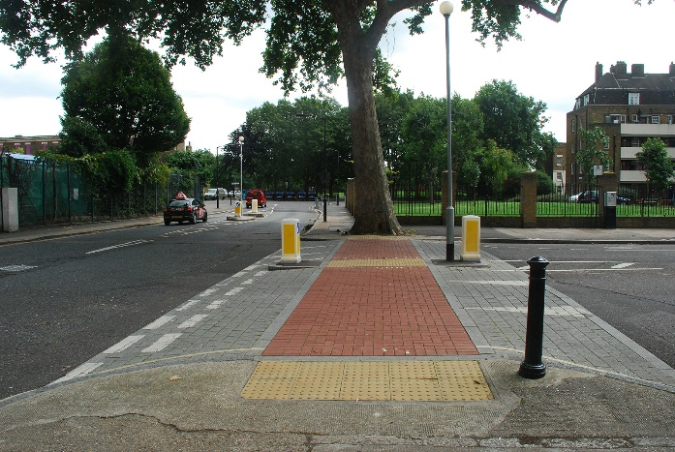
School Street  Section of street outside a school with restricted access during school pick-up and drop-off times, enforced by physical measures or signs. Camera enforcement can be used but only London councils have legal powers to do this, though the DfT have announced plans for this to be extended to Highway Authorities in the rest of England in late 2021. | 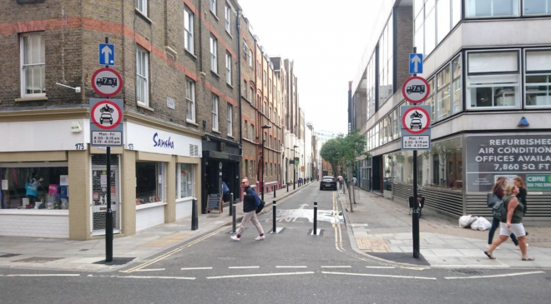
Separated path
A motor traffic-free path where pedestrians and cycles can travel in parallel, with their areas separated by a physical feature, such as a kerb, flat or raised white line or surfacing in different colours or materials
Shared use path
A motor traffic free path where the surface is fully shared by pedestrians and cycles. It can include pavements alongside carriageways as well as routes completely away from roads, like in parks. LTN1/20 recommends that shared paths are only used outside urban areas and where there is low pedestrian use.
Signing  Cycle direction signs help people cycling to navigate and can include information on destinations, distances (and times) as well as the name and numbers of cycle routes. Clear and accurate signing is important, not just to guide people who are already cycling, but also to market cycling to other people. | 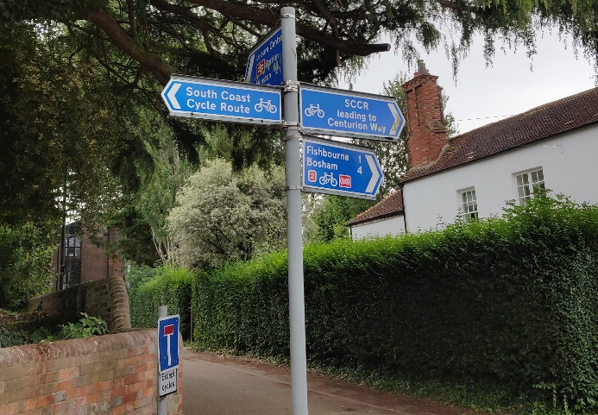
Staggered barriers & access controls  These are often used on shared or separated paths with the intention of slowing cycles. However they are a major barrier to people using cycle, especially with non-standard cycles. They also restrict movement by disabled people using wheelchairs and mobility scooters as well as people with pushchairs, and also obstruct use by blind and visually impaired people. For these reasons they are generally considered to breach the Equality Act and should only be considered following an Equality Impact Assessment. | 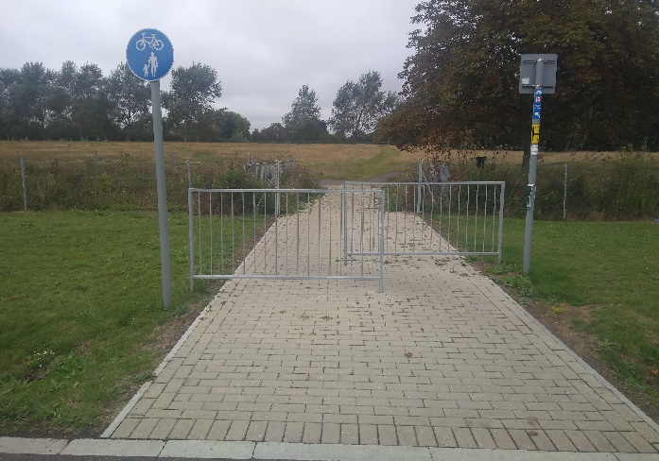  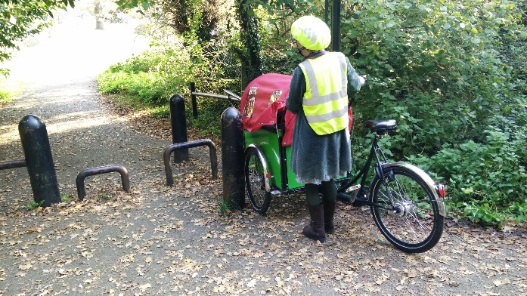
Tactile paving  Paving with raised lines or dimples alerting blind and visually impaired people to different uses of a path or area. ‘Tramline’ and ‘ribbed’ paving is used at the ends of sections of separated cycle and pedestrian paths. | 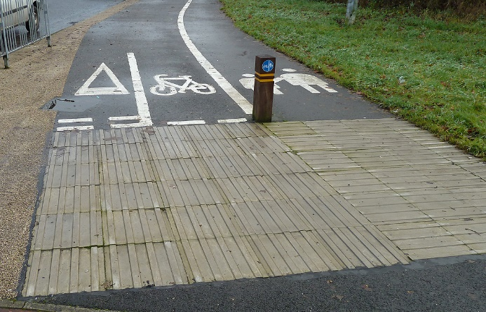
Toucan crossing  A signal controlled crossing that can be used by both pedestrians and cycles (may be on a raised table) | 