Chichester City LCWIP

Appendix B
Cycling audit & route assessments
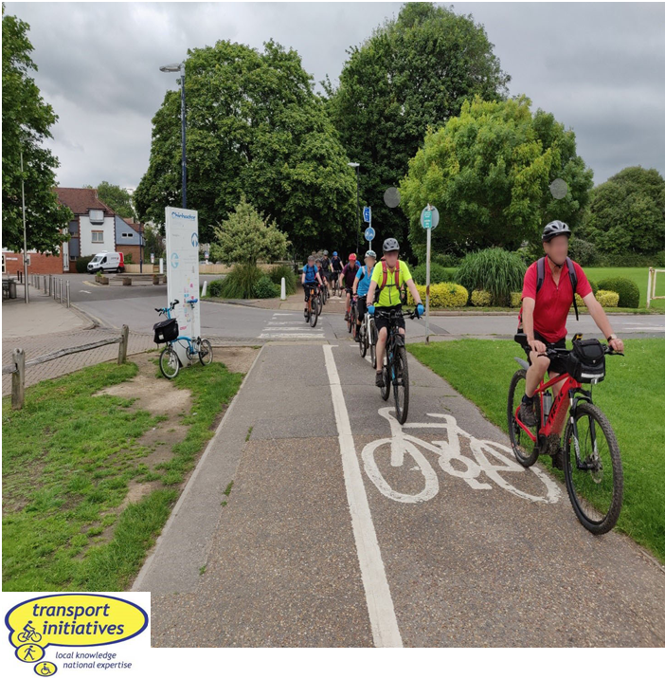

V1 June 2020
V2 Feb 2021

© Transport Initiatives LLP 2021
All photos © Transport Initiatives except where stated
All OS mapping © Crown copyright and database rights 2021 Ordnance Survey 100018803
1. Introduction
To assess how safe and convenient it is to cycle around Chichester, a desk-based study was carried out to assess the level of cycling skills needed to use the highway network. This was followed up by a number of site visits to confirm the desk research and investigate crossing points on the network.
The process was based on Transport Initiatives’ Cycle Skills Network Audit, scaled back for speed and cost-effectiveness (omitting an area-wide assessment of paths and cycle tracks). Detailed plans of the audit are given below, followed by assessments of the identified routes. These were revised following public consultation in late 2020, also taking into account new Government cycle design guidance LTN 1/20 published in July 2020.
Family cycling, South Street
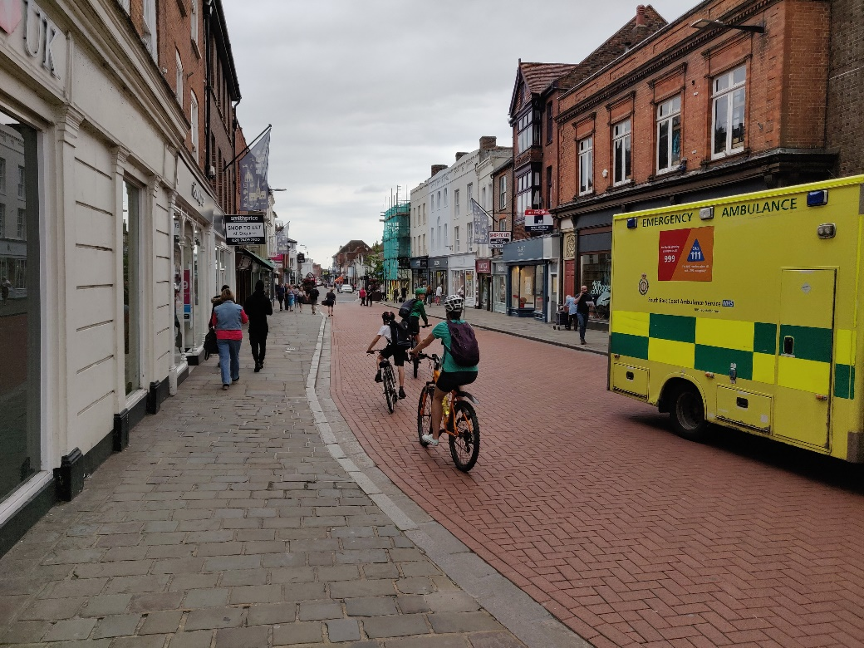
NCN 2 path between Chichester station and Chichester College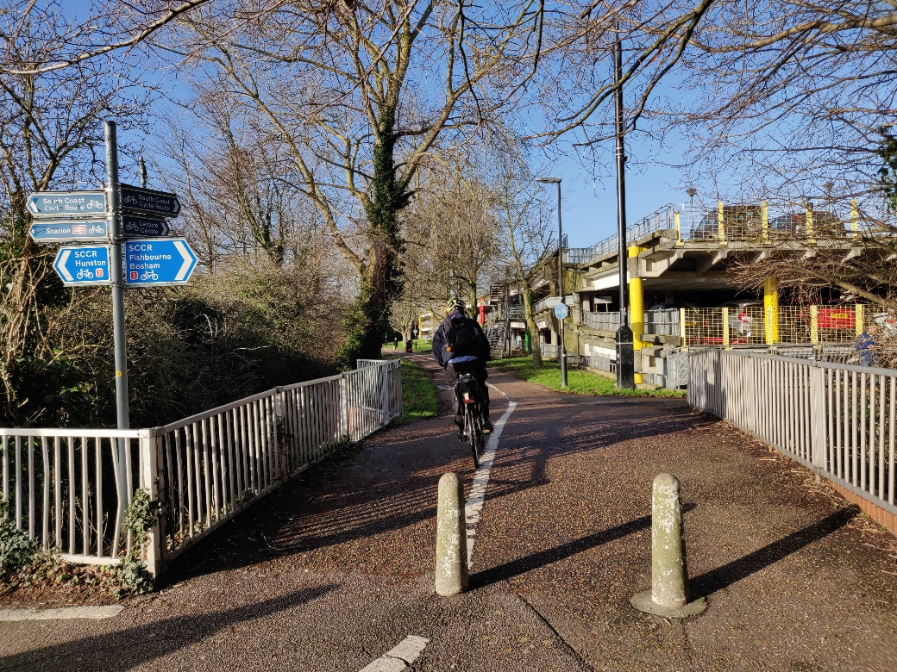
2. Cycle audit plans
Table 1 sets out the Bikeability assessment levels used in the following plans.
These are based on the Cycle Skills Network Audit (CSNA) process developed by Transport Initiatives. This has been carried out in many councils across the UK over the last ten years.
Table 1: Bikeability assessment audit levels
Level | Type | Description
Level 2 | Road | Residential or other quiet street, suitable for most people cycling including older children (i.e. with skills equivalent to Level 2 Bikeability)
Private | Road | Private street – access may be allowed at some times (generally similar to Level 2)
Level 3 (less busy/ rural) | Road | Busier road in urban areas (e.g. rat run) or minor road in rural areas with lower traffic but high speeds, generally only suitable for less risk averse cyclists
Level 3 (busy) | Road | Busy road only suitable for less risk averse cyclists (i.e. with skills equivalent to Level 3 Bikeability)
Beyond Level 3 | Road | Very busy road with fast moving traffic, unsuitable even for experienced cyclists (e.g. A27)
Steps | Crossing | Grade-separated crossing (bridge or subway) with steps
Ramp | Crossing | Grade-separated crossing with ramp but cycling prohibited
Level 1 | Crossing | Grade-separated crossing with ramp with cycling allowed
Level 2 | Crossing | Higher quality/protected crossing – walking only
Level 2 – cycles | Crossing | Higher quality/protected crossing – walking & cycling (or cycling-only)
Level 2 | Crossing | Lower quality/unprotected crossing – walking only
Level 2 – cycles | Crossing | Lower quality/unprotected crossing – walking & cycling (or cycling-only)
Beyond Level 3 | Crossing | Very hazardous crossing for any user

Plan 1: Bikeability assessment of roads and crossings in the LCWIP area
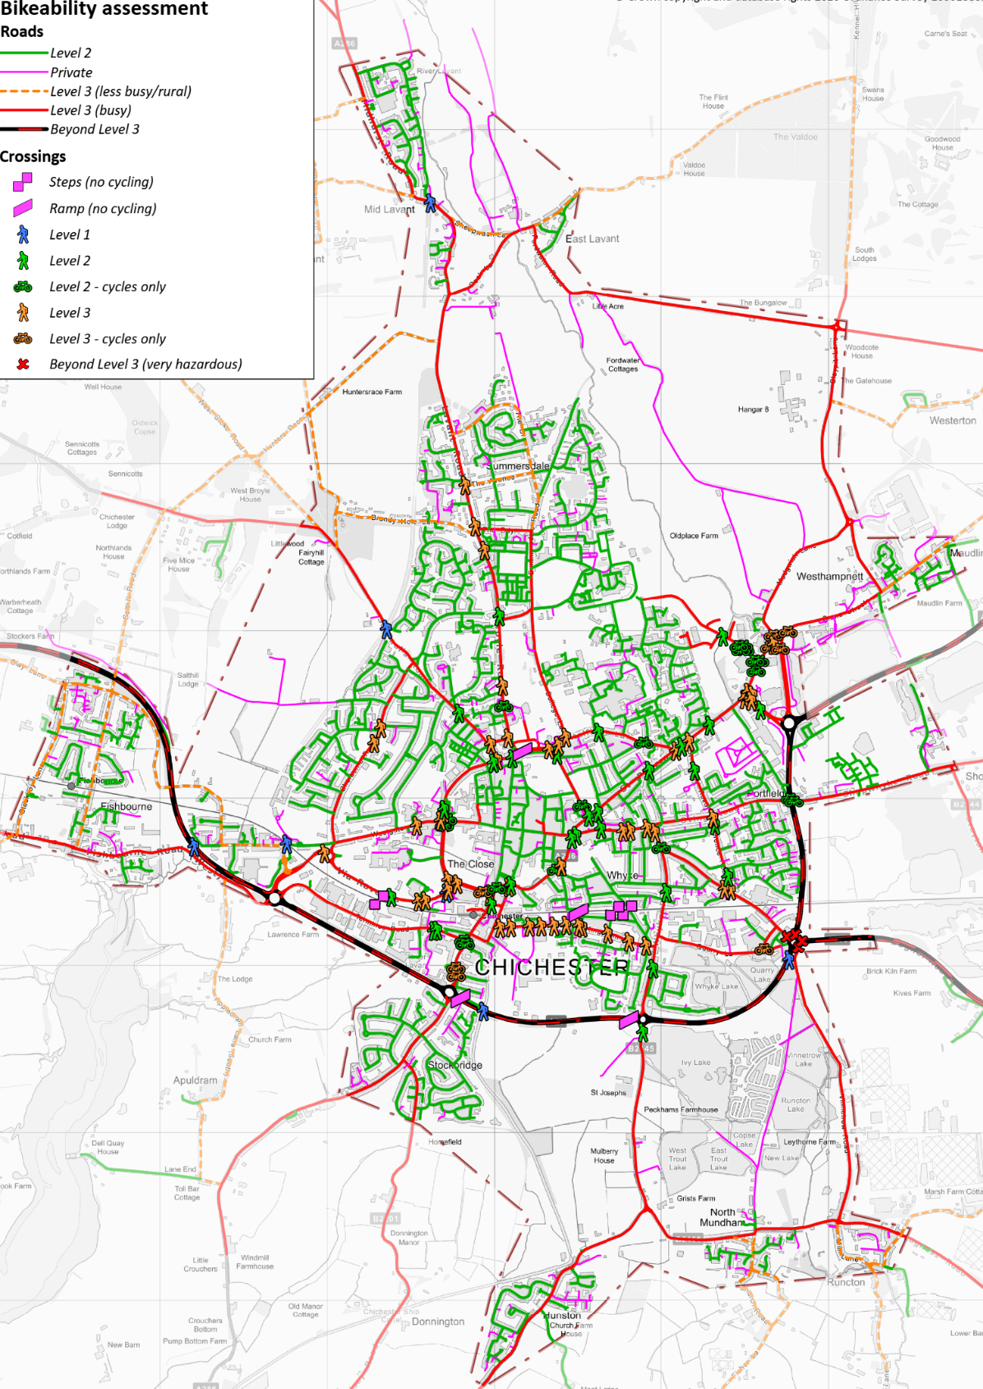

Plan 2: Bikeability assessment of roads and crossings in the Chichester city area
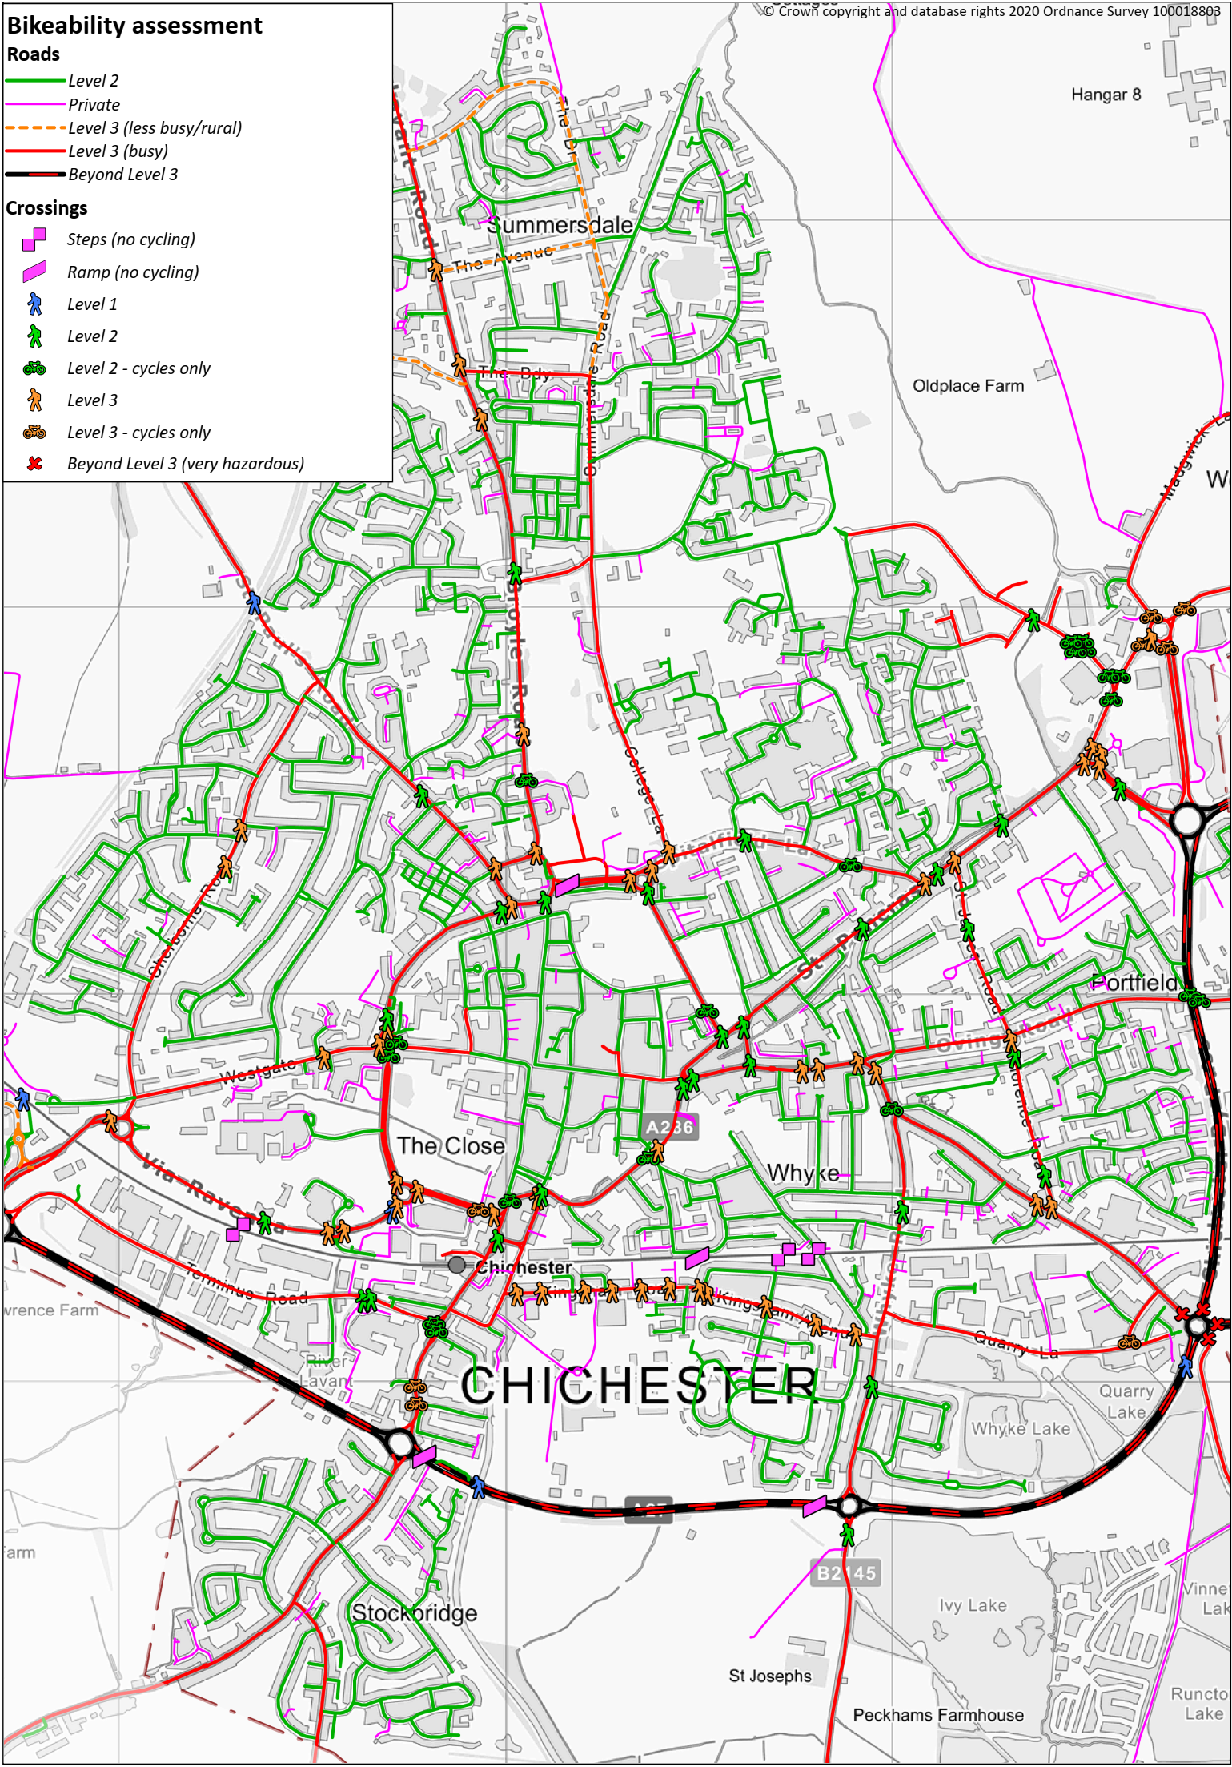

Plan 3: Bikeability assessment of roads and crossings in Chichester city centre
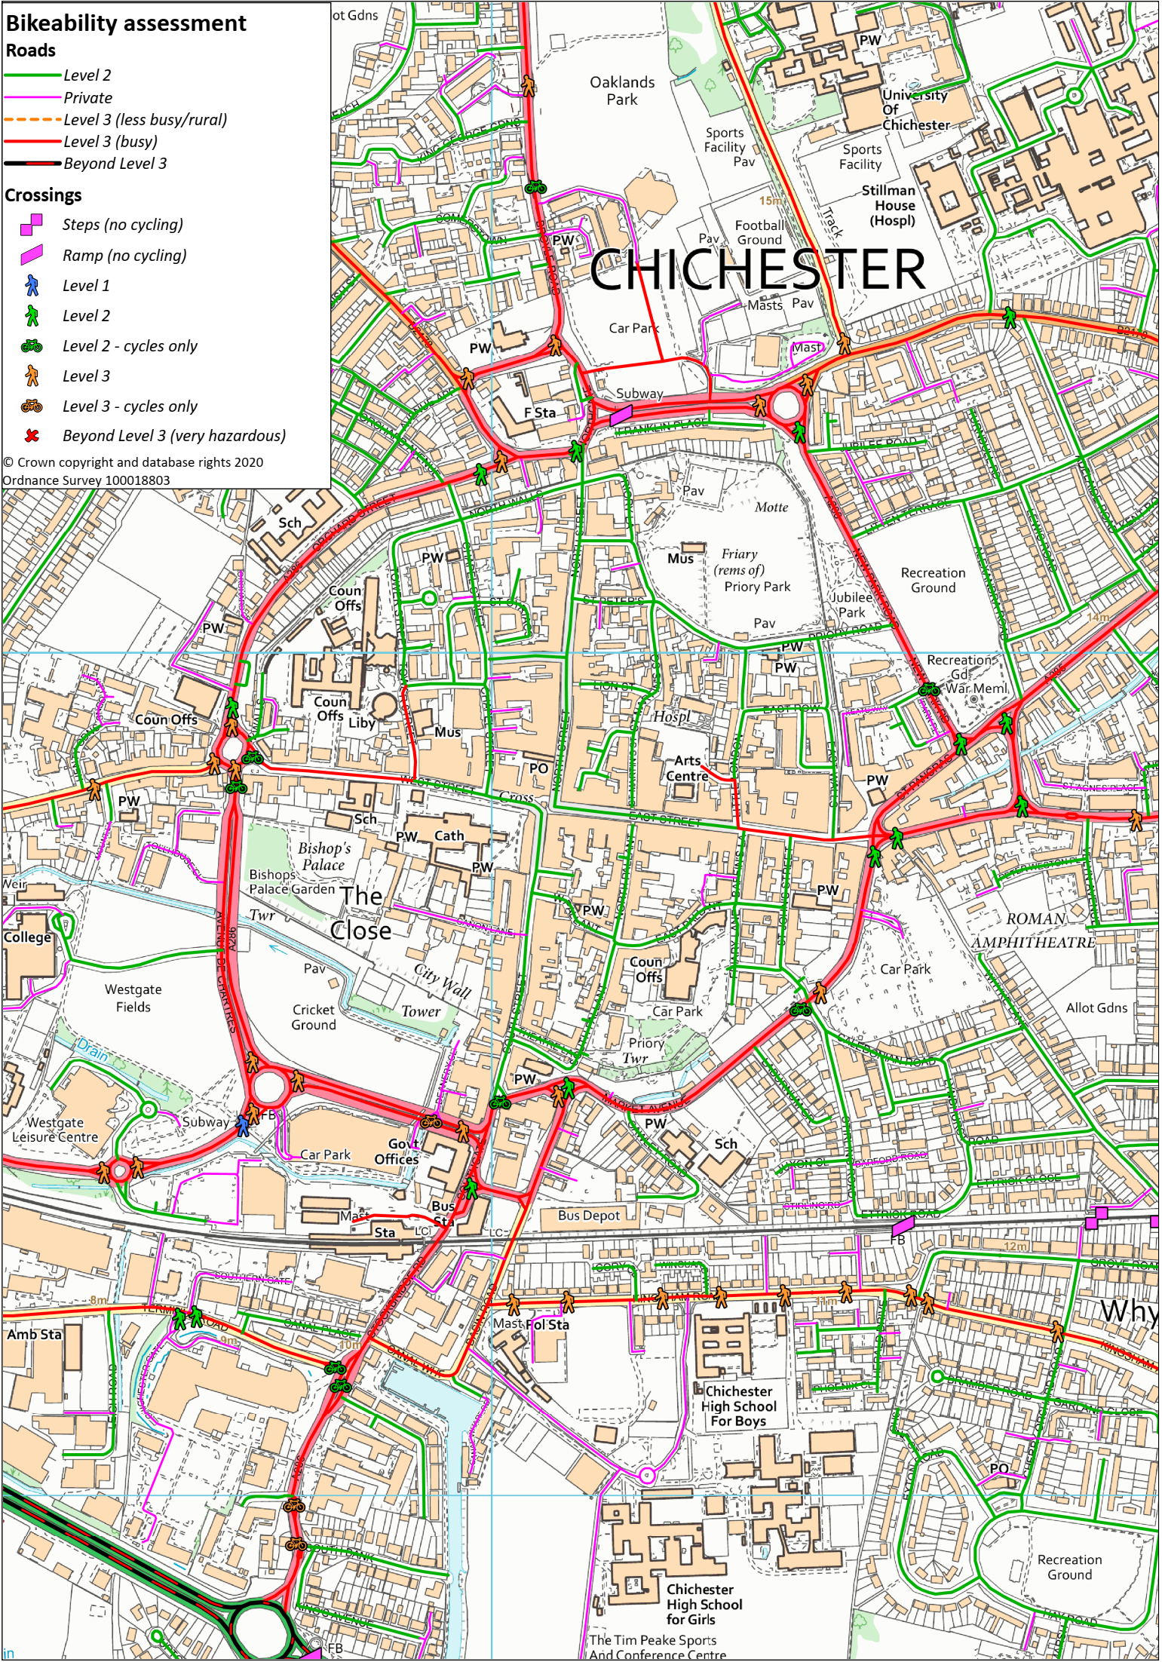

Plan 4. Crossings
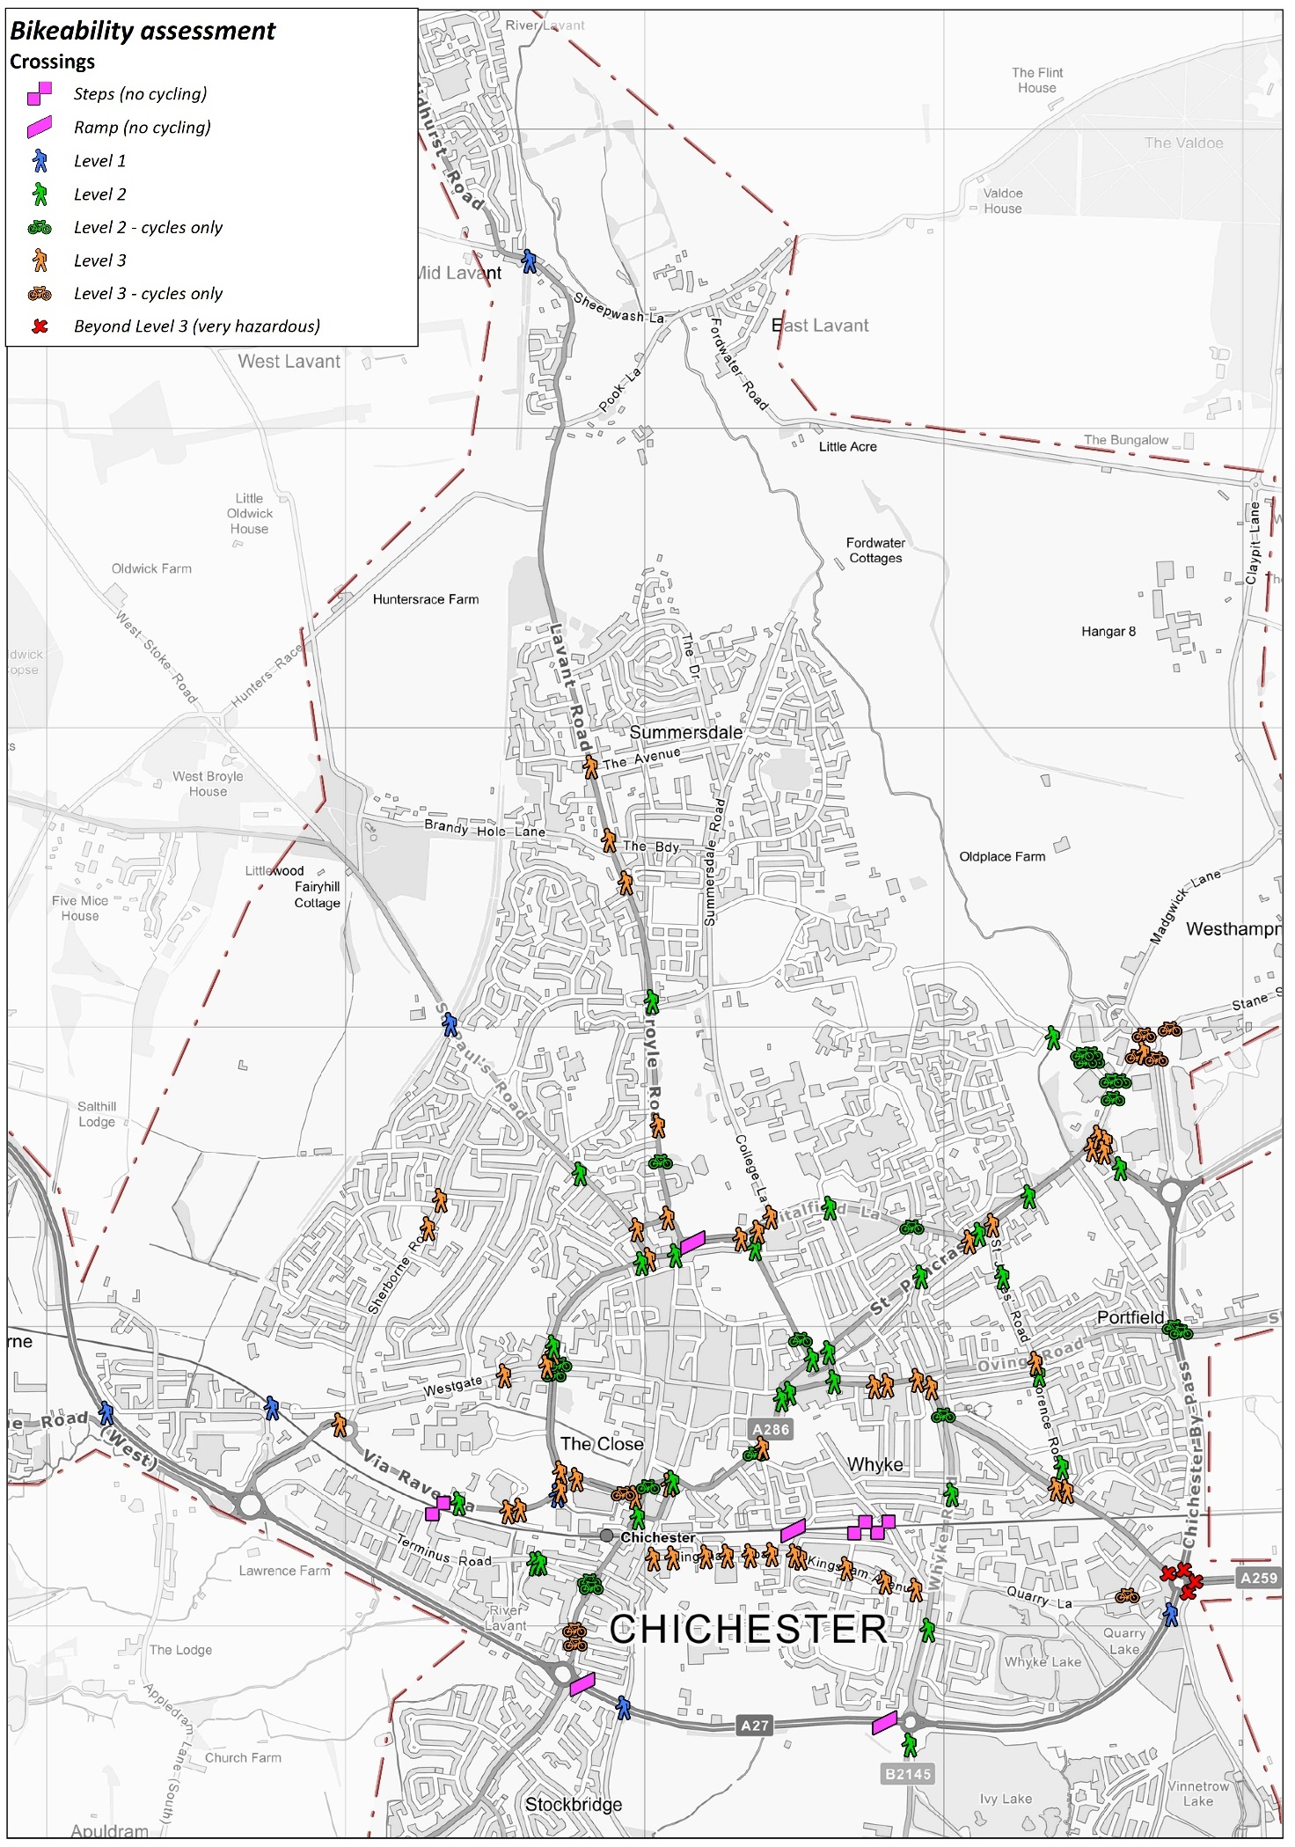

Plan 5. Crossings (north-west area)
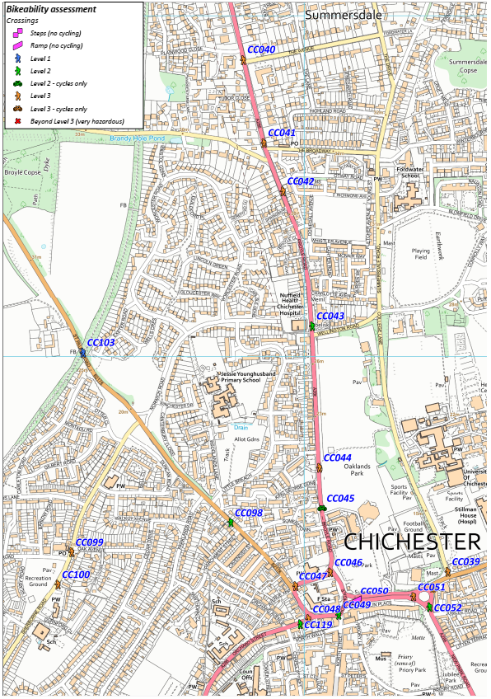

Plan 6. Crossings (north-east area)
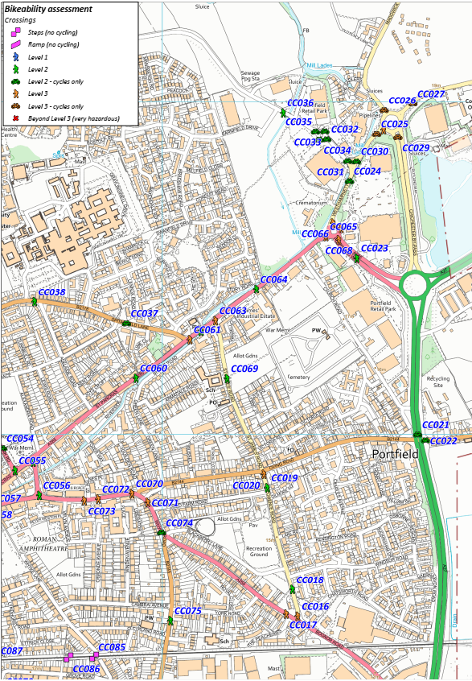

Plan 7. Crossings (south-east area)
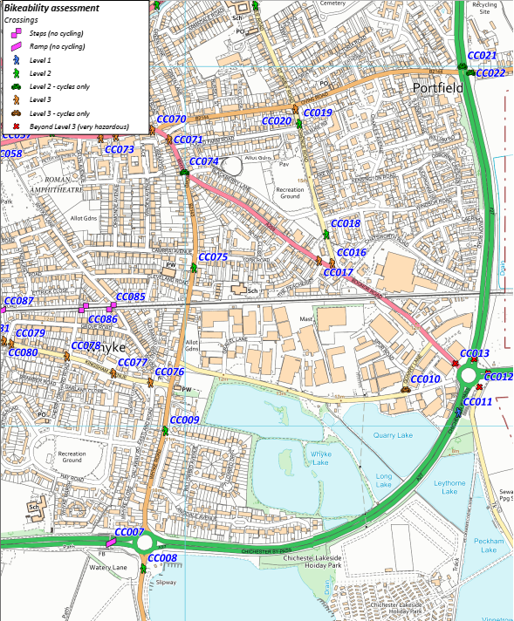

Plan 8. Crossings (south-west area)
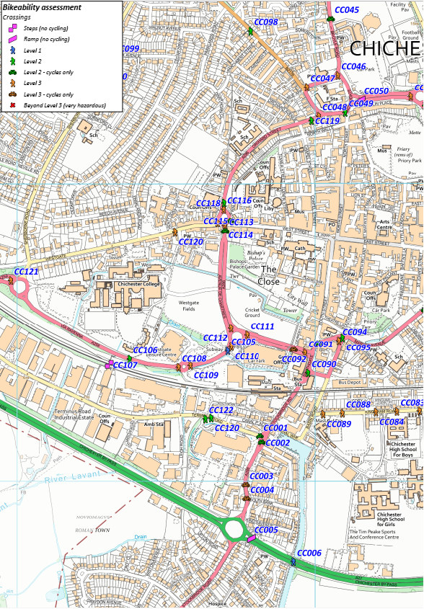

Table 2. Schedule of Crossings
Ref | Crossing type | Level | Gateway | Comments
CC001 | Toucan phase | 2.1 | Existing shared
CC002 | Toucan phase | 2.1 | Existing shared | Adequate for pedestrians but the intention is that southbound cyclists turn into very sub-standard cycle lane so Level 3 for cyclists
CC003 | Refuge | 3.1 | Existing pedestrian & potential shared
CC004 | Cycle only refuge into cycle lane | 3.1 | Potential cycle | Lane is narrow & lost in vegetation
CC005 | Footbridge | 0.5 | Existing pedestrian & potential shared
CC006 | Under bridge | 1 | Existing shared
CC007 | Footbridge | 0.5 | Existing pedestrian & potential shared
CC008 | Refuge | 2 | Existing pedestrian & potential shared
CC009 | Puffin | 2 | EP
CC010 | Dropped kerbs | 3.1 | Potential shared
CC011 | Footbridge | 1 | Existing shared
CC012 | Dropped kerbs | 4 | Potential shared | Awful
CC013 | Dropped kerbs | 4 | Potential shared | Awful
CC014 | Island | 4 | Potential shared | 5 lanes of fast moving traffic to cross
CC015 | Reservation | 4 | Potential shared | It may be wide but it is still very hazardous getting to it
CC016 | Refuge | 3 |  | Narrow & no tactile
CC017 | Refuge | 3 |  | Narrow & no tactile
CC018 | Puffin | 2 | Existing pedestrian & potential shared
CC019 | Puffin | 2
CC020 | Refuge | 3 |  | Narrow
CC021 | Toucan phase with reservation | 2.1
CC022 | Cycle only phase | 2.1 |  | Pointless as you need level 3 skills to get to it along the very hazardous Shopwyke Road
CC023 | Puffin with reservation | 2 | Existing pedestrian & potential shared
CC024 | Toucan | 2.1 | Existing shared
CC025 | Dropped kerbs | 3.1
CC026 | Island | 3.1
CC027 | Dropped kerbs | 3.1
CC028 | Island | 3
CC029 | Reservation | 3.1 |  | All this roundabout should be tightened up
CC030 | Island | 2.1 | Existing shared
CC031 | Island | 2.1 | Existing shared
CC032 | Island | 2.1 | Existing shared
CC033 | Island | 2.1 | Existing shared
CC034 | Island | 2.1 | Existing shared
CC035 | Island | 2.1 | Existing shared
CC036 | Puffin | 2 | Existing pedestrian
CC037 | Toucan | 2.1 | Existing shared
CC038 | Pelican | 2 | Existing pedestrian & potential shared
CC039 | Refuge | 3 |  | Narrow
CC040 | Refuge | 3 | Potential shared | Narrow & no tactile
CC041 | Refuge | 3 |  | Narrow & no tactile
CC042 | Refuge | 3 |  | Narrow
CC043 | Puffin | 2 | Existing pedestrian & potential shared
CC044 | Refuge | 3 |  | Steps on east side render this redundant for other than access to bus stop
CC045 | Toucan | 2.1 | Existing shared
CC046 | Island | 3 |  | Alignment of dropped kerbs is terrible to accommodate hazardous cycle give way & puts all users at more risk
CC047 | Island | 3 |  | Only access from east side of St Pauls Road to centre of gyratory. Angle of crossing awful & signs in island obstruct badly
CC048 | Island | 3 |  | No tactile & no proper dropped kerb on south side where pedestrians are pitched into a bus stop
CC049 | Island | 2 |  | Not great
CC050 | Subway | 0.5 | Existing pedestrian & potential shared
CC051 | Reservation | 3 |  | Two lanes of fast approaching traffic. No tactile
CC052 | Island | 2 |  | No tactile
CC053 | Island | 3 |  | Poor sightlines on south side
CC054 | Toucan | 2.1 | Existing shared
CC055 | 3 way island | 2 |  | No tactile on north/south arm
CC056 | 3 way island | 2 |  | No tactile
CC057 | Puffin | 2
CC058 | Puffin | 2
CC059 | 3 way island | 2 |  | No tactile
CC060 | Puffin | 2 | Existing pedestrian & potential shared
CC061 | Refuge | 3 |  | Narrow & no tactile
CC062 | Puffin | 2 | Existing pedestrian & potential shared
CC063 | Refuge | 3 |  | Narrow & no tactile
CC064 | Pelican | 2 | Existing pedestrian & potential shared
CC065 | Island | 3 |  | Wide fast approaches
CC066 | Island | 3 |  | Wide fast approaches
CC067 | Island | 3 |  | Wide fast approaches
CC068 | Island | 3 |  | Wide fast approaches
CC069 | Pelican | 2
CC070 | Refuge | 3 |  | Narrow & no tactile
CC071 | Refuge | 3 |  | Narrow & no tactile
CC072 | Refuge | 3 |  | Narrow
CC073 | Refuge | 3 |  | Narrow
CC074 | Toucan | 2.1 | Existing shared
CC075 | Puffin | 2 | Potential shared | Potential only if changed & moved to desire line by junction
CC076 | Raised junction | 3 | Potential shared
CC077 | Raised table | 3
CC078 | Raised junction | 3 | Potential shared
CC079 | Raised junction | 3 | Potential shared
CC080 | Raised junction | 3 | Potential shared
CC081 | Raised table with build out | 3 | Potential shared
CC082 | Raised table with build out | 3
CC083 | Raised table with build out | 3 | Potential shared
CC084 | Raised table with build out | 3 | Potential shared
CC085 | Footbridge | 0 | Potential shared | Steps only
CC086 | Footbridge | 0 | Potential shared | Steps only
CC087 | Footbridge | 0.5 | Existing pedestrian & potential shared
CC088 | Raised table with build out | 3
CC089 | Raised table with build out | 3
CC090 | 3 way pelican with island | 2 | Existing pedestrian & potential shared
CC091 | Puffin with reservation | 3 | Existing pedestrian & potential shared
CC092 | Cycle gaps | 3.1 | Potential cycle | Awful
CC093 | Toucan | 2.1 | Existing shared
CC094 | Island | 3 |  | To/from island. Poor sightlines. Should be signals
CC095 | Puffin with island | 2 | Existing pedestrian & potential shared | Staggered
CC096 | Toucan | 2.1 | Existing shared
CC097 | Refuge | 3 |  | Narrow & no tactile
CC098 | Puffin | 2
CC099 | Raised junction | 3 | Potential shared
CC100 | Raised table | 3
CC101 | Footbridge | 1 | Existing shared | Railway, Westgate
CC102 | Subway | 1 | Existing shared | A27, Fishbourne
CC103 | Bridge | 1 | Existing shared
CC104 | Subway | 1 | Existing shared | Centurion Way, Lavant
CC105 | Subway | 1 | Existing shared
CC106 | Puffin | 2 | Existing pedestrian & potential shared
CC107 | Footbridge | 0 | Potential shared | Steps only
CC108 | Island | 3 | Potential shared | Tapers narrow & wide approaches. No tactile
CC109 | Island | 3 | Potential shared | Tapers to narrow & wide approaches. No tactile
CC110 | Island | 3 | Potential shared | Wide fast approaches & no tactile
CC111 | Reservation | 3 |  | Wide fast approaches & no tactile
CC112 | Reservation | 3 |  | Wide fast approaches & no tactile
CC113 | Toucan | 2.1 | Existing shared
CC114 | Island | 3 |  | Narrow & no tactile
CC115 | Island | 2.1 | Existing shared
CC116 | Island | 3 | Potential shared | Narrow & no tactile
CC117 | Island | 3 | Potential shared | Narrow & no tactile
CC118 | Puffin | 2 | Existing pedestrian & potential shared
CC119 | Puffin | 2 | Existing pedestrian & potential shared | Not quite on desire line
CC120 | Semi raised junction | 3 | Potential shared | Only raised & not much on one side
CC121 | Island | 3 | Potential shared | Two lane fast approaches. No tactile
CC122 | Pedestrian phase with refuge | 2 |  | No tactile in refuge
CC120 | Pedestrian phase | 2

Only 43% of crossings are Level 1 or 2 (including cycle crossings). This is very low compared to other areas studied in the UK.
Plan 9. Cycle routes (blue) and Rights of Way (green)
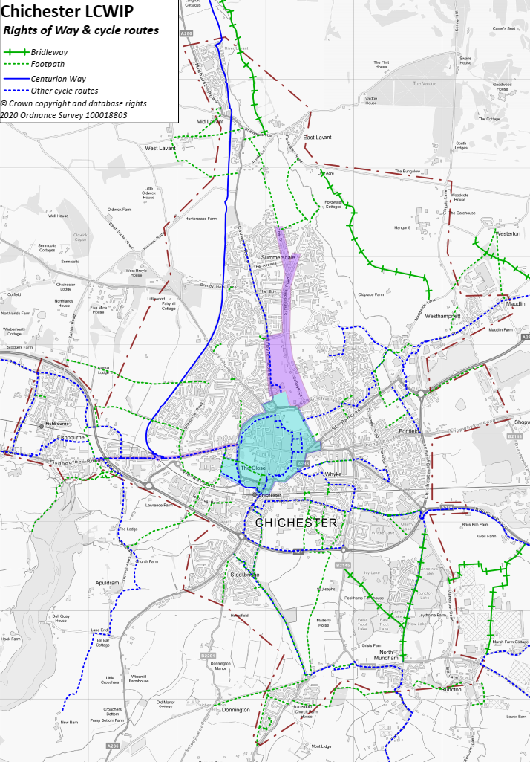

3. Route proposals & RST assessments
The plans below show the proposed interventions for the routes to be promoted by CDC, with RST (Route Selection Tool) assessments (based on the proposals in the initial LCWIP). There is no assessment for the town centre core zone as this contains individual links rather than defined routes.
Plan 10. Proposed cycle routes (inset shows Route R continuing to north)
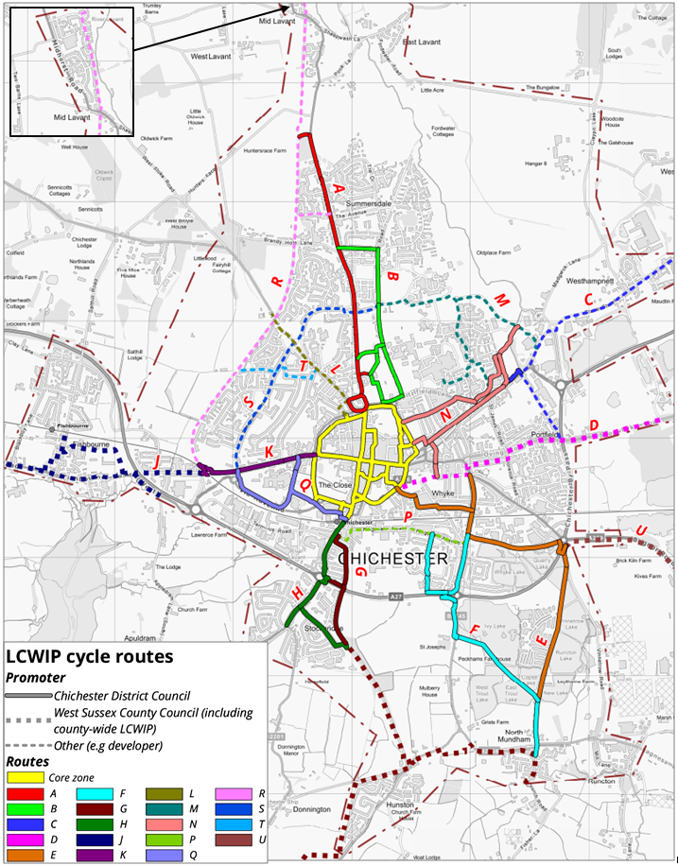

Plan 11. Proposed interventions in core zone
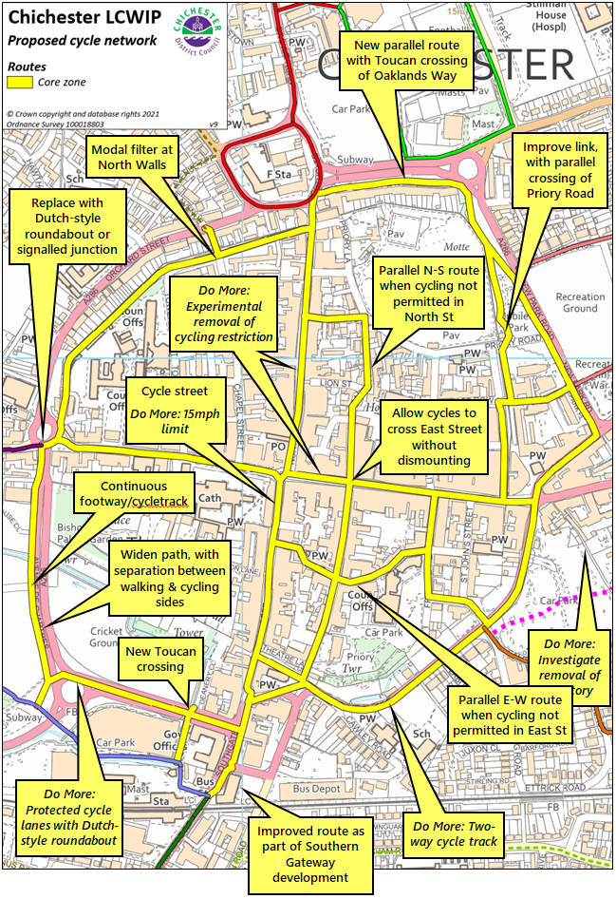

Route A – Lavant
Plan 12. Proposed interventions – Route A
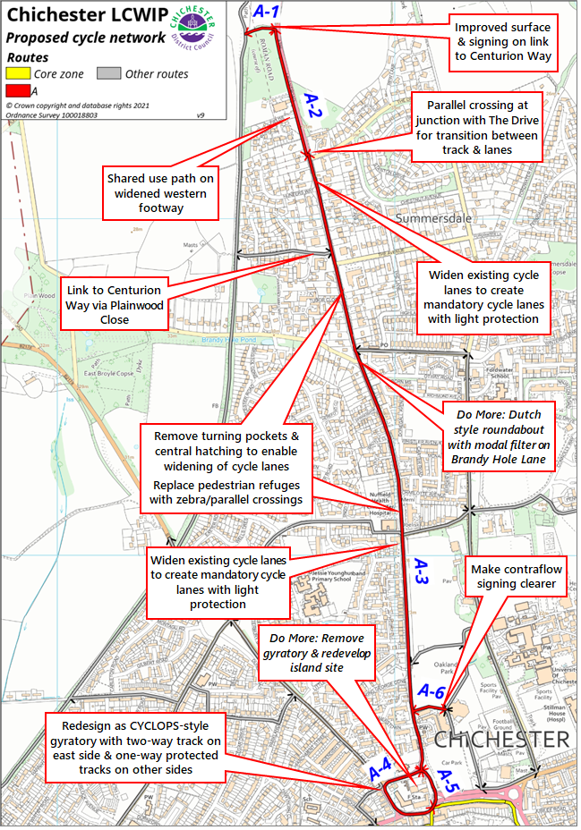
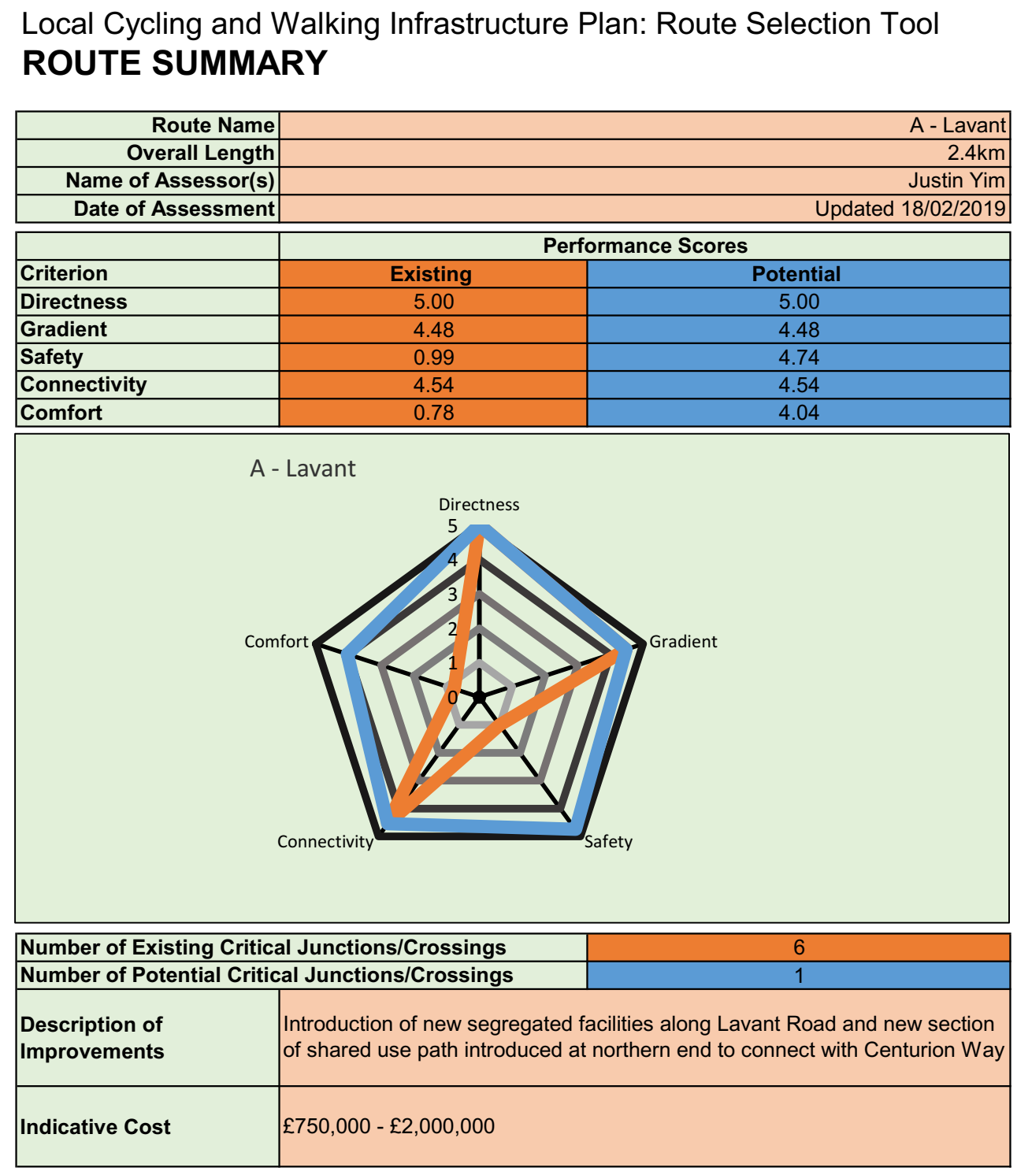
Route B – University
Plan 13. Proposed interventions – Route B
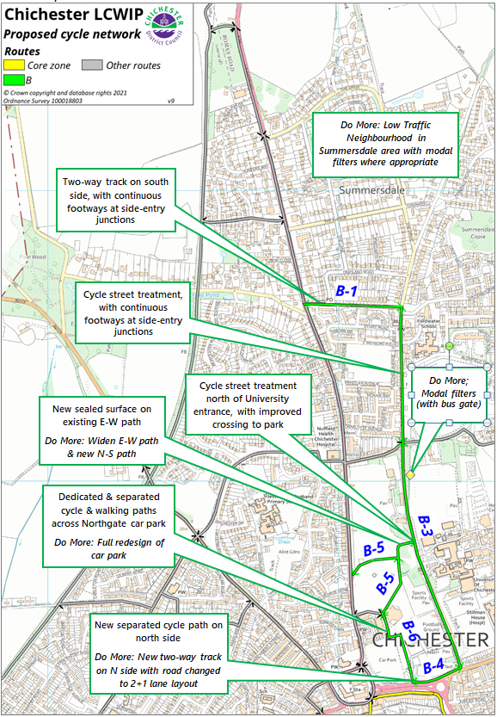
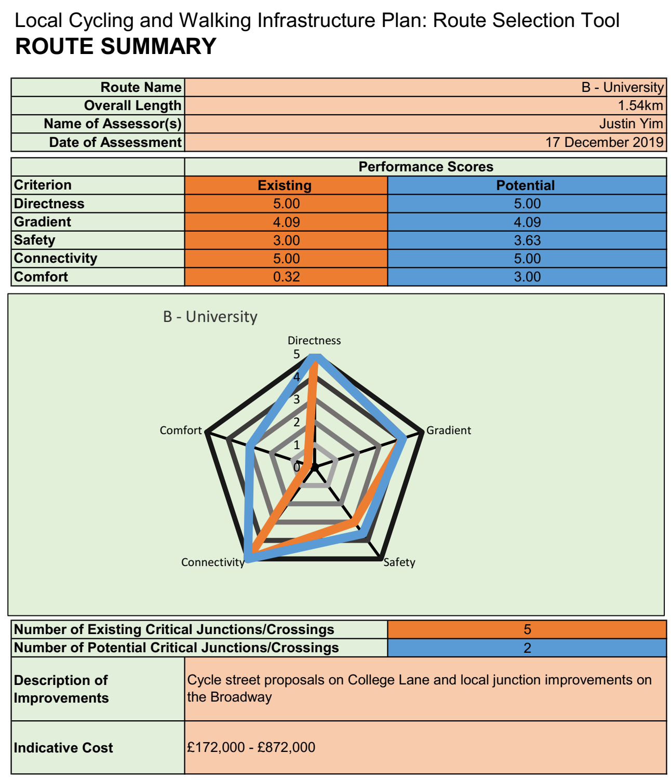

Route E – Vinnetrow
Plan 14. Proposed interventions – Route E
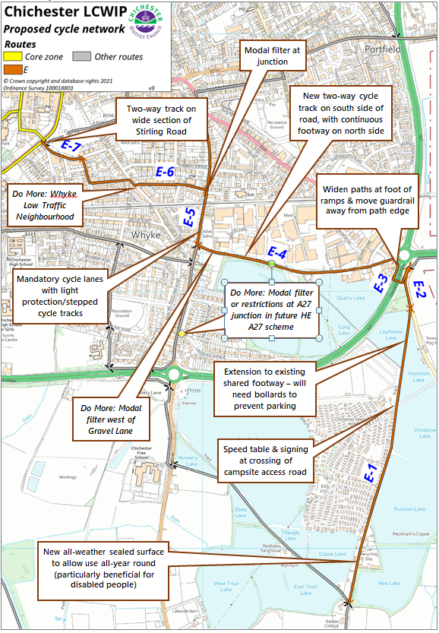
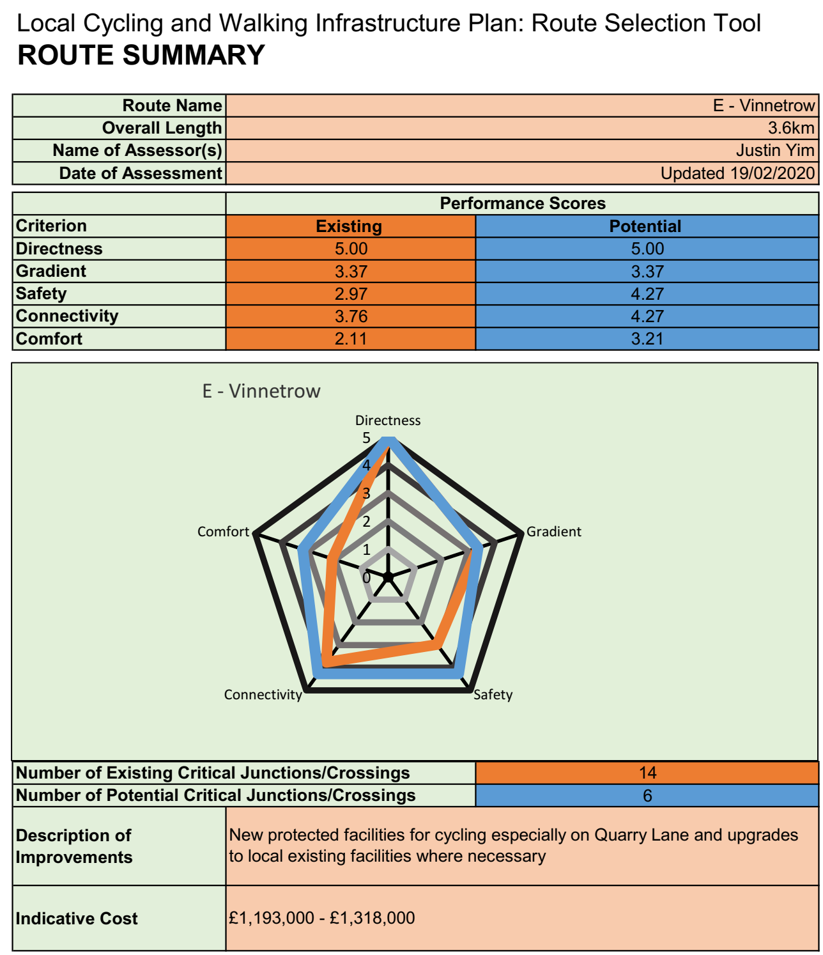
Route F – North Mundham
Plan 15. Proposed interventions – Route F
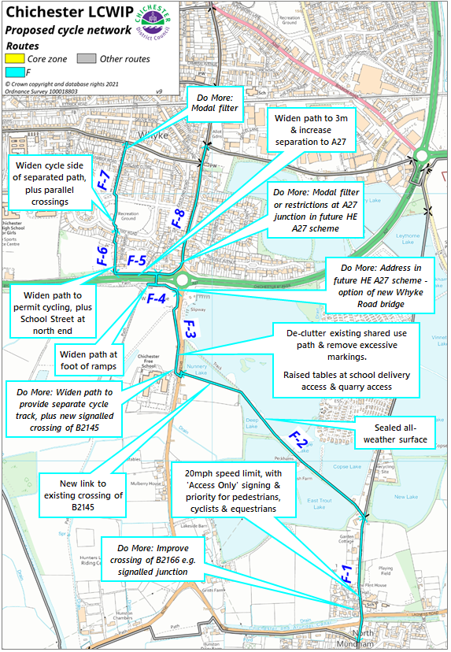

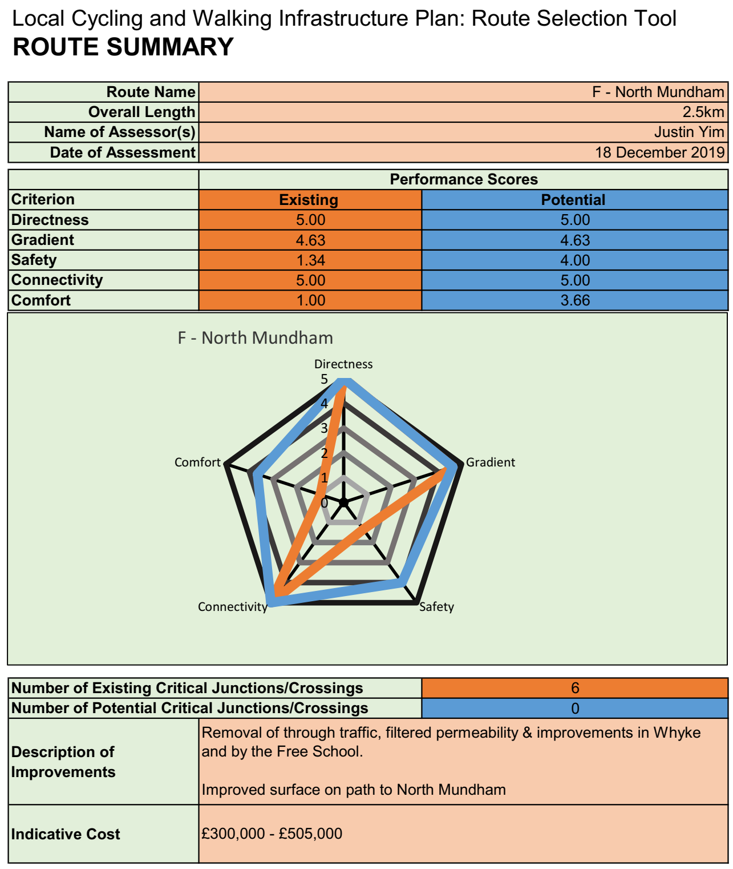

Routes G – Chichester Canal & H – Stockbridge
Plan 16. Proposed interventions – Routes G & H 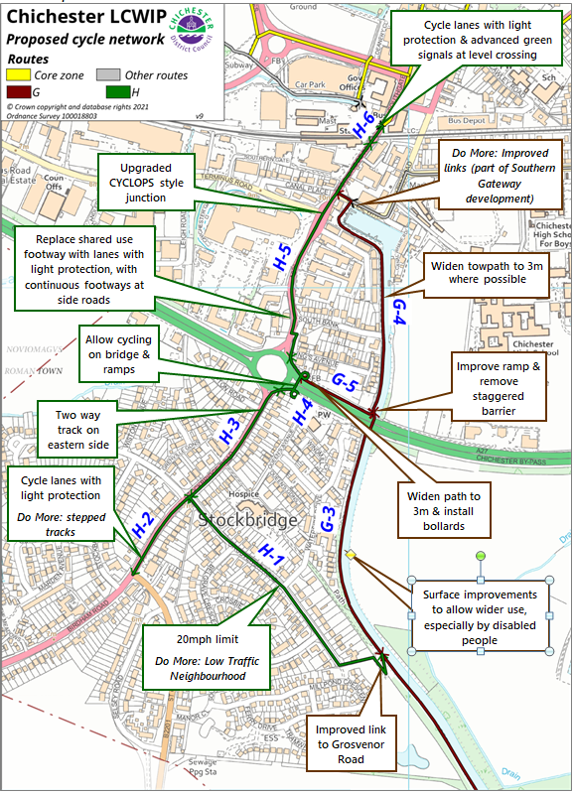
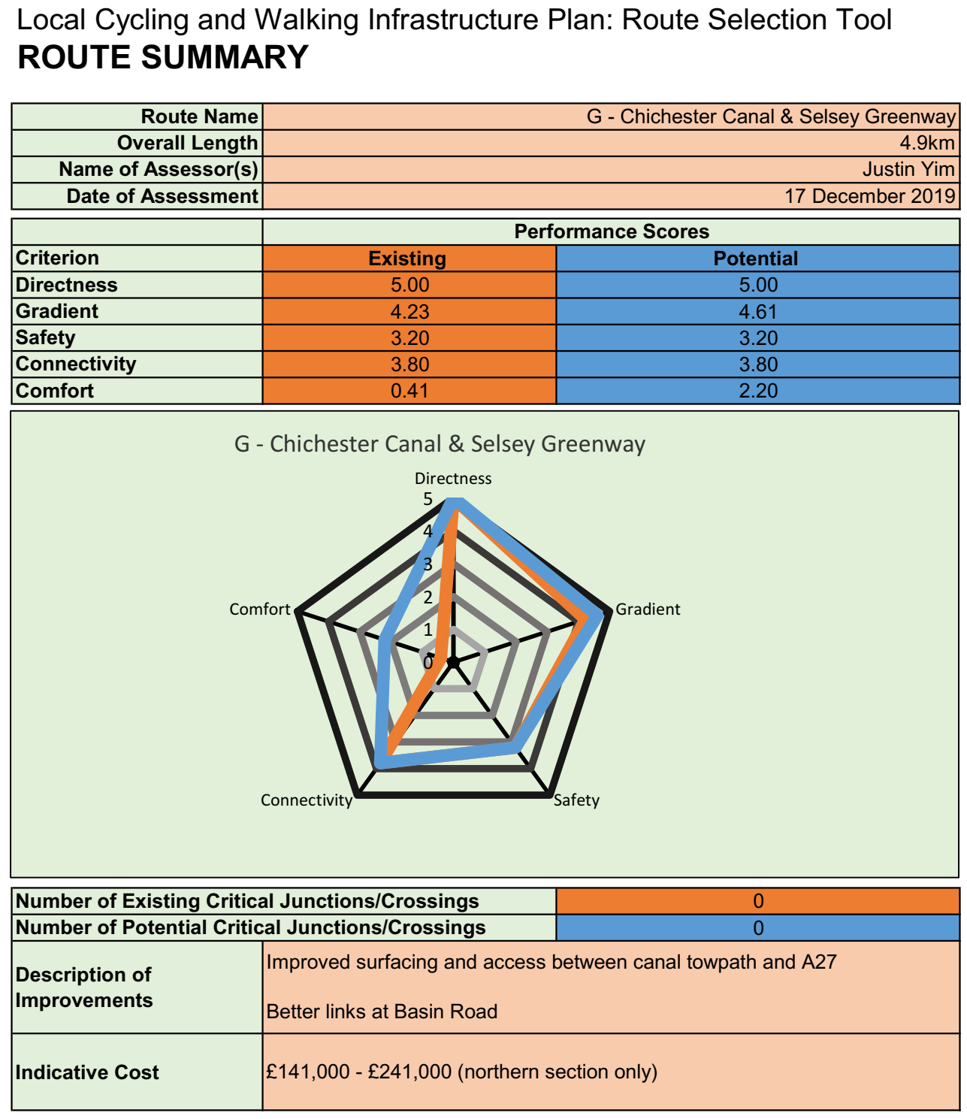
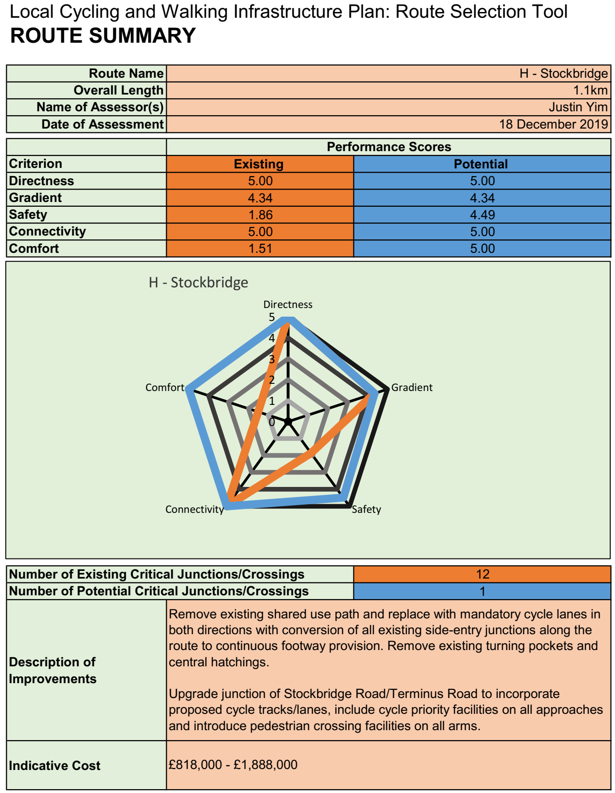

Route K – Westgate
Plan 17. Proposed interventions – Route K 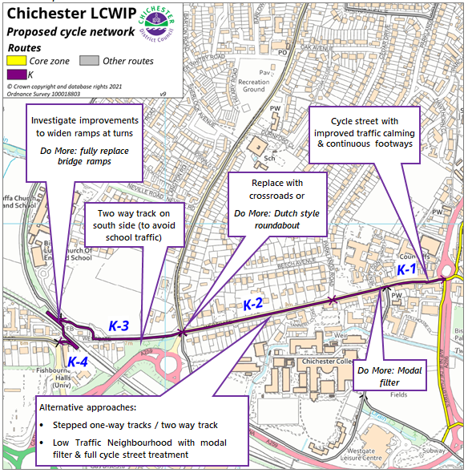

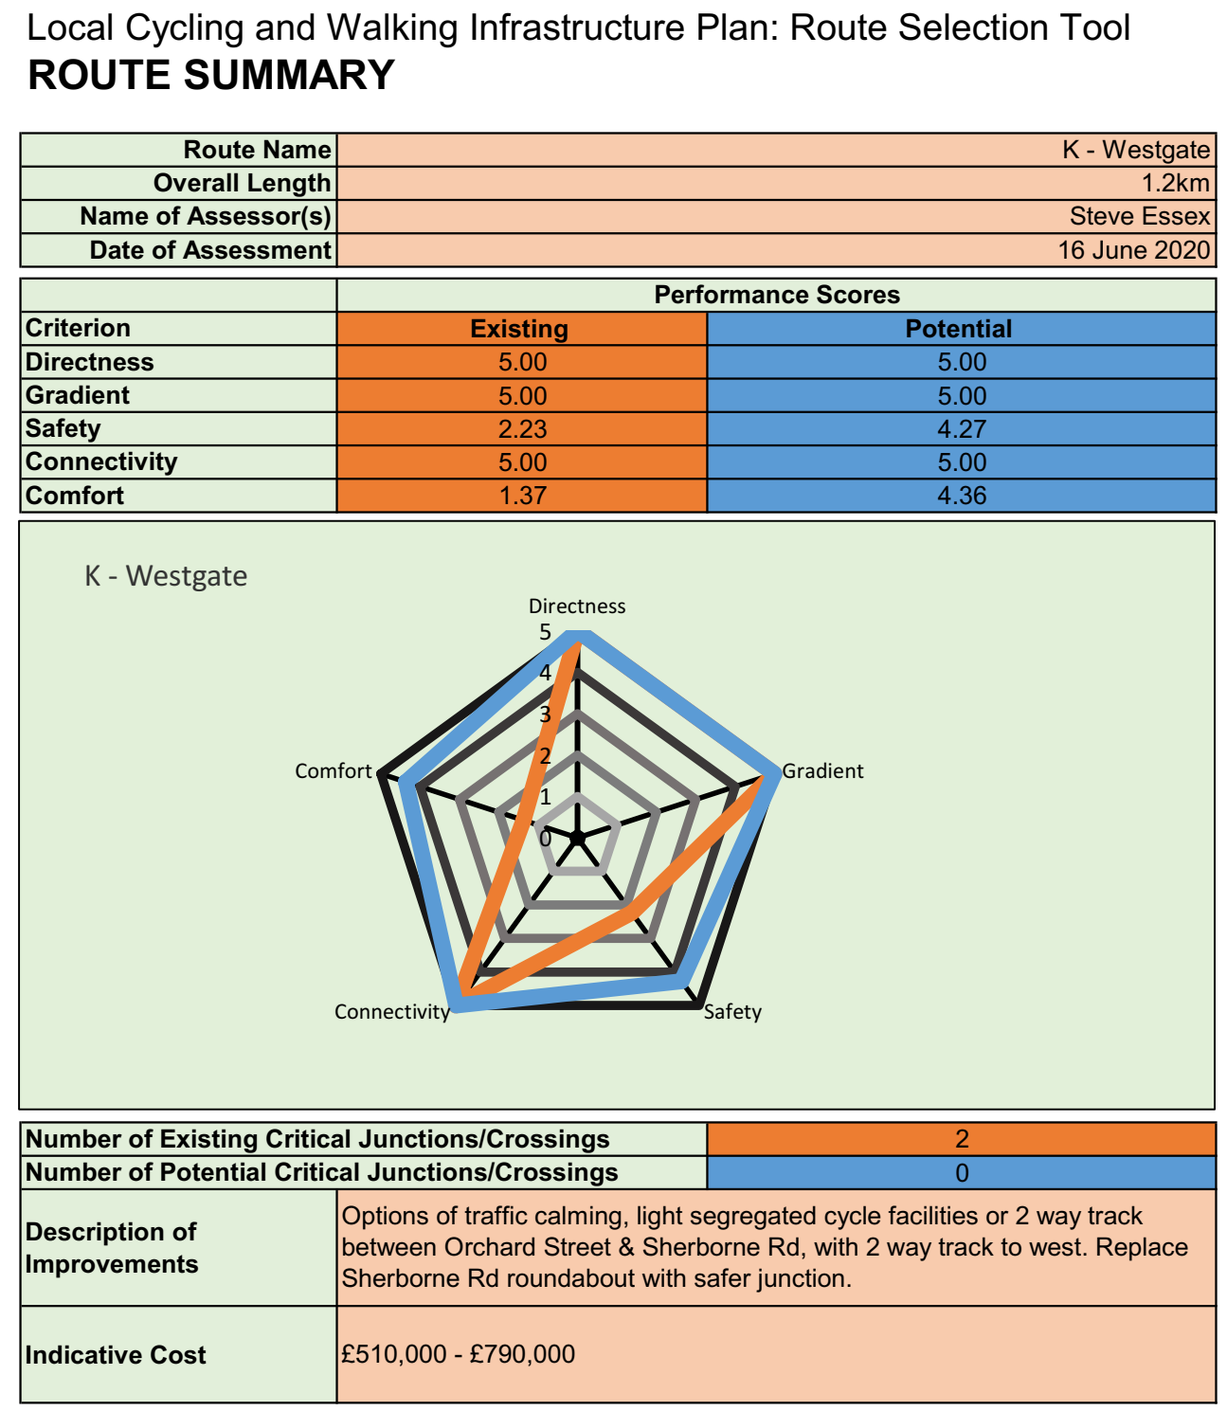

Route N – St Pancras
Plan 18. Proposed interventions – Route N 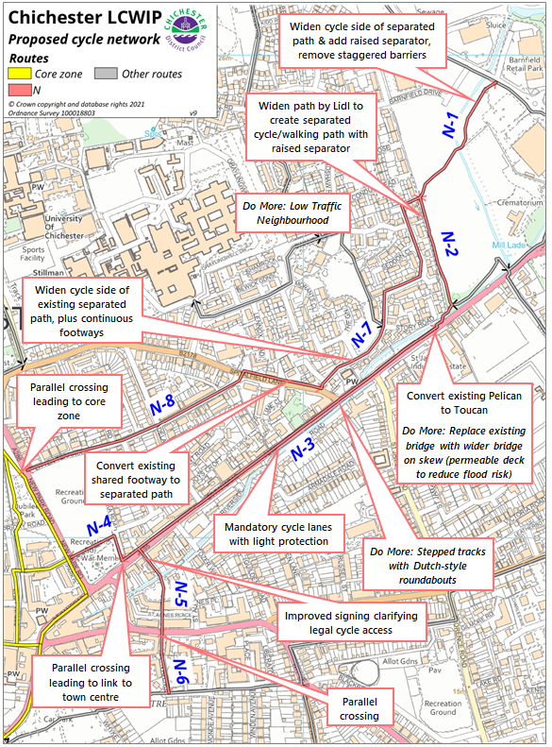
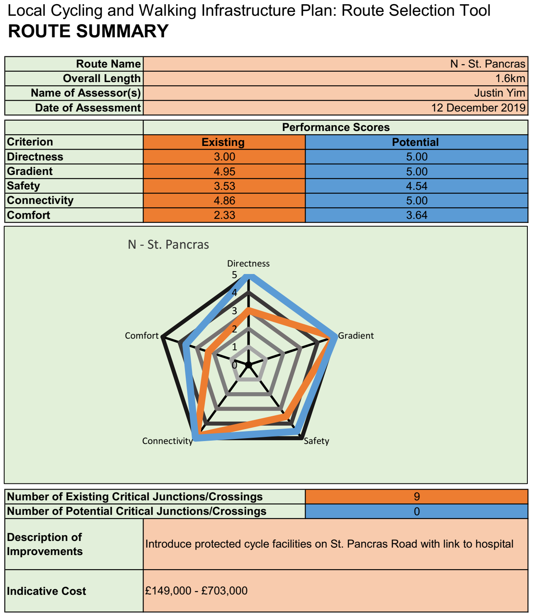

Route Q – College
Plan 19. Proposed interventions – Route Q 