Chichester City LCWIP
Appendix C
Walking audit – Core Walking Zone & key routes
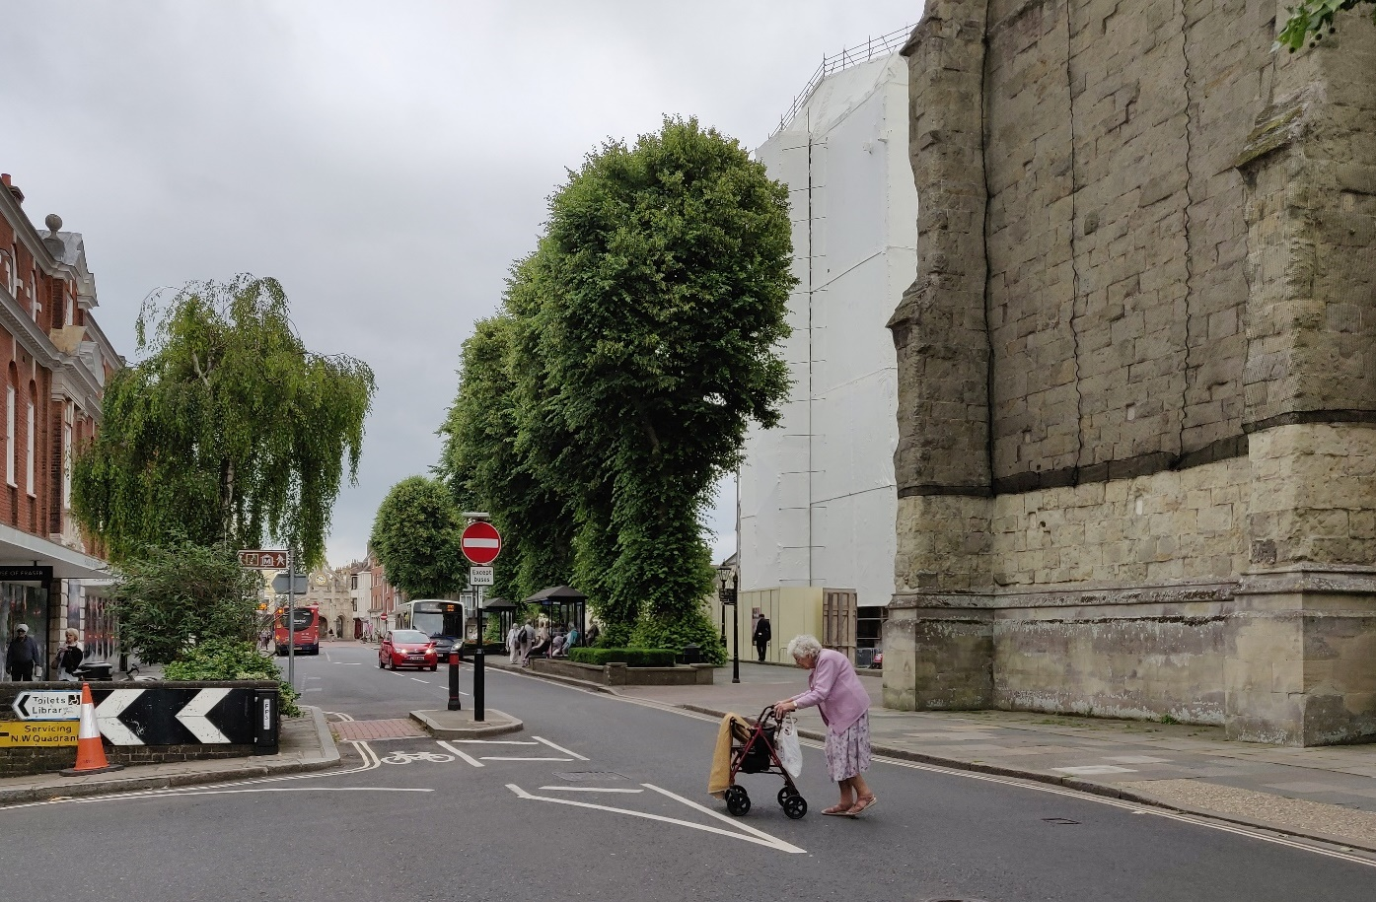
January 2021





© Transport Initiatives LLP 2020
All photos © Transport Initiatives except where stated
All OS mapping © Crown copyright and database rights 2020 Ordnance Survey 100018803

1. Introduction
Technical guidance on the development of a Local Cycling and Walking Infrastructure Plan (LCWIP) was published by DfT in April 2017. This sets out an approach to network planning for walking which includes the identification of a ‘Core Walking Zone’ in addition to longer key walking routes.
As part of the scoping of the LCWIP the area forming the Core Walking Zone was identified as the centre of Chichester. This was assessed in November 2019. In February 2020 a further survey was undertaken of two corridor routes running north and west from the core area. The core walking zone and the starting points of the key walking routes are shown in Plan 1 below.
Plan 1. Core Walking Zone & key walking routes 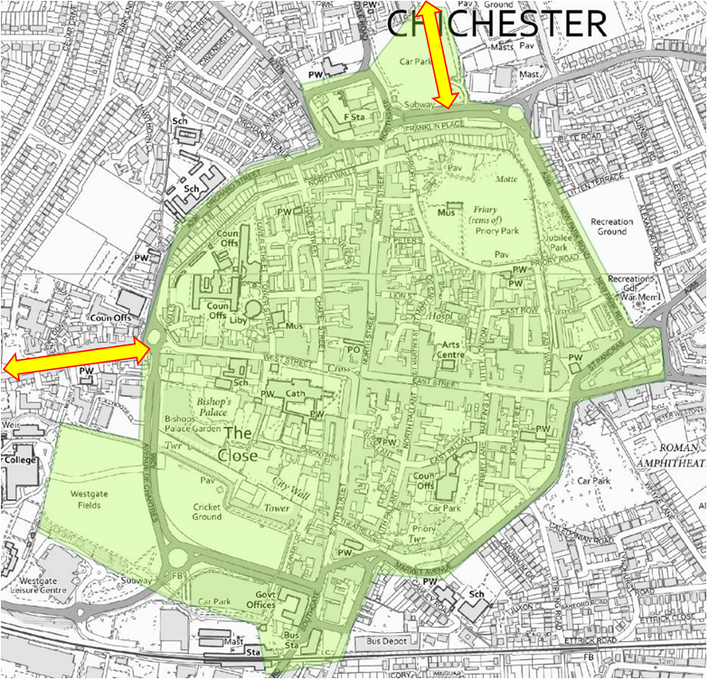

2. Walking audit process
An initial survey was carried out of the Core Walking Zone using GIS. The road and path network was divided into links and areas for more detailed auditing. Each link or area began and ended where the characteristics of the pedestrian environment changed significantly or were interrupted by a major junction.
Once determined, the links and areas were assessed using the LCWIP Walking Route Assessment Tool (WRAT). This tool looks at five core categories that are further split into twenty subcategories.
WRAT categories
Core category | Subcategory | Issues to be assessed
Attractiveness | - Maintenance | Maintenance of footways, removal of vegetation, rubbish and care of street furniture
 | - Fear of crime | Evidence of vandalism and how well the area is overlooked & observed
 | - Traffic noise & pollution | Level of traffic noise and pollution affecting the area
 | - Attractiveness - other | Any other issues such as lighting, excessive guardrails & bollards, refuse sacks etc.
Comfort | - Condition | How level the footways are and the quality of the surface
 | - Footway width | Generally, over 2m is considered good and less than 1.5m is poor
 | - Crossing width | The width of staggered crossings, specifically the width of refuges, islands and reservations
 | - Footway parking | How the footway is obstructed by footway parking
 | - Gradient | Are there significant gradients on the footway?
 | - Comfort - other | Other obstructions such as access gates opening onto footway, bus shelters, bins and other barriers
Directness | - Footway provision | How footways provide for pedestrian desire lines
 | - Location of crossings | How pedestrian crossings are located in relation to pedestrian desire lines
 | - Gaps in traffic | Can pedestrians crossing away from crossings find adequate gaps in traffic
 | - Crossing delay impact | How staggered crossings and waiting times affect journey times
 | - Green man time | Length of green man time
 | - Directness - other | Are bus stops etc. accommodated? Is the layout confusing leading to potential severance?
Safety | - Traffic volume | How much traffic is there and how close is it to pedestrians?
 | - Traffic speed | How fast the traffic is moving and its proximity to pedestrians
 | - Visibility | How well pedestrians can see and be seen
Coherence | - Dropped kerbs and tactile paving | Are dropped kerbs and tactile paving correct and where they should be?

Each of the twenty subcategories were scored on a three point scale
- Poor provision - score 0
- Adequate but should be improved if possible - score 1
- Good quality provision - score 2
The full descriptions of the scoring criteria as set out in the DfT guidance are at the end of this Appendix (see www.gov.uk/government/uploads/system/uploads/attachment_data/file/602531/walking-route-audit-tool.xlsx).
The maximum score possible is 40. The LCWIP guidance recommends that any item with a score under 70% (28 out of 40) is considered to be poor.
The DfT guidance does not differentiate between items scoring over 70%. However, to assist development of measures to improve walking we have divided these into two groups: Adequate (70%-85%) and Good (over 85%).
Example of Poor crossing provision (subcategory 12), South Street
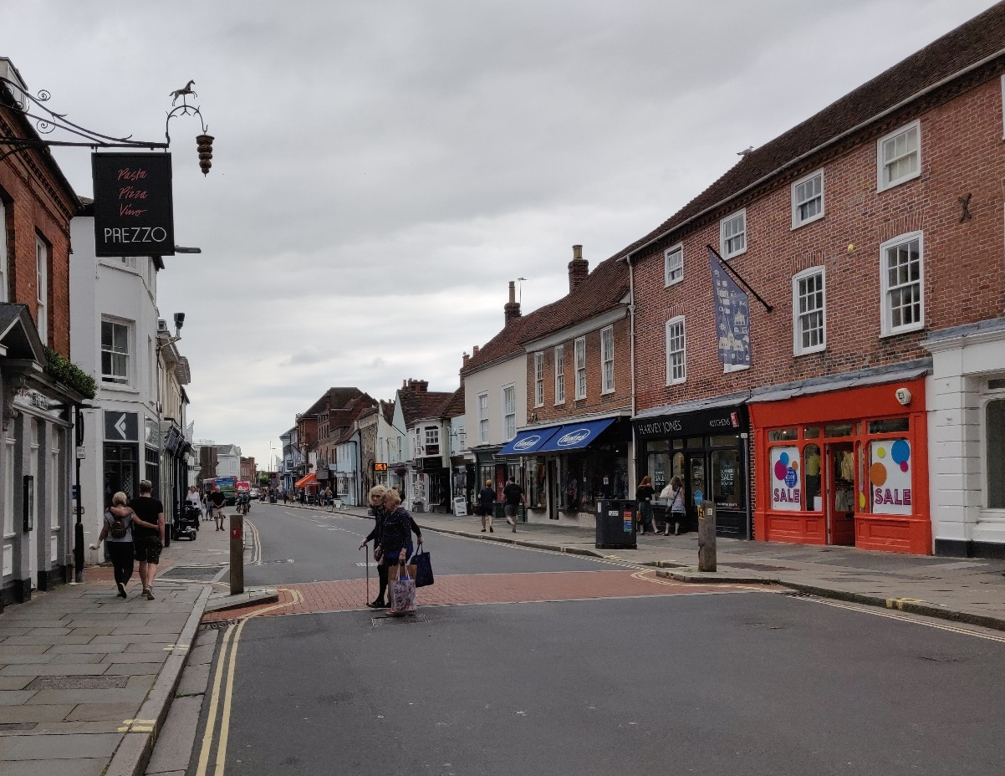

3. Core Walking Zone – detailed audit
The initial survey divided the audit area into 99 distinct items comprising 88 links and 11 areas (mostly car parks). These are shown in Plan 2 below (note different colours used only to indicate separate sections).
Plan 3 shows links and areas classified as Good (green), Adequate (amber) or Poor (Red) according to the percentage score. The smaller plan uses a reverse heat map version to allow for colour blindness.
Plan 2. Audit links and areas
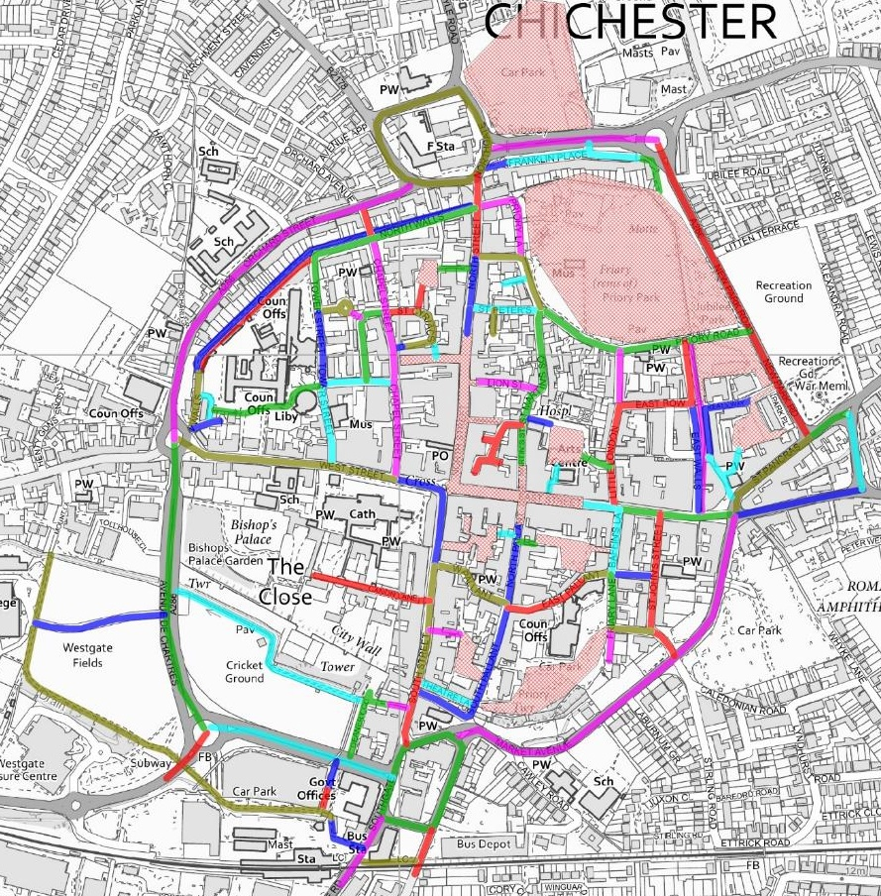

Plan 3. Audit links and areas classified by % score (with alternate version for colour blindness)
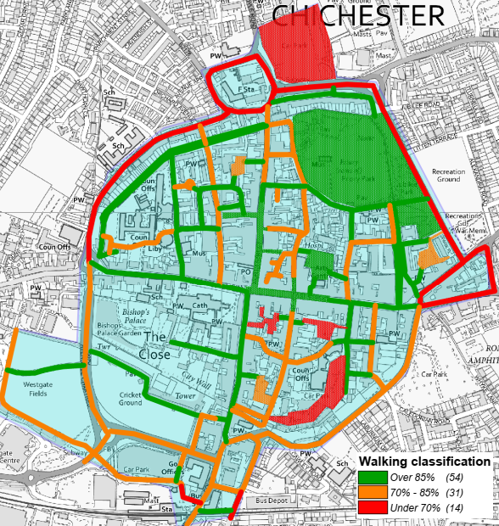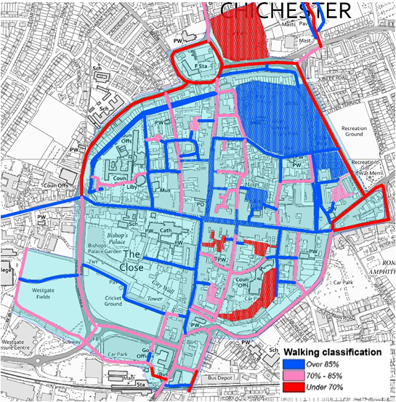
Overall, 54 links or areas were classified as Good, with 31 Adequate (i.e. improvements would be of some benefit) and 14 Poor. The latter are listed below.
Table 1. Links and areas classified as Poor
Ref. | Street / area | Score (max 40) | % | Comments
CW07 | Station Approach | 27 | 68% | Very poor for pedestrians accessing shared path away from the station. Pedestrian comfort sacrificed to accommodate disabled parking bays
CW81 | Cooper Street car park | 27 | 68% | Route through car park with no pedestrian provision. Minimal footpath on access road
CW04 | Basin Road | 26 | 65% | Very poor crossing at north end where pavement on west side peters out short of crossing point
CW19 | The Hornet | 26 | 65% | Narrow pavements. One build-out has dropped kerb but nothing opposite. Very poor
CW20 | Needlemakers | 26 | 65% | Unnecessarily wide with lots of fast traffic and inadequate crossings.
CW21 | St Pancras | 26 | 65% | Crossing at east end is poor for visibility and the whole thing is unsatisfactory
CW77 | Cawley Priory & East Pallant car parks | 26 | 65% | Car parks with no serious pedestrian provision
CW84 | Baffins Lane car park | 26 | 65% | No pedestrian provision through car park. Very poor provision on accesses. Narrowing, missing drops etc.
CW23 | Northgate car park | 25 | 63% | Another car park with no pedestrian provision and a clear route intended through it. Pedestrians just have to mix it
CW16 | Oaklands Way | 24 | 60% | No tactile and central reservation means no crossings. Narrow footpath overgrown in parts
CW10 | Orchard Street | 23 | 58% | Very narrow pavements at points. No tactile at side roads and accesses. Ponding at some. Poor pavement surface and narrow island at southern end by roundabout
CW24 | Northgate gyratory | 23 | 58% | The problems with this gyratory are well documented but the pedestrian provision at all arms is very poor and some of the pavements are very narrow
CW17 | New Park Road | 22 | 55% | Pavement not continuous on both sides and at points narrow. Insufficient crossings badly placed and some missing tactile
CW18 | St Pancras | 22 | 55% | Intimidating environment for pedestrians. Narrow pavements, poor quality of dropped kerbs, inadequate crossings and lots of speeding traffic on what feels like a one-way race track
There are some mitigating circumstances which need to be noted before more detailed analysis of the findings is discussed. Chichester is an historic city with historic streetscapes, the preservation of which restricts some of the things which can be done to change existing infrastructure. In the historic core there are many places where narrow pavements result in a score of zero, but where pavement widening is not a realistic option.

Similarly, many links scored low on fear of crime where paths are not well overlooked, such as those through parks or along the city walls. These will be fine during daylight hours but less so in darkness. However, it would not be reasonable to expect that this could or should be changed significantly as this is due to the nature of those locations.
Despite the relatively good performance, there are some significant issues to be addressed to make walking in the core area of Chichester attractive and convenient for both residents and visitors.
The density of car parks in and around the city centre makes a clear statement that people arriving by car are welcome. However, once drivers have parked the consistency of their experience on foot (including that of their passengers) is likely be much less satisfactory, particularly if they are less able bodied. Apart from one section of a single car park there is no dedicated pedestrian provision within car parks and hence after leaving their cars, drivers and passengers are expected to share car park roadways with vehicles arriving or leaving. In particular, Northgate, Baffins Lane and Cawley Priory/East Pallant car parks were all classified as Poor for people walking.
While the narrowness, or in some cases absence, of pavements is not unusual in an historic streetscape, what is less acceptable is the absence of adequate dropped kerbs to facilitate crossing where and when pavements cease. The almost total absence of tactile paving at the majority of crossings is also very poor. We would expect to see tactile paving as standard at any major junction or key crossing point (this can be provided in a way which is in keeping with conservation areas). This is not the case in Chichester, with the Northgate gyratory being an example of where a major series of junctions lack any tactile paving. Indeed, the overall walking and crossing provision at the gyratory is very poor.
As part of the cycling section of the LCWIP we carried out a partial Cycle Skills Network Audit (CSNA) of Chichester. This identified roads where cyclists or pedestrians would require skills greater than those achieved at Bikeability Level 2 (as taught at the end of primary school) to ride along or cross them in consistent safety.
The formal crossings on these roads were audited against the same criteria and the outcome of this audit are shown in Plan 4 below.
The CSNA shows that virtually all the roads in the city centre inside the inner ring road are were classified Level 2. The overall traffic safety issues in the city centre are satisfactory within the actual streets. However, the CSNA did not audit the car parks, just their access roads, so the lack of pedestrian provision within these is a genuine safety concern. Nearly as important is how the overall pedestrian experience might detract from enjoyment of the attraction of the historic city centre.
The pedestrianised streets in the centre are attractive, but while they were not failed in the walking audit it must be stated that the surface is very uneven in places. This is a drawback with York stone paving and cobbles which may fit the historic nature of the location but will be a problem those with pushchairs, wheelchairs or other mobility issues. Some historic towns and cities have found solutions that allow the retention of these materials while removing most of their inherent unevenness.
The detailed LCWIP audit found that the pedestrian environment of central Chichester is not coherent. The LCWIP walking audit categories provide the context for addressing the issues that lead to the lack of coherence. This will allow the development of a clear vision of what a pedestrian friendly Chichester should look like. The more detailed findings are dealt with below. By addressing these it will be possible to create a pedestrian environment that truly enhances the visitor experience and therefore benefits the whole of Chichester.
It is important to note that the overall score can mask those links or areas which were rated as Poor on one or more of the assessment categories, with a score of zero. Around two-thirds (68) of the items audited had scores of zero on at least one category. These are described below in detail and shown in Plans 4-21.
Plan 4. CSNA of central Chichester showing crossing provision
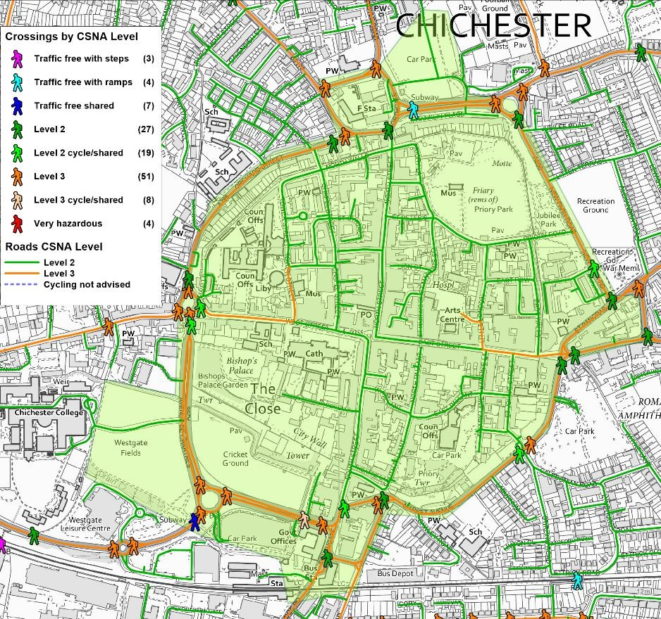

Attractiveness
Plans 5, 6 and 7 below show the links (highlighted dotted yellow) and areas (yellow fill) that failed on one or more of the attractiveness categories.
Plan 5. North west area
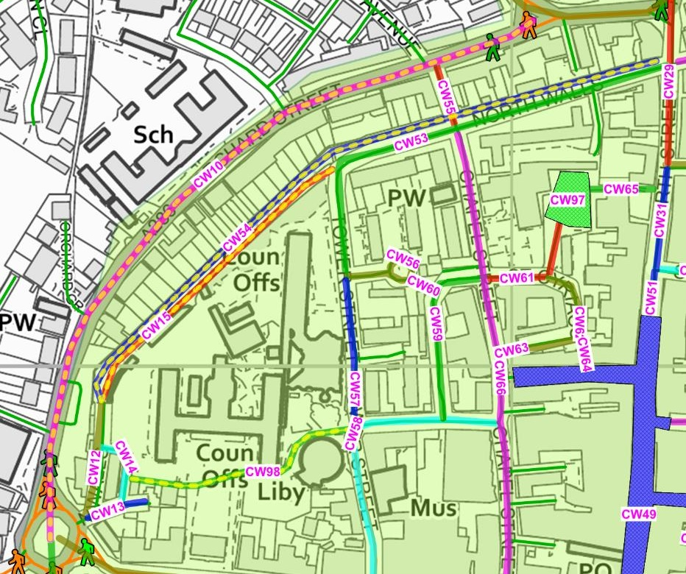
The links that failed on the attractiveness category were:
- CW10 Orchard Street, which failed on traffic noise and pollution.
- CW15 North Walls shared cycle/footpath and CW54 North Walls footpath, both of which failed on the fear of crime category due to their isolated nature. This could be a deterrent to people walking and cycling, particularly after dark.

Plan 6. North East area
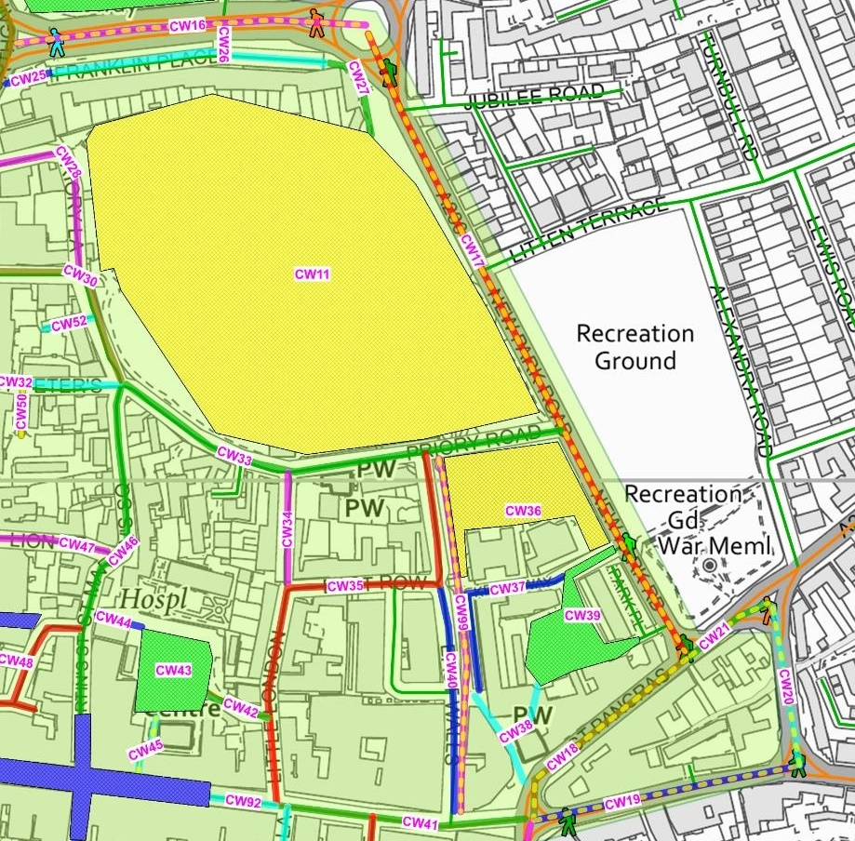
The links that failed on the attractiveness category were:
- CW16 Oaklands Way failed on maintenance as parts of the narrow footpath on the south side is significantly overgrown by adjacent bushes.
- CW17 New Park Road, CW18 & CW21 St Pancras, CW19 The Hornet and CW20 Needlemakers all failed on traffic noise and pollution.
- CW11 Priory Park, CW36 New Park open space and Keats Way and CW99 Upper Walls Walk failed on fear of crime, again due to their isolated nature.

Plan 7. South area
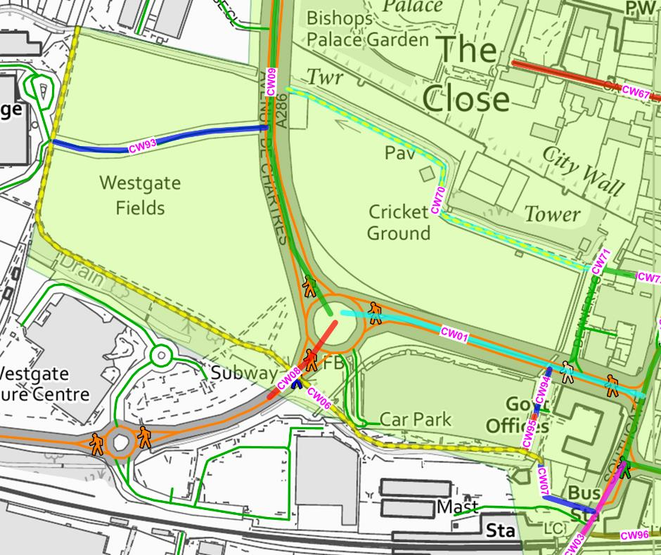
The links that failed on the attractiveness category were:
- CW06 Chichester Station - Chichester College path and CW70 Walls Walk by River Lavant, both of which failed on the fear of crime category due to their isolated nature.

Comfort
Plans 8, 9 and 10 below show the links (highlighted dotted yellow) and areas (yellow fill) that failed on one or more of the comfort categories.
Plan 8. North west area
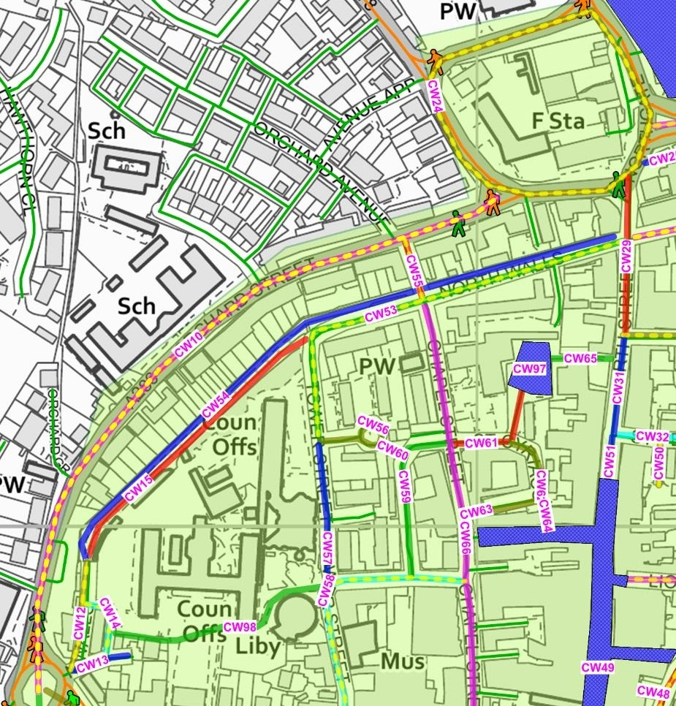
The links that failed on the comfort category were:
- CW10 Orchard Street has narrow pavements, areas of poor surfacing and a narrow island by the roundabout at its southern end.
- CW24 Northgate gyratory, also has sections of narrow pavement which is poor for such a major feature.
- CW12 and CW53 (both North Walls) and CW58 Tower Street & The Woolstaplers also have narrow pavements.

Plan 9. North east area
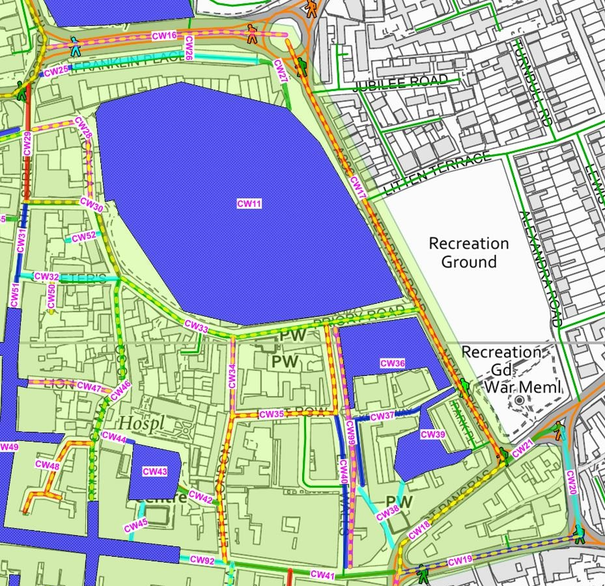
The links that failed on the comfort category were:
- CW16 Oaklands Way, CW17 New Park Road, CW19 The Hornet, CW33 Priory Road, CW34 Little London, CW47 Lion Street and CW52 Jays Walk all have narrow pavements.
- CW18 St Pancras and CW28 Priory Lane have narrow pavements and issues with poor surface quality.
- CW30 Guildhall & Priory Road have issues with crossing points.
- CW35 Little London and East Row and CW46 St Martin’s Street have bollards and parking meters obstructing and reducing already narrow pavement widths. Little London also has a redundant guardrail panel restricting it further.
- The north end of CW99 Upper Walls Walk can only be accessed via steps.

Plan 10. South area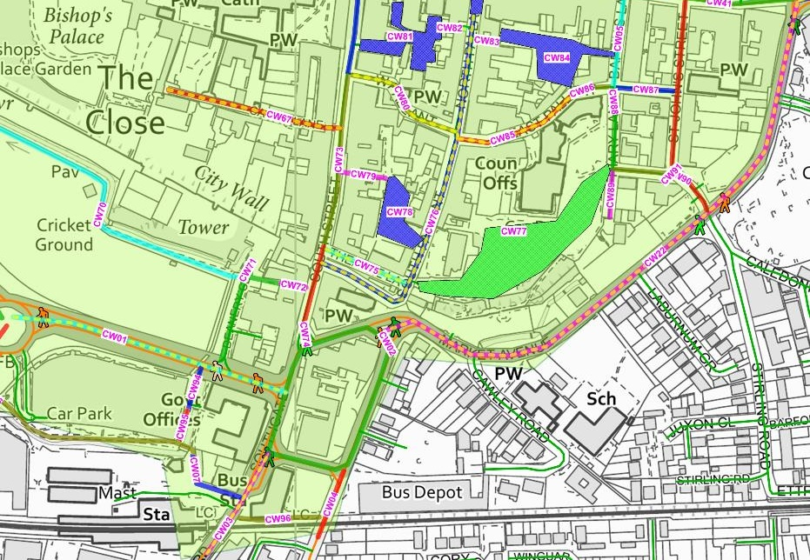
The links that failed on the comfort category were:
- CW03 Southgate & Stockbridge Road, CW75 Theatre Lane, CW76 North and South Pallant, CW80 West Pallant and CW85 East Pallant all have narrow pavements.
- CW01 Avenue de Chartres and CW22 Market Road both have narrow crossings.
- CW67 Canon Lane has a very poor pavement surfacing, and in particular the pavement on the north side is very narrow.

Directness
Plans 11-15 below show the links (highlighted dotted yellow) and areas (yellow fill) that failed on one or more of the directness category.
Plan 11. North area
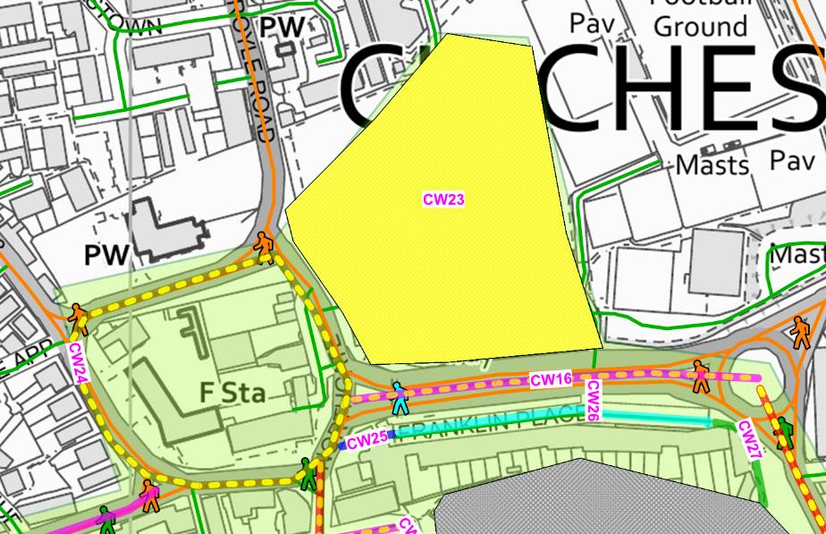
The links that failed on the directness category were:
- CW16 Oaklands Way has a central reservation which means there no places to cross informally along its length.
- CW23 Northgate car park has very poor provision for pedestrians (including drivers and passengers walking to or from their cars), with no footpath provision whatsover. There are pedestrian signs but these direct people along and across the car park roadways.
- CW24 Northgate gyratory is missing crossings on key desire lines.

Plan 12. North west area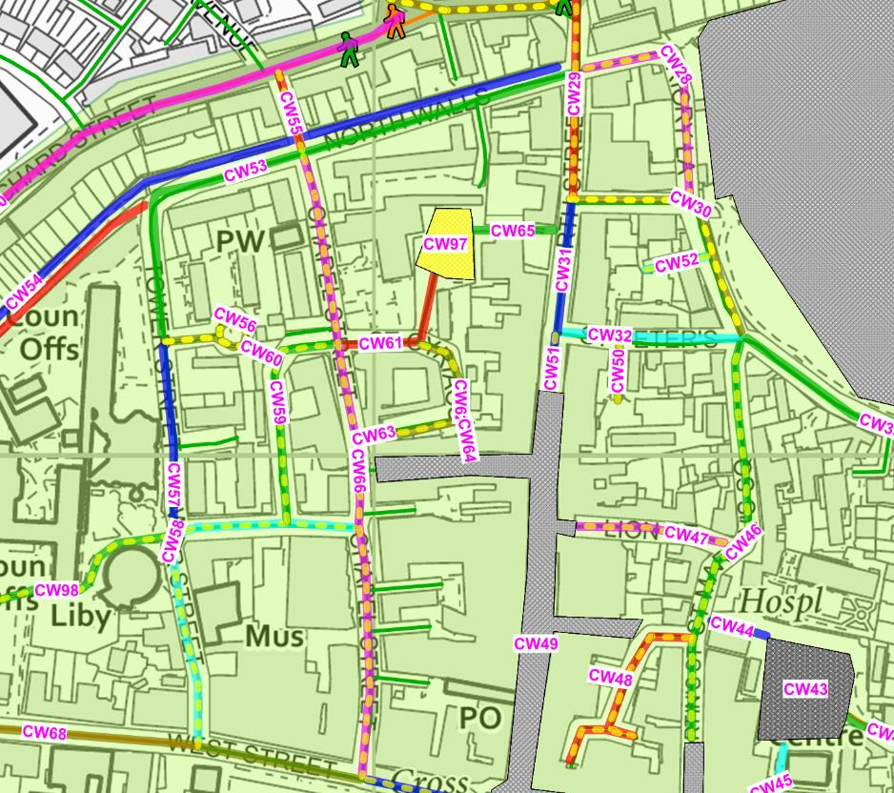
The links that failed on the directness category were:
- CW28 Priory Lane, CW52 Jays Walk, CW55 Orchard Street, CW62 St Cyriacs, CW97 St Cyriacs car park and CW98 West Sussex County Council campus all lack a pavement or other walking provision on key pedestrian desire lines.
- CW29 North Street, CW46 St Martin’s Street, CW47 Lion Street, CW51 North Street, CW58 Tower Street & the Woolstaplers, CW59 The Providence, CW60 Path between Tower Close and The Providence and CW66 Chapel Street all lack crossings on key pedestrian desire lines.
- CW30 Guildhall Street & Priory Road and CW56 Tower Close both have missing pavements and crossings on key pedestrian desire lines.

Plan 13. North east area
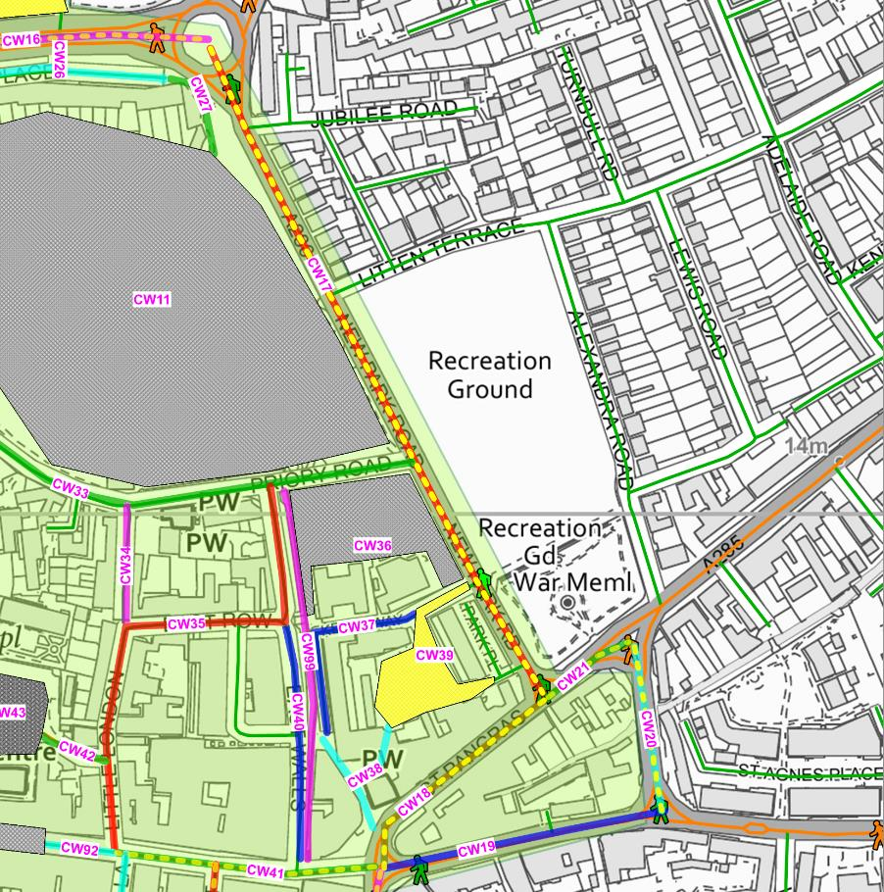
The links that failed on the directness category were:
- CW17 New Park Road which suffers from lack of continuous pavement provision, crossings on desire lines, gaps in traffic in peak periods and staggered nature of existing crossing points.
- CW18 St Pancras is also missing crossings on key desire lines and with staggered delay of exiting crossing provision.
- CW20 Needlemakers has poor crossing location and heavy traffic at peak hours reducing crossing gaps.
- CW21 St Pancras and CW41 East Street both lack crossings on key desire lines.

Plan 14. South east area
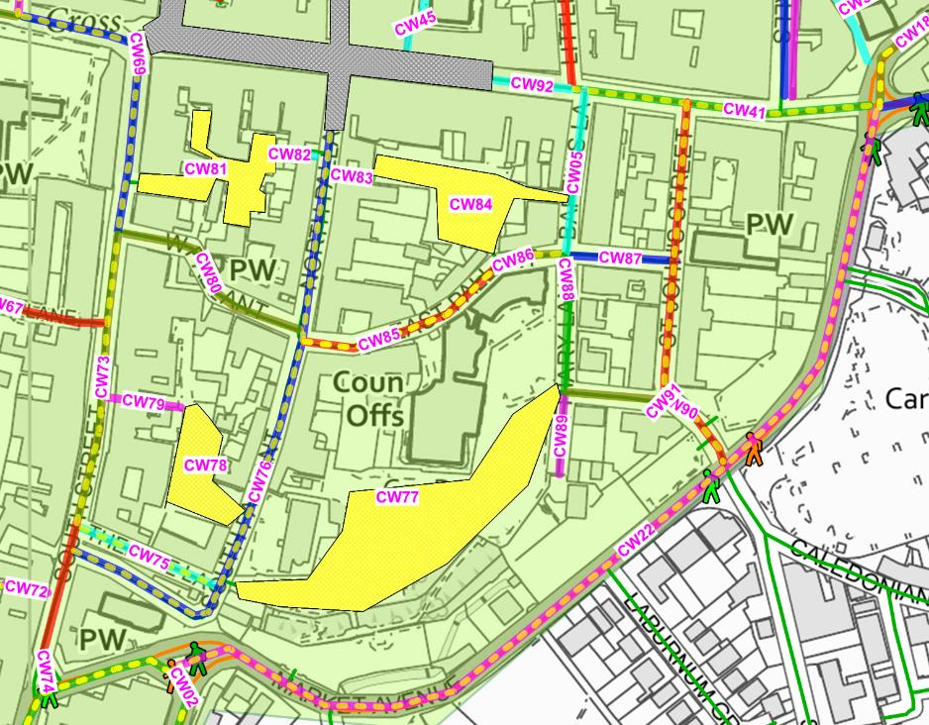
The links that failed on the directness category were:
- CW76 North & South Pallant and CW78 South Pallant car park both have no footpaths or other walking provision on pedestrian desire lines.
- CW77 Cawley Priory & East Pallant car parks, CW81 Cooper Street car park, CW84 Baffins Lane car park and CW85 East Pallant all lack direct pavement provision and crossings on desire lines.
- CW22 Market Road, CW69 West & South Streets, CW73 South Street, CW75 Theatre Lane, CW86 East Pallant and CW90 St John’s Street are all missing crossings on key pedestrian desire lines.

Plan 15. South west area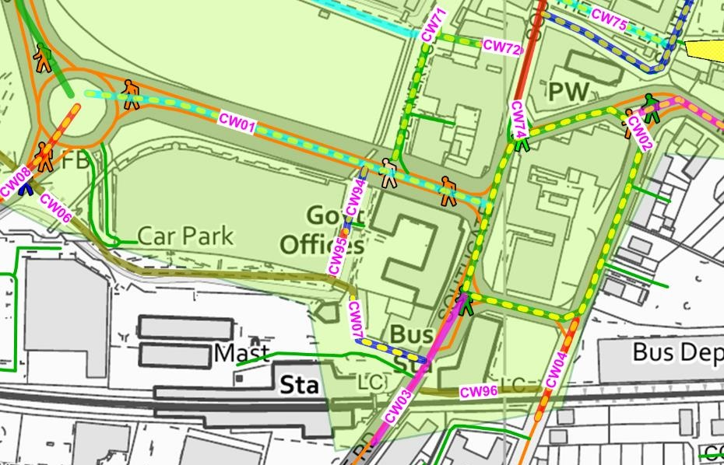
The links that failed on the directness category were:
- CW08 Via Ravenna is missing pavement provision.
- CW02 Southgate gyratory is missing continuous pavement provision and the staggered nature of existing crossings ads delay.
- CW07 Station Access lacks continuous pavement provision, crossings on desire lines and staggered crossings adding to delay.
- CW04 Basin Road and CW71 Deanery Close lack crossings on pedestrian desire lines.
- CW01 Avenue de Chartres lacks gaps in traffic during peak hours making it difficult to cross safely.

Safety
Plans 16, 17 and 18 below show the links (highlighted dotted yellow) and areas (yellow fill) that failed on one or more of the safety categories.
Plan 16. North west area
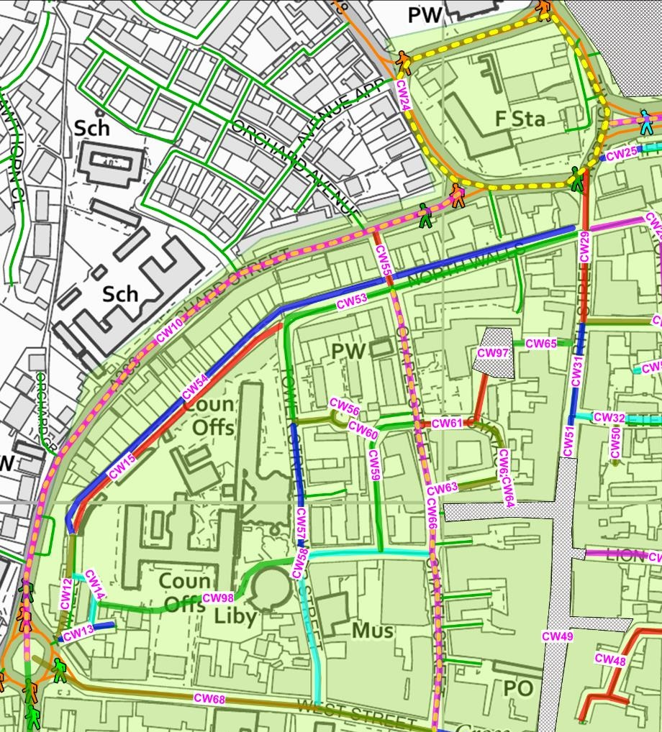
The links that failed on the safety category were:
- CW66 Chapel Street where the crossings of side streets are consistently sited away from junctions where visibility was compromised.
- CW10 Orchard Street has heavy traffic very close to pedestrians.
- CW24 Northgate gyratory fails on all three safety categories, with proximity to heavy and fast moving traffic and some visibility issues at crossings.

Plan 17. North east area
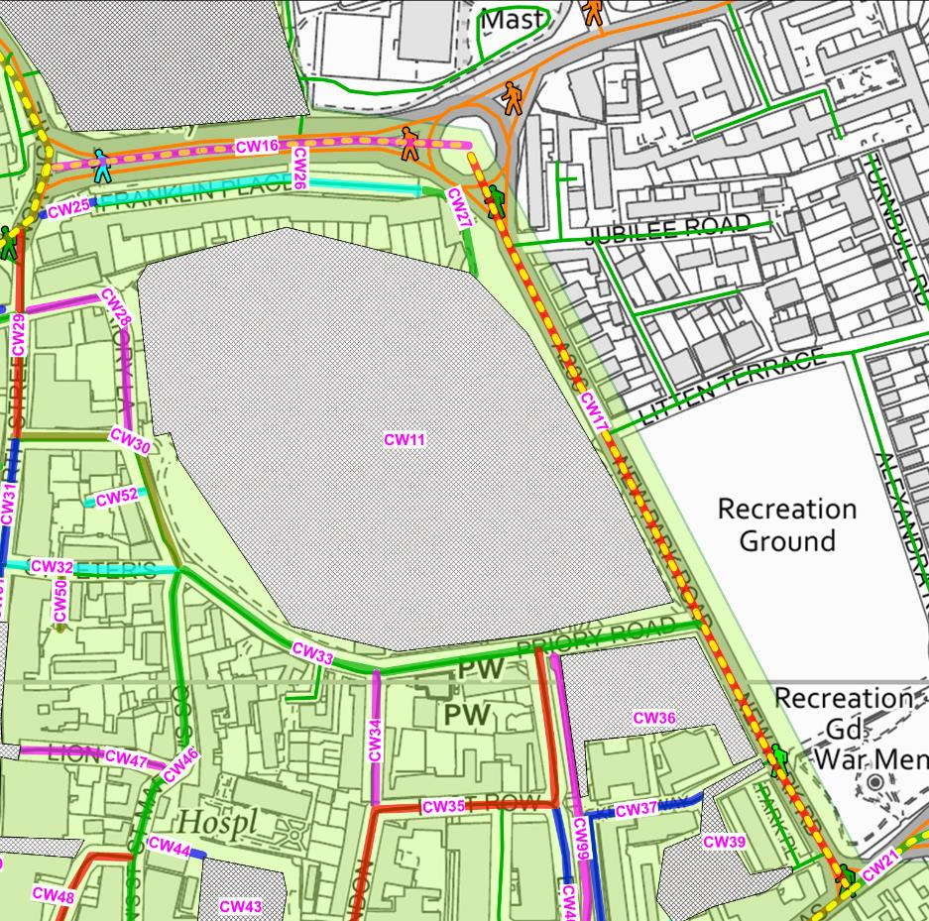
The links that failed on the safety category were:
- CW16 Oaklands Way has pedestrian proximity to heavy traffic.
- CW17 New Park Road has close pedestrian proximity to heavy and fast moving traffic.

Plan 18. South east area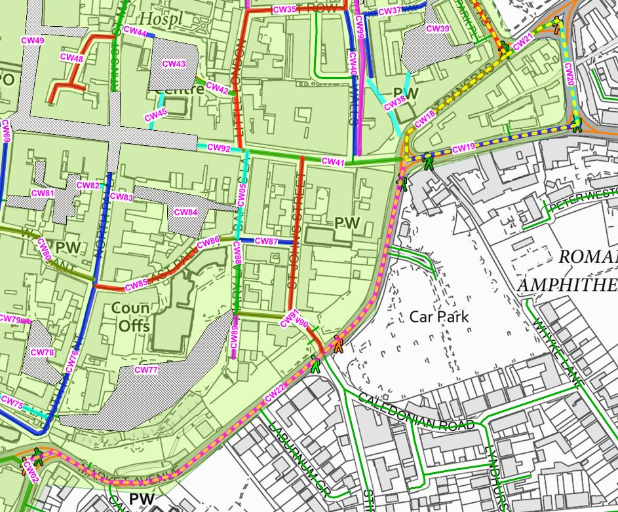
The links that failed on the safety category were:
- CW22 Market Road has fast moving traffic.
- CW18 St Pancras, CW19 The Hornet and CW20 Needlemakers has heavy fast moving traffic in close proximity to pedestrians
- CW21 St Pancras failed on all three safety categories, with proximity to heavy and fast moving traffic and some visibility issues at crossings.

Coherence
Plans 19, 20 and 21 below show the links (highlighted dotted yellow) and areas (yellow fill) that failed on one or more of the directness categories.
Note that coherence refers to the clarity of the walking environment i.e. how clearly and sensibly walkers are given visual and tactile guidance on where to walk and are provided with minimal delay and inconvenience. It does not address other issues such as wayfinding.
Plan 19. North area
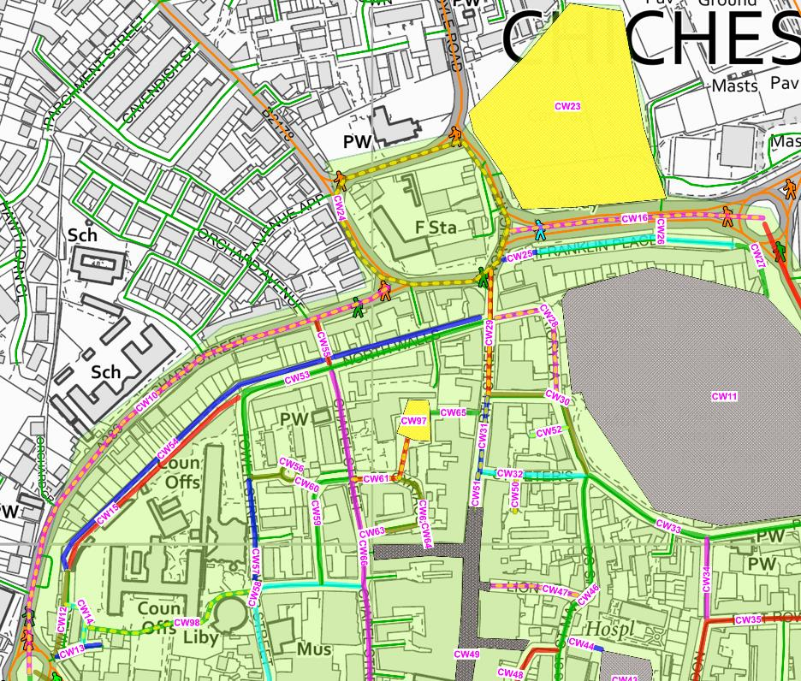
The following links and areas failed on the coherence category:
- CW10 Orchard Street
- CW14 West Sussex County Council access road
- CW16 Oaklands Way
- CW23 Theatre car park
- CW24 Northgate gyratory
- CW28 Priory Lane
- CW29 and CW31 North Street
- CW47 Lion Street
- CW50 St Peters
- CW51 North Street
- CW60 Path - Tower Close to The Providence
- CW61 St Cypriacs
- CW97 St Cypriacs car park
- CW98 West Sussex County Council buildings
Plan 20. South east area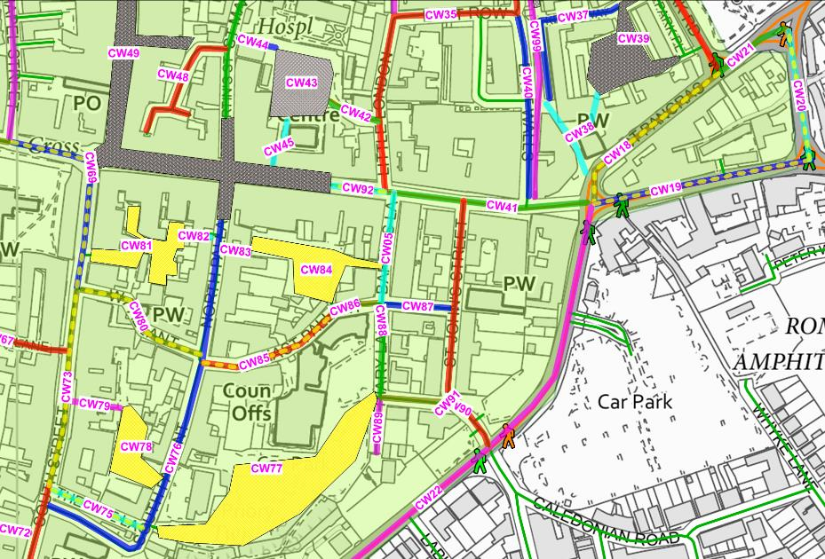
The following links and areas failed on the coherence category:
- CW18 St Pancras
- CW19 The Hornet
- CW20 Needlemakers
- CW69 West Street & South Street
- CW73 South Street
- CW75 Theatre Lane
- CW77 Cawley Priory car park
- CW78 South Pallant car park
- CW80 West Pallant
- CW81 Cooper Street car park
- CW84 Baffins Lane car park
- CW85 East Pallant
- CW92 East Street

Plan 21. South west area
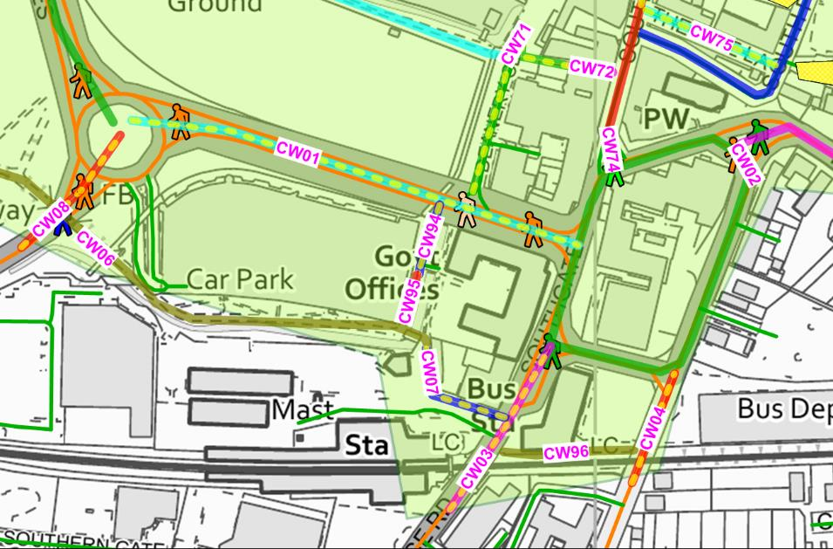
The following links and areas failed on the coherence category:
- CW01 Avenue de Chartres
- CW03 Southgate and Stockbridge Road
- CW04 Basin Road
- CW07 Station Approach
- CW08 Via Ravenna
- CW73 South Street
- CW94 Access by multi-storey car park
3. Key walking routes – detailed audit
A survey was undertaken of two corridor routes running north and west from the core area:
- Northern route – from the north of the core walking zone (Chichester Festival Theatre car park), including access to the University along College Lane and then further to the north along Summersdale Road. A linking section along Broyle Road and Wellington Road completed this corridor. The path from College Lane across Oaklands Park was also surveyed.
- Western route – west of the core walking zone along Westgate as far as Fishbourne Road West and Fishbourne Palace.
Northern route
Plan 22 Northern route
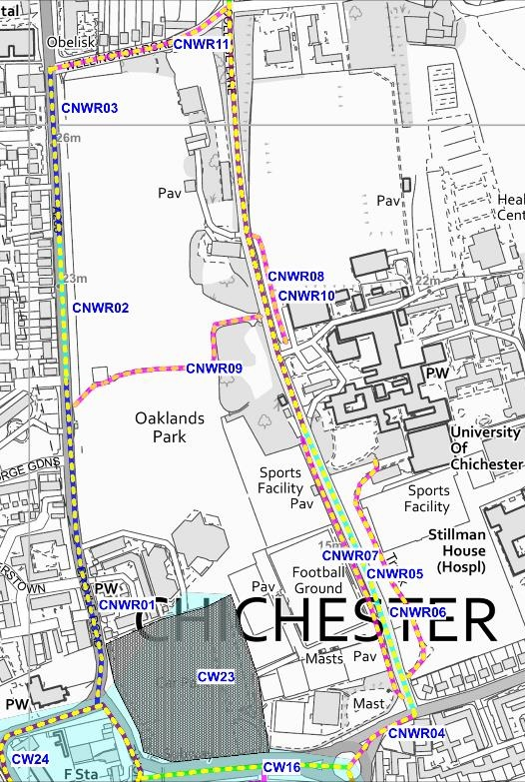 | 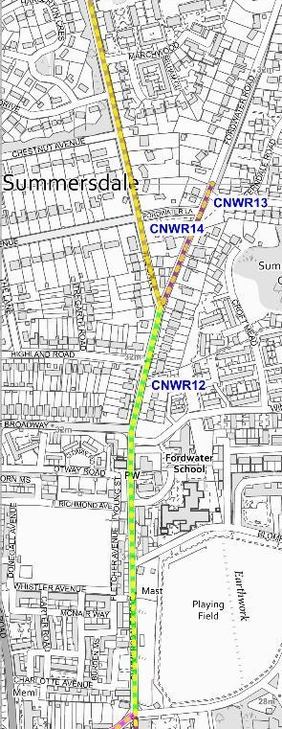
The northern route was split into 14 separate sections which are shown on the two plans to the left and right. All these sections are dotted yellow in the plans, indicating that they all failed at least one of the twenty assessment criteria.
The key section is the routing along College Lane between Spitalfield Lane and Wellington Road and particularly the southern section of this from the entrance to the University. This latter is served by three possible approaches. However, one of these CNWR07, the path to the east of College Lane, only gives limited access to the south of the University.
College Lane itself is narrow with a footpath on the east side only. The footpath is very narrow and its condition is very poor. While the road is not heavily trafficked what traffic there is tends pass at speed due partly to being on a gradient and the overall tunnel effect is further exacerbated by walls and then trees along both sides. The environment feels very hostile for pedestrians in daylight hours.
The path on the west side is behind the wall and some height above the road. This path is quite wide and winds through trees. In daylight it is well used by students but in darkness and quieter periods it is not really overlooked so is likely to be unattractive to lone pedestrians.
A solution to make this approach more attractive for walkers and cyclists would be make College Lane one way northbound as far as the college entrance, reducing the carriageway to single width and introducing traffic calming to reduce speeds. The footway could then be widened and a two-way cycle path constructed. There is likely to be more traffic to provide passive surveillance in the evening.
Alternatively, a full filter (with a bus gate) could be implemented.
Western Route
Plan 23 Western route
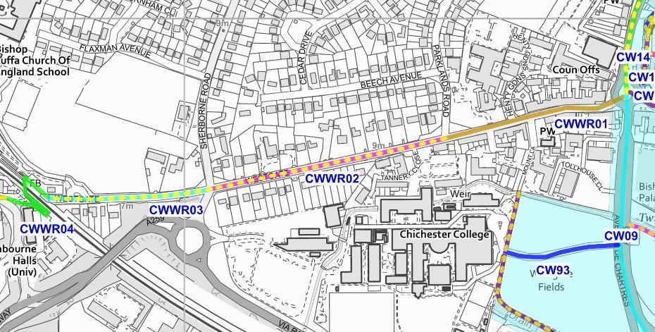
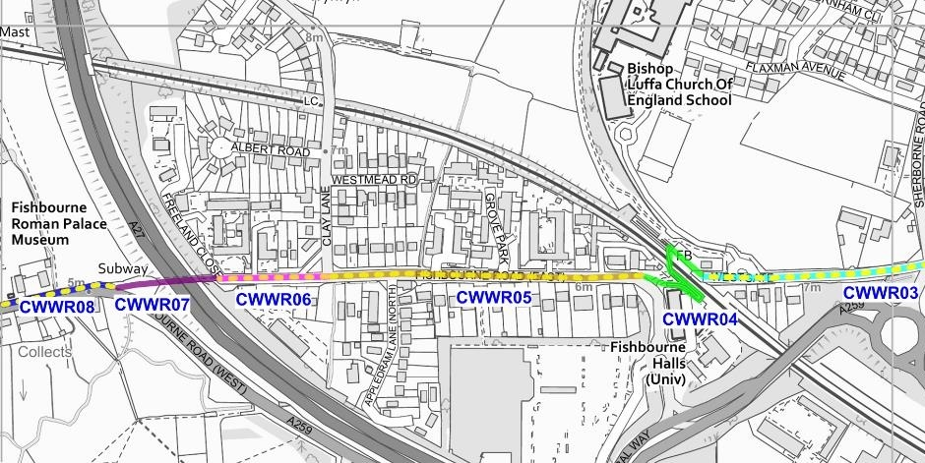
The eight sections of the western route are shown in the plan above. Those that failed any of the twenty assessment criteria are dotted yellow. Unlike the northern route there were three sections that did not fail any of the criteria.
It should be noted that the footbridge over the railway did not fail. While it is sub-standard from a cycle perspective, it is reasonable for people walking with a relatively gentle gradient and good visibility.
Four of the five sections that failed did so for coherence. This is primarily an absence of tactile paving and/or dropped kerbs at key desire crossing points. While we would expect all crossings of junctions and busier private accesses to have tactile paving, the provision at older minor accesses is often mixed. For the sections assessed here the presence of tactile paving was generally not coherent, with some minor crossings having tactile paving and some major ones lacking it. This is worse than having nothing at all as visually impaired people might then have a false sense of security.
The critical fails for each section are:
- CWWR02 Westgate – failed for coherence and more crucially for the lack of crossing provision at its west end at the junction with Sherborne Road. This is a fairly busy roundabout where pedestrians on the south of Westgate must cross to the north as there is no footpath on the south side of Westgate west of the junction. This is wholly unsatisfactory for the most serious at grade crossing on the whole route.
- CWWR03 Westgate – failed for the same reason of the crossing of its eastern junction, and coherence. The issues are even more severe on this side of the junction with missing crossing points and the disappearing footpath. Also at peak hours, traffic queues across the junction increasing the perceived hazard.
- CWWR05 & CWWR06 Fishbourne Road East – both failed for issues of coherence and inconsistency in provision of tactile paving. Junctions also had wide swept curve accesses no matter how minor.
- CWWR08 Fishbourne Road West – failed for some very poor surfacing and the total absence of any crossing from its south to north side on this section.
The full assessment scores for all the sections are shown in Section 4 below.
Junction of Westgate / Sherborne Road, from the south - traffic can back onto this from the south at peak times  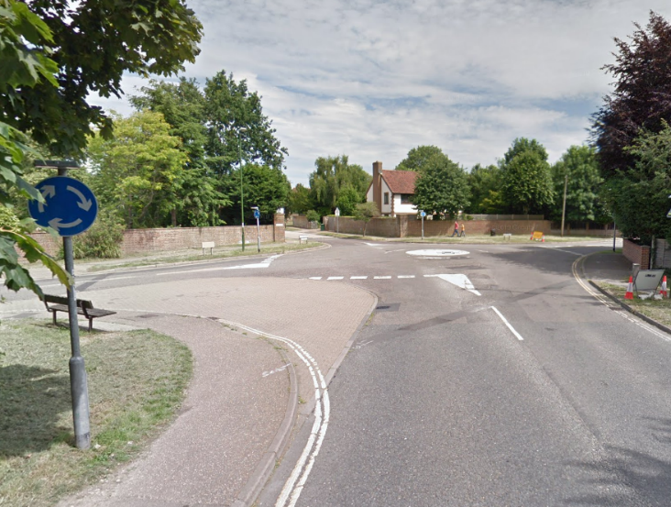 | Typical junction splay for a private residential access – much too large for this location  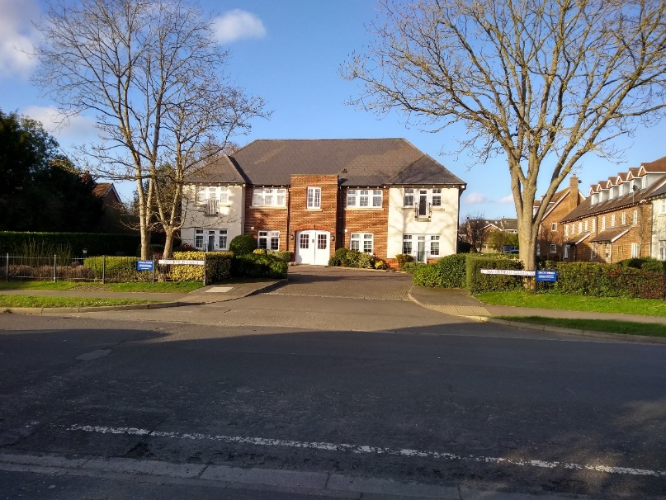

4. Detailed WRAT tables
Core Walking Zone links & areas scores (critical fails highlighted red)
Ref | Street name | ATTRACTIVE-NESS |  |  |  | COMFORT |  |  |  |  |  | DIRECTNESS |  |  |  |  |  | SAFETY |  |  | COHER-ENCE | TOTAL
 |  | A1 | A2 | A3 | A4 | Cm1 | Cm2 | Cm3 | Cm4 | Cm5 | Cm6 | D1 | D2 | D3 | D4 | D5 | D6 | S1 | S2 | S3 | Ch1 | SCORE | % | Comments
CW01 | Avenue de Chartres | 2 | 2 | 1 | 2 | 1 | 1 | 0 | 2 | 2 | 2 | 2 | 2 | 0 | 2 | 1 | 2 | 1 | 1 | 2 | 0 | 28 | 70% | Missing tactile at Deanery Close crossing. Narrow refuge at Southgate junction. Central reservation means crossing away from fixed crossings difficult. Serious tree route issues on not wide paths
CW02 | Southgate gyratory | 2 | 2 | 1 | 1 | 2 | 1 | 2 | 2 | 2 | 2 | 0 | 2 | 1 | 0 | 2 | 2 | 1 | 1 | 2 | 2 | 30 | 75% | No pedestrian route past bus station & narrow pavement on inside of gyratory at this point
CW03 | Southgate & Stockbridge Road | 2 | 2 | 1 | 1 | 1 | 0 | 2 | 2 | 2 | 2 | 2 | 2 | 1 | 2 | 2 | 2 | 1 | 1 | 2 | 0 | 30 | 75% | Tactiles missing and pavement width poor at level crossing
CW04 | Basin Road | 1 | 2 | 1 | 1 | 1 | 1 | 2 | 2 | 2 | 2 | 1 | 0 | 1 | 1 | 2 | 2 | 1 | 1 | 2 | 0 | 26 | 65% | V poor crossing at north end - pavement on west side peters out short of crossing point
CW05 | Baffins Lane | 2 | 2 | 2 | 2 | 2 | 1 | 2 | 2 | 0 | 2 | 2 | 1 | 2 | 2 | 2 | 2 | 2 | 2 | 2 | 1 | 35 | 88%
CW06 | Chichester Station - Chichester College path | 1 | 0 | 2 | 2 | 1 | 1 | 2 | 2 | 1 | 2 | 2 | 2 | 2 | 2 | 2 | 2 | 2 | 2 | 2 | 2 | 34 | 85% | Shared use (line separated) path with some sections too narrow, odd bit of overgrown bushes
CW07 | Station Approach | 2 | 2 | 1 | 1 | 2 | 1 | 2 | 2 | 2 | 2 | 0 | 0 | 2 | 0 | 2 | 2 | 1 | 2 | 1 | 0 | 27 | 68% | Very poor for pedestrians accessing shared path away from the station. Pedestrian comfort sacrificed to accommodate disabled parking bays
CW08 | Via Ravenna | 2 | 2 | 2 | 2 | 2 | 2 | 2 | 2 | 2 | 2 | 0 | 2 | 1 | 2 | 2 | 2 | 1 | 1 | 2 | 0 | 33 | 83% | No pavements and no tactiles at crossing at junction
CW09 | Avenue de Chartres | 2 | 1 | 1 | 2 | 1 | 1 | 2 | 2 | 2 | 2 | 2 | 2 | 1 | 2 | 1 | 2 | 1 | 1 | 2 | 2 | 32 | 80% | Some narrow points and tree root issues on path. Also path away from carriageway at points
CW10 | Orchard Street | 2 | 2 | 0 | 2 | 0 | 0 | 0 | 2 | 2 | 2 | 2 | 1 | 1 | 2 | 1 | 2 | 0 | 1 | 1 | 0 | 23 | 58% | Very narrow pavements at points. No tactiles at side roads and accesses. Ponding at some. Poor pavement surface and narrow island at southern end by roundabout
CW11 | Priory Park | 2 | 0 | 2 | 2 | 2 | 2 | 2 | 2 | 2 | 2 | 2 | 2 | 2 | 2 | 2 | 2 | 2 | 2 | 2 | 2 | 38 | 95%
CW12 | North Walls | 2 | 1 | 2 | 2 | 2 | 0 | 2 | 2 | 2 | 2 | 2 | 2 | 2 | 2 | 2 | 2 | 2 | 2 | 2 | 1 | 36 | 90% | Very narrow pavement
CW13 | Wall Cottage Drive | 2 | 2 | 2 | 2 | 2 | 2 | 2 | 2 | 2 | 2 | 2 | 1 | 2 | 2 | 2 | 2 | 2 | 2 | 2 | 2 | 39 | 98%
CW14 | West Sussex County Council access | 2 | 1 | 2 | 2 | 2 | 0 | 2 | 2 | 2 | 2 | 0 | 1 | 2 | 2 | 2 | 2 | 2 | 2 | 2 | 0 | 32 | 80% | Not coherent
CW15 | North Wall shared path | 1 | 0 | 2 | 2 | 2 | 2 | 2 | 2 | 2 | 2 | 2 | 2 | 2 | 2 | 2 | 2 | 2 | 2 | 2 | 2 | 37 | 93% | Very pleasant but not overlooked and vegetation needs trimming
CW16 | Oaklands Way | 0 | 1 | 1 | 2 | 1 | 0 | 2 | 2 | 1 | 2 | 2 | 0 | 1 | 2 | 2 | 2 | 0 | 1 | 2 | 0 | 24 | 60% | No tactiles, central reservation means no crossings. Narrow footpath overgrown in parts
CW17 | New Park Road | 2 | 2 | 0 | 2 | 2 | 0 | 2 | 2 | 2 | 2 | 0 | 0 | 0 | 0 | 1 | 2 | 0 | 0 | 2 | 1 | 22 | 55% | Pavement not continuous on both sides and at points narrow. Insufficient crossings badly placed and some missing tactile
CW18 | St Pancras | 2 | 2 | 0 | 1 | 0 | 0 | 2 | 2 | 2 | 2 | 2 | 0 | 1 | 0 | 2 | 2 | 0 | 0 | 2 | 0 | 22 | 55% | Very poor - narrow pavements, awful kerbs, inadequate crossings and lots of speeding traffic on one way race track
CW19 | The Hornet | 2 | 2 | 0 | 1 | 2 | 0 | 2 | 2 | 2 | 2 | 2 | 1 | 1 | 2 | 2 | 2 | 0 | 0 | 1 | 0 | 26 | 65% | Very poor - narrow pavements & build out with dropped kerb on one side only
CW20 | Needlemakers | 2 | 2 | 0 | 1 | 2 | 1 | 2 | 2 | 2 | 2 | 2 | 0 | 0 | 2 | 2 | 2 | 0 | 0 | 2 | 0 | 26 | 65% | Very wide with lots of fast traffic and inadequate crossings
CW21 | St Pancras | 2 | 2 | 0 | 1 | 1 | 2 | 2 | 2 | 2 | 2 | 2 | 0 | 1 | 2 | 2 | 2 | 0 | 0 | 0 | 1 | 26 | 65% | Crossing at east end is poor for visibility & the whole thing is very sub-standard
CW22 | Market Road | 2 | 2 | 2 | 2 | 2 | 2 | 0 | 2 | 2 | 2 | 2 | 0 | 1 | 1 | 2 | 2 | 1 | 0 | 2 | 2 | 31 | 78% | Crossings off desire lines and one narrow refuge
CW23 | Northgate car park | 2 | 1 | 1 | 1 | 2 | 0 | 2 | 2 | 2 | 2 | 0 | 0 | 1 | 2 | 2 | 2 | 1 | 1 | 1 | 0 | 25 | 63% | Large car park with no pedestrian provision despite a route signed through it. Pedestrians have to mix with traffic.
CW24 | Northgate gyratory | 2 | 2 | 1 | 2 | 1 | 0 | 2 | 2 | 2 | 2 | 2 | 0 | 1 | 2 | 2 | 0 | 0 | 0 | 0 | 0 | 23 | 58% | The problems with this gyratory are well documented but the pedestrian provision at all arms is dreadful and some of the pavement is very narrow
CW25 | Path access on west end of Franklin Place | 2 | 2 | 2 | 2 | 2 | 2 | 2 | 2 | 2 | 2 | 2 | 2 | 2 | 2 | 2 | 2 | 2 | 2 | 2 | 2 | 40 | 100%
CW26 | Franklin Place | 2 | 2 | 2 | 2 | 1 | 2 | 2 | 2 | 2 | 1 | 2 | 2 | 2 | 2 | 2 | 2 | 2 | 2 | 2 | 2 | 38 | 95% | No catering for pedestrian access at junction with Oaklands Way although this is probably not currently an issue
CW27 | Path access on east end of Franklin Place | 2 | 2 | 2 | 2 | 2 | 1 | 2 | 2 | 2 | 2 | 2 | 2 | 2 | 2 | 2 | 2 | 2 | 2 | 2 | 2 | 39 | 98%
CW28 | Priory Lane | 2 | 1 | 2 | 2 | 0 | 0 | 2 | 2 | 2 | 2 | 0 | 2 | 2 | 2 | 2 | 2 | 2 | 2 | 2 | 0 | 31 | 78% | No pavement on most of length
CW29 | North Street | 2 | 2 | 1 | 2 | 2 | 1 | 2 | 2 | 2 | 1 | 2 | 0 | 2 | 2 | 2 | 2 | 1 | 1 | 2 | 0 | 31 | 78% | No tactiles and no decent crossings
CW30 | Guildhall Street & Priory Road | 2 | 2 | 2 | 2 | 2 | 1 | 0 | 2 | 2 | 2 | 0 | 0 | 2 | 2 | 2 | 2 | 1 | 2 | 2 | 1 | 31 | 78% | Narrow pavement and incoherent when discontinued to cross to other side. No tactile
CW31 | North Street | 2 | 2 | 2 | 2 | 2 | 2 | 2 | 2 | 2 | 1 | 2 | 1 | 2 | 2 | 2 | 2 | 1 | 1 | 2 | 0 | 34 | 85% | No tactiles at crossings
CW32 | St Peters | 2 | 2 | 2 | 2 | 2 | 2 | 1 | 2 | 2 | 2 | 2 | 2 | 2 | 2 | 2 | 2 | 1 | 2 | 2 | 1 | 37 | 93% | One pavement pinch point
CW33 | Priory Road | 1 | 2 | 2 | 2 | 2 | 0 | 2 | 2 | 2 | 2 | 2 | 2 | 2 | 2 | 2 | 2 | 1 | 2 | 2 | 1 | 35 | 88% | Pavement very narrow in parts
CW34 | Little London | 2 | 2 | 2 | 2 | 2 | 0 | 2 | 2 | 2 | 2 | 2 | 2 | 2 | 2 | 2 | 2 | 2 | 2 | 2 | 1 | 37 | 93% | Very narrow pavements
CW35 | Little London & East Row | 2 | 2 | 2 | 2 | 2 | 0 | 2 | 2 | 2 | 0 | 2 | 2 | 2 | 2 | 2 | 2 | 1 | 2 | 2 | 1 | 34 | 85% | Narrow footpath includes pointless guardrail panel and some bollards
CW36 | New Park open space | 1 | 0 | 2 | 2 | 2 | 2 | 2 | 2 | 2 | 2 | 2 | 1 | 2 | 2 | 2 | 2 | 2 | 2 | 2 | 2 | 36 | 90%
CW37 | Lower Walls Walk & Keats Way | 2 | 1 | 2 | 2 | 2 | 2 | 2 | 2 | 2 | 2 | 2 | 2 | 2 | 2 | 2 | 2 | 2 | 2 | 2 | 2 | 39 | 98%
CW38 | Church Square | 2 | 1 | 2 | 2 | 2 | 2 | 2 | 2 | 2 | 2 | 2 | 2 | 2 | 2 | 2 | 2 | 2 | 2 | 2 | 2 | 39 | 98%
CW39 | New Park Road car park | 2 | 1 | 2 | 2 | 2 | 0 | 2 | 2 | 2 | 2 | 0 | 2 | 2 | 2 | 2 | 2 | 1 | 2 | 1 | 1 | 32 | 80% | No pedestrian provision through car park
CW40 | East Walls | 2 | 1 | 2 | 2 | 2 | 2 | 2 | 2 | 2 | 2 | 2 | 2 | 2 | 2 | 2 | 2 | 2 | 2 | 2 | 1 | 38 | 95%
CW41 | East Street | 2 | 2 | 1 | 2 | 2 | 2 | 2 | 2 | 2 | 2 | 2 | 0 | 2 | 1 | 2 | 2 | 1 | 2 | 2 | 2 | 35 | 88% | Crossing at new paved area east end not on key desire line
CW42 | Access to Little London car park | 2 | 2 | 2 | 2 | 2 | 2 | 2 | 2 | 2 | 2 | 2 | 2 | 2 | 2 | 2 | 2 | 1 | 2 | 2 | 1 | 38 | 95% | No tactiles, otherwise good
CW43 | Little London car park | 2 | 1 | 2 | 2 | 2 | 2 | 2 | 2 | 2 | 2 | 1 | 2 | 2 | 2 | 2 | 2 | 1 | 2 | 2 | 2 | 37 | 93% | This has some good pedestrian provision but only in the north section of the car park
CW44 | Path between St Martin's Street & Little London car park | 2 | 1 | 2 | 2 | 2 | 2 | 2 | 2 | 2 | 2 | 2 | 2 | 2 | 2 | 2 | 2 | 2 | 2 | 2 | 2 | 39 | 98%
CW45 | Path between Little London car park & East Street | 2 | 0 | 2 | 2 | 2 | 1 | 2 | 2 | 2 | 2 | 2 | 2 | 2 | 2 | 2 | 2 | 2 | 2 | 2 | 2 | 37 | 93% | Fine in daytime
CW46 | St Martin's Street | 2 | 2 | 2 | 2 | 2 | 1 | 2 | 2 | 2 | 0 | 2 | 0 | 2 | 2 | 2 | 2 | 2 | 2 | 2 | 1 | 34 | 85% | Missing crossing points. Bollards and parking payment machine cause extra pinch points
CW47 | Lion Street | 2 | 2 | 2 | 2 | 2 | 0 | 2 | 2 | 2 | 2 | 2 | 0 | 2 | 2 | 2 | 2 | 2 | 2 | 2 | 0 | 34 | 85% | Very narrow pavements with no dropped kerbs hence no formal crossings
CW48 | East Street pedestrian zone including Market Cross | 2 | 2 | 2 | 2 | 1 | 2 | 2 | 2 | 2 | 2 | 2 | 2 | 2 | 2 | 2 | 2 | 2 | 2 | 2 | 1 | 38 | 95% | York stone slabs can be a bit uneven, similarly brick paving to a lesser extent
CW49 | North Street pedestrianised zone | 2 | 2 | 2 | 2 | 1 | 2 | 2 | 2 | 2 | 2 | 2 | 2 | 2 | 2 | 2 | 2 | 2 | 2 | 2 | 1 | 38 | 95% | York stone slabs can be a bit uneven, similarly brick paving to a lesser extent
CW50 | St Peters | 2 | 0 | 2 | 2 | 2 | 0 | 2 | 2 | 2 | 2 | 0 | 2 | 2 | 2 | 2 | 2 | 2 | 2 | 2 | 0 | 32 | 80% | Pavement vanishes and is very narrow. No tactiles.
CW51 | North Street | 2 | 2 | 2 | 2 | 2 | 2 | 2 | 2 | 2 | 2 | 2 | 0 | 2 | 2 | 2 | 2 | 2 | 2 | 2 | 0 | 36 | 90% | No tactiles and no east west crossing at clear desire line at north end
CW52 | Jays Walk | 2 | 1 | 2 | 2 | 2 | 0 | 2 | 2 | 2 | 2 | 0 | 2 | 2 | 2 | 2 | 2 | 1 | 2 | 2 | 1 | 33 | 83% | Mostly no pavement
CW53 | North Walls | 2 | 2 | 2 | 2 | 2 | 0 | 2 | 2 | 2 | 2 | 1 | 2 | 2 | 2 | 2 | 2 | 2 | 2 | 2 | 1 | 36 | 90% | Inconsistent tactiles. Footpath only south side and very narrow at east end.
CW54 | North Walls path | 1 | 0 | 2 | 2 | 2 | 2 | 2 | 2 | 1 | 2 | 2 | 2 | 2 | 2 | 2 | 2 | 2 | 2 | 2 | 2 | 36 | 90% | Only stepped access between either end. Vegetation needs trimming.
CW55 | Orchard Street | 2 | 2 | 2 | 2 | 1 | 0 | 2 | 2 | 2 | 2 | 0 | 1 | 2 | 2 | 2 | 2 | 2 | 2 | 2 | 2 | 34 | 85% | Narrow pavements and discontinued on west side
CW56 | Tower Close | 2 | 2 | 2 | 2 | 2 | 1 | 2 | 2 | 2 | 2 | 0 | 0 | 2 | 2 | 2 | 2 | 2 | 2 | 2 | 1 | 34 | 85% | Pavement stops with unclear end
CW57 | Tower Street | 2 | 2 | 2 | 2 | 2 | 1 | 2 | 2 | 2 | 2 | 2 | 2 | 2 | 2 | 2 | 2 | 2 | 2 | 2 | 1 | 38 | 95%
CW58 | Tower Street & The Woolstaplers | 2 | 2 | 2 | 2 | 2 | 0 | 2 | 2 | 2 | 2 | 2 | 0 | 2 | 2 | 2 | 2 | 2 | 2 | 2 | 1 | 35 | 88% | Narrow pavements in Tower Street and missing crossing at start of The Woolstaplers. Mixed tactiles provision.
CW59 | The Providence | 2 | 2 | 2 | 2 | 2 | 2 | 2 | 2 | 2 | 2 | 2 | 0 | 2 | 2 | 2 | 2 | 2 | 2 | 2 | 1 | 37 | 93% | No tactiles and crossing missing at path exit/entrance and off desire line at east end
CW60 | Path between Tower Close & The Providence | 2 | 1 | 2 | 2 | 2 | 2 | 2 | 2 | 2 | 2 | 2 | 0 | 2 | 2 | 2 | 2 | 2 | 2 | 2 | 0 | 35 | 88% | No dropped kerb at east end
CW61 | St Cyriacs | 2 | 2 | 2 | 2 | 2 | 2 | 2 | 2 | 2 | 2 | 2 | 1 | 2 | 2 | 2 | 2 | 2 | 2 | 2 | 0 | 37 | 93% | No tactiles
CW62 | St Cyriacs | 2 | 2 | 2 | 2 | 2 | 1 | 2 | 2 | 2 | 2 | 0 | 1 | 2 | 2 | 2 | 2 | 2 | 2 | 2 | 1 | 35 | 88% | No tactiles. Pavement provision incoherent
CW63 | Path between St Cyriacs & Chapel Street | 2 | 1 | 2 | 2 | 2 | 2 | 2 | 2 | 2 | 2 | 2 | 2 | 2 | 2 | 2 | 2 | 2 | 2 | 2 | 2 | 39 | 98%
CW64 | Path between St Cyriacs & Crane Street | 2 | 1 | 2 | 2 | 2 | 2 | 2 | 2 | 2 | 2 | 2 | 2 | 2 | 2 | 2 | 2 | 2 | 2 | 2 | 2 | 39 | 98%
CW65 | Path between North Street & St Cyriacs car park | 2 | 1 | 2 | 2 | 2 | 2 | 2 | 2 | 2 | 2 | 2 | 2 | 2 | 2 | 2 | 2 | 2 | 2 | 2 | 2 | 39 | 98%
CW66 | Chapel Street | 2 | 2 | 2 | 2 | 2 | 1 | 2 | 2 | 2 | 2 | 2 | 0 | 2 | 2 | 2 | 2 | 1 | 2 | 0 | 0 | 32 | 80% | Crossings of side streets consistently off desire line, with some having no tactiles
CW67 | Canon Lane | 2 | 1 | 2 | 2 | 0 | 1 | 2 | 2 | 2 | 2 | 2 | 2 | 2 | 2 | 2 | 2 | 2 | 2 | 2 | 1 | 35 | 88% | Narrow pavement which is very bumpy. North side pavement less than 1m wide for majority of length
CW68 | West Street | 2 | 2 | 2 | 2 | 2 | 1 | 2 | 2 | 2 | 2 | 2 | 2 | 2 | 2 | 2 | 2 | 2 | 2 | 2 | 2 | 39 | 98%
CW69 | West Street & South Street | 2 | 2 | 2 | 2 | 1 | 2 | 2 | 2 | 2 | 2 | 2 | 0 | 2 | 2 | 2 | 2 | 2 | 2 | 2 | 0 | 35 | 88% | No tactiles at any crossing and no crossing at narrow at west end entry with obvious desire line
CW70 | Walls Walk by River Lavant | 1 | 0 | 2 | 2 | 1 | 2 | 2 | 2 | 2 | 2 | 2 | 2 | 2 | 2 | 2 | 2 | 2 | 2 | 2 | 2 | 36 | 90% | Not well overlooked but attractive path. Likely to suffer ponding in wet weather
CW71 | Deanery Close | 2 | 1 | 2 | 2 | 2 | 2 | 2 | 2 | 2 | 2 | 1 | 0 | 2 | 2 | 2 | 2 | 2 | 2 | 2 | 0 | 34 | 85% | Full pavement provision on west side only. Crossing with inadequate level of service and no tactiles at south end.
CW72 | Deanery Farm Lane | 2 | 1 | 2 | 2 | 2 | 2 | 2 | 2 | 2 | 2 | 2 | 2 | 2 | 2 | 2 | 2 | 2 | 2 | 2 | 2 | 39 | 98%
CW73 | South Street | 2 | 2 | 2 | 2 | 2 | 2 | 2 | 2 | 2 | 2 | 2 | 0 | 2 | 2 | 2 | 2 | 2 | 2 | 2 | 0 | 36 | 90% | Only able bodied people are expected to cross this street. One set of drops without tactiles
CW74 | Southgate | 2 | 2 | 1 | 2 | 2 | 2 | 2 | 2 | 2 | 2 | 2 | 2 | 2 | 2 | 2 | 2 | 2 | 2 | 2 | 2 | 39 | 98%
CW75 | Theatre Lane | 2 | 2 | 2 | 2 | 1 | 0 | 2 | 2 | 2 | 2 | 2 | 0 | 2 | 2 | 2 | 2 | 2 | 2 | 2 | 0 | 33 | 83% | Pavement narrow and non-existent on one side. Missing dropped kerbs.
CW76 | North & South Pallant | 2 | 2 | 2 | 2 | 1 | 0 | 2 | 2 | 2 | 2 | 0 | 1 | 2 | 2 | 2 | 2 | 2 | 2 | 2 | 1 | 33 | 83% | Pavement very narrow and virtually non-existent in places with missing drops. York stone slabs also uneven
CW77 | Cawley Priory & East Pallant car parks | 2 | 1 | 1 | 1 | 2 | 1 | 2 | 2 | 2 | 2 | 0 | 0 | 1 | 2 | 2 | 2 | 1 | 1 | 1 | 0 | 26 | 65% | Car park with no continuous pedestrian provision
CW78 | South Pallant car park | 2 | 1 | 1 | 1 | 2 | 2 | 2 | 2 | 2 | 2 | 0 | 2 | 2 | 2 | 2 | 2 | 1 | 2 | 1 | 0 | 31 | 78% | No pedestrian provision through car park
CW79 | Passageway between South Street & South Pallant car park | 2 | 1 | 2 | 2 | 1 | 1 | 2 | 2 | 2 | 2 | 2 | 2 | 2 | 2 | 2 | 2 | 2 | 2 | 2 | 2 | 37 | 93%
CW80 | West Pallant | 2 | 2 | 2 | 2 | 2 | 0 | 2 | 2 | 2 | 2 | 1 | 1 | 2 | 2 | 2 | 2 | 2 | 2 | 2 | 0 | 34 | 85% | Narrow pavement on one side only for full length. No drops to access pavement side when provision ends on opposite side
CW81 | Cooper Street car park | 1 | 1 | 2 | 2 | 1 | 0 | 2 | 2 | 2 | 2 | 0 | 0 | 2 | 2 | 2 | 2 | 1 | 2 | 1 | 0 | 27 | 68% | Route through car park with no pedestrian provision. Minimal footpath on access road
CW82 | Passageway between North Pallant & Cooper St | 2 | 1 | 2 | 2 | 2 | 0 | 2 | 2 | 2 | 2 | 2 | 2 | 2 | 2 | 2 | 2 | 2 | 2 | 2 | 1 | 36 | 90% | Narrow passageway
CW83 | Passageway between North Pallant & Baffins Lane car park | 2 | 1 | 2 | 2 | 2 | 1 | 2 | 2 | 2 | 2 | 2 | 2 | 2 | 2 | 2 | 2 | 2 | 2 | 2 | 1 | 37 | 93%
CW84 | Baffins Lane car park | 2 | 1 | 1 | 1 | 2 | 0 | 2 | 2 | 2 | 2 | 0 | 0 | 2 | 2 | 2 | 2 | 1 | 1 | 1 | 0 | 26 | 65% | No pedestrian provision through car park. Very poor provision on accesses. Narrowing, missing drop kerbs etc.
CW85 | East Pallant | 1 | 2 | 2 | 2 | 1 | 0 | 2 | 2 | 2 | 2 | 0 | 0 | 2 | 2 | 2 | 1 | 2 | 2 | 1 | 0 | 28 | 70% | Pavement narrows significantly on both sides and vanishes on one. Surface rather uneven and drops missing
CW86 | East Pallant | 2 | 2 | 2 | 2 | 2 | 2 | 2 | 2 | 2 | 2 | 2 | 0 | 2 | 2 | 2 | 2 | 1 | 2 | 2 | 1 | 36 | 90% | Missing drop kerbs at car park access
CW87 | New Town | 2 | 2 | 2 | 2 | 1 | 1 | 2 | 2 | 2 | 2 | 2 | 2 | 2 | 2 | 2 | 2 | 2 | 2 | 2 | 2 | 38 | 95%
CW88 | Friary Lane | 2 | 2 | 2 | 2 | 2 | 1 | 2 | 2 | 2 | 2 | 2 | 2 | 2 | 2 | 2 | 2 | 2 | 2 | 2 | 2 | 39 | 98%
CW89 | Friary Lane | 2 | 2 | 2 | 2 | 1 | 1 | 2 | 2 | 2 | 2 | 2 | 2 | 2 | 2 | 2 | 2 | 2 | 2 | 2 | 2 | 38 | 95%
CW90 | St John's Street | 2 | 2 | 2 | 2 | 1 | 1 | 2 | 2 | 2 | 2 | 2 | 0 | 2 | 2 | 2 | 2 | 1 | 1 | 1 | 1 | 32 | 80% | Missing drops for one crossing point desire line
CW91 | St John's Street | 2 | 2 | 2 | 2 | 2 | 2 | 2 | 2 | 2 | 2 | 1 | 2 | 2 | 2 | 2 | 2 | 2 | 2 | 2 | 1 | 38 | 95% | Pavement only north side for full length and missing tactiles
CW92 | East Street | 2 | 2 | 2 | 2 | 1 | 2 | 2 | 2 | 2 | 2 | 2 | 2 | 2 | 2 | 2 | 2 | 2 | 2 | 2 | 0 | 37 | 93% | Missing tactile on one side of critical crossing (north east end)
CW93 | Chichester College access road | 2 | 1 | 2 | 2 | 2 | 2 | 2 | 2 | 2 | 2 | 1 | 2 | 2 | 2 | 2 | 2 | 2 | 2 | 2 | 2 | 38 | 95% | Pavement on south side only
CW94 | Access road by multi-storey car park | 2 | 1 | 2 | 1 | 2 | 1 | 2 | 2 | 2 | 2 | 0 | 2 | 2 | 2 | 2 | 2 | 2 | 2 | 2 | 0 | 33 | 83% | Connects to path to station and footpath vanishes before road closure. No tactiles at dropped kerb crossing.
CW95 | Path between Chichester Station & Avenue de Chartres | 2 | 1 | 2 | 2 | 2 | 2 | 2 | 2 | 2 | 2 | 2 | 1 | 2 | 2 | 2 | 2 | 2 | 2 | 2 | 1 | 37 | 93%
CW96 | Access road by multi-storey car park | 2 | 1 | 2 | 1 | 2 | 2 | 2 | 2 | 2 | 2 | 2 | 2 | 2 | 2 | 2 | 2 | 2 | 2 | 2 | 2 | 38 | 95%
CW97 | St Cyriacs car park | 2 | 1 | 2 | 2 | 2 | 0 | 2 | 2 | 2 | 2 | 0 | 2 | 2 | 2 | 2 | 2 | 1 | 2 | 1 | 0 | 31 | 78% | Car park lacking any pedestrian provision on what could be a useful through route
CW98 | West Sussex County Council campus | 2 | 0 | 2 | 2 | 2 | 0 | 2 | 2 | 2 | 2 | 0 | 2 | 2 | 2 | 2 | 2 | 1 | 2 | 1 | 0 | 30 | 75% | Could be a useful link but as with other areas dominated by car parking there is no proper pedestrian provision
CW99 | Upper Walls Walk | 2 | 0 | 2 | 2 | 2 | 2 | 2 | 2 | 1 | 0 | 2 | 2 | 2 | 2 | 2 | 2 | 2 | 2 | 2 | 2 | 35 | 88% | Ramped access at south end only with steps at north end

Key northern and western walking routes scores (critical fails highlighted red)
Ref | Street name | ATTRACTIVE-NESS |  |  |  | COMFORT |  |  |  |  |  | DIRECTNESS |  |  |  |  |  | SAFETY |  |  | COHER-ENCE | TOTAL
 |  | A1 | A2 | A3 | A4 | Cm1 | Cm2 | Cm3 | Cm4 | Cm5 | Cm6 | D1 | D2 | D3 | D4 | D5 | D6 | S1 | S2 | S3 | Ch1 | SCORE | % | Comments
Northern route
CNWR01 | Broyle Road | 2 | 2 | 1 | 2 | 2 | 2 | 0 | 2 | 1 | 2 | 2 | 0 | 1 | 2 | 2 | 2 | 1 | 1 | 2 | 2 | 31 | 78% | Wide splays at junctions and refuge crossing has steps on east side and is narrow
CNWR02 | Broyle Road | 0 | 2 | 0 | 2 | 0 | 0 | 0 | 2 | 1 | 2 | 2 | 2 | 1 | 2 | 2 | 2 | 0 | 1 | 2 | 0 | 23 | 58% | Very narrow footway that is in poor condition on west side. Crossings at either end of this section are narrow and have steps only on east side
CNWR03 | Broyle Road | 2 | 2 | 1 | 2 | 2 | 2 | 0 | 2 | 2 | 2 | 2 | 0 | 1 | 1 | 1 | 2 | 1 | 1 | 2 | 1 | 29 | 73% | Crossing at south end narrow and steps only off on east side. Crossing at north end off desire line
CNWR04 | Spitalfield Lane | 2 | 2 | 1 | 2 | 2 | 2 | 2 | 2 | 2 | 2 | 2 | 0 | 0 | 2 | 2 | 2 | 0 | 1 | 0 | 0 | 28 | 70% | No proper crossing to university
CNWR05 | Path to west side of College Lane | 2 | 0 | 2 | 2 | 2 | 2 | 2 | 2 | 2 | 2 | 2 | 2 | 2 | 2 | 2 | 2 | 2 | 1 | 2 | 0 | 35 | 88% | May be lit but heavily wooded and not overlooked
CNWR06 | College Lane | 0 | 1 | 1 | 2 | 0 | 0 | 0 | 2 | 1 | 2 | 1 | 2 | 2 | 2 | 2 | 2 | 1 | 0 | 2 | 2 | 25 | 63% | Very narrow path on east side only. Poorly maintained & in bad condition. Very narrow refuge at southern crossing and dropped kerbs only at busy northern crossing. Speed high as on hill.
CNWR07 | Path through University grounds parallel to College Lane | 2 | 0 | 2 | 2 | 2 | 2 | 2 | 2 | 2 | 2 | 2 | 2 | 2 | 2 | 2 | 2 | 2 | 2 | 2 | 0 | 36 | 90% | Open and there is some CCTV but would be unattractive at quiet times in darkness
CNWR08 | College Lane | 1 | 1 | 1 | 2 | 2 | 0 | 2 | 2 | 2 | 2 | 1 | 0 | 2 | 2 | 2 | 2 | 2 | 0 | 1 | 0 | 27 | 68% | Narrow pavement on east side only and no dropped kerbs at northern end crossing of Connolly Lane which has very wide splays
CNWR09 | Path across Oaklands Park | 2 | 0 | 2 | 2 | 2 | 2 | 2 | 2 | 2 | 2 | 2 | 2 | 2 | 2 | 2 | 2 | 2 | 2 | 2 | 2 | 38 | 95% | Not lit or overlooked and winds past trees
CNWR10 | Path in university grounds parallel to College Lane | 2 | 1 | 2 | 2 | 2 | 2 | 2 | 2 | 2 | 2 | 2 | 2 | 2 | 2 | 2 | 2 | 2 | 2 | 2 | 0 | 37 | 93% | Stepped access only at northern end
CNWR11 | Wellington Road | 2 | 2 | 2 | 2 | 2 | 1 | 2 | 1 | 2 | 2 | 2 | 0 | 2 | 2 | 2 | 2 | 2 | 1 | 2 | 0 | 33 | 83% | No crossings at east end and off desire line to cross Broyle Road at west end
CNWR12 | Summersdale Road | 2 | 1 | 2 | 2 | 0 | 1 | 2 | 2 | 2 | 2 | 1 | 0 | 2 | 2 | 2 | 2 | 2 | 0 | 0 | 0 | 27 | 68% | Side roads have very wide splays and some dropped kerbs hidden round corners. North east footway in poor condition and also on sections on west by new development fortress wall
CNWR13 | Fordwater Road | 1 | 2 | 2 | 2 | 1 | 1 | 2 | 2 | 2 | 2 | 1 | 0 | 2 | 2 | 2 | 2 | 2 | 2 | 2 | 0 | 32 | 80% | Pavement one side only. Dropped kerbs absent and usual wide junction splays
CNWR14 | The Drive | 2 | 2 | 2 | 2 | 2 | 1 | 2 | 2 | 2 | 2 | 2 | 0 | 2 | 2 | 2 | 2 | 2 | 2 | 2 | 0 | 35 | 88% | No dropped kerbs at side road junctions
Western route
CWWR01 | Westgate | 2 | 2 | 1 | 2 | 2 | 2 | 2 | 2 | 2 | 2 | 2 | 1 | 1 | 2 | 2 | 2 | 1 | 2 | 2 | 1 | 35 | 88% | Wide splays at side road junction
CWWR02 | Westgate | 2 | 2 | 1 | 2 | 2 | 2 | 2 | 2 | 2 | 2 | 2 | 0 | 1 | 2 | 2 | 2 | 1 | 2 | 2 | 0 | 33 | 83% | Very poor junction at western end, pedestrians on south side need to cross to north to continue westwards but there is no clear provision for this. There are a few short narrow pavement sections.
CWWR03 | Westgate | 1 | 2 | 1 | 2 | 1 | 2 | 0 | 2 | 2 | 2 | 1 | 1 | 1 | 2 | 2 | 2 | 1 | 1 | 0 | 0 | 26 | 65% | Pavement on north side only and junction at east end is very poor for pedestrians, poor dropped kerbs and no tactiles on south side. Queuing traffic at peak times makes crossing hazardous
CWWR04 | Path & foot-bridge (Westgate – Fish-bourne Road East) | 2 | 1 | 2 | 2 | 2 | 2 | 2 | 2 | 1 | 2 | 2 | 2 | 2 | 2 | 2 | 2 | 2 | 2 | 2 | 1 | 37 | 93% | Signing at east end points to dead end
CWWR05 | Fishbourne Road East | 2 | 2 | 2 | 2 | 2 | 2 | 1 | 2 | 2 | 2 | 2 | 2 | 2 | 2 | 2 | 2 | 2 | 2 | 2 | 0 | 37 | 93% | The splays of all the side roads or accesses are very wide and some have tactile some not
CWWR06 | Fishbourne Road East | 2 | 2 | 2 | 2 | 2 | 2 | 2 | 2 | 2 | 2 | 1 | 1 | 2 | 2 | 2 | 2 | 2 | 2 | 2 | 0 | 36 | 90% | Where pavement ends on south side there is no dropped kerb or crossing
CWWR07 | Link between Fishbourne Road East & Fishbourne Road West | 2 | 1 | 2 | 2 | 2 | 2 | 2 | 2 | 2 | 2 | 2 | 2 | 2 | 2 | 2 | 2 | 2 | 2 | 2 | 2 | 39 | 98%
CWWR08 | Fishbourne Road West | 1 | 2 | 1 | 2 | 1 | 0 | 2 | 2 | 2 | 2 | 2 | 0 | 1 | 2 | 2 | 2 | 1 | 1 | 1 | 2 | 29 | 73% | Pavement very narrow at east end and no crossing point between south and north side, even beyond in sight to west. Earth covering pavement and vegetation encroachment
5. Full LCWIP Walking Route Assessment Tool criteria
NOTE: reproduced without changes (other than formatting) from DfT guidance:
www.gov.uk/government/uploads/system/uploads/attachment_data/file/602531/walking-route-audit-tool.xlsx

Audit Categories | 2 (Green) | 1 (Amber) | 0 (Red)
1. ATTRACTIVENESS - maintenance | Footways well maintained, with no significant issues noted. | Minor littering. Overgrown vegetation. Street furniture falling into minor disrepair (for example, peeling paint). | Littering and/or dog mess prevalent. Seriously overgrown vegetation, including low branches. Street furniture falling into major disrepair.
2. ATTRACTIVENESS  - fear of crime | No evidence of vandalism with  appropriate natural surveillance. | Minor vandalism. Lack of active frontage and natural surveillance (e.g. houses set back or back onto street). | Major or prevalent vandalism. Evidence of criminal/antisocial activity. Route is isolated, not subject to natural surveillance (including where sight lines are inadequate).
3. ATTRACTIVENESS  - traffic noise & pollution | Traffic noise and pollution do not affect the attractiveness | Levels of traffic noise and/or pollution could be improved | Severe traffic pollution and/or severe traffic noise
4. ATTRACTIVENESS  - other | Examples of ‘other’ attractiveness issues include:  - Evidence that lighting is not present, or is deficient;  - Temporary features affecting the attractiveness of routes (e.g. refuse sacks).  - Excessive use of guardrail or bollards
5. COMFORT  - condition | Footways level and in good condition, with no trip hazards. | Some defects noted, typically isolated (such as trenching or patching) or minor (such as cracked, but level pavers). Defects unlikely to result in trips or difficulty for wheelchairs, prams etc. Some footway crossovers resulting in uneven surface. | Large number of footway crossovers resulting in uneven surface, subsided or fretted pavement, or significant uneven patching or trenching.
6. COMFORT  - footway width | Able to accommodate all users without ‘give and take’ between users or walking on roads.  Footway widths generally in excess of 2m. | Footway widths of between approximately 1.5m & 2m.  Occasional need for ‘give and take’ between users and walking on roads. | Footway widths of less than 1.5m (i.e. standard wheelchair width). Limited footway width requires users to ‘give and take’ frequently, walk on roads and/or results in crowding/delay.
7. COMFORT  - width on staggered crossings / pedestrian islands / refuges | Able to accommodate all users without ‘give and take’ between users or walking on roads. Widths generally in excess of 2m to accommodate wheel-chair users. | Widths of between approximately 1.5m and 2m. Occasional need for ‘give and take’ between users and walking on roads. | Widths of less than 1.5m (i.e. standard wheelchair width). Limited width requires users to ‘give and take’ frequently, walk on roads and/or results in crowding/delay.
8. COMFORT  - footway parking | No instances of vehicles parking on footways noted. Clearance widths generally in excess of 2m between permanent obstructions. | Clearance widths between approximately 1.5m & 2m.  Occasional need for ‘give and take’ between users and walking on roads due to footway parking. Footway parking causes some deviation from desire lines. | Clearance widths less than 1.5m. Footway parking requires users to ‘give and take’ frequently, walk on roads and/or results in crowding/delay. Footway parking causes significant deviation from desire lines.
9. COMFORT  - gradient | There are no slopes on footway. | Slopes exist but gradients do not exceed 8% (1 in 12). | Gradients exceed 8% (1 in 12).
10.COMFORT  - other | Examples of ‘other’ comfort issues include:  - Temporary obstructions restricting clearance width for pedestrians (e.g. driveway gates opened into footway);  - Barriers/gates restricting access; and  - Bus shelters restricting clearance width.  - Poorly drained footways resulting in noticeable ponding issues/slippery surfaces
11.DIRECTNESS  - footway provision | Footways are provided to cater for pedestrian desire lines, e.g. next to road | Footway provision could be improved to better cater for pedestrian desire lines. | Footways are not provided to cater for pedestrian desire lines.
12.DIRECTNESS  - location of crossings in relation to desire lines | Crossings follow desire lines. | Crossings partially diverting pedestrians away from desire lines. | Crossings deviate significantly from desire lines.
13.DIRECTNESS  - gaps in traffic (where no controlled crossings present or if likely to cross away from these) | Crossing of road easy, direct, and comfortable and without delay (< 5s average). | Crossing of road direct, but associated with some delay (up to 15s average). | Crossing of road associated indirect, or associated with significant delay (>15s average).
14.DIRECTNESS  - impact of controlled crossings on journey time | Crossings are single phase pelican/puffin or zebra crossings. | Crossings are staggered but do not add significantly to journey time. Unlikely to wait >5s in pedestrian island. | Staggered crossings add significantly to journey time. Likely to wait >10s in pedestrian island.
15. DIRECTNESS  - green man time | Green man time is of sufficient length to cross comfortably. | Pedestrians would benefit from extended green man time but current time unlikely to deter users. | Green man time would not give vulnerable users sufficient time to cross comfortably.
16.DIRECTNESS  - other | Examples of ‘other’ directness issues include:  - Routes to/from bus stops not accommodated;  - Steps restricting access for all users;  - Confusing layout for pedestrians creating severance issues for users.
17.SAFETY  - traffic volume | Traffic volume low, or pedestrians can keep distance from moderate traffic volumes. | Traffic volume moderate and pedestrians in close proximity. | High traffic volume, with pedestrians unable to keep their distance from traffic.
18.SAFETY  - traffic speed | Traffic speeds low, or pedestrians can keep distance from moderate traffic speeds. | Traffic speeds moderate and pedestrians in close proximity. | High traffic speeds, with pedestrians unable to keep their distance from traffic.
19.SAFETY  - visibility | Good visibility for all users. | Visibility could be somewhat improved but unlikely to result in collisions. | Poor visibility, likely to result in collisions.
20. COHERENCE  - dropped kerbs/ tactile paving | Adequate dropped kerb and tactile paving provision. | Dropped kerbs and tactile paving provided, albeit not to current standards. | Dropped kerbs and tactile paving absent or incorrect.

https://assets.publishing.service.gov.uk/government/uploads/system/uploads/attachment_data/file/607016/cycling-walking-infrastructure-technical-guidance.pdf

