**Map 1 Proposed Nutbourne to Hambrook Strategic Wildlife Corridor CHICHESTER DISTRICT COUNCIL**

**Strategic Wildlife Corridors Technical Consultation**

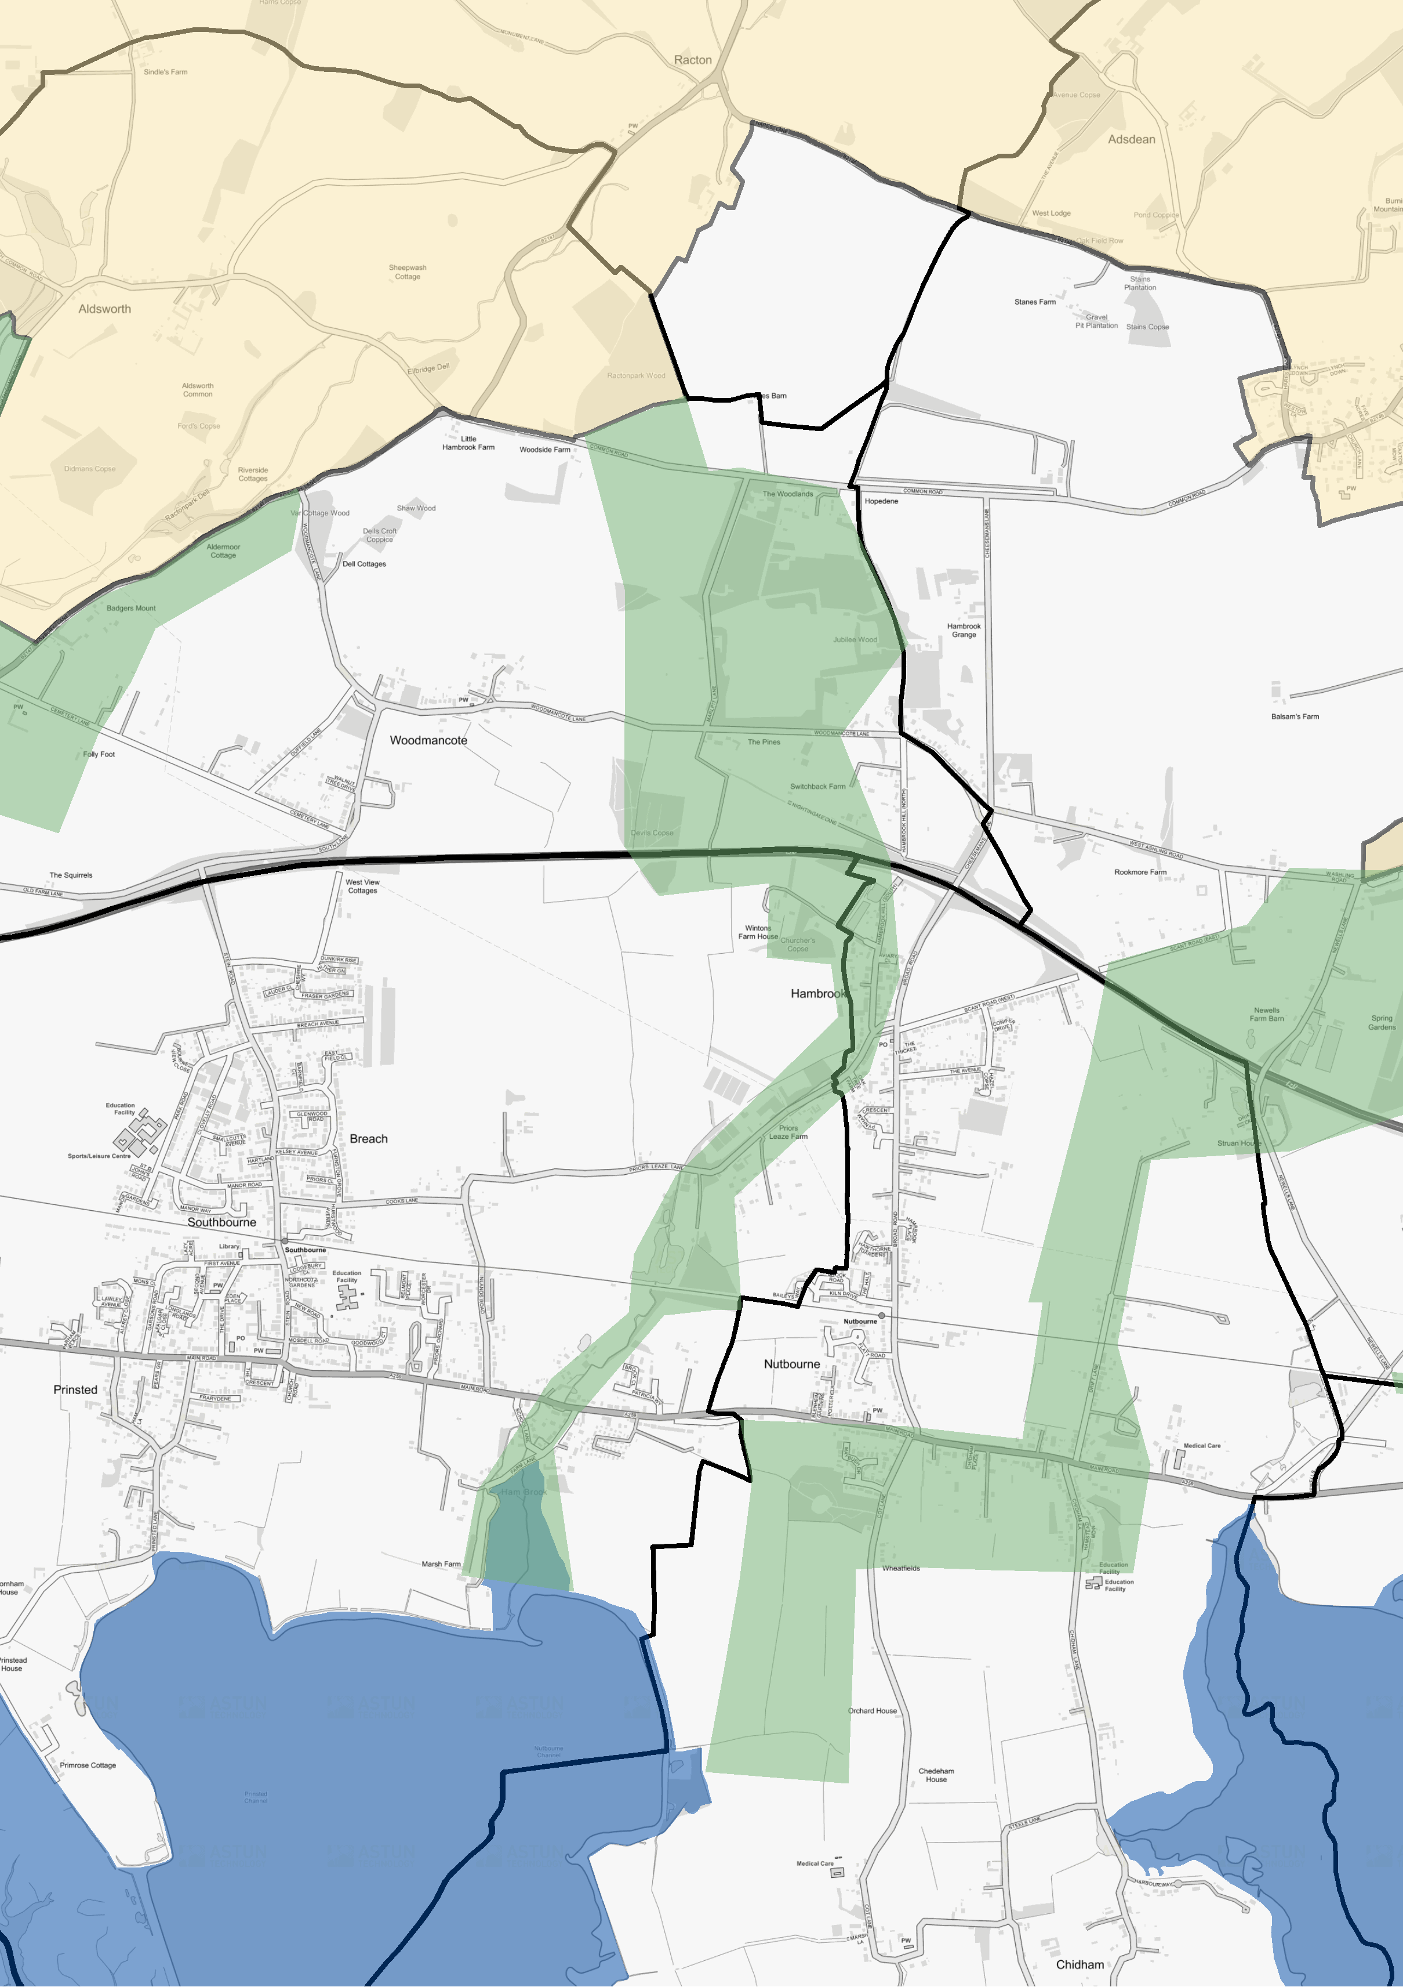

1:20,000

© Crown Copyright and database right 2021. Ordnance Survey 100018803.

**Legend**

SWC Preferred Approach Plan 2018 - West of City Proposed Nutbourne to Hambrook SWC

|  |
| --- |
|  |
|  |
|  |
|  |
|  |
|  |
|  |

South Downs National Park Boundary

Special Protection Area Parish boundary