**Map 2 Proposed change to the Pagham to Westhampnett Strategic Wildlife Corridor CHICHESTER DISTRICT COUNCIL**

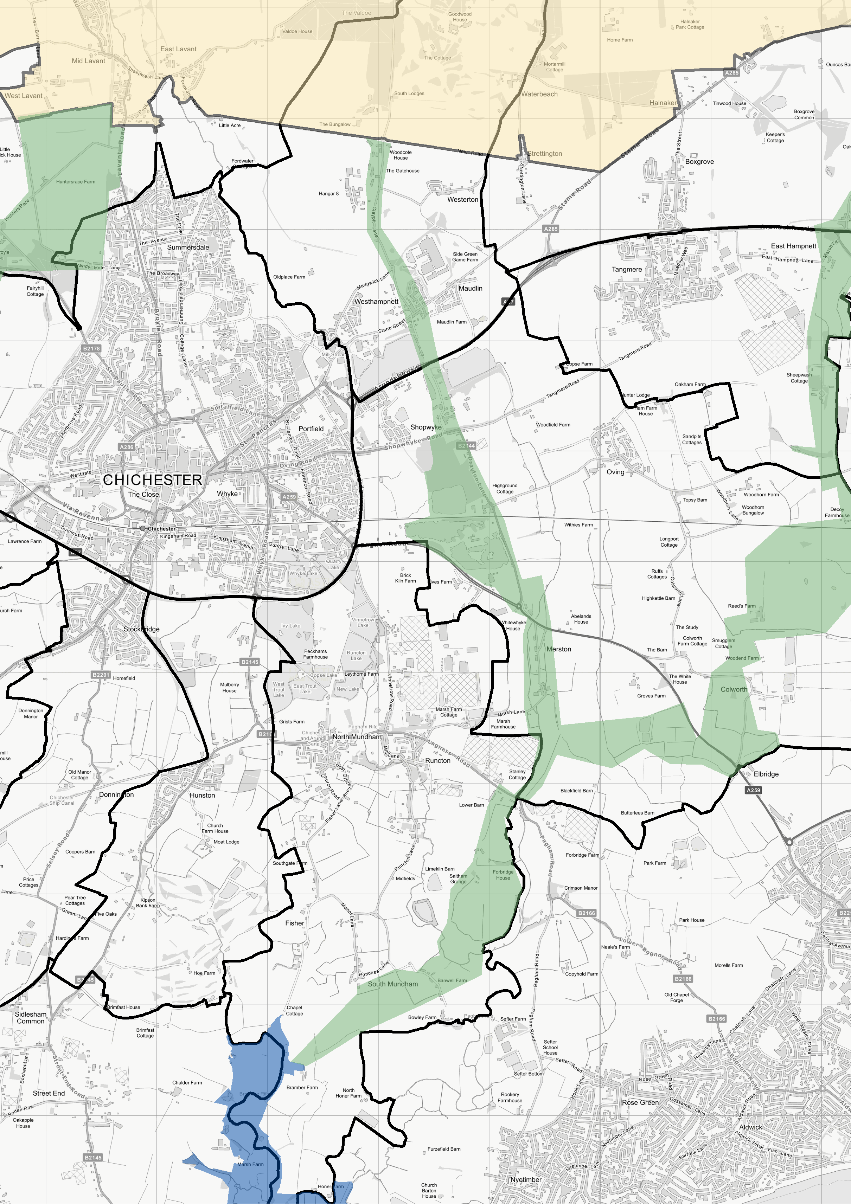

**Strategic Wildlife Corridors Technical Consultation**

1:37,500

© Crown Copyright and database right 2021. Ordnance Survey 100018803.

**Legend**

SWC Preferred Approach Plan 2018 - East of City SWC Preferred Approach Plan 2018 - West of City SWC Technical Consultation 2021

|  |
| --- |
|  |
|  |
|  |
|  |
|  |
|  |
|  |

South Downs National Park Boundary

Special Protection Area Parish boundary