Map 4 West of City Strategic Wildlife Corridors - Comparison of Preferred Approach and Proposed Changes CHICHESTER DISTRICT COUNCIL

Strategic Wildlife Corridors Technical Consultation

**Legend**

SWC Preferred Approach Plan 2018 - West of City SWC Technical Consultation 2021

|  |
| --- |
|  |
|  |
|  |
|  |
|  |
|  |
|  |

South Downs National Park Boundary

Special Protection Area

# 1:40,000

Parish boundary © Crown Copyright and database right

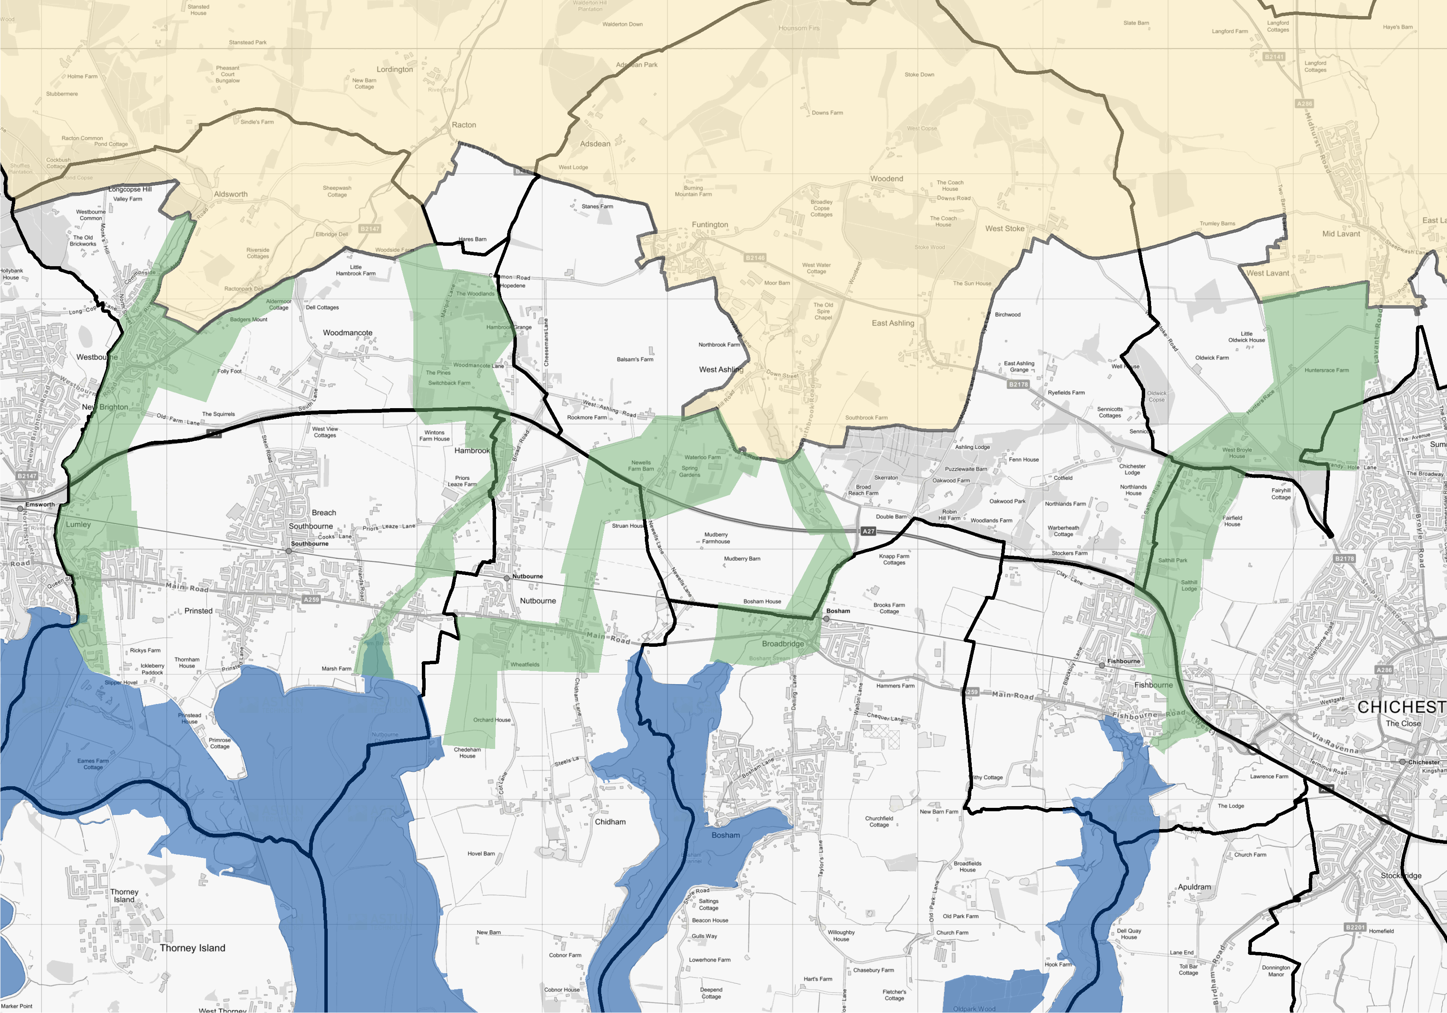

# 2021. Ordnance Survey 100018803.