Map 5 East of City Strategic Wildlife Corridors - Comparison of Preferred Approach and Proposed Changes CHICHESTER DISTRICT COUNCIL

Strategic Wildlife Corridors Technical Consultation

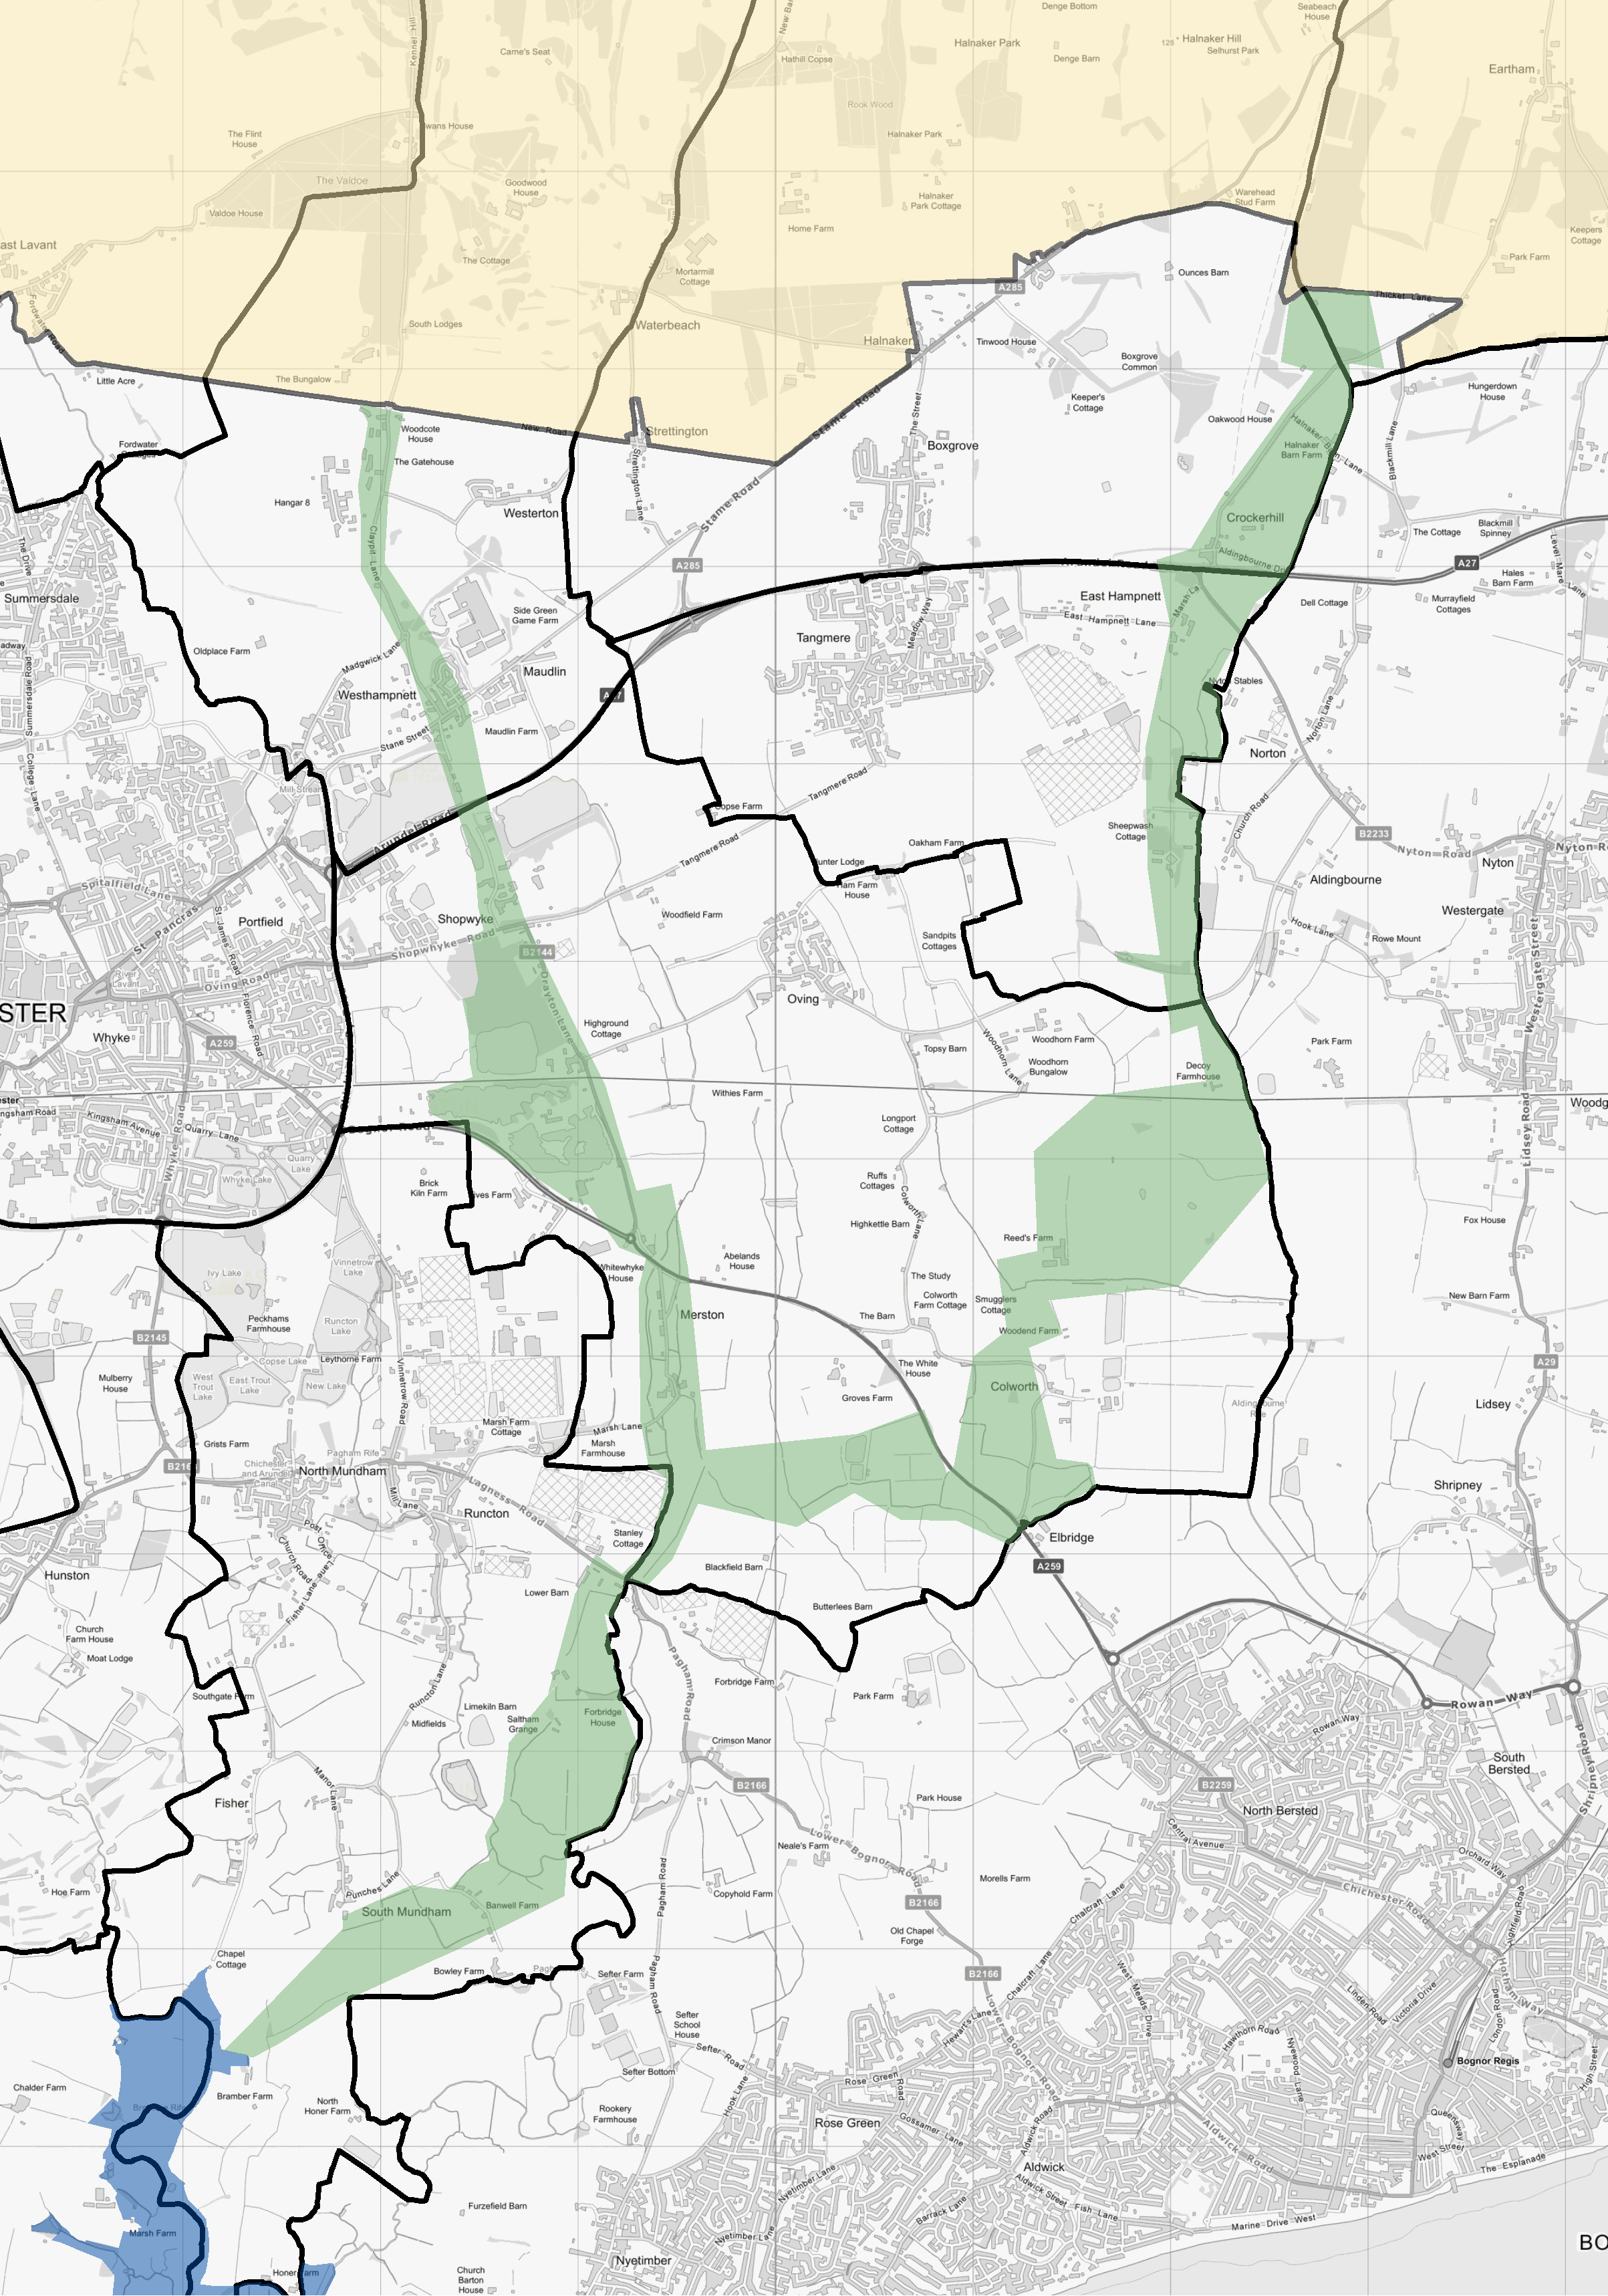

# 1:40,000

© Crown Copyright and database right 2021. Ordnance Survey 100018803.

**Legend**

SWC Preferred Approach Plan 2018 - East of City SWC Technical Consultation 2021

|  |
| --- |
|  |
|  |
|  |
|  |
|  |
|  |
|  |

South Downs National Park Boundary Special Protection Area

Parish boundary