7a Pindock Mews, Little Venice, London W9 2PY, UK T: +44 (0)20 3713 8500 E: [contact@dominiclawson.co.uk](mailto:contact@dominiclawson.co.uk)



[www.dominiclawson.co.uk](http://www.dominiclawson.co.uk/)

**Representation to the Plaistow and Ifold Neighbourhood Plan**

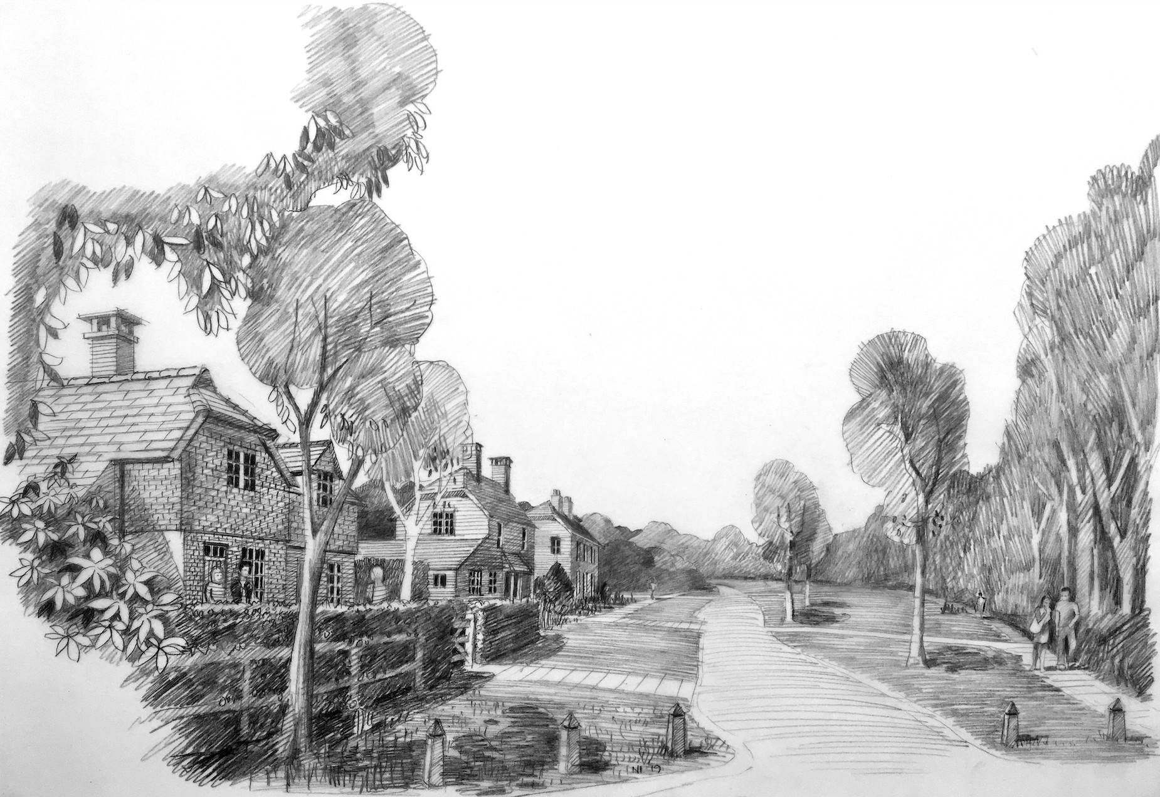

Site Name: Land to the north of Crouchlands Farm, Rickman’s Lane, Plaistow RH14 0LE On behalf of: Artemis Land and Agriculture Ltd

Date: 29 April 2020

DLBP Ltd is registered in England & Wales at the above address, number 7229435. VAT registration number 260 6370 18.

# INTRODUCTION AND SUMMARY

1. This representation has been prepared by DLBP Ltd on behalf of Artemis Land and Agriculture Ltd, the owners of Crouchlands Farm.
2. Since Artemis purchased Crouchlands Farm in 2019, its focus has been on the remediation and regeneration of the farm - a long term restoration plan focused on rurally-orientated and environmentally sustainable enterprises. The end goal of this is to improve the use of the farm, support the local community and provide sound employment opportunities.
3. As part of supporting the local community, Artemis has also identified part of its land (to the north of Crouchlands Farm) that could provide a limited number of residential properties that would form a suitable extension to Plaistow. These homes would assist with meeting local housing need and would support local businesses and enterprises including Crouchlands Farm. The land would also deliver a large area of public open space, for the benefit of the village.
4. The site itself is just over 4 hectares, located to the south of Plaistow (please see the accompanying site plan). Unlike the site currently proposed for allocation in Plaistow, it is free of both planning and technical constraints. Artemis has identified that the site could deliver up to 21 new dwellings alongside the public open space, and this number could be secured through a policy in the emerging Neighbourhood Plan.
5. Inclusion of the site within the emerging Neighbourhood Plan would also assist in ensuring that the Plan meets the basic conditions required before it can progress to referendum, including the conditions that the Plan:
   * *has regard to national policies and advice contained in guidance issued by the Secretary of State -* the draft Neighbourhood Plan has not met this basic condition, by failing to “*boost significantly*” the supply of a wide choice of high-quality homes and failing to meet the needs of specific groups, particularly those that require affordable housing. Allocating the Land to the north of Crouchlands Farm would therefore assist in meeting this basic condition;
   * *has special regard to the desirability of preserving any listed building or its setting or any features of special architectural or historic interest that it possesses - there is no evidence to support the allocation of the proposed housing allocation (draft policy H1) in terms of its impact on surrounding listed buildings. The Examiner cannot therefore be confident that the current allocation will not harm these heritage assets. Allocation of the Land to the north of Crouchlands Farm would assist instead in meeting this basic condition as it is not in close proximity to any listed buildings;*
   * *has special regard to the desirability of preserving or enhancing the character or appearance of any conservation area -* similar to the above, there is no evidence to support the allocation of the proposed housing allocation (draft policy H1) in terms of its impact on

the Plaistow Conservation Area. Allocation of the Land to the north of Crouchlands Farm would assist instead in meeting this basic condition as it is not in close proximity to the conservation area; and

* + *is in general conformity with the strategic policies contained in the development plan for the area of the authority (or any part of that area) -* the Chichester Local Plan identifies Plaistow and Ifold Parish as capable of accommodation 10 new dwellings as an *“indicative minimum”.* Allocating the Land to the north of Crouchlands Farm would assist instead in meeting this basic condition as it would deliver a modest addition to the village that delivers a higher number of homes whilst preserving the character and appearance of the village.

1. As demonstrated in this representation, the site is in a suitable location that could support up to 21 residential units to help meet local need, through being able to provide a mix of housing types and sizes. Through sensitive design, low-density residential development at this site will have minimal impact on the character of the village, its heritage assets and the surrounding landscape, and will positively add to the vitality of the village.
2. By engaging in conversations with key stakeholders, including the Parish Council, Steering Group and Chichester District Council, we hope that this site will be a welcomed as a beneficial addition to the Plaistow and Ifold Neighbourhood Plan.

# PLANNING LEGISLATION AND POLICY CONTEXT

1. The legislation for neighbourhood plans is set out in the Town and Country Planning Act 1990 (as amended), with further guidance in The Neighbourhood Planning (General) Regulations 2012 (as amended).
2. As part of the formal submission for independent Examination, there is a requirement for the Parish Council, as the ‘qualifying body’ to illustrate that they have complied with a series of ‘basic conditions’ as set out in Paragraph 8 of Schedule 4B of the Town & Country Planning Act 1990 (as amended). The conditions ensure that the plan:
3. has regard to national policies and advice contained in guidance issued by the Secretary of State;
4. has special regard to the desirability of preserving any listed building or its setting or any features of special architectural or historic interest that it possesses, it is appropriate to make the order;
5. has special regard to the desirability of preserving or enhancing the character or appearance of any conservation area, it is appropriate to make the order;
6. contributes to the achievement of sustainable development;
7. is in general conformity with the strategic policies contained in the development plan for the area of the authority (or any part of that area);
8. does not breach, and is otherwise compatible with, EU obligations; and
9. meets prescribed conditions, including that the plan has considerations of the effects on habitat sites and has regard to all material planning considerations (including heritage impacts).
10. To ensure that the basic conditions (particularly i and v) are met, the site is also assessed against the National Planning Policy Framework (2019) and relevant policies of the Chichester Local Plan: Key Policies 2014-2029 (2015) and the Site Allocation Development Plan Document 2014-2029 (2019).

# LAND TO THE NORTH OF CROUCHLANDS FARM

## The site

1. The site is approximately 4.04 ha in size and comprises vacant pastureland. Like its surrounding context, the site is in the countryside and is designated as a Rural Area under Section 157 of the Housing Act 1985 in the Chichester Local Plan. There are no other planning designations that would constrain development at the site.

### Wider context

1. The site forms the northern part of Crouchlands Farm, owned by Artemis Land and Agriculture Ltd. Since Artemis purchased Crouchlands Farm in 2019, its focus has been on the remediation and regeneration of the farm - a long term restoration plan focused on rurally-orientated and environmentally sustainable enterprises. The end goal of this is to improve the use of the farm, support the local community and provide sound employment opportunities.
2. To date, in excess of £3,000,000 has been committed or spent on the clean-up which has seen extensive restoration of the ditches, land drainage work, trackway repairs to the Public Rights of Way and the removal of all of the old biogas plant. Artemis has also engaged ecology and woodland experts to create a biodiversity enhancement strategy which respects the beautiful landscape, the Ancient Woodland, and the rich and diverse ecology of the Farm, with the aim of generating ecological gain and giving members of the public access to enjoy.
3. To the north of the site is the village of Plaistow. Plaistow benefits from a village green, a village shop, a church and a pub. The village shop has been owned and run by the Payne family for over 20 years and is a sustainable business which has expanded to offer hot food and coffees, a delicatessen and gift shop. The Sun Inn is a traditional pub and online it states opening hours are from 12pm - 4pm and 7pm - 11pm Monday to Sunday.
4. There is a good road network around the site. The A283 is located to the west of the site, with links to Brighton, and the A272 is located to the south of the site, with links to Winchester. There are relatively low volumes of traffic on the smaller roads surrounding the site, as expected in a predominantly rural area.
5. The nearest bus service to the site is located at Crouchlands Farm bus stop on Rickman’s Lane with limited services 64 and 69 running towards Billingshurst. The nearest train station to the site is in Billingshurst, which is approximately 8 miles from the site.
6. The nearest primary schools are Plaistow and Kirdford Primary School (located in Plaistow), Loxwood Primary School and Wisborough Green Primary School. According to the West Sussex Planning School Places (2018) the primary schools in Billingshurst (including these two schools) were deemed at full capacity in 2015 and 2016 and were 3% off being deemed

full capacity in 2017. There are extensions proposed at Loxwood Primary and Wisborough Green Primary School over the next 7 years, with 5 new places being provided each year. This highlights the growing interest to live in the rural area.

## Suitability for an allocation

1. As above, the site is free from any technical or planning constraints. In addition:

* the site provides the opportunity for a brand new area of publicly accessible open space;
* Artemis is the sole owner, providing certainty over deliverability of the site and over matters such as access (from Rickman’s Lane);
* the site is located in a suitable and sustainable location, with residential properties to the immediate east. The site is an approximate 10-minute walk from The Sun Inn pub and the nearest bus stop is located on Rickman’s Lane just a 1-minute walk from the proposed access point;
* the site is large enough to provide an appropriate low-density residential development that can be designed to be sensitive to the rural setting of the Parish and which will respect the natural environment and landscape;
* the size of the site also allows the news homes to be designed to respect amenity and the pattern of adjoining houses; and
* plenty of space would be allowed around the development so that the public footpath along the northern boundary and the Ancient Woodland fringe and public Right of Way to the west are preserved within a parkland setting.

# MEETING THE BASIC CONDITIONS

1. As set out in Section B, the Neighbourhood Plan is required to meet certain basic conditions as set out in Paragraph 8 of Schedule 4B of the Town & Country Planning Act 1990 (as amended). This ensures that the Plan:
2. has regard to national policies and advice contained in guidance issued by the Secretary of State;
3. has special regard to the desirability of preserving any listed building or its setting or any features of special architectural or historic interest that it possesses, it is appropriate to make the order;
4. has special regard to the desirability of preserving or enhancing the character or appearance of any conservation area, it is appropriate to make the order;
5. contributes to the achievement of sustainable development;
6. is in general conformity with the strategic policies contained in the development plan for the area of the authority (or any part of that area);
7. does not breach, and is otherwise compatible with, EU obligations; and
8. meets prescribed conditions, including that the plan has considerations of the effects on habitat sites and has regard to all material planning considerations (including heritage impacts).
9. The representation focuses on conditions i, ii, iii and v, and sets out how the allocation of the Land to the north of Crouchlands Farm will assist in ensuring that the Neighbourhood Plan meets these conditions.

## Conditions i and iv - housing need

1. The site is proposed to deliver up to 21 residential units, helping to support the Government’s objective of significantly boosting the supply of a wide choice of high-quality homes on a sufficient amount and variety of land as stated in paragraph 59 of the Framework.
2. The site is located in the North of the Plan Area, which is predominately rural with a few sizeable settlements. Whilst conserving the rural character of the area is a key objective in the Local Plan, there is an identified need to accommodate some development to address local housing needs and to support village facilities.
3. The indicative local housing need for Plaistow and Ifold is 10 units, as set out in Policy 5 of the adopted Local Plan. This allocation is not a maximum requirement for the Parish and allows for a degree of flexibility to respond to current and future housing need.
4. This future change in housing demand is likely to be reflected in the emerging Chichester Local Plan, which is in the early stages of progression. Although this cannot yet be given considerable weight, the emerging Local Plan Review: Preferred Approach 2016-2035

indicates that a supply of 489 new homes is anticipated in the North of the Plan Area throughout the plan period. This is an increase of 150 compared with the adopted Local Plan, highlighting how future housing need in the Parish is likely to be greater than the indicative minimum 10 units.

1. By considering future housing demand as set out in the emerging Local Plan, it can be ensured that basic condition 5 (conformity with strategic policies of the development plan) is satisfied. An allocation of up to 21 residential dwellings will also help to ensure that Chichester District Council does not fall below its 5-year housing land supply requirements.
2. By allocating the site at Crouchlands Farm, the Neighbourhood Plan could also assist in safeguarding the area from future speculative applications that could adversely impact the countryside setting of the village and surrounding landscape.

### Housing mix

1. As part of the Neighbourhood Plan Household Survey and Housing Needs Assessment (2016), a public consultation with local residents was conducted. This confirms that there is a greater need for smaller dwellings (1-2 or 2-3 bedrooms) in the Parish. Some of these are required to be suitable for elderly residents.
2. The site is suitable for a mix of housing types and sizes, including family homes and smaller homes that will be suitable for the elderly in an idyllic setting, thus contributing to the housing mix.

### Affordable housing

1. Policy H4 of the Neighbourhood Plan seeks to ensure that affordable housing will be provided to meet the identified need in the Parish, in order to maintain a balanced community. To conform with Policy 34 of the Local Plan, affordable housing provision will be sought on residential developments of more than 10 dwellings.
2. The Neighbourhood Plan Household Survey and Housing Needs Assessment (2016) revealed that nearly 64% of respondents found great difficulty in finding affordable housing within the Parish. However, the current allocation in Plaistow would not provide any affordable housing, which means that the Neighbourhood Plan as currently drafted would not address its own evidence base and indeed the requirements of the National Planning Policy Framework to address the needs of groups with specific housing requirements (paragraph 59) and reflect these needs in policies (paragraph 61).
3. With an indicative capacity for 21 new homes, the site would be capable of providing a meaningful contribution towards affordable housing within the Parish. By providing affordable housing on site, the development will conform with paragraph 34 of the Framework and the basic conditions will be met.
4. By way of an example, on site affordable housing could be provided in the form of shared ownership, a system by which the occupier owns a portion of the property and pays rent on the remainder, typically to a suitable housing association or local authority.
5. By providing on-site affordable housing options, the likes of public service staff, such as nurses, and rural workers will be more likely to settle in the village. This would positively impact the community and the village’s services and facilities.

## Conditions ii and iii - heritage impacts

1. Basic condition ii ensures that the Neighbourhood Plan has special regard to the desirability of preserving any listed building or its setting or any features of special architectural or historic interest that it possesses. Basic condition iii ensures the preservation and enhancement of the character or appearance of conservation areas.
2. Policy EH1 of the Neighbourhood Plan and Policy 47 of the Chichester Local Plan therefore seek to ensure that development will not adversely impact upon the unique character, heritage or setting of the heritage assets, as to conform with relevant paragraphs of the Framework.
3. The existing allocation is in close proximity to a number of listed buildings and adjoins the Plaistow Conservation Area. In this respect, there is no evidence to suggest that there will be no impact on the setting of heritage assets and that basic condition 2 will be met.
4. There are no listed buildings within the setting of the Land to the north of Crouchlands Farm and the site is not within, nor adjoins the Plaistow Conservation Area, so there will be no harm in terms of heritage impacts. The land to the north of Crouchlands Farm thus meets the basic conditions in terms of heritage impacts and ensures that policy EH1 is complied with. The robustness of the Neighbourhood Plan can therefore be strengthened to ensure it meets the requirements of basic conditions 2 and 3.
5. We consider that through sensitive design, a low-density residential development of up to 21 units at this site will have minimal impact on the character of the village and the surrounding landscape and will positively add to the vitality of the village.