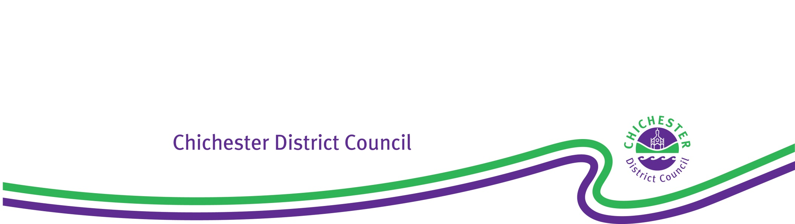

**Hunston Neighbourhood Development Plan 2019-2037 – Reg 15 Submission Plan**

**CDC Response on Strategic Environmental Assessment for the Hunston Neighbourhood Plan December 2020 (AECOM)**

The Strategic Environmental Assessment (SEA) framework and themes appear sound and the assessment of the sites, policies and alternatives all appear to be well reasoned. However, given that the SEA was triggered by the need for Habitats Regulations Assessment (HRA), there is hardly any cross reference between the two processes.

For all the six sites the biodiversity assessment says “Therefore, consultation with Natural England will be required regarding any potential impacts to Pagham Harbour Ramsar and SPA, Chichester and Langstone Harbours Ramsar and SPA, and the Solent Maritime SAC. The site is also within the 12km buffer zone for the Singleton and Cocking Tunnels SAC.”

Whereas it should mention that mitigation for recreational disturbance impact on Chichester and Pagham Harbours will be needed due to the parish lying in the long established zones of influence, although this mitigation can be secured using adopted Chichester Local Plan Key Policies (CLPKP) Policies 50 and 51 and therefore concluding that no change to the Hunston NDP is required. Also only site 6 and the very northern most part of site 5 lie within the 12km zone for Singleton and Cocking tunnels SAC.  For the other potential development sites this should be corrected and as the selected sites are all outside the zone, then no impact can be concluded. This is in effect noting the conclusion of the HRA within the SEA.

Suggest amending the SEA wording to:

“Therefore, mitigation will be required regarding any potential recreational disturbance impacts to Pagham Harbour Ramsar and SPA, Chichester and Langstone Harbours Ramsar and SPA, and the Solent Maritime SAC.  This can be secured using CLPKP Policies 50 and 51 and so no changes to the Hunston NDP are required to secure this mitigation.”

**Exercise of Delegated Authority – Director of Planning and Environment**

I hereby exercise my delegated power in accordance with Chichester District Council’s Constitution:

‘to carry out such other procedural processes, requirements, assessment and determinations as may be necessary in accordance with the Town and Country Planning Act 1990, the Neighbourhood Planning (General) Regulations 2012 (as amended) and any other relevant regulations to enable preparation of a neighbourhood plan.

AND DETERMINE THAT, the *attached officer comments relating to the Strategic Environmental Assessment for the Hunston Neighbourhood Plan December 2020 (AECOM)*are approved by Chichester District Council on the **Hunston Neighbourhood Development Plan 2019-2037 Reg 15 Submission Plan** in relation to the Act and Regulations referred to above.

Signed:

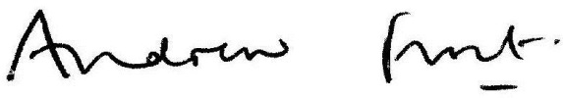

**Director of Planning and Environment**

Date: 13 September 2021