

2017 Air Quality Annual Status Report (ASR)

In fulfilment of Part IV of the

Environment Act 1995

Local Air Quality Management

September 2017

|  |  |
| --- | --- |
| Local Authority Officer | Kate Simons  Simon Ballard |
| Department | Housing and Environment |
| Address | East Pallant House  1 East Pallant  Chichester  West Sussex  PO19 1TY |
| Telephone | 01243 521160 |
| E-mail | [ksimons@chichester.gov.uk](mailto:ksimons@chichester.gov.uk)  [sballard@chichester.gov.uk](mailto:sballard@chichester.gov.uk) |
| Report Reference number | ASR 2017 |
| Date | September 2017 |

# Executive Summary: Air Quality in Our Area

## Air Quality in Chichester District

Air pollution is associated with a number of adverse health impacts. It is recognised as a contributing factor in the onset of heart disease and cancer. Additionally, air pollution particularly affects the most vulnerable in society: children and older people, and those with heart and lung conditions. There is also often a strong correlation with equalities issues, because areas with poor air quality are often the less affluent areas[1],[2].

The annual health cost to society of the impacts of particulate matter alone in the UK is estimated to be around £16 billion[3].

The main source of air pollution in the district is from road transport, particularly on roads in and adjacent to Chichester City and also for one road in Midhurst. The principal pollutant of concern is nitrogen dioxide (NO2). Concentrations of NO2 show a slight decrease over the last five years but there are hotspots within Chichester and one in Midhurst where exceedances of the national air quality Objective[4] for NO2 occur. Air Quality Management Areas (AQMAs) have been declared at three locations as follows:

• Stockbridge roundabout at the junction with the A27 and A286

• Orchard Street, Chichester

• St Pancras, Chichester

See link: <http://www.chichester.gov.uk/pollutioncontrolairquality>

An Air Quality Action Plan (AQAP) was adopted by CDC in 2008 and revised in 2015, see web link above. Air quality is seen by the Council as an important public health and place setting issue but it is not something we can improve on our own. We are actively working with other services within the Council, partners at West Sussex County Council (WSCC) and the Sussex Air Quality Partnership (SAQP) to tackle this issue.

Since our first AQAP dated 2008, we have won in excess of £290k of grant monies from a variety of sources. We have delivered a number of initiatives including Chichester’s first car club, enabled the installation of two electric vehicle charging points, provided 140 additional bike parking spaces in the city centre, trained around 150 cyclists to ride more confidently, maintain their bikes and explore Chichester on led rides and contributed data to the air-Alert forecasting service.

During 2016 we replaced the NO2 analyser at our Orchard Street monitoring station and have been monitoring at this location since September. We also replaced an ageing NO2 analyser at our Stockbridge monitoring station.

West Sussex County Council (WSCC) has produced a Walking and Cycling Strategy 2016 – 2026 which sets out the County Council’s aims and objectives for walking and cycling together with its priorities for investment in infrastructure improvements. Chichester District Council will be updating its own Infrastructure Development Plan (IDP) in line with WSCC’s strategy in order to prioritise infrastructure provision across the district. CDC is also in the process of reviewing its Local Plan. As part of this process we are also working with our development management policy planners to ensure that air quality policies in the Plan are robust and appropriately ambitious.

## Actions to Improve Air Quality

We have worked with partners on a number of projects over the last year including:

* Setting up a programme of cycling initiatives such as guided rides, cycle confidence training and bike maintenance courses to encourage people to cycle, particularly for commuting to work. During 2016 over 50 people accessed these initiatives and some tried more than one activity. We have also provided funding to two schools to enable them to hold Bike It breakfasts to continue the legacy of this work.
* We secured a Cabinet Resolution in 2015 to install up to ten electric vehicle (EV) charging points across the District. Additional funding opportunities are also being investigated in order that additional ‘rapid’ charge points (50kW) can be delivered. The Council’s Car Parking Strategy is being written by our Parking Service which will help to suggest where the EV points could be installed. Delivery of the EV charging points is anticipated by the end of March 2018.
* We have received consultancy advice from the Energy Savings Trust regarding replacement of fleet vehicles with electric vehicles and have a Cabinet resolution in place that where there is a business case this will be supported. We are working with a number of Council services to ascertain a business case for relevant vehicles.
* Our project to upgrade a section of path to dual use within one of the City’s parks (Jubilee Gardens) is progressing and construction work is intended to commence during autumn 2017.

## Conclusions and Priorities

This year’s NO2 monitoring has not identified exceedences at either of the monitoring stations. There are five diffusion tube locations where the air quality objective of 40 µg/m3 was exceeded, namely:

* St Pancras, within the St Pancras AQMA
* The Hornet, close to the St Pancras AQMA
* Claremont Court, within the Stockbridge Roundabout AQMA
* Stockbridge Road south, adjacent to the Stockbridge Roundabout AQMA however this tube is not located at a location where the Objective applies. The calculated concentration at the nearest receptor is 28µg/m3 which is below the air quality objective (see Appendix C for more details).
* Rumbold’s Hill, Midhurst - not within an AQMA. This tube has been in place for 18 months. Further monitoring is planned for this location in order to determine the trend at this location.

The above diffusion tube locations showed similar trends last year with the exception of The Hornet (which was slightly lower last year at 40 µg/m3). At the other 7 diffusion tube locations not within AQMAs there were no exceedences of the air quality objective of 40 µg/m3. There are no proposed changes to the AQMAs at the current time.

The Air Quality Action Plan (AQAP) was updated in 2015 and we are currently working on a number of actions to improve air quality across the district see Table 2.2.

Our priorities for the coming year to address air quality include:

* Getting a policy agreed by our planning policy team for inclusion within the revised Local Plan to enable air quality to be given greater importance within the land use planning process.
* To understand and respond to potentially significant changes to the local road network, including; possible improvements to the A27 and the Southern Gateway redevelopment and also trips related to any published new Local Plan housing numbers.
* Ensuring that modal-shift is part of the Southern Gateway proposals for the redevelopment of this area of Chichester.

## Local Engagement and How to Get Involved

The Council made comments on the Highways England proposals for the A27 Chichester Bypass Improvement Scheme in March 2016. A final decision has not been made on a preferred route and Government funding has not yet been committed. Additional community consultation is currently taking place in order to put forward an alternative scheme that may attract funding. It is hoped that a decision can be made within the next 12 months.

The public can get involved by supporting our campaigns for behavioural change (eg joining the Car Club or car sharing and walking, cycling or using public transport wherever possible. Further information can be obtained by emailing: [airquality@chichester.gov.uk](mailto:airquality@chichester.gov.uk)

The Chichester and District Cycle Forum provides information on local cycling opportunities and campaigns on behalf of cyclists. The Forum is open to the public and further information can be obtained by emailing [cycle@chichester.gov.uk](mailto:cycle@chichester.gov.uk)

**Table of Contents**

Executive Summary: Air Quality in Our Area i

Air Quality in Chichester District i

Actions to Improve Air Quality ii

Conclusions and Priorities ii

Local Engagement and How to Get Involved iii

1 Local Air Quality Management 1

2 Actions to Improve Air Quality 2

2.1 Air Quality Management Areas 2

2.2 Progress and Impact of Measures to address Air Quality in Chichester District 4

2.3 PM2.5 – Local Authority Approach to Reducing Emissions and/or Concentrations 11

3 Air Quality Monitoring Data and Comparison with Air Quality Objectives and National Compliance 12

3.1 Summary of Monitoring Undertaken 12

3.1.1 Automatic Monitoring Sites 12

3.1.2 Non-Automatic Monitoring Sites 12

3.2 Individual Pollutants 12

3.2.1 Nitrogen Dioxide (NO2) 12

3.2.2 Particulate Matter (PM10) 15

3.2.3 Ozone (O3) 15

Comparison to the DEFRA banding below shows that in 2016 at Lodsworth there were 14 days when ‘moderate pollution’ occurred and no ‘high pollution’ days, see box for health messages of DEFRA pollution bands. 16

**Health messages of the DEFRA Pollution Bands** 16

Appendix A: Monitoring Results 18

Appendix B: Full Monthly Diffusion Tube Results for 2016 31

Appendix C: Supporting Technical Information / Air Quality Monitoring Data QA/QC 33

Appendix D: Map(s) of Monitoring Locations and AQMAs 36

Appendix E: Summary of Air Quality Objectives in England 39

Glossary of Terms 40

References 42

**List of Tables**

Table 2.1 – Declared Air Quality Management Areas 3

Table 2.2 – Progress on Measures to Improve Air Quality 6

**List of Figures**

| **Figure A.1 – Annual Mean NO2 Concentrations at monitoring stations** | 22 |
| --- | --- |
| **Figure A.2 – Trends in Number of NO2 1-Hour Means > 200µg/m3 (100 ppb)** | 24 |
| **Figure A.3 – Trends in NO2 diffusion tubes 2011 – 2016** | 26 |
| **Figure A.4 – Annual Mean PM10 Concentrations at Stockbridge monitoring site** | 28 |
| **Figure A.5 Number of 24-Hour Mean PM10 Results >50µg/m3 at Stockbridge monitoring site** | 30 |

# Local Air Quality Management

This report provides an overview of air quality in Chichester District during 2016. It fulfils the requirements of Local Air Quality Management (LAQM) as set out in Part IV of the Environment Act (1995) and the relevant Policy and Technical Guidance documents.

The LAQM process places an obligation on all local authorities to regularly review and assess air quality in their areas, and to determine whether or not the air quality objectives are likely to be achieved. Where an exceedance is considered likely the local authority must declare an Air Quality Management Area (AQMA) and prepare an Air Quality Action Plan (AQAP) setting out the measures it intends to put in place in pursuit of the objectives. This Annual Status Report (ASR) is an annual requirement showing the interventions employed by Chichester District Council to improve air quality and any progress that has been made.

The statutory air quality objectives applicable to LAQM in England can be found in Table E.1 inAppendix E.

# Actions to Improve Air Quality

## Air Quality Management Areas

Air Quality Management Areas (AQMAs) are declared when there is an exceedance or likely exceedance of an air quality objective. After declaration, the authority must prepare an Air Quality Action Plan (AQAP) within 12-18 months setting out measures it intends to put in place in pursuit of compliance with the objectives.

A summary of AQMAs declared by Chichester District Council can be found in Table 2.1. Further information related to declared AQMAs, including maps of AQMA boundaries are available at Appendix D (also available online at

<http://www.chichester.gov.uk/pollutioncontrolairquality>

Table 2.1 – Declared Air Quality Management Areas

|  |  |  |  |  |  |  |  |  |
| --- | --- | --- | --- | --- | --- | --- | --- | --- |
| **AQMA Name** | **Date of Declaration** | **Pollutants and Air Quality Objectives** | **City / Town** | **One Line Description** | **Is air quality in the AQMA influenced by roads controlled by Highways England?** | **Level of Exceedance (maximum monitored/modelled concentration at a location of relevant exposure)** | | **Action Plan (inc. date of publication)** |
| **At Declaration** | **Now** |
| AQMA Stockbridge Roundabout | 24-Aug-06 | NO2 annual mean | Chichester | An area encompassing the Stockbridge Roundabout at the junction of the Chichester bypass (A27) and Stockbridge Road (A286) | YES | 44.9 | 42 | CDC AQAP 2008, revised in 2015 http://www.chichester.gov.uk/pollutioncontrolairquality#plan |
| AQMA Orchard Street | 17-May-07 | NO2 annual mean | Chichester | An area along Orchard Street, Chichester at the eastern end of the street where it meets Northgate | NO | 40.7 | 38 | CDC AQAP 2008, revised in 2015 |
| AQMA St Pancras | 17-May-07 | NO2 annual mean | Chichester | An area along St Pancras, Chichester between Eastgate Square and New Park Road. Note: St Pancras forms a street canyon in this section | NO | 48.3 | 51 | CDC AQAP 2008, revised in 2015 |

**CDC confirms the information on UK-Air regarding their AQMA(s) is up to date**

## 

## Progress and Impact of Measures to address Air Quality in Chichester District

Defra’s appraisal of last year’s ASR concluded that the existing measures within the action plan may need further development to address local problems. The appraisal suggested that the AQAP needed to reconsider the prioritisation of measures that can significantly impact on reducing pollution below objective levels on a clear understanding of current and future transport management within the city. The measures in Table 2.3 have been re-ordered in order to focus on measures that are likely to be delivered in the short to medium term. Consideration will be given to re-modelling the city including updating the source apportionment in line with other proposals being put forward by WSCC in its Roadspace Audit which will be finalised during 2017. This Roadspace Audit is likely to influence the emerging Parking Strategy. Source apportionment would facilitate the optimal understanding of where to target air quality actions for best effect.

The appraisal also suggested two amendments to the maps of the monitoring sites which have been updated as suggested. Results of monitoring have also been corrected for distance where necessary (see Table B1).

Chichester District Council has taken forward a number of direct measures during the current reporting year of 2016 in pursuit of improving local air quality. Details of all measures completed, in progress or planned are set out in Table 2.2.

More detail on these measures can be found in the respective Action Plan. Key completed measures are:

* Alternatives to private car use: the Car Club originally set up using Defra funding has continued to grow and the utilisation rate across all four cars averaged >20% for the year. Proposals have been put forward to add an additional car and we are working with the provider to secure a suitable location. Agreement has been reached on a location and it is hoped an additional vehicle will be in place by early 2018.
* Promoting travel alternatives: we have continued to promote cycling through activities including guided cycle rides, bike maintenance courses, cycle confidence training and engaged with over 50 people during the year. We also provided two schools with funding to enable them to hold Bike It Breakfasts to continue the work instigated last year by the Bike It Officer.
* Promoting low emission transport: we have been working with our Car Parks Service to establish where EV charging points could be installed. A Car Parks Strategy is being finalised which is due for delivery in 2018. We have a funded Cabinet resolution to install a number of EV charging points and we are also looking at additional funding opportunities to increase the number of EV charging points that can be delivered.

Chichester District Council expects the following measures to be completed over the course of the next reporting year:

* Promoting low emission transport: Chichester District Council intends to replace some of its fleet vehicles with electric vehicles over the next 12 months (where the business case for this kind of vehicle is attractive).

Chichester District Council’s priorities for the coming year are:

* To develop air quality policy for incorporation in the revised Local Plan in order to enable the air quality impact of new development to be properly considered and to provide a policy ‘hook’ from which we can associate a Supplementary Policy Document once the revised Local Plan is adopted.
* To bring forward the Southern Gateway project which helps to deliver the Vision for Chichester which will involve significant redevelopment of the area around Chichester bus and train stations and neighbouring land.
* Work up standards for electric vehicle charging points as planning contributions.

The principal challenges and barriers to implementation that Chichester District Council anticipates facing are;

* Delays to the decision on improvements to the A27 by Highways England mean that there is increasing congestion on the A27 trunk road, leading to traffic diverting through Chichester with resulting impacts on local air quality in the City.
* Availability of funding for infrastructure projects.

Progress on the following measures has been slower than expected due to:

* Real Time Passenger Information (RTPI) displays at bus shelters have continued to be delayed at Market Avenue, Chichester but we have been advised by WSCC Highways that four displays will be installed during 2017.

Whilst the measures stated above and in Table 2.2 will help to contribute towards compliance, Chichester District Council anticipates that further additional measures not yet prescribed will be required in subsequent years to achieve compliance and enable the revocation of all three AQMAs within the District.

Table 2.2 – Progress on Measures to Improve Air Quality

|  |  |  |  |  |  |  |  |  |  |  |  |
| --- | --- | --- | --- | --- | --- | --- | --- | --- | --- | --- | --- |
| **Measure No.** | **Measure** | **EU Category** | **EU Classification** | **Organisations involved and Funding Source** | **Planning Phase** | **Implementation Phase** | **Key Performance Indicator** | **Reduction in Pollutant / Emission from Measure** | **Progress to Date** | **Estimated / Actual Completion Date** | **Comments / Barriers to implementation** |
| 1 | Set up Air Quality Working Group | Promoting Travel Alternatives | Other | CDC | June/Dec 2008 | Dec-08 | 2 meetings per year | N/A | 9 meetings held and 1 planned | Ongoing | No meetings held in last 24 months while LAQM regime updated and National Air Quality Plan being finalised but meeting planned for Sept 2017 |
| 2 | Cleaner vehicles | Promoting Low and zero Emission Transport | Procuring alternative Refuelling infrastructure to promote Low Emission Vehicles, EV recharging, Gas fuel recharging | WSCC/CDC | 2010 | 2011 | No. of electric vehicle recharging points |  | 2 recharging points in Chichester, secured funding to install additional charging points during 2016-17. Part of regional network of rapid charging points through Sussex-air project | Ongoing | WSCC has purchased one EV and one hybrid. CDC aiming to replace some diesel vehicles during 2017. |
| 3 | Planning policy | Policy Guidance and Development Control | Low Emissions Strategy | CDC | 2010/11 | Ongoing | No. of planning conditions imposed on planning consultations |  | Sussex-air produced Planning Guidance and Low Emissions Strategy and in discussion with CDC Policy Planners regarding adopting LES approach. Sussex-air is reviewing its guidance and refreshed document due in 2017 | Ongoing | Local Plan has to be reviewed within 5 years – aim to have new policy in place within updated Plan. Surveying peer Sussex authorities with regard to policies in place elsewhere and draft policy to be agreed by end 2017 |
| 4 | Cycling and walking initiatives | Promoting Travel Alternatives | Promotion of cycling | CDC/WSCC | 2009 | 2010 | % increase in cycling |  | Cycle Challenge run 2010-14, over 140 additional bike racks installed during 2010-16 to increase cycle parking in City centre. Bike Week events held each year, guided cycle rides, cycle training and bike maintenance courses held each summer 6.5% inc in cycling from 2015- 2016 | Ongoing | Promote various cycling events to encourage behavioural change. |
| 5 | Car Clubs | Alternatives to private vehicle use | Car Clubs | CDC | 2010 | 2011 | Utilisation rate of cars to be 20% |  | 4 cars now available to book, development worker employed 2014-16 to promote Club, utilisation rate of >20% (average) during 2016-17 across all 4 cars | Ongoing | Planning to install additional car in Chichester during 2018 plus additional vehicles possible in period from existing developer S106 commitments. |
| 6 | School travel plans | Promoting Travel Alternatives | School Travel Plans | WSCC | 2008/9 | 2009/10 | % children travelling to school by sustainable means |  | During 2016/17 Living Streets project engaged with 6 primary schools in the District to support Walk to School scheme (WOW) and engaged students and staff at Chichester University | Ongoing | Funding provided to two schools to enable them to hold Bike It breakfasts |
| 7 | WSCC and CDC travel plans | Promoting Travel Alternatives | Workplace Travel Planning | WSCC/CDC | 2010 | 2011/12 | % WSCC and CDC staff travelling by sustainable means |  | Grey fleet business mileage was 5.15million miles below 6.0 million miles target. Easit scheme at WSCC and CDC to encourage rail use. Cycle to work scheme at CDC | Ongoing | Steady increase in users of Easit scheme for rail use at CDC however ongoing industrial action by Southern Rail has reduced reliability of rail travel |
| 8 | Business travel plans | Promoting Travel Alternatives | Workplace Travel Planning | WSCC | 2009 | Ongoing | Travel Plan implemented within target time period |  | Over 26 Travel Plans submitted since 2009 and Travel Plan group set up attended by large organisations to work on joint measures. | Ongoing | Developments of certain size required to implement Travel Plan – 6 submitted during 2016 |
| 9 | Residential travel plans | Promoting Travel Alternatives | Personalised Travel Planning | WSCC | 2009 | Ongoing | Travel Plan implemented within target time period |  | Over 24 Travel Plans have been submitted since 2009 | Ongoing | Developments of certain size required to implement Travel Plan – 4 submitted during 2016 |
| 10 | TravelWise/smarter choices | Public Information | Via Leaflets | WSCC/CDC | 2009 onwards | Ongoing | No. of users of WSCC car share database for PO19 area |  | Steady increase in number of users of database for 2016 | Ongoing | Previous campaigns have included bus back adverts, refuse vehicle adverts radio adverts |
| 11 | Cycle route information | Promoting Travel Alternatives | Promotion of cycling | CDC | 2009 | Ongoing | No. of maps sold through Tourist Information or other outlets. |  | 5 route leaflets have been produced so far and over 1300 copies have been sold to date. 117 leaflets sold in 2016. | Ongoing | Leaflets updated during 2015 to reflect changes of address and re-prints produced |
| 12 | Cycle journey planning | Public Information | Via the Internet | WSCC | 2010 | 2011 | No. of journeys planned on website |  | Web link available on WSCC and CDC websites | Ongoing | 3829 journeys planned 2016-17 |
| 13 | Public transport infrastructure | Transport Planning and Infrastructure | Public transport improvements-interchanges stations and services | WSCC | 2010 | 2011-15 | Increase in use of public transport |  | RTPI displays installed at key locations across City | Ongoing | 4 RTPI displays planned for shelters during 2017-18 |
| 14 | Cleaner buses | Promoting Low Emission Transport | Public Vehicle Procurement -Prioritising uptake of low emission vehicles | WSCC | 2009 | Ongoing | %of Euro 5 buses |  | Stagecoach has 70% of fleet Euro V and replaced 5 older Euro 2 buses with Euro 3 buses during 2016 | Ongoing | Promote cleaner buses to the other bus companies |
| 15 | Licensing requirement for taxis | Promoting Low Emission Transport | Taxi Licensing conditions | CDC | 2009/10 | 2011 | No. of Euro 4 vehicles |  | For vehicles 5 years and over, MOT and fitness test required every 6 months | Ongoing | Standard must be met for newly registered vehicles after 4.4.11 |
| 16 | Forecasting, monitoring and public information | Public Information | Via other mechanisms | SAQP | 2008 | Ongoing | No. of people registered to receive alerts |  | Over 855 subscribers registered across Sussex | Ongoing | Forecast hit rates varied between 40-72%for all site classifications and pollution types, best hit rate for rural ozone 85% |
| 17 | AQ monitoring and traffic monitoring | Traffic Management | UTC, Congestion management, traffic reduction | CDC/WSCC | 2008 | Ongoing | Reduction in traffic volumes |  | Traffic flows between 2008 – 2016 reduced by between 1.5 - 2.6% in AQMA areas | Ongoing |  |
| 18 | A27 by-pass improve-ments | Traffic Management | Strategic highway improvements, Re-prioritising road space away from cars, including Access management, Selective vehicle priority, bus priority, high vehicle occupancy lane | HE | Ongoing | Post 2018 | Reduction in congestion |  | HE have consulted during 2016 on options for improving A27 around Chichester | 2019 | No agreement on route following consultation and funding withheld. New consultation commenced early 2017. Decision awaited. |
| 19 | Variable message signing (VMS) on A27 | Traffic Management | UTC, Congestion management, traffic reduction | HE | 2009 | Pilot by 2020 | No. of warnings made per year |  | HE decision awaited | Ongoing | Mobile VMS signs were trialled during 2012. CDC will communicate with HE re this action depending on the outcome of the A27 improvements decision. |
| 20 | Park and ride schemes in and around City | Alternatives to private vehicle use | Bus based Park & Ride | CDC | Post 2015 | Post 2018 | Reduce traffic in City centre by 3% |  | Linked to A27 improvements that have not yet been brought forward | Ongoing | Would need agreement by all stakeholders, WSCC, CDC, local residents, HE CDC’s parking strategy is under review though awaiting recommendations and transport modelling and the outcome of the A27 improvement plan and WSCC Roadspace Audit consultation. |
| 21 | Speed limit changes – 20 mph as part of school safety zone | Traffic Management | Reduction of speed limits, 20mph zones | WSCC | 2009 | 2012/13 | Reduction in traffic queues within Orchard St AQMA area |  | Signs installed around schools and on nearby residential streets | Completed | Reductions in NO2 within AQMA could be achieved through smoothing of traffic flow |
| 22 | Blanket 20mph scheme on residential streets | Traffic Management | Reduction of speed limits, 20mph zones | WSCC | 2012/13 | 2013/14 | Reduced speed on residential streets |  | WSCC contracted officer to promote 20mph and work with schools and community and CDC hosted officer and provided support | Completed | Roads monitored before and after implementation and speed reductions achieved on some roads |
| 23 | MOVA traffic signal optimisation | Traffic Management | UTC, Congestion management, traffic reduction | WSCC | 2009/10 | 2010 | Reduction in traffic queues within AQMAs |  | 2 new Puffins to replace existing crossings implemented | Completed | Improves emissions by eliminating ghost users and reducing red time |

Please note the measures in Table 2.2 have been re-numbered since last year’s report.

## PM2.5 – Local Authority Approach to Reducing Emissions and/or Concentrations

As detailed in Policy Guidance LAQM.PG16 (Chapter 7), local authorities are expected to work towards reducing emissions and/or concentrations of PM2.5 (particulate matter with an aerodynamic diameter of 2.5µm or less). There is clear evidence that PM2.5 has a significant impact on human health, including premature mortality, allergic reactions, and cardiovascular diseases.

Chichester District Council is taking the following measures to address PM2.5:

• Measure 15 - taxi licensing conditions - since 2011 we have required vehicles that are 5 years old and over to have MOT and fitness tests every 6 months. As vehicle licensing requirements in London become more stringent, (new London taxis will need to be zero emission capable from 2018) this licensing condition will be reviewed in conjunction with our licensing colleagues.

• Measure 14 – cleaner buses – Fleet managers report that upgrades to the fleet are ongoing in order to introduce cleaner buses. We shall continue to engage with them to promote any funding opportunities that may enable upgrades to the fleet.

Where considered appropriate we have recommended that construction environmental management plans (CEMP) are put in place at new developments which include dust control strategies.

# Air Quality Monitoring Data and Comparison with Air Quality Objectives and National Compliance

## Summary of Monitoring Undertaken

### Automatic Monitoring Sites

This section sets out what monitoring has taken place and how it compares with objectives.

Chichester District Council undertook automatic (continuous) monitoring at three sites during 2016. Table A.1 in Appendix A shows the details of the sites.

Maps showing the location of the monitoring sites are provided in Appendix D. Further details on how the monitors are calibrated and how the data has been adjusted are included in Appendix C.

### Non-Automatic Monitoring Sites

Chichester District Council undertook non-automatic (passive) monitoring of NO2 at eleven sites during 2016. Table A.2 in Appendix A shows the details of the sites.

Maps showing the location of the monitoring sites are provided in Appendix D. Further details on Quality Assurance/Quality Control (QA/QC) for the diffusion tubes, including bias adjustments and any other adjustments applied (e.g. “annualisation” and/or distance correction), are included in Appendix C.

## Individual Pollutants

The air quality monitoring results presented in this section are, where relevant, adjusted for bias, “annualisation” and distance correction. Further details on adjustments are provided in Appendix C.

### Nitrogen Dioxide (NO2)

Table A.3 in Appendix A compares the ratified and adjusted monitored NO2 annual mean concentrations for the past 5 years with the air quality objective of 40µg/m3.

For diffusion tubes, the full 2016 dataset of monthly mean values is provided in Appendix B. Figure

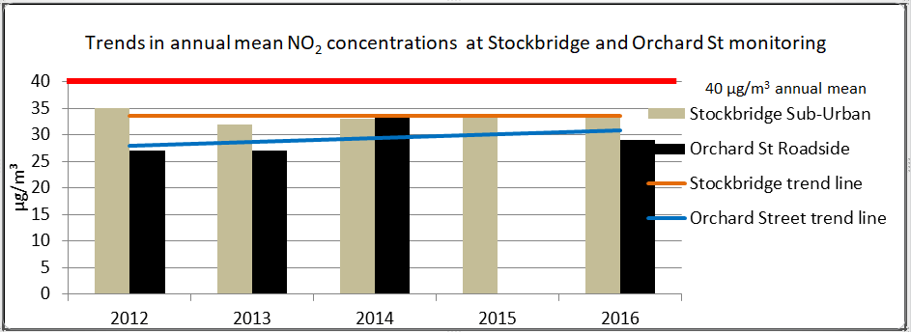

Table A.4 in Appendix A compares the ratified continuous monitored NO2 hourly mean concentrations for the past 5 years with the air quality objective of 200µg/m3, not to be exceeded more than 18 times per year.

From Table A.3, there has been no increase in the NO2 annual mean concentration at the Stockbridge monitoring station (it has remained at 34 µg/m3) and the air quality objective was not exceeded. The results at this location have been broadly similar for the past five years, ranging from 32 - 35 µg/m3. The monitoring station is not within the AQMA and does not represent a location of relevant exposure however it is the only suitable long term location available for monitoring near the Stockbridge AQMA.

At the Orchard Street monitoring station the NO2 annual mean concentration was 29 µg/m3 (monitored between September to December 2016). This result has been annualised in accordance with the methodology in TG16. Results at this monitoring station have ranged from 27 to 34 µg/m3 over the last five years and the air quality objective has not been exceeded. At the nearest diffusion tube location, the annual mean was 38 µg/m3 and results at this location have ranged from 33 – 39 µg/m3 over the last five years. It is intended that monitoring will continue for the next few years to establish the ongoing trend at this location. Both the monitoring station and the diffusion tube are located within the AQMA and represent relevant exposure.

At five of the diffusion tube locations, the air quality objective of 40 µg/m3 was exceeded, namely:

* St Pancras, within the St Pancras AQMA
* The Hornet, close to the St Pancras AQMA
* Claremont Court, within the Stockbridge Roundabout AQMA
* Stockbridge Road south, adjacent to the Stockbridge Roundabout AQMA however this tube is not located at a location of relevant public exposure. The calculated concentration at the nearest receptor is 28µg/m3 which is below the air quality objective (see Appendix C for more details).
* Rumbold’s Hill, Midhurst - not within an AQMA. This tube has been in place for 18 months and is located within 0.5m of a residential facade. Monitoring will continue in order to determine the trend at this location and enlarge the dataset.

At all of the other diffusion monitoring sites the NO2 concentration has increased from 2015 to 2016 however the concentration at these non-AQMA locations was comfortably compliant with the NO2 air quality objective of 40 µg/m3.

From Table A.4 there have been no exceedences of the NO2 1-hour mean concentration at the Stockbridge or Orchard Street monitoring stations for the past 5 years (however it should be noted there was no monitoring 2015 at Orchard Street and the 2016 result is based on 4 months’ data). The DEFRA guidance suggests that the 1-hour mean Objective is unlikely to be breached unless the annual mean concentration is 60µgm-3 or above.

CDC does not intend intend declaring a further AQMA or expanded AQMAs at the current time. We await confirmation of various strategically important development decisions in the district and a further year’s monitoring data prior to formalising our position in this regard.

### Particulate Matter (PM10)

Table A.**5** in Appendix A compares the ratified and adjusted monitored PM10 annual mean concentrations for the past 5 years with the air quality objective of 40µg/m3.

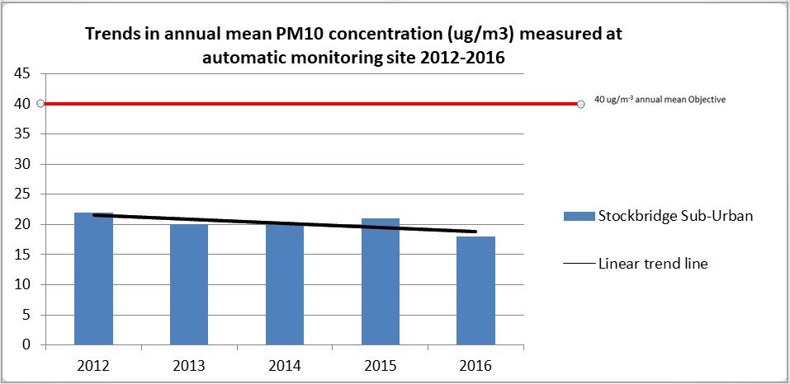

Table A.6 in Appendix A compares the ratified continuous monitored PM10 daily mean concentrations for the past 5 years with the air quality objective of 50µg/m3, not to be exceeded more than 35 times per year.

From Table A.5, the annual mean concentration has reduced over the last 5 years from 22µg/m3 (2012) to 18µg/m3 (2016) and is compliant with the air quality objective of 40µg/m3. In addition, the number of PM10 daily mean concentrations exceeding the Objective has fallen from 11 exceedences in 2012 to 1 exceedence in 2016. The air quality objective of 50µg/m3, not to be exceeded more than 35 times per year has therefore been met for the last 5 years.

### Ozone (O3)

Chichester District Council has been monitoring ozone in the rural village of Lodsworth for over ten years. Ozone concentrations can become elevated when nitrogen dioxide and volatile organic compounds react in the presence of strong sunlight. CDC has been monitoring this pollutant due to its importance with regard to public health and to provide information to the Sussex-air air-Alert public information system (see Table 2.2 Measure no. 16).

The Table below compares the ratified and adjusted monitored O3 concentrations and indicates that the number of exceedances of the running 8 hour mean (of 100 µg/m3 or 50ppb) has fluctuated over the last five years from thirteen in 2012 to sixteen in 2016. The latest data shows that the Objective was not achieved in 2016 as there were more than ten exceedances of the running 8 hour mean during the year, see Figure below.

| **Site ID** | **Site Type** | **Valid Data Capture for Monitoring Period (%) (1)** | **Valid Data Capture 2015 (%) (2)** | **O3 - No more than 10 days where maximum rolling 8 hr mean >= 100 µg/m3** | | | | |
| --- | --- | --- | --- | --- | --- | --- | --- | --- |
| **2012** | **2013** | **2014** | **2015** | **2016** |
| AR1 | Rural  (Lodsworth) | 98 | 98 | 13 | 25 | 17 | 7 | 16 |

(1) Data capture for the monitoring period, in cases where monitoring was only carried out for part of the year.

(2) Data capture for the full calendar year (e.g. if monitoring was carried out for 6 months, the maximum data capture for the full calendar year is 50%).

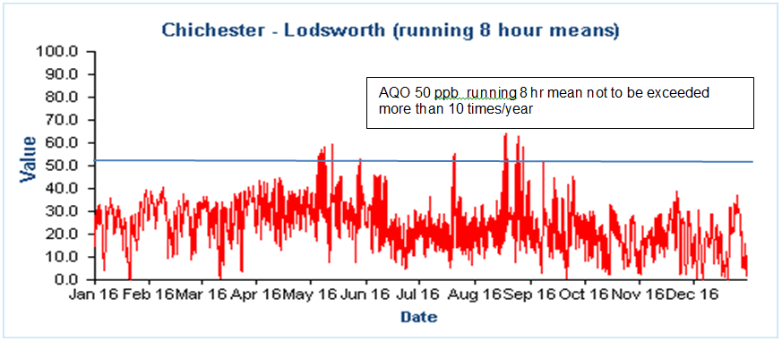

Comparison to the DEFRA banding below shows that in 2016 at Lodsworth there were 14 days when ‘moderate pollution’ occurred and no ‘high pollution’ days, see box for health messages of DEFRA pollution bands.

**Health messages of the DEFRA Pollution Bands**

|  |  |
| --- | --- |
| Pollution band and numerical index | Health messages for at-risk groups* |
| 1 – 3 (low) | Enjoy your usual outdoor activities. |
| 4 – 6 (moderate) | Adults and children with lung problems, and adults with heart problems, who experience symptoms, should consider reducing strenuous physical activity, particularly outdoors. |
| 7 – 9 (high) | Adults and children with lung problems, and adults with heart problems, should reduce strenuous physical exertion, particularly outdoors, and particularly if they experience symptoms. People with asthma may find they need to use their reliever inhaler more often. Older people should also reduce physical exertion. |
| 10 (very high) | Adults and children with lung problems, adults with heart problems, and older people, should avoid strenuous physical activity. People with asthma may find they need to use their reliever inhaler more often. |
| *\*Adults and children with heart or lung problems are at greater risk of symptoms.* | |

NB. Local authorities are no longer obliged to report annually on the following pollutants: 1,3 butadiene, benzene, carbon monoxide and lead, unless local circumstances indicate there is an issue. National monitoring results are available at https://uk-air.defra.gov.uk/data/

# Appendix A: Monitoring Results

Table A.1 – Details of Automatic Monitoring Sites

|  |  |  |  |  |  |  |  |  |  |  |
| --- | --- | --- | --- | --- | --- | --- | --- | --- | --- | --- |
| **Site ID** | **Site Name** | **Site Type** | **X OS Grid Ref** | **Y OS Grid Ref** | **Pollutants Monitored** | **In AQMA?** | **Monitoring Technique** | **Distance to Relevant Exposure (m) (1)** | **Distance to kerb of nearest road (m) (2)** | **Inlet Height (m)** |
| CI1 | Stockbridge | Suburban | 485881 | 103791 | NO2, PM10 | NO | chemilumin-escence/TEOM | 25m | 26m | 3m |
| CI4 | Orchard Street | Roadside | 485982 | 105221 | NO2 | YES | chemilumin-escence | 10m | 3.75m | 2m |
| AR1 | Lodsworth | Rural | 492396 | 123248 | O3 | NO | UV | n/a | n/a | 2.1m |

**Notes:**

(1) 0m if the monitoring site is at a location of exposure (e.g. installed on the façade of a residential property).

(2) N/A if not applicable.

Table A.2 – Details of Non-Automatic Monitoring Sites

|  |  |  |  |  |  |  |  |  |  |  |
| --- | --- | --- | --- | --- | --- | --- | --- | --- | --- | --- |
| **Site ID** | **Site Name** | **Site Type** | **X OS Grid Ref** | **Y OS Grid Ref** | **Pollutants Monitored** | **In AQMA?** | **Distance to Relevant Exposure (m) (1)** | **Distance to kerb of nearest road (m) (2)** | **Tube collocated with a Continuous Analyser?** | **Height (m)** |
| 1 | Kings Ave/Southbank Jct | Roadside | 485776 | 103961 | NO2 | N | 11 | 2.25 | N | 3 |
| 2 | Claremont Court | Roadside | 485772 | 103847 | NO2 | Y | 0 | 7.5 | N | 3 |
| 3 | Cabin | Suburban | 485880 | 103791 | NO2 | N | 25 | 26 | Y | 2.7 |
| 4 | Cabin | Suburban | 485880 | 103791 | NO2 | N | 25 | 26 | Y | 2.7 |
| 5 | Cabin | Suburban | 485880 | 103791 | NO2 | N | 25 | 26 | Y | 2.7 |
| 6 | Stockbridge Road South | Roadside | 485696 | 103731 | NO2 | N | 14 | 2 | N | 2.85 |
| 7 | Cleveland Rd | Urban Background | 486953 | 104414 | NO2 | N | 18 | 1.8 | N | 2.8 |
| 8 | Westhampnett Road | Roadside | 487341 | 105474 | NO2 | N | 3 | 1.65 | N | 2.85 |
| 9 | Hornet | Roadside | 486502 | 104795 | NO2 | N | 0 | 1.8 | N | 3.1 |
| 10 | St Pancras | Roadside | 486533 | 104860 | NO2 | Y | 0 | 2 | N | 3 |
| 11 | Arthur Purchase | Urban Background | 486082 | 105026 | NO2 | N | 0 | 6 | N | 2.7 |
| 12 | 174 Orchard St | Roadside | 485914 | 105185 | NO2 | Y | 0 | 2 | N | 2.65 |
| 14 | Rumbold’s Hill, Midhurst | Roadside | 488561 | 121479 | NO2 | N | 0.5 | 1.5 | N | 3.4 |

**Notes:**

(1) 0m if the monitoring site is at a location of exposure (e.g. installed on/adjacent to the façade of a residential property).

(2) N/A if not applicable.

**Table A.3 – Annual Mean NO2 Monitoring Results**

|  |  |  |  |  |  |  |  |  |  |
| --- | --- | --- | --- | --- | --- | --- | --- | --- | --- |
| **Site ID** | **Site Type** | **Monitoring Type** | **Valid Data Capture for Monitoring Period (%) (1)** | **Valid Data Capture 2016 (%) (2)** | **NO2 Annual Mean Concentration (µg/m3) (3)** | | | | |
| **2012** | **2013** | **2014** | **2015** | **2016** |
| CI1 | Suburban | Automatic |  | 98 | 35 | 32 | 33 | 34 | 34 |
| CI4 | Roadside | Automatic | 100 | 31 | 27 | 27 | 34 | x | 29 |
| 1 | Roadside | Diffusion Tube |  | 100 | 33 | 30 | 32 | 30 | 33 |
| 2 | Roadside | Diffusion Tube |  | 100 | 37 | **42** | **42** | **42** | **42** |
| 3 | Suburban | Diffusion Tube |  | 100 | 33 | 30 | 33 | 34 | 34 |
| 4 | Suburban | Diffusion Tube |  | 92 | 38 | 33 | 33 | 34 | 33 |
| 5 | Suburban | Diffusion Tube |  | 100 | 24 | 33 | 33 | 34 | 35 |
| 6 | Roadside | Diffusion Tube |  | 100 | 40 | **45** | **41** | **41** | 28 |
| 7 | Urban Background | Diffusion Tube |  | 100 | 25 | 20 | 16 | 17 | 18 |
| 8 | Roadside | Diffusion Tube |  | 100 | 38 | 36 | 31 | 30 | 31 |
| 9 | Roadside | Diffusion Tube |  | 100 | **45** | **42** | 38 | 40 | **41** |
| 10 | Roadside | Diffusion Tube |  | 100 | **48** | **53** | **52** | **46** | **51** |
| 11 | Urban Background | Diffusion Tube |  | 100 | 25 | 20 | 18 | 18 | 20 |
| 12 | Roadside | Diffusion Tube |  | 100 | 38 | 38 | 39 | 33 | 38 |
| 14 | Roadside | Diffusion Tube |  | 92 | x | x | x | **48** | **51** |

**Diffusion tube data has been bias corrected**

**Annualisation has been conducted where data capture is <75%**

**If applicable, all data has been distance corrected for relevant exposure**

**Notes:**

Exceedances of the NO2 annual mean objective of 40µg/m3 are shown in **bold**.

(1) Data capture for the monitoring period, in cases where monitoring was only carried out for part of the year.

(2) Data capture for the full calendar year (e.g. if monitoring was carried out for 6 months, the maximum data capture for the full calendar year is 50%).

(3) Means for diffusion tubes have been corrected for bias. All means have been “annualised” as per Boxes 7.9 and 7.10 in LAQM.TG16 if valid data capture for the full calendar year is less than 75%. See Appendix C for details.

**Note for 2016 results - at locations 6, 8 and 14 the results have been distance corrected to represent nearest exposure but this correction was not shown in the table in previous years.**

**Figure A.1 – Annual mean NO2 concentrations at monitoring stations**

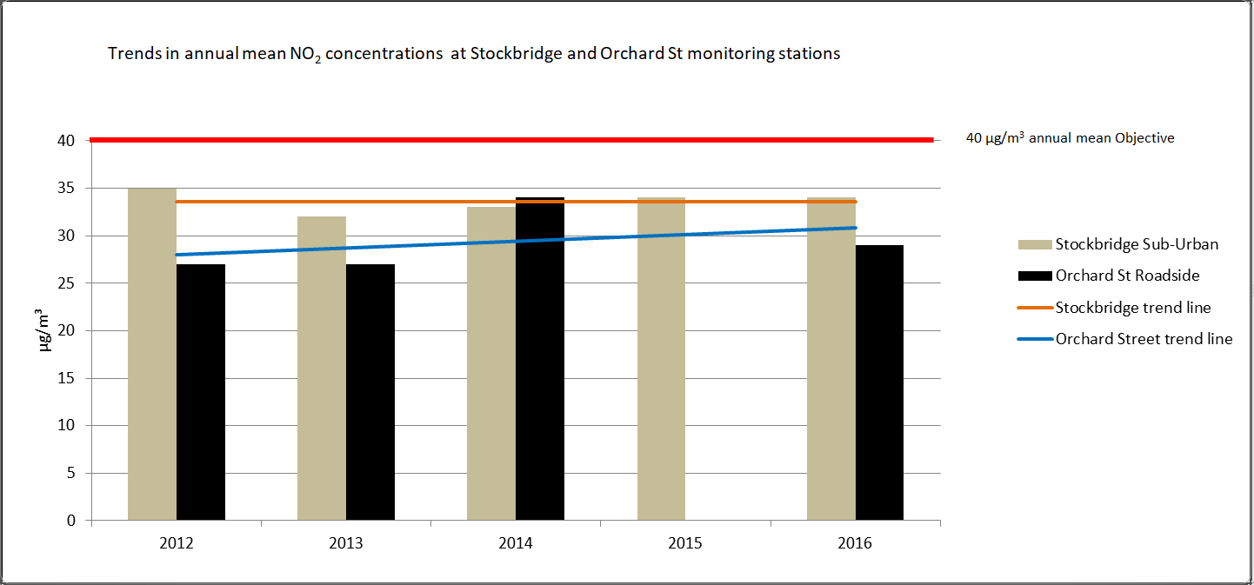

Table A.4 – 1-Hour Mean NO2 Monitoring Results

|  |  |  |  |  |  |  |  |  |  |
| --- | --- | --- | --- | --- | --- | --- | --- | --- | --- |
| **Site ID** | **Site Type** | **Monitoring Type** | **Valid Data Capture for Monitoring Period (%) (1)** | **Valid Data Capture 2016 (%) (2)** | **NO2 1-Hour Means > 200µg/m3 (3)** | | | | |
| **2012** | **2013** | **2014** | **2015** | **2016** |
| CI1 | Suburban | Automatic | 98 | 98 | 0 | 0 | 0 | 0 | 0 |
| CI4 | Roadside | Automatic | 100 | 31 | 0 | 0 | 0 | x | 0 |

**Notes:**

There were no exceedances of the NO2 1-hour mean objective (200µg/m3 not to be exceeded more than 18 times/year)

(1) Data capture for the monitoring period, in cases where monitoring was only carried out for part of the year.

(2) Data capture for the full calendar year (e.g. if monitoring was carried out for 6 months, the maximum data capture for the full calendar year is 50%).

(3) If the period of valid data is less than 85%, the 99.8th percentile of 1-hour means is provided in brackets.

X - no monitoring undertaken

**Figure A.2 – Trends in Number of NO2 1-Hour Means > 200µg/m3 (100 ppb)**

There have been no 1 hour mean concentrations that exceed the 200µg/m3 (100ppb)Objective in 2016 at either monitoring station

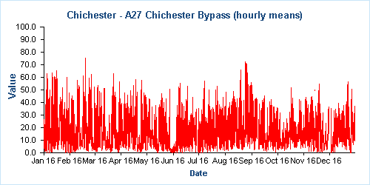**­**

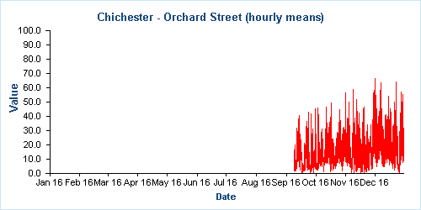

**Figure A.3 – Trends in NO2 diffusion tubes 2011 – 2016** 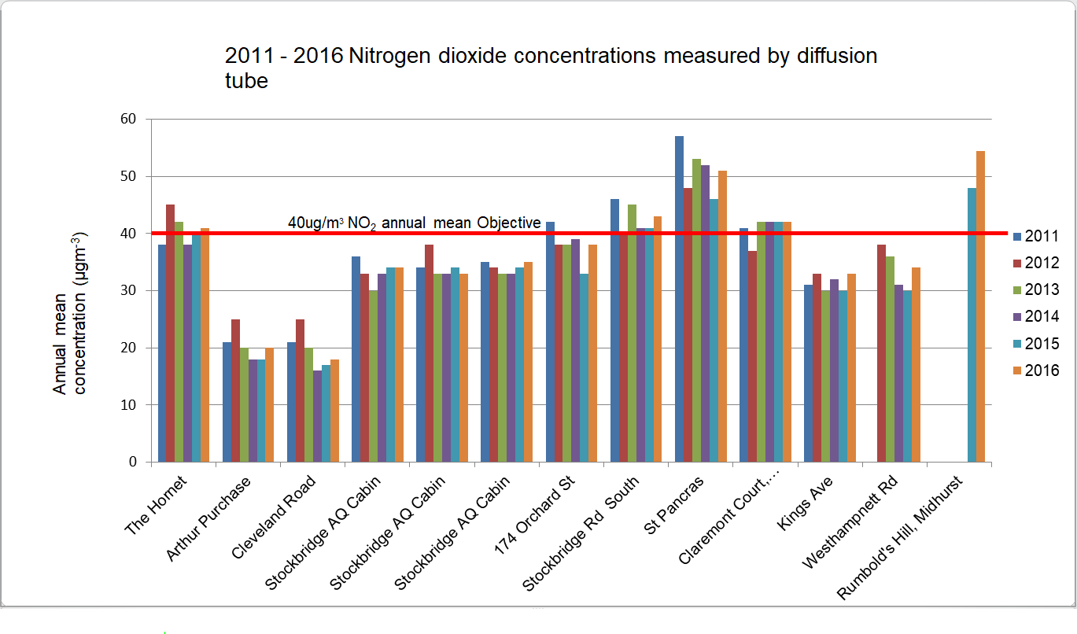

**Table A.5 – Annual Mean PM10 Monitoring Results**

|  |  |  |  |  |  |  |  |  |
| --- | --- | --- | --- | --- | --- | --- | --- | --- |
| **Site ID** | **Site Type** | **Valid Data Capture for Monitoring Period (%) (1)** | **Valid Data Capture 2016 (%) (2)** | **PM10 Annual Mean Concentration (µg/m3) (3)** | | | | |
| **2012** | **2013** | **2014** | **2015** | **2016** |
| CI1 | Suburban |  | 99 | 22 | 20 | 20 | 21 | 18 |

**Annualisation has been conducted where data capture is <75%**

**Notes:**

There have been no exceedances of the PM10 annual mean objective of 40µg/m3

(1) Data capture for the monitoring period, in cases where monitoring was only carried out for part of the year.

(2) Data capture for the full calendar year (e.g. if monitoring was carried out for 6 months, the maximum data capture for the full calendar year is 50%).

**Figure A.4 – Annual Mean PM10 Concentrations at Stockbridge monitoring site**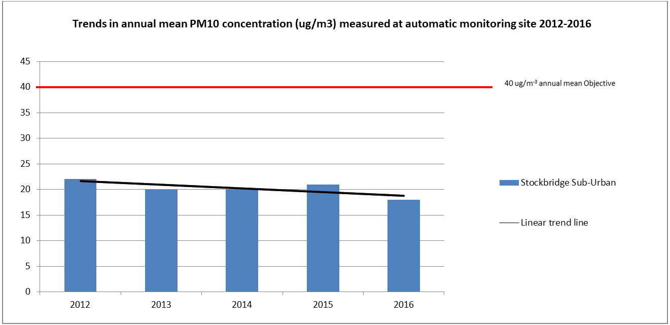

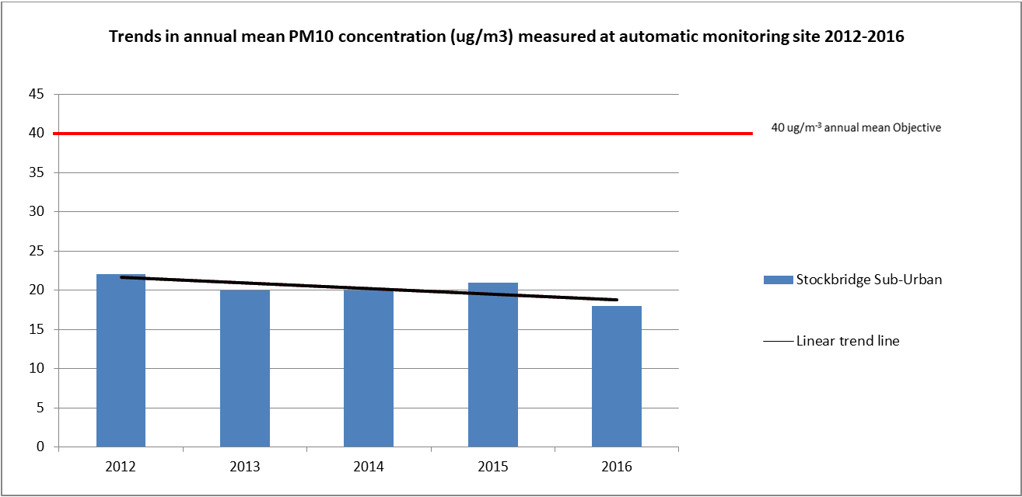

Table A.6 – 24-Hour Mean PM10 Monitoring Results

|  |  |  |  |  |  |  |  |  |
| --- | --- | --- | --- | --- | --- | --- | --- | --- |
| **Site ID** | **Site Type** | **Valid Data Capture for Monitoring Period (%) (1)** | **Valid Data Capture 2016 (%) (2)** | **PM10 24-Hour Means > 50µg/m3 (3)** | | | | |
| **2012** | **2013** | **2014** | **2015** | **2016** |
| CI1 | Suburban |  | 99 | 11 | 1 | 2 | 4 | 1 |

**Notes:**

There have been no exceedances of the PM10 24-hour mean objective (50µg/m3 not to be exceeded more than 35 times/year)

(1) Data capture for the monitoring period, in cases where monitoring was only carried out for part of the year.

(2) Data capture for the full calendar year (e.g. if monitoring was carried out for 6 months, the maximum data capture for the full calendar year is 50%).

**Figure A.5 Number of 24-Hour Mean PM10 Results >50µg/m3 at Stockbridge monitoring site**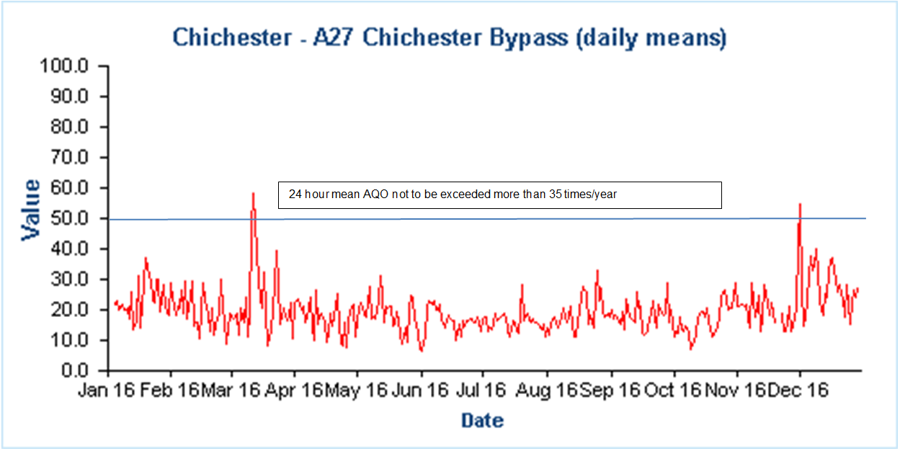

# Appendix B: Full Monthly Diffusion Tube Results for 2016

Table B.1 – NO2 Monthly Diffusion Tube Results - 2016

|  |  |  |  |  |  |  |  |  |  |  |  |  |  |  |  |
| --- | --- | --- | --- | --- | --- | --- | --- | --- | --- | --- | --- | --- | --- | --- | --- |
| **Site ID** | **NO2 Mean Concentrations (µg/m3)** | | | | | | | | | | | | | | |
| **Jan** | **Feb** | **Mar** | **Apr** | **May** | **Jun** | **Jul** | **Aug** | **Sep** | **Oct** | **Nov** | **Dec** | **Annual Mean** | | |
| **Raw Data** | **Bias Adjusted (1.114) and Annualised (1)** | **Distance Corrected to Nearest Exposure (2)** |
| 1 | 35.76 | 28.19 | 26.43 | 24.57 | 23.50 | 28.15 | 29.06 | 26.39 | 31.73 | 32.12 | 33.70 | 38.67 | 29.86 | 33.24 | **n/a** |
| 2 | 42.18 | 37.27 | 29.89 | 32.30 | 38.57 | 37.62 | 37.77 | 40.68 | 40.32 | 35.04 | 38.51 | 41.49 | 37.64 | **41.91** | **41.9** |
| 3 | 38.50 | 30.83 | 19.17 | 27.96 | 24.25 | 29.91 | 35.11 | 34.75 | 33.74 | 24.57 | 32.81 | 38.11 | 30.81 | 34.30 | **n/a** |
| 4 | 28.11 | 29.38 | 23.42 | 27.22 | 1.22 | 28.27 | 36.50 | 32.88 | 34.40 | 24.07 | 29.98 | 33.73 | 29.81 | 33.20 | **n/a** |
| 5 | 37.96 | 28.92 | 22.63 | 28.99 | 25.99 | 30.24 | 33.92 | 34.61 | 33.20 | 24.66 | 32.62 | 38.09 | 30.99 | 34.50 | **n/a** |
| 6 | 41.17 | 40.10 | 35.66 | 33.71 | 35.63 | 36.03 | 31.98 | 34.84 | 36.00 | 47.10 | 46.91 | 45.97 | 38.76 | **43.15** | 28.0 |
| 7 | 23.10 | 14.89 | 14.24 | 14.11 | 12.03 | 10.20 | 10.71 | 12.65 | 14.84 | 20.49 | 23.30 | 24.04 | 16.22 | 18.06 | **n/a** |
| .. | 36.12 | 29.62 | 25.23 | 26.81 | 27.64 | 31.19 | 27.57 | 20.03 | 31.94 | 29.92 | 40.45 | 39.78 | 30.52 | 33.99 | 31.2 |
| 9 | 40.00 | 34.42 | 35.29 | 32.37 | 37.60 | 36.55 | 27.74 | 34.85 | 35.15 | 36.15 | 45.44 | 48.06 | 36.97 | **41.16** | **41.2** |
| 10 | 50.95 | 38.65 | 38.53 | 39.25 | 45.25 | 47.29 | 42.28 | 47.22 | 52.70 | 42.05 | 47.09 | 56.82 | 45.67 | **50.85** | **50.9** |
| 11 | 21.93 | 18.02 | 15.95 | 14.24 | 14.55 | 15.23 | 14.45 | 15.18 | 16.50 | 19.71 | 23.63 | 28.52 | 18.16 | 20.22 | 20.2 |
| 12 | 46.67 | 29.51 | 29.41 | 29.90 | 31.11 | 29.65 | 25.82 | 31.08 | 35.33 | 34.13 | 40.36 | 42.55 | 33.79 | 37.63 | 37.6 |
| 14 | 53.62 | 35.92 | A | 43.98 | 44.78 | 51.01 | 46.76 | 51.41 | 48.06 | 49.36 | 60.44 | 52.36 | 48.88 | **54.43** | **51.2** |

n/a - where bias adjusted mean does not exceed the annual mean objective of 40 ug/m3 and site is background or suburban, no distance correction has been calculated**. µg/m3** **µg/m3**

**Local bias adjustment factor used**

**National bias adjustment factor used**

**Annualisation has been conducted where data capture is <75%**

**Notes:**

Exceedances of the NO2 annual mean objective of 40µg/m3 are shown in **bold**.

(1) See Appendix C for details on bias adjustment and annualisation.

(2) Distance corrected to nearest relevant public exposure.

# Appendix C: Supporting Technical Information / Air Quality Monitoring Data QA/QC

**Significant changes to sources**No significant changes noted

**Monitoring campaigns in the District**

None undertaken

**Additional Evidence gathered**

None noted

**QA/QC of Automatic Monitoring**

All sites are visited by an officer for calibration and filter changes on a bi-monthly basis. CDC has a service agreement with a third party who provides site maintenance, auditing, regular inspections and 48-hour callout response if problems are encountered at the sites. Data is downloaded from all sites twice daily by the ERG[5] and is available to download online[6]. CDC has a contract with ERG to calibrate and ratify all real time data collected.

For more information please contact the ERG helpdesk[7].

**QA/QC Diffusion Tube Data**

Chichester District Council uses Gradko Environmental for supplying and analysing the diffusion tubes. The tube preparation method is 50% TEA/Acetone and ANA UKAS Method GLM 7 and GLM 9. CDC uses a local bias adjustment factor.

**Factor from Local Co-location Studies**

Three diffusion tubes are co-located with the Stockbridge monitoring station. These are used to calculate a bias-correction for the NO2 diffusion tubes. The automatic monitoring station’s data is quality assured by ERG. The annual average concentrations from the three co-located tubes are compared to the annual average real time data derived concentration for the same period. A factor can then be derived to correct all other diffusion tube data. The ‘bias correction’ calculation is as per the table below.

|  |  |
| --- | --- |
| Annual mean (automatic monitor) a,b,c | = 34 µg/m3 |
| Annual average mean (NO2 diffusion tubes) d | = 30.5 µg/m3 |
| Correction factor calculation | = 34//30.5  1.115 |

a 1st January 2016 – 31st December 2016

b Real-time data capture for 2016 = 98%

c All data ratified by Environmental Research Group

d Diffusion tube data capture for the period Jan - Dec = 100%

**QA/QC of Diffusion Tube Monitoring**

CDC has confirmed by checking the web site provided that Gradko Environmental uses the Workplace Scheme for Proficiency (WASP) indicator rating for quality control. The result for 2016 was Satisfactory (Z score +/- 2) for 100% of results submitted. For more information please contact Gradko Environmental[8].

**Annualising monitoring data for monitoring station at Orchard Street, Chichester**

See Box 7.9 in TG16 for details of method used.

| Comparative Roadside site | Annual Mean (Am) | Period Mean (Pm) | Ratio Am/Pm (Ra) | annual data capture rate % |
| --- | --- | --- | --- | --- |
| Worthing Grove Lodge | 48 | 47.6 | 1.0084 | 94 |
| Horsham Park Way | 28.7 | 35.1 | 0.8176 | 95 |
|  |  | Sum Ra | 1.8260 |  |
|  |  | Average Ra | 0.9130 |  |
| measured mean for Orchard St |  | M | 32 |  |
|  | annual mean for site | annual mean for site | M x Ra | 29.21 |

Both comparative sites chosen are long-term, continuous monitoring sites and lie within a radius of 50 miles of Orchard Street, Chichester. As the site to be annualised is a roadside site the comparative sites chosen are also roadside sites.

**Distance calculations for roadside diffusion sites where monitoring is not carried out at a location of relevant exposure**

Stockbridge Road South

Stockbridge Road South

Westhampnett Road

Westhampnett Road

Rumbold’s Hill Midhurst

Rubmold's hill midhurst

# Appendix D: Map(s) of Monitoring Locations and AQMAs

Figure D.1 Stockbridge Roundabout AQMA and automatic and diffusion tube locations

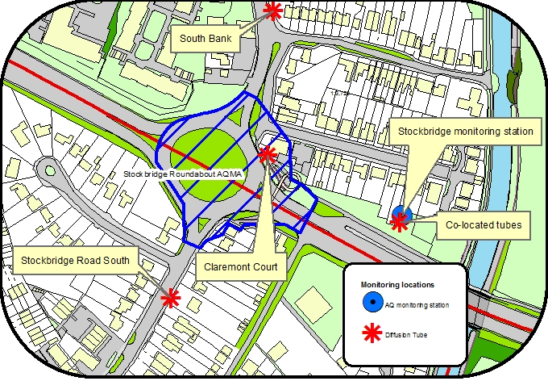

© Crown Copyright and database right 2016. Ordnance Survey 100018803

Figure D.2 Orchard Street AQMA and automatic and diffusion tube locations

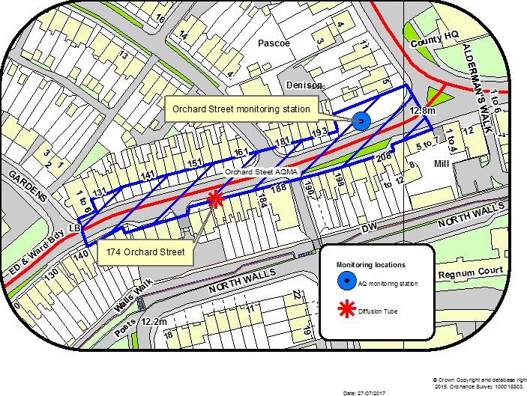

© Crown Copyright and database right 2016. Ordnance Survey 100018803

Figure D.3 St Pancras AQMA and diffusion tube locations

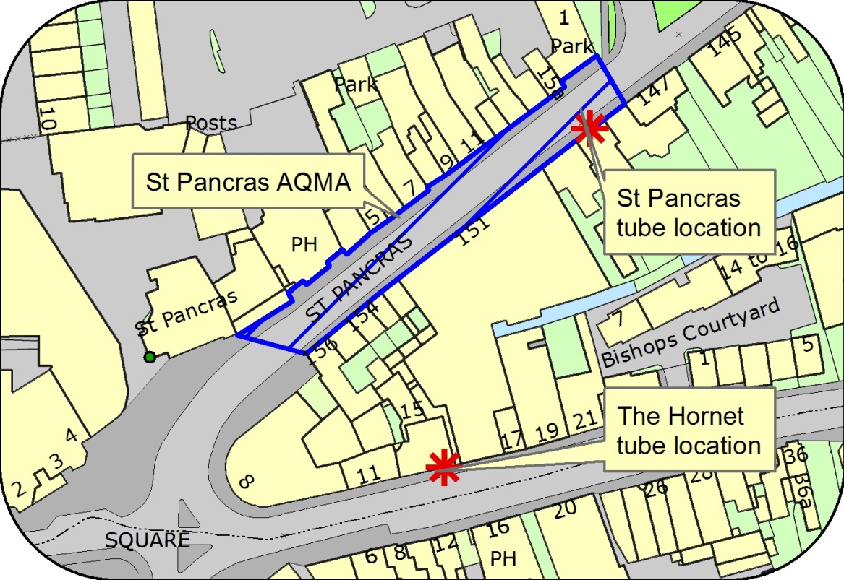

© Crown Copyright and database right 2016. Ordnance Survey 100018803

Figure D.4 Map of diffusion tube sites in Chichester

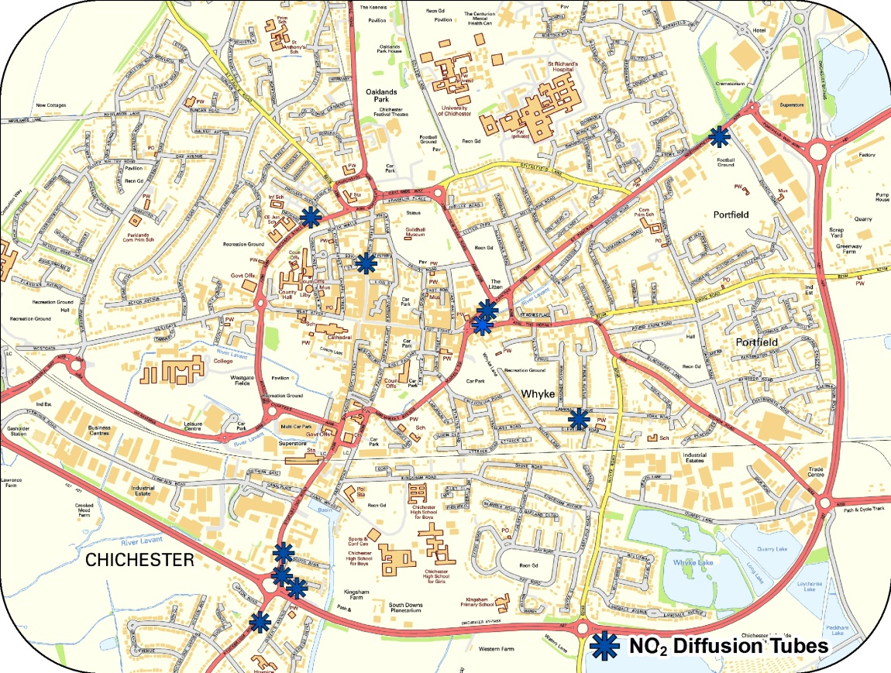

© Crown Copyright and database right 2016. Ordnance Survey 100018803

Figure D.5 Location of ozone monitoring station in Lodsworth

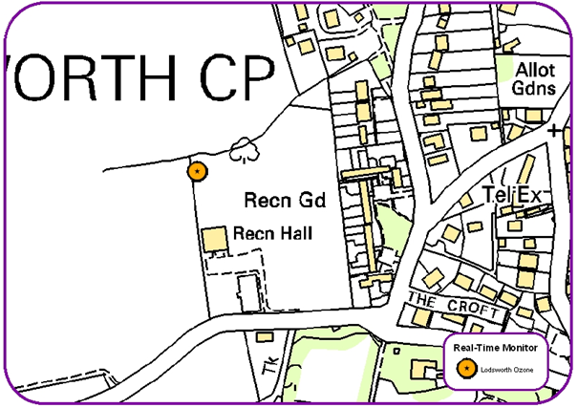

© Crown Copyright and database right 2016. Ordnance Survey 100018803

Figure D.6 Map of diffusion tube site in Midhurst

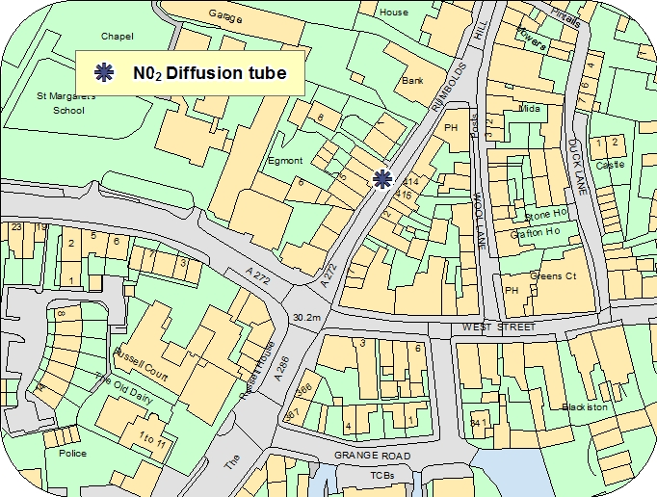

© Crown Copyright and database right 2016. Ordnance Survey 100018803

# Appendix E: Summary of Air Quality Objectives in England

Table E.1 – Air Quality Objectives in England

| **Pollutant** | **Air Quality Objective[9]** | |
| --- | --- | --- |
| **Concentration** | **Measured as** |
| Nitrogen Dioxide (NO2) | 200 µg/m3 not to be exceeded more than 18 times a year | 1-hour mean |
| 40 µg/m3 | Annual mean |
| Particulate Matter (PM10) | 50 µg/m3, not to be exceeded more than 35 times a year | 24-hour mean |
| 40 µg/m3 | Annual mean |
| Sulphur Dioxide (SO2) | 350 µg/m3, not to be exceeded more than 24 times a year | 1-hour mean |
| 125 µg/m3, not to be exceeded more than 3 times a year | 24-hour mean |
| 266 µg/m3, not to be exceeded more than 35 times a year | 15-minute mean |

# Glossary of Terms

|  |  |
| --- | --- |
| **Abbreviation** | **Description** |
| AQAP | Air Quality Action Plan - A detailed description of measures, outcomes, achievement dates and implementation methods, showing how the local authority intends to achieve air quality limit values’ |
| AQMA | Air Quality Management Area – An area where air pollutant concentrations exceed / are likely to exceed the relevant air quality objectives. AQMAs are declared for specific pollutants and objectives |
| ASR | Air quality Annual Status Report |
| CCTV | Closed circuit television |
| CDC | Chichester District Council |
| Defra | Department for Environment, Food and Rural Affairs |
| DMRB | Design Manual for Roads and Bridges – Air quality screening tool produced by Highways England |
| EU | European Union |
| EV | Electric vehicle |
| FDMS | Filter Dynamics Measurement System |
| HE | Highways England |
| LAQM | Local Air Quality Management |
| LES | Low Emissions Strategy |
| LSTF | Local Sustainable Transport Fund |
| MOVA | Microprocessor Optimised Vehicle Actuation |
| NHS | National Health Service |
| NO2 | Nitrogen Dioxide |
| NOx | Nitrogen Oxides |
| OLEV | Office of Low Emission Vehicles |
| O3 | Ozone |
| PM10 | Airborne particulate matter with an aerodynamic diameter of 10µm (micrometres or microns) or less |
| PM2.5 | Airborne particulate matter with an aerodynamic diameter of 2.5µm or less |
| QA/QC | Quality Assurance and Quality Control |
| RTPI | Real Time Passenger Information |
| SAQP | Sussex Air Quality Partnership |
| SO2 | Sulphur Dioxide |
| UTC | Urban Transport Controls |
| VMS | Variable message signing |
| WSCC | West Sussex County Council |

# References

Towards Better Air Quality: An Air Quality Action Plan for Chichester District 2015-16

produced by Chichester District Council

West Sussex Walking and Cycling Strategy 2016 – 2026 produced by WSCC

1. Environmental equity, air quality, socioeconomic status and respiratory health, 2010
2. Air quality and social deprivation in the UK: an environmental inequalities analysis, 2006
3. Defra. Abatement cost guidance for valuing changes in air quality, May 2013
4. Stated as an annual mean concentration.
5. The Environmental Research Group (ERG), part of the School of Biomedical and Health Sciences at King’s College London, a leading provider of air quality information and research in the UK.
6. www.sussex-air.net
7. Contact ERG on 020 7848 4022
8. Contact Gradko on 01962 860331
9. The units are in microgrammes of pollutant per cubic metre of air (µg/m3).