

# Idox Public Access For Consultee Access

**User Guide**

Ideas, solutions, suggestions, hints and procedures from this document are the intellectual property of

Idox Software Ltd and thus protected by copyright. They may not be reproduced, transmitted to third parties or used in any form for commercial purposes without the express permission of Idox Software Ltd.

ID.314.1213

Idox PA for Consultee Access User Guide December 2013



# Contents

**Introduction User Details**

Registration 5

Log In 7

My Profile 8

Consultee In Tray 14

Searching

Simple Search 21

Advanced Search 22

Weekly/Monthly Lists Search 23

Property Search 24

Map Search 26

Search Results

Saving A Search 34

Record Details 34

Tracking Applications 34

**Introduction**

# Introduction

The Idox Public Access For Consultee Access website has been designed to provide an efficient and easy-to-use process for members of consultee bodies to search for and track applications in a variety of sectors. It also allows them to submit and track comments made on selected areas of interest.

This document describes how to use the site.

**User Details**

Registration

# User Details

Anyone can use the Idox Public Access site but to take advantage of the advanced profile fea- tures you must first register a user account.

## Registration

Registering for an Idox Public Access user account only requires you to provide your name and relevant contact details.

1. 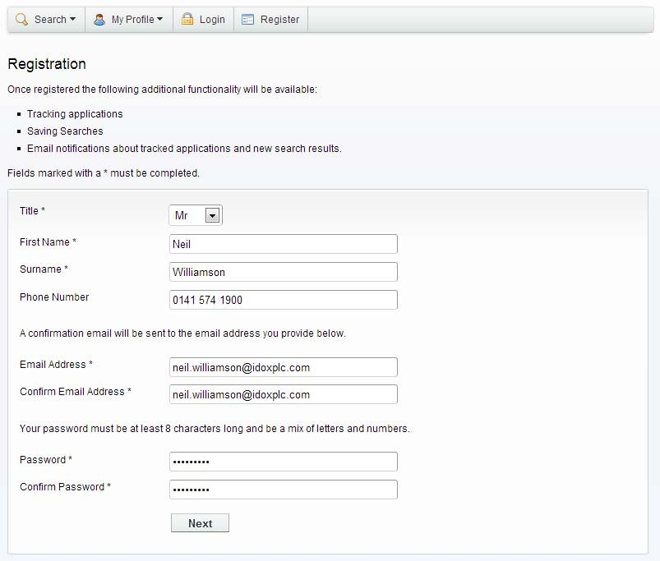To create
2. a new user account click on **Register** in the menu bar.
3. Register your personal details by filling in the following fields:
   * **Title** - select the title you wish to be addressed by.
   * **First Name** - enter your first name.
   * **Surname** - enter your surname.
   * **Email Address** - enter your email address. Enter it again to confirm that it is correct.
   * **Password** - enter a password that will allow only you to access your account.

Note Passwords must be eight characters or longer, must contain a mixture of letters and numbers and must not contain spaces. Enter the password again below to confirm that it is correct.

1. Click on Next.

**User Details**

Registration

1. Enter your postcode, the press Next.

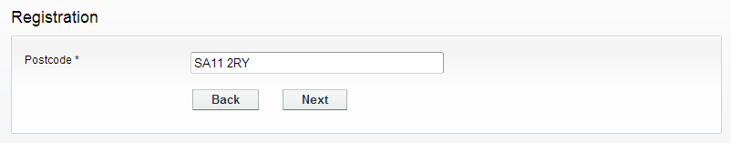

1. Select your address from the drop down list, then click on Next.

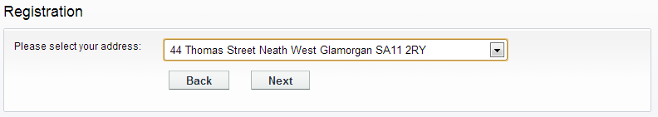

1. If your address is not listed, select **My address is not in the list** and click on Next.
2. Enter your address details in the appropriate fields, then click on Next.

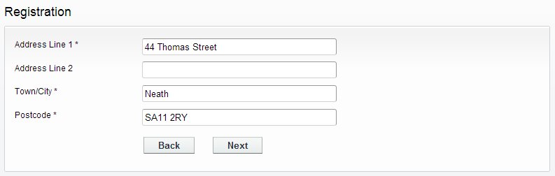

1. Click to read the Terms and Conditions and Privacy Policy that apply to the use of the site. When you have done so, tick the check box to indicate that you agree to them.
2. Check that your personal and login details are correct. To register them, click on the Next button.
3. An email will be sent to the address you entered. This provides final confirmation that you want to create an Idox Public Access account. When the email arrives, click on the link to be returned to the Idox Public Access site.

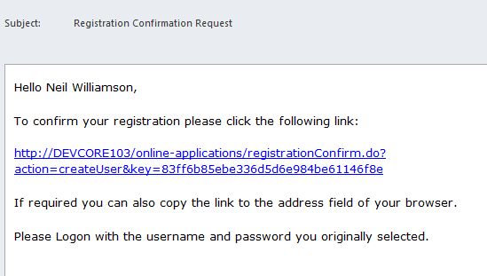

**User Details**

Log In

## Log In

In order to use the full range of features offered by Idox Public Access you need to log in to the site using the username and password you provided when you registered your account.

1. Click on Login in the menu bar.
2. Enter your email address and password, then click on the Login button.

### Forgotten password

1. If you forget your password, click on the **Forgotten password?** link.
2. Enter your email address and then enter a new password twice. Press the **Change Password**

button.

1. A confirmation email will be sent to your email address. When it arrives, click on the confir- mation link. You will now be able to log in with your new password.

### Log out

When you are finished using Idox Public Access, remember to log out by clicking on the Logout button in the menu bar.

## My Profile

Once your account has been created, you can access your My Profile area. This area allows you to configure your personal details as well as manage your searches and applications.

* **Profile Details** - your full personal details
* **Saved Searches** - a list of searches which you have saved
* **Notified Applications** - notifications that applications that you are tracking, or are the subject of saved searches, have been modified
* **Tracked Applications** - a list of applications that you have elected to track.

### Profile details

The Profile Details pages allow you to view and update your account details.

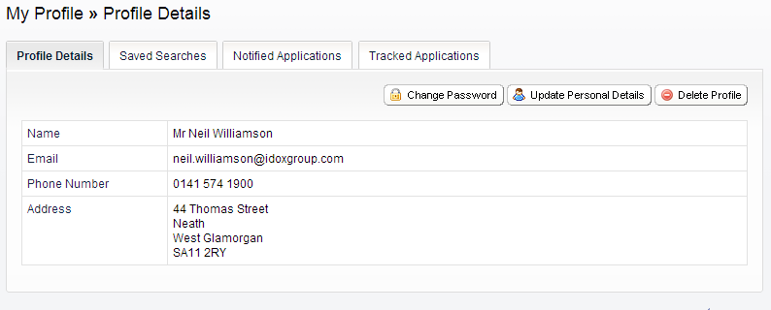

1. Select **Profile Details** from the My Profile drop down list in the menu bar.

The Personal Details page allows you to view the details you registered with. You can change any of those details or update your password.

1. To update your password click on **Change Password**.
2. Enter your email address and then enter a new password twice.
3. Press the **Change Password button**. A confirmation email will be sent to your email address. When it arrives, click on the confirmation link. You will now be able to log in with your new password.
4. To change your details click on **Update Personal Details**. Alter your details as required, click- ing on the Next button to page through the sections.
5. When you no longer wish to use Idox Public Access, click on **Delete Profile**.

### In Tray Settings

The In Tray Settings page displays the interest areas that you have membership of within your consultee group. It also displays whether you are the coordinator of each interest area.

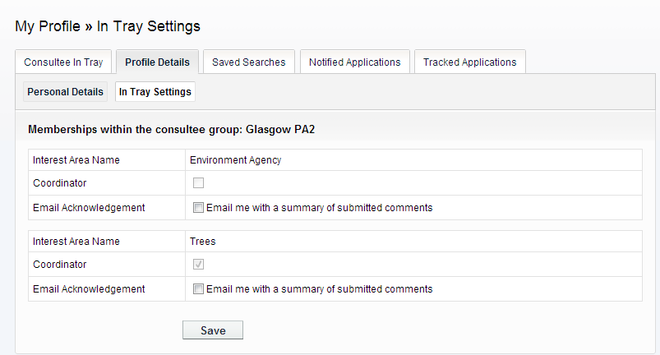

* 1. Select the **In Tray Settings** tab.
  2. For each interest area listed you can choose to receive an email summary of comments sub- mitted about it. To do this, check the **Email Acknowledgement** boxes for the relevant interest areas.
  3. Click on the Save button.

### Saved searches

The primary activity on the Idox Public Access site is to perform searches for information. Searches that will be performed frequently can be saved so that they may be repeated easily as often as you like (see “Searching” on page 20).

Any changes to the status of applications previously found by your search criteria or any new applications which match the criteria of a saved search will trigger a notification. Notifications are listed in the Notified Applications page.

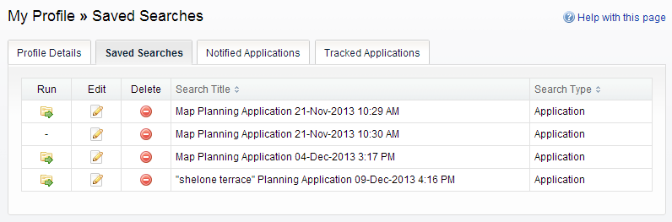

1. To view your saved searches, select **Saved Searches** from the My Profile drop down list.
2. You can sort the list by clicking on the appropriate column headings:
   * **Search Title** - sort the list alphabetically by search title
   * **Search Type** - sort the list alphabetically by search type.
3. To perform a saved search now, click on the **Run** button for that search.

Note Circular map searches cannot be run from the Saved Searches page.

1. To modify the search criteria, click on the **Edit** button for that search. This returns you to the appropriate search form and allows you to change the details of the search.
2. To remove a search from the list, click on the **Delete** button for that search.

### Tracked applications

After locating an application of interest by searching, you can choose to keep a watch on what happens to it by tracking it. Applications are displayed on the Tracked Applications page. When applications that you are tracking are modified a notification will appear on the Notified Applica- tions page and you will be sent a notification email.

1. To view these applications, select **Tracked Applications** from the My Profile drop down list.

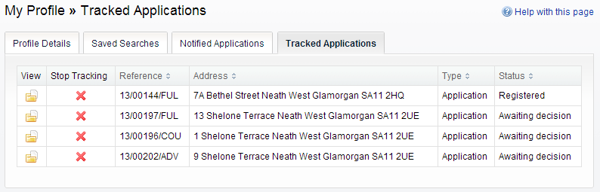

1. You can sort the list by clicking on the appropriate column headings:
   * **Reference** - sort the list alphanumerically by reference
   * **Address** - sort the list alphanumerically by the address that is the subject of the applica- tion
   * **Type** - sort the list alphabetically by the application type
   * **Status** - sort the list alphabetically by the status of the application.
2. To view a tracked application, click on the View button for that application.
3. To remove an application from the tracked applications list, click on the **Stop Tracking** button for that application.

### Notified applications

When applications that are the subject of a saved search or are in your Tracked Applications list are modified, a list of those applications will appear in the Notified Applications page. You will also be sent a notification email.

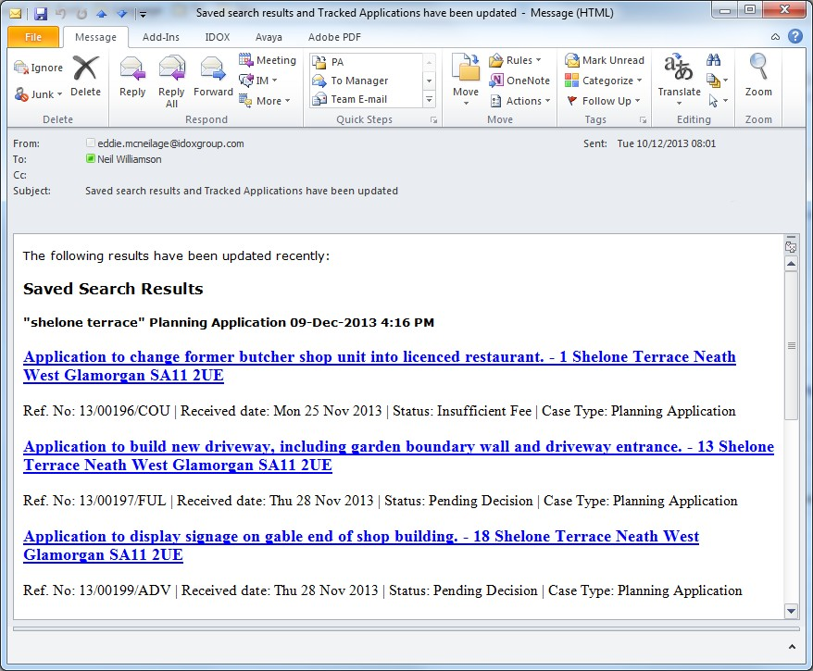

1. To view your notifications, select **Notified Applications** from the My Profile drop down list.

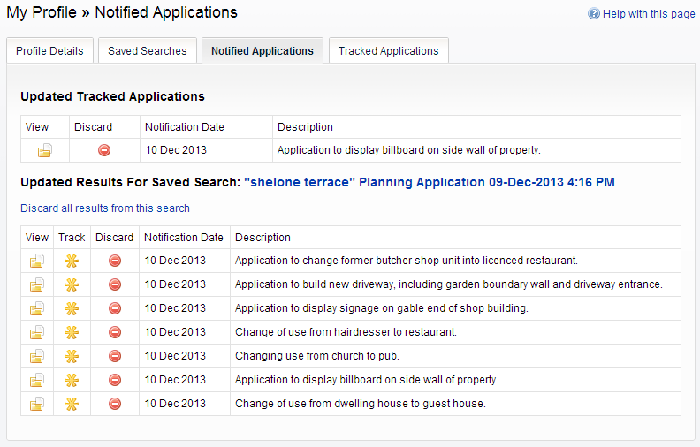

1. The tracked applications that have been modified are listed at the top of the screen. These are followed by the modified applications that are subject to your saved searches.
2. To view an application, click on the **View** button for that application.
3. To remove an application from the notifications list, click on the **Discard** button for that appli- cation. To delete all of the notified results for a particular search, click on **Discard All Results From This Search**.
4. Additionally, you can select saved search applications from the notifications list and track these. Click on the **Track** icon for the applications of interest. These will now be added to your Tracked Applications page.

## Consultee In Tray

As a Consultee user, you have a set of consultee pages that allow you to view new, active and past consultations for your Interest Area. You can also perform a consultation search.

### In tray

The In Tray displays a list of applications on which requests for consultation in your interest area have been made. Each application may have one or more requests for consultation associated with it.

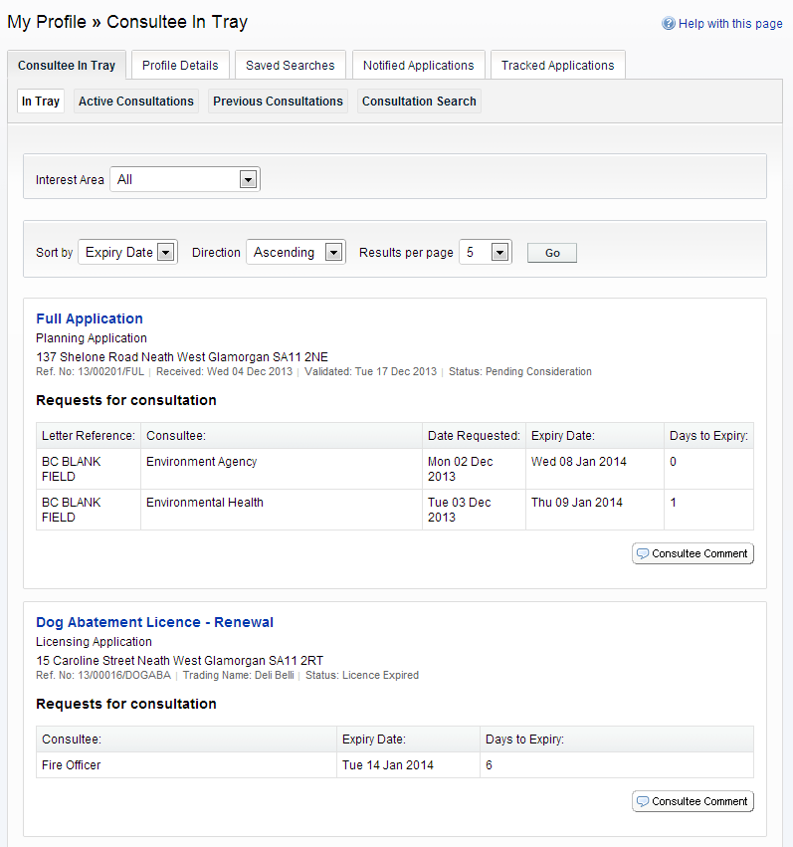

1. You can choose to display applications related to one interest areas to which you belong, or to all of them. Select from the **Interest Area** drop down list.
2. You can configure the way the list is displayed.
   * To sort the results, select a criterion from the **Sort by** list.
   * To change the direction of the listed results select Ascending or Descending from the

**Direction** list.

* + To change the number of results displayed at one time select a value from the **Results per page** list.

When you have made your display selections, press **Go**.

1. You can browse the In Tray for consultations of interest to you. If there are more results than fit on one page, use the Next and Previous buttons or go to a particular page to speed up navigation.

Each request for consultation displays information appropriate to the type of application, including:

* + **Letter Reference** - the relevant letter reference number
  + **Consultee** - the person or body who raised the request for consultation
  + **Date Requested** - the date the request for consultation was initiated
  + **Expiry Date** - the date that consultee comments must be made by
  + **Days to Expiry** - the number of days until the expiry date.

1. To view the details of the application click on its title. You will also be able to read any public and consultee comments that have already been made.
2. To comment on an application click on the **Consultee Comment** button. You can submit a consultee comment either by typing a note directly or by uploading an existing document. You can also send a message directly to a consultee group coordinator.

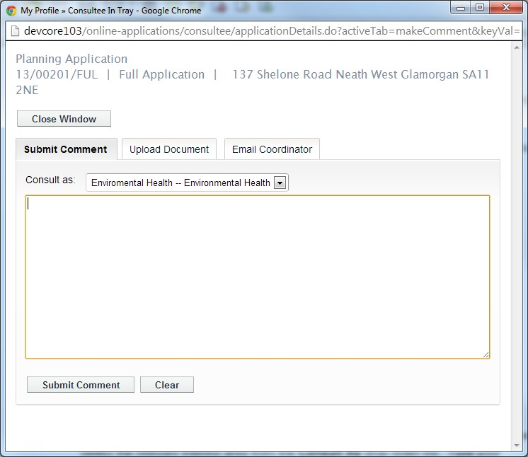

1. To submit a comment directly, select the **Submit Comment** tab in the pop-up window. Select the relevant interest area from the **Consult as** drop down list. Type your comment into the text box. When you are finished, click on the **Submit Comment** button.
2. To upload a pre-prepared submission as a document, select the **Upload Document** tab in the pop-up window. Select the relevant interest area from the **Consult as** drop down list. Click on the **Choose file** button and navigate to the document's location on your computer or network. When you have located your document, click on the Upload button.
3. To send a message to consultee group coordinator, select the **Email Coordinator** tab. Select the relevant interest area from the **Consult as** drop down list. Type the text of the message that you want to send then click on the **Email to Group Coordinator** button.

### Active consultations

The Active Consultations page displays a list of applications currently under consultation on which you have made a consultee comment. You have until the expiry date to make any further comment. After this date they will be moved into the Previous Consultations page.

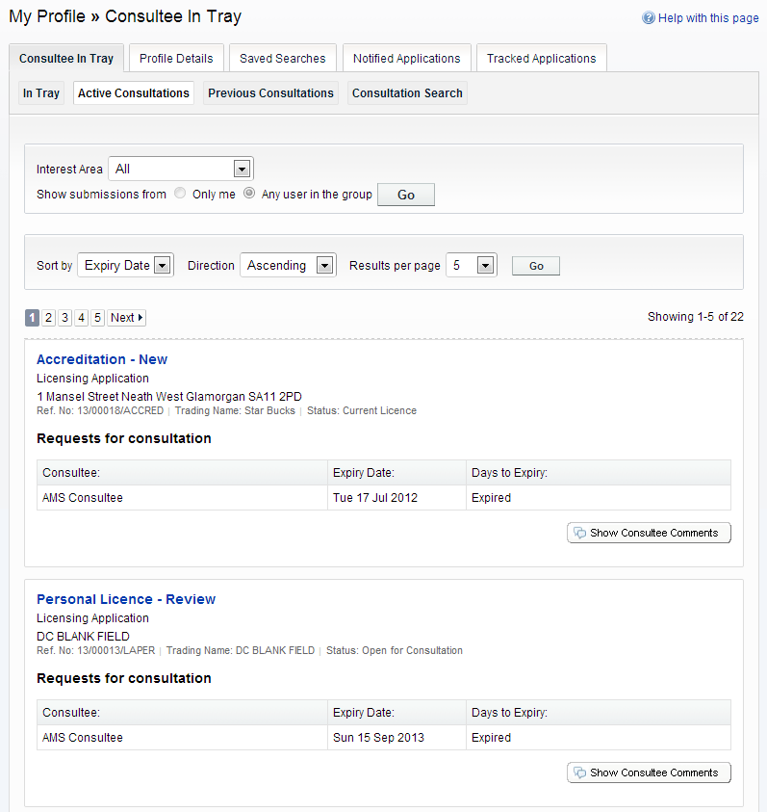

1. You can choose to display applications related to one interest areas to which you belong, or to all of them. Select from the **Interest Area** drop down list.
2. You can display only submissions that were made by you or submissions that were made by other members of your consultee group. Select **Only me** or **Any user in the group**, then press Go.
3. You can configure the way the list is displayed.
   * To sort the results, select a criterion from the **Sort by** list.
   * To change the direction of the listed results select Ascending or Descending from the

**Direction** list.

* + To change the number of results displayed at one time select a value from the **Results per page** list.

When you have made your display selections, press **Go**.

1. You can browse for consultations of interest. If there are more results than fit on one page, use the Next and Previous buttons or go to a particular page to speed up navigation.

Each request for consultation displays information appropriate to the type of application, including:

* + **Letter Reference** - the relevant letter reference number
  + **Consultee** - the person or body who raised the request for consultation
  + **Date Requested** - the date the request for consultation was initiated
  + **Expiry Date** - the date that consultee comments must be made by
  + **Days to Expiry** - the number of days until the expiry date.

1. To view the details of the application click on its title. You will also be able to read your previ- ous submission, and any other public and consultee comments.

Alternatively, to go straight to the consultee comments, press **Show Consultee Comments**.

1. To add a further comment on an application click on the Consultee Comment button. You can submit a consultee comment either by typing a note directly or by uploading an existing document.

Note Some interest groups do not permit you to make more than one comment.

1. To submit a comment directly, select the **Submit Comment** tab in the pop-up window. Select the relevant interest area from the **Consult as** drop down list. Type your comment into the text box. When you are finished, click on the **Submit Comment** button.
2. To upload a pre-prepared submission as a document, select the **Upload Document** tab in the pop-up window. Select the relevant interest area from the **Consult as** drop down list. Click on the **Choose file** button and navigate to the document's location on your computer or network. When you have located your document, click on the Upload button.
3. To send a message to consultee group coordinator, select the **Email Coordinator** tab. Select the relevant interest area from the **Consult as** drop down list. Type the text of the message that you want to send then click on the **Email to Group Coordinator** button.

### Previous consultations

The Previous Consultations page displays a list of applications whose consultation expiry has passed on which you have made a consultee comment. These are listed here for reference pur- poses and will be automatically removed a certain time later as determined by your consultee group administrator.

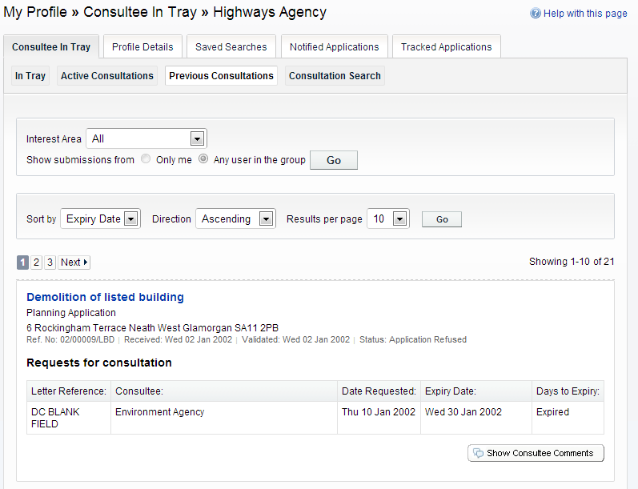

1. You can choose to display applications related to one interest areas to which you belong, or to all of them. Select from the **Interest Area** drop down list.
2. You can display only submissions that were made by you or submissions that were made by other members of your consultee group. Select **Only me** or **Any user in the group**, then press Go.
3. You can configure the way the list is displayed.
   * To sort the results, select a criterion from the **Sort by** list.
   * To change the direction of the listed results select Ascending or Descending from the

**Direction** list.

* + To change the number of results displayed at one time select a value from the **Results per page** list.

When you have made your display selections, press **Go**.

1. You can browse for consultations of interest. If there are more results than fit on one page, use the Next and Previous buttons or go to a particular page to speed up navigation.

Each request for consultation displays information appropriate to the type of application, including:

* + **Letter Reference** - the relevant letter reference number
  + **Consultee** - the person or body who raised the request for consultation
  + **Date Requested** - the date the request for consultation was initiated
  + **Expiry Date** - the date that consultee comments must be made by
    - **Days to Expiry** - expired.

1. To view the details of the application click on its title. You will also be able to read your previ- ous submission, and any other public and consultee comments.

Alternatively, to go straight to the consultee comments, press **Show Consultee Comments**.

1. You cannot add further consultee comments to applications in the Previous Consultations page because their consultation period has expired.

### Consultation search

Consultees can search for applications that have been commented on.

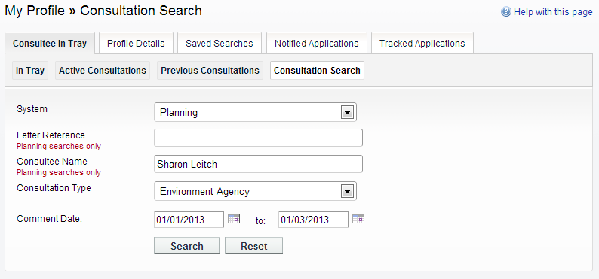

1. Choose which functional area to search within from the **System** drop down list.
2. If the search relates to Planning, enter appropriate information in the **Letter Reference** and

**Consultee Name** boxes, if known.

1. Select the interest area from the **Consultation Type** drop down list.
2. In the **Comment Date** boxes, enter the beginning and end dates between which comments have been made.

**Searching**

# Searching

The primary activity in the Idox Public Access site will be to search for records according to a variety of criteria. There are a variety of search methods to allow you to find the information you are looking for.

Note These vary according to the Idox Public Access module being used.

* **Simple** - search quickly for applications, appeals or enforcements according to some entered text
* **Advanced** - search according to a wide combination of relevant factors
* **Weekly/monthly list** - search for applications whose status is validated or decided within a particular time period
* **Property** - search for a particular property to which applications may apply
* **Map** - search using an interactive map tool.

**Searching**

Simple Search

## Simple Search

A simple search allows you to search quickly for an application, appeal or enforcement by enter- ing some text that will help identify it.

1. From the Search drop down list then select **Simple Search**.

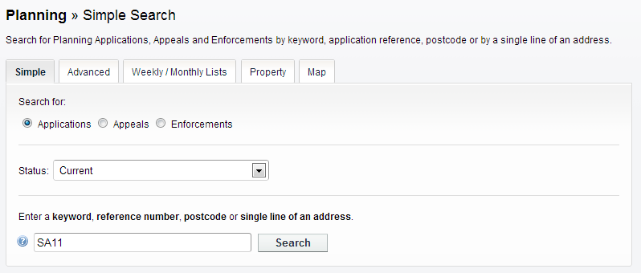

1. Click to select the type of record that you want to locate.
2. Choose the appropriate option from the **Status** drop down list.
3. Enter some text in the **Search** box that will correspond to one of:
   * reference number (for example, "2008/0125/DET")
   * post code (for example, "G1 3PL")
   * part of an address (for example, "Drymen", "Scott Street").
4. Click on the **Search** button to display the results of your search (see “Search Results” on page 33).

**Searching**

Advanced Search

## Advanced Search

An advanced search allows you to build a complex combination of specific criteria on which to search for information.

1. 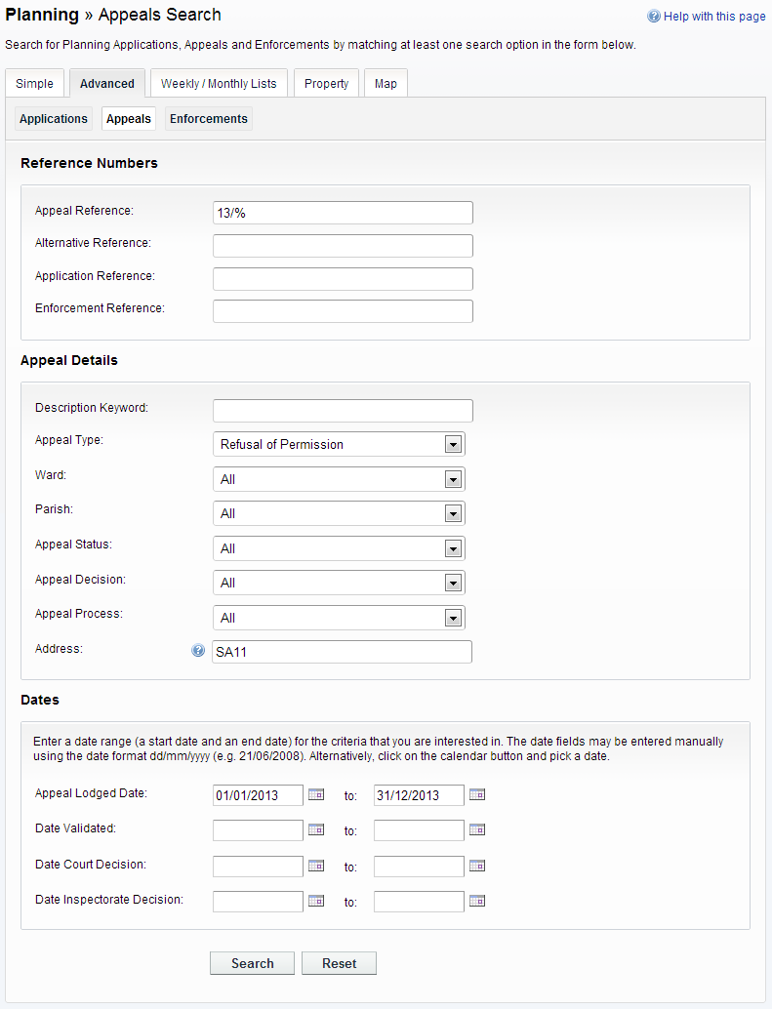From the Search drop down list select **Advanced Search**.
2. Click to select the type of record that you want to locate.
3. A variety of reference numbers are associated with planning records. Enter one or more to help identify a specific record.
4. The details you can fill in depend on the record type selected.Enter the details you want to search on.
5. Every planning case has a number of important dates associated with it (for example, the date the application was validated or the date that a court decision was issued). Use the date pickers to define an appropriate period to search within for any dates of interest.
6. Click on the Search button to display the results of your search (see “Search Results” on page 33).

**Searching**

Weekly/Monthly Lists Search

## Weekly/Monthly Lists Search

The weekly or monthly lists feature allows you to search for applications according to the week or month in which they were validated or decided, as published in the local authority’s lists.

* 1. From the Search drop down list select **Weekly/Monthly Lists**.

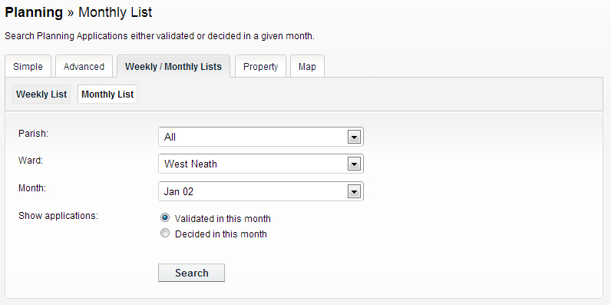

* 1. Click on **Weekly List** or **Monthly List** to select which list you want to search.
  2. You can narrow your search to a particular area by selecting from the **Parish** or **Ward** drop down lists.
  3. Specify the **Week** or **Month** by selecting from the drop down list.
  4. Under **Show applications**, select which records to display.
  5. Click on the Search button to display the results of your search (see “Search Results” on page 33).

**Searching**

Property Search

## Property Search

The property search feature allows you to search for a specific property in the gazeteer. There are two property search options:

* **Address** - search for applications at a specified address
* **A to Z Street** - search for applications on a specified street chosen from an alphabetical list.

### Address search

1. From the Search drop down list select **Property Search**.
2. To search for a specific property by its address, select the **Address Search** tab.

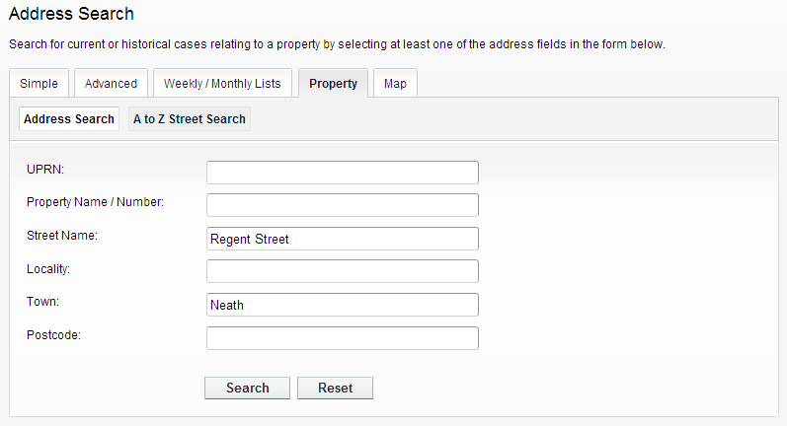

1. Enter as many details as you know in the appropriate fields, then press the Search button to display the results of your search (see “Search Results” on page 33).
2. If you need to clear the fields and start again, press the **Reset** button.

**Searching**

Property Search

### A to Z Street search

* 1. From the Search drop down list select **Property Search**.
  2. To search for a street alphabetically, select **A to Z Street Search**.
  3. Click on the initial letter of the street you are interested in to display all the streets that begin with that letter.

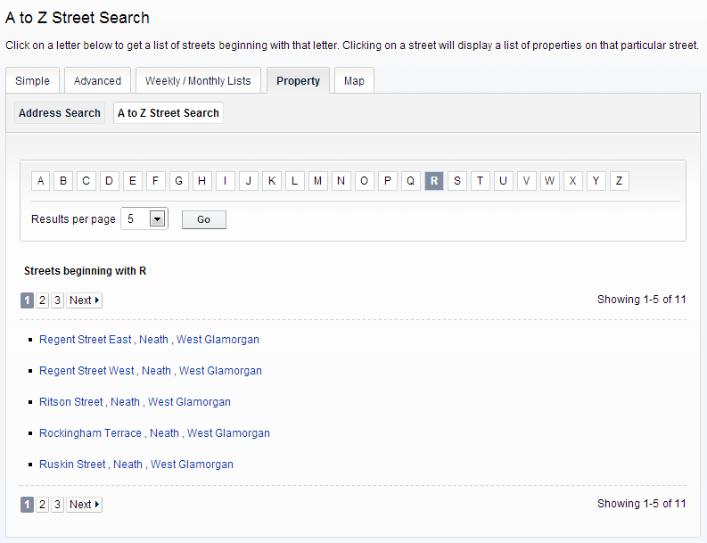

* 1. Select a street from the list to display the addresses on that street, then choose an address to discover whether any planning records exist for that address.
  2. To go back and chose a different street, click on the **Refine Search** button.

## Map Search

Map search allows you to identify properties that are the subjects of applications, appeals or enforcements using an interactive map. The map allows you to zoom in and examine each prop- erty to locate the records of interest to you. You can filter the display by adding or removing record types and by changing the time period.

Alternatively, if you are interested in applications relevant to a specific geographical area, such as close to your home, you can search for records limited either to the currently displayed map extent or to a specified radius from the map’s centre. These searches can be saved to your Saved Searches.

1. From the Search menu, choose the select **Map Search**.

The initial view shows applications submitted within the last six months.

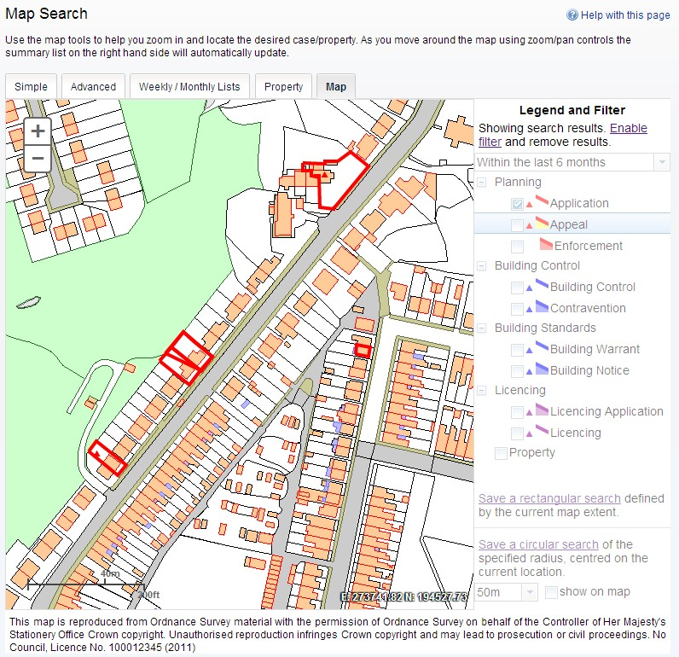

1. To zoom in on a specific location, click on a point on the map and click on the + button. To zoom out, click on the - button.

Alternatively you can zoom in and out by scrolling the mouse wheel.

Note The scale at the bottom left of the map changes as you zoom.

1. To pan the image around, click on the map and, keeping the mouse button depressed, drag in the direction you want to pan.
2. To refine the display, click on **Enable Filter**.

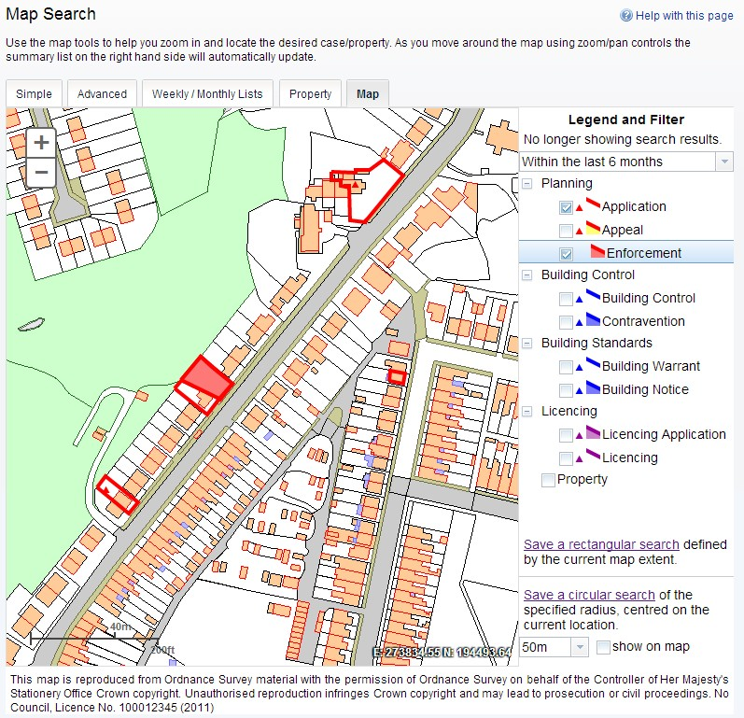

1. The initial view displays applications submitted within the last six months. To change the time period select from the **Time Period** drop down list.

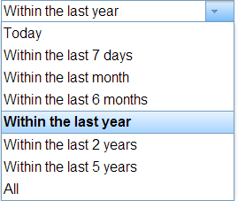

1. To display more record types on the map, check the relevant boxes in the **Legend and Filter**

list. To remove record types from the map, uncheck them. Most records can be displayed in two ways:

* + Records which only affect the property which is the subject of the application are shown as triangular points.
  + Records which affect others (for example, neighbours or the public) are displayed as a polygon which illustrates the boundary of the property affected by the application.

|  |  |  |
| --- | --- | --- |
| Module | Record type | Displayed As |
| **Planning** | **Applications** - properties for which planning applications have been submitted. |  |
| **Appeals** - properties which are the subject of planning appeals. |  |
| **Enforcements** - properties which are the subject of planning enforcements. |  |
| **Building Control** | **Applications** - properties for which building control applications have been submitted. |  |
| **Contraventions** - properties which are the subject of building control contraventions. |  |
| **Building Standards** | **Warrants** - properties for which applications for building warrants have been submitted. |  |
| **Notices** - properties which are the subject of building notices. |  |
| **Licensing** | **Applications** - properties for which licence applications have been submitted. |  |
| **Licences** - properties which hold one or more licences. |  |
| **All** | **Properties** - all valid properties in your local area. You can click on any of these to see if any current record (for example, application, or licence) exists at that address. |  |

1. Once you have identified a record of interest, click on the triangle point or polygon to display a summary of the information about the record.

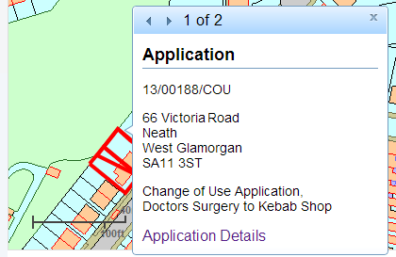

If there is more than one record associated with the property, you can click on the navigation arrows to page through the record summaries.

To view the full record details click on the **Details** link.

1. When the black Properties markers are displayed, you can click on any of these to view the property summary.

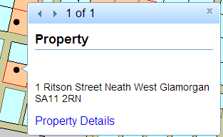

To view full details about that property, including any historical records that do not fall into the time period displayed on the map, click on **Property Details**.

### Saving map searches

You can add a map search to your Saved Searches list in one of two formats:

* **Rectangular search** - saves all of the records of the selected record type that apply to the area currently shown on the map
* **Circular search** - saves all of the records of the selected record type that apply to the area within a specified radius of the map centre.

Note Map searches can only be saved for one record type (for example, applications) at a time. If you want to save a search for another record type in the same geographical area, you must save it as a different search.

#### Rectangular search

The rectangular search allows you to display occurrences of a record type over the geographical area currently displayed on the map. By re-running the search, you can monitor new occur- rences. For example, if you have zoomed the map to display your town centre and filtered the legend to display planning applications in the last month you can save an extents search that allows you to monitor new applications arising in the town centre on a monthly basis.

1. Zoom and pan the map to display the geographical area of interest.
2. Select the required time period.
3. Filter the legend to display one record type.
4. Click on **Save a rectangular search**.

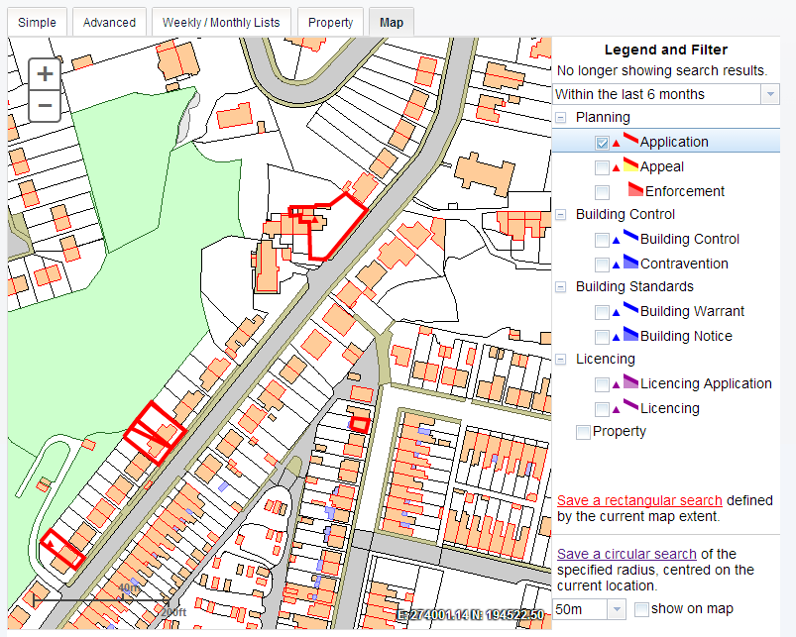

1. On the **Saved Search Options** page you may change the default search title if you wish.

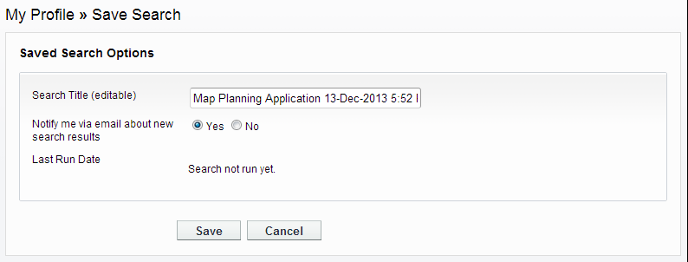

1. If you want to be notified by email of any new records matching your search criteria, select Yes. These notifications are displayed in your Notified Applications tab (see “Notified appli- cations” on page 12).
2. Click Save to save the search to your list of Saved Searches (see “Saved searches” on page 10).

#### Circular search

The circular map search allows you to display occurrences of a record type over the geographi- cal area currently displayed within a specified proximity of the centre of the map. By re-running the search, you can monitor new occurrences. For example, if you have zoomed the map to dis- play your home and filtered the legend to display planning applications submitted in the last year you can save a proximity search that allows you to monitor new planning applications arising within a specified distance of your home on a yearly basis.

1. Zoom and pan the map, placing the geographical point of interest at the centre.
2. Select the required time period.
3. Filter the legend to display one record type.
4. Select the radial distance from the centre in which to search for records.

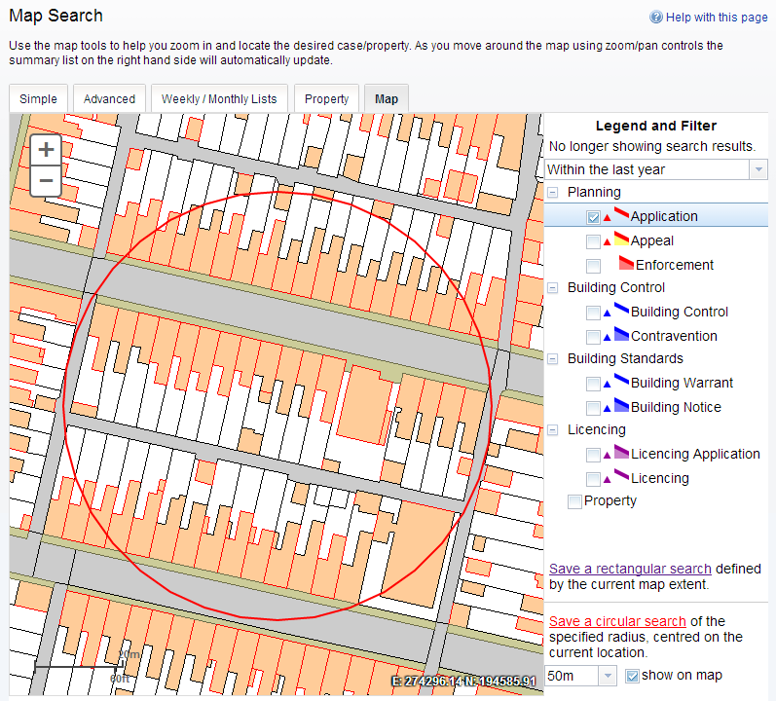

Check the **Show on map box** to display the proximity as a circle around the centre. You can pan the map to make adjustments if required.

1. Click on **Save a circular search**.
2. In the Saved Search Options box you may change the default search title if you wish.

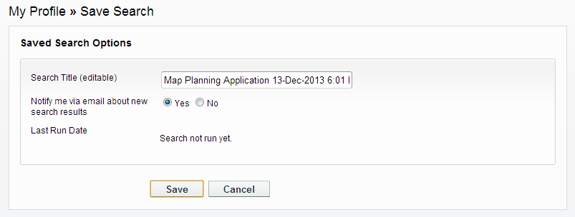

1. If you want to be notified by email of any new records matching your search criteria, select Yes. These notifications are displayed in your Notified Applications tab (see “Notified appli- cations” on page 12).
2. Click Save to save the search to your list of Saved Searches (see “Saved searches” on page 10).

**Search Results**

# Search Results

Once you have run a search, a list of records matching the search criteria is displayed.

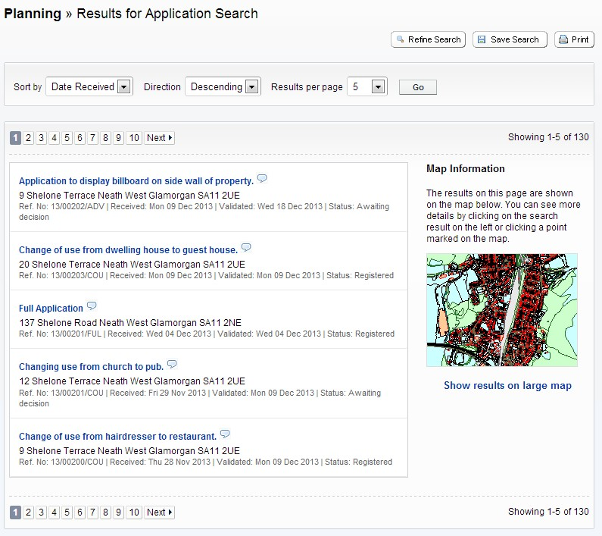

Note A speech bubble icon attached to a record indicates that comments may be made about that record at this time

* 1. You can manipulate how the search results are displayed to help you find applications of particular interest:
     + **Sort By** - re-order the results according to a selected criterion
     + **Direction** - choose whether the results are displayed in ascending or descending order
     + **Results per page** - choose how many results should be displayed on the page at once. When you have made your display selections, click on the Go button.
  2. The number of results displayed (out of the total number of results) is shown. If there are more results than fit on to one page you can navigate between the results pages either by clicking on Next to view the next page or Previous to view the previous one, or by clicking directly on the page number
  3. A map of the relevant area is displayed. Click on **Show results on Large map** to see the loca- tions of the search results in greater detail (see “Map Search” on page 26).
  4. If there are too many results, or if the results do not contain the applications you are looking for, you can go back and amend your search criteria. Press the **Refine Search** button.
  5. To display the current page of search results in a printable format, click on the **Print** button. Click on Print again in the new window to send the page to your local printer. Press Close when you are finished with this window.
  6. To view an individual record in detail, click on its title.

**Search Results**

Saving A Search

## Saving A Search

You may find that you use a particular search regularly. For example, a simple search based on your post code or an advanced search charting the progress of a specific planning application. As a registered users you can save these searches to be run again from your Saved Searches page (see “Saved searches” on page 10). Additionally, when new records corresponding to a saved search arrive, news of these will automatically appear on your Notified Applications page (see “Notified applications” on page 12).

1. To save a search, click on the **Save Search** button.
2. Change the default search title if you wish.
3. If you want to be notified by email of any new records matching your search criteria, select

**Yes**.

1. Click on **Save** to save the search.

## Record Details

When you select to view a record, the application details are displayed at the top of the page, with further tabs below containing all of the relevant information about the application. (See the relevant Idox Public Access User Guide for details).

1 Click on the relevant tab to view the information of interest.

## Tracking Applications

Any application can be tracked so that you can keep up to date with its progress without having to search for it again. These cases are listed in your **Tracked Applications** page (see “Tracked applications” on page 11).

1. If you want to add a case to your Tracked Applications page click on the **Track** button.

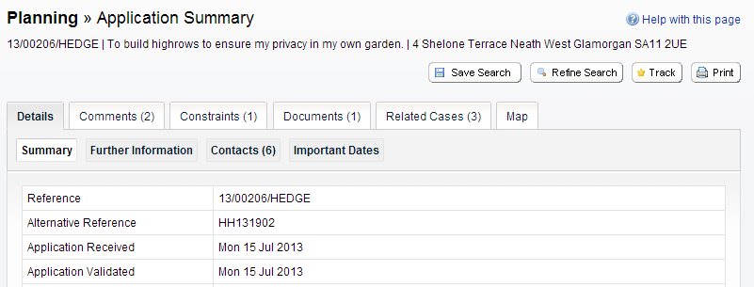

1. To find this case again, select Tracked Applications under My Profile.
2. To stop tracking an application, return to the application details and click the **Stop Tracking** button at the top of the page. Alternatively click the Stop Tracking button next to the applica- tion in the Tracked Applications page.