**TO LET**

**Warehouse / Office Premises**

**Willow Park, Terminus Road, Chichester, PO19 8TX**

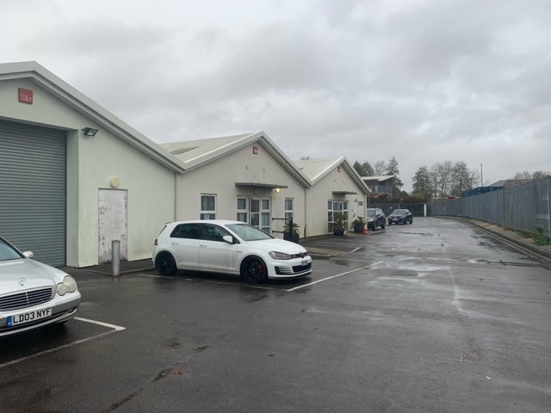 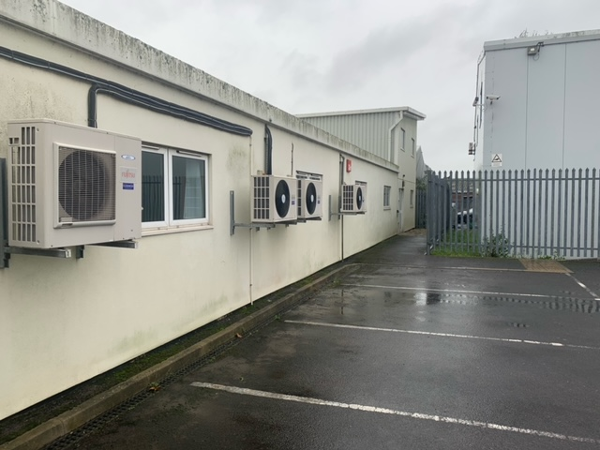

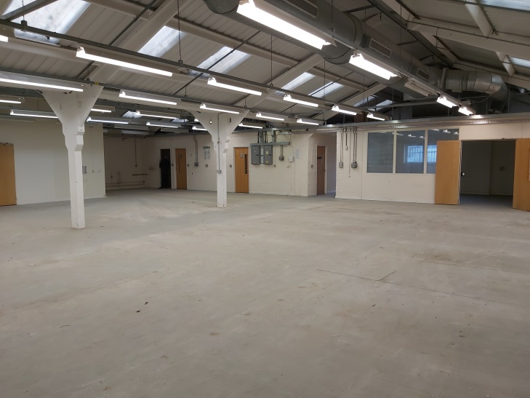 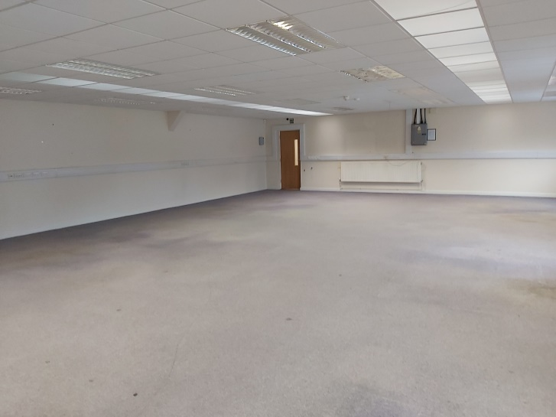

| **Part of building** | **sq m** | **sq ft** |
| --- | --- | --- |
| Bays 1 & 2 (Warehouse / workshop / store) | 448.7 | 4,830 |
| Bay 3 (Office) | 224.4 | 2,415 |
| Bay 4 (Office) | 224.4 | 2,415 |
| Ground Floor Rear (Office) | 143.4 | 1,543 |
| First Floor Rear (Office) | 143.4 | 1,543 |
| Total | 1,184.3 | 12,746 |

**DESCRIPTION & LOCATION**

Willow Park, Plot 4B Terminus Road, Chichester comprises a 2 storey office building with lift and 4 bay office / workshop / warehouse space with an eaves height of around 3 metres. Some of this workshop space has been fitted out for office use with partitioned areas, suspended ceilings and air conditioning, with the remainder being left as open warehouse. The property benefits from gas central heating and there is parking to the side and rear within a secure yard.

There may be potential to split the space into two or more units.

Terminus Road is a thriving industrial estate within walking distance of Chichester city centre. It is home to many well-known businesses and has easy access to the A27, rail network and Chichester bus station.

**USE**

Willow Park offers very flexible accommodation with a large warehouse, open plan and smaller office accommodation, together with meeting / board room space and kitchen / WC facilities. There is also ample off road parking and a bicycle shelter within a secure yard.

**TERMS**

The property is available to let by way of a new full repairing and insuring lease at £125,000 pa exclusive plus VAT. The lease will be contracted out of the provisions of the Landlord and Tenant Act 1954 Sections 24-28.

**EPC**

The premises have an EPC rating of C

**RATES**

Rateable Value: £77,500 (2017)

Rates Payable 2021/22: £39,680

**REPAIRS & MAINTENANCE**

The tenant is to be responsible for all repairs other than those that may be subject to a recharge of the Council’s costs for undertaking work on a common basis.

**OUTGOINGS**

The lessee will be responsible for rates, utilities and reimbursement of the insurance costs. Insurance of contents and any other outgoings that may be applicable will be the responsibility of the tenant.

**RENT DEPOSIT / GUARANTEE**

The Council will require a rent deposit as guarantee for the rent and tenant obligations.

**VIEWING**

Prospective tenants wishing to be considered for a tenancy of this property should contact the Estates Service at:

Chichester District Council

East Pallant House

1 East Pallant

Chichester

West Sussex, PO19 1TY

t: 01243 534632

e:property@chichester.gov.uk

Viewing is by appointment only

**COSTS**

Each party will bear their own costs in preparing the lease.

|  |  |
| --- | --- |
| **BLOCK PLAN**  **Site Plan** | **FLOOR PLANS**  **Ground floor**  Ground Floor Plan  **First floor**  First Floor Plan |

Chichester District Council declares that (1) these particulars are set out as a general outline only and do not constitute part of any offer or contract (2) all descriptions, dimensions, reference to condition and other details are given without responsibility on the part of the Council and prospective purchasers/lessees must satisfy themselves as to their correctness and in particular no services or appliances mentioned have been tested (3) the Council nor any person in their employment has any authority to make or give any representation or warranty in respect of the property'