www.chichester.gov.uk/parking

Parking Services Annual Report 2020/2021

Foreword
1. Introduction 4
1.1. Overview 5
1.2. Parking Services responsibilities 6
1.3. Why have parking controls? 7
2. Penalty Charge Notice (PCN) statistics and information 8
2.1. Warning notices 9
2.2. Higher and lower PCN split 9
2.3. Regulation 10 PCNs 10
2.4. Top 3 contraventions on-street and off-street 11
2.5. Top 3 locations to receive a PCN 13
2.6. PCN Payments and correspondence 14
2.7. Debt collection and vulnerability 16
3. Cancellations 18
3.1. Top 3 reasons for cancellation 18
4. Online appeals and FOAM 20
4.1. Learning from appeals 21
5. Ongoing projects 22
5.1. Blue Badge enforcement 22
5.2. Electric vehicles 23
5.3. Managing coastal traffic 23
6. Our online presence 25
6.1 Improvements to online services 25
6.2 Social media 26
6.3 Website page views 27
6.4 Payments through our website 28
7. Off-Street car parks overview 29
7.1. Suspending parking charges in car parks 29
7.2. Supporting hospital staff 30
7.3. New signage advertising MiPermit 30
7.4. Subsidised and ‘free’ parking 30
7.5. Providing flexibility when parking 31
7.6. Car parks throughout the year 31
7.7. Keeping it clean and safe 31
8. Digital season tickets 32
9. MiPermit 33
10. On-Street parking overview 35
10.1 WSCC charge reviews 35
10.2 City Centre on-street pay and display 35
10.3 Lines and signs 35
10.4 Suspending parking to support returning to the high street 35
10.5 Protecting parking schemes 35
11. School enforcement 37
12. On-Street Permits 38
12.1 Non Resident Permits 39
12.2 Resident Visitor Permits (RVPs) 39
13. Dispensations and suspensions 40
14. West Sussex County Council CPZ Extension 41
15. Partnership working 42
16. Freedom of Information requests and subject access requests 44
17. Equality of access to our services 45
18. Complaints and compliments 48
19. Financial information 50
19.1 Income 50
19.2 Expenditure 51
20. Looking back and looking forward 53
20.1 Accreditation of Safer Parking Award 53
20.2 NHS digital season tickets 53
20.3 West Sussex County Council, CPZ extension 53
20.4 Electric Vehicles and Electric Vehicle Charging Points 53
20.5 Parking strategy 54
20.6 Parking incentives 54
21. Parking strategy 55
22. Key areas of work for 2021/22 56
23. Appendices 57
Appendix A – Contravention code list 57
Contravention Code List – On-Street 57
Contravention Code List – Off-Street 58
Appendix B - Pricing details for Pay & Display Car Parks across the District 59
Appendix C - On-street Pay and Display machines map 65
On-street Pay and Display machines and locations 66
Appendix D - Controlled Parking Zones map 67
Appendix E - Location of Chichester City Centre Car Parks map 68

Foreword

Welcome to Chichester District Council’s Annual Parking Services Report for 2020-21.

Our report covers the varied work undertaken by the team, from enforcement of parking restrictions and how Penalty Charge Notices are processed to our commitment to developing convenient and reliable services for the public. Although this year has been dominated by the significant impact of Covid 19, the report also highlights key achievements, demonstrating the importance of the work carried out by the Parking Services team during this challenging time.
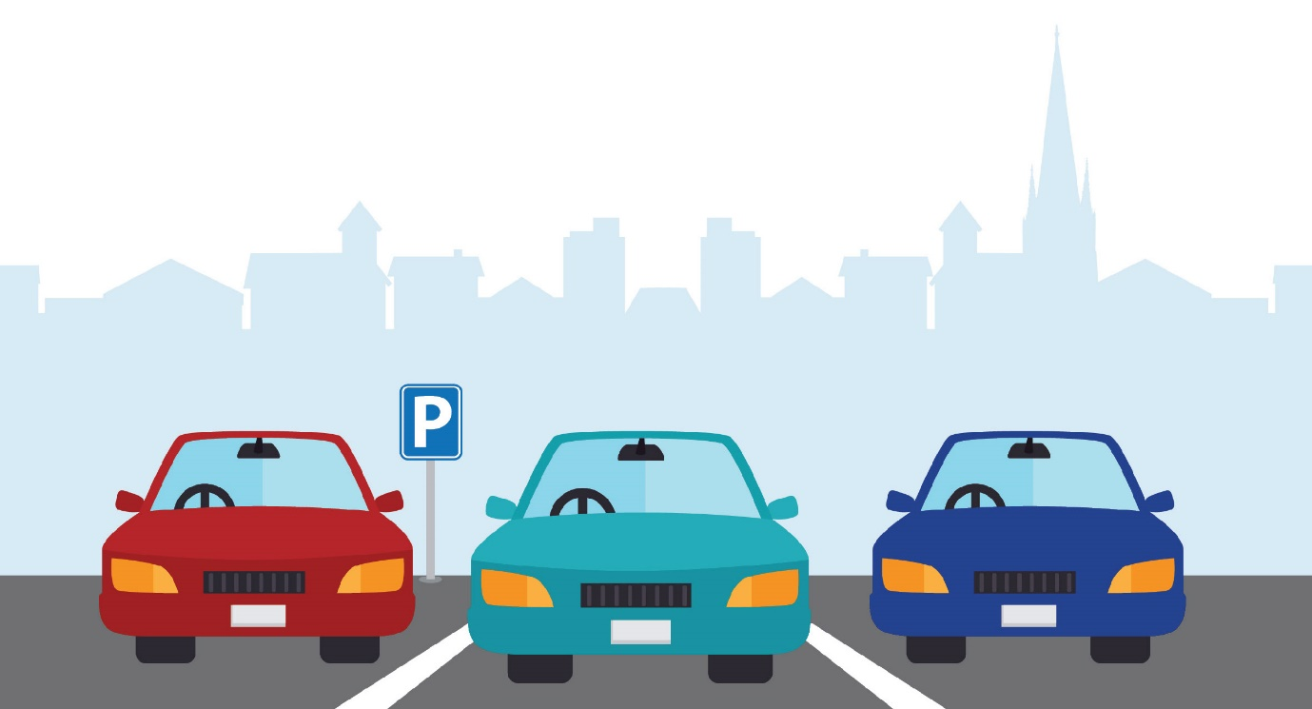

Numerous improvements have been made to our online services during the year propelled by the need to maintain access to services but also to ensure more efficient ways of working. These improvements will assist customers for years to come and have helped us achieve key objectives around Channel Shift. Channel Shift is a project where we look to encourage customers to self-serve at a time that is convenient for them by refining online information and introducing new tools.

Some projects which were planned for this year such as the redesign of Northgate car park in Chichester have needed to take a back seat. However, the year ahead will see the gradual return to planned projects when restrictions lift and it is safe to do so. Other projects such as supporting West Sussex County Council to implement new Controlled Parking Zones in Chichester City Centre have continued. This project has seen the development of a new digital platform for on street permits which will go live in the first quarter of next year.

We were delighted that for another year 28 of our 31 car parks maintained their accreditations for both the Safer Parking Award and Disabled Parking Accreditation. We made the important decision to keep all car parks open during the pandemic to continue to support those who were still using the road networks and were able to consider the most appropriate charging structure which was in place to reflect this time. We have also worked with partners to encourage safe and considerate parking in the District, especially in coastal locations where many visitors come to enjoy the beaches. Our team of Civil Enforcement Officers has been fundamental in the response to the heightened demand for coastal parking during the summer.

It is no surprise that where several national lockdowns were implemented by the government and the public were told to stay at home, that income usually generated from parking charges has been significantly affected. We continue to evaluate what customers need and with the continuation of the development of the refreshed Parking Strategy this coming year, new concepts outlining what parking is needed going forward will be explored.

Thank you for taking the time to read our Annual Report.
Tony Dignum, Cabinet Member, Growth and Place

Introduction

Our annual report aims to provide a useful overview of the work carried out by the Parking Services team during 2020-2021 and also acts as a helpful tool to those who are curious about why we operate and how we deliver the service.

The total population of the Chichester District is 113,800 and we attract 6.2 million tourists a year. Residents and visitors alike enjoy the beauty and diversity of the rolling Sussex downs, our spectacular coastline and the historic prominence of the bustling city centre. As well as visiting for pleasure, Chichester District also attracts more people into the area to work than there are residents who commute out and it is therefore continuously important for us to make sure that there are sufficient accessible and safe parking spaces to accommodate our visitors when they
reach us.

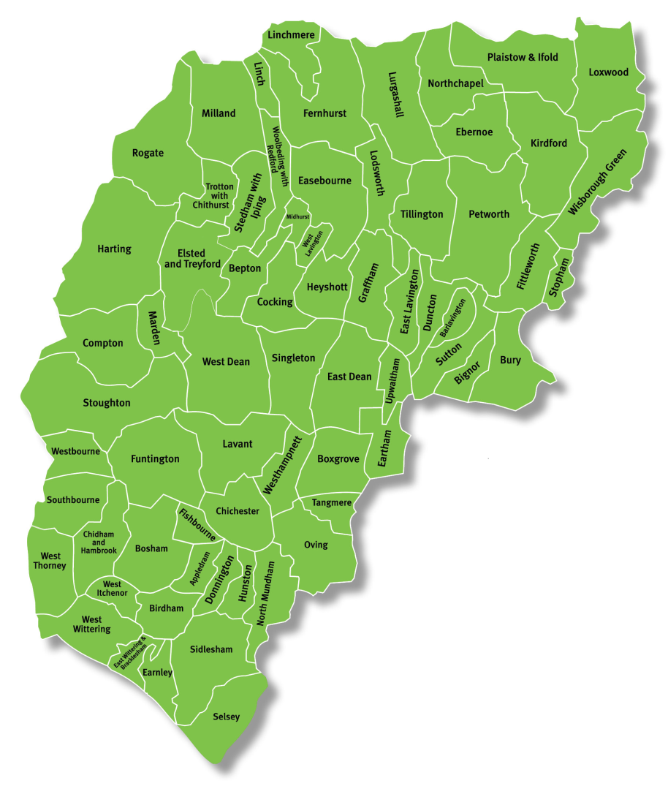

Overview

Chichester District Council (CDC) has operated under Civil Parking Enforcement (CPE) since April 2010 and work as agents for West Sussex County Council (WSCC) to cover on street enforcement across the district on their behalf. This complements the off street (car parks) services which is managed by CDC.

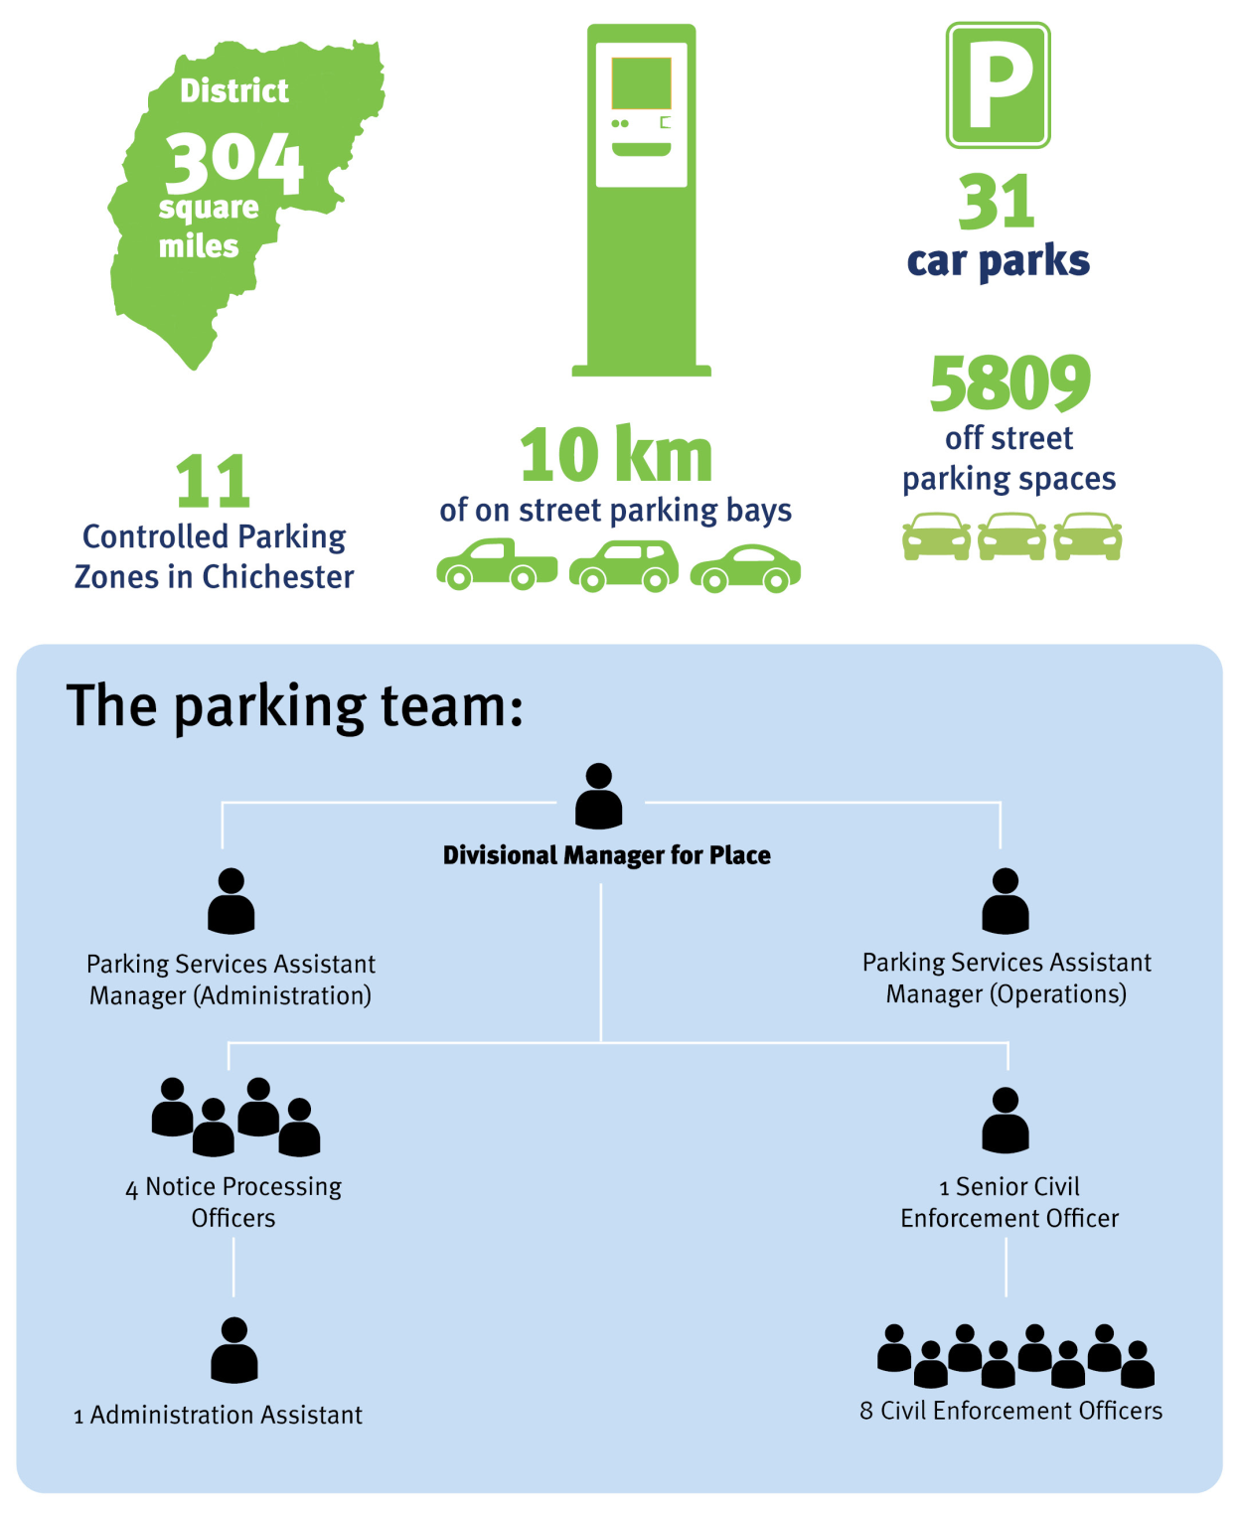

Parking Services responsibilities

Where we are a two tiered authority, some functions are carried out by the Parking Services Team and others by colleagues at West Sussex County Council

Chichester District Council |  | West Sussex County Council
 | Employs Civil Enforcement Officers to patrol and enforce on street and off street. |  | Implement and review on street parking restrictions and resident parking schemes.
 | Employ an Administration team including Notice Processing Officers. |  | Maintain lines and signs on street (outside of the Controlled Parking Zones (CPZ)).
 | Administer on street permit schemes and administer season tickets for car parks |  | Process and issue skip licenses
 | Administer bay suspensions and dispensations. |  | Coordinate street works
 | Process and respond to appeals against Penalty Charge Notices (PCNs) on and off street |  | Attending to pot holes
 | Report defects on and off street. |  | Process requests for new Traffic Regulation Orders
 | Attend to and maintain payment machines  on and off street. |  | Issuing (Temporary Traffic Regulation Orders) (TTROs).
 | Reacting to parking problems on and off street |  | Set on-street parking guidance for Chichester District Council and other local authorities in West Sussex.
 | Carry out Blue Badge Enforcement. |  | Determine parking charges on the highway.
 | Set off-street parking guidance for District council owned car parks. Determine parking charges in council-owned car parks.

Why have parking controls?

It is widely recognised that places need to adapt to keep up with the changing needs of the people who live, work or visit an area. Well planned restrictions, reasonable well designed charging tariffs and parking schemes help us to achieve this and respond to the changing demands of our city. Parking controls therefore aim to:
- Assist with the free-flow of traffic and reduce issues of access for emergency vehicles
- Support different groups of motorist
- Provide fair access to parking spaces
- Support the local economy
- Help reduce congestion on street and minimise the environmental impact of vehicles in town centres
- Support the environmental agenda

Whilst there is no doubt that parking restrictions are needed to manage the growing number of vehicles on our roads, the Parking Services department undertakes more than just issuing PCNs. The work carried out by the team assists to balance the needs of a multitude of customers, including businesses, allowing Blue Badge holders to park close to amenities, delivery vehicles near to shops and residents close to their homes, all of which promote the sustainable economic growth of the district.

Penalty Charge Notice (PCN) statistics
and information

Table 1 - Total PCNs issued

Financial year | On street | Off street | All PCNs
2018-19 | 5,240 | 4,607 | 9,847
2019-20 | 5,572 | 4,494 | 10,066
2020-21 | 3,829 | 2,451 | 6,280

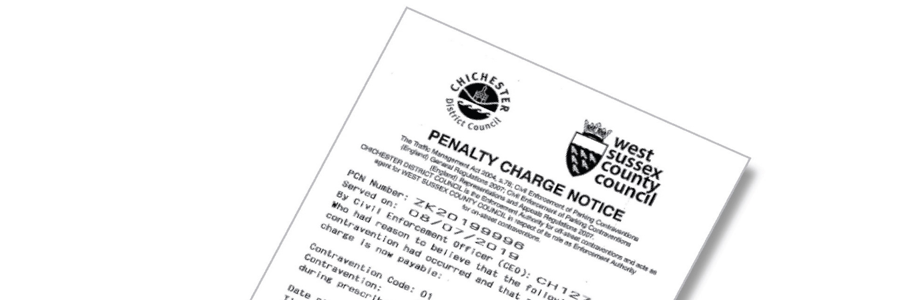

During 2020 the number of Penalty Charge Notices issued to vehicles reduced by 37%. In response to the Covid-19 emergency and in line with the recommendations from the British parking Association, Civil Enforcement Officers (CEOs) focused enforcement for a number of months where there were safety restrictions or where a vehicle was preventing access to a parking space. The emphasis on enforcement was to ensure that roads were kept clear from congestion and that those still using the road network were able to do so unimpeded. Alongside this, the authority took the decision to suspend parking charges in council owned car parks for a period of time to assist with the delivery of essential services across the district.

Warning notices



Where restrictions are newly implemented or where the parking conditions are insufficiently clear to a motorist a warning notice will be issued instead of a PCN. During 2020-21, a total of 41 on street and 6 off street warning notices were issued to vehicles. Warning notices help motorists to avoid future PCNs by drawing attention to the restrictions in place.

Higher and lower PCN split

Due to the emphasis relating to on street enforcement over the past year and the significant reduction in the use of car parks, we saw a higher proportion of higher category contraventions recorded in 2020/21. High category PCNs are issued at a higher charge and reflect the seriousness of the contravention. These may include parking on double yellow lines or loading bans.

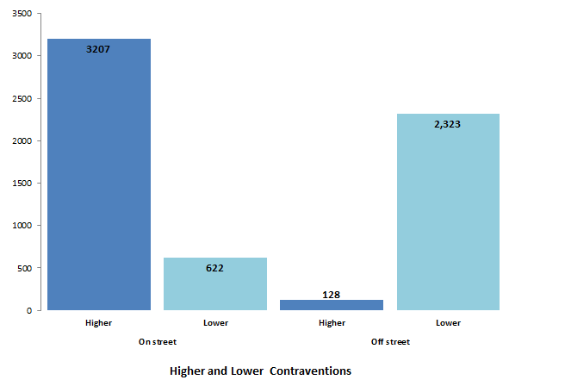

Regulation 10 PCNs

Civil Enforcement Officer are able to issue Regulation 10 PCNs to reduce the number of incidents where a Penalty Charge Notice has been prevented from being served.
A Regulation 10 PCN refers to the manner in which a Notice is issued. Whilst the majority of PCNs are issued under Regulation 9 of The Civil Enforcement of Parking Contraventions (England) General Regulations 2007 which provides that a PCN can be either affixed to a vehicle or handed to the driver, Regulation 10 enables a local authority to serve the PCN by post if the CEO has been prevented from issuing the PCN, or where the vehicle was driven away before the PCN could be served.

It is essential that motorists feel that the system is fair and consistent. Issuing Regulation 10 PCNs helps to demonstrate that anyone committing a parking contravention is subject to the same enforcement. Motorists who prevent a PCN being served by either driving away or adopting threatening or abusive behaviour towards CEOs, have historically avoided any penalty and therefore poor parking habits have been perpetuated. This has had a detrimental effect on road safety and compliance. Regulation 10 PCNs assist with preventing the public perception of ‘selective’ enforcement where the CEO was prevented from issuing a PCN and minimise the loss of Civil Enforcement Officer (CEO) time.

The level of Regulation 10 PCNs has remained low during 2020-21. All CEOs are trained to clearly inform a motorist of the process in place for serving PCNs by post and a driver may reconsider their intention to avoid being served a PCN when this information is provided. However, over the course of the year 3 Regulation 10 PCNs have been issued and of these 2 have been paid.

Top 3 contraventions on-street and off-street

Table 2 - Highest contraventions on-street

Financial Year | Code 01  Waiting restriction | Code 16  No permit | Code 30  Overstay Limited Waiting
2018-19 | 1,525 | 1,001 | 593
2019-20 | 1,445 | 1,256 | 571
2020-21 | 1,396 | 754 | 415

The table above shows the split of Penalty Charge Notices which were issued on street.

Code 01 – Waiting Restriction continues to be the highest proportion of Penalty Charge Notices which are issued. These are Penalty Charge Notices where yellow line restrictions or ‘waiting restrictions’ are sited in locations where it is unsuitable for vehicles to wait or park.

Enforcing on vehicles parking on waiting restrictions helps to reduce congestion and helps to keep our roads safe. Although yellow lines restrict vehicles waiting, there are various exemptions which apply to ensure that particular activities can be carried out. One example of an exemption enables a motorist to load and unload from a vehicle. Another may be if a vehicle is displaying a valid Blue Badge where the conditions of the Blue Badge Scheme allow parking for up to three hours.

Within Chichester there are 11 Controlled Parking Zones (CPZs) which occupy the city centre and each zone provides designated Permit Holder bays for residents and their visitors. Other Permit Holders including Healthcare workers and Carers can also use these bays whilst working to provide services to residents within parking schemes. Contravention Code 16, ‘Parked in a permit space or zone without clearly displaying a valid permit’ is one of the most common reasons a PCN is issued on-street. Motorists contravening this code could have forgotten to display a permit or may not be entitled to park in the bay at all.

The third highest proportion of Penalty Charge Notices issued was for Code 30 – Overstay Limited waiting bays. These bays provide short stay parking places and promote a higher turnover of parking spaces. These restrictions can prevent vehicles parking for long periods of time which in turn encourages more visitors to the area.

Table 3 - Highest contraventions off-street

Financial Year | Code 83  No valid ticket | 82  Expired ticket | 85  Parked without permits | 86  Parked beyond bay markings
2018-19 | 2,995 | 1,005 | 274 | N/A
2019-20 | 2,992 | 743 | 297 | N/A
2020-21 | 1,945 | 355 | 56 | 86

The table above shows the split of Penalty Charge Notices issued off-street. Contravention Code 83 ‘Parked in a car park without clearly displaying a valid pay & display ticket or voucher or parking clock’ remained the most common reason for a PCN being issued.

Where customers do not purchase sufficient time to cover their stay or where they are late returning to their vehicle a PCN will be issued because the pay and display ticket has expired. Since phone payments were introduced in 2017, we have seen a reduction every year in PCNs issued under code 82. This may be due to customers using the MiPermit cashless parking service, which provides the ability to extend a parking stay remotely and opt for a reminder text when parking is due to expire.

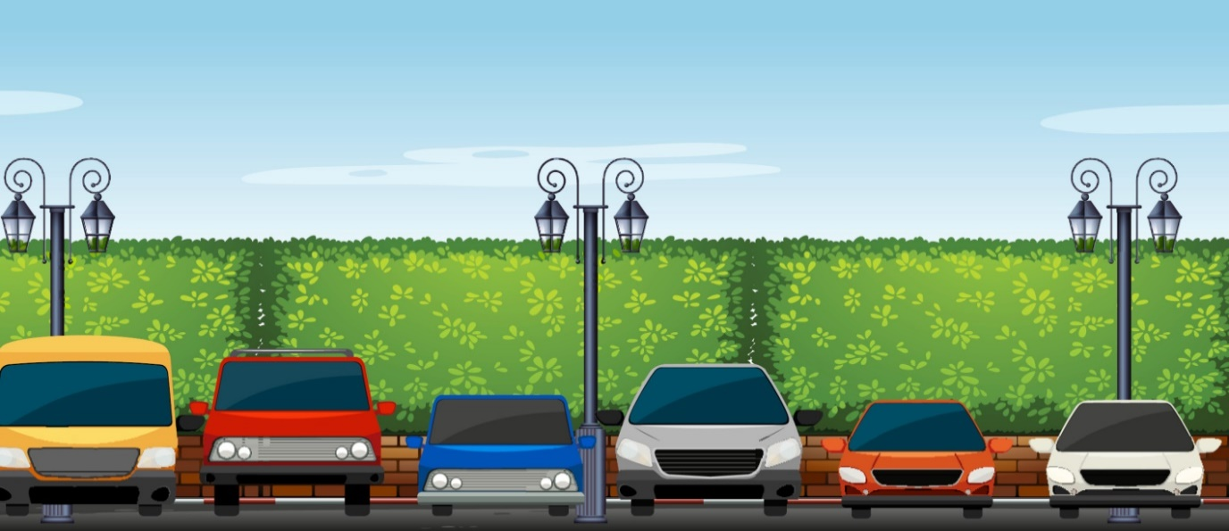

Top 3 locations to receive a PCN

The Parking Services Team are able to monitor the district for the areas which are most likely to attract a Penalty Charge Notice being issued. The figures for 2020-21 have been impacted by the Covid-19 pandemic, where both driver and enforcement activity has been significantly affected. In general, where there are locations with significant numbers of parking spaces there will be a higher level of Penalty Charge Notices having been issued. This applies to the larger car parks and the busiest locations in the city and town centres. The team uses heat mapping to understand patterns, showing the level of PCNs issues, how often vehicles are observed by the CEOs and to ensure that CEO enforcement activity coverage is spread across the whole area.

The heat mapping reporting tool can therefore provide useful information in the detection and prevention of perceived parking problems, by producing data which helps to better direct resources. Revisiting and monitoring the maps following changes to enforcement, creates a visual representation about whether compliance improved, how effective the action has been and whether displacement is observed. Where high numbers of PCNs are issued, information provided by the heat mapping tool supports measures to maximise compliance with the restrictions. These measures can include, improving signage and lines, increased enforcement, providing different payment options and making it easier for customers to park correctly. Where requests for enforcement are received or where Parking Services is asked to demonstrate how often CEOs patrols in a particular location, we are able to supply useful and clear information to support enforcement activities.

During the summer of 2020, the coastal area of the district saw a significant increase in the usual visitor number of and subsequent issue of Penalty Charge Notices. This was due largely to the very favourable weather and the lockdown restrictions as a result of the Covid-19 pandemic which meant that the public were not permitted to travel abroad and consequently sought to undertake higher levels of day trips etc. to the beaches in the UK. The Parking Team worked closely with Sussex Police and other agencies to deal with the increased demand and to assist with keeping the highway clear.

PCN Payments and correspondence

There are defined stages to the Parking Penalty Enforcement Process and the charge will increase at each stage. There are also defined stages to the appeals process and three opportunities to challenge the PCN.

During 2020-21, there were a total of 3438, challenges, representations and other
correspondence received and processed by the Notice Processing team.

To make challenging as accessible as possible, customers can contact us via our online
portal, email us or write to us. Customers can also review photographic evidence and
submit documents with their challenge, online.

- parkingservices@chichester.gov.uk
- https://www.chichester.gov.uk/parkingtickets

- Parking Services
1 East Pallant
East Pallant House
Chichester
West Sussex
PO19 1TY

Payments | Correspondence
PCNs issued (informal stage)

69% of all customers paid at the discounted amount of £25 or £35.  80% of customers pay during the informal stage prior to the Notice to Owner being served. | 49% of all correspondence was received during the informal stage.  818 (48%) challenges related to off street PCNs and 880 (52%) to on street PCNs. A challenge can be  made online, verbally, by email or by letter.
Notice to Owners served (formal)

10% of customers pay £50 or £70 during the formal stage, following service of a Notice to Owner to the registered keeper. | 11% of all correspondence was received at the formal representations stage where the owner or an authorized person can submit representations against the Notice to Owner.  152 (41%) representations related to off-street PCNs and 219 (59%) to on-street PCNs.
Charge Certificates served (formal)

11.5% of customers pay £75 or £105 following service of the Charge Certificate. | 4% of all correspondence was received following service of the Charge Certificate. While there is no formal right to appeal at this stage, Parking Services will check to ensure that that a case has been carried out correctly.

Correspondence Received Post-Charge Certificate | Evidence and Supporting Information
6% of all correspondence was received following service of the Order for Recovery. Correspondence may include completed Witness Statements and applications for out of time witness. statements, where the council is issued with instructions by the Traffic Enforcement Centre. | 30% of all correspondence received was supporting information, invariably where evidence has been requested in order to further consider a PCN.

Early settlement of PCNs incurs the customer less costs, therefore it is imperative that all challenges are considered fully and that a thorough response is sent to ensure that customers can make well informed decisions as to whether they will pay, or continue to appeal a PCN. As there are costs associated with the appeals process, it is also important to minimise the number of times a customer needs to contact Parking Services so that the team is able to direct resources efficiently.

Debt collection and vulnerability

Parking Services undertakes debt collection through Enforcement Agents (EAs) when all other methods have been unsuccessful. Processes are in place to communicate what a customer can expect if a PCN remains unpaid.

By way of The Taking Control of Goods Regulations 2014 (TCOG), the team will instruct EAs to recover unpaid debts. Whilst most PCNs have been either paid or a Challenge/Representation accepted by this stage, the team during 2020-21 sent 995 PCNs to Enforcement Agents as warrants.

EA fees are set out in The Taking Control of Goods (Fees) Regulations and 2014 (TCOG).

- Compliance stage - £75.00 applies in addition to the debt and EA will seek to contact the debtor

- Enforcement stage - £235.00 applied to debt and compliance fee where an EA will seek to visit the debtor.

- Sale or disposal stage - £110.00 applied in addition to the aforementioned fees, should the EA take control of goods.

During 2020-21:

995 warrants were issued.
85 cases were referred to their specialized welfare teams.
485 Payment Plans were arrangements 298 of which were paid within 3 months.
46% of cases were paid in full at compliance stage
54% of cases were paid in full at enforcement stage

The work undertaken by Enforcement Agents has been affected by Covid-19 and in April 2020, temporary regulations were introduced which prevented Enforcement Agents carrying out visits to customer properties. While regulations were lifted in August and EAs introduced robust safety protocol, they remained unable to enter properties until such time as the regulations permit.

CDC made the decision to temporarily suspend enforcement action for a period of time during the Covid pandemic in line with best practice and national guidelines. Decisions made regarding debt collection have been led by WSCC and were considered proportionate in the Council’s response to the health emergency. Although various measures were introduced to support those finding themselves in financial hardship, it was also recognised that for others, the period of lockdown presented the opportunity to pay off debts.

Vulnerability

The Taking Control of Goods Regulations place an emphasis on identifying and considering vulnerability and during 2020-2021, 85 warrants were reviewed and investigated by dedicated welfare teams. Parking Services react to all claims of vulnerability and consider cases carefully should vulnerability be suspected or communicated to us. Based on the information available, Notice Processing Officers will consider the most appropriate course of action to take and whilst a PCN will not necessarily be written off, customers can be guided to support services and independent advice, or can be offered payment plans to help spread payments over longer periods of time.

The Parking Services team also works closely with the council’s Communities Team to consider any issues of vulnerability when these are presented to us by customers. This helps to ensure that the team is providing the correct advice and is signposting to partner organisations where necessary.

Cancellations

Top 3 reasons for cancellation
Table 4 – Percentages of PCNs cancelled (2018-21)

Month | 2018-19 | 2019-20 | 2020-21
April | 8% | 8% | 13%
May | 7% | 7% | 4%
June | 8% | 7% | 10%
July | 7% | 9% | 8%
August | 7% | 9% | 8%
September | 10% | 10% | 10%
October | 9% | 10% | 12%
November | 7% | 8% | 10%
December | 6% | 10% | 14%
January | 10% | 8% | 9%
February | 8% | 12% | 9%
March | 8% | 14% | 6%
Total | 8% | 8% | 10%
Spoiled deduction | 7% | 7% | 8%

Cancellations occur when a PCN is found to be incorrectly issued, incorrectly processed, where the contravention did not take place or where it is proven that mitigating circumstances took place. When a PCN is cancelled, Parking Services will record this and where there are contact details, write to the customer to explain that no payment or further action is required.
Notice Processing is a defined process which is set down in parking legislation. In some circumstances, failure to adhere to the requirements may result in the cancellation of the Notice, for example, where a processing error leads to a Charge Certificate being served before a representation is responded to. One of the more challenging areas of a Notice Processor’s role is being able to determine whether mitigating circumstances led to the customer receiving a PCN by asking pertinent questions and obtaining adequate evidence to support a decision. Whilst it may be the case that a customer deems a PCN to be unjust due to a perceived minor infringement, or that the actions which led to the PCN being issued were not deliberate, if a contravention has occurred and there were no mitigating factors which led to the PCN being issued, it may not be cancelled.

Amount cancelled
Reason | 2018-19 | 2019-20 | 2020-21
P&D Not Displayed | 175 | 171 | 89
Valid Season Ticket | 94 | - | -
Defect in Notice | 96 | - | -
Virtual Payment Verified | - | 113 | 95
CEO Error | - | 86 | -
Mitigation | - | - | 41
Table 5 – Top 3 reasons for cancellations

CEOs are careful to ensure that all PCNs are issued correctly and accurately, however some errors can occur. Processes are in place to address concerns and raise training issues to prevent errors occurring. As specific details are required to be recorded correctly in line with regulations, should these details be incorrect, the PCN will be cancelled. For example, the wrong contravention code. As expected, where use of the MiPermit digital parking system is growing, the number of PCNs being cancelled for reasons relating to use of this service has increased. The team considers mitigation when reviewing challenges where circumstances leading to a contravention may have been out of the motorists’ control. A reduction in the number of PCNs cancelled due to a defect being found in the notice during 2019-20 and 2020-21 has been a positive reflection of the new Hand Held Devices which have been issued to CEOs. The new devices are better able to handle large amounts of digital data which is now required for short term and season ticket customers and will work more effectively in areas where phone reception can be more patchy.

Online appeals and FOAM

If a customer is unhappy with the decision made by the Council, once a rejection to a representation has been made they have the right to appeal to the Traffic Penalty Tribunal (TPT). TPT is made up of independent Adjudicators and their role is to hear and decide appeals brought against Penalty Charge Notices.

During 2020-21, 24 customers submitted appeals via the Fast Online Appeals Management (FOAM) system provided by the Traffic Penalty Tribunal. FOAM has provided improved access to the tribunal service for both the appellant and the Council alike and this helps to reduce staff time and cost associated with compiling cases. Only 17% of all customers using the appeal service requested their cases to be printed and posted to them.
- 87.5% of appeals were decided without the customer requesting a hearing.
- 12.5% of customers requested a telephone.
- 8.3% of appeals were multiple PCN appeal which is where the appellant has more than one PCN and appeals them all in one hearing.

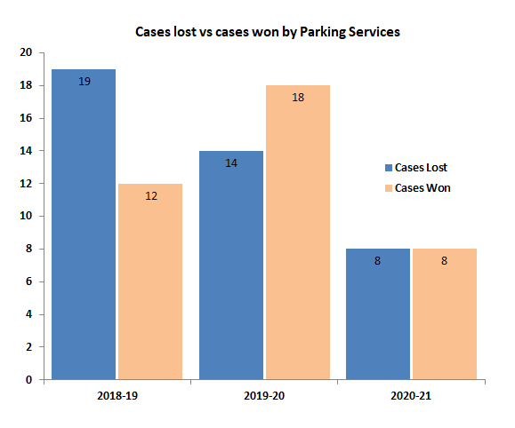

Learning from appeals

Notice Processing Officers use the Adjudicator decisions and have determined to non-contest more cases than in previous years. The Parking Services team reviews each appeal decision to ensure that future cases can be considered in light of observations made by adjudicators of the Traffic Penalty Tribunal. Adjudicator decisions are shared between other local authorities in West Sussex and discussed at county-wide meetings to ensure that all staff processing appeals are aware of useful information to improve their own appeal outcomes, and to promote consistency.

Table 6 – Rate of Appeals

Financial year | Appeals | Rate of appeal per PCN | Not contested by CDC | Cases Lost by CDC | Cases Won by CDC
2018-19 | 32 | 0.32% | 1 | 19 | 15
2019-20 | 34 | 0.33% | 2 | 14 | 12
2020-21 | 24 | 0.38% | 8 (33%) | 8 (33%) | - (33%)

Ongoing projects

Blue Badge enforcement

Blue Badges are vital to those who need them and the Parking Services team works hard to protect the integrity of the scheme and to enable use of accessible spaces. Whilst the Civil Enforcement Officers undertake enforcement relating to the correct use of Blue Badges on a day to day basis as part of their regular enforcement activity, the team also works closely with WSCC, along with dedicated Enforcement Officers from Brighton and Hove City Council to undertake dedicated enforcement days to enforce and retain misused Blue Badges. Alongside this, regular communication is shared via both councils social media channels to provide information relating to how Blue Badge misuse can be reported and to increase awareness of the scheme.

This year, fewer badges were retained due to the temporary suspension on Blue Badge enforcement activity during the public health emergency. However, the following activity still took place:

- Six Disabled Blue Badges have been retained (Badges are returned to the badge holders after we have dealt with the misuse. Everything is logged and put on their file)
- Community Resolution with Sussex Police have been arranged
- Two badges have been destroyed due to displaying a deceased person’s or an expired badge.

Electric vehicles


Parking Services increased the number of electric vehicle parking bays in 2019 and now have a combination of fast (3 hour) and rapid (1 hour) bays located in the following car parks across the district:

- Bosham Lane car park, Bosham | - East Street car park, Selsey
- East Pallant car park, Chichester | - Northern Crescent car park, East Wittering
- Avenue de Chartres car park, Chichester | - North Street car park, Midhurst
- Pound Street car park, Petworth | - Northgate car park, Chichester

Chichester District Council recognised that Parking Services could contribute to its Climate Change Action Plan and in 2019 we were pleased to integrate two new electric cars into the fleet of CEO vehicles. In the coming year, a further electric vehicle will replace a petrol-run van. While demand can easily be met with the current level of electric vehicle charging bays, next year, a review will be undertaken into the usage of these bays to understand more clearly what customers need and how to future proof this element of the service.

Managing coastal traffic

During 2020, a combination of factors led to a significant increase in the number of visitors to coastal locations across the UK. Chichester District is the proud home to many renowned beaches and where the government restrictions were lifted in the summer following a lockdown, we saw an increase in visitors to the coast. This led to a high number of vehicles parking in contravention in these regions which in turn led to concerns for safety on the highway and raised complaints from residents. Parking Services increased CEO patrols in coastal areas and endeavored to guide and advise motorists where possible. While the question has been raised whether on street higher Penalty charges are sufficient to adequately prevent inconsiderate or dangerous parking, the presence of CEOs in coastal areas can help to encourage motorists to make better choices when parking. Parking Services worked closely with local partners, including local landowners to progress actions to assist with improving the situation, these included variable messaging systems, placing bollards on verges and further clear communications ahead of busy periods.

Alongside this, Parking Services and colleagues from Community Safety and Environmental Health teams have worked to produce and share travel guidance to assist with queries from the general public and address some common misconceptions.

The travel guidance was shared with partners and was available at https://www.chichester.gov.uk/travelguidance.

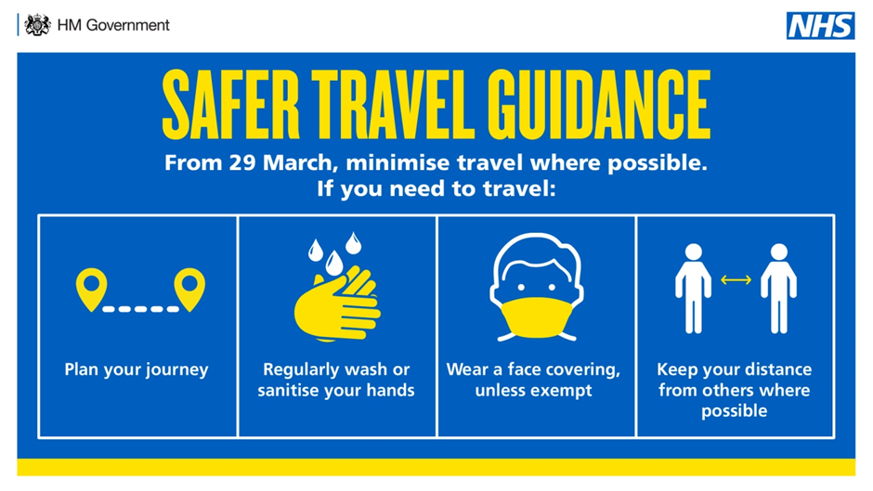

During the pandemic, the decision was made to keep th majority of car parks open and measures were in place to ensure those still requiring parking could access off street parking while encouraging social distancing and contactless methods of payments.

6. Our online presence

Improvements to online services

Covid-19 has dramatically changed normal office working for both the Parking team and also for many of the customers we provide services to. The team has reacted quickly to adapt to different ways of working particularly where the Council’s reception closed to the public therefore reducing the ways customers could interact with us. As a result the team saw a marked increase in the level of email correspondence being received. In April the team responded to just over 800 emails, with this increasing to in excess of 1300 emails in March 21. To work towards more efficient ways of working and to maximise use of online services, the team has been supported by colleagues in the Information and Communications Team to:

- Redesign parking web pages to improve the customer journey
- Streamline and reduce information for ease of use
- Provide further online, self-service options for applications and refunds
- Provide simple ways to report issues to the team
- Ensure web accessibility across pages and documents

In February, the team introduced a new eform, replacing paper application forms required for resident parking permits. Since its introduction, over 300 residents have benefitted from a more convenient and flexible way of handling applications and it is anticipated that the majority of paper permit applications will be replaced over the next 12 months. The team continue to work to develop eforms for other areas of the service. 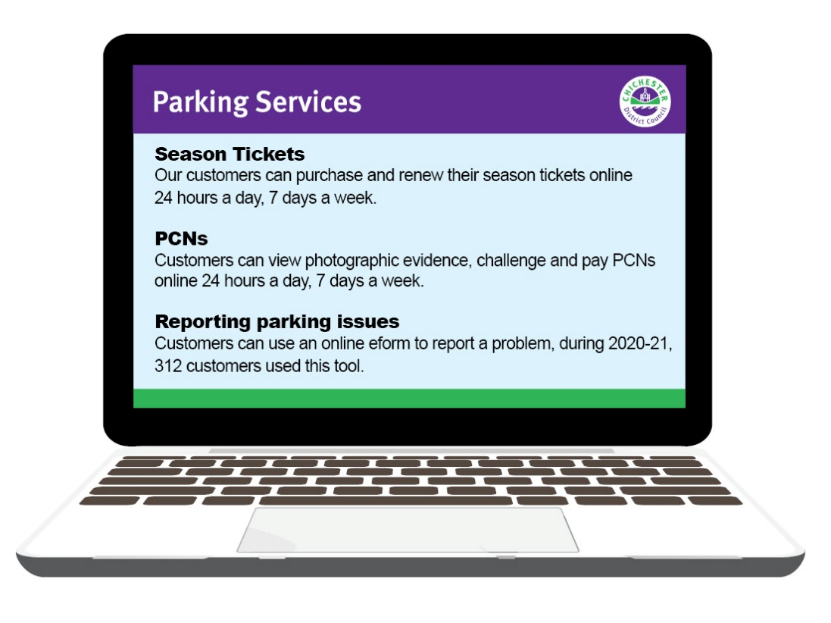

Social media

Social platforms help us to connect with our customers, increase awareness about services and share important information. With so many people around the world using social media, communicating in a way that is relevant to different users is important to us. We currently have over 9,500 followers on Facebook and over 8,200 on twitter. Across both platforms we have responded to over 100 customers comments. During 2020-21, we ran several campaigns to share messages with the public.
Collectively 158,900 customers have viewed our social media posts throughout the various campaigns we have run this year

Social Media Campaign | How many customers viewed our posts
MiPermit | 13,500
Summer parking incentives | 80,700
Christmas Parking incentives | 7,500
Coronavirus and parking | 38,100
Chichester Off Street Parking Consultation | 1,200
Christmas Parking Messages | 17,900

Notably, this year we increased our use of social media platforms to assist with advertising the consultation for new parking charges proposed for the following year. It was considered that this type of consultation would enable more customers to engage with us at a time when they may not visit car parks to view signage.

We used social media to emphasize important safety messages and changes to our services throughout the pandemic and these messages reinforced other Council communications in line with government guidance. The campaigns also enabled us to:

- Further advertise our services
- Encourage customers to interact in different ways
- Promote use of contactless payments through MiPermit, our cashless parking operator.
- Support the high street

Examples of our messages include the following:

“MiPermit is the easy way to pay for parking in the Chichester District. From 8^{t} June, get one hour’s free parking when purchasing two hours if using MiPermit. This is available in all car parks, except for Westgate Leisure Centre and Avenue de Chartres. Download MiPermit on the Apple store”

“Before travelling, check where you can park and make arrangements in advance where possible. West Wittering beach car park will be operating a pre-book system in their car park again this year. Most roads in and around the area are restricted so check out the other car parks in the area where you can park safely and considerately. www.chichester.gov.uk/parking”.

Website page views

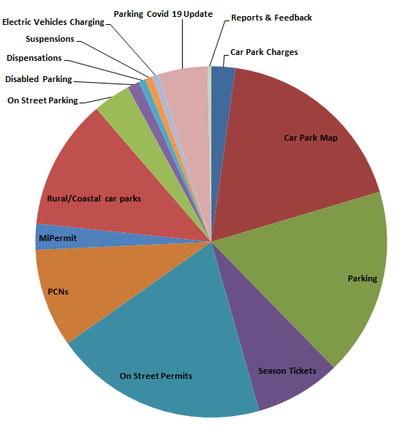
Website visits reduced by 22% to 95,790 during 2020-21. Where Covid 19 has prevented any travel, visitors to our car parks significantly reduced both for tourism and commuting/working purposes. In 2019 almost 30,000 customers checked information relating to parking charges; comparatively this year, only 3000 customers visited this page. The web redesign work carried out this year will further ensure that customers are able to find what they are looking for quickly and easily, reducing the time spent on our website.

Payments through our website

PCNs | Total | Web | % | Non Web | %
2018/19 | 7,959 | 5,931 | 71% | 2,563 | 29%
2019/20 | 8,987 | 6,920 | 77% | 2,067 | 23%
2020/21 | 5,763 | 4,778 | 82% | 985 | 18%

Season Tickets and Permits | Total | Web | % | Non Web | %
2018/19 | 11,581 | 9,280 | 80% | 2,338 | 20%
2019/20 | 11,641 | 9,989 | 86% | 1,652 | 14%
2020/21 | 7,475 | 6,228 | 83% | 1,247 | 17%

7. Off Street car parks overview

Chichester District Council own 31 car parks across the district and manage everything from tree maintenance to machine faults. We are proud to have been awarded the ‘Park Mark’, safer parking award in the majority of our car parks. The award demonstrates our continued commitment to provide safe places for customers to leave their vehicles and also discourages criminal behaviour. During this year, visitors to the car parks significantly reduced where the government implemented lockdowns and restricted travel for all but essential workers.



Suspending parking charges in car parks

In response to the Covid-19 pandemic and to support essential workers at the time, the council made the decision to suspend all parking charges at the start of lockdown (23rd March) across all council-owned car parks. Charges were subsequently resumed on 8th June, following a decision at Cabinet, with a number of parking incentives in place at the time to continue to reflect the ongoing pandemic.

Supporting hospital staff

Prior to the government introducing a national parking scheme for emergency response workers with a Covid Parking Pass in off-street and on-street bays, Parking Services introduced a free of charge season ticket for use by NHS staff working at St Richards Hospital. Over 600 season tickets were issued to staff and the scheme ran for just under a year until 31st March 2021.

New signage advertising MiPermit

The service has undertaken to introduce MiPermit signage across all car parks to further promote cashless parking which encourages social distancing but also offers customers convenience when parking.

Subsidised and ‘free’ parking

During 2020-21 we continued to offer subsided parking in the rural car parks and 142,066 tickets (equating to £92,500) were issued free of charge. It is considered that the ‘free’ period of parking can assist with encouraging some customers to visit the district but there is a balance which must be maintained in terms of ensuring that customers do not rush back to their vehicle to purely park for the ‘free’ period, which does not help to support the local economy. There are significant costs involved with the provision of car parks and it is therefore important that parking charges are considered carefully to assist with covering these costs.

Parking Services introduced parking incentives in both the summer and over the Christmas period 2020. The incentives encouraged customers to visit their local shops and support the high street. In the summer, 8,000 customers benefitted from free weekend parking in the Avenue de Chartres car park and 15,000 from the MiPermit free hour when selecting two. In the summer, 3,322 customers benefitted from free weekends in ADC and 8,235 from the free hours’ parking using MiPermit.

Providing flexibility when parking

All but one of our charging car parks provide payment machines which are capable of accepting coin, card and contactless payment. MiPermit, cashless parking is also offered across the district. Many frequent customers take advantage of season tickets which can be used in 15 of our car parks and are available to buy online, at a substantially reduced cost.

Car parks throughout the year

The impact of Covid-19 has understandably affected normal driver behaviour. The busiest months in our car parks have been August, September and October with over half of all transactions taking place during this time. The quieter months during 2020-21 coincided with the national lockdowns and the busiest car parks over the course of the year have been Northgate, Cattle Market and also City Centre car parks such as Baffins Lane and Little London, Chichester. In Midhurst, North Street car park was the busiest and the coastal car parks having also seen a significant increase in use. Some of the car parks have been used for either a temporary Covid ‘pop-up’ test site, for a longer term Covid test site or to assist with parking provision for residents attending a Covid vaccination in the district.

The usual Christmas Park and Ride was not offered during 2020-21 given the pandemic, with parking concessions being introduced instead to help support the high street. Coastal car parks were busy during the summer months as a result of the national lockdown meaning that there was an increase in the number of people having a staycation.

Keeping it clean and safe

All our payment machines in surface car parks are solar powered to reduce the cost of electricity and support the Council’s environmental agenda and Climate Change Action Plan. The team works to keep restriction signs and charges boards clean, line markings free of foliage and maintain our spaces by reporting and resolving defects. Taking into consideration feedback from CEOs, all car park inspection defect reports are undertaken using digital means, with inspections being undertaken on a regular basis to ensure that our car parks are as safe as possible. In addition, CEOs are all trained to respond to reports of antisocial behaviour, assisting our Communities team and the Police. Regular cleaning of machines has taken place throughout the pandemic.

8. Digital season tickets


Digital season tickets provide good value for frequent customers and added convenience. The successful move to Digital Season Tickets from paper season tickets has reduced the reliance on direct contact with the Parking Services Team and also reduced transactions through the Contact Centre. A reduction in season ticket sales however, has been observed in previous years and the sudden shift in customer parking needs, in particular the requirement for many to work from home as a result of Covid-19, has further impacted season ticket sales.

While it is anticipated that the sale of season tickets will recover, Parking Services have looked at how best we might provide new season tickets to better suit the needs of customers in the future. The team is developing and aim to trial a new part-time season ticket next year allowing customers to select the days they wish to park rather than paying for a season ticket to park every day. 66% of customers still choose to buy monthly season tickets with the second and third most popular durations being 2 and 12 months, respectively.
Key information about our season tickets:
- 15 digital season tickets
- 3 season tickets which guarantee a parking space in a central car park
- 5509 season tickets sold in 2020-21
- Park for as little as £1.66 a day in Chichester
- Park for as little as 57p in rural car parks

9. MiPermit

MiPermit was introduced to customers as an alternative way to paying for parking at traditional pay and display machines, customers have benefitted from increased flexibility when parking in our car parks. Despite a significant reduction in car park income and transactions, MiPermit only saw a 1% decrease in use compared to 2019-20.

MiPermit customers can pay for parking using: • A smartphone app Apple/Android • Online at www.mipermit.com • By telephone • A mobile phone by SMS • By SMS - Text PARK with your vehicle registration to 61600

The table below shows all MiPermit transactions since 2018, split across all car parks.

Table 7 – MiPermit parking stays
Car Park | 2018-19 | 2019-20 | 2020-21
Baffins Lane Car Park | 4944 | 7368 | 5531
Basin Road Car Park | 1706 | 2746 | 2692
Bosham Lane Car Park | 1363 | 2360 | 6637
Bosham Lane Coach & Lorry Park | 9 | 26 | 64
Bracklesham Lane Car Park | 920 | 1398 | 3579
Cattle Market Car Park | 13887 | 21356 | 21131
Cawley Priory Car Park | 3290 | 4592 | 3120
Coach Park Via Ravenna | 105 | 155 | 31
East Beach Car Park | 92 | 107 | 690
East Pallant Car Park | 5618 | 8718 | 7889
East Street Car Park | 245 | 322 | 220
Grange Road Car Park | 1476 | 1481 | 2362
Little London Car Park | 4897 | 8141 | 10020
Lorry Park Via Ravenna (Overnight Only) | 3 | 2 | 14
Marine Drive Car Park | 435 | 574 | 2348
Market Avenue Car Park | 248 | 367 | 170
Market Avenue/St John's Street Car Park | 960 | 1136 | 1208
Market Road Car Park | 288 | 451 | 289
New Park Road Car Park | 4112 | 6417 | 6418
North Street Car Park | 2093 | 3142 | 3738
Northern Crescent Car Park | 115 | 164 | 329
Northgate Car Park | 16006 | 22099 | 14943

Orchard Street Car Park | 1553 | 1947 | 1633
Orchard Street Car Park (D Park) | 97 | 145 | 103
Post Office Car Park | 2148 | 2148 | 1662
Pound Street Car Park | 4153 | 4383 | 4078
Selsey Marine Car Park | 34 | 61 | 157
South Pallant Car Park | 2954 | 4432 | 4594
St Cyriacs Car Park | 2803 | 5087 | 4447
Total parking stays | 76554 | 111325 | 110097

The team has worked to promote the service further by producing posters, running social media campaigns, distributing cards and offering incentives for customers using MiPermit. It was recognised during 2020/21 that MiPermit was an attractive way for customers to pay for parking given that it is totally contactless. MiPermit also provides the facility for customers to extend their parking stay, this feature was promoted during the pandemic as customers would benefit from having this option when there were queues at shopping centres and other facilities to help with social distancing. MiPermit was therefore promoted as part of our response to the Covid pandemic and the team were able to use funding through HM Government’s Reopening High Streets Safely Fund to advertise this in local newspapers and on local radio advertising. In addition, Parking Services partnered with ‘Loyal Free’ an application available to Chichester Business Improvement District levy payers whereby local deals and offers can be advertised which in turn helps encourage customers to shop locally.

The use of MiPermit has increased from 6% up to 12% across all our car park transactions during 2020-21. The car parks attracting the highest number of MiPermit customers are our two largest long stay car parks and our largest city centre car park (Northgate, Cattle Market and East Pallant) but also a short stay car park too, Little London car park.

What benefits does MiPermit offer?
- No need to call or visit the Council
- No need to display a season ticket or ticket in a vehicle
- The ability to update vehicle details at any time, day or night.
- A secure and reliable way to purchase season tickets or parking stays
- Purchase stays in advance of your visit
- Use the basket function to purchase multiple season tickets
- Use a personal account via MiPermit Website or App In addition to reducing the postage, stationery and administrative costs

10. On Street parking overview

WSCC charge reviews

WSCC undertake to review on street charges each year. In September the team implemented charge changes affecting all on street permits. The team proceeded to implement further changes to on street charges for April. Charges implemented for 2020-21 include the introduction of 6 month permits across most permit types along with provision for owners of Low Emission Vehicles to obtain permits for 25% less than the standard permit charge, a decision which reflects the County Council’s commitment to become carbon neutral by 2030.

10.2 City Centre on-street pay and display

The voucher scheme is now largely phased out and 29 solar powered payment machines are located in convenient locations in Chichester city centre. Motorists can make the most of city centre parking locations for up to 1 hour which assists with the turnover of spaces near shops and businesses.

10.3 Lines and signs

By nature of their position, lines on the highway can become worn or damaged and often CEOs are the first to discover these defects. For a third year, Parking Services has ordered work to resolve on-street defects which are found within the Controlled Parking Zones (CPZ). CEOs are also now reporting and ordering remedial work for defects outside of the CPZ.

Suspending parking to support returning to the high street

Locations for temporary parking bay suspensions were determined to assist with social distancing in preparation for the reopening of the high street following periods of national lockdown. A suspension in East Street, Chichester assisted to ensure that customers visiting local retailers could queue safely without obstructing other pedestrians.

Protecting parking schemes

Permit schemes are managed stringently, to ensure that only those who are eligible to use permits are doing so. Enforcement of permit holder bays ensures that we secure the parking for those who need it most. Where there are incidences of permit misuse or fraud the Council’s Fraud Investigation Officer will investigate such cases.
Problem parking and directing enforcement

In 2020-21 Parking Services logged 295 requests for Enforcement from members of the public.

Customers are able to contact Parking Services using the ‘Report It’ facility on the council’s website or by phone or email to advise if they observe a vehicle which they believe is parked in contravention of the regulations. Unfortunately we are unable to issue a Penalty Charge Notices (PCNs) using the photographs and the details customers provide, as a CEO must view vehicles parked in contravention at the time. However, all requests for enforcement where there are restrictions and a Traffic Regulation Order/Parking Order in place are passed to the Civil Enforcements who will look in to the situation and deal with it accordingly. This might include increasing the number of visits made to the particular area of concern.

The top three reasons for customers contacting the team to report issues of concern were:

- Vehicles parking on a yellow line restrictions (117)
- No valid permit displayed in a controlled parking zone (42)
- Vehicles causing an obstruction (33)

September 2020 saw the highest level of reports from customers (58) and there were a number of contacts made in relation to concerns of parking close to a school in the district.

The team received 8 reports where the CEOs were unable to action due to no Traffic Regulation Order or the Council not owning the car park. Another 33 reports were received for obstruction which unfortunately our CEOs do not have the power to issue PCNs for, and customers are advised that these issues should be reported to the Police.

11. School enforcement

Designated school enforcement is scheduled into CEO patrol rotas and whilst inherently time consuming, it is considered a very important part of their work. As we dedicate enforcement to around 50 schools in the area, it is accepted that CEOs cannot always be present; however, a rota system allows officers to attend various locations as frequently as possible. When CEOs observe particular parking issues at schools it is raised and periods of concentrated enforcement can be scheduled.



The Parking Services team recognise that there are some locations in the district where it is not easy for parents to park when dropping off or collecting children from school. We provide some schools with alternative parking options for ‘drop offs’ and ‘pick ups’, including short term parking passes for on and off-street locations, however unfortunately vehicles continue to be parked where safety restrictions are in place.

On-Street Permits

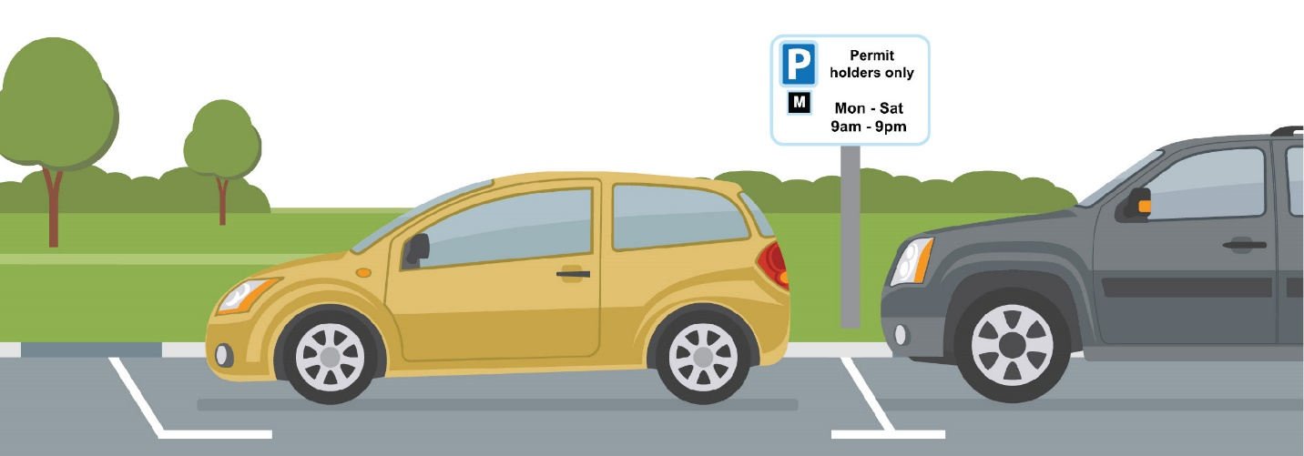

Tables 8 – Permits in Controlled Parking Zone

Zone | Uptake of Permits % | 1st Permit | 2nd Permit* | 3rd & 4th Permits | BBH's | Carer | +Health-care | Non- Resident | Total Issued excluding Non-Res.
E | 92% | 160 | 11 | 0 | 6 | 6 | 208 | 0 | 183
F | 90% | 266 | 52 | 3 | 8 | 3 |  | 17 | 332
G | 40% | 14 | 4 | 0 | 3 | 0 |  | 5 | 21
H | 48% | 85 | 15 | 0 | 11 | 0 |  | 11 | 111
H2 | 63% | 168 | 32 | 3 | 16 | 1 |  | 23 | 220
J | 91% | 31 | 9 | 0 | 0 | 2 |  | 0 | 42
K | 100% | 59 | 0 | 0 | 4 | 1 |  | 0 | 59
K Mon-Fri | 69% | 11 | 0 | 0 | 0 | 0 |  | 0 | 11
K Alt N | N/A | 6 | 0 | 0 | 0 | 0 |  | 0 | 6
L | 89% | 35 | 4 | 0 | 0 | 0 |  | 1 | 39
M | 55% | 51 | 13 | 3 | 5 | 0 |  | 2 | 72
N | 78% | 183 | 24 | 0 | 6 | 1 |  | 2 | 214
O | 64% | 134 | 38 | 0 | 13 | 4 |  | 2 | 189

* Where permits in zones are in high demand only 1st permits will be issued.
+Healthcare permits are valid for use across all zones.

Customers can benefit from 3 types of Resident Visitor Permits. In the past year there have been over 5,500 Resident Permits Issued.

Eleven CPZs (Controlled Parking Zones) are in place in Chichester, designed to manage on-street parking, maintain safety and access and improve the commercial viability of the city (see Appendix D for map of zones). Across the Resident Parking Scheme (RPS) permits enable customers to park in permitted parking bays. The largest group of permit holders are residents who make up 86% of live permits. Amongst those who are also eligible to apply for permits are residents holding Blue Badges, Carers and Healthcare workers, making up 17% of the permits we issued. Where demand exceeds supply, the team manage waiting lists. Waiting lists are monitored regularly to minimise the length of time that customers spend waiting.

12.1 Non Resident Permits
Non-Resident Permit holders account for 4% of permits issued during 2020-21. While it was expected that the demand for Non Resident Permits would reduce during the pandemic, as commuter parking was less likely to be needed the level of permits remained much the same. This may be due to the permits being used by essential workers who still required parking. Non-Resident Permits are offered to customers in roads where surplus capacity is recorded by CEOs.

12.2 Resident Visitor Permits (RVPs)

The number of RVPs being issued has fallen this year reflecting that travelling or visiting other properties during restrictions has been prohibited under most circumstances. While the number had been consistent over the past three years. Where customers have been unable to visit Chichester District Council while officers are closed, customers have been able to call the Contact Centre to request permits.

Table 9 – RVPs are available to residents to purchase for their visitors

 | Resident Visitor Permits
Duration | 2 Hourly | Daily | Weekly
Total RVPs 2019-20 | 6,275 | 3,130 | 156
2020-21 | 3,465 | 1,949 | 98

13. Dispensations and suspensions

The purpose of on-street dispensations is to help ensure that trades people who carry out work across the District can do so safely and conveniently if their vehicles are required for the activity taking place. Since 2018, the number of dispensations issued to tradespeople has reduced. Charges for dispensation had remained static since 2013. Since 2018 (when this cost increased), fewer dispensations have been issued, this has assisted with ensuring that only vehicles which have good reason to park on the highway do so and those who were benefitting from inexpensive on street parking without good reason, relocate to more suitable parking places.

On-street Suspensions suspend the normal restrictions in an area of the highway to allow a planned activity to take place. They may be requested in order to position a skip in a parking bay, to enable utility companies to carry out maintenance or simply to make certain that a space will be vacant. Suspensions can also help facilitate events, by preventing the use of parking bays throughout road closures. The Parking Services Team determines whether or not the location and timescales are suitable and how disruption can be minimised. By ensuring that signs are correctly displayed ahead of the suspension start date, the team provides warning to those who will be affected

Table 10 – On-Street Dispensations and Suspensions 2020-21

Month | Dispensations | Suspensions
April | 9 | 1
May | 3 | 3
June | 14 | 4
July | 14 | 7
August | 5 | 5
September | 3 | 6
October | 2 | 3
November | 2 | 6
December | 2 | 1
January | 1 | 12
February | 2 | 9
March | 1 | 6
Total | 58 | 63

14. West Sussex County Council CPZ Extension

During 2017 a Road Space Audit (RSA) was undertaken by West Sussex County Council (WSCC) which considered the demands and pressures on the road network in Chichester. Through this, it was found that there was justification to move forward with one of the resulting concepts, ‘Tackling Parking Issues’. This concept focusses on developing a city wide Parking Management Plan (PMP) to resolve local parking and traffic management issues. The proposed PMP covered the whole of the city centre and extended out to areas such as the Broyle Estate, Parklands and Donnington. Following consultation in 2019 and a second round of formal consultation between February and March 2020, plans were agreed in July 2020 and the decision was made to implement the PMP in phases tackling only specific locations first with a view to review the impact of these changes on neighbouring areas and implementing other CPZs, in a later phase.

Preparation for Phase 1a of the PMP began in December 2020. This introduces two new Controlled Parking Zones (CPZs), in the Donnington and Swanfield areas, and extends three of the existing zones. Work began on the highway during February 2021, with the intention of the new zones coming into force from June 2021.

The Parking Services Team at Chichester District Council will be administering and enforcing the scheme on behalf of West Sussex County Council, with customers in the extension to the zone being part of the digital permit process. This will result in a reduction in paper permits and postage, along with providing more flexibility for customers.

Once implemented, the success of the scheme will be monitored over the coming months.

15. Partnership working

Chichester District Council works in partnership with many organisations in its provision of the parking service. It is recognised that working in partnership assists us to deliver our services in the most effective way. Customers benefit from these partnerships as they enable us to deliver more joined-up services which better meet their needs and improves the customer experience. Partnerships also allow us to uphold the regulations which affect all road users more easily, minimising costs to the council.

Over the past year, partnership has been more important than ever. The Parking Services Team have worked closely with the NHS and Public Health England to provide parking provision in response to the Covid pandemic, allocating areas of car parks for Covid test or vaccination sites and providing free parking for partners involved in the essential work as a result of the Covid pandemic. Alongside this, the increased number of visitors during the summer months to the coastal area has meant that partnership working with the police has become increasingly important.
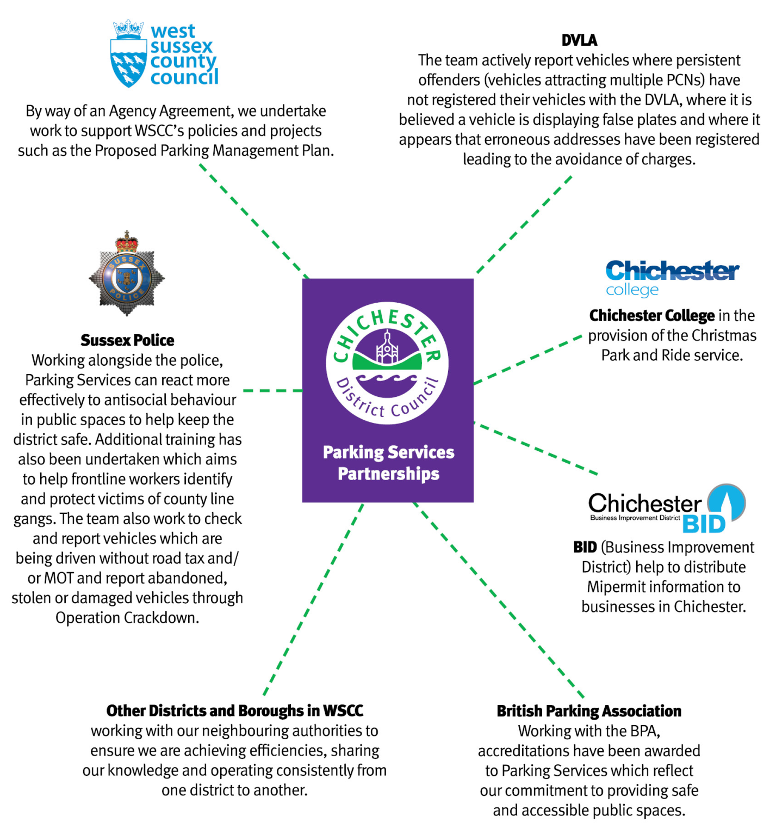

16. Freedom of Information requests and subject access requests

All requests for information received by Parking Services are answered in accordance with the Freedom of Information (FOI) Act 2000. The only exception will be an individual’s request for their own personal data, which must be handled under the terms of the General Data Protection Regulations (GDPR).

During 2020-21, 19 FOI requests were received, compared to 21 the previous year. While the number has decreased, the two most common questions still relate to the number of PCNs issued and the nature in which the service is operated. Other FOI requests have included enquiries into the number of parking transactions, Electric Vehicle Charging points and our contract with the Enforcement Agent.

Reviewing FOI topics can help us determine where we can make improvements to information we provide which may in turn prevent any unavoidable requests in the future. Parking Services publishes policies relating to PCN decision-making and offers advice online in relation to the PCN process which allows customers to find information themselves.

There were no Subject Access Requests received during 2020-21.

17. Equality of access to our services

The table below sets out the number of ways in which we constantly review how accessible our service is to all customers who have a variety of needs. The actions we undertake each year are reviewed and considered very carefully to ensure that we are improving the service we provide.

Chichester District Council Parking Forum | The Chichester District Parking Forum continues to have the Chichester Access group as one of its key members, contributing to discussions.
British Parking Association Safer Parking and Disabled Parking Accreditation | The British Parking Association provides an accreditation scheme, which assesses car park safety. This scheme has been in place in Chichester city car parks for a number of years; however, we have continued to work towards gaining it in as many car parks as possible. 28 of the 31 car parks across the District now have the accreditation. This provides assurances to customers from a safety perspective and feedback (particularly from older customers) suggests that this is important to them.  In addition, Disabled Parking Accreditation assessments have been carried out, with 28 car parks accredited under this scheme. The scheme requires owners/operators of car parks to adopt an active management strategy to ensure minimal occurrence of disabled bay abuse, facilities are suitable for disabled people and recognition is made of the extra time taken by disabled people in the form of a concession.
Penalty Charge Notices (PCNs) | Parking Services has undertaken to review and update the procedure for verbal challenges against PCNs. The process ensures that those who are unable to write to the council have other means to make their challenge, either in person or over the phone and that all staff are properly trained to follow the procedure.  PCN procedures have also been amended where Covid-19 may have had an impact on customers’ ability to pay. The opportunity to pay at a discount has been offered where appropriate along with the provision of further payment plans.

Health Care and Carer Permits | The Parking Services team continue to administer Health Care and Carer permits for healthcare workers visiting those receiving care in their homes within the Controlled Parking Zone. The permits help residents stay in their own homes for longer by enabling easy access to provide the required care. Where customers are in receipt of particular benefits, carer permits can be provided free of charge.
Parking Charges Consultation | Further publication of consultation relating to parking charges has been undertaken this year, which makes submitting responses more accessible to everyone on different platforms.
Website Accessibility | As part of the accessibility regulations (The Public Sector Bodies (Websites and Mobile Applications) (No.2) Accessibility Regulations 2018) we are continuing to improve our web estate. An accessibility statement has now been published outlining our level of accessibility. We have created a ‘Website accessibility contact form’, so customers can report an issue with accessibility. We have carried out a site-wide audit of all our documents and are working with services to make them accessible. We continue to promote the importance of accessibility and have created a section on the Council’s intranet for advice and guidance. Our commitment to the Local Digital Declaration means we will continue to design our services to meet the needs of customers and follow a unified set of content and accessibility standards.
Shopmobility | A Shopmobility service provided by Community First continues to operate from East Pallant car park, providing mobility scooters for visitors with limited mobility, to enable improved access to the city centre. Provision this year has been interrupted through lockdown, both through restrictions and reduced usage, but has resumed when safe to do so. The service has looked to increase support for new or existing users through temporary hire in their own homes. The service is supported by Parking Services (a number of parking bays are set aside for the service to operate from) and in part with Council Grant funding.
Blue Badge Enforcement | Civil Enforcement Officers continue to support West Sussex County Council to tackle Blue Badge misuse. They are trained to identify and retain misused and/or expired badges. In 2019/20, 32 badges were retained, which led to 13 motorists attending a Community Resolution and 1 case being sent for prosecution. The Council website also provides information and encourages customers to report badge misuse. This initiative recognises that Blue Badge misuse is not only fraud, but can mean that genuine, vulnerable users are deprived of vital services because parking spaces are taken by fraudsters.
Community Bus Bays | Several bays for Community Buses are provided within council-owned car parks for use by organisations who transport older, frail or disabled residents around the district. The bays provide a designated location for these customers to be safely dropped off and collected. Due to levels of demand, further bays have been provided in a rural car park.
Parking for Disabled Customers | To help people with disabilities gain easy access to the City, most pay and display car parks have specially allocated parking spaces. These spaces, along with any others in the pay and display car parks (the Avenue de Chartres Pay on Foot car park excepted) can be used free of charge provided the vehicle is displaying a valid blue badge or foreign disabled badge and the registered person is driving or a passenger.
Parking Payment Options | Parking payment machines are fully compliant with the British Standard relating to Parking control equipment (BS 8300). All machines except for those in the Westgate and Avenue De Chartres car parks accept coin, card and contactless payment. In addition, the MiPermit facility is in place across all car parks, enabling payment by phone or app. Many customers from protected groups (particularly older customers and those with mobility issues) benefit from the accessible machines or from being able to pay for parking without the need to visit a machine. Parking payment machines also provide information in a number of different languages.
Resident Visitor Permits | A new system has been set up whereby customers can telephone to order Resident Visitor Permits rather than visit the council. There will also be additional improvements to the Resident Permit process in the coming weeks.

18. Complaints and compliments

With such a busy service dealing with many customers, Parking Services has occasions where a customer wants to provide feedback. Whether it’s due to a delay in postage, a faded permit or payment machine fault, whatever the complaint is we work very hard to sort it out.

The Council’s complaints procedure provides three stages at which the complaint can be investigated. During 2020-21, we received a total of 13 first stage complaints, 2 second stage complaint and 1 complaint which was submitted to the Local Government Ombudsman.

Examples of complaints and our response include the following:

Customer:

“I am afraid I need to complain about the barrier at the Avenue De Chartres car park in Chichester… The last few days we have all had issues getting in and out of the car park”

Parking Services:

I would like to apologise to you and your colleagues for the issues you are experiencing. We aim to provide a high standard of service so it is very disappointing when we hear our season ticket holders are dissatisfied. I would like to reassure you that we are working to find a solution and in the meantime, the vehicle registrations which you have explained are experiencing these issues at the barriers in the car park have been passed to the supervisor of our out of hours team which should help make your exits and exits as quick as possible if you or your colleagues do need to press for assistance.

Customer:

“Chichester staff to issue parking tickets and do their job. Sorry if they have to drive 5 miles but that is part of their job. Reported by phone and E-Mail no reply.”

Parking Services:

I can confirm that Bosham is on a daily route for our team of Civil Enforcement Officers (CEOs). I can also confirm that since you contacted us, we have increased visits to the area and from 18th November to date, there have been 22 visits. I have duly checked all incoming emails, website reports and phone calls and I can see that the team here have taken action and / or responded to you on every occasion. All reports of parking issues are logged and shared with our CEOs and whilst we may not always be able to react immediately, normally we are able to deploy an Officer relatively quickly.

We know it’s more likely to hear from customers if something went wrong, but during the year we receive good feedback too. During 2020-21, we received 8 compliments.

Examples of these are below:

“I spoke today with your Parking Officer in Midhurst, a very nice man, very friendly and very helpful and knowledgeable. He gave me all the information we needed for disabled parking in Midhurst.”

“Many thanks for your help, efficiency and care. It is most appreciated.”

“With the joint efforts between CDC CEO's and West Wittering Estates the parking issues along Pound Road and in West Wittering have been very well managed over the weekend. Please convey my thanks to all.”

“I would like to express my sincere thanks to the traffic warden, who was working in the west wittering area last Wednesday 24/06/20. He was extremely calm and professional in dealing with the appalling traffic conditions created by unreasonable and ignorant visitors to the area. He kept his calm demeanour even as the temperature and visitors tempers soared.“

19. Financial information

19.1 Income

Income from parking charges is used to meet the direct costs of operating the car parks, the cost of provision of pay and display and season tickets for customers, enforcement, staff costs, utilities, licencing, repair work and maintenance to the car parks themselves. Income is also used to assist with introducing and taking advantage of new technology to assist with improving the service provided. Parking income also assists with supporting essential services within the council for our communities and visitors. Charges are reviewed to ensure that they remain competitive to encourage turnover within the car parks to make the best of the resources in place.

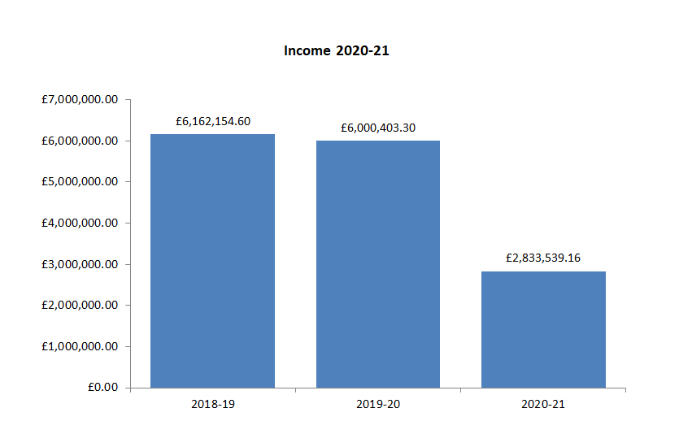

Table 11 – Income by source

Income by source | Amount | % of Parking Services Income
Pay and Display Machines | £2,004,227.28 | 77.23%
Season Tickets (car parks) | £347,616.98 | 12.56%
Penalty Charge Notices (car parks) | £248,364.80 | 5.50%
Residents Parking Vouchers | £167,703.58 | 2.73%
Licence Income | £81,459.82 | 1.69%
Advertising Income | £4,196.00 | 0.16%
Rental Income | £15,826.00 | 0.29%
Refunds | (£35,855.30) | (-0.17%)

On-street and off-street income and expenditure is managed and split according to the income source. As the Council works as agent for WSCC, an annual contribution is made to Parking Services which helps to pay for enforcement. Income generated through CPZs is paid to WSCC and the income from PCNs is split between the two authorities based on the percentage of on and off-street parking contraventions.

19.2 Expenditure

Professional Service costs relating to the provision for card and contactless payments at each parking machine have increased again over the past year where customers make use of these methods of payment instead of using cash. A rise in the number of customers benefiting from digital services has also led to an increase in costs where the Council pay a fee for each digital season ticket to the service provider. There was an increase in the capital charges during 2020-21. This is due to the fact that the Avenue de Chartres car park land was re-valued, resulting in a loss, along with capital charges relating to depreciation and amortization.

20. Looking back and looking forward

Despite a turbulent year where some projects have had to be paused temporarily in order to respond to the consequences of the Covid 19 pandemic, there have been a number of key achievements during the year relating to the service we provide to customers. These have included:

Accreditation of Safer Parking Award

All car parks across the district holding the British Parking Association’s Safer Parking Award (28 of our 30 car parks), successfully maintained their accreditation. This accreditation assists with reducing crime and the fear of crime in car parks and provides assurances to the public that measure have been introduced to ensure that the parking facility is a safe environment. These same 28 car parks have also been awarded the Disabled Parking Accreditation which recognises off street parking facilities which are accessible to disabled people.

NHS digital season tickets

Digital season tickets have been introduced to support hospital staff working at St Richards Hospital and have been in place until March 31st. The season tickets enabled essential workers to park in Northgate car park free of charge during this time.

West Sussex County Council, CPZ extension

Following consultation in February 2020, WSCC has started work to implement 2 new Controlled Parking Zones (CPZ) and three zone extensions in the current CPZ. The Parking team are working on their behalf to implement a new digital permit platform on MiPermit and will also administer and enforce the new scheme. Work has been carried out to keep residents updated and the scheme is scheduled to ‘go live’ in summer 2021.

Electric Vehicles and Electric Vehicle Charging Points

Electric Vehicle charging bays were introduced at the end of 2019 across a number of the council’s car parks. The use of these bays has been monitored since this time and a further review will be undertaken during 2021-22 to further understand the level of use. Alongside this, the purchase of an Electric Van will be undertaken to add to the existing two Electric cars which have recently replaced the diesel vehicles.

Parking strategy

Work on a revised Parking Strategy for Chichester District will continue, to reflect the requirements of the district, which will include consideration of the changing needs of customers going forward.

Parking incentives

As well as providing free parking at weekends in one of our long stay car parks in Chichester, we also offered free periods of parking using MiPermit across all other car parks. These incentives were widely used and also assisted us to encourage further use of the cashless platform which offers benefits to both the Council and our customers.

21. Parking strategy

The Chichester District Parking Strategy 2010-2020 was published in the autumn of 2010 following consideration and approval by the Chichester District Parking Forum, the then Executive Board and Council. The Strategy recognises the importance of car parking for local infrastructure, tourists, commuters and residents and that when parking is provided well it can contribute to the attractiveness, convenience and prosperity of a place to do business, visit or live. The Strategy attempted to balance the often-competing demands from car park users and pedestrians and ensure that the public car parking service continued to meet the needs of various users until 2020.

At the time of the production of the Strategy a number of assumptions relating to the demand and use of car parking spaces were made, based on the predicted growth in the district along with other societal changes and developments which were predicted. A decision was taken in 2019 that the Strategy should be refreshed, and consultants were appointed to assist with the work. Work began on this, with an initial draft report having been provided. However, with the Covid-19 pandemic it was recognised that the agreed approach to progressing the Parking Strategy required consideration, with travel needs and behaviours having changed dramatically in a short period of time across the UK. Whilst it is still unclear as to when and for how long it will take to get back to normality, and what that level of normality will look like, it was considered appropriate to pause the work on the Strategy to determine what types of scenarios might be seen going forward. Work on the Strategy was therefore proposed to begin again during 2021/22.

The revised Parking Strategy will attempt to balance the often-competing demands from car park users and pedestrians and ensure that the public car parking service continues to meet the needs of various users.

Amongst others, key considerations will be:

• The changing use of our high streets on the demand for parking
• Air quality action plans
• The emerging developments in parking payment technology and enforcement
• Electric Vehicle Charging points.
• The provision and location of disabled parking facilities
• Proposals relating to the Local Plan and other projects which will impact parking
• Factors affecting the need for parking in the district which determine the quantity of parking required to support anticipated growth in housing numbers but potential decline in the need for spaces linked to employment.
• The implications of the extension to the Controlled Parking Zone in Chichester city.
• Current car park usage including spare capacity and predictions of future use.

22. Key areas of work for 2021/22

- Review of Parking Strategy
- Review and Enhancement of Bosham Car Park
- Extension of WSCC Controlled Parking Zones
- Review of car parks – to include lighting, usage and layout (including Northgate)
- Review Electric Vehicle parking provision

23. Appendices

Appendix A – Contravention Code List

Contravention Code List – On-Street
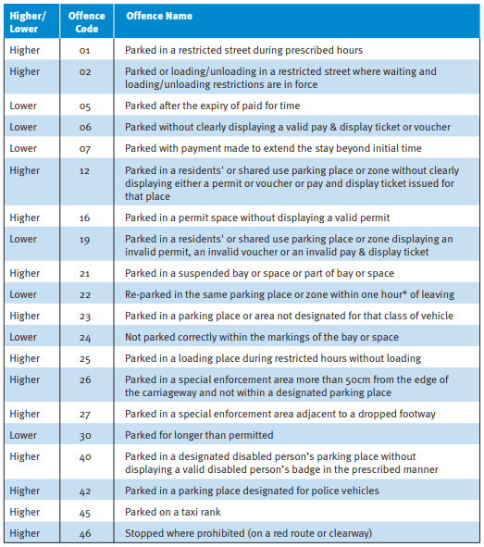
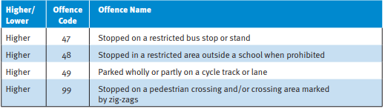

Contravention Code List – Off-Street

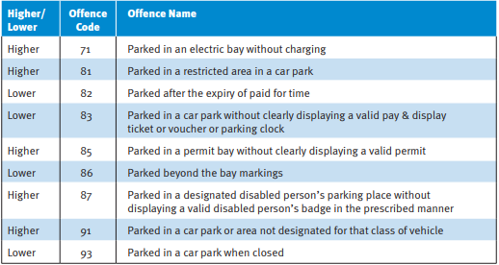

Appendix B - Pricing details for Pay & Display Car Parks across the District
Parking Places | Present Days and Hours of Charging | Period of Parking | 2020-2021 Charge
Chichester City Centre – Short Stay Central
Little London PO19 9SB | 8am to 6pm Monday to Saturday inclusive and Sunday 10am to 5pm | Up to 1 Hour | £2.00
Baffins Lane PO19 1PL |  | Up to 2 Hour | £4.00
 |  | Up to 3 Hours | £6.00
 |  | Up to 4 Hours | £8.00
 |  | Up to 5 Hours | £10.00
 |  | Up to 6 Hours | £12.00
 |  | Up to 8 Hours | £14.00
 |  | More Than 8 Hours | £16.00
Chichester City Centre - short stay
Orchard Street PO19 1DD | 8am to 6pm Monday to Saturday inclusive and Sunday 10am to 5pm | Up to 30 Mins | £0.60
St Cyriacs PO19 1AJ |  | Up to 1 Hour | £1.40
South Pallant PO19 1SU |  | Up to 2 Hour | £2.70
East Pallant PO19 1UF |  | Up to 3 Hours | £4.40
St John’s St. PO19 1JU |  | Up to 4 Hours | £6.90
Market Road PO19 1JW |  | Up to 5 Hours | £8.20
Market Ave PO19 1SY |  | Up to 6 Hours | £9.70
New Park Road PO19 7SB |  | Up to 8 Hours | £11.50
Cawley Priory PO19 1UF |  | More Than 8 Hours | £13.80

Chichester City Centre – Long stay
Avenue de Chartres PO19 1SB | 8am to 6pm Monday to Saturday | Up to 30 Mins | £0.60
Basin Road PO19 8PU |  | Up to 1 Hour | £0.90
Cattle Market PO19 1JW |  | Up to 2 Hour | £1.70
Northgate PO19 1BL |  | Up to 3 Hours | £2.50
 |  | Up to 4 Hours | £3.30
 |  | Up to 5 Hours | £4.10
 |  | Up to 6 Hours | £4.70
 |  | More Than 6 Hours | £5.80
Florence Road PO19 7PY |  | Maximum stay 3 hours, no return within 3 hours
Westgate PO19 8DL | 8am to 6pm Monday to Saturday inclusive and Sunday 10am to 5pm | Up to 30 Mins | £0.60
 |  | Up to 1 Hour | £0.90
 |  | Up to 2 Hour | £1.70
 |  | Up to 3 Hours | £2.50
 |  | Up to 4 Hours | £3.50
 |  | Up to 5 Hours | £4.50
 |  | Up to 6 Hours | £5.40
 |  | More Than 6 Hours | £6.60
Coach and Lorry Park PO19 1RJ | Monday to Saturday inclusive; Sun 10am - 5pm | Up to 2 Hours | £3.40
 |  | More than 2 Hours | £6.70
 | 5pm to Midnight; Monday to Sunday inclusive | Overnight fee | £6.70
Sunday Charge - Long Stay
Avenue de Chartres | Sunday 10am to 5pm | Up to 3 Hours | £1.00
Basin Road |  | Up to 4 Hours | £2.00
Northgate |  | More Than 4 Hours | £3.00
Cattle Market
Westgate
Midhurst
Grange Road GU29 9LT | Monday to Saturday 8am to 6pm. Free on Sundays | Up to 2 Hours | Free
 |  | Up to 3 Hours | £0.80
 |  | Up to 4 Hours | £1.00
 |  | Up to 5 Hours | £1.30
 |  | Up to 6 Hours | £1.50
 |  | Up to 7 Hours | £1.90
 |  | More Than 8 Hours | £2.30
Midhurst
North Street GU29 9DS |  | Up to 1 Hour | Free
Post Office GU29 9LT | Monday to Saturday 8am to 6pm. Free on Sundays | Up to 2 Hours | £0.60
 |  | Up to 3 Hours | £0.80
 |  | Up to 4 Hours | £1.00
 |  | Up to 5 Hours | £1.30
 |  | Up to 6 Hours | £1.50
 |  | Up to 7 Hours | £1.90
 |  | More Than 8 Hours | £2.30
Petworth
Pound Street GU280XD | Monday to Saturday 8am to 6pm. Free on Sundays | Up to 1 Hour | Free
 |  | Up to 2 Hours | £0.60
 |  | Up to 3 Hours | £0.80
 |  | Up to 4 Hours | £1.00
 |  | Up to 5 Hours | £1.30
 |  | Up to 6 Hours | £1.50
 |  | Up to 7 Hours | £1.90
 |  | More Than 8 Hours | £2.30
Sylvia Beaufoy GU28 0DX |  |  | Free
Fernhurst
Crossfield GU27 3JL |  |  | Free
Bosham
Bosham Lane PO18 8HT | 8am to 6pm Monday to Sunday inclusive | Up to 1 Hour | £0.70
 |  | Up to 2 Hours | £1.80
 |  | Up to 3 Hours | £2.40
 |  | Up to 4 Hours | £3.50
 |  | Up to 6 Hours | £3.90
 |  | Up to 24 Hours | £4.10
 |  | Up to 48 Hours | £6.20
 |  | Additional 24 Hours | £3.10
 |  | Up to 7 day max | £18.50
Bosham Lane coaches |  | Per Day | £6.20
Bracklesham
Bracklesham Lane PO20 8HP | 1 April – 31 Oct, 8am to 6pm Monday to Sunday inclusive | Up to 2 Hours | £2.20
 |  | Up to 4 Hours | £4.20
 |  | More Than 4 Hours | £5.40
 | Nov-31 March, 8am to 6pm Monday to Sunday inclusive | Up to 2 Hours | £0.70
 |  | More Than 2 Hours | £1.80
The Witterings
Northern Crescent PO20 8BD | Monday to Saturday inclusive 8am to 6pm | Up to 1 Hour | Free
 |  | Up to 2 Hours | £0.60
 |  | Up to 3 Hours | £0.80
 |  | Up to 4 Hours | £1.00
 |  | Up to 5 Hours | £1.30
 |  | Up to 6 Hours | £1.50
 |  | Up to 7 Hours | £1.90
 |  | More Than 8 Hours | £2.30
Marine Drive PO20 8HE | 1 April – 31 Oct Monday to Sunday 8am to 6pm | Up to 2 Hours | £2.20
 |  | Up to 4 Hours | £4.20
 |  | More Than 4 Hours | £5.40
 | 1 Nov-31 March Monday to Sunday 8am to 6pm | Up to 2 Hours | £0.70
 |  | More Than 2 Hours | £1.80
Selsey
East Street PO20 0BH | Monday to Saturday inclusive 8am to 6pm | Up to 1 Hour | Free
 | Free on Sunday | Up to 2 Hours | £0.60
 |  | Up to 3 Hours | £0.80
 |  | Up to 4 Hours | £1.00
 |  | Up to 5 Hours | £1.30
 |  | Up to 6 Hours | £1.50
 |  | Up to 7 Hours | £1.90
 |  | More Than 8 Hours | £2.30
East Beach PO20 0BH | 1 April-31Oct Monday to Sunday inclusive 8am to 6pm | Up to 1 Hour | £0.40
 |  | More Than 1 Hour | £1.70
Marine PO29 0LH | 1 April-31Oct Monday to Sunday inclusive 8am to 6pm | Up to 1 Hour | £0.40
 |  | More Than 1 Hour | £1.70

Schedule 2 – Chichester City Roving Season Ticket Charges

Parking Place | Days & Hours of Validity | Charge
Basin Road  Cattle Market | 8.00am to 6.00pm Monday to Saturday inclusive and Sunday 10.00am to 5.00pm | £56.00* per month - * £319.20 when 6 months purchased (5% discount); £468.72 when 9 months purchased (7% discount); and £616.00 when12 months purchased (1 month free)
Northgate | 8.00am to 8.00pm Monday to Saturday inclusive and Sunday 10.00am to 5.00pm
Basin Road  Cattle Market | 8.00am to 6.00pm Monday to Saturday inclusive and Sunday 10.00am to 5.00pm | Part-time Season Ticket (up to 12 days per month)  £34.00 per month - 1-12 months can be purchased in advance.
Northgate | 8.00am to 8.00pm Monday to Saturday inclusive and Sunday 10.00am to 5.00pm
Schedule 3 – Avenue de Chartres Car Park, Chichester Season Ticket Charges
Avenue de Chartres | 8.00am to 6.00pm Monday to Saturday inclusive and Sunday 10.00am to 5.00pm | £48.00* per month - *£273.60 when 6 months purchased (5% discount); £401.76 when 9 months purchased (7% discount); and £528.00 when 12 months purchased (1 month free)

Schedule 4 – Coastal and Rural Season Ticket Charges

Parking Place | Days & Hours of Validity | Charge
Bosham Lane, Bosham | Monday to Sunday 8.00am to 6.00pm | £20.50 – 1-12 months can be purchased in advance
Marine Drive, Wittering | Available 1 April to 31 October -8.00am to 6.00pm Monday to Sunday inclusive | £18.00 – 1-7 months can be purchased in advance
East Beach, Selsey
Pound Street, Petworth  Grange Road, Midhurst  Post Office, Midhurst  North Street, Midhurst  East Street, Selsey | 8.00am to 6.00pm Monday to Saturday inclusive | £18.00 – 1-12 months can be purchased in advance

Appendix C - On-street Pay and Display machines map

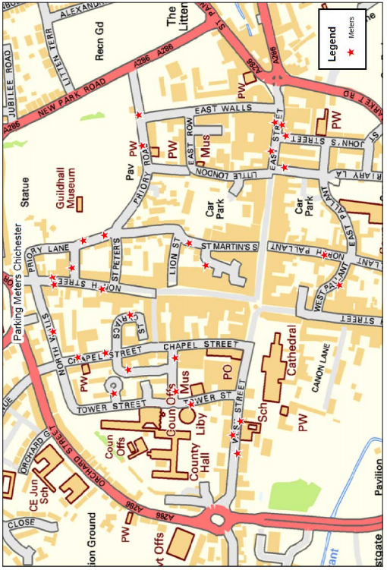

On-street Pay and Display machines and locations
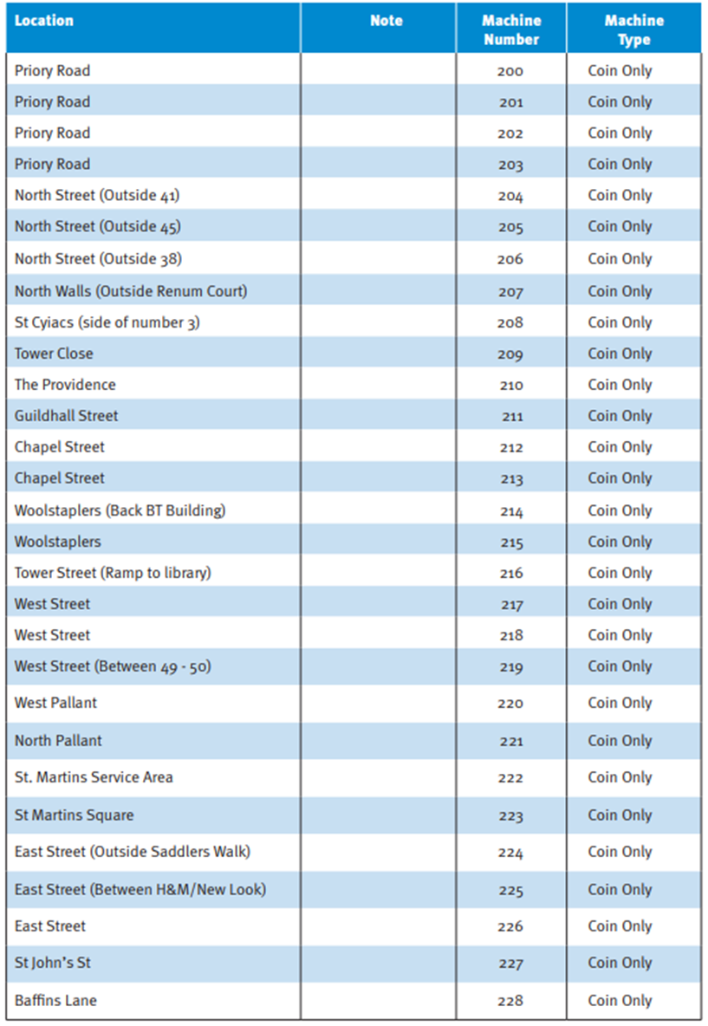

Appendix D - Controlled Parking Zones map
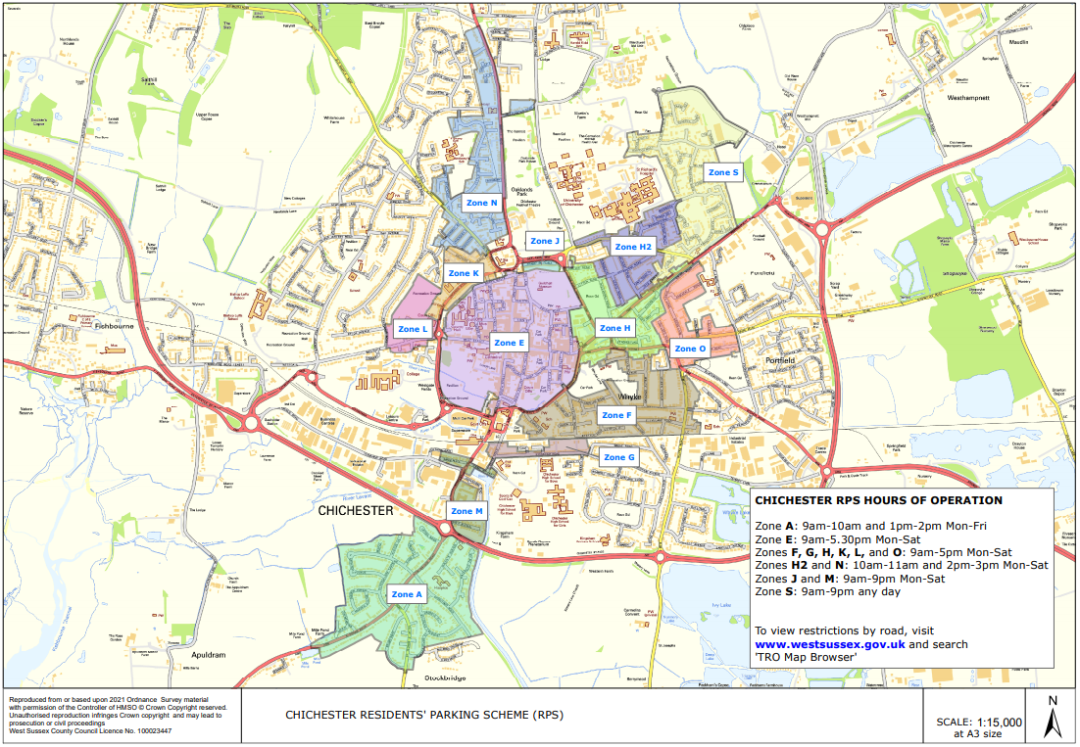

Appendix E - Location of Chichester City Centre Car Parks map

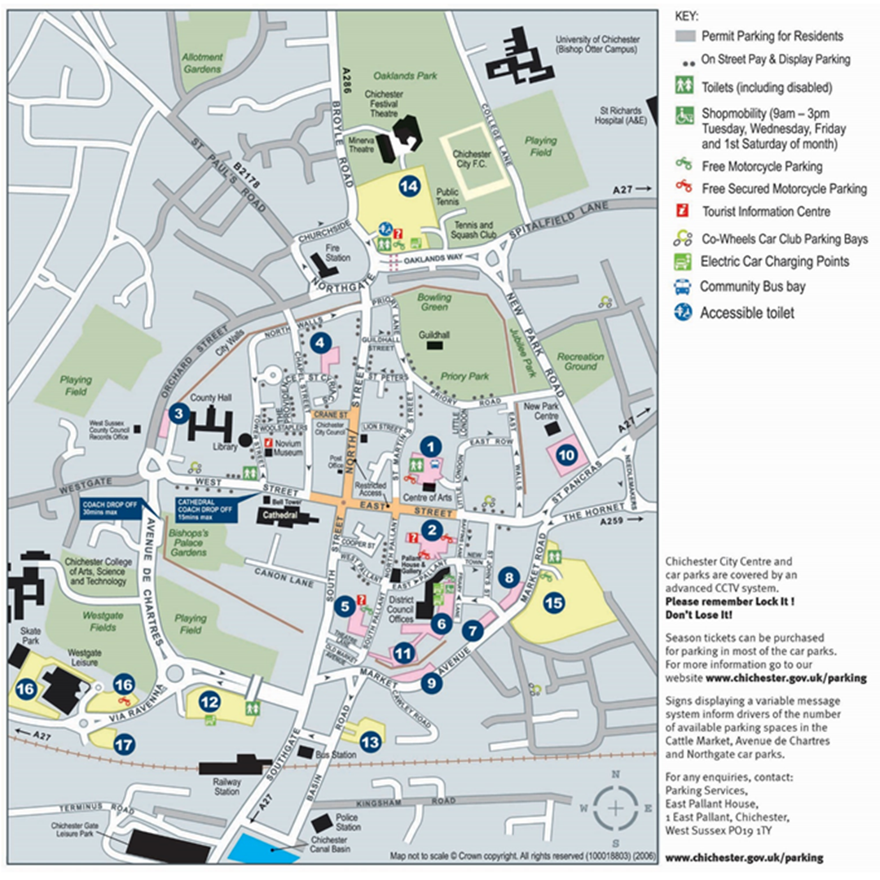

Parking Services,
Chichester District Council,
East Pallant House
1 East Pallant,
Chichester PO19 ITY

01243 534500
parkingservices@chichester.gov.uk
www.chichester.gov.uk/parking

www.chichester.gov.uk/parking

