# THE CHICHESTER DISTRICT COUNCIL (OFF STREET PARKING PLACES) (CONSOLIDATION) (VARIATION No. 2) ORDER 2022

*Road Traffic Regulation Act 1984, sections 32 and 35*

Chichester District Council (hereinafter called "the Council") in exercise of its powers under Sections 32, 35 and Part IV of Schedule 9 of the Road Traffic Regulation Act 1984, as amended ("the 1984 Act") and of all other enabling powers, with the consent of the West Sussex County Council in accordance with s.39(3) of the 1984 Act and after consultation with the Chief Officer of Police in accordance with Part Ill of Schedule 9 to the 1984 Act hereby makes the following Order:

# PART 1 GENERAL

Title

1. This order may be cited as the Chichester District Council (Off Street Parking Places) (Consolidation) Order 2022 and shall hereinafter be known as the 'Order'.

Commencement and Citation

1. This Order shall come into operation on the 1st day of April 2022 ("the Commencement Date").
2. Save as varied by this Order the Chichester District Council (Off-Street Parking Places) (Consolidation) Order 2021 ("the 2021 Order") as itself varied by the Chichester District Council (Off Street Parking Places) (Consolidation) (Variation No.1) Order 2021 ("the 2021 Order") shall continue to apply.
3. With effect from the Commencement Date, the 2021 Order as amended by the 2022 Order shall have effect with the variations specified in Part 2 hereof.

# PART 2 VARIATIONS

* 1. The parking fees schedule as attached.

GIVEN under the Common Seal of Chichester District Council on the 22nd day of May 2022

Picture of the Common seal of Chichester District Council


*,*

# SCHEDULE 7 - SCALE OF CURRENT CHARGES

|  |  |  |  |  |  |
| --- | --- | --- | --- | --- | --- |
| **Name of parking place** | **Classes of vehicles** | **Days of operation**  **(Hours of operation)** | **Charging days (Charging hours)** | **Pay on foot or pay and display parking place** | **Scale of charges** |
| **CHICHESTER CITY PAY AND DISPLAY PARKING PLACES** | | | | | |
| **CHICHESTER CITY** - **Central Short Stay** | | | | | |
| Baffins Lane car park | None | All days All hours | Monday to Saturday - 8.00am to 6.00pm  Sunday - 10.00am to 5.00pm | Pay and display | Up to 1 hour - £2.00 Up to 2 hours - £4.00 Up to 3 hours - £6.00 Up to 4 hours - £8.00 Up to 5 hours - £10.00 Up to 6 hours - £12.00 Up to 8 hours - £14.00  Up to 10 hours - £16.00 |
| Little London car park |
| **CHICHESTER CITY** - **Short Stay** | | | | | |
| Cawlev Priorv car park | None | All days All hours | Monday to Saturday - 8.00am to 6.00pm  Sunday - 10.00am to 5.00pm | Pay and display | Up to 30 minutes - 60p Up to 1 hour - £1.50 Up to 2 hours - £3.00 Up to 3 hours - £4.70 Up to 4 hours - £6.30  Up to 5 hours - £7.80 Up to 6 hours - £9.40 |
| East Pallant car park |
| Market Avenue/St John's  Street car park |
| Orchard Street (part) car  park |

|  |  |  |  |  |  |
| --- | --- | --- | --- | --- | --- |
| South Pallant car park |  |  |  |  | Up to 8 hours - £12.30 Up to 10 hours - £14.60 |
| St Cyriacs car park |
| Market Avenue car park (entire parking place) |
| Market Road car park (entire parking place) | None | All days All hours | Saturday - 8.00am to 6.00pm  Sunday - 10.00am to 5.00pm  Including bank holidays and public holidays | Pay and display | Up to 30 minutes - 60p Up to 1 hour - £1.50 Up to 2 hours - £3.00 Up to 3 hours - £4.70 Up to 4 hours - £6.30 Up to 5 hours - £7.80 Up to 6 hours - £9.40 Up to 8 hours - £12.30 Up to 10 hours -£14.60 |
| Orchard Street car park (entire parking place) |
|  |
| New Park Road car park | None | All days All hours | Monday to Saturday - 8.00am to 8.00pm  Sunday - 10.00am to 5.00pm | Pay and display | Up to 30 minutes - 60p Up to 1 hour - £1.50 Up to 2 hours - £3.00 Up to 3 hours - £4.70 Up to 4 hours - £6.30 Up to 5 hours - £7.80 Up to 6 hours - £9.40  Up to 8 hours - £12.30 |
|  |  |  |  |  | Up to 12 hours - £14.60 |
| **CHICHESTER CITY - Long Stay** | | | | | |
| Avenue de Chartres car park | Vehicles less than 1.93m in height | All days | Monday to Saturday - 8.00am to 6.00pm | Pay on foot parking place | Up to 30 minutes - 60p Up to 1 hour - 90p |
| Up to 2 hours - £1.90 |

|  |  |  |  |  |  |  |
| --- | --- | --- | --- | --- | --- | --- |
|  |  | All hours |  |  | Up to 3 hours - £2.80 Up to 4hours - £3.70 Up to 5 hours - £4.60 Up to 6 hours - £5.20  Up to 8 hours - £6.30 Up to 10 hours - £7.20 |  |
|  |
| Sunday - 10.00am to 5.00pm | Up to 3 hours - £1.00 Up to 4 hours - £2.00  More than 4 hours - £3.00 | |
| Basin Road car park | **None** | All days All hours | Monday to Saturday - 8.00am to 6.00pm | Pay and display | Up to 30 minutes - 60p Up to 1 hour - 90p  Up to 2 hours - £1.90 Up to 3 hours - £2.80 Up to 4 hours - £3.70 Up to 5 hours - £4.60 Up to 6 hours - £5.20  Up to 8 hours - £6.30 Up to 10 hours - £7.20 | |
| Cattle Market car park |
| Sunday - 10.00am  to 5.00pm | Up to 3 hours - £1.00 Up to 4 hours - £2.00  More than 4 hours - £3.00 | |
| Northgate car park | **None** | All days All hours | Monday to Saturday - 8.00am to 8.00pm | Pay and display | Up to 30 minutes - 60p Up to 1 hour - 90p  Up to 2 hours - £1.90 Up to 3 hours - £2.80 Up to 4 hours - £3.70 Up to 5 hours - £4.60 Up to 6 hours - £5.20  Up to 8 hours - £6.30 Up to 12 hours - £7.20 | |

|  |  |  |  |  |  |
| --- | --- | --- | --- | --- | --- |
|  |  |  | Sunday - 10.00am to 5.00pm |  | Up to 3 hours - £1.00 Up to 4 hours - £2.00  More than 4 hours - £3.00 |
| Rugby Club car park | None | All days All hours | Monday to Saturday  9.00am to 5.30pm | Pay and display | Up to 1 hour - 50p Up to 2 hours - £1.00 Up to 3 hours - £1.50 Up to 4 hours - £2.00 Up to 5 hours - £2.50  More than 5 hours - £3.50 |
| Westgate car park | None | All days All hours | Monday to Saturday  8.00am to 6.00pm | Pay and display | Up to 30 minutes - Free Up to 1 hour - Free  Up to 2 hours - Free Up to 3 hours - £2.80 Up to 4 hours - £3.70 Up to 5 hours - £4.80 Up to 6 hours - £5.70 Up to 8 hours - £6.80  Up to 10 hours - £7.70 |
| Sunday - 10.00am to 5.00pm | Up to 3 hours - £1.00 Up to 4 hours - £2.00  More than 4 hours - £3.00 |
| **CHICHESTER CITY - FREE OF CHARGE PARKING PLACES** | | | | | |
| Florence Road car park | None | All days  All hours | Free of charge - maximum stay 3 hours, no return  within 3 hours | Free of charge | Free of charge |
| **CHICHESTER CITY - COACH AND LORRY PARKING PLACE** | | | | | |

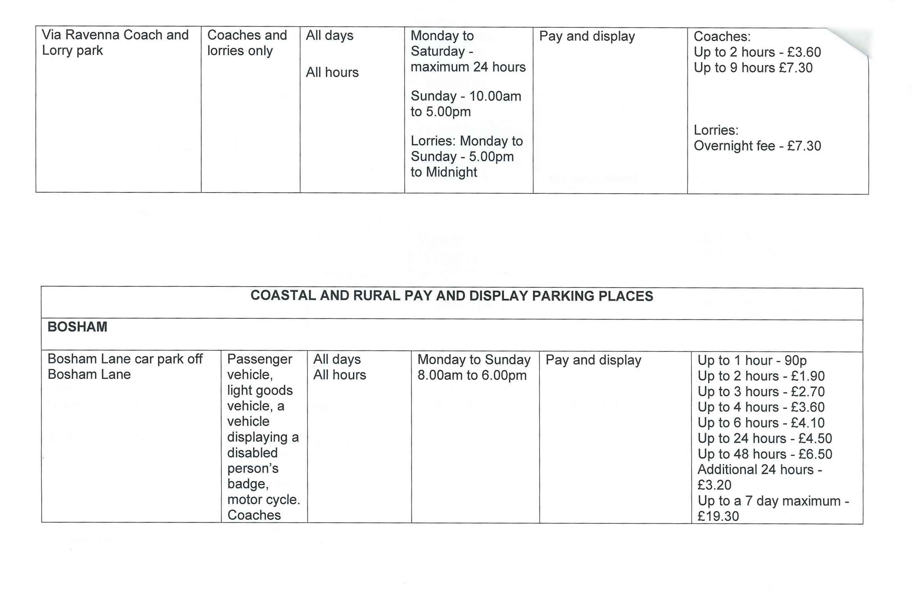

|  |  |  |  |  |  |
| --- | --- | --- | --- | --- | --- |
|  | and lorries in parking bays marked for coaches  and lorries |  |  |  | Coaches - £6.80 |
| **BRACKLESHAM BAY** | | | | | |
| Bracklesham Lane Car Park, Bracklesham Lane | None | All days All hours | 1st April to 31st October - Monday to Sunday - 8.00am to 6.00pm | Pay and display | Up to 2 hours - £2.30 Up to 4 hours - £4.40 Up to 10 hours - £5.60 |
|  |  |  | 1st November to 31st March - Monday to Sunday |  | Up to 2 hours - 70p Up to 10 hours - £1.90 |
|  |  |  | - 8.00am to 6.00pm |  |  |
| **WEST / EAST WITTERING** | | | | | |
| Marine Drive car park, Marine Drive (excluding the general season ticket car  park) | Passenger vehicle, light goods  vehicle, a | All days  All hours | 1st April to 31st October - Monday to Sunday -  8.00am to 6.00pm | Pay and display | Up to 2 hours - £2.30 Up to 4 hours - £4.40 Up to 10 hours - £5.60 |
|  | vehicle |  |  |  |  |

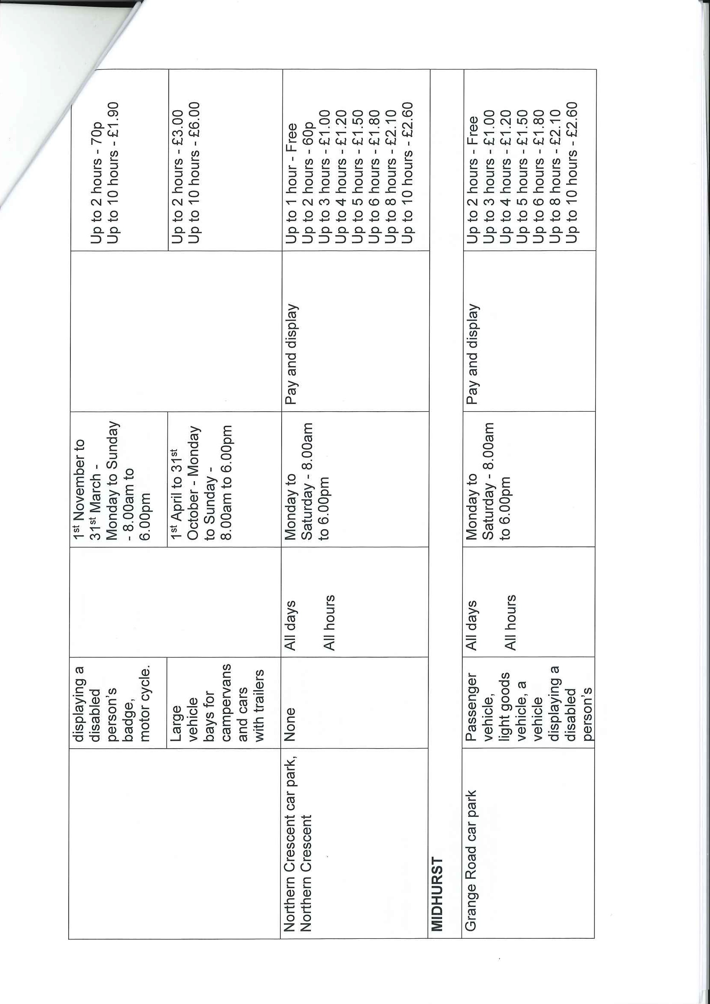

|  |  |  |  |  |  |
| --- | --- | --- | --- | --- | --- |
|  | badge, motor cycle. Coaches and lorries in parking bays marked for coaches  and lorries |  |  |  |  |
| Post Office car park, Grange Road | Passenger vehicle, light goods vehicle, a vehicle displaying a disabled person's badge, motor cycle. Coaches and lorries in parking bays marked for coaches  and lorries | All days All hours | Monday to Saturday - 8.00am to 6.00pm | Pay and display | Up to 1 hour - Free Up to 2 hours - 60p Up to 3 hours - £1.00 Up to 4 hours - £1.20 Up to 5 hours - £1.50 Up to 6 hours - £1.80 Up to 8 hours - £2.10 Up to 10 hours - £2.60 |
| North Street car park, North Street | Pay and display |
| **PETWORTH** | | | | | |
| Pound Street car park, Pound Street | Passenger vehicle, light goods  vehicle, a | All days | Monday to Saturday - 8.00am to 6.00pm | Pay and display | Up to 1 hour - Free Up to 2 hours - 60p Up to 3 hours - £1.00 |
| Uo to 4 hours - £1.20 |

\ -

|  |  |  |  |  |  |  |
| --- | --- | --- | --- | --- | --- | --- |
|  | vehicle displaying a disabled person's badge, motor cycle. Coaches and lorries in parking bays marked for coaches and lorries | All hours |  |  | Up to 5 hours - £1.50 Up to 6 hours - £1.80 Up to 8 hours - £2.10 Up to 10 hours - £2.60 |  |
|  |
| **SELSEY** | | | | | | |
| East Street car park, East Street | None | All days All hours | Monday to Saturday - 8.00am to 6.00pm | Pay and display | Up to 1 hour - Free Up to 2 hours - 60p Up to 3 hours - £1.00 Up to 4 hours - £1.20 Up to 5 hours - £1.50 Up to 6 hours - £1.80 Up to 8 hours - £2.10 Up to 10 hours - £2.60 | |
| East Beach car park | None | All days  All hours | 1st April to 31st October - Monday to Sunday - 8.00am to 6.00pm | Pay and display | Up to 1 hour - 50p  Up to 10 hours - £1.80 | |

|  |  |  |  |  |  |
| --- | --- | --- | --- | --- | --- |
| Selsey Marine car park, Hillfield Road | None | All days  All hours | 1st April to 31st October - Monday to Sunday - 8.00am to 6.00pm | Pay and display | Up to 1 hour - 50p Up to 10 hours- £1.80 |
| **COASTAL AND RURAL FREE OF CHARGE PARKING PLACES** | | | | | |
| **FERNHURST** | | | | | |
| Fernhurst car park | None | All days  All hours | Free of charge | Free of charge | Free of charge |
| **PETWORTH** | | | | | |
| Sylvia Beaufoy | None | All days  All hours | Free of charge | Free of charge | Free of charge |

|  |  |  |  |  |  |
| --- | --- | --- | --- | --- | --- |
| **CHICHESTER CITY - SEASON TICKET ONLY PARKING PLACES** | | | | | |
|  | Vehicles displaying a valid season ticket only or electronic payment has  been made | All days All hours | Monday to Saturday - 8.00am to 6.00pm  Sunday - 10.00am to 5.00pm | Pay and display | £90 per month (£513.00 when 6 months purchased (5% discount); £753.30 when 9 months purchased (7% discount); and £990.00 when 12  months purchased (1 month |
| Market Road car park |
| Orchard Street car park |
| free)) |

Chichester City - Roving season ticket parking places


|  |  |  |  |  |  |
| --- | --- | --- | --- | --- | --- |
|  | payment has been made |  | Sunday - 10.00am to 5.00pm |  |  |
| **CHICHESTER CITY - AVENUE DE CHARTRES CAR PARK SEASON TICKET PARKING PLACES** | | | | | |
| Avenue de Chartres car park | Vehicles displaying a valid season  ticket only or | All days  All hours | Monday to Saturday - 8.00am to 6.00pm | Pay on foot parking place | £49.00* per month - *£279.30 when 6 months purchased (5% discount); £410.13 when 9  months purchased (7% |
|  | electronic payment has been made |  | Sunday - 10.00am to 5.00pm |  | discount); and £539.00 when 12 months purchased (1 month free) |
| **CHICHESTER CITY - RUGBY CLUB CAR PARK SEASON TICKET PARKING PLACES** | | | | | |
| Rugby Club car park | Vehicles displaying a valid season ticket only | All days  All hours | Monday to Saturday  9.00am to 5.30pm | Pay and display | £500.00 per year  £150.00 quarterly |

i

|  |  |  |  |  |  |
| --- | --- | --- | --- | --- | --- |
| **COASTAL AND RURAL SEASON TICKET PARKING CHARGES/PLACES** | | | | | |
| Bosham Lane car park off Bosham Lane, Bosham | Vehicles displaying a valid season ticket only or | All days  All hours | All days  All hours | Pay and display | £22.00 per month  1 - 12 months can be purchased in advance |
|  | electronic |  |  |  |  |

|  |  |  |  |  |  |
| --- | --- | --- | --- | --- | --- |
|  | payment has  been made |  |  |  |  |
| Marine Drive car park, West  Wittering (general season ticket car park) | Vehicles  displaying a valid season ticket only or  electronic payment has | All days  All hours | Only available 1 April to 31 October  - Monday to Sunday - 9.00am to 5.00pm | Pay and display | £20.00 per month  1 - 7 months can be purchased in advance |
|  | been made |  |  |  |  |
| Pound Street, Petworth | Vehicles  displaying a valid season ticket only or electronic  payment has | All days  All hours | Monday to Saturday - 9.00am to 5.00pm | Pay and display | £20.00 per month  1 - 12 months can be purchased in advance |
|  | been made |  |  |  |  |
| Grange Road car park,  Midhurst | Vehicles  displaying a valid season ticket only or electronic  payment has | All days  All hours | Monday to Saturday - 9.00am to 5.00pm | Pay and display | £20.00 per month  1 - 12 months can be purchased in advance |
|  | been made |  |  |  |  |
| Post Office, Grange Road,  Midhurst | Vehicles  displaying a valid season ticket only or | All days | Monday to Saturday - 9.00am to 5.00pm | Pay and display | £20.00 per month  1 - 12 months can be purchased in advance |

|  |  |  |  |  |  |
| --- | --- | --- | --- | --- | --- |
|  | electronic payment has been made | All hours |  |  |  |
| North Street car park, Midhurst | Vehicles displaying a valid season ticket only or  electronic | All days All hours | Monday to Saturday - 9.00am to 5.00pm | Pay and display | £20.00 per month  1 - 12 months can be purchased in advance |
|  | payment has been made |  |  |  |  |
| East Street car park, Selsey | Vehicles displaying a valid season ticket only or electronic  payment has | All days All hours | Monday to Saturday - 9.00am to 5.00pm | Pay and display | £20.00 per month  1 - 12 months can be purchased in advance |
|  | been made |  |  |  |  |
| East Beach car park, Selsey | Vehicles displaying a | All days | 1st April to 31st October - Monday | Pay and display | £20.00 per month |
|  | valid season ticket only or electronic  payment has | All hours | to Sunday - 9.00am to 5.00pm |  | 1 - 12 months can be purchased in advance |
|  | been made |  |  |  |  |

**STATEMENT OF REASONS**

Income generated by car parking charges is regularly monitored. Parking charges are primarily a means of regulating a limited resource rather than raising income. Income raised is invested in maintaining and improving the car parks service, in retaining other Council services and in reducing Council Tax. The proposed charges have been considered by the Chichester District Parking Forum and reflect different circumstances and different methods of operation and various towns within the district. The District Council's Cabinet at its meeting on 5 November 2019 approved the recommendations with a minor amendment, ready for consultation with the public.

The proposals seek a balance between costs to residents, the needs of the local commerce and the importance of remaining competitive with other centres in the area. The charges are considered to be modest and in line with other similar areas and neighbouring authorities.

**PROPOSED PARKING CHARGES FOR CAR PARKS AT BOSHAM, CHICHESTER, MIDHURST, PETWORTH, SELSEY, EAST WITTERING and BRACKLESHAM BAY**

**Daily Parking Charges with effect from 1st April 2020**