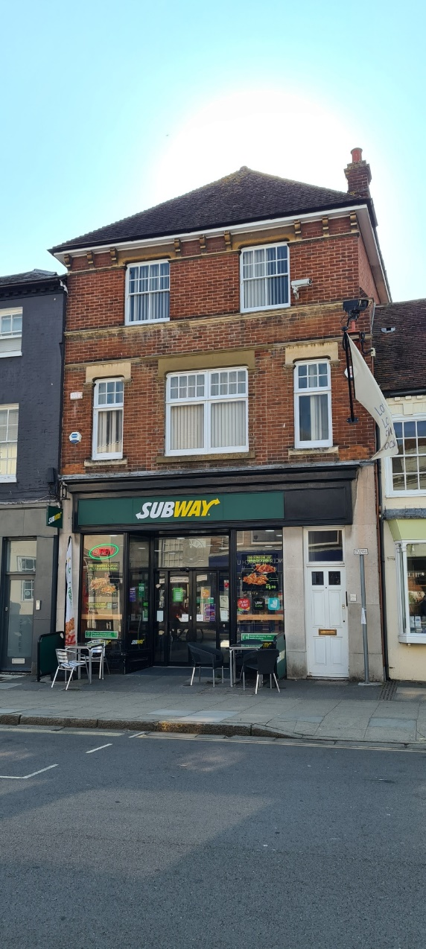**TO LET**

**Office Premises**

**PROPERTY AND DESCRIPTION**

This property is located on South Street in the historic city centre of Chichester in West Sussex and measures 127.62 m² (1,374 ft²).

The property benefits from its own access directly onto the street and is comprised of four offices over two floors (first and second floor) with its own toilet facilities and a kitchenette.

Please note that this property can only be accessed via stairs.

**USE**

The premises benefit from B1 use but alternative uses may be appropriate, subject to planning.

**TERMS**

The unit is available to let by way of a new lease with an asking rent of **£16,500 pa exclusive** in addition to a service charge. Alternative terms may be considered.

**29B South Street, Chichester**

**EPC**

The premises have an EPC rating of C.

**RATES**

The current rateable value is £12,250.

**OUTGOINGS**

The lessee will be responsible for rates, utilities, reimbursement of the insurance costs and any other outgoings that may be applicable.

**RENT DEPOSIT / GUARANTEE**

The Council will require a rent deposit as guarantee for the rent and tenant obligations.

**VIEWING**

Prospective tenants wishing to view this property should contact the Estates Service via:

e:[estatesservice@chichester.gov.uk](mailto:estatesservice@chichester.gov.uk)

t :01243 534632