**TO LET – INDUSTRIAL PREMISES**

**UNIT 4 WOODRUFF CENTRE**

**TERMINUS ROAD, CHICHESTER**

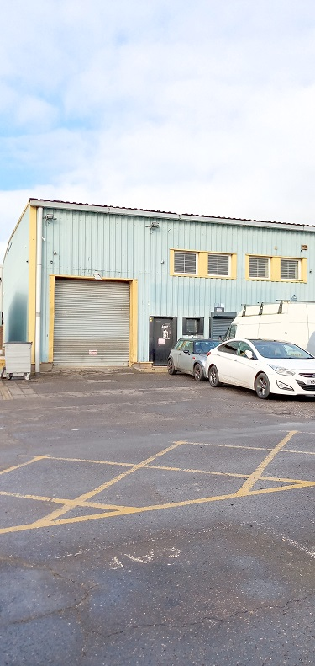

**PROPERTY**

The property is located on Terminus Road in Chichester and comprises of an industrial unit measuring 2,904ft². The property benefits from its own toilet facilities and a small kitchen.

**USE**

The property is suitable for industrial uses.

**ASKING RENT**

The Council is seeking rent in excess of £29,000 pa exclusive (plus VAT) in addition to a service charge. Alternative terms may be considered.

**EPC RATING**

The property has an EPC rating of C.

**OUTGOINGS**

The lessee will be responsible for rates, utilities, reimbursement of the insurance costs and any other outgoings that may be applicable.

**DEPOSIT**

The Council will require a deposit as guarantee for the rent and tenant obligations

**VIEWING**

Prospective tenants wishing to view this property should contact the Estates Service via:

Email: [estatesservice@chichester.gov.uk](mailto:estatesservice@chichester.gov.uk)

Tel: 01243 534632