**TO LET – INDUSTRIAL PREMISES**

**UNIT 7 WOODRUFF CENTRE, TERMINUS ROAD, CHICHESTER**

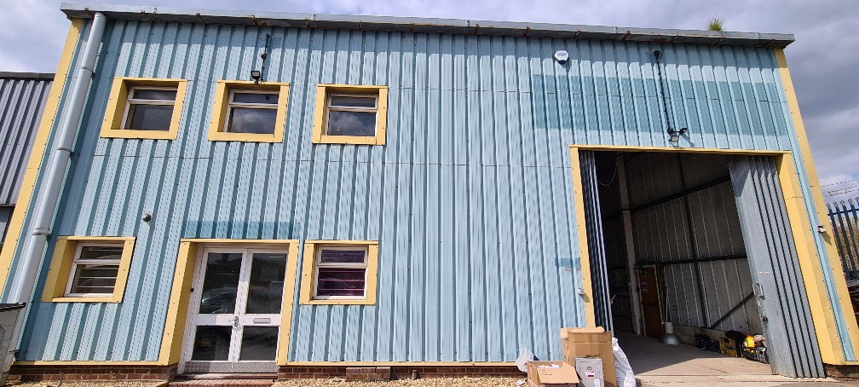

**PROPERTY**

The property is located on Terminus Road in Chichester and comprises of an industrial unit measuring 2,808ft² plus a mezzanine measuring 1,658ft². The property benefits from its own toilet facilities and a small kitchenette. There is office space at the front of the property.

**USE**

The property is suitable for industrial uses. The majority of uses on the estate are motor trade.

**ASKING RENT**

The Council is seeking rent in excess of £36,000 pa exclusive (plus VAT) in addition to a service charge. Alternative terms may be considered.

**EPC RATING**

The property has an EPC rating of B.

**OUTGOINGS**

The lessee will be responsible for rates, utilities, reimbursement of the insurance costs and any other outgoings that may be applicable.

**DEPOSIT**

The Council will require a deposit as guarantee for the rent and tenant obligations

**VIEWING**

Prospective tenants wishing to view this property should contact the Estates Service via:

Email : [estatesservice@chichester.gov.uk](mailto:estatesservice@chichester.gov.uk)

Tel : 01243 534632