### Greenhouse Gas (GHG) emissions inventory[1] for Chichester District Council for 2020-2021

1. **Overview**

This report follows the template set out in UK’s government Environmental Reporting Guidelines dated March 2019. The template is technical but the aim is to enable emissions reported by different organisations to be compared, so readers know that broadly speaking they are comparing like-for-like. This section aims to put across the key points in a non-technical way.

The first point is that we are trying to make our emissions inventory – our carbon footprint – better so that it includes more emission sources – even though we do not control them directly. We have focused on buildings that we own but lease out. So far, we have included our leisure centres. In this report, we have added in St James Industrial Estate, which has been re-built to higher standards of energy efficiency and included electricity generating solar panels. We have estimated emissions for all the years covered by the target for St James. Some other adjustments have been made to the list of smaller leased out assets in these years.

Our target is to reduce our emissions by 10% year-on-year from a start year of October 2018-September 2019. The year was chosen because it covers when the council declared a Climate Emergency and the start month of October reflects the start of the council’s energy contract. The changes outlined above - along with the addition of some missing electricity data - means that the reduction for the first year of the target (2019-2020) has been reduced from -16% to -12%.

This report covers the second year of the target, 2020-2021. Emissions have reduced by 4% in this year. This is below our 10% target. The advantage of year-on-year target is that the pressure is on immediately to make reductions. All our biggest emissions sources – see the graph in section 7 - either have projects underway to reduce their emissions or have just been assessed to see what can be done. These actions are described in our Climate Emergency Action Plan. However, it takes time for projects to be planned, equipment and contractors procured, and work to be done. Delivery times for renewable energy equipment are particularly long currently due to global supply chain issues. However, the effect of some projects should be visible in the October 2022-September 2023 figures, with the benefits of other actions coming through after that.

1. **Organisation information**

Chichester District Council is a lower-tier local authority with its main offices at 1 East Pallant, Chichester, West Sussex, PO19 1TY.

1. **Reporting period**

01/10/2020 to 30/9/2021

1. **Organisational boundary**[2]

We have used the operational control approach. Therefore, all services delivered directly by the council and Chichester Contract Services are included in Scope 1 and Scope 2 emissions.

This encompasses fuel and electricity use at:

* The council’s headquarters at East Pallant House which has solar electric (PV) and solar thermal arrays
* Westward House short stay accommodation
* Novium museum which has a wood pellet-fueled boiler
* Car parks
* Westhampnett depot
* Other smaller buildings
* Refuse fleet
* Other council-operated vehicles

We have been trying to include emissions from assets that we own but lease out to reflect our shared responsibility for these assets. These emissions fall into the Scope 3 emissions category for the council. For some smaller leased out assets,

we pay for the energy and then recharge the tenant. For other assets, we request the data from the tenant. This applies to the leisure centres (Westgate, Bourne and Grange) which were the first to be added to our inventory.

For this 2020-2021 report, emission estimates for St James industrial estate were added to the inventory. St James is a business park owned by CDC. It is being re-developed by the council to a higher energy efficiency standard and with PV panels on the roof. Emissions have been estimated pre re-development. Only emissions resulting from the use of communal areas and the heating and lighting of the business units have been estimated as the units have been used for different business purposes which could have widely different energy consumptions. Emissions have been estimated for the business units post-redevelopment and these will be incorporated into the CDC inventory as these units are let.

For this 2020-2021 report, the Well-To-Tank emissions from electricity lost during transmission and distribution on the grid are included for the first time and have been retrospectively added to 2019-2020 emission figures.

Adding emission sources triggers recalculation of the previous years’ emission figures. This makes it difficult to keep track of progress against the target, so extra sources will not now be added until the next target is set.

1. **Reasons for change in emissions**

There was a significant decrease in coal generation of electricity and an increase in the amount of renewable and nuclear electricity generation on the national grid. This means that for every kWh of electricity used from the grid, 9% fewer greenhouse gases were emitted compared to the previous reporting period (source: the UK Government GHG Conversion Factors for Company Reporting for 2021). This is the second year running that emissions per kWh have decreased by 9%.

On the other hand, the Well-to-Tank emissions per kWh have increased. Well-To-Tank emission factors account for the production, transport and distribution of the fuels used in electricity generation. The UK Government has improved the methodology for calculating the Well-To-Tank emissions factor for UK electricity. This has increased this emission factor from 0.03217 kgCO2e/kWh in 2019-2020 reporting year to 0.05529 kgCO2e/kWh in 2020-2021. Therefore, although our electricity consumption has decreased year-on-year, our emissions in this Scope 3 category have gone up by a substantial 24 tCO2e.

The changes above are due to changes in emission factors, but there are other ways that our emissions can change: through a reduction in energy use. National measures to reduce the spread of Covid fell within this period which affected working practices and use of the leisure centres and other facilities.

There are other factors specific to the council that affect its energy use. The depot has additional electricity using equipment on site. The vehicle washing facility started operating in the summer of 2020, so 2020-2021 would be the first full year of operation. The council’s data centre is now located at the depot. Data began to be backed up there from July 2000, although it did not become full operational until July 2022.

Correlating weather data with energy consumption would be a development that will enable CDC to understand its emissions better, but the focus for the moment is reducing emissions from the major emission sources.

1. **Quantification and Reporting Methodology**

The UK government’s Environmental Reporting Guidelines dated March 2019 and the 2021 UK Government Conversion Factors for Company Reporting have been used, along with the GHG Protocol Value Chain (Scope 3) Standard.

Electricity used via CDC’s network of public Electric Vehicle charge-points has for the first time been split out from CDC’s electricity use in its own operations. It is still accounted for within our inventory but as Scope 3 emissions rather than Scope 2. This change has been applied retrospectively applied to previous years.

1. **Operational Scopes**

We have estimated our Scope 1, 2 and certain Scope 3 emissions.

**Table 1: CDC’s Scope 1, Scope 2 and Scope 3 emissions**

| **Emissions in tCO2e[3]** | **2020-2021** | **Excluded emission sources** | **% of activity data[4] that is estimated** | **2019-2020** |
| --- | --- | --- | --- | --- |
| Gas consumption | 102 | Oving Jubilee Hall & 80 High Street, Selsey (aka Selsey Fire Station). Both used as Community Warden bases[5]. | 0 | 99 |
| LPG | 40 | None | 0 | 37 |
| Fuel emissions for vehicles | 1,114 | None | 0 | 1,154 |
| Fugitive[6] emissions of refrigerants used in air con. |  | Air con unit reporting is being developed. |  |  |
| TOTAL SCOPE 1 | 1,256 |  |  | 1,290 |
| Purchased electricity – location-based approach | 277 | Oving Jubilee Hall & 80 High Street, Selsey, public conveniences at Itchenor [7]. | 0 | 346 |
| TOTAL SCOPE 2[8] | 277 |  |  | 346 |
| **Scope 38 emissions in tCO2e** |  |  |  |  |
| Purchased goods & services |  | We have not tried to quantify these emissions yet. |  |  |
| Capital goods |  | We have not tried to quantify these emissions yet. |  |  |
| Electricity – transmission & distribution (T&D) losses | 24 |  | 0 | 30 |
| Fuel- and energy-related activities not included in Scopes 1 & 2 | 371 |  | 0 | 346 |
| Upstream transportation & distribution |  | We have not tried to quantify these emissions yet. |  |  |
| Waste generated in operations |  | We have not tried to quantify these emissions yet. Would include green waste from parks. |  |  |
| Business travel | 25 | Employees who use their own vehicles for business travel but do not claim the mileage allowance. Travel using rail. This is infrequent. | 2% is estimated. This is due to CDC not having the gCO2/km from the employee’s V5 vehicle document. | 33 |
| Employee commuting |  | We have not tried to quantify these emissions yet. |  |  |
| Upstream leased assets |  | Not thought to be relevant. |  |  |
| Downstream leased assets | 973 | Collecting data from leased out assets is being developed. | 0 | 995 |
| Downstream transportation & distribution |  | Not relevant. |  |  |
| Processing of sold products |  | Not relevant. |  |  |
| Use of sold products | 6 | Electricity used via CDC EV charge-points only. | 0 | 6 |
| End-of-life treatment of sold products |  | We have not tried to quantify these emissions yet. They would include emissions from trade waste collected by CCS. |  |  |
| Franchises |  | Not relevant. |  |  |
| Investments |  | We have not tried to quantify these emissions yet. |  |  |
| Biogenic emissions | 0 |  |  | 0.07 |
| **Intensity metrics** |  |  |  |  |
| Scope 1, Scope 2 & selected Scope 3 emissions per district resident  (tCO2e per capita) | 0.02 |  |  | 0.03 |
| Scope 1, Scope 2 & selected Scope 3 emissions per unit area (tCO2e per km2) | 3.61 |  |  | 3.75 |

**Table 2: Emissions totals**

|  | **2020-2021** | **2019-2020** | **% reduction** |
| --- | --- | --- | --- |
| **Emissions (S1, S2 & selected S3) tCO2e** | 2,930 | 3,046 | 4% |

The year-on-year change in emissions from the Council’s key emission sources is shown in the graph below.

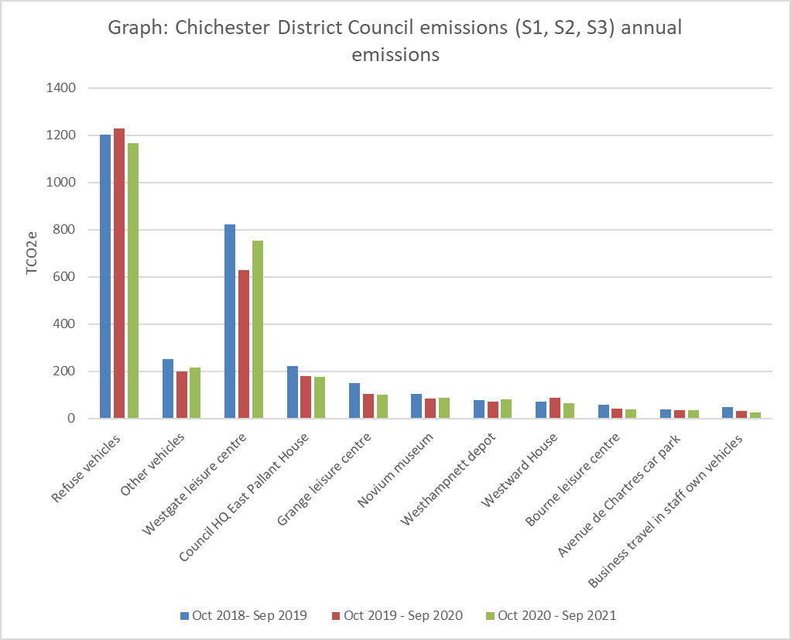

1. **Base year**

The base year is 01/10/2018 to 30/9/2019

We have chosen this period as it is:

• the year of the council’s climate emergency resolution

• fits with the electricity and gas contract periods

• the subsequent periods will show the effect of Covid 19 lockdown and any GHG reduction initiatives we put in place following the declaration of a climate emergency.

1. **Target**

Our target is a 10% year-on-year reduction from the 2018-2019 base year, covering Scopes 1 and 2 and selected Scope 3 categories until year-end 2025. When emissions were reported to full Council in January 2022, an emission reduction of 16% from 2018-2019 to 2019-2020 was reported. This has been revised downwards to 12%.

The change is due to several reasons. As explained in Section 4, the council has been developing its reporting of Scope 3 emissions from the downstream leased assets. Emissions from Bourne, Grange and Westgate leisure centres had already been included in our inventory and prior years have been recalculated as a result. To expand our coverage of leased out assets, estimates of emissions from St James Industrial Estate have been made for 2018-2019, 2019-2020 and 2020-2021 and added to those years’ emission figures. Furthermore, Well-to-Tank emissions from electricity lost during transmission and distribution on the grid are included for the first time for this year 2020-2021. This change has been applied retrospectively to previous years. These changes impact the previously reported percentage change in emissions reported for 2019-2020 compared to 2018-2019.

Two other changes affect previously reported emissions for 2019-2020: missing electricity data has now been added in; there have been adjustments to the leased out assets list; double-counting of emissions from 3 Market Road has been removed. The aggregate effect of these changes is that a 12% reduction is reported rather than a 16% reduction.

For 2010-2021, we can report that our emission reduction is 4%.

1. **Intensity Metrics**

Our chosen intensity metrics are Scope 1, Scope 2 and selected Scope 3 emissions per resident in the district (tCO2e per district resident) and emissions per unit area (tCO2e per km2). The number of residents within the district is a key factor in determining the scale of our activities and hence our emissions. The acreage of the district is a factor in determining the how we deliver those services i.e. the extent to which services can be centralised.

1. **Electricity & heat data**

| **Energy purchased for consumption (MWh)** | 1,303 MWh electricity. 556 MWh gas. |
| --- | --- |
| **Green tariffs or other renewable/low-carbon contractual instruments used** | Yes for both gas and electricity, but we have used a location-based accounting approach. |
| **Renewable electricity (in MWh) generated in council-operated plants that was exported to the grid** | Electricity is generated via the PV panels on East Pallant House roof, but data on the quantity exported to the grid is not yet known. |
| **Was this backed by Renewable Energy Guarantees of Origin (REGOs)?** | Not known |
| **Heat generated from council operated sources (in MWh).** | CDC has a solar thermal array generating hot water on East Pallant House roof. We do not have data on the quantity generated. |

1. Inventory is the technical term for a footprint.
2. There are different ways to draw a line around organisations – its boundary. We have used operational control so that we are accounting for emissions from activities over which we have day-to-day control.
3. tCO2e stands for metric tonnes of carbon dioxide equivalent. The global warming caused by gases is standardised to the warming caused by one unit of carbon dioxide hence carbon dioxide equivalent.
4. Activity data is the data used to estimate emissions e.g. how much fuel we have used, how many miles we have driven for business. Some activity data has not been measured or taken from records and is estimated instead.
5. CDC has no obligation to pay energy bills for these sites.
6. Fugitive is the technical terms for emissions from leaks or accidental venting of equipment.
7. These conveniences at Ferryside, The Street, are leased from Chichester Harbour Conservancy.
8. Scope 2 and scope 3 emissions are indirect emissions. They occur as a result of activities over which we do not have control e.g. a power station generating electricity or at the paper mill of the company making CDC stationery. However, we have influence over these emissions which is why they are reported. Scope 2 is a special category of indirect emissions covering electricity, heat, steam and cooling that has been acquired (usually purchased).