|  |  |
| --- | --- |
|  | Logo of Chichester District Council |
| **Parking Services**  **Annual Report 2021-2022** | |
| **Graphic of parked car in a bay** | |
|  | |

**www.chichester.gov.uk/parkingservices**

Contents

Foreword 2

1. Introduction 4

1.1. Overview 5

1.2. Parking Services Responsibilities 6

1.3. Why Have Parking Controls? 7

2. Penalty Charge Notice (PCN) Statistics and Information 8

2.1. Warning Notices 9

2.2. Higher and Lower Penalty Charge Notice Split 9

2.3. Regulation 10 Penalty Charge Notices 10

2.4. Top 3 Contraventions On-Street and Off-Street 11

2.5. Top 3 Locations to Receive a Penalty Charge Notice 13

2.6. Penalty Charge Notice Payments and Correspondence 14

2.7. Debt Collection and Vulnerability 16

3. Cancellations 18

3.1. Top 4 Reasons for Cancellation 18

4. Online Appeals and FOAM 20

4.1. Learning from Appeals 21

5. Ongoing Projects 22

5.1. Blue Badge Enforcement 22

5.2. Electric Vehicles 23

6. Our Online Presence 24

6.1 Improvements to Online Services 24

6.2 Social Media 25

6.3 Website Page Views 27

6.4 Payments Through our Website 28

7. Off-Street Car Parks Overview 29

7.1. Subsidised and ‘Free’ Parking 29

7.2. Providing Flexibility when Parking 30

7.3. Car Parks Throughout the Year 30

7.4. Keeping it Clean and Safe 30

8. Digital Season Tickets 31

9. MiPermit 32

10. On-Street Parking Overview 34

10.1 City Centre On-Street Pay and Display 34

10.2 Lines and Signs 34

10.3 Protecting Parking Schemes 34

10.4 Problem Parking and Directing Enforcement 34

11. School enforcement 36

12. On-Street Permits 37

12.1 Controlled Parking Zones 38

12.2 Non-Resident Permits 38

12.3 Resident Visitor Permits 38

13. Dispensations and Suspensions 39

14. West Sussex County Council CPZ Extension 40

15. Partnership Working 41

16. Freedom of Information and Subject Access Requests 42

17. Equality of Access to our Services 43

18. Complaints and Compliments 46

19. Financial Information 50

19.1 Income 50

19.2 Expenditure 51

20. Looking Back and Looking Forward 53

20.1 Accreditation of Safer Parking Award 53

20.2 West Sussex County Council, CPZ Extension 53

20.3 Electric Vehicles and Electric Vehicle Charging Points 53

20.4 Parking Strategy 54

20.5 Parking Incentives 54

20.6 Relining Car Parks 54

20.7 Blue Badge Enforcement 55

20.8 MiPermit 55

20.9 E-forms 55

20.10 PATROL Award 55

20.11 Managing Coastal Traffic 55

20.12 Key Areas of Work for 2022/2023 56

21. Parking Strategy 57

22.Common Myths and FAQs 58

22.1. Parking Myths 58

22.2. Frequently Asked Questions 60

23. Appendices 64

Appendix A – Contravention Code List 64

**Contravention Code List – On-Street** 64

**Contravention Code List – Off-Street** 65

Appendix B - Pricing Details for Pay & Display Car Parks Across the District 66

Appendix C - On-street Pay and Display Machines Map 71

Appendix D - Controlled Parking Zones map 73

Appendix E - Location of Chichester City Centre Car Parks Map 74

Foreword

Welcome to Chichester District Council’s Annual Parking Services Report for 2021-2022.

Chichester District Council sits in the middle of a proud landscape of historic towns, quaint villages, rolling countryside and scenic beaches. Each location has its own character which reflects the local community and enjoyed by our many visitors to the area. With this diversity comes the challenge of balancing the different needs of town, country, and coast, and how Parking Services works within it.

Through this report Chichester District Council will share information on how Parking Services and Civil Parking Enforcement is delivered across the Chichester District.

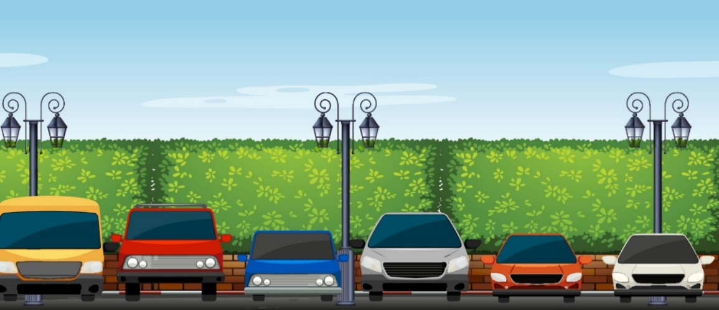

This year Parking Services have successfully achieved the implementation of two new Controlled Parking Zones which are entirely digital, and the extension of three existing zones. Along with the on-street developments, Parking Services has also continued to renew and re-line off-street car parks to improve the service for our customers.

I was delighted that for another year 28 of our 31 car parks maintained their accreditations for both the Safer Parking Award and Disabled Parking Accreditation. In addition to this, Parking Services received the 2020 PATROL PACER Award for Best use of Digital Channels.

Though there remains a lingering effect from Covid-19 regarding usage of our car parks and the changes of people’s parking requirements, the statistics within the report indicate that we are nearing pre-pandemic levels. There is an increase in commuters, visitors, and subsequently the issuing of Penalty Charge Notices.

During 2022/2023, there will be an increased emphasis on improving the car park experience for our customers through progressing the project for the refurbishment of Northgate car park, along with exploring options for further enhancements to Bosham car park.

The Parking Services team are always keen to receive ideas from customers on how to further improve our service. Should you have any comments or feedback on the service provided, please email: ParkingServices@chichester.gov.uk

I would like to thank the Parking Services team for their hard work and their ongoing commitment to improve and modernise the service, which continues to develop and deliver.

I would also like to thank you for taking the time to read our Annual Report, and I hope you will find it informative and answers any questions you may have regarding our service.

Tony Dignum

Cabinet Member, Growth and Place

# 1. Introduction

Our annual report aims to provide a useful overview of the work carried out by the Parking Services team during 2021-2022 and also acts as a helpful tool to those who are curious about why we operate and how we deliver the service.

The total population of the Chichester District is 124,000 and we attract 6.2 million tourists a year. Residents and visitors alike enjoy the beauty and diversity of the rolling Sussex downs, our spectacular coastline and the historic prominence of the bustling city centre. As well as visiting for pleasure, Chichester District also attracts more people into the area to work than there are residents who commute out and it is therefore continuously important for us to make sure that there are sufficient accessible and safe parking spaces to accommodate our visitors when they

reach us.

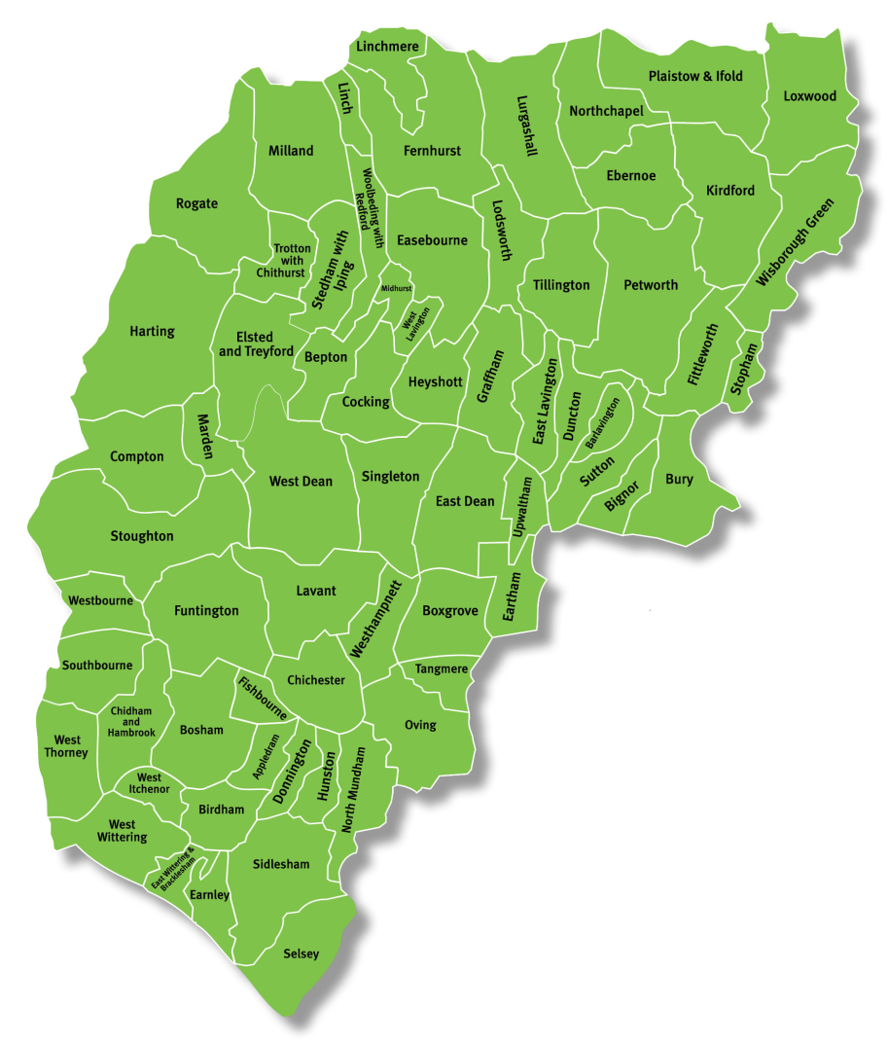

## Overview

Chichester District Council (CDC) has operated under Civil Parking Enforcement (CPE) since April 2010 and work as agents for West Sussex County Council (WSCC) to cover on-street enforcement across the district on their behalf. This complements the off-street (car parks) services which is managed by CDC.

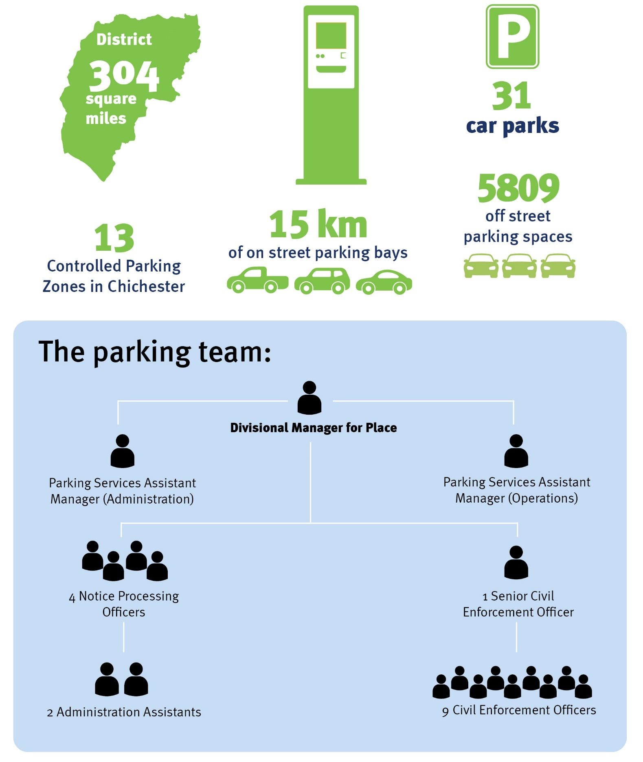

## Parking Services Responsibilities

Where we are a two-tiered authority, some functions are carried out by the Parking Services team and others by colleagues at West Sussex County Council

| Chichester District Council | | West Sussex County Council | |
| --- | --- | --- | --- |
| Illustration of a car | Employs Civil Enforcement Officers to patrol and enforce on-street and off-street. | Illustration of a car | Implement and review on-street parking restrictions and resident parking schemes. |
| Illustration of a car | Employ an Administration team including Notice Processing Officers. | Illustration of a car | Process and issue skip licenses |
| Illustration of a car | Administer on-street permit schemes and administer season tickets for car parks | Illustration of a car | Coordinate street works |
| Illustration of a car | Administer bay suspensions and dispensations. | Illustration of a car | Attending to potholes |
| Illustration of a car | Process and respond to appeals against Penalty Charge Notices (PCNs) on and off-street | Illustration of a car | Process requests for new Traffic Regulation Orders |
| Illustration of a car | Report defects on and off-street and maintain lines and signs on-street (outside of the Controlled Parking Zones (CPZ)). | Illustration of a car | Issuing (Temporary Traffic Regulation Orders) (TTROs). |
| Illustration of a car | Attend to and maintain payment machines  on and off-street. | Illustration of a car | Set on-street parking guidance for Chichester District Council and other local authorities in West Sussex. |
| Illustration of a car | Reacting to parking problems on and off-street | Illustration of a car | Determine parking charges on the highway. |
| Illustration of a car | Carry out Blue Badge Enforcement. |
| Illustration of a car | Set off-street parking guidance for District council owned car parks. Determine parking charges in council-owned car parks. |

## Why Have Parking Controls?

It is widely recognised that places need to adapt to keep up with the changing needs of the people who live, work, or visit an area. Well planned restrictions, reasonable well designed charging tariffs and parking schemes help us to achieve this and respond to the changing demands of our city. Parking controls therefore aim to:

* Assist with the free flow of traffic and reduce issues of access for emergency vehicles
* Support different groups of motorists
* Provide fair access to parking spaces
* Support the local economy
* Help reduce congestion on-street and minimise the environmental impact of vehicles in town centres
* Support the environmental agenda

Whilst there is no doubt that parking restrictions are needed to manage the growing number of vehicles on our roads, the Parking Services department undertakes more than just issuing Penalty Charge Notices. The work carried out by the team assists to balance the needs of a multitude of customers, including businesses, allowing Blue Badge holders to park close to amenities, delivery vehicles near to shops, and residents close to their homes; all of which promote the sustainable economic growth of the district.

# 2. Penalty Charge Notice (PCN) Statistics and Information

# 

Table 1 - Total Penalty Charge Notices issued

| Financial Year | On-Street | Off-Street | All PCNs |
| --- | --- | --- | --- |
| 2019-20 | 5,572 | 4,494 | 10,066 |
| 2020-21 | 3,829 | 2,451 | 6,280 |
| 2021-22 | 5,686 | 3,733 | 9,419 |

As we started to live with Covid-19 and move back to a more normal way of living, the issuing of Penalty Charge Notices on all contraventions resumed, rather than in 2020 when our focus was on-street where there were safety restrictions or where a vehicle was preventing access to a parking space. On-street enforcement is always our priority with an emphasis to ensure that roads are kept clear from congestion. The table above illustrates that Penalty Charge Notices are on the way to returning to the pre pandemic figurers.

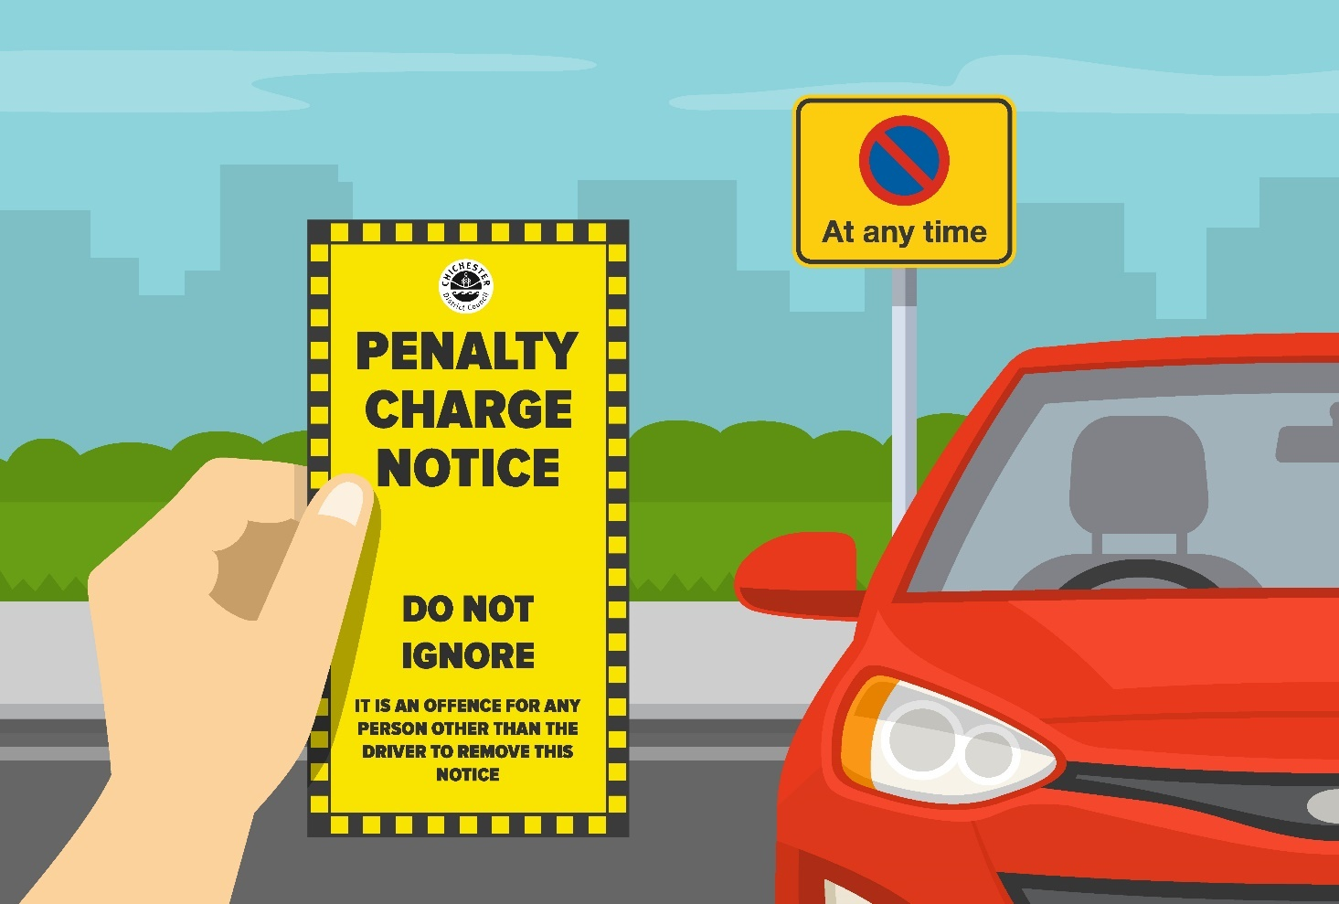



## 2.1. Warning Notices

Warning notices help motorists to avoid future Penalty Charge Notices by drawing attention to the restrictions in place. Where restrictions are newly implemented or where the parking conditions may require further clarification to a motorist, a warning notice will be issued instead of a Penalty Charge Notice.

During 2021-22 when implementing the new controlled parking zones of ‘Zone A’ and ‘Zone S’ we saw an increase of warning notices being issued due to warning drivers for the first two weeks that the restrictions came into force. A total of 104 on-street and 1 off-street warning notices were issued to vehicles during this period.



## 2.2. Higher and Lower Penalty Charge Notice Split

Some contraventions are less serious than others and this is reflected by the level of the higher charge. Higher contraventions are more likely to be on-street where there are safety related restrictions such as yellow lines and loading bans. A lower contravention may be where a customer failed to display a pay and display ticket correctly.

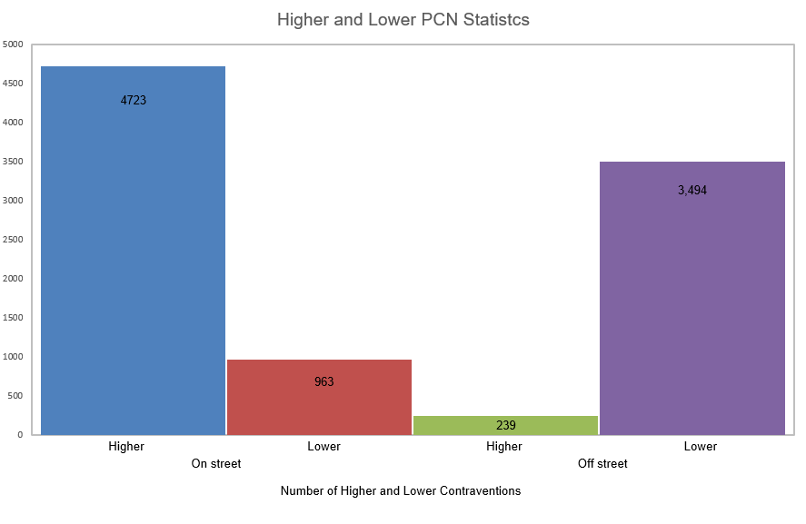

## Regulation 10 Penalty Charge Notices

Civil Enforcement Officers (CEOs) are able to issue Regulation 10 Penalty Charge Notices to reduce the number of incidents where a Penalty Charge Notice has been prevented from being served.

A Regulation 10 Penalty Charge Notice refers to the manner in which a Notice is issued. Whilst the majority of Penalty Charge Notices are issued under Regulation 9 of The Civil Enforcement of Parking Contraventions (England) General Regulations 2007 which provides that a Penalty Charge Notice can be either affixed to a vehicle or handed to the driver, Regulation 10 enables a local authority to serve the Penalty Charge Notice by post if the Civil Enforcement Officer has been prevented from issuing the Penalty Charge Notice, or where the vehicle was driven away before the Penalty Charge Notice could be served.

It is essential that motorists feel that the system is fair and consistent. Issuing Regulation 10 Penalty Charge Notices helps to demonstrate that anyone committing a parking contravention is subject to the same enforcement. Motorists who prevent a Penalty Charge Notice being served by either driving away or adopting threatening or abusive behaviour towards Civil Enforcement Officers, may have historically avoided any penalty and therefore poor parking habits have been perpetuated. This has had a detrimental effect on road safety and compliance. Regulation 10 Penalty Charge Notices assist with preventing the public perception of ‘selective’ enforcement where the Civil Enforcement Officer was prevented from issuing a Penalty Charge Notice and minimise the loss of Civil Enforcement Officer time.

The level of Regulation 10 Penalty Charge Notices has remained low during 2021-22. All Civil Enforcement Officers are trained to clearly inform a motorist of the process in place for serving Penalty Charge Notices by post and a driver may reconsider their intention to avoid being served a Penalty Charge Notice when this information is provided. However, over the course of the year, one Regulation 10 Penalty Charge Notice has been issued and payment for this has been made

## Top 3 Contraventions On-Street and Off-Street

Table 2 - Highest contraventions on-street

| Financial Year | Code 16  No permit | Code 01  Waiting restriction | Code 30  Overstay Limited Waiting |
| --- | --- | --- | --- |
| 2019-20 | 1,256 | 1,445 | 571 |
| 2020-21 | 754 | 1,396 | 415 |
| 2021-22 | 1,782 | 1,315 | 581 |

The table above shows the split of Penalty Charge Notices which were issued on-street for the top three highest contraventions.

Code 16 - ,‘Parked in a permit space or zone without clearly displaying a valid permit’ was the most common reason a Penalty Charge Notice is issued on-street. Motorists contravening this code could have forgotten to display a permit or may not be entitled to park in the bay at all.

Within Chichester there are 13 Controlled Parking Zones (CPZs) which occupy the city centre and surrounding area. Each zone provides designated Permit Holder bays for residents and their visitors. Other Permit Holders including Healthcare workers and Carers can also use these bays whilst working to provide services to residents within the parking scheme.

Code 01 – Waiting Restrictions have dropped for the first time in three years to the second highest proportion of Penalty Charge Notices which are issued. These are Penalty Charge Notices where yellow line restrictions or ‘waiting restrictions’ are sited in locations where it is unsuitable for vehicles to wait or park.

Enforcing on vehicles parking on waiting restrictions helps to reduce congestion and helps to keep our roads safe. Although yellow lines restrict vehicles waiting, there are various exemptions which apply to ensure that particular activities can be carried out. One example of an exemption enables a motorist to load and unload from a vehicle. Another may be if a vehicle is displaying a valid Blue Badge where the conditions of the Blue Badge Scheme allow parking for up to three hours.

Code 30 – Overstay Limited waiting bays was the third highest proportion of Penalty Charge Notices issued. These bays provide short stay parking places and promote a higher turnover of parking spaces. These restrictions can prevent vehicles parking for long periods of time which in turn encourages more visitors to the area.

Table 3 - Highest contraventions off-street

| Financial Year | Code 73  Parked without payment of parking charge | Code 83  No valid ticket | Code 82  Expired ticket | Code 85  Parked without permits | Code 86  Parked beyond bay markings |
| --- | --- | --- | --- | --- | --- |
| 2019-20 | N/A | 2,992 | 743 | 297 | N/A |
| 2020-21 | N/A | 1,945 | 355 | 56 | 86 |
| 2021-22 | 1,536 | 1,274 | 537 | N/A | N/A |

The table above shows the split of Penalty Charge Notices issued off-street.

Code 73 - ‘Parked without payment of parking charge’ was the most common reason which has overtaken Code 83 due to all but one of the Councils pay and display car parks now having phone payments.

Code 83 - ‘Parked in a car park without clearly displaying a valid pay & display ticket or voucher or parking clock’ was the second the most common reason for a Penalty Charge Notice being issued.

Where customers do not purchase sufficient time to cover their stay, or where they are late returning to their vehicle, these vehicles will be issued with a Penalty Charge Notice because the pay and display ticket has expired. Since phone payments were introduced in 2017, we have seen a reduction every year in Penalty Charge Notices issued under code 82. This may be due to customers using the MiPermit cashless parking service, which provides the ability to extend a parking stay remotely and opt for a reminder text when parking is due to expire.

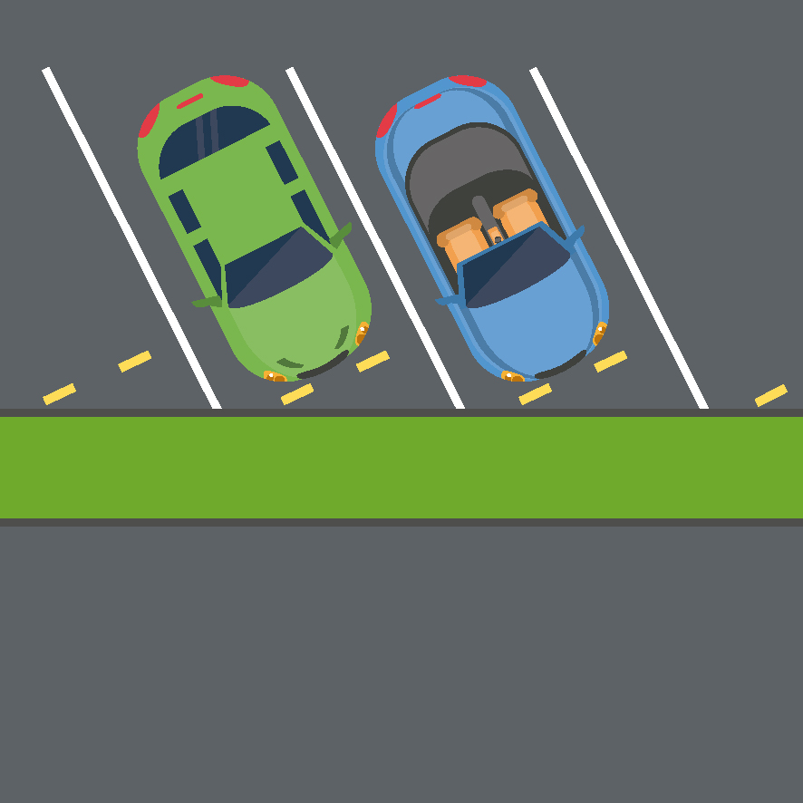

## Top 3 Locations to Receive a Penalty Charge Notice

The Parking Services team monitor the district for areas which are most likely to attract the issuing of a Penalty Charge Notice. In general, where there are locations with significant numbers of parking spaces, there will be a higher level of Penalty Charge Notices having been issued. This applies to the larger car parks and the busiest locations in the city and town centres.

Heat mapping can provide useful information in the detection and prevention of perceived parking problems by producing data which helps to better direct resources. Monitoring and revisiting maps following changes to enforcement creates a visual representation about whether compliance was improved, how effective the action has been, and whether displacement is observed. Where high numbers of Penalty Charge Notices are issued, information provided by the heat mapping tool with the back office system supports measures to maximise compliance with the restrictions. These measures can include, improving signage and lines, increased enforcement, providing different payment options and making it easier for customers to park correctly. Where requests for enforcement are received, or where Parking Services is asked to demonstrate how often Civil Enforcement Officers patrol in a particular location, we are able to supply useful and clear information to support enforcement activities.

**Top 3 Locations**

On-Street Off-Street

North Street Midhurst – 295 Cattle Market car park - 534

North Street Chichester – 245 East Pallant/Cawley Car Park – 370

East Street Chichester - 212 Little London Car Park - 309

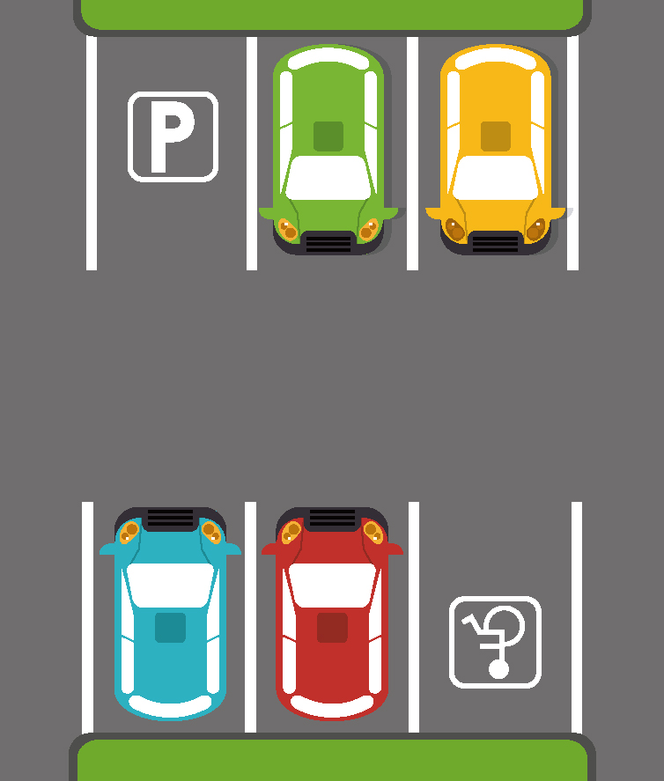

## Penalty Charge Notice Payments and Correspondence

There are defined stages to the Parking Penalty Enforcement Process and the charge will increase at each stage. There are also defined stages to the appeals process and three opportunities to challenge the Penalty Charge Notice.

During 2021-22, there were a total of 4,640 challenges, representations and other

correspondence received and processed by the Notice Processing team.

To make challenging as accessible as possible, customers can contact us via our online portal, email us or write to us. Customers can also review photographic evidence and submit documents with their challenge, online.

* [https://www.chichester.gov.uk/parkingtickets](https://www.chichester.gov.uk/parkingtickets%20)
* [parkingservices@chichester.gov.uk](mailto:parkingservices@chichester.gov.uk)
* Parking Services   
  1 East Pallant  
  East Pallant House

Chichester   
West Sussex

PO19 1TY

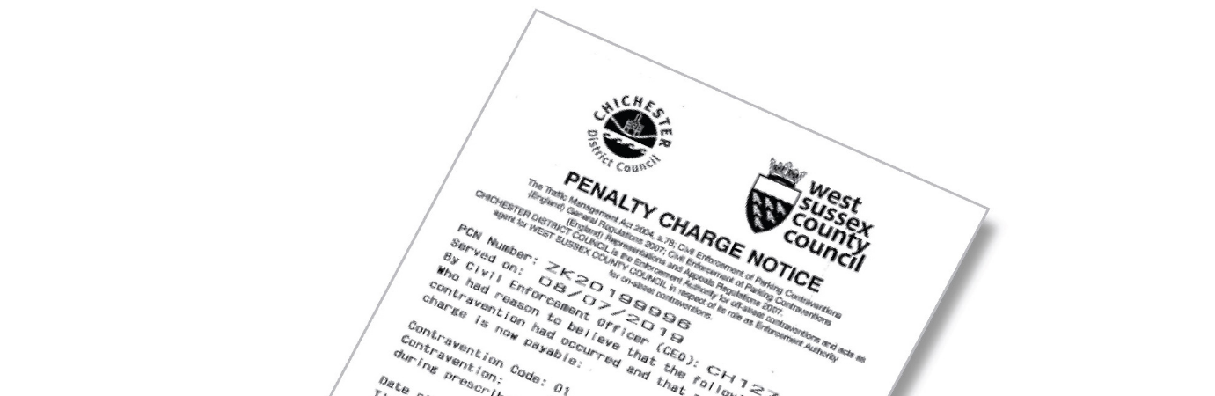

| Payments | Correspondence |
| --- | --- |
| **Penalty Charge Notices issued (informal stage)** | |
| **62%** of all customers paid at the discounted amount of £25 or £35.  **70%** of customers pay during the informal stage prior to the Notice to Owner being served. | **62%** of all correspondence was received during the informal stage.  231 (39%) challenges related to off-street PCNs and 3579 (61%) to on-street PCNs. A challenge can be made online, verbally, by email or by letter. |
| **Notice to Owners served (formal)** | |
| **7.4%** of customers pay £50 or £70 during the formal stage, following service of a Notice to Owner to the registered keeper. | **10%** of all correspondence was received at the formal representations stage where the owner or an authorized person can submit representations against the Notice to Owner.  581 (40%) representations related to off-street PCNs and 878 (60%) to on-street PCNs. |
| **Charge Certificates served (formal)** | |
| **2%** of customers pay £75 or £105 following service of the Charge Certificate. | **2%** of all correspondence was received following service of the Charge Certificate. While there is no formal right to appeal at this stage, Parking Services will check to ensure that that a case has been carried out correctly. |

| Correspondence Received Post-Charge Certificate | Evidence and Supporting Information |
| --- | --- |
| **2%** of all correspondence was received following service of the Order for Recovery. Correspondence may include completed Witness Statements and applications for out of time witness. statements, where the council is issued with instructions by the Traffic Enforcement Centre. | **23%** of all correspondence received was supporting information, invariably where evidence has been requested in order to further consider a PCN. |

Early settlement of Penalty Charge Notices incurs the customer less costs, therefore it is imperative that all challenges are considered fully. It is also imperative that a thorough response is sent to ensure that customers can make well informed decisions as to whether they will pay or continue to appeal a Penalty Charge Notice. As there are costs associated with the appeals process, it is also important to minimise the number of times a customer needs to contact Parking Services so that the team is able to direct resources efficiently.

## Debt Collection and Vulnerability

Parking Services undertakes debt collection through Enforcement Agents (EAs) when all other methods have been unsuccessful. Processes are in place to communicate what a customer can expect if a Penalty Charge Notice remains unpaid.

By way of The Taking Control of Goods Regulations 2013 (TCOG), the team will instruct Enforcement Agents to recover unpaid debts. Whilst most Penalty Charge Notices have been either paid or a Challenge/Representation accepted by this stage, the team during 2021-22 sent 663 Penalty Charge Notices to Enforcement Agents as warrants.

Enforcement Agents fees are set out in The Taking Control of Goods (Fees) Regulations and 2013 (TCOG).

* Compliance stage - £75.00 applies in addition to the debt and an Enforcement Agent will seek to contact the debtor
* Enforcement stage - £235.00 applied to debt and compliance fee where an Enforcement Agent will seek to visit the debtor
* Sale or disposal stage - £110.00 applied in addition to the aforementioned fees, should the Enforcement Agent take control of goods

**During 2021-22**:

**633** warrants were issued.

**28** cases were referred to their specialised welfare teams.

**465** Payment Plans were arrangements, 210 of which were paid within 3 months.

**54%** of cases were paid in full at compliance stage

**46%** of cases were paid in full at enforcement stage

The temporary regulations introduced which prevented Enforcement Agents carrying out visits to customer properties due to Covid-19 have been removed and normal enforcement has resumed.

**Vulnerability**

The Taking Control of Goods Regulations place an emphasis on identifying and considering vulnerability and during 2021-2022, 28 warrants were reviewed and investigated by dedicated welfare teams. Parking Services react to all claims of vulnerability and consider cases carefully should vulnerability be suspected or communicated to us. Based on the information available, Notice Processing Officers will consider the most appropriate course of action to take and whilst a Penalty Charge Notice will not necessarily be written off, customers can be guided to support services and independent advice, or can be offered payment plans to help spread payments over longer periods of time.

The Parking Services team also works closely with the Council’s Communities team to consider any issues of vulnerability when these are presented to us by customers. This helps to ensure that the team is providing the correct advice and is signposting to partner organisations where necessary.

This year we had a particular case where, after advice was given regarding a Penalty Charge Notice, it was identified that the customer was financially vulnerable and, after Parking Services liaised with the Contact Centre, food bank vouchers were provided to them. Further assistance was requested for the customer to be referred to West Sussex County Council’s welfare team.

# 3. Cancellations



## Top 4 Reasons for Cancellation

Table 4 – Percentages of Penalty Charge Notices cancelled (2018-22)

| Month | 2018-19 | 2019-20 | 2020-21 | 2021-22 |
| --- | --- | --- | --- | --- |
| April | 8% | 8% | 13% | 5% |
| May | 7% | 7% | 4% | 5% |
| June | 8% | 7% | 10% | 2% |
| July | 7% | 9% | 8% | 8% |
| August | 7% | 9% | 8% | 7% |
| September | 10% | 10% | 10% | 8% |
| October | 9% | 10% | 12% | 9% |
| November | 7% | 8% | 10% | 8% |
| December | 6% | 10% | 14% | 10% |
| January | 10% | 8% | 9% | 10% |
| February | 8% | 12% | 9% | 10% |
| March | 8% | 14% | 6% | 7% |
| Total | 8% | 8% | 10% | 8% |
| Spoiled deduction | 7% | 7% | 8% | 8% |

Cancellations occur when a Penalty Charge Notice is found to be incorrectly issued, incorrectly processed, where the contravention did not take place, or where it is proven that mitigating circumstances took place. When a Penalty Charge Notice is cancelled, Parking Services will record this and, where there are contact details, write to the customer to explain that no payment or further action is required.

Notice Processing is a defined process which is set down in parking legislation. In some circumstances, failure to adhere to the requirements may result in the cancellation of the Notice; for example, where a processing error leads to a Charge Certificate being served before a representation is responded to. One of the more challenging areas of a Notice Processor’s role is being able to determine whether mitigating circumstances led to the customer receiving a Penalty Charge Notice by asking pertinent questions and obtaining adequate evidence to support a decision. Whilst it may be the case that a customer deems a Penalty Charge Notice to be unjust due to a perceived minor infringement, or that the actions which led to the Penalty Charge Notice being issued were not deliberate, if a contravention has occurred and there were no mitigating factors which led to the Penalty Charge Notice being issued, it may not be cancelled.

| Amount cancelled | | | |
| --- | --- | --- | --- |
| Reason | 2019-20 | 2020-21 | 2021-22 |
| Virtual Payment Verified | 113 | 95 | 196 |
| P&D Not Displayed | 171 | 89 | 105 |
| CEO Error | 86 | - | 101 |
| Mitigation | - | 41 | 63 |

Table 5 – Top 4 Reasons for Cancellations

Civil Enforcement Officers are careful to ensure that all Penalty Charge Notices are issued correctly and accurately, however some errors can occur. Processes are in place to address concerns and raise training issues to prevent errors occurring. As specific details are required to be recorded correctly in line with regulations, should these details be incorrect, the Penalty Charge Notice will be cancelled: for example, the Penalty Charge Notice is issued with the wrong contravention code. As expected, where use of the MiPermit digital parking system is growing, the number of Penalty Charge Notices being cancelled for reasons relating to use of this service has increased. The team considers mitigation when reviewing challenges where circumstances leading to a contravention may have been out of the motorists’ control.

# 4. Online Appeals and FOAM

If a customer is unhappy with the decision made by the Council, once a rejection to a representation has been made, they have the right to appeal to the Traffic Penalty Tribunal (TPT). The Traffic Penalty Tribunal is made up of independent Adjudicators and their role is to hear and decide appeals brought against Penalty Charge Notices.

During 2021-22, 28 customers submitted appeals via the Fast Online Appeals Management (FOAM) system provided by the Traffic Penalty Tribunal. FOAM has provided improved access to the tribunal service for both the appellant and the Council alike and this helps to reduce staff time and cost associated with compiling cases. Only 21% of all customers using the appeal service requested their cases to be printed and posted to them.

* 75.00% of appeals were decided without the customer requesting a hearing
* 11% of customers requested a telephone hearing
* 4% of appeals were multiple Penalty Charge Notice appeal which is where the appellant has more than one Penalty Charge Notice and appeals them all in one hearing
* 1 case was withdrawn by the customer before the adjudicator had looked at the appeal

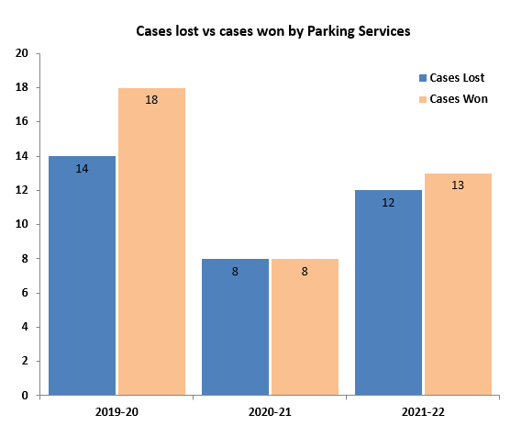



## Learning from Appeals

Notice Processing Officers take note of Adjudicator decisions and have used this information to determine if a case should be non-contested. More cases have been non-contested than in previous years. The Parking Services team reviews each appeal decision to ensure that future cases can be considered in light of observations made by adjudicators of the Traffic Penalty Tribunal. Adjudicator decisions are shared between other local authorities in West Sussex and discussed at county-wide meetings to ensure that all staff processing appeals are aware of useful information to improve their own appeal outcomes, and to promote consistency.

One improvement that has come from a Traffic Penalty Tribunal decision was to change our Notice of Rejection letter templates making the section clearer if the Council are asking for evidence. This will help ensure that the customer can provide the Council with the evidence to cancel a Penalty Charge Notice rather than make an unnecessary appeal to the Traffic Penalty Tribunal.

Table 6 – Rate of Appeals

|  |  |  |  |  |  |
| --- | --- | --- | --- | --- | --- |
| Financial year | Appeals | Rate of appeal per PCN | Not contested by CDC | Cases Lost by CDC | Cases Won by CDC |
| 2019-20 | 34 | 0.33% | 2 | 14 | 12 |
| 2020-21 | 24 | 0.38% | 8 | 8 | 8 |
| 2021-22 | 28 | 0.30% | 3 | 12 | 13 |

# 5. Ongoing Projects



## Blue Badge Enforcement

Blue Badges are vital to those who need them, and the Parking Services team works hard to protect the integrity of the scheme and to enable use of accessible spaces. Whilst the Civil Enforcement Officers undertake enforcement relating to the correct use of Blue Badges on a daily basis as part of their regular enforcement activity, the team also works closely with West Sussex, along with dedicated Enforcement Officers from Brighton and Hove City Council to undertake dedicated enforcement days to enforce and retain misused Blue Badges. Alongside this, regular communication is shared via both the Council’s social media channels to provide information relating to how Blue Badge misuse can be reported and to increase awareness of the scheme.

This year, the following activity took place:

* 37 Disabled Blue Badges have been retained
* 17 badges have been destroyed due to displaying a deceased person’s or an expired badge

## Electric Vehicles



Parking Services have a combination of fast (3 hour) and rapid (1 hour) bays located in the following car parks across the district:

|  |  |  |
| --- | --- | --- |
| Location | Number of Bays | Number of Machines |
| Avenue de Chartres car park, Chichester | 4 | 2 |
| Bosham Lane car park, Bosham | 2 | 1 |
| East Pallant car park, Chichester | 2 | 1 |
| East Street car park, Selsey | 2 | 1 |
| Northern Crescent car park, East Wittering | 2 | 1 |
| Northgate car park, Chichester | 2 | 1 |
| North Street car park, Midhurst | 2 | 1 |
| Pound Street car park, Petworth | 2 | 1 |

Chichester District Council recognised that Parking Services could contribute to its Climate Change Action Plan. We therefore purchased two electric vehicles and are pleased to report these have met the expectations of the department. In the coming year, we will also be replacing our remaining petrol-run vans with electric vehicles. While demand can easily be met at this time with the current level of electric vehicle charging bays, we continue to review the usage of these bays to understand more clearly what customers need and how to future proof this element of the service.

# 6. Our Online Presence

## 

## Improvements to Online Services

Parking Services has significantly enhanced our online services. The team continue to give a faster, more streamlined service, encouraging all our customers to go online to apply, seek information, and report any parking issues. Over the pandemic the team had to tackle the increased number of email correspondence and in response to this we introduced additional E-forms to assist customers, therefore during 2021-22 we have seen a reduction of emails and a significant shift to our online E-forms. We have worked closely and have been supported by our colleagues in the Information and Communications team who have enabled us to maximise online services for our customers. We have successfully completed the following:

* Improved the customer journey by redesigning the parking web pages
* Provided further online, self-service options for applications
* Provided a simple way to report issues to the team
* Ensured web accessibility across pages and documents

In June, the team introduced two new E-forms, replacing paper application forms required for all our other on-street parking permits (including Healthcare, Carer, Non-Resident, and Traders permits). Since its introduction, over 460 customers have benefitted from a more convenient and flexible way of submitting applications, and we look to become completely digital by introducing further E-forms next year across all areas of our to service.

We were delighted to receive recognition for our enhanced online presence through the award of the 2019-20 PATROL PACER Award for Best use of Digital Channels.

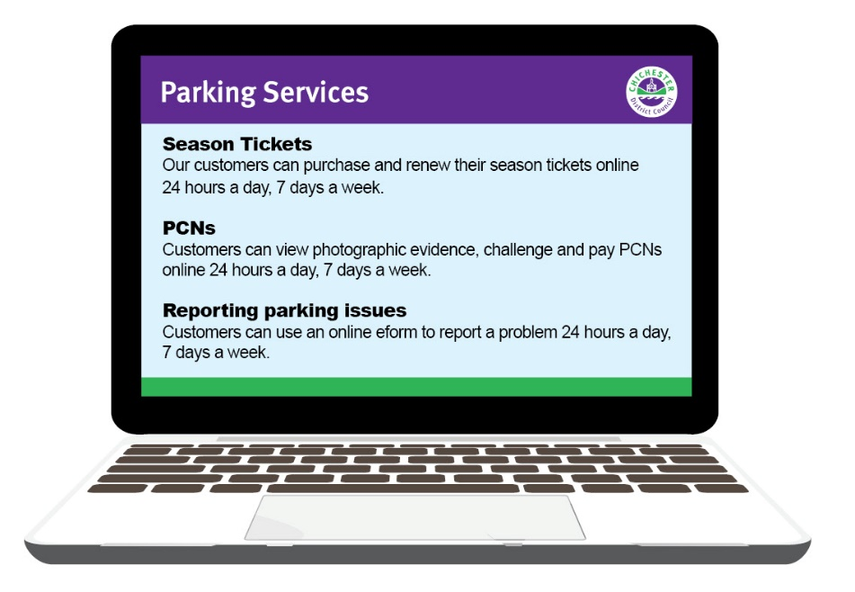

## Social Media

Social media platforms help us to connect with our customers, increase awareness about services and share important information. With so many people around the world using social media, communicating in a way that is relevant to different users is important to us. The council currently has 10,000 followers on Facebook, over 8,400 on Twitter, and more than 2,000 followers on Instagram. The council also has a LinkedIn account, a YouTube channel and a NextDoor page. Across all platforms during 2021-2022, we ran several campaigns to communicate a variety of different messages to the public and responded to customers comments.

Notably, social media proved a successful way of promoting our Christmas parking incentives, a campaign which aimed to encourage people to shop locally in the district’s high streets in the run up to Christmas. We also used social media to make people aware that the service had won a parking award, and that our resident and visitor parking permits application process was moving online. These campaigns helped us to:

* Further advertise our services and provide service updates
* Encourage customers to interact in different ways
* Promote use of contactless payments through MiPermit, our cashless parking operator
* Support the district’s high street businesses and support the local economy.

Examples of our messages include the following:

Example 1:

‘*Have you done your Christmas shopping yet? There’s still time to collect your free personalised gift tags and recycled wrapping paper in participating businesses in Chichester, East Wittering, Midhurst, Petworth and Selsey*.

*Why not take advantage of our brilliant festive parking offers now:*

*🎁Select two hours and get the third hour free in most of our council-owned car parks across the district when using the MiPermit app*

*🎁Free parking every weekend in December in our Avenue de Chartres car park in Chichester*

*Free parking after 4pm in the Avenue de Chartres car park for the Chichester late night shopping events on 9, 16 and 23 December*



*You can find out more about these amazing offers and how you can help* [*#SupportLocal*](https://www.facebook.com/hashtag/supportlocal?__eep__=6&__cft__%5b0%5d=AZU5h7g6KhCDf0AvLbsQfe1NAinES9ew_fR9VRNTteMEHplzcgq6suf2wa4DjIgnNkazCllY77N7JN32rQz5u_yKq4tXfl_sg_dWj_ph7WNQ8ombv1ijt_RtdcR_VsunEB_rbI01W1jDkcESbEYb6xPoHJH6N72sI6ThE3xS4umXGg&__tn__=*NK-R) *businesses here:* [*www.chichester.gov.uk/countdowntochristmas*](http://www.chichester.gov.uk/countdowntochristmas?fbclid=IwAR1b_Dpirt7O7nI6wbVgO_YcUeUA2x5pBgJhgLxy-Zzb0oOqjx4uJXnoCZQ)

[*#LoveFromChichester*](https://www.facebook.com/hashtag/lovefromchichester?__eep__=6&__cft__%5b0%5d=AZU5h7g6KhCDf0AvLbsQfe1NAinES9ew_fR9VRNTteMEHplzcgq6suf2wa4DjIgnNkazCllY77N7JN32rQz5u_yKq4tXfl_sg_dWj_ph7WNQ8ombv1ijt_RtdcR_VsunEB_rbI01W1jDkcESbEYb6xPoHJH6N72sI6ThE3xS4umXGg&__tn__=*NK-R)[*#LoveFromChichesterDistrict*](https://www.facebook.com/hashtag/lovefromchichesterdistrict?__eep__=6&__cft__%5b0%5d=AZU5h7g6KhCDf0AvLbsQfe1NAinES9ew_fR9VRNTteMEHplzcgq6suf2wa4DjIgnNkazCllY77N7JN32rQz5u_yKq4tXfl_sg_dWj_ph7WNQ8ombv1ijt_RtdcR_VsunEB_rbI01W1jDkcESbEYb6xPoHJH6N72sI6ThE3xS4umXGg&__tn__=*NK-R)[*#LoveFromEastWittering*](https://www.facebook.com/hashtag/lovefromeastwittering?__eep__=6&__cft__%5b0%5d=AZU5h7g6KhCDf0AvLbsQfe1NAinES9ew_fR9VRNTteMEHplzcgq6suf2wa4DjIgnNkazCllY77N7JN32rQz5u_yKq4tXfl_sg_dWj_ph7WNQ8ombv1ijt_RtdcR_VsunEB_rbI01W1jDkcESbEYb6xPoHJH6N72sI6ThE3xS4umXGg&__tn__=*NK-R)[*#LoveFromMidhurst*](https://www.facebook.com/hashtag/lovefrommidhurst?__eep__=6&__cft__%5b0%5d=AZU5h7g6KhCDf0AvLbsQfe1NAinES9ew_fR9VRNTteMEHplzcgq6suf2wa4DjIgnNkazCllY77N7JN32rQz5u_yKq4tXfl_sg_dWj_ph7WNQ8ombv1ijt_RtdcR_VsunEB_rbI01W1jDkcESbEYb6xPoHJH6N72sI6ThE3xS4umXGg&__tn__=*NK-R)[*#LoveFromPetworth*](https://www.facebook.com/hashtag/lovefrompetworth?__eep__=6&__cft__%5b0%5d=AZU5h7g6KhCDf0AvLbsQfe1NAinES9ew_fR9VRNTteMEHplzcgq6suf2wa4DjIgnNkazCllY77N7JN32rQz5u_yKq4tXfl_sg_dWj_ph7WNQ8ombv1ijt_RtdcR_VsunEB_rbI01W1jDkcESbEYb6xPoHJH6N72sI6ThE3xS4umXGg&__tn__=*NK-R)[*#LoveFromSelsey*](https://www.facebook.com/hashtag/lovefromselsey?__eep__=6&__cft__%5b0%5d=AZU5h7g6KhCDf0AvLbsQfe1NAinES9ew_fR9VRNTteMEHplzcgq6suf2wa4DjIgnNkazCllY77N7JN32rQz5u_yKq4tXfl_sg_dWj_ph7WNQ8ombv1ijt_RtdcR_VsunEB_rbI01W1jDkcESbEYb6xPoHJH6N72sI6ThE3xS4umXGg&__tn__=*NK-R)’

Example 2:

*‘🚘 Our permit application process is now online, making it even easier to apply, renew or pay for your resident and visitor parking permits*.’

This service can now be accessed anytime, anywhere at [www.chichester.gov.uk/permits](http://www.chichester.gov.uk/permits), with the aim of making the process more convenient for customers.   
  
Although our permits can no longer be purchased in person from our council offices, if you — or someone you know — can’t access our website or need support using the online system, our Parking Services team are here to help. Simply call: 01243 534500.’

Example 3:

‘*Need to stay longer in the Chichester District? Did you know, you can extend your parking time using MiPermit without going back to your car*.’

Find out more at: [www.mipermit.com/help](http://www.mipermit.com/help)

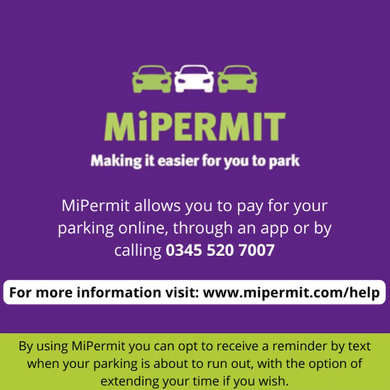

## Website Page Views

Website visits have increased by 52.84% to 145,930 during 2021-22. Where Covid-19 had previously restricted travel, visitors to our car parks has risen and the launch of our new design across the Parking Services webpages has helped both for tourism and commuting/working purposes.

In 2021-22 our top 3 most viewed areas were Car Park Charges, On Street Parking (this includes our Consultations pages from our zone expansion), with a lot of renewed interest in our Season Ticket pages.

On most of our webpages we have a website feedback tab where customers are encouraged to submit their experience to make sure we are giving the customer the best ‘journey’ they can have.

## Payments Through our Website

| PCNs | Total | Web | % | Non-Web | % |
| --- | --- | --- | --- | --- | --- |
| 2019/20 | 8,987 | 6,920 | 77% | 2,067 | 23% |
| 2020/21 | 5,763 | 4,778 | 82% | 985 | 18% |
| 2021/22 | 7,721 | 6,683 | 87% | 1,038 | 13% |

| Season Tickets and Permits | Total | Web | % | Non-Web | % |
| --- | --- | --- | --- | --- | --- |
| 2019/20 | 11,641 | 9,989 | 86% | 1,652 | 14% |
| 2020/21 | 7,475 | 6,228 | 83% | 1,247 | 17% |
| 2021/22 | 17,148 | 16,760 | 98% | 388 | 2% |

Payments through the website for both Penalty Charge Notices and Season tickets continues to increase, with the majority of payments now made in this way.

# 7. Off-Street Car Parks Overview

Chichester District Council own 31 car parks across the district and oversee everything from tree maintenance to machine faults. We are proud to have been awarded the ‘Park Mark’, safer parking award in the majority of our car parks. The award demonstrates our continued commitment to provide safe places for customers to leave their vehicles and also discourages criminal behavior. During this year, visitors to the car parks have increased but are not at the level they were pre- pandemic.

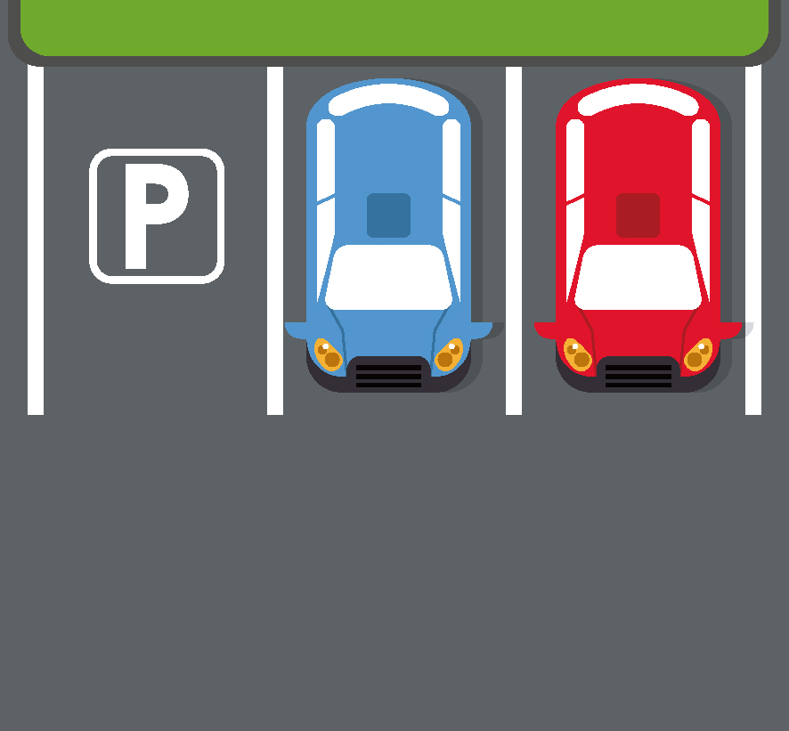



## Subsidised and ‘Free’ Parking

During 2021-22 we continued to offer subsidised parking in the rural car parks and 250,422 tickets (equating to £178,312.40) were issued free of charge. It is considered that the ‘free’ period of parking can assist with encouraging some customers to visit the district, but there is a balance which must be maintained in terms of ensuring that customers do not rush back to their vehicle to purely park for the ‘free’ period, which does not help to support the local economy. There are significant costs involved with the provision of car parks and it is therefore important that parking charges are considered carefully to assist with covering these costs.

The Christmas Park and Ride was not offered during 2021-22 as the car parks were not at full capacity. However, Parking Services introduced parking incentives over the Christmas period 2021. The incentives encouraged customers to visit their local shops and support the high street. 3,864 customers benefitted from free weekend and Christmas late night shopping parking in the Avenue de Chartres car park. and 14,575 from the MiPermit free hour when selecting two in all car parks across the district.

## Providing Flexibility when Parking

All but one of our charging car parks provide payment machines which are capable of accepting coin, card and contactless payment. MiPermit cashless parking is also offered across the district. Many frequent customers take advantage of heavily discounted season tickets which can be used in 14 of our car parks and are available to buy online at a substantially reduced cost.

In the next financial year, we will be considering the feasibility of adding MiPermit cashless parking into our last chargeable surface car park, Westgate.

## Car Parks Throughout the Year

The impact of Covid-19 has understandably affected normal driver behaviour such as working from home. However, the busiest months in our car parks have been August, December, and July. The busiest car parks over the course of the year have been Northgate and Cattle Market, and also the city centre car parks such as Baffins Lane and Little London, Chichester. In Midhurst, North Street car park was the busiest.

## Keeping it Clean and Safe

All our payment machines in surface car parks are solar powered to reduce the cost of electricity and support the Council’s environmental agenda and Climate Change Action Plan. The team works to keep restriction signs and charges boards clean, line markings free of foliage and maintain our spaces by reporting and resolving defects. Taking into consideration feedback from Civil Enforcement Officers, all car park inspection defect reports are undertaken using digital means, with inspections being undertaken on a regular basis to ensure that our car parks are as safe as possible. In addition, Civil Enforcement Officers are all trained to respond to reports of antisocial behaviour and assisting our Communities team and the Police.

# 8. Digital Season Tickets

Digital season tickets provide good value for frequent customers and added convenience. The successful move to digital MiPermit season tickets from paper season tickets has reduced the reliance on direct contact with the Parking Services team, and completely removed transactions through the Contact Centre freeing up the service and wait times.

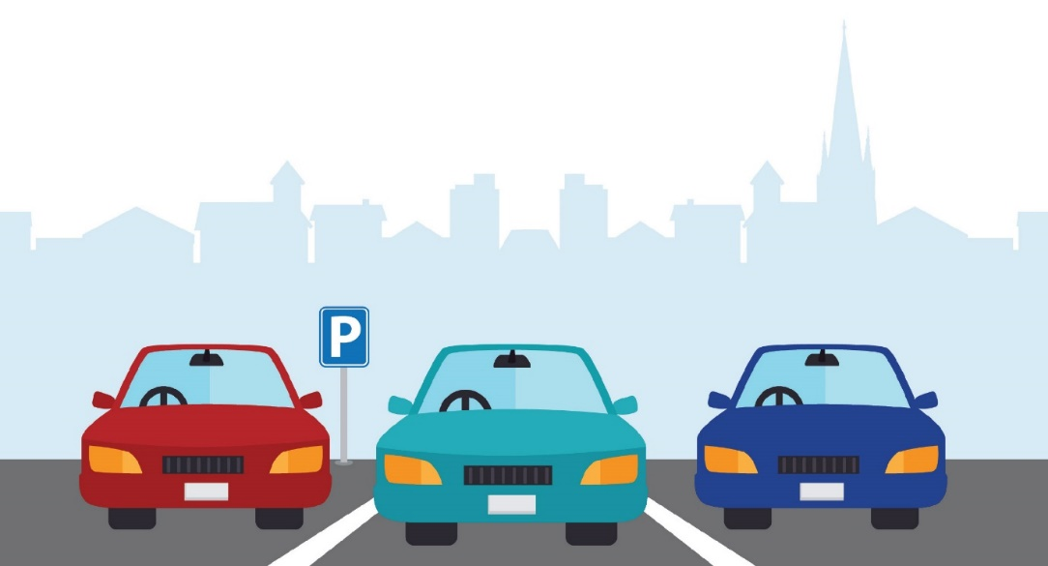

Since a reduction of season ticket sales during the pandemic, there has been renewed interest in these as commuters now begin to return to their places of work.

We have successfully developed a new part-time season ticket which allows customers to select the days they wish to park rather than paying for a season ticket to park every day. This new addition to our season tickets reflects the changing ways people work after the Covid pandemic, with more and more of our customers retaining the flexibility to work from home as well as travelling into their places of work.

74% of customers still choose to buy monthly season tickets, with the second and third most popular durations being 12 and 10 months, respectively.

Key information about our season tickets:

* 14 digital season tickets
* 2 season tickets which guarantee a parking space in a central car park
* 8063 season tickets sold in 2021-22
* Park for as little as £1.41 a day in Chichester
* Park for as little as 58p in rural car parks

# 9. MiPermit

MiPermit is an alternative way to pay for parking in all but two of our chargeable car parks. In addition, customers also benefit from increased flexibility as all of our season tickets are now digital and can be accessed anytime.

MiPermit customers can pay for parking using:

• A smartphone app Apple/Android

• Online at [www.mipermit.com](http://www.mipermit.com)

• By telephone

• A mobile phone by SMS - Text PARK with your vehicle registration to 61600

The table below shows all MiPermit transactions since 2019, split across all car parks.

Table 7 – MiPermit Parking Stays

| Car Park | 2019-20 | 2020-21 | 2021-22 |
| --- | --- | --- | --- |
| Baffins Lane Car Park | 7,368 | 5,531 | 13,689 |
| Basin Road Car Park | 2746 | 2692 | 5,662 |
| Bosham Lane Car Park | 2,360 | 6,637 | 12,355 |
| Bosham Lane Coach & Lorry Park | 26 | 64 | 94 |
| Bracklesham Lane Car Park | 1,398 | 3,579 | 5,635 |
| Cattle Market Car Park | 21,356 | 21,131 | 52,484 |
| Cawley Priory Car Park | 4,592 | 3,120 | 9,367 |
| Coach Park Via Ravenna | 155 | 31 | 177 |
| East Beach Car Park | 107 | 690 | 1,058 |
| East Pallant Car Park | 8,718 | 7,889 | 21,473 |
| East Street Car Park | 322 | 220 | 677 |
| Grange Road Car Park | 1,481 | 2,362 | 4,397 |
| Little London Car Park | 8,141 | 10,020 | 24,083 |
| Lorry Park Via Ravenna (Overnight Only) | 2 | 14 | 10 |
| Marine Drive Car Park | 574 | 2,348 | 3,689 |
| Market Avenue Car Park | 367 | 170 | 1,745 |
| Market Avenue/St John's Street Car Park | 1,136 | 1,208 | 3,166 |
| Market Road Car Park | 451 | 289 | 821 |
| New Park Road Car Park | 6,417 | 6,418 | 17,847 |
| North Street Car Park | 3,142 | 3,738 | 8,653 |
| Northern Crescent Car Park | 164 | 329 | 848 |
| Northgate Car Park | 22,099 | 14,943 | 53,663 |

| Orchard Street Car Park | 1,947 | 1,633 | 4,945 |
| --- | --- | --- | --- |
| Orchard Street Car Park (D Park) | 145 | 103 | 393 |
| Post Office Car Park | 2,148 | 1,662 | 3,225 |
| Pound Street Car Park | 4,383 | 4,078 | 9,962 |
| Selsey Marine Car Park | 61 | 157 | 615 |
| South Pallant Car Park | 4,432 | 4,594 | 11,029 |
| St Cyriacs Car Park | 5,087 | 4,447 | 12,444 |
| Total parking stays | 111,325 | 110,097 | 284,206 |

The team has worked to promote the service further by producing posters, running social media campaigns, distributing cards and offering incentives for customers using MiPermit. Customers also provided feedback that they particularly liked this form of payment during the pandemic given that it is completely contactless. MiPermit also provides the facility for customers to extend their parking stay; this feature was promoted during the pandemic as customers would benefit from having this option when they were queueing at shops and other facilities to help with social distancing. This option also assists businesses in the district by ensuring customers do not have to rush back to their vehicles at the end of a parking stay as they are able to extend remotely should they wish to spend more time in the high streets.

The use of MiPermit has increased from 12% up to 17% across all our car park transactions during 2021-22. The car parks attracting the highest number of MiPermit customers are Northgate car park and Cattle Market car park, which are our largest long-stay car parks, but also Little London car park, which is our city centre short-stay car park.

What benefits does MiPermit offer?

* No need to call or visit the Council
* No need to display a season ticket or ticket in a vehicle
* The ability to update vehicle details at any time, day or night
* A secure and reliable way to purchase season tickets or parking stays
* Purchase stays in advance of your visit
* Use the basket function to purchase multiple season tickets
* Use a personal account via MiPermit Website or App reduces the postage, stationery and administrative costs

# 10. On-Street Parking Overview

## 10.1 City Centre On-Street Pay and Display

29 solar powered payment machines are located in convenient locations in Chichester city centre on-street locations. Motorists can make the most of city centre parking locations for up to 1-hour which assists with the turnover of spaces near shops and businesses. Previously there was a voucher scheme which is largely phased out, however any unused vouchers still in circulation are being honoured.

## 10.2 Lines and Signs

By nature of their position, lines on the highway can become worn or damaged and often Civil Enforcement Officers are the first to discover these defects. For a fourth year, Parking Services has ordered work to resolve on-street defects which are found within the Controlled Parking Zones (CPZ). Civil Enforcement Officers are also now reporting and ordering remedial work for defects outside of the CPZ.

## Protecting Parking Schemes

Permit schemes are managed stringently, to ensure that only those who are eligible to use permits are doing so. Enforcement of permit holder bays ensures that we secure the parking for those who need it most. Where there are instances of permit misuse or fraud the Council’s Fraud Investigation Officer will investigate such cases.

## Problem Parking and Directing Enforcement

In 2021-22 Parking Services logged 431 requests for enforcement in specific locations from members of the public.

Customers are able to contact Parking Services using the ‘Report It’ facility on the council’s website, or by phone and email, to advise if they observe a vehicle which they believe is parked in contravention of the regulations. Regrettably, we are unable to issue a Penalty Charge Notices using the photographs and the details customers provide, as a Civil Enforcement Officer must view vehicles parked in contravention at the time. However, all requests for enforcement where there are restrictions and a Traffic Regulation Order/Parking Order in place are passed to the Civil Enforcements who will look into the situation and deal with it accordingly. This might include increasing the number of visits made to the particular area of concern.

Within the past year the areas that we have received the most reports for parking issues by the general public were, Dell Quay (Chichester), Southbank (Chichester), Claypit Lane (Westhampnett), Little Breach (Chichester) and High Street (Selsey).

The top three reasons for customers contacting the team to report issues of concern were:

* Vehicles parking on a double yellow line restriction (154)
* No valid permit displayed in a controlled parking zone (69)
* Vehicles causing an obstruction (54)

June 2021 saw the highest level of reports from customers (50) with most of these being attributed to reports of vehicles parked on double yellow lines (17).

The team received 9 reports where the Civil Enforcement Officers were unable to take action due to there being no Traffic Regulation Orders at the reported location.

54 reports were received for vehicles parked causing obstruction which regrettably our Civil Enforcement Officers do not have the power to issue Penalty Charge Notices for, and customers are advised that these issues should be reported to the Police.

# 11. School enforcement

Designated school enforcement is scheduled into Civil Enforcement Officer patrol rotas and it is considered a very important part of their work. As we dedicate enforcement to around 50 schools in the area, it is accepted that Civil Enforcement Officers cannot always be present; however, a rota system allows officers to attend various locations as frequently as possible. When Civil Enforcement Officers observe a particular parking issue at a school it is reported and periods of concentrated enforcement can be scheduled.



The Parking Services team recognise that there are some locations in the district where it is not easy for parents to park when dropping off or collecting children from school. We provide some schools with alternative parking options for ‘drop offs’ and ‘pick ups’, including short-term parking passes for on and off-street locations. Regrettably, vehicles continue to be parked where safety restrictions are in place.

# On-Street Permits

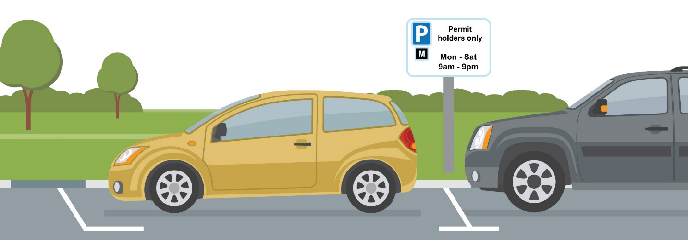

Table 8 – Permits in Controlled Parking Zone

| Zone | Uptake of Permits % | 1st Permit | 2nd Permit* | 3rd & 4th Permits | BBH's | Carer | +Health- care | Non- Resident | Total Issued excluding Non-Res. |
| --- | --- | --- | --- | --- | --- | --- | --- | --- | --- |
| A | 27% | 171 | 25 | 1 | 12 | 3 | 272 | 39 | 212 |
| E | 92% | 165 | 10 | 0 | 4 | 2 | 0 | 181 |
| F | 90% | 318 | 60 | 4 | 11 | 2 | 15 | 395 |
| G | 40% | 13 | 5 | 0 | 3 | 0 | 6 | 21 |
| H | 48% | 103 | 13 | 0 | 10 | 1 | 10 | 127 |
| H2 | 63% | 168 | 32 | 1 | 17 | 4 | 30 | 222 |
| J | 91% | 27 | 9 | 0 | 1 | 3 | 0 | 40 |
| K | 100% | 51 | 0 | 0 | 5 | 0 | 0 | 56 |
| K Mon-Fri | 69% | 16 | 0 | 0 | 0 | 0 | 0 | 16 |
| K Alt N | N/A | 8 | 0 | 0 | 0 | 0 | 0 | 8 |
| L | 89% | 34 | 5 | 0 | 2 | 1 | 1 | 42 |
| M | 55% | 54 | 14 | 3 | 5 | 1 | 4 | 77 |
| N | 78% | 256 | 47 | 3 | 10 | 2 | 7 | 318 |
| O | 64% | 145 | 39 | 1 | 10 | 1 | 7 | 196 |
| S | 57% | 190 | 55 | 11 | 10 | 2 | 18 | 268 |

* Where permits in zones are in high demand only 1st permits will be issued.

+Healthcare permits are valid for use across all zones.

## 12.1 Controlled Parking Zones

Thirteen Controlled Parking Zones (CPZs) are in place in Chichester, designed to manage on-street parking, maintain safety, and access and improve the commercial viability of the city (see Appendix D for map of zones). Across the Resident Parking Scheme (RPS) permits enable customers to park in permitted parking bays or areas. The largest group of permit holders are residents who make up 68% of permits. Amongst those who are also eligible to apply for permits are residents holding Blue Badges, Carers, and Healthcare workers, making up 17% of the permits we issued. Where demand exceeds supply, the team manage waiting lists. Waiting lists are monitored regularly to minimise the length of time that customers spend waiting.

## 12.2 Non-Resident Permits

Non-Resident Permit holders account for 4% of permits issued during 2021-22. With commuters returning to the city centre we have seen the Non-Resident permits in demand with waiting lists in operation, especially in the Zones surrounding the Hospital. Non-Resident Permits are offered to customers in roads where surplus capacity is recorded by Civil Enforcement Officers, following discussion and agreement with West Sussex County Council.

## 12.3 Resident Visitor Permits

Customers can benefit from 3 types of Resident Visitor Permits. In the past year there have been over 7,000 Resident Visitor Permits issued.

It is believed that the number of Resident Visitor Permits being issued has risen this year as restrictions have been lifted and there are therefore more visitors to the district. Where customers were unable to visit Chichester District Council during the pandemic, customers were able to call the Contact Centre to request permits and the introduction last year of the E-form to order Resident Visitor Permits online is proving increasingly popular.

Table 9 – Resident Visitor Permits are Available to Residents to Purchase for their Visitors

|  |  |  |  |
| --- | --- | --- | --- |
|  | Resident Visitor Permits (RVPs) | | |
| Duration | 2 Hourly | Daily | Weekly |
| Total RVPs 2019-20 | 6,275 | 3,130 | 156 |
| Total RVP’s 2020-21 | 3,465 | 1,949 | 98 |
| Total RVP’s 2021-22 | 5,217 | 2,120 | 213 |

# 13. Dispensations and Suspensions

The purpose of on-street dispensations is to help ensure that trades people who carry out work across the District can do so safely and conveniently if their vehicles are required for the activity taking place. Since 2018, the number of dispensations issued to tradespeople has reduced at the same time as the cost of these significantly increased. As a consequence, fewer dispensations have been issued. This price increase has assisted with ensuring that only vehicles which have good reason to park on the highway do so, and those who were benefitting from inexpensive on-street parking without good reason, relocate to more suitable parking places.

Charges for dispensations were slightly increased again in 2021.

On-street parking bay suspensions suspend the normal restrictions in an area of the highway to allow a planned activity to take place. They may be requested in order to position a skip in a parking bay, to enable utility companies to carry out maintenance, or simply to make certain that a space will be vacant. Suspensions can also help facilitate events by preventing the use of parking bays throughout road closures. The Parking Services team determines whether or not the location and timescales are suitable and how potential disruption can be minimised. By ensuring that signs are correctly displayed ahead of the suspension start date, the team provides warning to those who will be affected.

Table 10 – On-Street Dispensations and Suspensions 2021-22

|  |  |  |
| --- | --- | --- |
| Month | Dispensations | Suspensions |
| April | 1 | 6 |
| May | 3 | 5 |
| June | 7 | 8 |
| July | 22 | 8 |
| August | 16 | 10 |
| September | 20 | 2 |
| October | 5 | 8 |
| November | 11 | 12 |
| December | 19 | 3 |
| January | 11 | 7 |
| February | 1 | 11 |
| March | 10 | 20 |
| Total | 126 | 100 |

# 14. West Sussex County Council CPZ Extension

During 2017 a Road Space Audit (RSA) was undertaken by West Sussex County Council (WSCC) which considered the demands and pressures on the road network in Chichester. Through this, it was found that there was justification to move forward with one of the resulting concepts, ‘Tackling Parking Issues’. This concept focusses on developing a city-wide Parking Management Plan (PMP) to resolve local parking and traffic management issues. The proposed PMP covered the whole of the city centre and extended out to areas such as the Broyle Estate, Parklands and Donnington. Following consultation in 2019 and a second round of formal consultation between February and March 2020, plans were agreed in July 2020 and the decision was made to implement the PMP in phases, tackling only specific locations first with a view to review the impact of these changes on neighbouring areas and implementing other CPZs, in a later phase.

Preparation for Phase 1a of the PMP began in December 2020. This introduced two new Controlled Parking Zones (CPZs), in the Donnington and Swanfield areas, and extended three of the existing zones (Zone F, Zone H and Zone N). Work began on the highway during February 2021 and completed in June 2021 when it came into force.

The Parking Services team at Chichester District Council has been administering and enforcing the scheme on behalf of West Sussex County Council, with customers in the extension to the zone being part of the digital permit process. Digital permits are virtual so there is no requirement for paper permits and postage. This kind of system provides more flexibility to customers.

The scheme has been implemented with success, and since February 2022 West Sussex County Council have started a CPZ Review to monitor the scheme.

# 15. Partnership Working

Chichester District Council works in partnership with many organisations in its provision of the Parking Service. It is recognised that working in partnership assists us to deliver our services in the most effective way. Customers benefit from these partnerships as they enable us to deliver more joined-up services which better meet their needs and improves the customer experience. Partnerships also allow us to uphold the regulations which affect all road users more easily, minimising costs to the council.

The Parking Services team continued to work closely with the NHS and Public Health England to provide parking provision in response to the Covid pandemic, allocating areas of car parks for Covid test or vaccination sites. Alongside this, the increased number of visitors during the summer months to the coastal area has meant that partnership working with the police has become increasingly important.

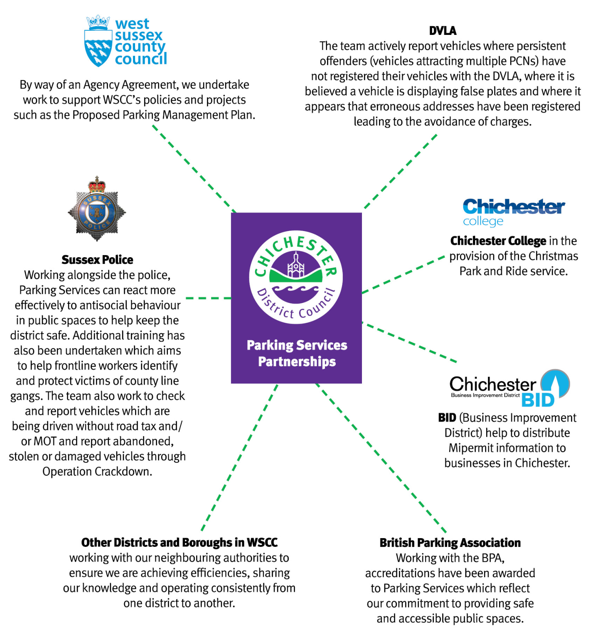

# 16. Freedom of Information and Subject Access Requests

All requests for information received by Parking Services are answered in accordance with the Freedom of Information (FOI) Act 2000. The only exception will be an individual’s request for their own personal data, which must be handled under the terms of the General Data Protection Regulations (GDPR).

During 2021-22, Chichester District Council received 32 FOI requests, compared to 19 the previous year. With this increase in the number of requests the two most common questions relate to Electric Vehicle Charging Points and Travellers. Other FOI requests have included enquiries into the number of Penalty Charge Notices issued, parking charges, streetlights, and the number of Penalty Charge Notices issued to a particular make of vehicle.

Reviewing FOI topics can help us determine where we can make improvements to information we provide, which may in turn prevent any unavoidable requests in the future. Parking Services publishes policies relating to Penalty Charge Notice decision-making and offers advice online in relation to the Penalty Charge Notice process which allows customers to find information themselves.

There was one Subject Access Request received in September 2021. This entitles the customer to see the data containing personal information that is held by the Council and how it is used. This covers all types of records held by the Council including copies of any letters, memos, telephone call recordings (all calls to Customer Services and our Revenues Client Support team are recorded) and emails of which the customer is the focus.

# 17. Equality of Access to our Services

The table below sets out the number of ways in which we constantly review how accessible our service is to all customers who have a variety of needs. The actions we undertake each year are reviewed and considered very carefully to ensure that we are improving the service we provide.

| Chichester District Council Parking Forum | The Chichester District Parking Forum continues to have the Chichester Access Group as one of its key members, contributing to discussions. |
| --- | --- |
| British Parking Association Safer Parking and Disabled Parking Accreditation | The British Parking Association provides an accreditation scheme, which assesses car park safety.  This scheme has been in place in Chichester city car parks for a number of years; however, we have continued to work towards gaining it in as many car parks as possible. 28 of the 31 car parks across the district now have the accreditation. This provides assurances to customers from a safety perspective and feedback (particularly from older customers) suggests that this is important to them.  In addition, Disabled Parking Accreditation assessments have been carried out, with 28 car parks accredited under this scheme.  The scheme requires owners/operators of car parks to adopt an active management strategy to ensure minimal occurrence of disabled bay abuse, facilities are suitable for disabled people and recognition is made of the extra time taken by disabled people in the form of a concession. |
| Penalty Charge Notices (PCNs) | Parking Services has undertaken to review and update the procedure for verbal challenges against PCNs. The process ensures that those who are unable to write to the council have other means to make their challenge, either in person or over the phone and that all staff are properly trained to follow the procedure. |

| Health Care and Carer Permits | The Parking Services team continue to administer Health Care and Carer permits for healthcare workers visiting those receiving care in their homes within the Controlled Parking Zone. The permits help residents stay in their own homes for longer by enabling easy access to provide the required care. Where customers are in receipt of particular benefits, carer permits can be provided free of charge. |
| --- | --- |
| Website Accessibility | As part of the accessibility regulations (The Public Sector Bodies (Websites and Mobile Applications) (No.2) Accessibility Regulations 2018) we are continuing to improve our web estate. An accessibility statement has now been published outlining our level of accessibility. We have created a ‘Website accessibility contact form’, so customers can report an issue with accessibility. We have carried out a site-wide audit of all our documents and are working with services to make them accessible. We continue to promote the importance of accessibility and have created a section on the Council’s intranet for advice and guidance. Our commitment to the Local Digital Declaration means we will continue to design our services to meet the needs of customers and follow a unified set of content and accessibility standards. |
| Shopmobility | A Shopmobility service provided by Community First continues to operate from East Pallant car park, providing mobility scooters for visitors with limited mobility, to enable improved access to the city centre. The service has looked to increase support for new or existing users through temporary hire in their own homes. The service is supported by Parking Services (a number of parking bays are set aside for the service to operate from) and in part with Council Grant funding. |
| Blue Badge Enforcement | Civil Enforcement Officers continue to support West Sussex County Council to tackle Blue Badge misuse. They are trained to identify and retain misused and/or expired badges. In 2021/22, 37 badges were retained, which led to 21 motorists attending a Community Resolution. The Council website also provides information and encourages customers to report badge misuse. This initiative recognises that Blue Badge misuse is not only fraud, but can mean that genuine, vulnerable users are deprived of vital services because parking spaces are taken by fraudsters. |
| Community Bus Bays | Several bays for Community Buses are provided within council-owned car parks for use by organisations who transport older, frail or disabled residents around the district. The bays provide a designated location for these customers to be safely dropped off and collected. Due to levels of demand, further bays have been provided in a rural car park. |
| Parking for Disabled Customers | To help people with disabilities gain easy access to the city, most pay and display car parks have specially allocated parking spaces. These spaces, along with any others in the pay and display car parks (the Avenue de Chartres Pay on Foot car park excepted) can be used free of charge provided the vehicle is displaying a valid blue badge or foreign disabled badge and the registered person is driving or a passenger. |
| Parking Payment Options | Parking payment machines are fully compliant with the British Standard relating to Parking control equipment (BS 8300). All machines except for those in the Westgate and Avenue De Chartres car parks accept coin, card and contactless payment. In addition, the MiPermit facility is in place across all car parks, enabling payment by phone or app. Many customers from protected groups (particularly older customers and those with mobility issues) benefit from the accessible machines or from being able to pay for parking without the need to visit a machine. Parking payment machines also provide information in a number of different languages. |
| Resident Visitor Permits | A new system has been set up whereby customers can order and purchase Resident Visitor Permits online rather than visit the Council’s offices.  To assist residents who do not have internet access, they can still telephone the council. |

# 18. Complaints and Compliments

With such a busy service dealing with many customers, Parking Services has occasions where a customer wants to provide feedback. Whether it’s due to a delay in postage, a faded permit or payment machine fault, whatever the complaint is we work very hard to sort it out.

The Council’s complaints procedure provides three stages at which the complaint can be investigated. During 2021-22, we received a total of 11 first stage complaints, and 2 second stage complaints.

Examples of complaints and our response include the following situations regarding Travellers and our website being down:

**Customer Complaint:**

“Please can you tell me why 2 caravan/travellers + vans and their cars have taken over a section of the car park using your barriers to allow them more room and have a generator going (noise) for a while now + using one of your public green rubbish bins for themselves. This car park is also being used by other people now for sleeping over. I pay my council tax and taxes. This needs to be policed and not allowed as why should I pay for anything if they do not. Are they using the public toilets as well?? This is just unacceptable that they have been here this long. Who is stopping overnight sleeping/parking otherwise it will be a free caravan/camping site.”

**Parking Services Response:**

“I can confirm that we are aware of the Travellers who are currently situated in Marine Drive car park and that we are doing everything we can to move the caravans on and that we continually take steps to prevent Travellers entering and using Local Authority spaces. notice to move has been issued by WSCC on our behalf and that we are working closely with WSCC and the police to assist with moving on as quickly as possible within the processes which are currently available to us. We follow prescribed procedures to handle unlawful encampments with colleagues from West Sussex County Council’s Gypsy and Traveller team, our own Communities team and the Police and we have taken every action we have available to us.

We act quickly when unauthorised encampments arrive on our land however, you may be aware that due to the pandemic, the court system which is ordinarily used to move groups on, is subject to delay which means that progress is regrettably slower.

We have duly passed on your concerns and I wholly acknowledge that you have said that this is causing disturbance. West Sussex County Council has already issued the legal notice to move the group on and we are regularly passing details regarding community safety to the police.

Chichester District Council has considered use of barriers in some car parks however, barriers can present issues for other motorists wishing to visit our car parks and therefore prevent some customers with larger vehicles accessing parking spaces. Unfortunately, barrier systems do not always prevent unauthorised use of car parks either but I can assure you that we do work to minimise the disruption caused by this type of activity.”

**Customer Complaint:**

“I have recently paid and requested an updated residents permit as I have recently changed vehicles. Your website was down last Saturday when I tried to change the relevant details so this could then not be completed until Sunday but still had to wait an addition 24 hours for a payment link to be sent to me. I have still not received a permit and have just spoken to a lovely lady in your office who has advised me that the permit was not even printed until yesterday. This is an absolute joke. I pay enough to park my vehicle outside my own house (if I’m lucky) let alone having to incur more expense of buying visitors permits or if I get hit with a parking ticket because of the delay of the shoddy parking services that this city council provides. I am away over the next 4 days and will have to park my new car somewhere undesirable that is free parking - this is an absolute outrage. Why you cannot provide me with a duplicate copy of my permit is absolutely ridiculous.”

**Parking Services Response**:

“I can confirm that Chichester District Council administers the on-street controlled parking zone on behalf of West Sussex county Council. West Sussex County Council set the policies and procedures which are applicable to administering the parking scheme. I have noted that you first contacted Parking Services via email regarding losing your permit and a registration change on 5th October and an officer replied a few minutes later informing you how to proceed with the permit change. From investigating your complaint it appears that the officer omitted to advise that you needed to apply for a lost permit which is a £10.00 charge and not a £5.00 permit change. I will ensure that the officer is made aware of the error and that action is taken to prevent this situation from reoccurring.

I can confirm that the Council’s website was down on Saturday 9th October between 8am and 7pm due to an essential upgrade. Whilst I appreciate that this was inconvenient, it was necessary.

You therefore applied for the registration change on Sunday 10th October. Any application for a registration change can only be actioned by Parking Services within the Council’s opening hours, this is advised within the resident permit terms and conditions. In addition, it is also advised on the website before submitting the change “The Permit Holder must allow at least 3 working days for these requests to be processed and also consider council opening hours, Bank and Public holidays.” I note from our records that your request was approved and an email advising you to make payment was sent on Monday 11th October 2021 at 13:14. You then subsequently paid for the change the same day at 13:17. At 14:47 your new updated permit was created by a Parking Services Officer. At the time the Council had limited post due to COVID 19 implications, it was only being sent from the office on a Monday and a Wednesday at 2pm, as your permit was created at 14:47 it missed the Monday post and was sent out on the Wednesday. The Parking Services team aim to process paid applications as quickly as possible and I can see that your application was processed within 3 working days.

When a valid permit is unable to be displayed as an exemption, it is required that Resident Visitor Permits (RVPs) are used or alternate parking is arranged elsewhere so that a vehicle is not left parked in contravention, this is also stated in the terms and conditions. It is therefore not felt that issuing a refund or supplying complimentary RVPs are applicable.

I would like to thank you for raising your concerns with the Council and offering us the opportunity to learn about the services we provide. I will ensure that the website is updated to include that the posting of the permit also needs to be taken into consideration.”

We know we are more likely to hear from customers if something goes wrong, but during the year, we received good feedback too. During 2021 we received 9 compliments.

Examples of compliments:

**Customer Compliment:**

“Thank you for your e-mail regarding my Wife's new blue badge and disabled parking in Midhurst and Chichester. The on-line map you sent us by e-mail looks fine but we cannot print it off the internet so will have to collect one when next in Chichester from your offices in the Pallant. I spoke today with your Parking Officer in Midhurst, a very nice man, very friendly and very very helpful and knowledgeable. He gave me all the information we needed for disabled parking in Midhurst. Thank you for your assistance”

**Customer Compliment:**

“Thank you so much for sorting this issue out for me. I successfully gained access to the car park this morning which was a relief! Your help in this matter is very much appreciated.”

**Customer Compliment:**

“I can report to you that your Parking Services staff relined the parking bays in St Cyriacs car park here in Chichester this morning. I am not certain whether this was undertaken to address some of the concerns that I expressed in our correspondence but I can tell you that your staff carried out the task very efficiently and skilfully. The result is a significant improvement in the car park with the bays now effectively outlined. Whether or not my letters had any effect I am very grateful to you and your staff. I would be grateful if you could express my gratitude to the appropriate manager and his excellent staff. As mentioned in my last email, the placement of an appropriate sign on the wall close to the bay adjacent to our garage would be a great help.”

**Customer Compliment:**

“I completely understand the rationale to limit the number of visitor permits in Chichester and very much appreciate the offer of an increase in our monthly allocation. I will apply today and then again in early September for further visitor permits reflecting the allocation you outline in your reply. Many, many thanks.”

**Customer Compliment:**

“Customer called to ask some questions regarding his permit at the end of the call he wanted me to pass on to the parking team what a lovely team we have and how efficient they are. He said they have always been so helpful and friendly to him.”

**Customer Compliment:**

“Thank you so much. I have to say I'm really impressed with the service, for keeping me updated and following up to make sure I'm refunded. Even though there is an issue with refunding me it's nice to see you following up before I even notice there was an issue.”

# 19. Financial Information

## 19.1 Income

Income from parking charges is used to meet the direct costs of operating the car parks, the cost of provision of pay and display and season tickets for customers, enforcement, staff costs, utilities, licencing, repair work and maintenance to the car parks themselves. Income is also used to assist with introducing and taking advantage of new technology to assist with improving the service provided. Parking income also assists with supporting essential services within the council for our communities and visitors. Charges are reviewed to ensure that they remain competitive to encourage turnover within the car parks to make the best of the resources in place.

* The lower level of income for 2020-2021 is the result of the Covid-19 pandemic. The Council chose not to charge for car park stays for a number of months to support essential workers and those making essential journeys.

Table 11 – Income by Source

| Income by source | Amount | % of Parking Services Income |
| --- | --- | --- |
| Pay and Display Machines | £4,193,422.51 | 76.78% |
| Season Tickets (car parks) | £560,129.55 | 10.26% |
| Penalty Charge Notices (car parks) | £316,879.00 | 5.80% |
| Residents Parking Vouchers | £243,745.21 | 4.46% |
| Licence Income | £81,459.82 | 2.24% |
| Advertising Income | £7,168.67 | 0.13% |
| Rental Income | £20,198.33 | 0.37% |
| Refunds | (-£2,240.31) | (-0.04%) |

On-street and off-street income and expenditure is managed and split according to the income source. As the Council works as agent for West Sussex County Council, an annual contribution is made to Parking Services which helps to pay for enforcement. Income generated through the Controlled Parking Zone is paid to West Sussex County Council and the income from Penalty Charge Notices is split between the two authorities based on the percentage of on-street and off-street parking contraventions.

## 19.2 Expenditure

Professional Service costs relating to the provision for card and contactless payments at each parking machine and these have increased again over the past year where customers make use of these methods of payment instead of using cash. A rise in the number of customers benefiting from digital services has also led to an increase in costs where the Council pay a fee for each digital season ticket to the service provider. Capital Charges have decreased this year compared to the increase from the re-value of the Avenue de Chartres car park in 2020-21 but are still running higher than previous years. We have a noticeable increase in our Employees cost due to taking on additional staff to manage and launch the expansion of the Controlled Parking Zones.

# 20. Looking Back and Looking Forward

Due to the continued knock-on effect of the pandemic, there have been delays in scheduled projects and works which sometimes prevented completion. However, there have been a number of key achievements during the year relating to the service we provide to customers. These have included:

## Accreditation of Safer Parking Award

All car parks across the district holding the British Parking Association’s Safer Parking Award (28 of our 31 car parks), successfully maintained their accreditation. This accreditation assists with reducing crime and the fear of crime in car parks and provides assurances to the public that measure have been introduced to ensure that the parking facility is a safe environment. These same 28 car parks have also been awarded the Disabled Parking Accreditation which recognises off-street parking facilities which are accessible to disabled people.

## West Sussex County Council, CPZ Extension

West Sussex County Council has introduced two new Controlled Parking Zones (CPZ) and three zone extensions in the current Controlled Parking Zones

The Parking team worked on their behalf to implement this new digital permit platform on MiPermit and have administered and enforced the new scheme.

## Electric Vehicles and Electric Vehicle Charging Points

Electric Vehicle Charging Bays continue to be an attractive and useful addition to our car parks with the influx of electric cars on the market and an increase of these vehicles on the roads.

The use of these bays has been monitored since this time and a review was undertaken during 2021-22 to further understand the level of use. The demand can easily be met at this time with the current level of electric vehicle charging bays, however we continue review the usage of these bays to understand more clearly what customers need and how to future proof this element of the service. Alongside this, the purchase of an Electric Van will be undertaken to add to the existing two Electric cars which replaced the diesel vehicles.

## Parking Strategy

Work on a revised Parking Strategy for Chichester District will continue, to reflect the requirements of the district in the coming years, which will include consideration of the changing needs of customers going forward.

## Parking Incentives

Parking incentives were introduced during the Christmas period to assist with supporting the high street to encouraging people to shop locally. These incentives replaced the Christmas Park and Ride. The parking incentives offered free periods of parking and were active during December:

* Free parking in the Avenue de Chartres multistorey car park for the Christmas light switch-on
* Free parking in the Avenue de Chartres multistorey car park every Saturday and Sunday in December
* Free parking in the Avenue de Chartres multistorey car park for the four late-night shopping events
* Select 2hrs and get the 3rdhour free in the majority of the Council’s car parks when using the MiPermit App

These incentives were widely used and also assisted us to encourage further use of the cashless platform which offers benefits to both the Council and our customers.

## Relining Car Parks

The Council are committed to making sure the car parks are freshly maintained, clearly lined and signed, and welcoming to our visitors. As part of this continued maintenance, the following car parks were relined:

2021

* East Street, Selsey
* Orchard Street, Chichester
* Bracklesham Lane, Bracklesham
* St Cyriacs, Chichester

2022

* Westgate, Chichester
* Market Avenue, Chichester
* Market Avenue/St Johns, Chichester
* Coach/Lorry Park, Chichester
* Post Office, Midhurst

## Blue Badge Enforcement

Investigation of Blue Badge Misuse has continued, in partnership with West Sussex County Council and specially trained investigators.

## MiPermit

Customers continue to make use of the many ways to pay in car parks, with use of the phone/app MiPermit solution having increased significantly by an amazing 158% from last year.

## E-forms

Improved online services including the further implementing of our E-forms has successfully helped more customers to self-serve, which in turn assists with reducing customer transactions within the team.



## PATROL Award

The work previously carried out on our online services (included in our 2019-2020 annual report) resulted in recognition at the national PATROL (Parking and Traffic Regulation Outside London) awards 2021.

## Managing Coastal Traffic

Chichester District is the proud home to many renowned beaches, which inevitably leads to a high number of people visiting the region and some regrettably parking in contravention. This influx of vehicles led to concerns for safety on the highway and raised complaints from residents. Parking Services increased Civil Enforcement Officer patrols in coastal areas and endeavored to guide and advise motorists where possible. While the question has been raised whether on-street higher Penalty charges are sufficient to adequately prevent inconsiderate or dangerous parking, the presence of Civil Enforcement Officers in coastal areas can help to encourage motorists to make better choices when parking. Parking Services worked closely with local partners, including local landowners to progress actions to assist with improving the situation, these included variable messaging systems, placing bollards on verges and further clear communications ahead of busy periods.

## Key Areas of Work for 2022/2023

* Develop a project to improve connectivity and accessibility between Northgate Car Park and the surrounding facilities
* Delivery of a refreshed Parking Strategy and action plan
* Implement new regulations within the Traffic Management Act 2004 to reflect the amendment to the name of the regulations.
* Review and enhancement of Bosham car park
* Review of recommendations from Decarbonisation feasibility study to progress projects, alongside considering resources for delivery. Project will include review of potential for solar panels in Avenue de Chartres and Cattle Market car parks and potential light replacement programme
* Implementation of on-street parking charges for October 2022 in partnership with West Sussex County Council
* The removal of the Covid-19 vaccination test site in Northgate car park
* Relining of the following car parks:
  + Florence Road, Chichester
  + Northern Crescent
  + East Wittering
  + Little London, Chichester
  + South Pallant, Chichester
* Renewing Tariff Boards to reflect updated conditions of use in our car parks

# 21. Parking Strategy

The Chichester District Parking Strategy 2010-2020 was published in the autumn of 2010 and recognises the importance of car parking for local infrastructure, tourists, commuters, and residents, and that when parking is provided well it can contribute to the attractiveness, convenience and prosperity of a place to do business, visit or live.  The Strategy attempted to balance the often-competing demands from car park users and pedestrians and ensure that the public car parking service continued to meet the needs of various users.  At the time of the production of the Strategy a number of assumptions relating to the demand and use of car parking spaces were made, based on the predicted growth in the district along with other societal changes and developments which were predicted.

Work to review the technical information to form the current and predicted baseline took place during the past year, (although the challenge of evaluating current and future demand and capacity was recognised to be more challenging due to the impact on parking of the Covid 19 pandemic).  It is recognised that travel needs and behaviours have changed dramatically in a short period of time across the UK.  Whilst it is still unclear as to when and for how long it will take to get back to normality, calculations have been made based on technical modelling of various assumptions.  High level options for consideration will be provided during 2022-23, with a draft strategy and action plan to be considered by the Parking Forum in the autumn of 2022.

The revised Parking Strategy will attempt to balance the often-competing demands from car park users and pedestrians and ensure that the public car parking service continues to meet the needs of various users.

# 22.Common Myths and FAQs

## 22.1. Parking Myths

**Civil Enforcement Officers get commission** **-** Civil Enforcement Officers do not get commission. They are paid a salary regardless of how many Penalty Charge Notices they issue.

**Civil Enforcement Officers have targets -** Civil Enforcement Officers do not have targets. They can only issue Penalty Charge Notices if a parking contravention is observed and they must gather prescribed information which supports the notice. Civil Enforcement Officers also make notes in every Penalty Charge Notice, and this information can help to either uphold the Penalty Charge Notice if it is challenged or can support a customer’s comments so the Penalty Charge Notice is cancelled.

**Civil Enforcement Officers target vehicles** **-** Chichester District Council currently employs 10 Officers who patrol the whole of the Chichester district. Our Officers do not patrol with the intention of persecuting motorists and they are allocated different routes to patrol. It is therefore very unlikely that they would commit to memory the details of individuals’ vehicles.

**Civil Enforcement Officers can issue a Penalty Charge Notice if a vehicle is parked causing an obstruction -** While Civil Enforcement Officers can issue a Penalty Charge Notice for many reasons, when observing the parking contraventions where restrictions are in place, they do not have the power to issue a Penalty Charge Notice if it is causing an obstruction. This is the responsibility of the Police and customers should report incidents such as these to their non-emergency telephone number 101. If a vehicle is parked dangerously, risking life, customers should call 999.

**You can park without an exemption or on a waiting restriction on a Bank holiday -** Unless the Traffic Regulation Order and signs indicate otherwise, parking restrictions will apply on Bank Holidays.

**Making a complaint to the Council will cancel a Penalty Charge Notice -** a Penalty Charge Notice must be dealt with in line with the parking penalty enforcement process and The Traffic Management Act 2004, and not a complaint through the Councils Corporate complaint procedure. Therefore the two matters will be handled separately.

**My local MP or Councillor can cancel a Penalty Charge Notice or help me appeal -** Civil Parking Enforcement is undertaken under the legislation as set by the Traffic Management Act 2004. This prescribes the process which must be followed and includes three stages of appeal (two by qualified Officers in the Parking Team) and a third stage through an Independent National Appeal Panel, the Traffic Penalty Tribunal. The Secretary of State considers that the exercise of discretion should rest with the Notice Processing staff, this provides greater consistency in the enforcement of traffic regulations and ensures that only fully trained staff make decisions on the facts presented.

**A Civil Enforcement Officer can take back a Penalty Charge Notice once it is issued** **-** Civil Enforcement Officers are not permitted to withdraw a Penalty Charge Notice. Once a Penalty Charge Notice is deemed served, if the driver wishes to dispute the Penalty Charge Notice they must make a challenge. Removing or handling the Penalty Charge Notice after it has been served would leave Civil Enforcement Officers vulnerable to allegations of inconsistency, favouritism or suspicion of bribery.

**The Civil Enforcement Officer should have given me a warning** **-** A Civil Enforcement Officer is not required to issue Warning Notices to vehicles parked in contravention. It is considered that the exercise of discretion should, in the main, rest with the Notice Processing staff as part of considering challenges against Penalty Charge Notices and representations against a Notice to Owner.

**The Civil Enforcement Officer told me the Penalty Charge Notice would be cancelled if I challenge -** Although a Civil Enforcement Officer is able to advise a motorist how to challenge the Penalty Charge Notice, they are not permitted to give any indication of whether challenges or representations to the Council are likely to be successful. The exercise of discretion should, in the main, rest with the Notice Processing staff as part of considering challenges against Penalty Charge Notices

**Penalty Charge Notices are only issued to make the Council money** **–** Civil Parking Enforcement is a regulatory measure and a Penalty Charge Notice will only be issued if a contravention is believed to have taken place. Any surpluses gained from Civil Parking Enforcement are ring-fenced to highways or environmental related matters.

**Penalty Charge Notice appeals go to court** **-** since Civil Parking Enforcement has been introduced, receiving a Penalty Charge Notice is no longer considered a criminal offence and therefore cases do not go to court. If a recipient of a Penalty Charge Notice wish to appeal against the Council’s decision they are able to appeal to an Independence Adjudicator. The Adjudicator will consider an appeal and make a final decision.

**I can pay a Penalty Charge Notice and then appeal** **-** The Regulations applying to Civil Parking Enforcement state that payment of a Penalty Charge Notice is an admission of liability therefore payment should not be made if a challenge is being submitted.

**I pay my council tax each month so I should not have to pay to park** **-** The payment of Council Tax does not entitle anyone to park, irrespective of where they live, as parking schemes are measures that are self-financed and not funded by any other tax.

## 22.2. Frequently Asked Questions

The following 'Questions and Answers' may be useful when considering whether to Challenge or make Representations to the Council against a Penalty Charge Notice.

**Q. The details on the Penalty Charge Notice are incorrect, will the Penalty Charge Notice be cancelled?**

**A.** If the Vehicle Registration Mark, the location or the Contravention Code is incorrectly recorded on the Penalty Charge Notice, the Council will cancel it. All the other details that the Officer records on the Penalty Charge Notice are supportive and therefore if they noted incorrectly, would not justify cancelling the Penalty Charge Notice.

**Q. I was arrested so couldn't move my vehicle, will the Penalty Charge Notice be cancelled?**

**A.** If you can supply evidence of the arrest which covers the time in which the Penalty Charge Notice was issued, the Council may be able to cancel the Penalty Charge Notice.

**Q. I was loading or unloading, will the Penalty Charge Notice be cancelled?**

**A.** Depending on the restriction you were parked on, what you were loading or unloading and if you can supply evidence of this, the Council may consider cancelling the Penalty Charge Notice. The Civil Enforcement Officer must carry out an observation period when issuing a Penalty Charge Notice under certain contravention codes and this is to determine whether an exempt activity is being carried out. For example, a Civil Enforcement Officer will allow at least 5 minutes observation before issuing a Penalty Charge Notice to a vehicle parked on a yellow line restriction.

**Q. I ran out of petrol, will the Penalty Charge Notice be cancelled?**

**A.** It is the responsibility of the motorist to make sure that the vehicle has sufficient petrol for a journey. As running out of petrol could be avoided, the Penalty Charge Notice may not be cancelled.

**Q. My car broke down, will the Penalty Charge Notice be cancelled?**

**A.** If your car was parked on the street and you can supply evidence of the vehicle breaking down the Council may consider cancelling the Penalty Charge Notice. If your vehicle was in a car park, payment for parking can be made even if you have no access to your vehicle and therefore the Penalty Charge Notice may not be cancelled. In these circumstances the Council would expect contact to be made by the vehicle owner to advise that the vehicle has broken down.

**Q. I was delayed arriving back to my car, will the Penalty Charge Notice be cancelled?**

**A.** Although it is recognised that delays do occur; it is the responsibility of a motorist to take into consideration any unforeseen delays which may occur. For example, it is likely that there could be a queue in a shop or in a bank and therefore the appropriate charge and location for parking should be arranged to cover any possible delay. A Penalty Charge Notice may not be cancelled unless evidence is provided which demonstrates that the delay was unexpected, such as an emergency situation arising.

**Q I have a valid Blue Badge but I didn't display it, will the Penalty Charge Notice be cancelled?**

**A.** For a Blue Badge to be considered as a valid exemption it must be clearly displayed continuously on the dashboard of a vehicle. If this was not the case, then the Penalty Charge Notice may not be cancelled. The conditions relating to Blue Badges are described in 'The Blue Badge Scheme: rights and responsibilities in England' handbook which is provided when every Blue Badge is issued. If the Blue Badge had fallen from view but the Civil Enforcement Officer was able to see an identifiable item on a badge in the vehicle, this will be noted and a Challenge may be accepted and the Penalty Charge Notice cancelled if a copy of the badge is provided.

**Q. I didn’t set my Blue Badge Clock/Disc correctly, will the Penalty Charge Notice be cancelled?**

**A.** For a Blue Badge to be deemed a valid exemption the clock must be displayed correctly with the badge itself and set to the time of arrival. If this was not the case, then the Penalty Charge Notice may not be cancelled. The conditions relating to Blue Badges are described in 'The Blue Badge Scheme: rights and responsibilities in England' handbook which is provided when every Blue Badge is issued.

**Q. I didn't realise that my Blue Badge had expired, will the Penalty Charge Notice be cancelled?**

**A.** For a Blue Badge to be deemed a valid exemption it must be in date and displayed clearly. If this was not the case, then the Penalty Charge Notice may not be cancelled. The conditions relating to Blue Badges are described in 'The Blue Badge Scheme: rights and responsibilities in England' handbook which is provided when every Blue Badge is issued.

**Q. I parked in a loading bay and displayed my Blue Badge, will the Penalty Charge Notice be cancelled?**

**A.** Blue badges are not valid for use in loading bay restrictions, and therefore the Penalty Charge Notice may not be cancelled. The conditions relating to Blue Badges are described in 'The Blue Badge Scheme: rights and responsibilities in England' handbook which is provided when every Blue Badge is issued.

**Q. I became sick/ill, will the Penalty Charge Notice be cancelled?**

**A.** Some situations are unforeseen and therefore the Council may consider cancelling the Penalty Charge Notice if evidence is provided to support the circumstances which are described.

**Q. I lost my car keys, will the Penalty Charge Notice be cancelled?**

**A.** If you are parked in a council car park, there are remote services (MiPermit) to pay for your parking until the vehicle can be moved in this circumstance the Penalty Charge Notice may not be cancelled.  If you are parked on street and you can supply evidence that you lost your keys and/or purchased another set the Council may be prepared to cancel the Penalty Charge Notice.

**Q. I had a Pay and Display (P&D) ticket but it flipped over / fell off the dashboard, will the Penalty Charge Notice be cancelled?**

**A.** Civil Enforcement Officers will check a vehicle thoroughly when patrolling. If they can see the serial number on a P&D ticket inside a vehicle they will log it in their notes. The Council may consider cancelling a Penalty Charge Notice on the first occasion if the P&D is supplied and if it was valid at the time the Penalty Charge Notice was issued and has a matching serial number. Therefore, any future Penalty Charge Notices issued for the same reason may not be cancelled.

**Q. I forgot to display the P&D ticket, will the Penalty Charge Notice be cancelled?**

**A.** The P&D ticket is only valid when displayed clearly on the dashboard of the car. As it is the responsibility of the driver to display the P&D ticket before leaving the vehicle parked, cancelling the Penalty Charge Notice is not felt to be justifiable in these circumstances.

**Q. The P&D machine was out of order/didn't accept my money, will the Penalty Charge Notice be cancelled?**

**A.** The Council acknowledges that occasionally faults can occur. If you are parked in a council car park, there are remote services (MiPermit) to pay for your parking and there are at least two pay and display machines in all of the car parks. If you are parked on street there will at least two pay and display machines covering that location. The Council may therefore not consider cancelling a Penalty Charge Notice as it would be reasonable to expect a customer to use another machine or a different payment method. We would always request that customers report faults at the time if a problem arises.

**Q. I didn't have any change to pay, will the Penalty Charge Notice be cancelled?**

**A.** It is the motorist’s responsibility to arrive at the parking location with adequate change or another means to pay for parking as soon as the vehicle is parked. If this is not the case alternative parking should be found as the Council may not cancel the Penalty Charge Notice.

**Q. I didn't know I had to pay/display a P&D ticket to park, will the Penalty Charge Notice be cancelled?**

**A.** To make sure that the conditions of parking are clear, there are signs in off street and on street parking places. Having ensured that all the information is clear, it is then the responsibility of the motorist to observe all signs and lines/road markings and charges boards prior to leaving the vehicle parked. As there is sufficient information to alert motorists of the hours that the pay and display charges are operative, the Penalty Charge Notice may not be cancelled.

**Q. I thought I put the right amount of money into the pay and display machine, will the Penalty Charge Notice be cancelled?**

**A.** The payment machines enable customers to check the value of the coins which have registered.  It is the responsibility of the motorist to check this and the ticket prior to leaving the vehicle. If you can supply the pay and display ticket that you purchased and it was valid at the time the Penalty Charge Notice was issued, the Council may be prepared to cancel the Penalty Charge Notice.

**Q. I forgot to display/renew my permit or season ticket, will the Penalty Charge Notice be cancelled?**

**A.** We do provide a reminder email to help customers to remember to renew season tickets or permits, however, it remains the customer's responsibility to ensure that it's valid when parking and if it is not, the Council may not cancel the Penalty Charge Notice.

**Q. I didn't receive my renewal reminder will the Penalty Charge Notice be cancelled?**

**A.** Whereas the Council choose to send reminders to help customers remember to renew, it remains the customer's responsibility to ensure that the season ticket or permit is valid when parking. The Council may not cancel the Penalty Charge Notice.

**Q. My permit was displayed but it fell from view, will the Penalty Charge Notice be cancelled?**

**A.** The Council will check records and if only one Vehicle Registration Mark is logged against the permit, we may consider cancelling a Penalty Charge Notice on the first occasion. Therefore, any further Penalty Charge Notice's issued for the same reason may not be cancelled.  If multiple Vehicle Registration Marks are allocated to the permit the Council may not cancel the Penalty Charge Notice.

**Q I had a valid permit / season ticket but it didn't have the correct Vehicle Registration Mark assigned to it, will the Penalty Charge Notice be cancelled?**

**A.** Permits and season tickets are vehicle specific therefore the correct registration marks must be logged against them. Forgetting to change a registration or logging the incorrect registration would not usually justify the cancellation of the Penalty Charge Notice.

# 23. Appendices

## Appendix A – Contravention Code List

### **Contravention Code List – On-Street**

|  |  |  |
| --- | --- | --- |
| Higher/ Lower | Offence Code | Offence Name |
| Higher | 01 | Parked in a restricted street during prescribed hours |
| Higher | 02 | Parked or loading/unloading in a restricted street, where waiting and loading /unloading restrictions are in force |
| Lower | 05 | Parked after the expiry of paid time |
| Lower | 06 | Parked without clearly displaying a valid pay & display ticket or voucher |
| Higher | 12 | Parked in a residents' or shared use parking place or zone without either clearly displaying a valid permit or voucher or pay and display ticket issued for that place, or without payment of the parking charge |
| Higher | 16 | Parked in a permit space or zone without a valid virtual permit or clearly displaying a valid physical permit where required |
| Lower | 19 | Parked in a resident’s or shared use parking place or zone with an invalid virtual permit or displaying an invalid physical permit or voucher or pay and display ticket, or after the expiry of paid for time. |
| Higher | 21 | Parked wholly or partly in a suspended bay or space |
| Lower | 22 | Re-parked in the same parking place or zone within the prescribed parking period after leaving |
| Higher | 23 | Parked in a parking place or area not designated for that class of vehicle |
| Lower | 24 | Not parked correctly within the markings of the bay or space |
| Higher | 25 | Parked in a loading place during restricted hours without loading |
| Lower | 30 | Parked for longer than permitted |
| Higher | 40 | Parked in a designated disabled person’s parking place without displaying a valid disabled person’s badge in the prescribed manor |
| Higher | 45 | Stopped on a taxi rank |
| Higher | 47 | Stopped on a restricted bus stop or stand |
| Higher | 48 | Stopped in a restricted area outside a school, a hospital or a fire, police or ambulance station when prohibited |
| Higher | 49 | Parked wholly or partly on a cycle track or lane |
| Higher | 99 | Stopped on a pedestrian crossing or crossing area marked by zigzags |

### **Contravention Code List – Off-Street**

|  |  |  |
| --- | --- | --- |
| Higher/ Lower | Offence Code | Offence Name |
| Higher | 71 | Parked in a electric vehicles' charging place during restricted hours without charging |
| Lower | 73 | Parked without payment of the parking charge |
| Higher | 81 | Parked in a restricted area in a car park |
| Lower | 82 | Parked after the expiry of paid for time |
| Lower | 83 | Parked in a car park without clearly displaying a valid pay & display ticket or voucher or parking clock |
| Higher | 85 | Parked without a valid virtual permit or clearly displaying a valid physical permit where required |
| Lower | 86 | Not parked correctly within the markings of a bay or space |
| Higher | 87 | Parked in a designated disabled person's parking place without displaying a valid disabled person's badge in the prescribed manner |
| Higher | 91 | Parked in a car park or area not designated for that class of vehicle |
| Lower | 93 | Parked in a car park when closed |

## Appendix B - Pricing Details for Pay & Display Car Parks Across the District

| Parking Places | Present Days and Hours of Charging | Period of Parking | 2020-2021 Charge |
| --- | --- | --- | --- |
| **Chichester City Centre – Short Stay Central** |  |  |  |
| Little London PO19 1PL | 8am to 6pm Monday to Saturday inclusive  Sunday 10am to 5pm | Up to 1 Hour | £2.00 |
| Baffins Lane PO19 9SB | Up to 2 Hour | £4.00 |
| Up to 3 Hours | £6.00 |
| Up to 4 Hours | £8.00 |
| Up to 5 Hours | £10.00 |
| Up to 6 Hours | £12.00 |
| Up to 8 Hours | £14.00 |
| More Than 8 Hours | £16.00 |
| **Chichester City Centre - short stay** |  |  |  |
| Orchard Street PO19 1DD | 8am to 6pm Monday to Saturday inclusive (except New Park Road which is Monday to Saturday 8am to 8pm)  Sunday 10am to 5pm | Up to 30 Mins | £0.60 |
| St Cyriacs PO19 1AJ | Up to 1 Hour | £1.40 |
| South Pallant PO19 1SU | Up to 2 Hour | £2.70 |
| East Pallant PO19 1UF | Up to 3 Hours | £4.40 |
| St John’s St. PO19 1JU | Up to 4 Hours | £6.90 |
| Market Road PO19 1JW | Up to 5 Hours | £8.20 |
| Market Ave PO19 1SY | Up to 6 Hours | £9.70 |
| New Park Road PO19 7SB | Up to 8 Hours | £11.50 |
| Cawley Priory PO19 1UF | More Than 8 Hours | £13.80 |

| **Chichester City Centre – Long stay** |  |  |  |
| --- | --- | --- | --- |
| Avenue de Chartres PO19 1SB | 8am to 6pm Monday to Saturday (except Northgate which is Monday to Saturday 8am to 8pm) | Up to 30 Mins | £0.60 |
| Basin Road PO19 8PU | Up to 1 Hour | £0.90 |
| Cattle Market PO19 1JW | Up to 2 Hour | £1.70 |
| Northgate PO19 1BL | Up to 3 Hours | £2.50 |
| Up to 4 Hours | £3.30 |
| Up to 5 Hours | £4.10 |
| Up to 6 Hours | £4.70 |
| More Than 6 Hours | £5.80 |
| Florence Road PO19 7PY |  | Maximum stay 3 hours, no return within 3 hours |  |
| Westgate PO19 IRJ | 8am to 6pm Monday to Saturday inclusive  Sunday 10am to 5pm | Up to 30 Mins | £0.60 |
| Up to 1 Hour | £0.90 |
| Up to 2 Hour | £1.70 |
| Up to 3 Hours | £2.50 |
| Up to 4 Hours | £3.50 |
| Up to 5 Hours | £4.50 |
| Up to 6 Hours | £5.40 |
| More Than 6 Hours | £6.60 |
| Coach and Lorry Park PO19 1RJ | Monday to Saturday inclusive; Sun 10am - 5pm | Up to 2 Hours | £3.40 |
|  | More than 2 Hours | £6.70 |
| 5pm to Midnight; Monday to Sunday inclusive | Overnight fee | £6.70 |
| **Sunday Charge - Long Stay** |  |  |  |
| Avenue de Chartres | Sunday 10am to 5pm | Up to 3 Hours | £1.00 |
| Basin Road | Up to 4 Hours | £2.00 |
| Northgate | More Than 4 Hours | £3.00 |
| Cattle Market |
| Westgate |
| **Midhurst** |  |  |  |
| Grange Road GU29 9LT | Monday to Saturday 8am to 6pm.  Free on Sundays | Up to 2 Hours | Free |
| Up to 3 Hours | £0.80 |
| Up to 4 Hours | £1.00 |
| Up to 5 Hours | £1.30 |
|  |  | Up to 6 Hours | £1.50 |
| Up to 7 Hours | £1.90 |
| More Than 8 Hours | £2.30 |
| **Midhurst** |  |  |  |
| North Street GU29 9DS | Monday to Saturday 8am to 6pm.  Free on Sundays | Up to 1 Hour | Free |
| Post Office GU29 9LT | Up to 2 Hours | £0.60 |
| Up to 3 Hours | £0.80 |
| Up to 4 Hours | £1.00 |
| Up to 5 Hours | £1.30 |
| Up to 6 Hours | £1.50 |
| Up to 7 Hours | £1.90 |
| More Than 8 Hours | £2.30 |
| **Petworth** |  |  |  |
| Pound Street GU28 0DX | Monday to Saturday 8am to 6pm.  Free on Sundays | Up to 1 Hour | Free |
| Up to 2 Hours | £0.60 |
| Up to 3 Hours | £0.80 |
| Up to 4 Hours | £1.00 |
| Up to 5 Hours | £1.30 |
| Up to 6 Hours | £1.50 |
| Up to 7 Hours | £1.90 |
| More Than 8 Hours | £2.30 |
| Sylvia Beaufoy GU28 0ET |  |  | Free |
| **Fernhurst** |  |  |  |
| Crossfield GU27 3JL |  |  | Free |
| **Bosham** |  |  |  |
| Bosham Lane PO18 8HT | 8am to 6pm Monday to Sunday inclusive | Up to 1 Hour | £0.70 |
| Up to 2 Hours | £1.80 |
| Up to 3 Hours | £2.40 |
| Up to 4 Hours | £3.50 |
| Up to 6 Hours | £3.90 |
| Up to 24 Hours | £4.10 |
| Up to 48 Hours | £6.20 |
| Additional 24 Hours | £3.10 |
| Up to 7 day max | £18.50 |
| Bosham Lane coaches |  | Per Day | £6.20 |
| **Bracklesham** |  |  |  |
| Bracklesham Lane PO20 8HP | 1 April – 31 Oct, 8am to 6pm Monday to Sunday inclusive | Up to 2 Hours | £2.20 |
| Up to 4 Hours | £4.20 |
| More Than 4 Hours | £5.40 |
| Nov-31 March, 8am to 6pm Monday to Sunday inclusive | Up to 2 Hours | £0.70 |
| More Than 2 Hours | £1.80 |
| **The Witterings** |  |  |  |
| Northern Crescent PO20 8BD | Monday to Saturday inclusive 8am to 6pm | Up to 1 Hour | Free |
| Up to 2 Hours | £0.60 |
| Up to 3 Hours | £0.80 |
| Up to 4 Hours | £1.00 |
| Up to 5 Hours | £1.30 |
| Up to 6 Hours | £1.50 |
| Up to 7 Hours | £1.90 |
| More Than 8 Hours | £2.30 |
| Marine Drive PO20 8HE | 1 April – 31 Oct Monday to Sunday 8am to 6pm | Up to 2 Hours | £2.20 |
| Up to 4 Hours | £4.20 |
| More Than 4 Hours | £5.40 |
| 1 Nov-31 March Monday to Sunday 8am to 6pm | Up to 2 Hours | £0.70 |
| More Than 2 Hours | £1.80 |
| **Selsey** |  |  |  |
| East Street PO20 0BH | Monday to Saturday inclusive 8am to 6pm  Free on Sunday | Up to 1 Hour | Free |
| Up to 2 Hours | £0.60 |
| Up to 3 Hours | £0.80 |
| Up to 4 Hours | £1.00 |
| Up to 5 Hours | £1.30 |
| Up to 6 Hours | £1.50 |
| Up to 7 Hours | £1.90 |
| More Than 8 Hours | £2.30 |
| East Beach PO20 0BH | 1 April-31Oct Monday to Sunday inclusive 8am to 6pm | Up to 1 Hour | £0.40 |
| More Than 1 Hour | £1.70 |
| Marine PO29 0LH | 1 April-31Oct Monday to Sunday inclusive 8am to 6pm | Up to 1 Hour | £0.40 |
| More Than 1 Hour | £1.70 |

|  |  |  |  |  |  |  |  |  |  |  |  |  |  |  |  |  |  |  |  |  |
| --- | --- | --- | --- | --- | --- | --- | --- | --- | --- | --- | --- | --- | --- | --- | --- | --- | --- | --- | --- | --- |
| **Schedule 2 – Chichester City Roving Season Ticket Charges**   |  |  |  | | --- | --- | --- | | Parking Place | Days & Hours of Validity | Charge | | Basin Road  Cattle Market | 8.00am to 6.00pm Monday to Saturday inclusive and Sunday 10.00am to 5.00pm | £55.00* per month - * £313.50 when 6 months purchased (5% discount); £460.35 when 9 months purchased (7% discount); and £605.00 when12 months purchased (1 month free) | | Northgate | 8.00am to 8.00pm Monday to Saturday inclusive and Sunday 10.00am to 5.00pm | |  |  |  | | **Schedule 3 – Avenue de Chartres Car Park, Chichester Season Ticket Charges** | | | | | Avenue de Chartres | 8.00am to 6.00pm Monday to Saturday inclusive and Sunday 10.00am to 5.00pm | £47.00* per month - *£266.00 when 6 months purchased (5% discount); £393.39 when 9 months purchased (7% discount); and £517.00 when 12 months purchased (1 month free) |   **Schedule 4 – Coastal and Rural Season Ticket Charges** | | |
|  | | |
| **Parking Place** | **Days & Hours of Validity** | **Charge** | |
| Bosham Lane, Bosham | Monday to Sunday 8.00am to 6.00pm | £20.00 – 1-12 months can be purchased in advance | |
| Marine Drive, Wittering | Available 1 April to 31 October -8.00am to 6.00pm Monday to Sunday inclusive | £17.50 – 1-7 months can be purchased in advance | |
| East Beach, Selsey |
| Pound Street, Petworth  Grange Road, Midhurst  Post Office, Midhurst  North Street, Midhurst  East Street, Selsey | 8.00am to 6.00pm Monday to Saturday inclusive | £17.50 – 1-12 months can be purchased in advance | |

## Appendix C - On-street Pay and Display Machines Map

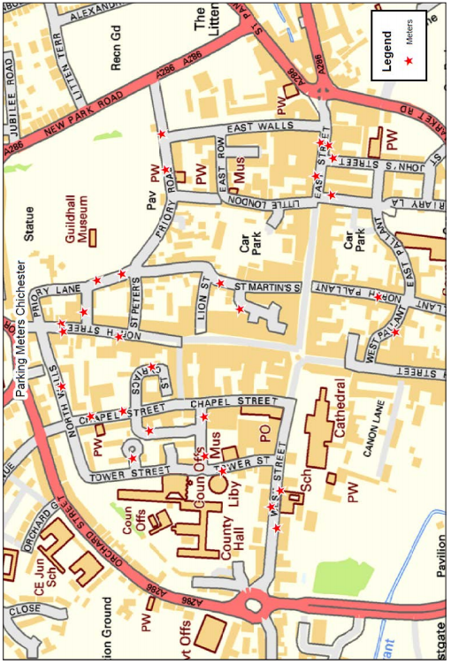

On-street Pay and Display Machines and Locations

|  |  |  |
| --- | --- | --- |
| Location | Machine Number | Machine Type |
| Priory Road | 200 | Coin Only |
| Priory Road | 201 | Coin Only |
| Priory Road | 202 | Coin Only |
| Priory Road | 203 | Coin Only |
| North Street (outside 41) | 204 | Coin Only |
| North Street (outside 45) | 205 | Coin Only |
| North Street (outside 38) | 206 | Coin Only |
| North Walls 9Outside Regnum Court) | 207 | Coin Only |
| St Cyriacs (Side of number 3) | 208 | Coin Only |
| Tower Close | 209 | Coin Only |
| The Providence | 210 | Coin Only |
| Guildhall Street | 211 | Coin Only |
| Chapel Street | 212 | Coin Only |
| Chapel Street | 213 | Coin Only |
| Woolstaplers (Back BT Building) | 214 | Coin Only |
| Woolstaplers | 215 | Coin Only |
| Tower Street (Ramp to Library) | 216 | Coin Only |
| West Street | 217 | Coin Only |
| West Street | 218 | Coin Only |
| West Street (Between 49-50) | 219 | Coin Only |
| West Pallant | 220 | Coin Only |
| North Pallant | 221 | Coin Only |
| St. Martins Service Area | 222 | Coin Only |
| St. Martins Square | 223 | Coin Only |
| East Street (outside T.K.Maxx) | 224 | Coin Only |
| East Street (Outside H&M) | 225 | Coin Only |
| East Street | 226 | Coin Only |
| St John's Street | 227 | Coin Only |
| Baffins Lane | 228 | Coin Only |

## Appendix D - Controlled Parking Zones map

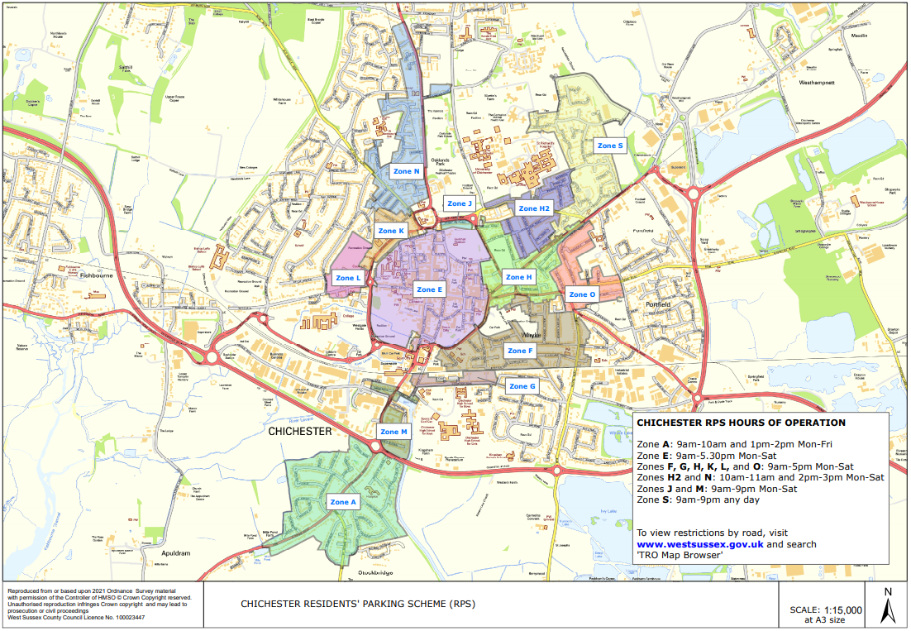

## Appendix E - Location of Chichester City Centre Car Parks Map

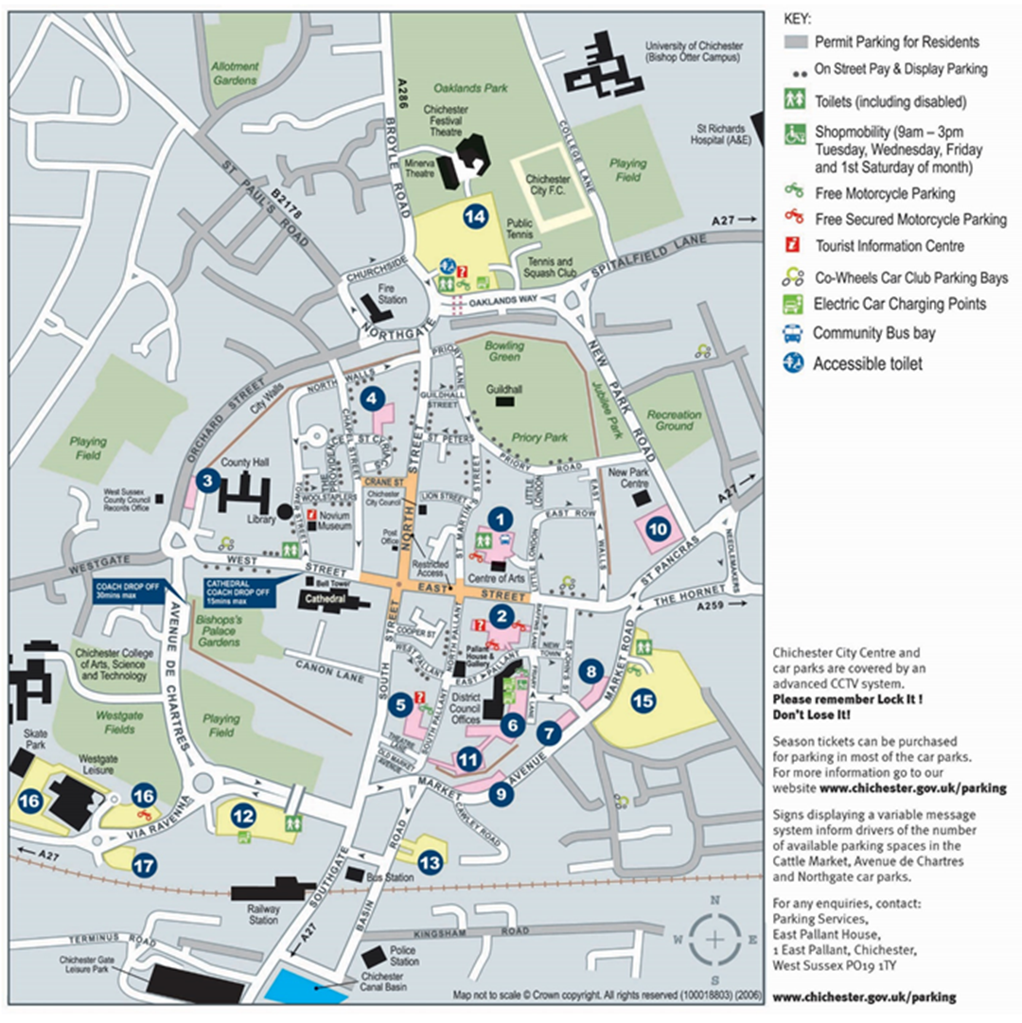

Parking Services

Chichester District Council

East Pallant House

1 East Pallant

Chichester

PO19 ITY

[01243 534500](tel:01243534500)

[parkingservices@chichester.gov.uk](mailto:parkingservices@chichester.gov.uk)

[www.chichester.gov.uk/parking](http://www.chichester.gov.uk/parking)

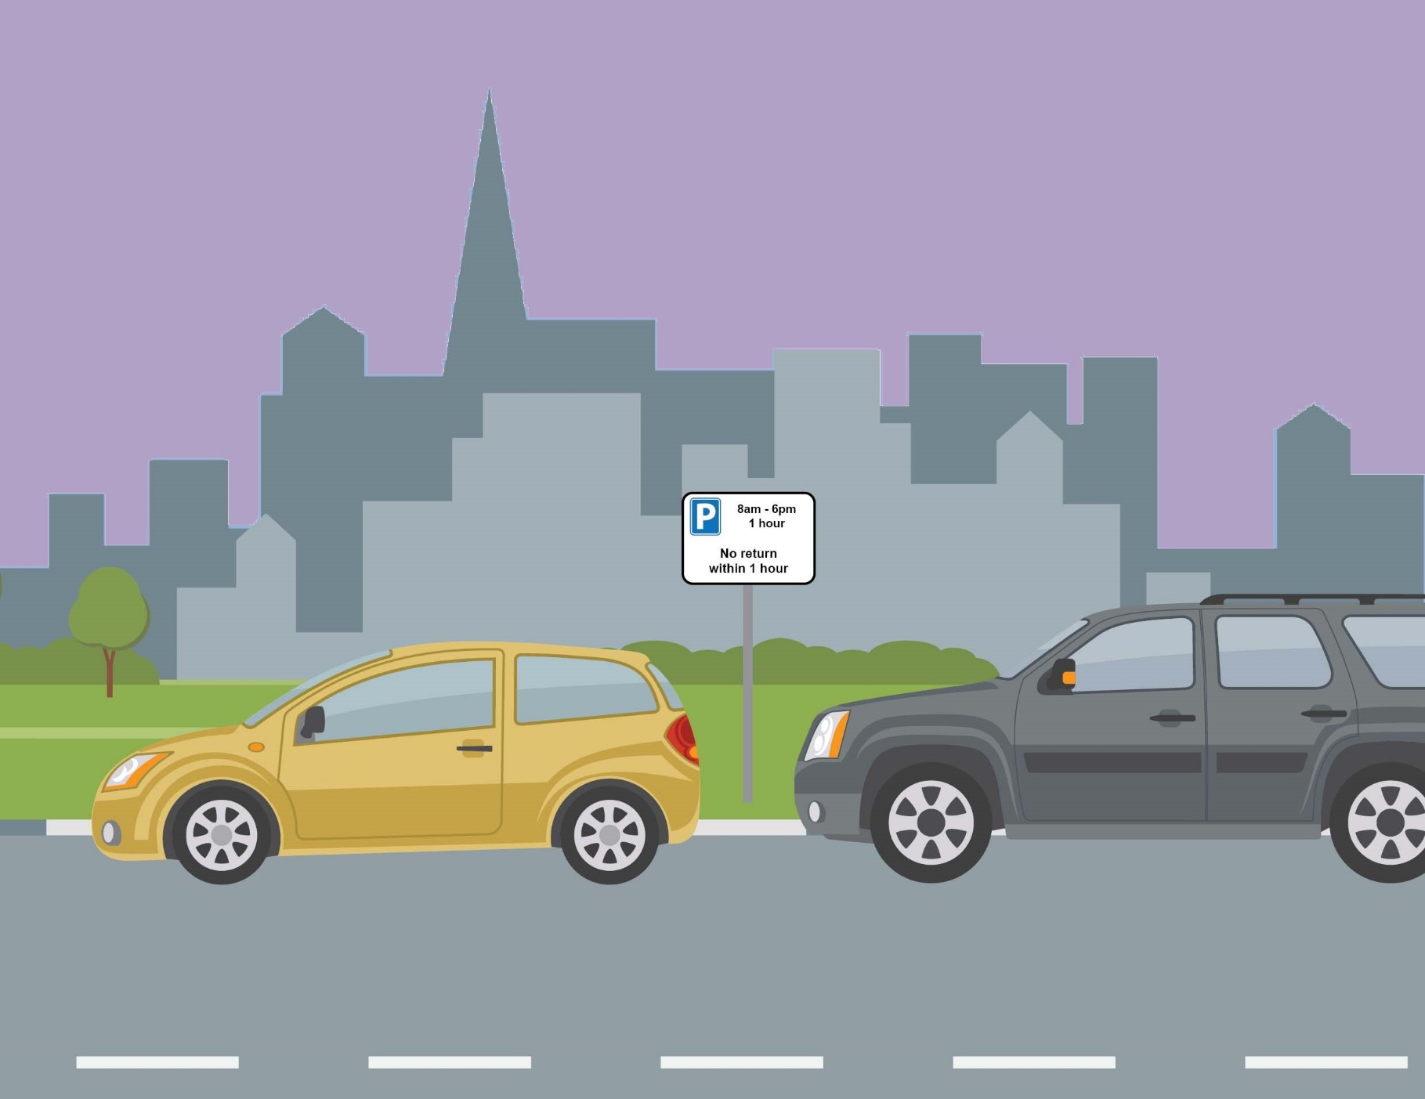

www.chichester.gov.uk/parking