 |  | Available Now  Industrial Units to Let
St. James Industrial Estate
Westhampnett Road, Chichester, PO19 7JU
 |  | 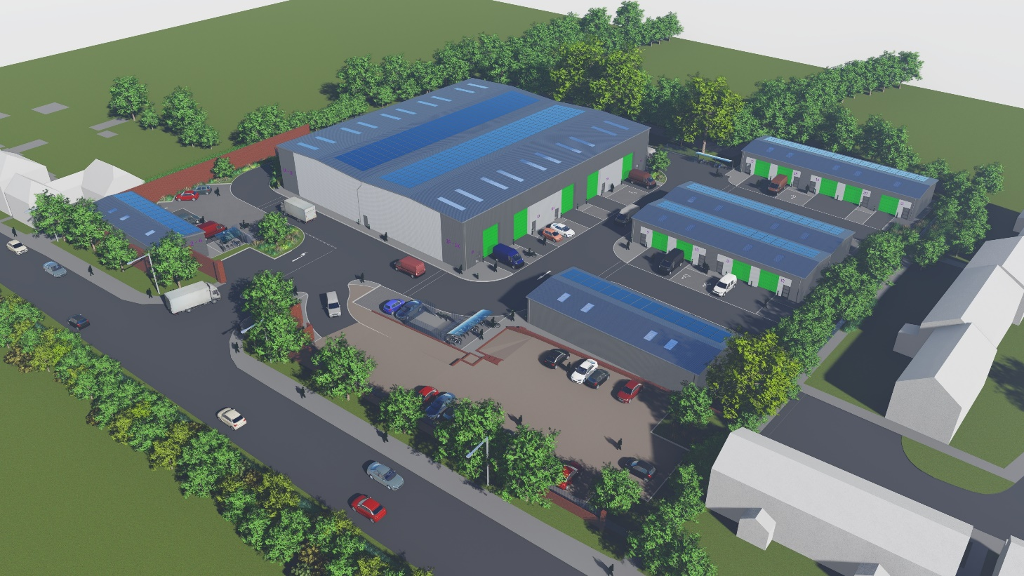
 |  | A new development of energy efficient industrial units on Westhampnett Road in Chichester, West Sussex. The development will provide high quality industrial and storage space (E(g)(ii), E(g)(iii) & B8) close to the city centre. The Estate provides easy access to the main road and rail networks to Brighton, Southampton and London.
 |  | Features include:
- Units with flexible space from 53 sq m (570 sq ft) to 240 sq m (2,580 sq ft) or more if required
- Eaves heights of 8.1 m (Block 1) and 4.1 m (Blocks 2, 3, 4 and 5)
- Three phase electricity
- Access to ultrafast full fibre network
- Allocated parking and active electric car charging points
Rent: On application

Terms: The units will be available on new full repairing and insuring occupational leases on commercial terms to be agreed between the parties. There will be an estate service charge.

Business Rates: To be assessed
 |  | E: property@chichester.gov.uk T: 01243 534632

