**TO LET**

**Retail Premises**

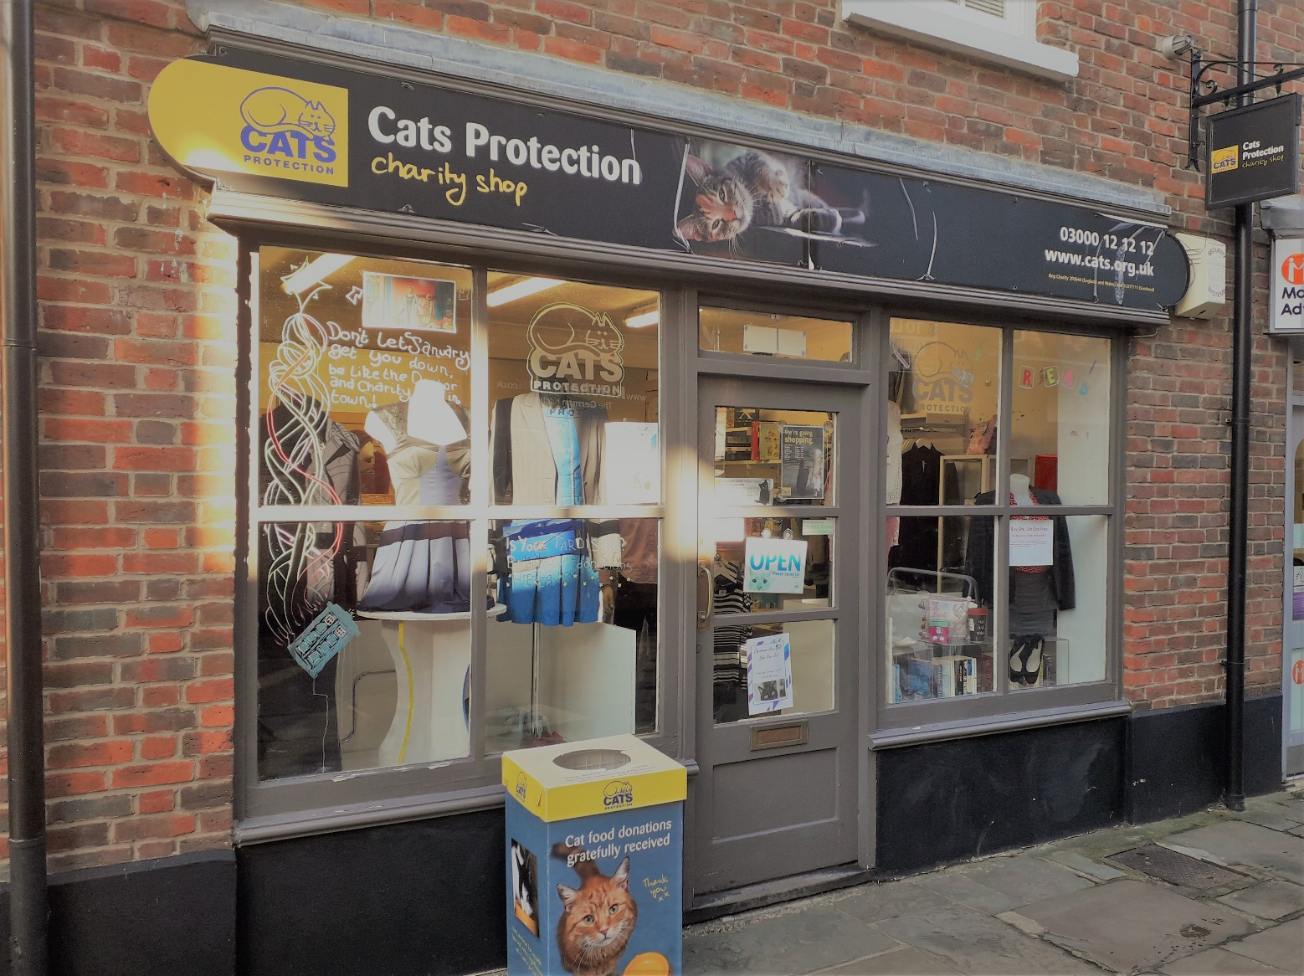

**7a Crane Street, Chichester PO19 1LH**

|  |  |
| --- | --- |
|  |  |

**DESCRIPTION & LOCATION**

The Crane Street shopping parade is conveniently located off North Street in the historic city centre of Chichester in West Sussex.

Chichester is a charming and bustling city, attracting a broad demographic of shoppers from surrounding smaller towns and rural villages, along with tourist and visitors from a wide area. Weekly street markets bring individual craftspeople, traders selling delicious artisan foods and fresh essentials, home and garden accessories and clothing.

Shops in Crane Street provide an opportunity for small businesses to obtain affordable retail space in close proximity to the main streets and benefit from the footfall of national retailers, such as The White Company, Marks & Spencer, L’Occitane, Greggs and the West Cornwall Pasty Co.

The unit totals 413 sq ft and is mainly open plan, with two store rooms, kitchenette and WC to the rear

**USE**

The premises benefit from A1 Retail use. Alternative uses may be appropriate, subject to planning permission.

**TERMS**

The unit is available to let by way of a new (effectively) full repairing and insuring lease of **£14,000 p.a. exclusive** plus VAT. The lease will be contracted out of the provisions of the Landlord and Tenant Act 1954 Sections 24-28.

**EPC**

The premises have an EPC rating of D

**RATES**

Rateable Value: £13,000

Rates Payable 2023/24: £6,487.00

The tenant may be able to claim Small Business Relief if this is the only business property.

**REPAIRS & MAINTENANCE**

The tenant is to be responsible for all repairs other than those that are the subject to a service charge or recharge of the Council’s costs of undertaking the work on a common basis.

**SERVICE CHARGE**

The service charge is currently £500 per annum.

**OUTGOINGS**

The lessee will be responsible for rates, utilities, reimbursement of the insurance costs (which will be invoiced to the tenant directly by the Council’s Insurance Officer), insurance of contents and any other outgoings that may be applicable.

**RENT DEPOSIT / GUARANTEE**

The Council will require a rent deposit as guarantee for the rent and tenant obligations.

**VIEWING**

Prospective tenants wishing to be considered for a tenancy of this property should contact The Estates Service at;

Chichester District Council

East Pallant House

1 East Pallant

Chichester

West Sussex, PO19 1TY

t: 01243 534632

e:[estatesservice@chichester.gov.uk](mailto:estatesservice@chichester.gov.uk)

Viewing is by appointment only

**COSTS**

Each party will bear their own costs in preparing the lease.

|  |  |
| --- | --- |
| **LOCATION PLAN**  Map showing location of 7a Crane Street | **FLOOR PLAN**  Floor plan of 7a Crane Street |

Chichester District Council declares that (1) these particulars are set out as a general outline only and do not constitute part of any offer or contract (2) all descriptions, dimensions, reference to condition and other details are given without responsibility on the part of the Council and prospective purchasers/lessees must satisfy themselves as to their correctness and in particular no services or appliances mentioned have been tested (3) the Council nor any person in their employment has any authority to make or give any representation or warranty in respect of the property'