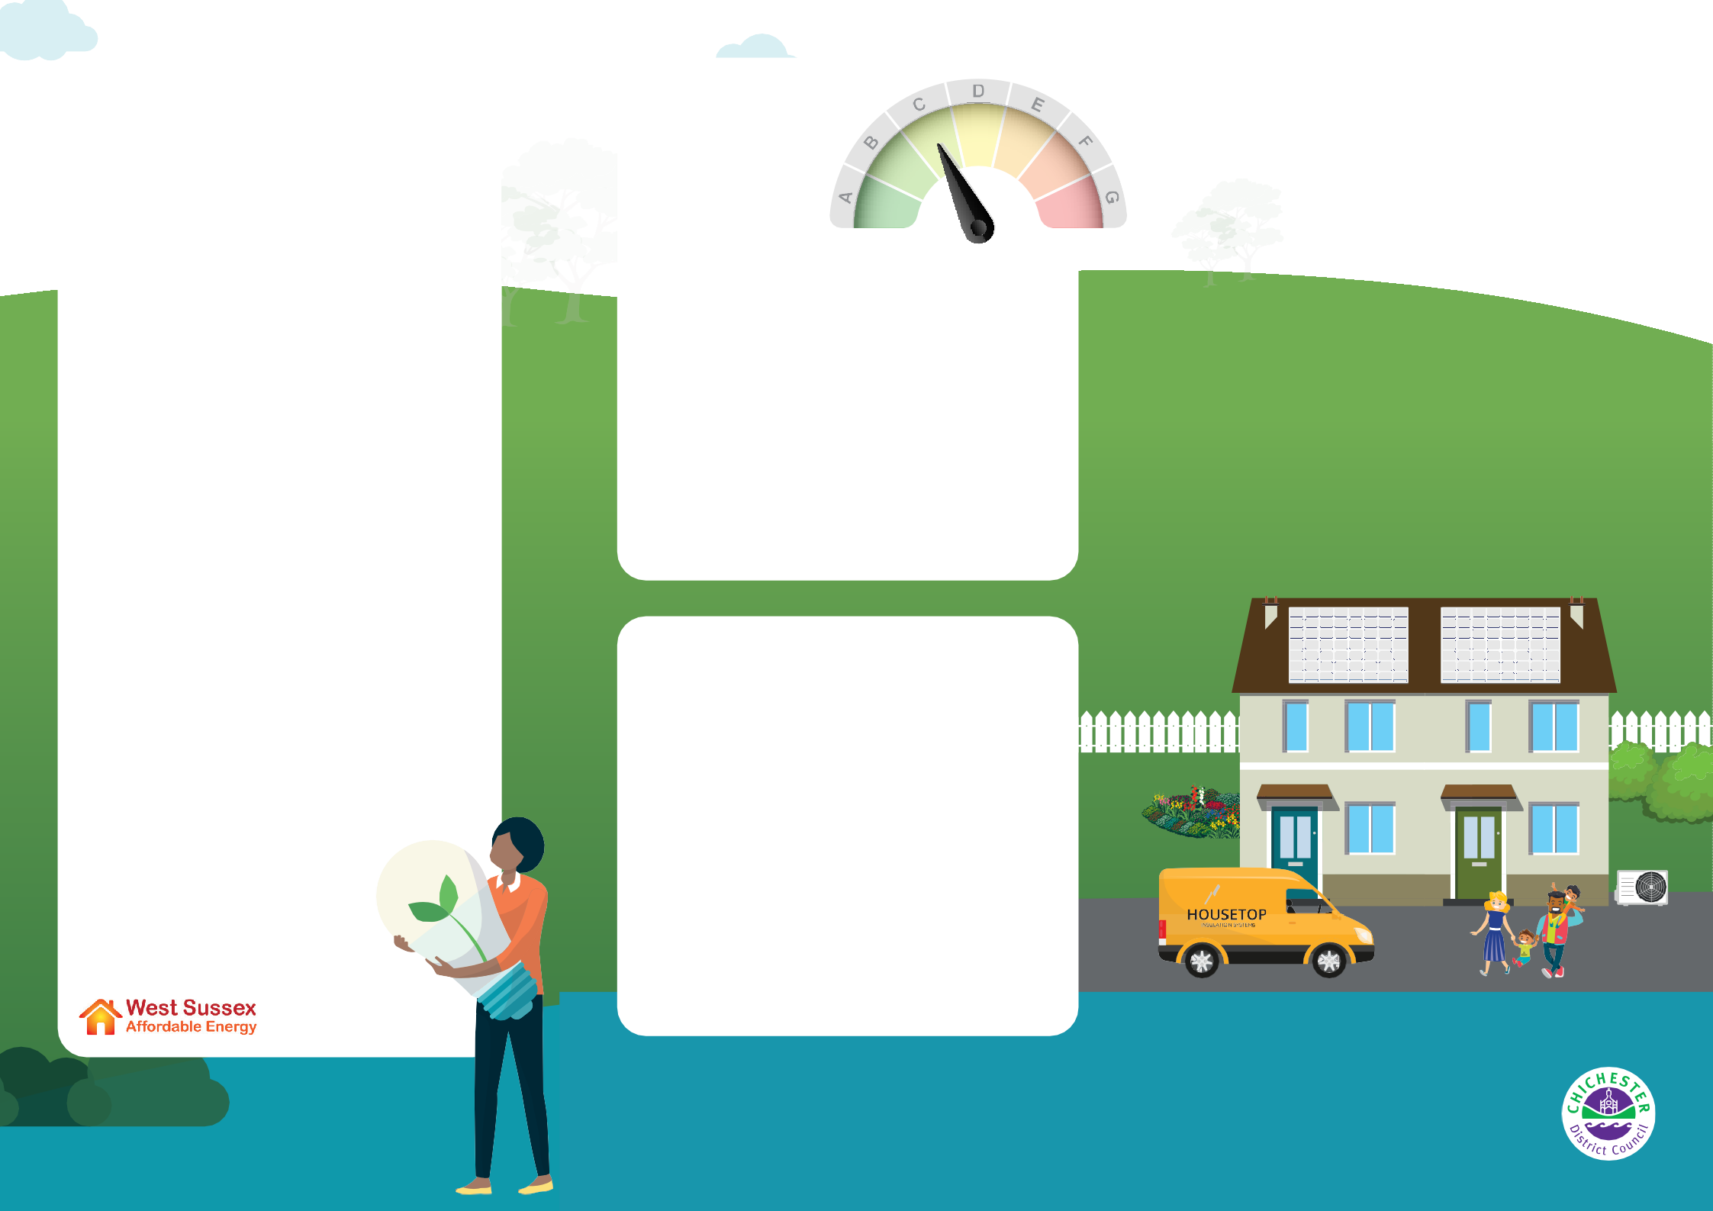This leaflet provides an overview of the government home energy efficiency grants that are currently available.

For energy saving tips visit the Help for Households web page: [**helpforhouseholds. campaign.gov.uk/energy-saving-advice**](https://helpforhouseholds.campaign.gov.uk/energy-saving-advice/)

To find out what measures and grant schemes may be available to you, visit: [**chichester.gov.uk/homeenergyefficiency**](http://www.chichester.gov.uk/homeenergyefficiency)

# Problems paying your energy bills?

For advice, contact your energy supplier or contact CAB or LEAP: [**www.arunchichestercab.org.uk**](http://www.arunchichestercab.org.uk/)[**www.applyforleap.org.uk**](http://www.applyforleap.org.uk/)

# Able to pay but want guidance?

* Register with the SuperHomes Network:

[**www.superhomes.org.uk/join-the-network**](http://www.superhomes.org.uk/join-the-network)

* Enquire about a Whole House Retrofit Plan through PeCAN: [**www.petersfieldcan.org/ home-energy/**](https://petersfieldcan.org/home-energy)
* Register your interest in Solar Together, a group buying scheme for solar panels and battery storage:   
  [**https://solartogether.co.uk/ chichester/home**](https://solartogether.co.uk/chichester/home)
* Find informative guides from the Energy Saving Trust: [**energysavingtrust.org.uk/ energy-at-home**](https://energysavingtrust.org.uk/energy-at-home)

For detailed information on grants and how to make your home energy efficient, visit: [**www.westsussexenergy.co.uk**](http://www.westsussexenergy.co.uk/)

# What is an EPC?

An Energy Performance Certificate (EPC) is needed whenever a property is built, sold or rented. It contains

information about a property’s energy use, typical energy costs and recommendations on how to reduce energy and save money.

An EPC is valid for 10 years and gives a property an energy efficiency rating from A (most efficient) to G (least efficient).

You can check if your house has an EPC, and find out how to get one at:

[**www.gov.uk/get-new-energy-certificate**](http://www.gov.uk/get-new-energy-certificate)[**www.gov.uk/find-energy-certificate**](http://www.gov.uk/find-energy-certificate)

# How to find an installer

It is important to find an installer accredited with the correct scheme.

**TrustMark:** A government endorsed scheme, assuring work is carried out to high standards with protection in place [**www.trustmark.org.uk**](http://www.trustmark.org.uk/)

**Insulation:** Your installer should be a member of The National Insulation Association (NIA) **https://www.nia-uk.org/find-an-installer/**

**Heat Pumps and Solar Panels:** Installers should be accredited with the Microgeneration Certification Scheme (MCS) [**www.mcscertified.com/find-an-installer**](http://www.mcscertified.com/find-an-installer)



Home Energy

Efficiency Grants

**Information on grants available to help make your home more energy efficient**

**Warmer homes, lower bills, cut carbon emissions**

If you want to find out more visit

[**www.chichester.gov.uk/climatechange**](http://www.chichester.gov.uk/climatechange)

or email: [**climatechange@chichester.gov.uk**](mailto:climatechange@chichester.gov.uk)

(Correct as of April 2024)

**What energy efficiency grants are available?**

**h to**

**ur ur**



|  |  |  |  |
| --- | --- | --- | --- |
| **Who can apply** | **Eligibility** | **What it can provide** | **How to apply** |
| **Boiler Upgrade Scheme (BUS)** | | | |
| Homeowners and landlords | * Valid EPC with no recommendations for loft or cavity wall insulation * Must be replacing fossil fuel heating systems (such as oil, gas or electric) * May not include new build | You can get one grant per property for:   * £7,500 towards an air source heat pump * £7,500 towards a ground source heat pump (including water source heat pumps and those on shared ground loops) * £5,000 towards a biomass boiler | Check eligibility and apply online via: **www.gov.uk/apply-boiler-upgrade-scheme** |
| **Chichester Warm Home Initiative** | | | |
| Homeowners and landlords | * Household income less than £25,000   **or**   * In receipt of means tested benefits,   DLA or PIP   * **And** Occupant is in fuel poverty (rating F or G) | Up to £10,000 for properties on mains gas or up to £25,000 for properties not on gas, for the following measures:   * a whole-house efficient heating system, * thermal insulation, * boiler repair, * hot water tank repair/replacement, and; * window repair or replacement.   **Landlords** are required to pay 50% of the cost. | Apply online via the Chichester District Council website: [**www.chichester.gov.uk/applywarmhomesinitiative**](http://www.chichester.gov.uk/applywarmhomesinitiative) |
| **Energy Company Obligation (ECO) and Great British Insultation Scheme (GBIS)** | | | |
| Homeowners, landlords, park home and social housing tenants | * Household income less than £31,000   **or**   * In receipt of means tested benefits * **And** property has EPC rating of D, E, F or G (E, F or G only for rented properties) * **And** someone in your household is vulnerable (under 4 or over 65 years of age; has a health condition that makes them vulnerable to cold) * **Or** you may be referred by your energy company or CAB if you are struggling to pay energy bills   **GBIS:**   * EPC rating of D, E, F or G * Property in Council Tax bands A-D | **Homeowners:**   * Insulation (Cavity Wall, Loft, Room-In-Roof, Solid Wall (internal or external) and Underfloor) * Replacement boiler or upgrade to renewable heating system * Heating controls * Draught proofing * Window glazing   **Landlords:**   * Upgrade to renewable heating system * First time central heating * External solid wall insulation **Park home:** Insulation only | **ECO:** You can contact any obligated energy suppliers  to find registered installers:**www.ofgem.gov.uk/eco-supplier-contact-details**  Or contact the Citizens’ Advice West Sussex  Energy Team on **0800 145 6879** to check your eligibility and get a list of installers working in the local area.  **GBIS:** Check if you are eligible and apply online at: **www.gov.uk/apply-great-british-insulation-scheme**  You may be contacted by installers – always check they’re registered with the relevant accreditation schemes (see ‘How to Find an Installer’). Council  staff will never cold call you about these  schemes. If you want to check  something is genuine, please  contact us: **climatechange @chichester.gov.uk** |
| **Warmer Homes Home Upgrade Grant (HUG)** | | | |
| Homeowners and landlords (*with 4 or less rental properties) | * Only for properties that do not use mains gas for heating. * Household income less than £36,000   **or**   * In receipt of means tested benefits * **And** property has EPC rating of D, E, F or G | Warmer Homes can fully fund the following measures for properties not on mains gas:   * Insulation (Cavity Wall, Loft, Room-In-Roof, Solid Wall – internal or external – and Underfloor) * High Heat Retention Storage Heaters (off-gas homes only) * Air Source Heat Pumps * Solar PV panels * Heating Controls * Eligible landlords*are required to pay 50% of the cost. | Apply online via: [**www.warmerhomes.org.uk**](http://www.warmerhomes.org.uk/) or call (free): **0800 038 5737** or email  [**info@warmerhomes.org.uk**](mailto:info@warmerhomes.org.uk)  Warmer homes logo |