# Greenhouse Gas (GHG) emissions inventory[1] for Chichester District Council

## 1. Overview

This report follows the template set out in UK Government’s Environmental Reporting Guidelines dated March 2019. The template is technical but the aim is to enable emissions reported by different organisations to be compared, so readers know that broadly speaking they are comparing like-for-like. This section aims to put across the key points in a non-technical way.

This report covers the council’s fleet including its refuse collection vehicles, which are the council’s biggest source of emissions. It also covers the council’s headquarters, East Pallant House, the Novium museum, Westhampnett vehicle depot, short stay accommodation for people facing homelessness (Westward House and Freeland Close), car parks and small buildings such as public conveniences.

The report also includes some leased out buildings: three leisure centres (Westgate, Bourne and Grange) and St James Industrial Estate. CDC does have other leased assets that are not included in the target e.g. Ravenna Point and Chichester Enterprise Centre, both business accommodation.

Our target is to reduce our emissions by 10% year-on-year from a start year of October 2018-September 2019. The year was chosen because it covers when the Council declared a Climate Emergency and the start month of October reflects the start of the Council’s energy contract.

In the first year, emissions were reduced by 12% and in the second year by 4%. This report covers the third year of the target 2021-2022. Emissions have increased by 2%. This is probably due to a partial return to a pre-Covid way of life and the joint hottest summer on record which can increase electricity use for cooling. The benefit of emission reduction measures such as work on Westgate leisure centre and two electric refuse vehicles entering service as well as some other changes should come through in the next reporting period. For more detail, see Section 6.

## 2. Organisation information

Chichester District Council is a lower-tier local authority with its main offices at 1 East Pallant, Chichester, West Sussex, PO19 1TY.

## 3. Reporting period

01/10/2021 to 30/9/2022

## 4. Organisational boundary[2]

We have used the operational control approach. Therefore, all services delivered directly by the Council and Chichester Contract Services are included in Scope 1 and Scope 2 emissions.

This encompasses fuel and electricity use at:

* The council’s headquarters at East Pallant House which has solar electric (PV) and solar thermal arrays
* Westward House and Freeland Close short stay accommodation. Freeland Close also has PV panels.
* Novium museum which has a wood pellet-fueled boiler
* Car parks
* Westhampnett depot
* Other smaller buildings
* Refuse fleet
* Other council-operated vehicles

We have been trying to include emissions from assets that we own but lease out to reflect our shared responsibility for these assets. These emissions fall into the Scope 3 emissions category for the council. For some leased out buildings, we pay for the energy and then recharge the tenant e.g. St James Industrial Estate. For other buildings, we request the data from the tenant e.g. the leisure centres. So far, we have included Westgate, Bourne and Grange leisure centres and St James industrial estate within the inventory.

## 5. Reasons for change in emissions

There was a significant decrease in coal generation of electricity and an increase in the amount of renewable and nuclear electricity generation on the national grid in this period. This means that for every kWh of electricity used from the grid, 9% fewer greenhouse gases were emitted compared to the previous reporting period (source: the UK Government GHG Conversion Factors for Company Reporting for 2022). This is the third year running that emissions per kWh have decreased by 9%.

Well-to-Tank emissions per kWh have decreased too. Well-To-Tank emission factors account for the production, transport and distribution of the fuels used in electricity generation The UK Government has improved the methodology for calculating the Well-To-Tank emissions factor for UK electricity, resulting in a decrease.

Turning to electricity, gas, diesel and petrol consumption, the council’s biggest source of reported emissions is its fleet of diesel refuse collection vehicles. See Graph 1. There has been little change (+4%) in waste vehicle diesel use. Two electric refuse vehicles have been bought by the council as a trial to see how they cope with the collection routes and to gain experience of their use. Their benefits should be seen in the next reporting period.

The leisure centres saw increases in electricity use: Westgate (+55%), Grange (+55%) and Bourne (+30%). Part of this increase may be due to increased demand for cooling during the summer of 2022 (the joint hottest summer on record according to the Met Office). Another reason was that electricity use the previous year was exceptionally low, due to Covid closures and restrictions in place during October 2020-September 2021. Gas use changes were: Westgate (1%), Grange (-6%) and Bourne (+20%). Leisure centre operator EveryoneActive has been working to reduce energy use through changes to equipment settings. Furthermore, Westgate - the council’s second biggest source of reported emissions – has had £1.3m spent on it so renewable energy can be used on site. Although out of sight, the swimming pool hall roof is now completely covered with heat- and electricity-generating panels with electricity-generating panels on some other roofs. An air source heat pump has also been installed. The benefit of this project should be seen in next year’s report.

The Novium museum also saw a 53% increase in electricity use. Again, this appears to be due to the very low figure reported for the previous year. Gas use increased by 12%. The museum was affected by the wood pellet boiler being out-of-action during the reporting period, so the museum was wholly reliant on gas for heating. The wood pellet boiler was repaired in June 2023.

East Pallant House also saw a 10% increase in electricity use and a 48% increase in gas use. This is attributed to higher staffing numbers in the office and certain portions of the building that had been shut off came back into use so that would have had a small impact. The standalone aircon units had been taken out of action during 2020-2021 and would have operating in this reporting period.

Avenue de Chartres multistorey car park had a 13% increase in electricity use which is probably due to increased use after a dip due to Covid and increased use of the electric vehicle chargepoints, which went up by 64% in year-on-year electricity consumption in this particular car park.

Overall, there was a three-fold increase in the use of the council’s network of public electric charge-points in the district, but this only led to an increase in the council’s reported emissions of less than 1%.

The ICT team’s multi-year roll-out of laptop across the organization is now complete. Laptops use about a sixth of the electricity of a desktop computer. A disaster recovery data centre that is located separately to the servers located at East Pallant House became fully operational in June 2022.

A new facility opened in March 2022: Freeland Close short-stay accommodation for people facing homelessness. Freeland Close has PV panels, two electric vehicle charge points, water use reduction measures and bird and bat boxes. Like its sister facility, Westward House, it is an all-electric facility. It has added less than 1% to the council’s emissions footprint. Westward House saw minor variation in its electricity use. It underwent major energy efficiency improvements which were completed in October 2022. The benefit of this should be visible in next year’s report.

St James’ industrial estate has caused a major drop in the council’s emission figures this reporting period– as can be seen from Graph 1. This industrial estate is owned by the council which leases out units to tenants. At the beginning of the target in 2018-2019, occupancy of the site was reducing and the plan was to re-develop the site. In this reporting period October 2021- September 2022, only one unit was occupied – hence the low emission figures in this period. The site was re-developed by the council to a higher energy efficiency standard and the new estate re-opened in 2023. It has 32 electric vehicle charging points, electricity-generating solar panels on every building, and a comprehensive landscaping scheme. Tenants have begun to occupy the new units.

## 6. Quantification and Reporting Methodology

The UK government’s Environmental Reporting Guidelines dated March 2019 and the 2022 UK Government Conversion Factors for Company Reporting have been used, along with the GHG Protocol Value Chain (Scope 3) Standard.

Data for St James’ industrial estate is completely modelled. Prior to demolition, tenants were responsible for their own electricity purchase, so CDC does not know how much electricity was used and tenants’ electricity use would have varied according to the nature of their business. CDC bought electricity only for the communal areas. After re-building, CDC is buying electricity for the whole site and re-charging tenants for their use. Tenants will not be the same ones as prior to demolition. To enable comparison of the greenhouse gas emissions before and after re-building, only energy use for heating, lighting and aircon will be factored into our emission figures. This has been estimated using the Energy Performance Certificates of the units before demolition. The new units’ energy use for heating, lighting and aircon has been modelled using construction plan data. Emissions will be incorporated into the CDC inventory as these units are let.

## 7. Operational Scopes

We have estimated our Scope 1, 2 and certain Scope 3 emissions. Scope 1 (S1) is direct emissions from burning fuels or emissions from air conditioning units. Scope 2 (S2) are indirect emissions from electricity use. They take place at power stations. Scope 3 (S3) emissions are all other emissions. They encompass emissions from goods we purchase to emissions as a consequence of the services we provide. We do not report on all S3 emissions. We do report on buildings CDC leases out, from the energy it takes to make and deliver the gas, fuel and electricity CDC uses, business mileage employees do in their own vehicles, and the electricity that CDC provides to the public via its network of EV chargepoints . Emissions are measured in tCO2e or tonnes of carbon dioxide equivalent.

### Table 1: CDC’s Scope 1, Scope 2 and Scope 3 emissions

| **Emissions in tCO2e[3]** | **2021-2022** | **Excluded emission sources** | **% of activity data[4] that is estimated** | **2020-2021** |
| --- | --- | --- | --- | --- |
| Gas consumption | 133 | None | 0 | 102 |
| LPG | 31 | None | 0 | 40 |
| Fuel emissions for vehicles | 1170 | None | 0 | 1,114 |
| Fugitive[5] emissions of refrigerants used in air con. |  | Air con unit reporting is to be developed. |  |  |
| TOTAL SCOPE 1 | 1,333 |  |  | 1,256 |
| Purchased electricity – location-based approach | 277 | Public conveniences at Itchenor[6]. | 0 | 277 |
| TOTAL SCOPE 2 | 277 |  |  | 277 |
| **Scope 38 emissions in tCO2e** |  |  |  |  |
| Purchased goods & services |  | We have not tried to quantify these emissions yet. |  |  |
| Capital goods |  | We have not tried to quantify these emissions yet. |  |  |
| Electricity – transmission & distribution (T&D) losses | 25 |  | 0 | 24 |
| Fuel- and energy-related activities not included in Scopes 1 & 2 | 378 |  | 0 | 371 |
| Upstream transportation & distribution |  | We have not tried to quantify these emissions yet. |  |  |
| Waste generated in operations |  | We have not tried to quantify these emissions yet. Would include green waste from parks. |  |  |
| Business travel | 25 | Employees who use their own vehicles for business travel but do not claim the mileage allowance. Travel using rail. This is infrequent. | 5% is estimated. This is due to CDC not having the gCO2/km from the employee’s V5 vehicle document. | 25 |
| Employee commuting |  | We have not tried to quantify these emissions yet. |  |  |
| Upstream leased assets |  | Oher organizations’ premises used by community wardens as bases. |  |  |
| Downstream leased assets | 948 | Collecting data from leased out assets is being developed. | Less than 1% is estimated. | 973 |
| Downstream transportation & distribution |  | Not relevant. |  |  |
| Processing of sold products |  | Not relevant. |  |  |
| Use of sold products | 16 | Electricity used via CDC EV charge-points only. | 0 | 6 |
| End-of-life treatment of sold products |  | We have not tried to quantify these emissions yet. They would include emissions from trade waste collected by CCS. |  |  |
| Franchises |  | Not relevant. |  |  |
| Investments |  | We have not tried to quantify these emissions yet. |  |  |
| Biogenic emissions | 0 | From wood pellets only. Emissions from the biogenic part of petrol & diesel has not been calculated yet. |  | 0 |
| **Intensity metrics** |  |  |  |  |
| Scope 1, Scope 2 & selected Scope 3 emissions per district resident  (tCO2e per capita) | 0.02 |  |  | 0.02 |
| Scope 1, Scope 2 & selected Scope 3 emissions per unit area (tCO2e per km2) | 3.70 |  |  | 3.61 |

### Table 2: Emissions totals

|  | **2021-2022** | **2020-2021** | **% change** |
| --- | --- | --- | --- |
| **Emissions (S1, S2 & selected S3) tCO2e** | 3,002 | 2,930 | 2% increase |

The year-on-year change in emissions from the Council’s key emission sources is shown in Graph 1 below. The data used for Graph 1 is presented below in Table 3.

Scope 1 (S1) emissions are from burning gas or fuel. Scope 2 (S2) emissions are from electricity use. Scope 3 (S3) emissions are from buildings CDC leases out, from the energy it takes to make and deliver the gas, fuel and electricity CDC uses, and from business mileage employees do in their own vehicles. emissions are measured in TCO2e or tonnes of carbon dioxide equivalent.

### Table 3: Chichester District Council annual emissions (S1, S2, S3)

|  |  |  |  |  |
| --- | --- | --- | --- | --- |
| **Emission sources** | **Oct 2018- Sep 2019** | **Oct 2019 - Sep 2020** | **Oct 2020 - Sep 2021** | **Oct 2021 - Sep 2022** |
| Waste teams' vehicles | 1201 | 1230 | 1167 | 1,235 |
| Westgate leisure centre | 821 | 628 | 752 | 783 |
| Other teams' vehicles | 252 | 198 | 214 | 214 |
| St James' industrial estate units heating & lighting only | 226 | 213 | 71 | 1 |
| Council HQ East Pallant House | 220 | 180 | 176 | 204 |
| Grange leisure centre | 149 | 105 | 101 | 110 |
| Novium museum | 105 | 84 | 86 | 104 |
| Westhampnett depot | 77 | 71 | 81 | 69 |
| Westward House | 71 | 88 | 63 | 60 |
| Bourne leisure centre | 56 | 40 | 38 | 46 |
| Business travel in staff own vehicles | 49 | 33 | 25 | 25 |
| Avenue de Chartres car park | 37 | 34 | 33 | 34 |
| Freeland Close |  |  |  | 6 |

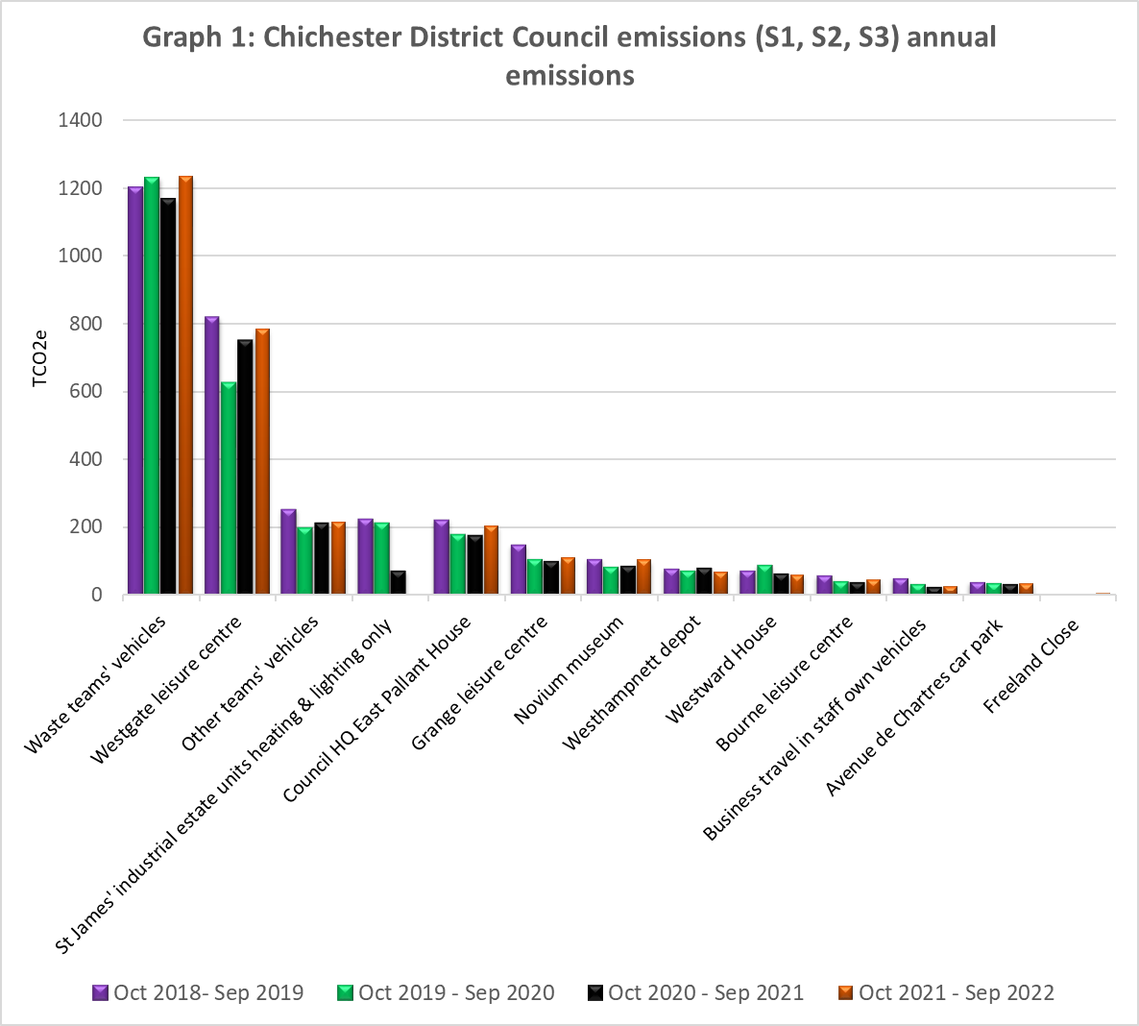

## 8. Base year

The base year is 01/10/2018 to 30/9/2019

We have chosen this period as it is:

• the year of the council’s climate emergency resolution

• fits with the electricity and gas contract periods

• the subsequent periods will show the effect of Covid 19 lockdown and any GHG reduction initiatives we put in place following the declaration of a climate emergency.

## 9. Target

Our target is a 10% year-on-year reduction from the 2018-2019 base year, covering Scopes 1 and 2 and selected Scope 3 categories until year-end 2025.

## 10. Intensity Metrics

Our chosen intensity metrics are Scope 1, Scope 2 and selected Scope 3 emissions per resident in the district (tCO2e per district resident) and emissions per unit area (tCO2e per km2). The number of residents within the district is a key factor in determining the scale of our activities and hence our emissions. The acreage of the district is a factor in determining the how we deliver those services i.e. the extent to which services can be centralised.

## 11. Electricity & heat data

### Table 4: Electricity and heat data

| **Energy purchased for consumption (MWh)** | 1,431 MWh electricity. 726 MWh gas. |
| --- | --- |
| **Green tariffs or other renewable/low-carbon contractual instruments used** | Yes, but we have used a location-based approach. |
| **Renewable electricity (in MWh) generated in council-operated plants that was exported to the grid** | Electricity is generated via the PV panels on East Pallant House roof and on Freeland Close, but data on the quantity exported to the grid has not been calculated. |
| **Was this backed by Renewable Energy Guarantees of Origin (REGOs)?** | Not known |
| **Heat generated from council operated sources (in MWh).** | CDC has a solar thermal array generating hot water on East Pallant House roof. We do not have data on the quantity generated. |

1. Inventory is the technical term for a footprint.
2. There are different ways to draw a line around organisations – its boundary. We have used operational control so that we are accounting for emissions from activities over which we have day-to-day control.
3. tCO2e stands for metric tonnes of carbon dioxide equivalent. The global warming caused by gases is standardised to the warming caused by one unit of carbon dioxide hence carbon dioxide equivalent.
4. Activity data is the data used to estimate emissions e.g. how much fuel we have used, how many miles we have driven for business. Some activity data has not been measured or taken from records and is estimated instead.
5. Fugitive is the technical terms for emissions from leaks or accidental venting of equipment.
6. These conveniences at Ferryside, The Street, are leased from Chichester Harbour Conservancy.