

FOOD SAFETY SERVICE PLAN 2024

1.0 Section 1 – Service Aims & Objectives

**1.1 Introduction**

1.1.1 This Food Safety Service Plan 2024 meets the requirements of the Food Standards Agency document, “Framework Agreement on Local Authority Food Law Enforcement”.

1.1.2 The District Council, as a “Food Authority” is required to develop and publish a plan which combines its obligations on food law enforcement services arising from statutes and related guidance documents and to set out requirements for the planning, management and delivery of its food safety services.

1.1.3 The Service Plan will provide the basis on which the Food Standards Agency will audit the Food Authority and its work.

**1.2 Aims**

1.2.1To safeguard the public by ensuring that all food and drink intended for sale for human consumption, which is produced, stored, sold, distributed, handled or consumed within the district is fit and suitable for consumption.

1.2.2To enforce and ensure compliance with appropriate food and hygiene legislation and to promote general food hygiene standards in accordance with the Council’s Enforcement Policy and the relevant FSA Codes of Practice.

1.2.3 To assist food premises to raise and maintain standards, particularly in relation to the Food Hygiene Rating Scheme

1.2.4 To prevent the spread of food borne infection and food poisoning.

1.2.5 To ensure the effective management of the Service.

**1.3 Objectives**

* + 1. Food Hygiene
       1. To inspect the 1492 food premises (as of 1 April 2024) in the District based on risk, in accordance with the planned food hygiene inspection programme, incorporating alternative enforcement strategies where appropriate and the plan of inspection for approved premises.
       2. Whilst completing inspections due, greater emphasis will be directed towards any premises having poor standards. Action will be taken in line with our published enforcement policy.
       3. To adopt a balanced enforcement mix including advice, education, sampling and inspection with proportionate enforcement action. The Council is well known for its supportive approach. Formal action is only taken when other less formal means have been unsuccessful or when conditions are so bad as to represent immediate and serious risks to the health of the public.
       4. To investigate food and food premises complaints in accordance with local priorities.
       5. To provide paid advice visits, food hygiene training and Safer Food Better Business (SFBB) coaching to businesses on an income generating basis.
       6. To provide advice to businesses and members of the public with respect to food safety either verbally or in the form of advisory leaflets and other written guidance. A periodical newsletter for businesses, “Foodbites” is emailed to businesses on a quarterly basis.
       7. Officers can work flexibly so that issues can be addressed at the most relevant time from a risk perspective.
    2. Food Poisoning/Food Borne Disease Control

1.3.2.1 To fully investigate food poisoning notifications and outbreaks, in partnership with the UK Health Surveillance Agency (UKHSA), through the Consultant in Communicable Disease Control (CCDC), and to take appropriate measures to control their spread and prevent recurrence.

* + - 1. To respond appropriately to Food Alerts and Allergy Alerts received from the Food Standards Agency where action is required.
      2. To inspect/sample food to ensure that it is fit for consumption and to ensure that waste, unfit and unsound food is disposed of properly.
    1. Sampling

1.3.3.1 To carry out food and water sampling at food premises based on local and national priorities detailed in Codes of Practice and UKHSA annual sampling initiatives.

* + 1. Registration/Approval

1.3.4.1 To register/approve persons/premises in accordance with legislation and guidance.

* + - 1. To provide export certification in the form of Export Health Certificates and Certificates of Good Manufacturing Practice before food is exported into the EU and around the world.
    1. Food Hygiene Education

1.3.5.1 To provide low-cost food hygiene training at all levels to food handlers and others in the food industry. This is a chargeable service.

* + - 1. To provide bespoke training to businesses as the need arises. This is a chargeable service.
      2. To participate in campaigns aimed at raising food safety awareness and to provide speakers to address young persons, special needs groups and the homeless to stimulate interest in the subject. This will include expanding work to support initiatives in the wider public health agenda such as obesity and social deprivation.
      3. To provide information and paid advice to those operating or proposing to operate food businesses in the District and contribute to the FSA’s food hygiene campaigns, which aim to raise awareness of food hygiene issues.
      4. To participate on World Food Safety Day.
      5. To promote the Safer Food Better Business initiative through giving advice, mentoring visits and, if appropriate, seminars. A charge may be made for this support.
      6. To promote the National Food Hygiene Rating Scheme and to ensure that premises in the district are rated accurately and in a timely manner. To visit to re-rate premises as requested by the business for a charge.
      7. To issue a quarterly newsletter “Foodbites” to all food businesses which gives information on legislative changes, current issues and training opportunities.

**1.4 Links to Corporate Objectives and Plans**

1.4.1 **Supported Communities** – Any resident and visitor may frequent premises with poor food safety standards. Food safety advice and regulation helps to ensure that risks to everyone, including those who are vulnerable, are reduced.

1.4.2 **Homes for all** - Development of safe and secure living and working environments and mitigating the risks to health and wellbeing. Food safety advice and regulation is a major contributor to mitigating risks to people’s health and wellbeing from potentially harmful foodstuffs.

1.4.3 **Thriving Economy** - Good food businesses have good food safety standards.  The team’s regulatory activities help good businesses flourish by penalising those breaking the law.  Following successful prosecution, we have ensured that the worst operators are banned by the court from managing a food business.  Health Protection team staff support large local events that are important for the district, such as those at Goodwood, by offering advice and expertise in planning stages and by carrying out food safety inspections   
  
during the event.  The Council gives advice to businesses generally on food safety matters in order that they can improve.

1.4.4 Financial prudence – By following a risk-based approach the Council’s resources are appropriately directed as well as ensuring improvement in food safety.

1.4.5 A Cared for Environment – A well operated, efficiently run and compliant food business is more likely to ensure that waste is reduced, recycled and disposed of responsibly which has impact on improving and sustaining the environment around the District.

2.0 Section 2 – Background

**2.1 Profile of the Local Authority**

1.2.1 Chichester District Council is situated in the very western part of West Sussex bordering Hampshire to the West and Surrey to the North. The Districts of Arun and Horsham lie to the East and the English Channel in the form of Chichester Harbour and Selsey Bill sits to the South. The district covers 303 square miles in total and has an overall population of 120,000.

1.2.2 The main city within the district is Chichester which sits towards the South and other significant towns include Midhurst, Petworth and Selsey. Apart from these, the district is predominately rural comprising a significant number of villages. The South Downs National Park runs through the centre of the district. There are also several large privately owned estates including Cowdray and Goodwood; the latter of which holds several large events each year bringing in over 240,000 people to the area each weekend.

1.2.3 The District has a variety of manufacturing, retail and catering outlets including small independent retailers and producers, farm shops, larger  
supermarkets, national manufacturers and packers, as well as high street retailers and cafes. The coastal areas also have a significant holiday industry and seasonal influx of visitors affecting Selsey and East Wittering in particular.

1.2.4 As a District Council, Chichester’s food service is concerned only with food hygiene; because the food standards and feeding stuffs function is delivered by West Sussex County Council Trading Standards.

**2.2 Organisational Structure**

2.2.1 Senior Leadership Team – see Appendix 1a

2.2.2 Health Protection Team – see Appendix 1b

**2.3 Scope of the Food Service**

2.3.1 Inspections in both horizontally registered and specifically approved premises (Dairy, Fish, Meat and Egg related areas).

2.3.2 Registration and approval of relevant food premises.

2.3.3 Food hygiene training at all levels

2.3.4 Advice to businesses and the public

2.3.5 Food and water sampling

2.3.6 Investigation of food poisoning and food borne diseases

2.3.7 Taking appropriate action following Food Alerts

2.3.8 Investigation of food complaints

2.3.9 Respond to other service requests relating to food safety, including planning consultations, food condemnations, complaints relating to food premises and hygiene practices

2.3.10 Undertaking food safety promotional work

2.3.11 Rating premises under the National Food Hygiene Rating Scheme.

2.3.12 Issuing of Export Health Certificates and Certificates of Good Manufacturing Practice.

**2.4** **Demands on the Food Service**

2.4.1 The Council maintains a database of food premises in its area on the Uniform computer software and as of the 1st April 2024 the numbers of food premises and inspections due of those premises are (where A’s are the highest risk and E’s are the lowest risk);

*Numbers of Food Premises and Inspections due in 2024/25*

|  |  |  |  |  |  |
| --- | --- | --- | --- | --- | --- |
| **Category** | | **Score** | | **No of Premises** | **Total Due** |
| **A** | | **92 - 999** | | **3** | **6** |
| **B** | | **72 - 91** | | **52** | **52** |
| **C\*** | | **42 - 71** | | **241** | **145** |
| **D\*** | | **31 - 41** | | **629** | **249** |
| **E\*** | | **0 - 30** | | **499** | **172** |
| **Unrated** | |  | | **48** | **48** |
| **TOTALS** | |  | | **1492** | **672** |
| **Risk Group** | **Points Range** | | Minimum Frequency of inspections | | |
| A  B  C  D  E | 92 to 196  72 to 91  42 to 71  31 to 41  0 to 30 | | A minimum of two inspections within financial year  A minimum of one inspection within financial year  Every 18 months  Every 2 years  Alternative Enforcement Strategy | | |

* Suitable C, D and E rated premises may be subject to an alternative enforcement strategy.

2.4.2 23 premises are approved premises (separate specific legislative requirements for meat, fish and dairy manufacturers/producers) and these are subject to an additional enhanced enforcement regime which has to be approved by the Council.

2.4.3 Throughout the District there are also various food premises which involve a greater degree of risk either because they are large in nature or they involve specialist or complex processes. Aside from the approved premises detail below we have approximately 20 large manufacturing premises, many of which operate nationally and a large hospital.

2.4.4 The Council Offices are based at East Pallant House, 1 East Pallant, Chichester, West Sussex PO19 1TY and are open Monday to Friday 09:00 – 16:00 hours. The Health Protection team do operate outside of these hours where there is a requirement to inspect at any appropriate time. The team have flexibility to work evenings and weekends where required.

2.4.5 Outside of office hours there is a Duty Environmental Health Officer available by contact via PPP Takingcare (previously Careline), for emergencies only. Non-emergencies can wait to be dealt with the next working day. Where a food-related emergency is received the Duty EHO is directed to contact the Food Lead Officer or another competent food EHO for advice or action.

**2.5 Regulation Policy**

2.5.1 Enforcement will be carried out in a way that is effective, consistent, transparent, proportionate, accountable and targeted in accordance with the Regulator’s Code and the Council’s Environmental Health and Licensing Enforcement Policy 2022-2027. This policy is published and made available to businesses and consumers in printed format and on the Council’s website.

2.5.2 All officers have due regard for this policy when making enforcement decisions. Any departure from the policy must be exceptional, capable of justification and approved by the Director of Planning and Environment.

3.0 Section 3 – Service Delivery

**3.1** **Food Premises inspections/interventions**

3.1.1 The Council keeps a database of food premises within the District, which is regularly updated. Food businesses will receive either a primary or a secondary inspection. The primary inspections form the planned programme of inspections for that year, where risk criteria are used to establish the frequency of the inspections. Inspections of high and medium risk premises take place at least every 6 months to once every 2 years depending on the risk posed by the food business. The lower risk premises and some businesses that are exempt from registration will be inspected using alternative enforcement strategies such as a self-audit questionnaire or by project based inspections. Where officers identify any increased food safety risk a full inspection will be undertaken.

3.1.2 The Food Law (England) Code of Practice [June 2023] allows for ‘alternative interventions’ in certain better premises. These may be ‘monitoring, surveillance, verification or sampling’, all of which are ‘official controls’. A premise can only receive a new inspection rating after a full or partial inspection or audit. There is much greater scope for sensible use of staff resources to tackle the greatest food safety hazards. It is not possible to quantify at this stage how many of these alternative interventions may be completed in the coming year. There is reliance upon the inspecting officer to carry out interventions appropriate to what they find at the time of their visit.

However an alternative intervention can only be used on an alternating basis with an inspection. [NB. The Food Hygiene Delivery Model is currently under consultation with changes to be made and brought in throughout 2024, with full implementation by 2026 – as at 1 April 2024 this date has been delayed and no changes will be introduced before 1 April 2025].

3.1.3 The Council joined the **National Food Hygiene Rating Scheme** in April 2011. This gives premises a score of 0 – 5 based on 3 inspection criteria from the last food safety inspection carried out. A score of 0 indicates that ‘Urgent Improvement is necessary’ and a score of 5 indicates that the hygiene standards in those premises are ‘very good’. These scores are available to the public through a link on the Councils website. The public may also look for the score on a sticker displayed on the premises. It is not mandatory that such stickers are displayed by the food business operator meaning that often no sticker is displayed on poor premises. The Food Standards Agency, who runs the scheme, is still lobbying for a change in legislation to make displaying mandatory. This has been passed by the Secretary of the State but still requires the lengthy process of the Legislation being put in place. Participating in this scheme has two benefits

* It drives up food safety standards
* It allows the public to make an informed choice of where to eat.

It does however have resource implications in making food safety inspections longer. There is also a requirement that staff revisit premises that have made improvements to re-rate them (which is a service the team now charge for) within 3 months of the original inspection.

3.1.4 Officers will use an appropriate enforcement mix based on inspections, intelligence, education and demand by the public and proprietors.

3.1.5 Inspections of food businesses are undertaken at various times when they are open for business; this includes resourcing inspections in the evening, night or early hours of the morning where appropriate.

3.1.6 **Revisits** following a primary inspection are made, where, in the officer’s judgement, food safety is compromised, or the number/type of breaches indicate ineffective management at the premises. In this instance a revisit would be carried out but the rating cannot be changed. Once a business has demonstrated with evidence that any outstanding legal requirements have been dealt with then they can apply for a revisit to re-rate for a charge.

3.1.7 A review of the past years inspection targets and achievements are shown below:

*Recent year’s inspection targets and achievements*

|  |  |  |
| --- | --- | --- |
| **Year** | **Planned Food Hygiene Inspections** | Achievement |
| 2010/11 | 709 | 624 = 88% achieved. |
| 2011/12 | 761 | 751 = 98.6% achieved |
| 2012/13 | 716 | 698 = 97.4 achieved |
| 2013/14 | 875 | 848 = 96.9% achieved |
| 2014/15 | 815 | 803 = 98.5% achieved |
| 2015/16 | 794 | 792 = 99.7% achieved |
| 2016/17 | 713 | 711 = 99.8% achieved |
| 2017/18 | 764 | 753 = 98.6% achieved |
| 2018/19 | 762 | 701 = 90.8% achieved |
| 2019/20 | 790 | 654 = 82.78% achieved |
| 2020/21 | 898 | 219 = 24.39% achieved* |
| 2021/22 | 1337 | 1055 = 78.91% achieved** |
| 2022/23 | 711 | 706 = 99.30% achieved |
| 2023/24 | 724 | 720 = 99.45% achieved |

* The figure shows the impact of the Covid pandemic where the Food Standards Agency suspended the food hygiene inspection programme from March 2020 to July 2021. A reduced number of inspections were completed and on those considered high risk or new premises.

** As a result of the Covid pandemic, the food hygiene inspection programme did not commence till July 2021. Given the 18-month backlog of inspections, the programme size was higher than average.

3.1.8In addition, the Authority is required to inspect and **approve** food businesses that are subject to EU product-specific food hygiene Regulations. These approved premises are subject to specific legislation that imposes significantly higher standards due to a particular risk that they present. In Chichester District there are 7 meat products premises (including a large baby food manufacturer and a biltong producer), 6 dairy products (all of which have on-farm pasteurisers), 5 fishery products and shellfish businesses and 7 egg packing stations that require approval.

3.1.9 **Imported Food** - It is the responsibility of the Council’s Health Protection Team to look for illegally imported foodstuffs whilst carrying out other food safety duties. In particular products of animal origin and food not of animal origin from outside the UK are considered (now that we are a Third Country). If products are found that give rise to concern that they have not received the necessary border checks before entering the UK, then officers are obliged to carry out checks into the background of the goods and if required to seize the goods and arrange for them to be incinerated.

3.1.9 In addition, any premise which is looking to export Products of Animal Origin must ensure the consignment is accompanied by an **Export Health Certificate**, to any country outside the EU. Whilst DEFRA carry this out for those premises relating to meat products, Local Authority Environmental Health Officers are obliged to inspect consignments and authorise such certification with respect to fishery and egg products. The impact of Brexit has been less than expected however the team have seen a sharp increase in the number of requests for Certificates of Good Manufacturing Practice which are required for products not of animal origin.

**3.2** **Food Complaints**

3.2.1 Food complaints may be received via a number of methods: telephone, personal contact, post, from Trading Standards or other Local Authorities.

3.2.2 All food complaints are investigated in line with the Food Law Code of Practice, Guidance from the Food Standards Agency, the Council’s Enforcement Policy and its documented procedure contained in the Food Safety Service Quality Manual. The trend in food complaints is shown below.

*Table 1: Trend in Food Complaints*

|  |  |
| --- | --- |
| **Year** | **No. of Food Complaints** |
| 2000/01 | 29 |
| 2001/02 | 39 |
| 2002/03 | 45 |
| 2003/04 | 41 |
| 2004/05 | 31 |
| 2005/06 | 40 |
| 2006/07 | 22 |
| 2007/08 | 25 |
| 2008/09 | 23 |
| 2009/10 | 6 |
| 2010/11 | 7 |
| 2011/12 | 22 |
| 2012/13 | 17 |
| 2013/14 | 33 |
| 2014/15 | 13 |
| 2015/16 | 15 |
| 2016/17 | 21 |
| 2017/18 | 10 |
| 2018/19 | 23 |
| 2019/20 | 27 |
| 2020/21 | 15 |
| 2021/22 | 17 |
| 2022/23 | 29 |
| 2023/24 | 9 |

3.2.3 Formal examination of food complaints, where further information is required to complete the investigation, is undertaken by either designated Public Analysts or Food Examiners. Additional costs to the Authority may be involved in submitting a food complaint for analysis, typically around £350 per sample.

**3.3** **Primary Authority Principle**

3.3.1 The Council supports the Primary Authority Principle which allows businesses to be involved in their own regulation. It enables them to form a statutory partnership with one local authority which then provides robust and reliable advice for other local regulators to consider when carrying out inspections or addressing non-compliance.

3.3.2 Chichester DC act as “Originating Authority” for several producers/manufacturers within the District meaning that the foodstuffs originating in this district have been manufactured or processed here. We respond to requests from other enforcing authorities for information on those businesses, particularly if another Authority has received a food complaint relating to one of the producers/manufacturers in our area. In practice, we act as originating authority for some **23** premises in our area ranging from meat/fish manufacturers to dairy producers.

3.3.3 The Primary Authority scheme is also operational now. This Council currently has no Primary Authority partners but has regard to the Primary Authority principles when carrying out inspections or dealing with other matters in relevant premises including regular consultation for the PAA website and noting any assured advice or inspection plans.

**3.4** **Advice to Businesses**

3.4.1 Wherever possible and within resource constraints, the council is committed to providing necessary advice to business both for those businesses setting up and those already in operation.

3.4.2 It is the Council’s policy, resources permitting, that requests for advice from businesses will receive an on-site visit prior to them opening.

3.4.3 Advice is also given through the quarterly newsletter “Foodbites”.

**3.5** **Food Sampling**

3.5.1 Each year a sampling programme is produced to reflect the variety and scope of food production throughout the district. There is a legal requirement that specially approved premises are sampled to ensure compliance with legal standards. In addition, samples are taken from premises where there is felt to be the greatest need to monitor ongoing standards. These are identified during routine programme inspections, following complaints or following a food poisoning incident. The Council participates in local Sussex and national sampling initiatives.

In 2023/24 **149** food samples were taken. These consisted of:

* **146** food samples
* **3** water samples

NB. The oyster beds within Chichester Harbour were declassified in 2022 due to the lack of viability of commercial harvesting because of the decline in population of the Native Oyster.  Should the level of Native Oysters return to levels that can sustain commercial harvesting then the classification process would be commenced at that time and sampling will resume.  The team will continue to work alongside partner agencies and local fishermen to keep this under review.

3.5.2 Any unsatisfactory samples resulted in further action being taken. This ranged from giving advice to making visits and re-sampling. Areas found to need improvement included adjustments to chilled storage facilities, changing cleaning solutions and changes to food handling procedures.

* + 1. Samples are taken from Private Water supplies by the Environmental Protection team.

**3.6** **Outbreak Control and Infectious Disease Control**

3.6.1 The Council liaises with the Consultant in Communicable Disease Control (CCDC) appointed by the Public Health team at West Sussex County Council, in relation to the control and investigation of food related infectious disease (ID) and food poisonings (FP). The Council has a policy of investigating all food poisoning/infectious disease notifications immediately or within 48 hours for less urgent cases in line with the *‘UKHSA South East: Single Case Plan for Kent, Surrey and Sussex Environmental Health Teams and Horsham Health Protection Team’*.

Figures for the last 10+ years show the following trend: -

|  |  |  |
| --- | --- | --- |
| **Year** | **No. of Notifications** | |
|  | **ID** | **FP** |
| 2009/10 | 32 | 278 |
| 2010/11 | 5 | 255 |
| 2011/12 | 1 | 305 |
| 2012/13 | 0 | 283 |
| 2013/14 | 8 | 189 |
| 2014/15 | 8 | 200 |
| 2015/16 | 0 | 183 |
| 2016/17 | 0 | 168 |
| 2017/18 | 1 | 224 |
| 2018/19 | 0 | 231 |
| 2019/20 | 2 | 214 |
| 2020/21 | 2 | 178 |
| 2021/22 | 2 | 190 |
| 2022/23 | 2 | 212 |
| 2023/24 | 2 | 227 |

*Table to show trend in Infectious Disease and Food Poisoning Cases*

3.6.2 This authority has a joint plan with UKHSA, *‘Kent, Surrey, Sussex UKHSA Centre Outbreak/Incident Control Plan’* for the control of a major outbreak of communicable disease occurring in the community. The CCDC heads any outbreak control team, which includes representatives from the Planning and Environment Directorate’s Health Protection team.

**3.7**  **Food** **Safety Incidents**

3.7.1 A “Food Alert” is a notification from the Food Standards Agency concerning a problem associated with food. Food Alerts are issued under three categories, “For Action”, “For Information” and ‘Allergy Alerts’. “For Action” alerts detail the specific action the Authority must take to advise consumers/food businesses. This can involve contacting all registered food businesses to warn them of the hazard involved and the course of action to be taken. This may be done by phone calls, letter, emails, press releases or visits by officers. The Council’s policy reflects the requirements of the FSA Code of Practice.

3.7.2 Food Alerts are received by the Service automatically through electronic mail, text message or to nominated officer’s out-of-hours. The Lead Officer for handling Food Alerts is the Health Protection Manager. Some Food Alerts are dealt with by West Sussex County Council Trading Standards. The Secretary of the Sussex Food Liaison Group is tasked with liaising with Trading Standards following receipt of a warning to ascertain which organisation can most appropriately deal with the matter. This ensures consistency of approach across the Sussex Authorities.

3.7.3 During 2023/24 there were 125 Food Alerts. Allergy alert commonly applies to incorrectly manufactured or labelled food that may present a hazard to

particular consumers. Examples include nut traces in a product claiming to be nut free.

**3.8** **Liaison with other Organisations**

3.8.1 In delivering the food safety service, the following specialist services are provided by other organisations:

* The Council engages the services of the Food Examiner based at UKHSA Public Health Laboratory Services, Porton Down to undertake microbiological examinations.
* The Council engages the services of the Public Analyst of **“Hampshire Kent Scientific Services”** to undertake all food analysis. Food is couriered to their facilities around the country. This service serves all Sussex authorities.
* The Council works closely with the UKHSA Consultant in Communicable Disease Control when investigating food poisoning and infectious disease outbreaks.
* The Council is an active participant in the Sussex Food Liaison Group and CIEH Sussex Food Study Group. These promote consistency of approach across the county. In addition, staff attend various other co-ordinating groups such as the Sussex Health Protection Group and Southern Shellfish Liaison Group.
* There is regular liaison with West Sussex County Council Trading Standards department through Single Point of Contacts (SPOC).

3.8.2 In addition, all staff have access and regularly refer to Food Standards Agency (FSA) RIAMS Smarter Communication system and Knowledge Hub websites.

**3.9 Food Safety Promotion**

3.9.1 The Council remains committed to providing food safety promotional training courses.

For 2023/24 the following was achieved: -

* **63** Level 2 Food Hygiene Certificates were awarded. The number undertaken was impacted by Covid as the demand has been less whilst food businesses have been operating differently and courses have been run at half the capacity to ensure Covid mitigation measures could be complied with.

3.9.2 We use a variety of venues around the District to encourage businesses to send staff and have run courses bespoke to business needs within their premises. The Council is very proud of its training programme and will continue with the following targets for the coming year: -

* To promote Safer Food Better Business to all relevant premises.
* The Council participates in World Food Safety Day which takes place each year on 7th June.
* To train at least 90 persons at Level 2 Food Hygiene Level

**3.10 Partnership Initiatives**

3.10.1National Food Hygiene Rating Scheme – a pan Sussex peer review audit took place in 2015/16 to ensure consistency of approach. The Council substantially met the required standards with only a few minor issues requiring addressing. A similar audit is proposed for this Service Plan period. Consistency training is also carried out several times a year – twice run within Sussex authorities and one run by the Food Standards Agency each year.

3.10.2 For many years, the Health Protection team have consistently received intelligence relating to the illegal harvesting of shellfish from within Chichester Harbour.

There is a need for us to take action here because of serious concerns that contaminated shellfish, which is unfit for human consumption, may be making its way into the food chain.

We led a multi-agency approach back in 2021 alongside Sussex Police, the Food Standards Agency’s National Food Crime Unit and the Gangmasters Licensing Abuse Authority to tackle this jointly which brought an end to activity that season.

Intelligence has again begun to pick up and with the use of bodycams we hope to deliver an effective enforcement approach to deter anyone attempting to gather shellfish in illegal quantities.

**4.0 Section 4 - Resources**

**4.1** **Financial Allocation**

4.1.1 The level of expenditure in providing the combined food and safety service is set out below;

|  |  |  |
| --- | --- | --- |
| **Cost Element** | **2022/23** | **2023/24\*** |
| Employee Related Expenditure | 345,346.46 | 332,480.35 |
| Travel/Transport Related | 7,790.86 | 9,257.65 |
| Supplies and Services (including analysis of samples and equipment) | -1,932.91 | 1,849.53 |
| Support Services including Legal Costs | 102,040.40 | 125,172.65 |
| Income | - 7,503.33 | -8,778.00 |
| **Service Cost** | **445,741.48** | **459,982.18** |

* Estimated Figures as at 20/05/24. Full amount not yet added to the budget.

**4.2** **Staffing Allocation – Health Protection Team**

4.2.1 Staff are authorised under the Health and Safety at Work etc Act 1974, Food Safety Act 1990 and any Associated Retained EU Regulations in accordance with HP team procedures.

4.2.2 Levels of authorisation are dependent on ability, training and position within the structure. The quality of staff employed is currently high; Environmental Health Officer’s in the team are Members of the Chartered Institute of Environmental Health (CIEH) and the majority have also achieved the higher “Chartered Environmental Health Practitioner” status.

4.2.3 **There are 1.4 FTE engaged on Health and Safety work and 4.75 FTE on Food Safety work**. This includes managerial and clerical support.  At present, unless team members have to be redirected onto other tasks e.g. a lengthy Health and Safety investigation/prosecution or food fraud investigation or as we have seen with the enforcement of the Covid legislation, then the team has sufficient resource to complete the food safety work specified in section 3.

**4.3** **Staff Development Plan**

The Planning and Environment Management Team hold an annual “Training Needs Analysis” meeting following staff appraisals to address the Services training needs to ensure staff receive structured on-going training. Statutory Codes of Practice dictate that all food safety enforcement staff must receive at least 10 hours a year food based training. In addition, members of the CIEH must achieve 20 hours a year training and Chartered Environmental Health Practitioners at least 30 hours a year training. The Health Protection Manager ensures that the team meet these requirements by monitoring during 121’s throughout the year and assessing at appraisal time.

##### 5.0 Section 5 – Quality Assessment

**5.1** **Quality Assessment and internal monitoring**

5.1.1 Staff carrying out Food Safety work must be assessed against a Competency Framework which was introduced at national level within the FSA Food Law Code of Practice. Food Safety Officers are assessed against 19 criteria and the Food Lead Officer was assessed against 32 criteria. All members of the team were found to be competent to continue with duties for which they are authorised. These are reviewed annually when the staff appraisals are carried out.

Continuing assessment of staff performance will be carried out by the Food Lead Officer which is a position held by the Health Protection Manager.

5.1.2 The team have a documented internal monitoring procedure to verify conformance with relevant legislation, FSA codes of practice, FSA and Local Government Regulation guidance and Chichester documented policies including the Enforcement Policy. Monitoring procedures include aide memoires, standard letters and paragraphs, accompanied visits, team meetings, internal audits and performance review meetings.

5.1.3 The Food Standards Agency carried out an external audit of the Council’s procedures in 2018. The audit focused on how the team deals with complaints from the public about food and food premises, as well as their procedures for dealing with Infectious Disease notifications. The audit result was good for the team. Some minor areas were identified for improvements and the team completed an action plan in line with specific timescales.

5.1.4 The Health Protection team take part in at least three Food Hygiene Rating Scheme (FHRS) consistency exercises each year. One is provided by the Food Standards Agency and two are put together by the Sussex Food Liaison Group. Each scenario is discussed and a response is put together on behalf of the team.

##### 6.0 Section 6 – Review

**6.1** **Review against the Service Plan**

The Health Protection Manager is responsible for monitoring the effectiveness of the Plan. The Food Safety Service Plan is discussed at Team Meetings. In addition, the Planning and Environment Management Team discusses performance standards, targets and outcomes for the annual Performance Plan and reports outcomes for the previous year. The Health Protection Manager reports on the review of the Plan and how improvements can be made. Performance against the Plan together with planned improvements are considered by Members. The Council’s ‘Ideagen’ monitoring system (previously known as Pentana) allows easy access to performance data. This system is updated by the Health Protection Manager on a quarterly basis.

**6.2** **Identification of any Variation from the Service Plan**

The Health Protection Manager is responsible for monitoring performance against the Plan. The Divisional Manager – Environment & Health Protection is notified in writing of any serious non-conformances identified. Less serious issues are discussed at weekly meetings. The Director of Planning and Environment also has direct access to the Ideagen system to monitor performance at any time and it is a standing item on Service management meetings.

If non-conformance is identified the Health Protection Manager will take remedial action to address the non-conformance. Should additional measures be necessary, the Health Protection Manager will discuss these with the Divisional Manager – Environment & Health Protection. Changes to overall service delivery will be made, as necessary, to ensure that the requirements of the Food Safety Service Plan are met.

**6.3 Areas for Improvement**

6.3.1 The Council carried out a Service Review involving the Health Protection team in 2019. One of the outcomes involved the purchase of an app linked to our database with the view to officers undertaking inspections electronically using tablets and allowing them to go paperless. There have been significant issues and delays involving the software provider and unfortunately this app remains unavailable to officers on tablets although we are attempting to work with the provider to resolve this.

**7.0 Section 7 - Conclusion**

This Service Plan has been authorised by Director of Planning & Environment, followed by consultation with the Cabinet Portfolio Holder. It is available to view on request and is published in the Member’s Bulletin.

Signed:

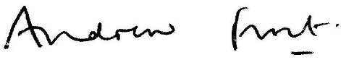

Andrew Frost

Director of Planning & Environment

Dated: 14 August 2024

Signed:

Councillor Jonathan Brown signature

Councillor Jonathan Brown

Cabinet Portfolio Holder - Environment & Health Protection

Dated: 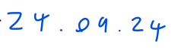



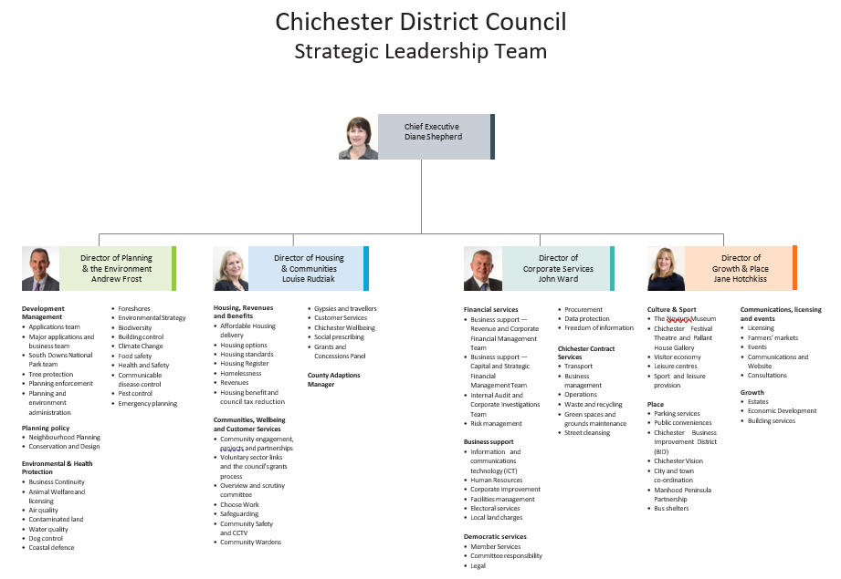

Appendix 1a

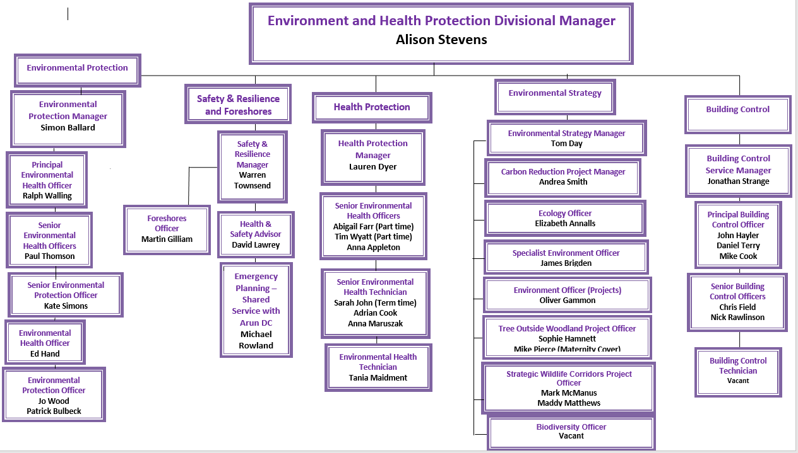

Appendix 1b