|  |
| --- |
| 13 December 2023 |
| By email |
| Secretary of State for Levelling Up, Housing and Communities  Planning Casework Unit  23 Stephenson Street  Birmingham  B2 4BH  pcu@levellingup.gov.uk |
| Dear Sir/Madam |
| Chichester District Council (Tangmere) (No 2) Compulsory Purchase Order 2023 (the "Order")  Withdrawal of objection on behalf of Dr Alice Rebecca Chishick of Tangmere Medical Centre, Malcolm Road, Tangmere, Chichester, PO20 2HS (our "Client") |

We refer to the objection to the Order dated 5 May 2023 lodged on behalf of our Client.

We are pleased to inform you that our Client has reached an agreement with Chichester District Council and that our Client's objection to the Order is therefore withdrawn.

Yours faithfully

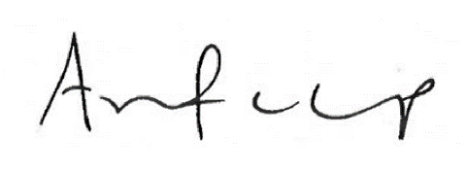

**Ashurst LLP**